**Sustainable Development Goals**

**Asanya Angus**

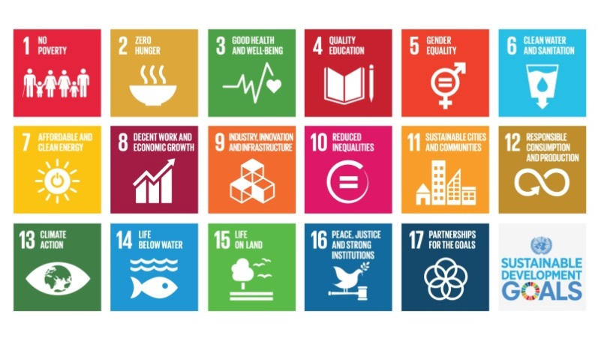

I will start out by defining what sustainable Development Goals means to me. Sustainable Development Goals are global goals that focus on improving livelihoods, food security, ecosystem service, bio- diversity and resource efficiency. The 17 sustainable Development goals are encompass in multiple sectors that guide global development towards achieving, targeting and reducing poverty, fighting inequalities, tackling climate change, while increasing health and well-being. Forest, agriculture and other landscape uses will be crucial components for achieving many of the potential goals, including reducing poverty, increasing health and addressing climate changes. The SDG helps in eradicating all forms of poverty by calling for action by countries, rich or poor in promoting prosperity while protecting the planet. I’m going to be talking about 2 indicators out of the 17 that I received from my teacher, which are no poverty and no hunger. Social development is directly or indirectly related to economic development and pertains to improvements in living condition (improved health, better education, affordable housing, employment and better wages and working conditions, improved wellbeing) and the standard of living in general. Working definitions of economic development often encompass social development. For the purposes of this work, social development refers to the social structures of the society, availability of and access to social services, social justice, the social status and quality of life in general.

* Proportion of population below the international poverty line $1.25, by sex, age, employment status and geographical location
* Proportion of population living below the national poverty line, by sex and age
* Find out if the described indicator is being monitored in Aruba:
* If so, who collects it? If possible, include a link or reference to the data.
* If not, describe where you inquired, and what the response was (e.g. CBS).

**Finding out if the described indicator is being monitored in Aruba?**

Aruba, a small country in the South Caribbean Sea, has been regarded as a popular vacation spot where tourism continues to thrive. Accounting for 30 percent of the island’s income, the tourism industry has been on the rise since 1985. This has brought an increase in business to the hotel industry as well as construction and the food industry. Tourism has helped create a flourishing economy and contributed to the low poverty rate in Aruba.

These increases of industry have paved the way for an increase in jobs. This contributes to the low unemployment rate, 6.9 percent as of 2005. Aruba’s Gross Domestic Product (GDP) has been estimated at about $23,500 per capita in 2011, which is [among the highest](http://www.photius.com/rankings/2017/economy/gdp_per_capita_2017_0.html%E2%80%93) in Central and South America as well as the Caribbean.

Aruba’s tourism industry has continued to thrive in recent years. Increases in the tourism industry have created low unemployment and have contributed to the low poverty rate in Aruba. The tourism industry is expected to continue to prosper in Aruba due to the stable economy and exchange rate. Continued low rates of poverty can also be expected for the near future of Aruba according to (*Podosek* 2014).

Aruba offers further an array of public assistance programs to help in times of economic and financial hardships and legal issues: welfare transfer program („Bijstand‟, „Kosteloze Rechtskundige Bijstand‟) and social support services to help citizens overcome personal, family and relational crises, and to meet basic needs. These are delivered both by pubic departments as well as (largely) publicly subsidized voluntary entities active in the social and healthcare sectors. Moreover, direct accessibility to primary, secondary and tertiary educations is warranted. And lastly, utilities, in particular potable water, are (partially) subsidized. Aruba’s poverty level is low due to the GDP.

**Poverty Line**

Seeking to assess the size of the population deemed indigent in our society. There are different methodologies used to establish poverty lines by applying normative indicator of relative poverty. Furthermore, a proportion of people above the relative poverty line cannot meet some basic needs while the standard of living of some individuals under the poverty line are positively affected by their assets, such as homes, productive land and stocks, job security and a strong informal network.

By applying the Organization for Economic Co-operation and Development (OECD-countries) criteria of “poor” and using the data of the 2010 Census, one out of every five households (20.7%) in Aruba was deemed poor.

The median household income equaled Afl. 2,300. The relative poverty line of 60% of the median income was Afl, 1,380. We should note that the minimum wage at the time the Census was administered was Afl. 1,543 per month. [1]According to the Rabobank‟s estimate, the global financial crisis and the two oil refinery shutdowns resulted that the cumulative GDP contracted with circa 15 percent before growing again with 3.9 percentage points in the year 2013 due to growth in tourism

|  |  |  |  |
| --- | --- | --- | --- |
| **Relative Poverty Line** | **Relative** | **Total households* below poverty line** | **Minimum wage (Afl.)** |
| **Afl. 1,380 (60% of median income)** | **20.7%** | 7,202 | 1,543 |
| **Afl. 1,610 (70% of median income)** | **27.1%** | 9,460 | 1,543 |
| **Afl. 1,150 (50% of median income)** | **15.7%** | 5,486 | 1,543 |
| (Source: Census 2010, CBS Aruba) |
| [2] |

According to *[3]*[Sarah Kirkpatrick](https://prezi.com/user/rmje20x8sxy_/) she stated that the percentage of poverty in Aruba is 28.9 combined for Adults and Children, she also mentioned about the Cost of Groceries in Aruba.  
Since Aruba is an island in the Caribbean, the cost of importing household products is 10% more than in the U.S.A. This links to waste management productions by understanding how much we produce, what we produce, recycling, reusing and reducing household hazardous waste that can approve our environmental liabilities on Aruba (Principles of Environmental Science 7th edition pg 340-350).

A situational analysis is carried out to attempt to ascertain the state of and progress in economic condition and social development in Aruba. It is asserted that a less equal society fosters ill health, lack of community, violence, crimes, drug, and mental illness affecting adversely everyone within[4]. In fact, studies from, e.g., the World Bank based on insights from different countries indicate that the main determinant of poverty alleviation is the combination of economic growth and reduction in inequality[5], leading to a (more) socially inclusive and sustainable economic development.[6] Concomitantly, the promotion of active citizenship is a key component of the ministry of Social Affairs, Youth and Labor’s policy for the 2013-2017 periods. A primary objective of the latter is the development of self-reliance and problem-solving skills under the vulnerable social groups, in particular. In this light the ministry fosters partnership and collaboration between the public sector and the voluntary and private sectors.

1. Centrale Bank van Aruba (2002) Annual Report 2001. p 1. Oranjestad.

   Van der Molen, M. (2014) Rabobank Country Report Aruba. Retrieved from: https://economics.rabobank.com/publications/2014/june/country-report-aruba/
2. CBS Aruba, Income and Expenditure Survey 2006: Selected Tables, p. 7, 2008, Oranjestad.

   Commission of the European communities, Draft Report on Social Exclusion, p, 13.
3. <https://borgenproject.org/poverty-rate-in-aruba/>
4. Pickett, K. & Wilkinson, R. (2010) The Spirit Level: Why More Equal Societies Almost Always Do Better. Power Point Presentation. Available at: https://www.equalitytrust.org.uk/resources/the-spirit-level
5. Rami Ben Haj Kacem (2012) Monetary Versus Non-monetary Pro-poor Growth: Evidence from Rural Ethiopia from 2004-2008. Retrieved from: http://www.economics-ejournal.org/economics/discussionpapers/2012-62/file
6. Regering van Auba (2014) Binden, Bouwen en Bestendigen.