Waste management in Aruba

Ecotech, Interviews about waste management in Aruba

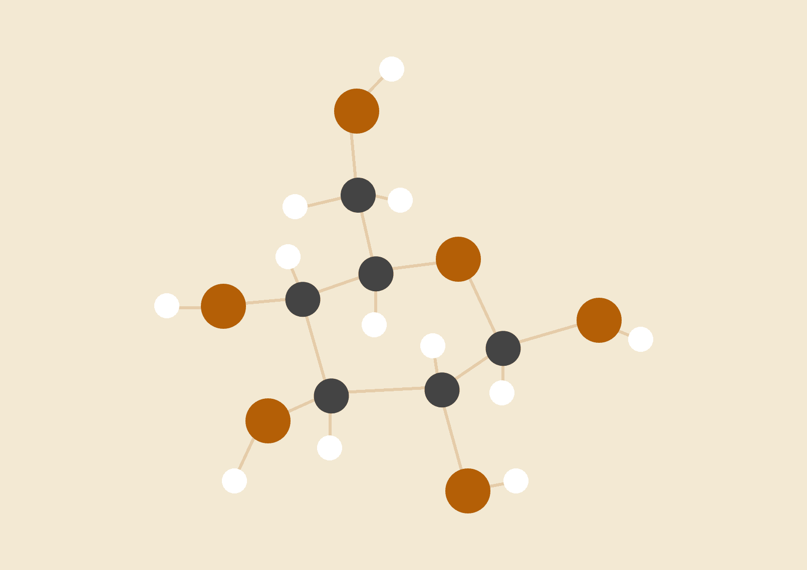

**Geraldine, Denilaire & Justin**

20-11-2017

Tony Sevold & Christie Mettes

# Environmental Science

# INTRODUCTION

Waste management has become a very common topic point to talk worldwide. Nowadays, the amount of waste has been increasingly grown among the years. In this project we had the privilege to interview Ecotech, a company of waste management program whose focus is on raising awareness to contribute to recycling. This company was established on November 1999 where it has grown his population due his excellent service and the way they separate the waste. All the collected waste is brought to Eco-Tech's sister company, Eco Gas, a state of the art waste separation plant build in 2009. The interview was Conducted by Mr. Ramsey who is the manager director of Eco-gas and responsible of different operations whose aim is to offer a high-quality service throughout his employees and obtain an effective and efficient way to fulfill the demand of the customers. He touched some points where he gave his personal and professional impressions about the waste management in Aruba and testify certain ways of how to reduce the smell, smoke, bugs and how manage the waste to improve the air pollution in Aruba.

# Waste management in Aruba

Eco-tech is located in different areas on the island. Who is the leading company, collecting most of the commercial waste in Aruba, offering the customers a variety of closed bins in different sizes depending on their needs. By this, they offer a variety of collection, recycling and processing capabilities to a wide range of customers in the commercial, industrial, and medical industries. Mr. Ramsey explained that Eco-tech is in charge of the 30% of the collection and Eco-gas process it and separate it in many ways so it could be use into useful materials.

First of all, Eco-gas separates the wastes in many forms such as; the sand, glass, rocks, food waste, toxic metals and non-toxic metals out of the waste stream. The remaining waste can be able to turn it in two ways: convert it into gas or electricity or compressed the left-over material and store it in invariable where they will be used to reclaim land. For instance, use it in abandoned place and convert it into a useful place. In addition to this, he explains that Eco-tech and Eco-gas works together with other companies such as Serlimar who takes care of the sand and stone, Car Rental service obtains the steel and aluminum and WEB takes the remaining waste to convert it in electricity.

Secondly, his personal impression of waste management in Aruba was that the way Aruba manage the waste should be more improved. People in Aruba have become aware of waste disposal problems in their communities, which more people are trying to recycle more materials. He explains that there are people who do not have the knowledge of it they just throw everything in the waste meaning that the variety of wastes that we all produce, from domestic garbage, yard wastes to industrial, commercial, and construction refuse. Most of the times the materials in our waste stream would be valuable resource if they were not mixed with other garbage. In his opinion if Arubans learn how to recycle and understand the impacts of the environment, contribute the safeguarding of their environment it can help to reduce waste in Aruba.

Thirdly, one of the main problems in Aruba is the financial one. Eco-tech offers to their clients to pay 26 florins a month where they receive a bin and the company is responsible to pick up their waste twice a week. This income will help Eco-tech to avoid the waste to be thrown away by the dump and instead send it to Eco-Gas, so they could be able to process it and separate in different ways. However, Serlimar which is another company of waste management does not require this rule, which leads this company to throw away the waste by the dump generating more waste in the landfill, leading to a unpleasant view for the island and causing the beach to be in danger due Aruba’s landfill is close to it. Mr. Ramsey believes that the government should step up and come up with a law where the residents are forced to pay an average month fee, so the waste management companies could have an income to reduce and work with the waste. Since these companies also produce huge investments to obtain certain equipment to keep Aruba clean.

**Population**

To go deeper in that topic, “waste management in Aruba’’ the population involved has to take in more consideration, especially how they behave toward waste or how they manage waste. The current population of Aruba is over 100,000 people, they produce 240 tons a day according to Mr. Ramsey, these waste produce could be less if they have made a good manage about what they consider as waste. Mr. Ramsey assumes that, the population only focus that waste management is just dumped everything they do not need vaguely which could have be done through a process. For example: by throwing can with a liquid inside of it takes more time to do the recycling, so they could drop the liquid and dumped the can. That is one the reason which causes the Eco-Gas can only deal with 100 tons of waste in Aruba. Thus, Mr. Ramsey assumes that if the waste management in Aruba is included by separating all household waste by type, plastic, metal, paper/cardboard, food, hazardous (like batteries), garden, wood etc., that will help for a better management of waste.

# RESULTS

The desired future for the waste management is where people learn to manage the waste they produce at home in a way that makes the work for these men better, for example by not dumping liquids into the garbage it will reduce the smell that the workers have to face every day. Another example is when people are done with their food they can give it to their pets or by making compost out of it, because they majority of trash collected is food waste and by doing this it brings down to total of waste. A desired future is where the majority or all the residents in Aruba know how to reduce the waste by controlling the waste in their homes and by the choosing the right waste processor who knows how to use the waste efficiently (e.g. landfills and natural gas made from waste) no matter the cost.

Obstacles seen in getting to this desired future scenario is that waste management is related much more to the business then a must among the bodies concerned, however to keep the environment safe and clean, the management of waste should be a must to bodies concerned.

People still not wanting to pay waste processors for services that could help in the reducing of waste due to low income or not knowing the difference between which waste processor just dumps waste or one that uses the waste for energy. People still not learning about waste, how to reduce waste at home and knowing how the workers of waste processors work. So, working with, one purpose, collaboration, less competition to encounter, the waste threats are emphasized the obstacles to get to this desired future of waste management in Aruba.

# CONCLUSION

Market for improved waste management in Aruba (who would pay for better waste management in Aruba? (e.g. recycling). In conclusion, one of the important goals that should be considered one of the main topics here on the island is to create awareness by educating the people of Aruba on the necessity to recycle. In addition to this, options to existing waste handling and dumping techniques must be clearly communicated. Arubans can become involved in contributing to the improvement and safeguarding of their environment and help to reduce the waste in Aruba. Mr. Ramsey stated that the only way to improve the future of Aruba is to reuse some materials and recycle the plastic items such as bottles and so on. Furthermore, if we change the Aruban mentality by paying and convince them in paying more for a better waste system it will reduce the waste management in the landfill and decrease chances to damage our ocean since they are near to each other.

# REFERENCES

<https://ecotecharuba.com/faq/>

<https://ecotecharuba.com>

<http://countrymeters.info/en/Aruba>