part2_4

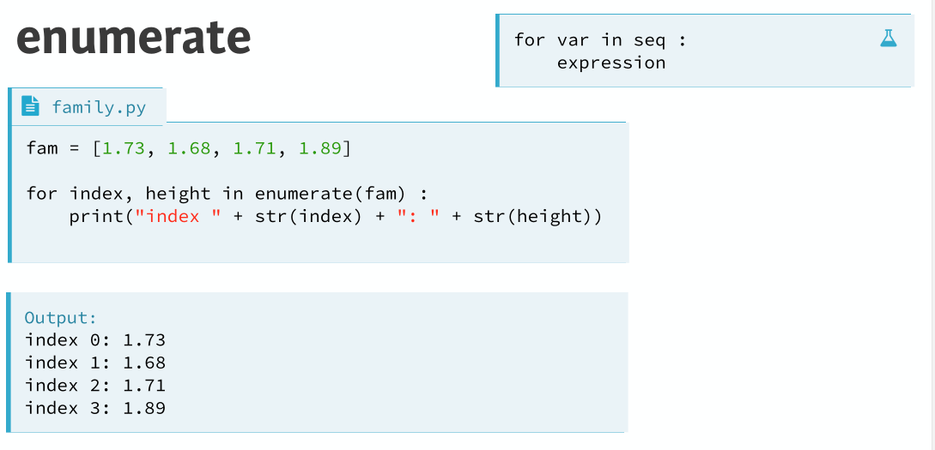

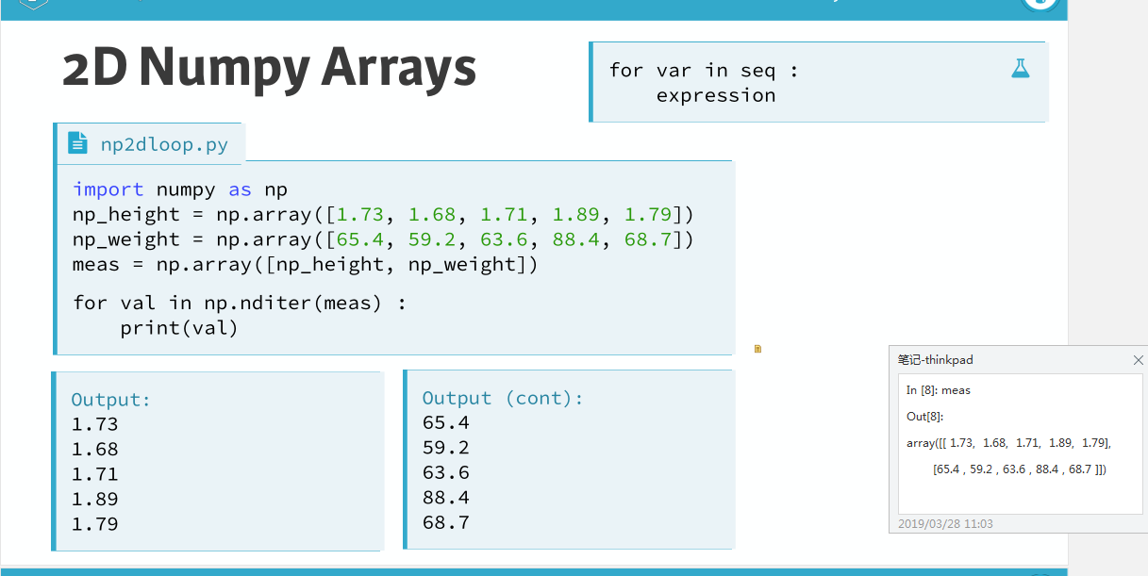

https://blog.csdn.net/jiangjiang_jian/article/details/77540599

1. a = np.arange(6).reshape(2, 3)
2. **print** a
4. **for** x **in** np.nditer(a, op_flags = ['readwrite']):
5. x[...] = 2*x
7. **print** a
9. [[0 1 2]
10. [3 4 5]]
11. [[ 0  2  4]
12. [ 6  8 10]]

