**Frequencies**

|  |  |  |  |  |  |  |
| --- | --- | --- | --- | --- | --- | --- |
| **Statistics** | | | | | | |
|  | | The gender of the respondent | The age of the respondent | The occupation of the respondent | The relationship the respondent has to the contributor | The customer's location |
| N | Valid | 10 | 10 | 10 | 10 | 10 |
| Missing | 0 | 0 | 0 | 0 | 0 |

**Frequency Table**

|  |  |  |  |  |  |
| --- | --- | --- | --- | --- | --- |
| **The gender of the respondent** | | | | | |
|  | | Frequency | Percent | Valid Percent | Cumulative Percent |
| Valid | Female | 5 | 50.0 | 50.0 | 50.0 |
| Male | 5 | 50.0 | 50.0 | 100.0 |
| Total | 10 | 100.0 | 100.0 |  |

|  |  |  |  |  |  |
| --- | --- | --- | --- | --- | --- |
| **The age of the respondent** | | | | | |
|  | | Frequency | Percent | Valid Percent | Cumulative Percent |
| Valid | 18-24 | 2 | 20.0 | 20.0 | 20.0 |
| 25-34 | 2 | 20.0 | 20.0 | 40.0 |
| 35-44 | 2 | 20.0 | 20.0 | 60.0 |
| 45-54 | 2 | 20.0 | 20.0 | 80.0 |
| 55+ | 2 | 20.0 | 20.0 | 100.0 |
| Total | 10 | 100.0 | 100.0 |  |

|  |  |  |  |  |  |
| --- | --- | --- | --- | --- | --- |
| **The occupation of the respondent** | | | | | |
|  | | Frequency | Percent | Valid Percent | Cumulative Percent |
| Valid | Employed | 4 | 40.0 | 40.0 | 40.0 |
| Self employed | 5 | 50.0 | 50.0 | 90.0 |
| Claimant | 1 | 10.0 | 10.0 | 100.0 |
| Total | 10 | 100.0 | 100.0 |  |

|  |  |  |  |  |  |
| --- | --- | --- | --- | --- | --- |
| **The relationship the respondent has to the contributor** | | | | | |
|  | | Frequency | Percent | Valid Percent | Cumulative Percent |
| Valid | Self | 5 | 50.0 | 50.0 | 50.0 |
| Family member | 3 | 30.0 | 30.0 | 80.0 |
| Friend | 2 | 20.0 | 20.0 | 100.0 |
| Total | 10 | 100.0 | 100.0 |  |

|  |  |  |  |  |  |
| --- | --- | --- | --- | --- | --- |
| **The customer's location** | | | | | |
|  | | Frequency | Percent | Valid Percent | Cumulative Percent |
| Valid | Nairobi | 2 | 20.0 | 20.0 | 20.0 |
| Rift Valley | 2 | 20.0 | 20.0 | 40.0 |
| Central/Eastern | 2 | 20.0 | 20.0 | 60.0 |
| Nyanza/Western | 2 | 20.0 | 20.0 | 80.0 |
| Coast/North Eastern | 2 | 20.0 | 20.0 | 100.0 |
| Total | 10 | 100.0 | 100.0 |  |

**Bar Chart**

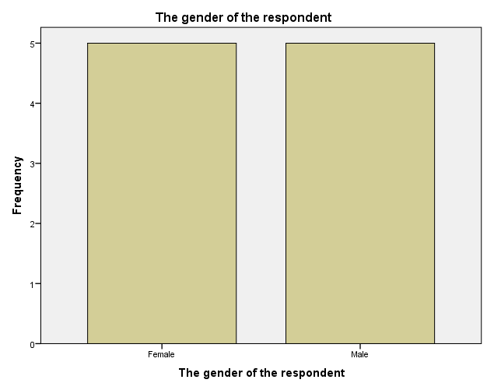

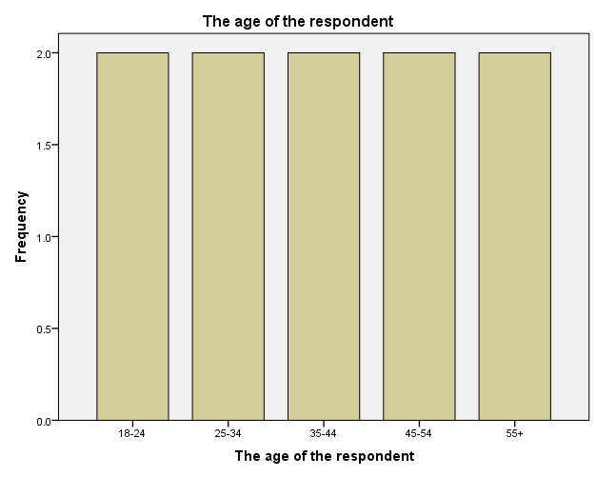

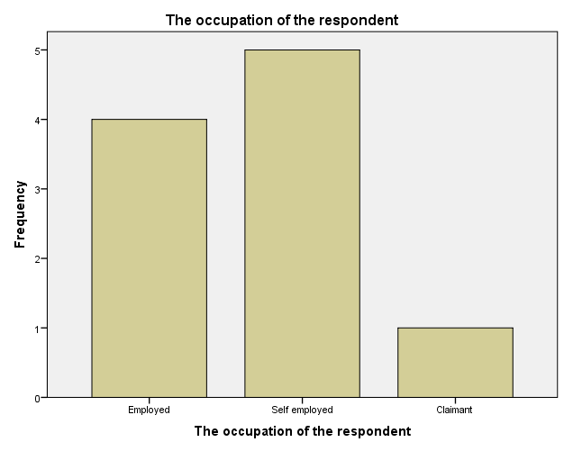

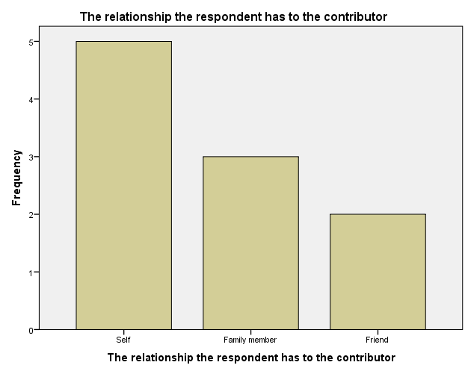

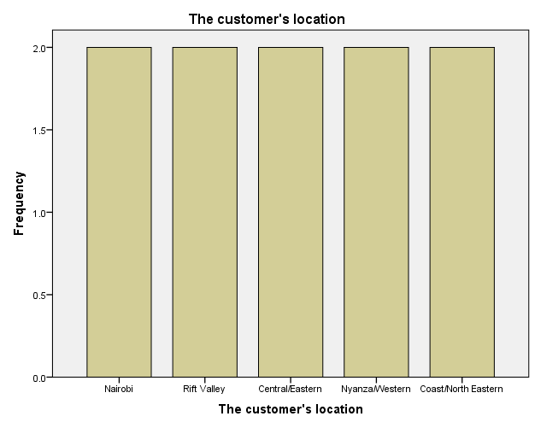

**Multiple Response**

|  |  |  |  |  |  |  |
| --- | --- | --- | --- | --- | --- | --- |
| **Case Summary** | | | | | | |
|  | Cases | | | | | |
| Valid | | Missing | | Total | |
| N | Percent | N | Percent | N | Percent |
| $Awareness_source_about_NSSFa | 10 | 100.0% | 0 | 0.0% | 10 | 100.0% |

|  |
| --- |
| a. Dichotomy group tabulated at value 0. |

|  |  |  |  |  |
| --- | --- | --- | --- | --- |
| **$Awareness_source_about_NSSF Frequencies** | | | | |
|  | | Responses | | Percent of Cases |
| N | Percent |
| Source of awareness about NSSFa | If the respondent got to know about NSSF through the radio | 5 | 17.2% | 50.0% |
| If the respondent got to know about NSSF through the television | 4 | 13.8% | 40.0% |
| If the respondent got to know about NSSF through newspapers | 4 | 13.8% | 40.0% |
| If the respondent got to know about NSSF through friends/relatives/colleagues | 4 | 13.8% | 40.0% |
| If the respondent got to know about NSSF through publicity boards | 4 | 13.8% | 40.0% |
| If the respondent got to know about NSSF through their employers | 3 | 10.3% | 30.0% |
| If the respondent got to know about NSSF through visiting the NSSF premises | 5 | 17.2% | 50.0% |
| Total | | 29 | 100.0% | 290.0% |

|  |
| --- |
| a. Dichotomy group tabulated at value 0. |

**Multiple Response**

|  |  |  |  |  |  |  |
| --- | --- | --- | --- | --- | --- | --- |
| **Case Summary** | | | | | | |
|  | Cases | | | | | |
| Valid | | Missing | | Total | |
| N | Percent | N | Percent | N | Percent |
| $aware_of_the_benefita | 10 | 100.0% | 0 | 0.0% | 10 | 100.0% |

|  |
| --- |
| a. Dichotomy group tabulated at value 0. |

|  |  |  |  |  |
| --- | --- | --- | --- | --- |
| **$aware_of_the_benefit Frequencies** | | | | |
|  | | Responses | | Percent of Cases |
| N | Percent |
| Respondents aware of these NSSF benefitsa | If the respondent is aware of Age/Retirement Benefit as an NSSF benefit | 10 | 30.3% | 100.0% |
| If the respondent is aware of Survival Benefit as an NSSF benefit | 5 | 15.2% | 50.0% |
| If the respondent is aware of Invalidity Benefit as an NSSF benefit | 2 | 6.1% | 20.0% |
| If the respondent is aware of Funeral Grant as an NSSF benefit | 5 | 15.2% | 50.0% |
| If the respondent is aware of Emigration Benefit as an NSSF benefit | 4 | 12.1% | 40.0% |
| If the respondent is aware of Withdrawal Benefit as an NSSF benefit | 7 | 21.2% | 70.0% |
| Total | | 33 | 100.0% | 330.0% |

|  |
| --- |
| a. Dichotomy group tabulated at value 0. |

**Multiple Response**

|  |  |  |  |  |  |  |
| --- | --- | --- | --- | --- | --- | --- |
| **Case Summary** | | | | | | |
|  | Cases | | | | | |
| Valid | | Missing | | Total | |
| N | Percent | N | Percent | N | Percent |
| $Awareness_source_about_NSSF_benefitsa | 10 | 100.0% | 0 | 0.0% | 10 | 100.0% |

|  |
| --- |
| a. Dichotomy group tabulated at value 0. |

|  |  |  |  |  |
| --- | --- | --- | --- | --- |
| **$Awareness_source_about_NSSF_benefits Frequencies** | | | | |
|  | | Responses | | Percent of Cases |
| N | Percent |
| Source of awareness about NSSF benefitsa | If the respondent got aware of the NSSF benefits through the radio | 5 | 11.4% | 50.0% |
| If the respondent got aware of the NSSF benefits through the television | 5 | 11.4% | 50.0% |
| If the respondent got aware of the NSSF benefits through the newspapers | 6 | 13.6% | 60.0% |
| If the respondent got aware of the NSSF benefits through friends/relatives/colleagues | 8 | 18.2% | 80.0% |
| If the respondent got aware of the NSSF benefits through publicity boards | 6 | 13.6% | 60.0% |
| If the respondent got aware of the NSSF benefits through their employers | 4 | 9.1% | 40.0% |
| If the respondent got aware of the NSSF benefits through the NSSF staff | 10 | 22.7% | 100.0% |
| Total | | 44 | 100.0% | 440.0% |

|  |
| --- |
| a. Dichotomy group tabulated at value 0. |

**Frequencies on Level of Satisfaction**

|  |  |  |
| --- | --- | --- |
| **Statistics** | | |
| Respondents level of satisfaction on NSSF office distribution in the country | | |
| N | Valid | 10 |
| Missing | 0 |

|  |  |  |  |  |  |
| --- | --- | --- | --- | --- | --- |
| **Respondents level of satisfaction on NSSF office distribution in the country** | | | | | |
|  | | Frequency | Percent | Valid Percent | Cumulative Percent |
| Valid | Very satisfied | 1 | 10.0 | 10.0 | 10.0 |
| Satisfied | 4 | 40.0 | 40.0 | 50.0 |
| Neutral | 2 | 20.0 | 20.0 | 70.0 |
| Dissatisfied | 2 | 20.0 | 20.0 | 90.0 |
| Very dissatisfied | 1 | 10.0 | 10.0 | 100.0 |
| Total | 10 | 100.0 | 100.0 |  |

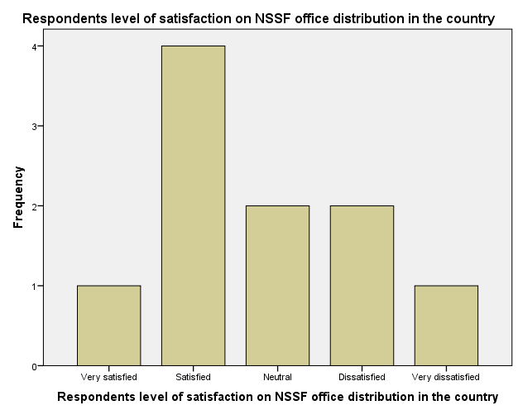

|  |  |  |
| --- | --- | --- |
| **Statistics** | | |
| Respondents level of satisfaction on NSSF registration process | | |
| N | Valid | 10 |
| Missing | 0 |

|  |  |  |  |  |  |
| --- | --- | --- | --- | --- | --- |
| **Respondents level of satisfaction on NSSF registration process** | | | | | |
|  | | Frequency | Percent | Valid Percent | Cumulative Percent |
| Valid | Very satisfied | 3 | 30.0 | 30.0 | 30.0 |
| Satisfied | 5 | 50.0 | 50.0 | 80.0 |
| Neutral | 1 | 10.0 | 10.0 | 90.0 |
| Dissatisfied | 1 | 10.0 | 10.0 | 100.0 |
| Total | 10 | 100.0 | 100.0 |  |

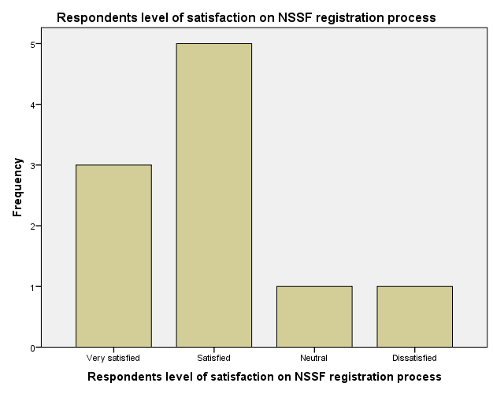

|  |  |  |
| --- | --- | --- |
| **Statistics** | | |
| Respondents level of satisfaction on the modes of contribution to NSSF | | |
| N | Valid | 10 |
| Missing | 0 |

|  |  |  |  |  |  |
| --- | --- | --- | --- | --- | --- |
| **Respondents level of satisfaction on the modes of contribution to NSSF** | | | | | |
|  | | Frequency | Percent | Valid Percent | Cumulative Percent |
| Valid | Very satisfied | 2 | 20.0 | 20.0 | 20.0 |
| Satisfied | 4 | 40.0 | 40.0 | 60.0 |
| Neutral | 1 | 10.0 | 10.0 | 70.0 |
| Dissatisfied | 3 | 30.0 | 30.0 | 100.0 |
| Total | 10 | 100.0 | 100.0 |  |

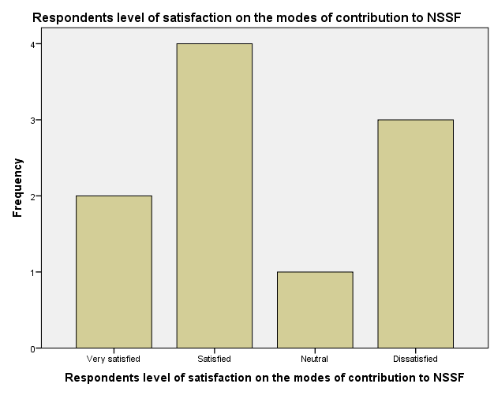

|  |  |  |
| --- | --- | --- |
| **Statistics** | | |
| Level of satisfaction if the contribution to NSSF is within the respondents’ budget | | |
| N | Valid | 10 |
| Missing | 0 |

|  |  |  |  |  |  |
| --- | --- | --- | --- | --- | --- |
| **Level of satisfaction if the contribution to NSSF is within the respondent’s budget** | | | | | |
|  | | Frequency | Percent | Valid Percent | Cumulative Percent |
| Valid | Very satisfied | 1 | 10.0 | 10.0 | 10.0 |
| Satisfied | 5 | 50.0 | 50.0 | 60.0 |
| Neutral | 1 | 10.0 | 10.0 | 70.0 |
| Dissatisfied | 3 | 30.0 | 30.0 | 100.0 |
| Total | 10 | 100.0 | 100.0 |  |

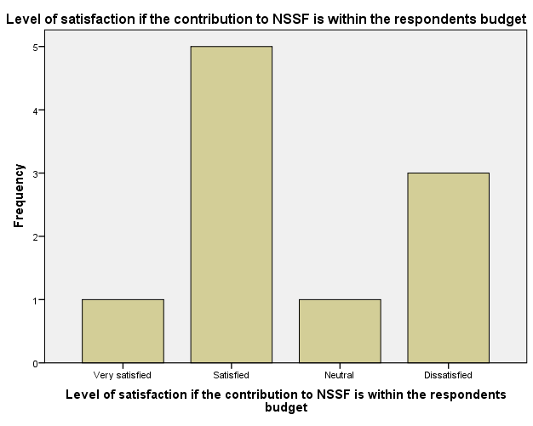

|  |  |  |
| --- | --- | --- |
| **Statistics** | | |
| Level of satisfaction if the contributions of the respondent shall enable sufficient final income | | |
| N | Valid | 10 |
| Missing | 0 |

|  |  |  |  |  |  |
| --- | --- | --- | --- | --- | --- |
| **Level of satisfaction if the contributions of the respondent shall enable sufficient final income** | | | | | |
|  | | Frequency | Percent | Valid Percent | Cumulative Percent |
| Valid | Very satisfied | 1 | 10.0 | 10.0 | 10.0 |
| Satisfied | 2 | 20.0 | 20.0 | 30.0 |
| Neutral | 1 | 10.0 | 10.0 | 40.0 |
| Dissatisfied | 2 | 20.0 | 20.0 | 60.0 |
| Very dissatisfied | 3 | 30.0 | 30.0 | 90.0 |
| Don't know | 1 | 10.0 | 10.0 | 100.0 |
| Total | 10 | 100.0 | 100.0 |  |

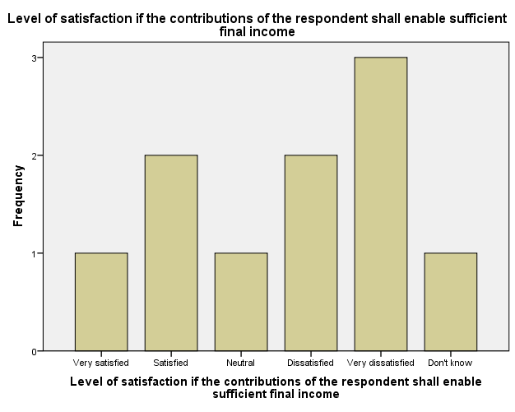

|  |  |  |
| --- | --- | --- |
| **Statistics** | | |
| Respondents level of satisfaction on the safety of the contributions made to NSSF | | |
| N | Valid | 10 |
| Missing | 0 |

|  |  |  |  |  |  |
| --- | --- | --- | --- | --- | --- |
| **Respondents level of satisfaction on the safety of the contributions made to NSSF** | | | | | |
|  | | Frequency | Percent | Valid Percent | Cumulative Percent |
| Valid | Very satisfied | 2 | 20.0 | 20.0 | 20.0 |
| Satisfied | 2 | 20.0 | 20.0 | 40.0 |
| Neutral | 1 | 10.0 | 10.0 | 50.0 |
| Dissatisfied | 2 | 20.0 | 20.0 | 70.0 |
| Don't know | 3 | 30.0 | 30.0 | 100.0 |
| Total | 10 | 100.0 | 100.0 |  |

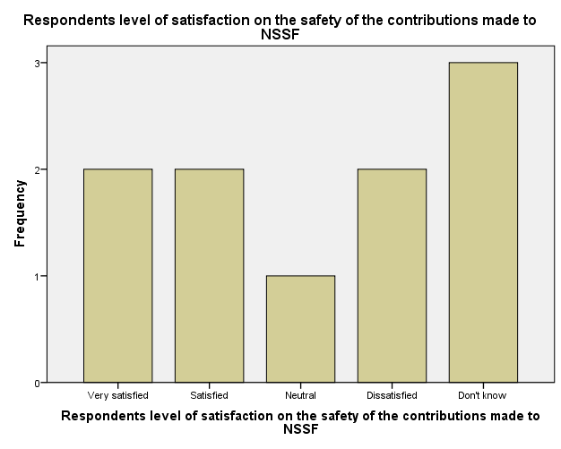

|  |  |  |
| --- | --- | --- |
| **Statistics** | | |
| Respondents level of satisfaction on the investments made by NSSF using their contribution | | |
| N | Valid | 10 |
| Missing | 0 |

|  |  |  |  |  |  |
| --- | --- | --- | --- | --- | --- |
| **Respondents level of satisfaction on the investments made by NSSF using their contribution** | | | | | |
|  | | Frequency | Percent | Valid Percent | Cumulative Percent |
| Valid | Very satisfied | 2 | 20.0 | 20.0 | 20.0 |
| Dissatisfied | 3 | 30.0 | 30.0 | 50.0 |
| Very dissatisfied | 1 | 10.0 | 10.0 | 60.0 |
| Don't know | 4 | 40.0 | 40.0 | 100.0 |
| Total | 10 | 100.0 | 100.0 |  |

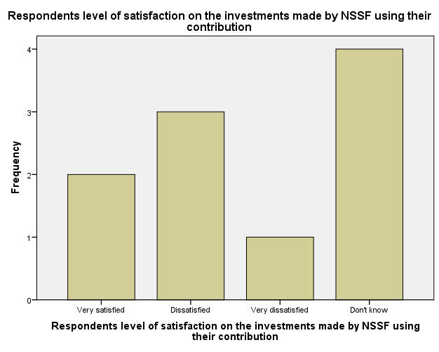

|  |  |  |
| --- | --- | --- |
| **Statistics** | | |
| Respondents level of satisfaction on NSSF's benefits compared to competitors' benefits | | |
| N | Valid | 10 |
| Missing | 0 |

|  |  |  |  |  |  |
| --- | --- | --- | --- | --- | --- |
| **Respondents level of satisfaction on NSSF's benefits compared to competitors' benefits** | | | | | |
|  | | Frequency | Percent | Valid Percent | Cumulative Percent |
| Valid | Satisfied | 4 | 40.0 | 40.0 | 40.0 |
| Neutral | 2 | 20.0 | 20.0 | 60.0 |
| Dissatisfied | 2 | 20.0 | 20.0 | 80.0 |
| Very dissatisfied | 2 | 20.0 | 20.0 | 100.0 |
| Total | 10 | 100.0 | 100.0 |  |

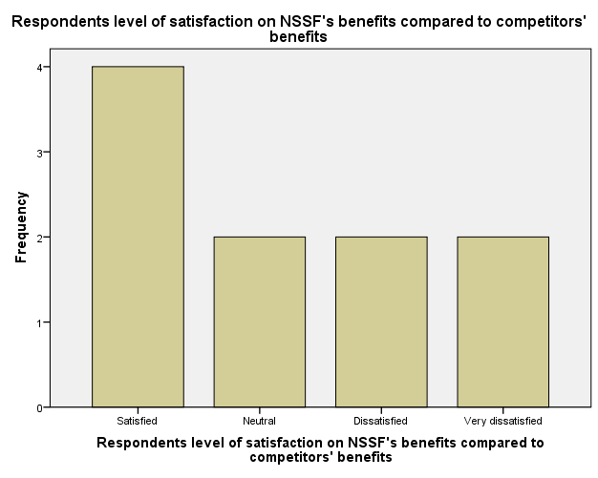

|  |  |  |
| --- | --- | --- |
| **Statistics** | | |
| Respondents level of satisfaction on the rules and decisions exercised by NSSF staff | | |
| N | Valid | 10 |
| Missing | 0 |

|  |  |  |  |  |  |
| --- | --- | --- | --- | --- | --- |
| **Respondents level of satisfaction on the rules and decisions exercised by NSSF staff** | | | | | |
|  | | Frequency | Percent | Valid Percent | Cumulative Percent |
| Valid | Very satisfied | 3 | 30.0 | 30.0 | 30.0 |
| Satisfied | 4 | 40.0 | 40.0 | 70.0 |
| Neutral | 3 | 30.0 | 30.0 | 100.0 |
| Total | 10 | 100.0 | 100.0 |  |

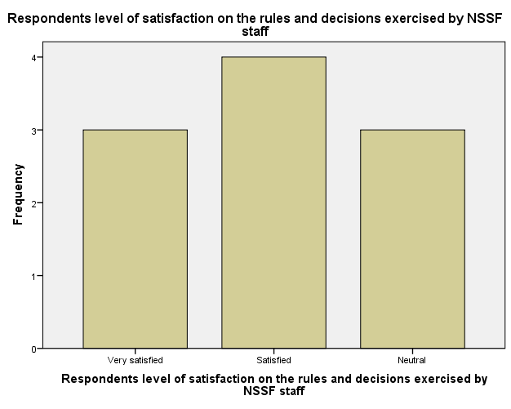

**Frequencies 0n Level of Agreement**

|  |  |  |
| --- | --- | --- |
| **Statistics** | | |
| Respondents level of agreement that NSSF does not tolerate corrupt activities | | |
| N | Valid | 10 |
| Missing | 0 |

|  |  |  |  |  |  |
| --- | --- | --- | --- | --- | --- |
| **Respondents level of agreement that NSSF does not tolerate corrupt activities** | | | | | |
|  | | Frequency | Percent | Valid Percent | Cumulative Percent |
| Valid | Strongly agree | 2 | 20.0 | 20.0 | 20.0 |
| Agree | 3 | 30.0 | 30.0 | 50.0 |
| Neither agree nor disagree | 3 | 30.0 | 30.0 | 80.0 |
| Disagree | 1 | 10.0 | 10.0 | 90.0 |
| Don't know | 1 | 10.0 | 10.0 | 100.0 |
| Total | 10 | 100.0 | 100.0 |  |

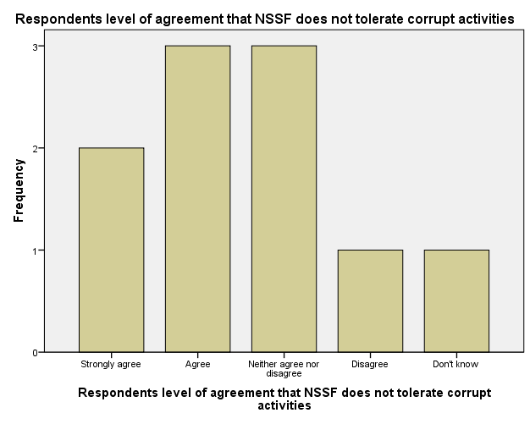

|  |  |  |
| --- | --- | --- |
| **Statistics** | | |
| Respondents level of agreement that NSSF staff come up with new/better ways of delivering service | | |
| N | Valid | 10 |
| Missing | 0 |

|  |  |  |  |  |  |
| --- | --- | --- | --- | --- | --- |
| **Respondents level of agreement that NSSF staff come up with new/better ways of delivering service** | | | | | |
|  | | Frequency | Percent | Valid Percent | Cumulative Percent |
| Valid | Strongly agree | 1 | 10.0 | 10.0 | 10.0 |
| Agree | 1 | 10.0 | 10.0 | 20.0 |
| Neither agree nor disagree | 4 | 40.0 | 40.0 | 60.0 |
| Disagree | 3 | 30.0 | 30.0 | 90.0 |
| Don't know | 1 | 10.0 | 10.0 | 100.0 |
| Total | 10 | 100.0 | 100.0 |  |

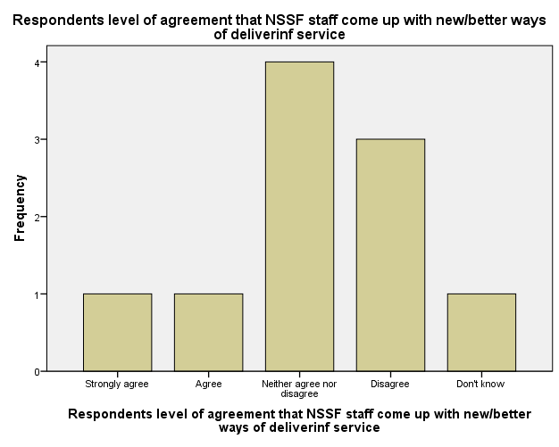

|  |  |  |
| --- | --- | --- |
| **Statistics** | | |
| Respondents level of agreement that NSSF staff act responsibly and openly in their work | | |
| N | Valid | 10 |
| Missing | 0 |

|  |  |  |  |  |  |
| --- | --- | --- | --- | --- | --- |
| **Respondents level of agreement that NSSF staff act responsibly and openly in their work** | | | | | |
|  | | Frequency | Percent | Valid Percent | Cumulative Percent |
| Valid | Strongly agree | 2 | 20.0 | 20.0 | 20.0 |
| Agree | 2 | 20.0 | 20.0 | 40.0 |
| Neither agree nor disagree | 2 | 20.0 | 20.0 | 60.0 |
| Disagree | 3 | 30.0 | 30.0 | 90.0 |
| Don't know | 1 | 10.0 | 10.0 | 100.0 |
| Total | 10 | 100.0 | 100.0 |  |

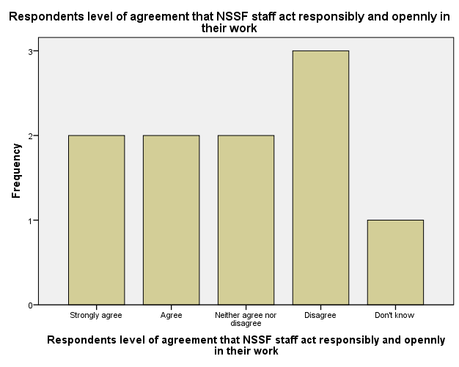

|  |  |  |
| --- | --- | --- |
| **Statistics** | | |
| Level of agreement that the NSSF staff work together when necessary to meet the respondents needs | | |
| N | Valid | 10 |
| Missing | 0 |

|  |  |  |  |  |  |
| --- | --- | --- | --- | --- | --- |
| **Level of agreement that the NSSF staff work together when necessary to meet the respondents needs** | | | | | |
|  | | Frequency | Percent | Valid Percent | Cumulative Percent |
| Valid | Strongly agree | 1 | 10.0 | 10.0 | 10.0 |
| Agree | 3 | 30.0 | 30.0 | 40.0 |
| Neither agree nor disagree | 1 | 10.0 | 10.0 | 50.0 |
| Disagree | 2 | 20.0 | 20.0 | 70.0 |
| Don't know | 3 | 30.0 | 30.0 | 100.0 |
| Total | 10 | 100.0 | 100.0 |  |

