ECDL Web
Module 5:
JavaScript:
The Complete
Coursebook

Brendan Munnelly
with Paul Holden

"European Computer Driving Licence" and ECDL and Stars device are registered trademarks of the European Computer Driving Licence Foundation Limited in Ireland and other countries.

ECDL Web Module 5 - JavaScript: The Complete Coursebook may be used in assisting students to prepare for the European Computer Driving Licence Web Module 5Examination. The authors makes no warrant that the use of this book will ensure passing the relevant Examination.

Any and all assessment tests and/or performance based exercises contained in ECDL Web Module 5 - JavaScript: The Complete Coursebook relate solely to this book and do not constitute, or imply, certification by the European Driving Licence Foundation in respect of any ECDL Examinations. For details on sitting ECDL Examinations in your country please contact the local ECDL Licensee or visit the European Computer Driving Licence Foundation Limited web site at http://www.ecdl.com.

References to the European Computer Driving Licence (ECDL) include the International Computer Driving Licence (ICDL).

© 2002 Brendan Munnelly

Brendan Munnelly is at http://www.munnelly.com

Contents

1 Writing Your First Scripts 9
Objectives 9
Vocabulary 9
Exercise Files 9
The HTML <SCRIPT> Tag and Attributes 10
Strings and Concatenation 11
Joining Strings Together 11
Typing and Escaping Special Characters 12
Combining HTML With JavaScript 14
Single and Double Quotes 14
Creating Line and Paragraph Breaks 15
Commenting Your Scripts 16
Making a JavaScript Statement 16
Working With window.alert() and window.confirm() Dialog Boxes 17
The window.alert() Dialog Box 17
The window.confirm() Dialog Box 17
2 Introducing Objects, Properties and Methods 21
Objectives 21
Vocabulary 21
Exercise Files 21
Objects Are; Methods Do 22
Properties of Objects 22
Viewing Object Properties With document.write() 25
Hiding Your Scripts From Older Browsers 26
The Alternative <NOSCRIPT>...</NOSCRIPT> Tag Pair 26
Chapter Summary 28
3 JavaScript Functions and Event Handlers 29
Objectives 29
Vocabulary 29
Exercise Files 29
About Functions and Event Handlers 30
Rules For Working With Functions 31
About the <BUTTON>…</BUTTON>Tag 33
Working With Event Handlers 33
Document-level Event Handlers 34
Multiple Functions, Multiple Event Handlers 35
More Complex Functions 35
Chapter Summary 36
4 JavaScript Variables and Operators 37
Objectives 37
Vocabulary 37
Exercise Files 37
About Variables 38
Variable Types in JavaScript 39
Variable Names 39
JavaScript Numeric Variables 39
Arithmetic Operators 40
Operator Precedence 41
Exercise 5.17: Using Parentheses in Calculations 41
About The Assignment Operator 42
Automatic Variable Retyping 43
The typeof Operator 43
Exercise 5.18: Investigating a Variable’s Type 43
Chapter Summary 46
5 JavaScript Variables and HTML Text Form Fields 47
Objectives 47
Vocabulary 47
Exercise Files 47
Variables: Your Values or Mine? 48
Obtaining Values From a window.prompt() Box 48
Using Forms with JavaScript 50
Exercise 5.20: Building a Simple JavaScript-controlled Form 50
About the Forms Object 51
Reading a User-entered Text Box Value with JavaScript 52
Writing a Script-generated Value to a Text Box JavaScript 52
Making the Connection: HTML Form Field Names and JavaScript Variable Names 53
Displaying Form Values in Scrolling Text Boxes 54
Handling User-entered Numbers in HTML Order Forms 55
The parseInt() and parseFloat Methods 55
Setting Decimal Places With The toFixed(n) Method 55
Chapter Summary 61
6 More About Functions 63
Objectives 63
Vocabulary 63
Exercise Files 63
Functions That Need Parameters 64
About Literals 66
The Passing of Parameters: A Review 66
Passing Multiple Parameters 67
Functions That Return Values 67
Calling Functions With Keyboard Events 70
Chapter Summary 71
7 Making Decisions With JavaScript 73
Objectives 73
Vocabulary 73
Exercise Files 73
Decision-making With The if Command 74
The if Command In Action 74
Comparison Operators 75
Multiple if Commands 76
The All-purpose else Command 77
Linking Conditions With Logical Operators 78
The Alternative else if Approach 80
The switch and case Commands 81
The toUpperCase() and toLowerCase() Methods 83
Chapter Summary 84
8 Looping in JavaScript 85
Objectives 85
Vocabulary 85
Exercise Files 85
Going On and On: JavaScript Loops 86
About Loop Conditions 86
About the Increment and Decrement Operators 86
The for Loop Structure 87
More About for Loops 88
The while Loop 90
More About while Loops 91
The do…while Loop 91
More About while Loops 93
Interrupting Loops with break and continue 94
About the break Command 94
About the continue Command 94
Chapter Summary 96
9 Working With Arrays 97
Objectives 97
Vocabulary 97
Exercise Files 97
Arrays: When Variables Are Not Enough 98
Reading Values from an Array 99
Reading Array Values With Loops 100
The Array Length Property 100
Adding, Modifying and Deleting Array Values 102
Adding Array Values 102
Modifying Array Values 102
Deleting Array Values 102
Copying Array Values to a String 105
Sorting the Values of an Array 106
Chapter Summary 109
10 Working With Clickable Form Elements 111
Objectives 111
Vocabulary 111
Exercise Files 111
Capturing User Choices 112
Working With SELECT Form Elements 112
Setting a Default List Option 113
SELECT Lists and the onchange() Event Handler 114
Working With Checkbox Form Elements 115
Setting a Default Checkbox Option 116
Working With Radio Button Form Elements 117
Setting a Default Button Option 118
Setting Focus to a Text Box 120
Chapter Summary 121
11 Controlling Window Behaviour 123
Objectives 123
Vocabulary 123
Exercise Files 123
About the Window Object 124
Working With the Status Bar 125
Methods of the Window Object 126
Working With Child Windows 127
Child Window On/Off Properties 128
Child Window Size 128
Child Window Position 129
Closing Child Windows 130
Chapter Summary 132
12 Controlling Browser Behaviour 133
Objectives 133
Vocabulary 133
Exercise Files 133
The Document Object 134
The URL and Referrer Properties 134
The Location Object 135
The History Object 136
History Length Property 136
History Methods 136
Chapter Summary 138
13 Working With String Objects 139
Objectives 139
Vocabulary 139
Exercise Files 139
About String Objects 140
Formatting Strings 140
Examining String Length 142
Examining String Content 142
String Analysis With the charAt() Method 142
String Analysis With the indexOf() Method 143
Checking That a Character is Present 143
Checking That a Character is Absent 144
Defining a Starting Parameter With The indexOf() Method 144
Searching and Replacing String Content 146
Converting Strings to Arrays 147
Substrings from Strings 148
Chapter Summary 150
14 Working With the Math Object 151
Objectives 151
Vocabulary 151
Exercise Files 151
Beyond Arithmetic 152
Methods of the Math Object 152
Rounding Number Values 154
Generating Random Numbers 155
Returning Only Integers 155
Avoiding the Return of Zero 155
Special Numeric Values 156
Numbers That Are Too Big or Too Small 156
JavaScript Maths: A Warning 156
Chapter Summary 157
15 Working With Dates and Times 159
Objectives 159
Vocabulary 159
Exercise Files 159
The Date Object 160
Creating and Using Date Values 160
Working With Date Components 160
Extracting the Year, Month, Day of the Month and Day of the Week 160
Extracting the Hours, Minutes and Seconds 161
Creating JavaScript Clocks 162
Formatting Months and Days 162
Formatting a 12-hour Clock 162
Formatting AM and PM 163
Formatting a Real-time Clock: The setTimeOut() Command 163
About Time Zones 165
Working With Non-Current Dates and Times 166
Chapter Summary 169
16 Working With Images and Animations 171
Objectives 171
Vocabulary 171
Exercise Files 171
About the Image Object 172
Working With Image Rollovers 173
Preloading Images 175
Animating Text with JavaScript 176
Chapter Summary 177

Exercises
Exercise 5.1: Editing JavaScript Code 10
Exercise 5.2: Concatenating Strings 12
Exercise 5.3: Escaping Special Characters 13
Exercise 5.4: Inserting HTML Tags Within a Script 14
Exercise 5.5: Creating a window.alert() Dialog Box 17
Exercise 5.6: Creating a window.confirm() Dialog Box 18
Exercise 5.7: Displaying Some Document Properties 23
Exercise 5.8: Displaying Some Web Browser Properties 24
Exercise 5.9: Setting Some Document Properties 25
Exercise 5.10: Testing a Script in a No-script Browser 26
Exercise 5.11: Creating a Simple Function 30
Exercise 5.12: Creating a Simple Event Handler 32
Exercise 5.13: Changing Event Handler Types 34
Exercise 5.14: Using the onload and onunload Event Handlers 35
Exercise 5.15: Working With Variables 38
Exercise 5.16: Creating a Simple Arithmetic Script 40
Exercise 5.19: Capturing a Value From a window.prompt() Box 49
Exercise 5.21: Manipulating Values Captured in a Form 52
Exercise 5.22: Displaying Form Values in a Scrolling Text Box 54
Exercise 5.23: Converting User-entered Values to Numbers 55
Exercise 5.24: Building a Web-based Order Form 57
Exercise 5.25: Passing a Colour Code Parameter to a Function 65
Exercise 5.26: Passing a String Parameter to a Function 65
Exercise 5.27: Passing Multiple Parameters to a Function 67
Exercise 5.28: Returning a Value from a Function 69
Exercise 5.29: Displaying Keypress Events 70
Exercise 5.30: Using a Simple if Structure 75
Exercise 5.31: Using a Multiple if Structure 76
Exercise 5.32: Building a Simple User Access Web Page 78
Exercise 5.33: Building an User Input Test Web Page 79
Exercise 5.34: Using an else if Structure 81
Exercise 5.35: Using a case and switch Structure 82
Exercise 5.36: Building a Simple for Loop 87
Exercise 5.37: Building a User-controlled for Loop 89
Exercise 5.38: Building a Simple while Loop 90
Exercise 5.39: Building a Simple do…while Loop 92
Exercise 5.40: Skipping Unlucky 13 95
Exercise 5.41: Creating a Simple Array: Single Line Method 98
Exercise 5.42: Creating a Simple Array: Method 2 99
Exercise 5.43: Reading Array Values With a for Loop 101
Exercise 5.44: Manipulating and Array 103
Exercise 5.45: Copying Values From an Array to a String Variable 105
Exercise 5.46: Copying Values From an Array to a Sorted String Variable 107
Exercise 5.47: Capturing a Form SELECT Option 113
Exercise 5.48: Setting a Form SELECT Option 114
Exercise 5.49: Building a Click-and-Go SELECT List 114
Exercise 5.50: Capturing Checkbox Options 115
Exercise 5.51: Setting a Checkbox Option 116
Exercise 5.52: Capturing a Form Radio Button Option 117
Exercise 5.53: Setting a Form Radio Button Option 118
Exercise 5.54: Building a Web-based Booking Form 118
Exercise 5.55: Creating a User-opened Child Window 129
Exercise 5.56: Creating a Pop-Up Window 130
Exercise 5.57: Closing a Child Window 130
Exercise 5.58: Redirecting the User 135
Exercise 5.59: Building a Navigation Page List 135
Exercise 5.60: Working With The History Object 136
Exercise 5.61: Modifying the Format of a String 141
Exercise 5.62: Validating an Email Address 145
Exercise 5.63: Extracting Substrings from a String 148
Exercise 5.64: Applying Math Methods 153
Exercise 5.65: Generating a Random Quote 156
Exercise 5.66: Extracting Components From a JavaScript Date 161
Exercise 5.67: Building a Live Clock and Calendar 164
Exercise 5.68: Calculating the Days Since Birth 167
Exercise 5.69: Scripting Image Width and Height 172
Exercise 5.70: Creating a Simple Image Rollover 174
Exercise 5.71: Creating a Rollover with Preloaded Images 175
Exercise 5.72: Creating Text That Scrolls 176

Writing Your First Scripts

Objectives
In this Chapter you will learn how to:
- Separate JavaScript code from the remainder of a HTML document using the <SCRIPT>…</SCRIPT> tag and its attributes
- Write text with HTML formatting to the web browser window using the document.write() statement
- Escape special characters within the document.write(), window.alert() and window.confirm() statements
- Create dialog boxes with text messages that display in front of the web browser window using the window.alert() and window.confirm() statements
- Concatenate strings within the document.write(), window.alert() and window.confirm() statements.

Vocabulary
In this chapter you will meet the following terms:
- String
- Concatenation
- Escape code
- JavaScript statement

Exercise Files
In this chapter you will work with the following HTML files:
- exercise_5-1_before.htm
- exercise_5-2_before.htm
- exercise_5-3_before.htm
- exercise_5-4_before.htm
- exercise_5-5_before.htm
- exercise_5-6_before.htm

The HTML <SCRIPT> Tag and Attributes
When a web page contains both HTML and JavaScript code how does the web browser know which type of code it is dealing with at any one time? The answer to that question is provided by the <SCRIPT>…</SCRIPT> tag pair. This says to the web browser: “Everything you read between these opening and closing tags a script.”
<SCRIPT LANGUAGE=”JavaScript” TYPE=”text/javascript”>
script goes here
</SCRIPT>
You can see that the <SCRIPT> tag has two attributes:
Attribute | Description
LANGUAGE | This attribute specifies that the script is JavaScript. Other values include VBScript and JScript.
TYPE | This attribute specifies that the script code is in plain-text, ASCII file format.
Note that the <SCRIPT>…</SCRIPT> tag is part of HTML, not JavaScript. Exercise 5.1 take you through the steps of editing an already existing script contained in a web page.

Exercise 5.1: Editing JavaScript Code
- Open the following file in your text editor and web browser:
exercise_5-1_before.htm
You can see some JavaScript code within the body of the web page.
<SCRIPT LANGUAGE=”JavaScript” TYPE=”text/javascript”>
document.write("Hello. This is my first script.");
</SCRIPT>
It produces the output shown below in the web browser window.
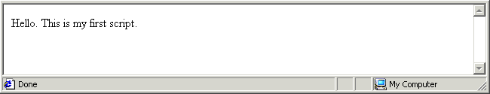
- Edit the script code as shown below.
document.write("Hello. This is my very first script.");
- Save your file with the following name and reload your web browser.
exercise_5-1_after.htm
The result should look as shown below. You can close the file when finished.
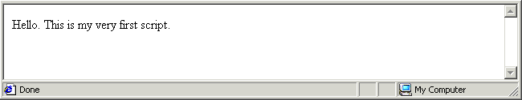

Strings and Concatenation
In Exercise 5.1 the text ‘Hello. This is my first script.’ is an example of a string. In JavaScript a string is simply any collection of letters, numbers or other keyboard characters enclosed within single or double quotes.
A string can consist of one or more blank or white spaces, and nothing else. The following script writes a single blank space to the web browser window.
document.write(" ");
String
One or more alphabetic, numeric or punctuation characters, or white (blank) spaces enclosed within single or double quotes.

Joining Strings Together
You can join two or more strings together so that they display as a single string in the web browser window. String joining is achieved with the plus (+) operator, and is known as concatenation. Consider the following script.
document.write("Last train"+"to Clarksville.");
This produces the following output in a web browser.
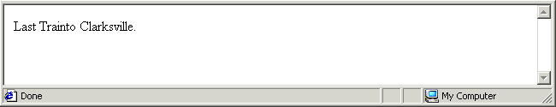
Notice anything missing? Yes: a single white space at the location where the two strings join together. You can edit the code in any one of three ways to correct this problem.
- One approach is to amend the first string by inserting a white space at the end of it.
document.write("Last train "+"to Clarksville.");
- A second approach is to amend the second string by inserting a white space at the start of it.
document.write("Last train"+" to Clarksville.");
- A third approach is to insert the white space as a separate third string between the two existing strings. The result is not two but three strings joined together.
document.write("Last train"+" "+"to Clarksville.");
Whichever approach you take the corrected code displays as follows in the browser window.
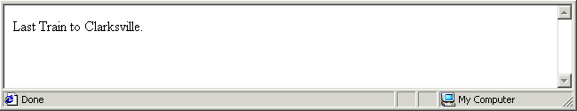
Concatenation
The joining together of separate strings with the plus (+) operator so that they display as a single string in the web browser window. You may need to insert white space characters to preserve readability between joined strings.
Exercise 5.2 takes you through the steps of concatentating a number of strings.

Exercise 5.2: Concatenating Strings
- Open the following file in your text editor and web browser:
exercise_5-2_before.htm
It contains the following script.
document.write("Thank you for visiting my web page.");
- Edit the script code as shown below.
document.write("Thank ”+”you for visiting ”+”my web”+” “+”page.”);
- Save your file with the following name and reload your web browser.
exercise_5-2_after.htm
The result should look as shown below. You can close the file when finished.
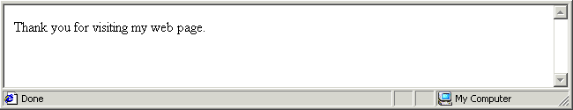

Typing and Escaping Special Characters
All characters are not the same, at least not when used with JavaScript statements. There are a number of keyboard characters that produce unexpected results or even errors when typed directly into a document.write() statement. Among these special characters are the double quote ("), the single quote ('), the backslash (\) and the forward slash (/).
JavaScript overcomes this problem by providing so-called escapes codes.
Character | Escaped Character
Double quote (“) | \”
Single quote (‘) | \’
Backslash (\) | \\
Forward slash(/) | \/
The following JavaScript statement does not contain the relevant escape codes and generates an error in the web browser window.
document.write(“She said: “JavaScript is brilliant.” Or words to that effect.”);
You correct this statement by escaping the double quotes within the text as follows.
document.write(“She said: \“A stitch in time saves nine.\” Or words to that effect.”);
Here’s another example that does not produce the expected result. This one contains both double and single quotes.
document.write(“She said: “I’m a huge fan of JavaScript.”);
You correct this statement by escaping both types of quotes within the text as follows.
document.write(“She said: \“I\’m a huge fan of JavaScript.\”);
You may want to use the forward slash (/) character when referring to file paths, and the backslash (\) character in HTML closing tags. The following statement provides an example.
document.write(“<B>The file is located in C:\My Documents.</B>”);
You correct this statement by escaping both types of slashes as follows.
document.write(“<B>The file is located in C:\\My Documents.<\/B>”);
Escaped Character
A character that, when used in a JavaScript string, needs to be preceded by a backslash (\) to display. Characters that need to be escaped are the double quote (\“), single quote (\‘), forward slash (\/) and the backslash (\\) character itself.
In Exercise 5.3 you will practice escaping characters within a JavaScript statement.

Exercise 5.3: Escaping Special Characters
- Open the following file in your text editor and web browser:
exercise_5-3_before.htm
It contains the following script.
document.write("She is certain that JavaScript is "great".");
Your web browser should not display the line of text because the double quotes are not escaped.
- Edit the script code as shown below.
document.write("She is certain that JavaScript is \"great\".");
- Save your file with the following name and reload your web browser.
exercise_5-3_after.htm
Your web browser should now display the line of text correctly.
- Edit the script code as shown below.
document.write("She\’s certain that JavaScript is \"great\".");
Resave the file and reload your web browser. The line of text displays correctly because the single quote is escaped.
- Edit the script code as shown below.
document.write("She\’s certain that JavaScript is <B>\"great\"<\/B>.");
- Resave the file and reload your web browser. The line of text displays correctly because the forward slash character in the closing </B> tag is escaped. The result should look as shown below. You can close the file when finished.
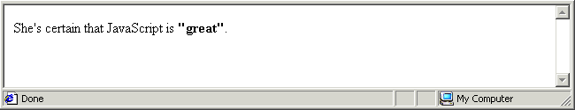

Combining HTML With JavaScript
You have learnt how to insert JavaScript code within a HTML document. And in the Exercise 5.3 you have discovered that the opposite is also possible: HTML tags can be inserted within JavaScript code. Consider the following example.
<SCRIPT LANGUAGE=”JavaScript” TYPE=”text/javascript”>
<I>
document.write("This string in displayed in italics.");
</I>
</SCRIPT>
The above code produces an error because the web browser expects to find JavaScript code after the opening <SCRIPT> tag; instead it finds the HTML <I> tag. The following code does work.
<SCRIPT LANGUAGE=”JavaScript” TYPE=”text/javascript”>
document.write("<I>This string in displayed in italics.<\/I>");
</SCRIPT>
The second example differs from the first in that the <I>…</I> tag pair is now mixed in with the string text used by the script. Also notice that the forward slash (/) in the closing italic tag is escaped. In Exercise 5.4 you will include HTML tags within a string to produce formatted text.

Exercise 5.4: Inserting HTML Tags Within a Script
- Open the following file in your text editor and web browser:
exercise_5-4_before.htm
It contains the following script.
document.write("A heading. Some text with bold formatting.");
- Edit the script code as shown below.
document.write("<H1>A heading<\/H1><P> Some text with <B>bold<\/B>
formatting.<\/P>");
(You should type the above code on a single line.)
- Save your file with the following name and reload your web browser.
exercise_5-4_after.htm
The result should look as shown below. You can close the file when finished.
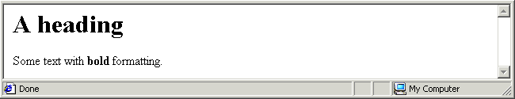

Single and Double Quotes
In JavaScript you can enclose a string within either single or double quotes. A web browser displays the following two strings in exactly the same way:
document.write(“This is a sample string.”);
document.write(‘This is a sample string’);
JavaScript programmers tend to prefer double quotes because they may want to include some text within single quotes in a string. The following script outputs the string text in a font colour of red.
document.write("<FONT COLOR='RED'>This is text is in red.<\/FONT>");
The following code does not work because the web browser is confused about where the string ends, and whether there are one or two strings present.
document.write("<FONT COLOR=”RED”>This is text is in red.<\/FONT>");
The following code, for example, writes a HTML table to the web page.
document.write("<TABLE BORDER='1' WIDTH='120'>");
document.write("<TR>");
document.write("<TD>Cell 1<\/TD>");
document.write("<\/TR>");
document.write("<TR>");
document.write("<TD>Cell 2<\/TD>");
document.write("<\/TR>");
document.write("<\/TABLE>");
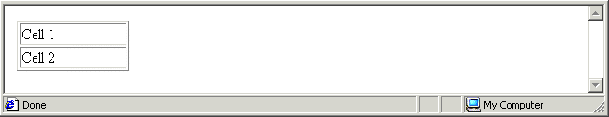
Notice that single quotes enclose HTML tag attribute values (such as WIDTH=’120’) while double quotes enclose the entire contents of the document.write() parentheses. Note also the forward slash characters (/) in the closing tags are correctly escaped.

Creating Line and Paragraph Breaks
The web browser does not insert a line break after a document.write() statement. In your text editor the following might look like three separate text lines.
document.write("One for sorrow, two for joy.”);
document.write("Three for a girl,”);
document.write("And four for a boy.”);
But in the web browser these three document.write() statements display as shown.
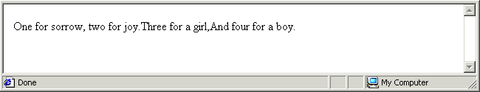
To insert line breaks you could include a separate document.write() statement for break.
document.write(“<BR>”);
A more common approach is to include the line break at the end of the document.write() statement.
document.write("Three for a girl,<BR>”);
You can also use paragraph breaks within a document.write() statement.
document.write("<P>Three for a girl,<\/P>”);

Commenting Your Scripts
It’s good practice to add comments to your scripts. Text within the comment tags does not affect the working of the script, and does not display in the browser window. A sample comment is shown below.
/* This script changes the page background colour */
Comment tags always come in pairs. The opening tag is a forward slash and an asterisk; the closing tag is the reverse. Note that the asterisks go on the inside and the slashes on the outside.

Making a JavaScript Statement
In JavaScript as in other scripting and programming languages the word statement has a particular meaning. It is an instruction to perform a particular action. The semi-colon (;) acts as a statement terminator. It says to JavaScript: “The statement you have just read is now finished.”
Here are a few JavaScript statements of the kind that you will meet in future chapters with explanatory comments.
/* This statement adds two numbers */
SumTotal=firstNumber+secondNumber;
/* This statement displays the result of a calculation */
window.alert(result);
/* This statement places the value of a form field in a variable */
surname = document.myform.surname_field.value;
And here is a document.write() statement of the kind you have been working with in this Chapter.
document.write(“JavaScript is two words.”);
JavaScript Statement
An instruction to JavaScript to perform a particular action. The semi-colon (;) acts as a statement terminator.
Avoid Line Breaks Within Statements
Unlike HTML JavaScript does not ignore ASCII line breaks. Pressing the Enter key while typing a statement usually causes the statement to fail and an error to display when the script is run in a web browser You can tell that an ASCII line break is present in a statement by the presence of the ¶ symbol. The following JavaScript statement runs without error.
document.write("Did you enjoy your visit to my web page?");¶
This statement, however, does result in an error.
document.write("Did you enjoy your¶
visit to my web page?");

Working With window.alert() and window.confirm() Dialog Boxes
You have learnt how to use JavaScript’s document.write() statement to output text and HTML tags to the web browser window. Now you meet two other statements for displaying information to the web page visitor. Rather than show the information in the browser window, however, these two create dialog boxes that appear in front of the browser window.

The window.alert() Dialog Box
This type of dialog box offers just a single button: an OK button.
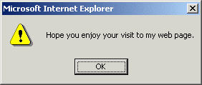

The window.confirm() Dialog Box
This type of dialog box offers two buttons: OK and Cancel.
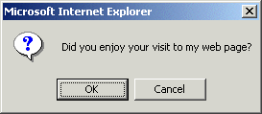
Here are three points to remember about the dialog box statements:
- Text-only: Both dialog boxes can display only text without HTML formatting.
- Concatenation: You can join together strings inside window.alert() and window.confirm() statements just as you can inside a document.write() statement.
- Escape codes: You must escape special characters inside the window.alert() and window.confirm() statements just as inside the document.write() statement.
In Exercise 5.5 you will create a window.alert() dialog box.

Exercise 5.5: Creating a window.alert() Dialog Box
- Open the following file in your text editor and web browser:
exercise_5-5_before.htm
It contains the following script.
document.write("Hope you enjoy your visit.");
- Edit the script code as shown below.
document.alert("Hope you enjoy your visit to my web page.”);
- Save your file with the following name and reload your web browser.
exercise_5-5_after.htm
You can see an error in the web browser window. The reason for this is that you have incorrectly combined the JavaScript terms ‘document’ and ‘alert()’.
- Edit the script as shown below. Resave your file and reload your browser.
window.alert("Hope you enjoy your visit to my web page.");
The following dialog box should display in front of your web browser window.
- Click OK to close the dialog box. You can close the file when finished.
In Exercise 5.6 you will create a window.confirm() dialog box.

Exercise 5.6: Creating a window.confirm() Dialog Box
- Open the following file in your text editor and web browser:
exercise_5-6_before.htm
It contains the following script.
document.write("Did you enjoy your visit?");
- Edit the script code as shown below.
window.confirm ("Did you <B>enjoy</B> your visit to my web page.”);
- Save your file with the following name and reload your web browser.
exercise_5-4_after.htm
The following dialog box should display in front of your web browser window.
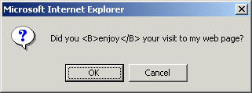
You can see that the HTML bold tag pair does not format the enclosed word, but is displayed as text.
- Edit the script code as shown below.
window.confirm ("Did you enjoy"+" "+"your visit to my web page?");
- Resave the file and reload your web browser. The dialog box should now look as shown below. Click OK or Cancel to close the dialog box.
You can close the file when finished.

Chapter Summary
JavaScript code in a web page must be enclosed with the HTML <SCRIPT> tag pair as follows.
<SCRIPT LANGUAGE=”JavaScript” TYPE=”text/javascript”>
script code goes here
</SCRIPT>
A script is made up of one or more statements. Each statement is an instruction to JavaScript to perform a particular action or task. The semi-colon (;) acts as a statement terminator. A string is any collection of alphabetic, numeric or punctuation characters, or white (blank) spaces enclosed within single or double quotes.
You can use the document.write() statement to write strings, with or without HTML formatting, to the web browser window. Insert the text and any HTML tags within the parenthesis of the document write() statement as shown in the example below.
document.write("Thank you for visiting my web page.");
A number of keyboard characters produce unexpected results or errors when typed directly into a document.write() or other JavaScript statement. Among these are the double quote ("), the single quote ('), the backslash (\) and the forward slash (/). To display such characters correctly you must escape them by preceding them with a forward slash as follows: \”, \”, \\ and \/. An example of a string with escaped characters is shown below.
document.write("She\’s certain that JavaScript is <B>\"great\"<\/B>.");
Concatenation is the joining together of separate strings with the plus (+) operator so that they display as a single string in the web browser window. You may need to insert white space characters to preserve readability between joined strings. An example is shown below.
document.write("Last train"+" "+"to Clarksville.");
The document.write() statement does not insert a line break after the string that it written to the browser window. To follow a string with a line break, include the HTML line break tag as follows.
document.write("Three for a girl,<BR>");
Unlike HTML JavaScript does not ignore ASCII line breaks. Pressing the Enter key while typing a JavaScript statement will almost certainly cause the statement to fail and an error to result. The statement below provides an example of an incorrectly inserted ASCII line break.
document.write("Did you enjoy your¶
visit to my web page?");
The window.alert() statement creates a dialog box in front of the browser window containing a text message and an OK button. The window.confirm() statement also creates a dialog box with a text message, but displays two buttons: OK and Cancel. Both dialog boxes can display only unformatted text. Strings can be concatenated within a dialog box, and special characters must be escaped.
It is good practice to include comments with your scripts. Text within comment tags does not affect the operation of the script, and does not display in the browser window.
/* This script changes the page background colour */
Comment tags always come in pairs. The opening tag is a forward slash and an asterisk; the closing tag is the reverse. The asterisks go on the inside and the slashes on the outside.

Introducing Objects, Properties and Methods

Objectives
In this Chapter you will learn how to:
- Display the properties of document and browser objects using the document.write() statement
- Set the properties of a document object using the document.write() statement
- Set the properties of a document object using a direction combination of object name and property name
- Prevent script code from displaying in non-JavaScript browsers
- Display alternative messages for non-JavaScript users with the <NOSCRIPT>… </NOSCRIPT> tag pair.

Vocabulary
In this chapter you will meet the following terms:
- Object
- Method
- Object properties

Exercise Files
In this chapter you will work with the following HTML files:
- exercise_5-7_before.htm
- exercise_5-8_before.htm
- exercise_5-9_before.htm
- exercise_5-10_before.htm

Objects Are; Methods Do
Objects and methods are two important concepts in JavaScript. In simple terms an object is a thing and a method is an action that can be performed on that thing.
For example, JavaScript treats the web page displayed in the web browser as an object. The act of writing something to that document is a method. The following statement uses the write() method of the document object to create output in the web browser.
document.write(“This is a sample string.”);
Apart from the HTML document, what other objects are there? One important object is the window object, the web browser window in which the page is loaded. The window object has a number of methods (that is, actions that can be performed on the window). In Chapter 1 you met the following two methods of the window object:
Window Object and Method | Description
window.alert(“string”); | Displays a dialog box containing a text-only string and an OK button.
window.confirm(“string”); | Displays a dialog box containing a text-only string, and OK and Cancel buttons.
Object
A container for a wide range of information. Objects can be acted on by methods in a script. Examples of objects include the document, window and browser objects.
A method’s name ends in a parenthesis. In some methods the parenthesis contains some content. For example:
document.write(“This is a sample string.”);
In other methods the parenthesis can be empty. The following code closes the currently open window. Or, to use JavaScript terminology, it applies the close() method to the window object.
window.close();
Method
An action performed on an object. Methods end with a parenthesis. The document object has a write() method, and the window object has alert(), confirm() and close() methods.

Properties of Objects
Objects in JavaScript have properties. Among the properties of the document object are background colour, text colour and date on which the document was last modified. Another object, the browser object, has properties such as product name and version number. Although this object is generally referred to as the ‘browser object’, its name is written in JavaScript code as ‘navigator’.
The standard JavaScript format an object and one of its properties is as follows.
objectname.propertyname
For example, document.bgColor is the background colour of the HTML document, and navigator.appName is the product name of the browser (that is, navigator) object.

The following table lists some of the properties the document and browser objects.
Object | Property Name | Description
document | bgColor | Background colour
 | fgColor | Text colour
 | url | Web page address
 | lastModified | The date on which the document was last amended
navigator | appName | Web browser product name
 | appVersion | Version of the web browser and the operating system it was created for
All object properties fall into one of two categories:
- Read-only properties: These are properties, such as the web browser product name, that a script can access and work with – but cannot change.
- Scriptable properties: These are properties that JavaScript can change. Examples include the text colour of the document object and message displayed in the status bar of the window object.
Object Properties
Features or characteristics of an object that can be accessed or set using JavaScript methods. Some properties are scriptable; others are read-only.
In Exercise 5.7 you will use a script to access and display some properties of the currently loaded web page.

Exercise 5.7: Displaying Some Document Properties
- Open the following file in your text editor and web browser:
exercise_5-7_before.htm
The BODY tag contains the following background and text (foreground) colour attributes.
<BODY BGCOLOR='#FFCCFF' TEXT='#003399' LINK="#000080"
VLINK="#800000" ALINK="#FF0000">
- Beneath the <BODY> tag you can see an empty <SCRIPT>…</SCRIPT> tag pair. Insert the following code within it.
document.write("Background Colour: "+document.bgColor);
document.write("<BR>");
document.write("Text Colour: "+document.fgColor);
document.write("<BR>");
document.write("Link Colour: "+document.linkColor);
document.write("<BR>");
document.write("Visited Link Colour: "+document.vlinkColor);
document.write("<BR>");
document.write("Active Link Colour: "+document.alinkColor);
document.write("<BR>");
document.write("Document URL: "+document.location);
document.write("<BR>");
document.write("Document Last Modified: "+document.lastModified);
- Save your file with the following name and realod your web browser.
exercise_5-7_after.htm
The result should look as shown below. You can close the file when finished.
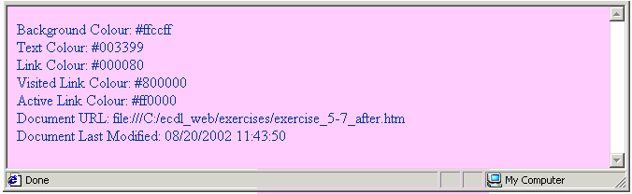
In Exercise 5.8 you will use a script to access and display some properties of your web browser product.

Exercise 5.8: Displaying Some Web Browser Properties
- Open the following file in your text editor and web browser:
exercise_5-8_before.htm
- Beneath the <BODY> tag you can see an empty <SCRIPT>…</SCRIPT> tag pair. Insert the following code within it.
document.write("Web Browser Name: <B>"+navigator.appName+"</B>");
document.write("<BR>");
document.write("Web Browser Version: <B>"+navigator.appVersion+"</B>");
- Save your file with the following name and view it in your web browser.
exercise_5-8_after.htm
If you are using Internet Explorer on Windows 2000 the result should look as shown below.
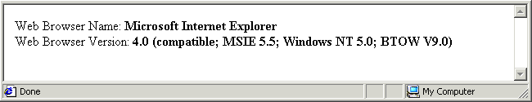
If you are using Netscape Navigator on Windows 2000 the result should look as shown below. This screen was generated by Navigator version 6.1, but it displays as 5.0.
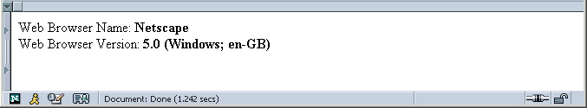
Finally, here the screen generated by the Opera browser, version 6.01. You can see that Opera ‘spoofs’ the navigator.appName object and property by pretending that it is Internet Explorer. Like Netscape version 6, Opera version 6 displays as version 5.0.
Also note that Operator shows the operating system as Windows 2000 while Internet Explorer displays it as Windows NT 5.0.
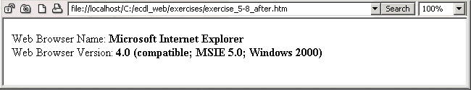

Viewing Object Properties With document.write()
When typing document.write() statements only enclose within quotes those items that you want interpreted literally. The following document.write() statement outputs the background colour of the current HTML document.
document.write("Background Colour: "+document.bgColor);
You don’t want the text ‘document.bgColor’ written to the web page; what you do want is the value of the object property. That is why the object property is not surrounded by double or single quotes. What would happen if you did enclose the document property within quotes as follows?
document.write("Background Colour: "+”document.bgColor”);
Your web browser would display the document.write() statement as shown below.
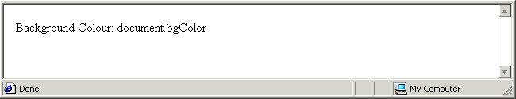
It does not produce an error but the result is probably not what you want. In Chapter 5 you will meet variables –- containers for holding values that can change over time. The variable called FirstName, for example, might on different occasions hold the value ‘John’, ‘Sheila or ‘Steven’. Typically it is the value and not the name of a variable that you want to write to a web page. A document.write() statement that combines string text and a variable should look as like this.
document.write("First Name: "+firstName);
In Exercises 5.7 and 5.8 you read some document and browser properties but did not change them. In Exercise 5.9 you will write a script that amends some properties of the document object.

Exercise 5.9: Setting Some Document Properties
- Open the following file in your text editor and web browser:
exercise_5-9_before.htm
Anything unusual about this file? Yes. You can see that the <BODY> tag is written to the web page by a document.write() method.
<SCRIPT LANGUAGE="JavaScript" TYPE="text/javascript">
document.write("<BODY>");
</SCRIPT>
- Edit the document.write() method to insert a background colour attribute in the <BODY> tag as shown.
document.write("<BODY BGCOLOR=’#99CC99’>");
- Save your file with the following name and reload your web browser.
exercise_5-9_after.htm
The JavaScript is perfectly valid and changes the background to the specified colour. When achieving such visual effects, however, it is better practice to manipulate the relevant object and property combination.
- Cut the <BODY> tag from the JavaScript code and paste it above the opening <SCRIPT> tag. Replace the document.write() method with the document.bgColor statement as shown below.
<BODY>
<SCRIPT LANGUAGE="JavaScript" TYPE="text/javascript">
document.bgColor=’#99CC99’;
</SCRIPT>
Resave the file and reload your web browser. The web page should show the same background colour as it did after Step 3 of the Exercise. You can close the file when finished.
You have probably seen web sites that offer the option to customise the page and text colours to suit the visitor’s personal taste. This customisation is achieved through the use of scripts that control the visual properties of the document object.

Hiding Your Scripts From Older Browsers
There are some web browsers that do not support JavaScript, and those browsers that do provide users the option of switching off JavaScript support. When JavaScript is unsupported or disabled some browsers will display any script or scripts in the browser window as if they were text.
To prevent a non-JavaScript web browser from displaying your scripts, hide them as follows.
<SCRIPT LANGUAGE="JavaScript" TYPE="text/javascript">
<!--
document.write("You cannot see this in a non-JavaScript web browser");
//-->
</SCRIPT>
As you can see the opening tag in the pair is a left angle bracket followed by an exclamation mark and two dashes (<!--). And the closing tag is two forward slashes following by two dashes and a right angle bracket (//-->).

The Alternative <NOSCRIPT>...</NOSCRIPT> Tag Pair
When a web page contains JavaScript it is good practice to include a message to that effect that will be visible to visitors using a non-JavaScript web browser. HTML has a tag pair especially for this purpose: the <NOSCRIPT>…</NOSCRIPT> tag pair. Here are four points to remember about this tag.
- A message enclosed within this tag is not displayed by a JavaScript-enabled browser.
- A message enclosed within this tag is displayed only by non-JavaScript browsers, or by browsers in which JavaScript support is disabled.
- The presence of this tag has no effect on the operation of any scripts in a web page.
- The tag is usually positioned at or near the top of the document body section.
In Exercise 5.10 you will use this tag offer an alternative message to non-JavaScript users.

Exercise 5.10: Testing a Script in a No-script Browser
- Open the following file in your text editor and web browser:
exercise_5-10_before.htm
You can see that this file contains a single document.write() statement.
<SCRIPT LANGUAGE="JavaScript" TYPE="text/javascript">
document.write("JavaScript is supported and enabled in this web browser.");
</SCRIPT>
- Insert a <NOSCRIPT> tag just after the <BODY> tag and before the JavaScript statement as shown.
<NOSCRIPT>This web page contains JavaScript.</NOSCRIPT>
<SCRIPT LANGUAGE="JavaScript" TYPE="text/javascript">
document.write("JavaScript is supported and enabled in this web browser.");
</SCRIPT>
- Insert opening and closing tags to hide your script from non-JavaScript browsers as follows.
<NOSCRIPT>This web page contains JavaScript.</NOSCRIPT>
<--
<SCRIPT LANGUAGE="JavaScript" TYPE="text/javascript">
document.write("JavaScript is supported and enabled in this web browser.");
//-->
</SCRIPT>
- Save your file with the following name and view it in your web browser.
exercise_5-10_after.htm
In a non-JavaScript browser the <NOSCRIPT> tag displays the alternative message as shown below. You can close the file when finished.
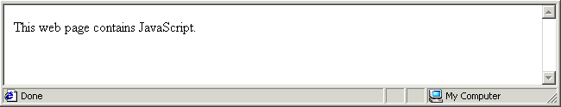

Chapter Summary
Objects and methods are two important concepts in JavaScript. An object is a container for a wide range of information. Examples of objects include the document, window and browser (navigator) objects. A method is an action performed on an object. Methods end with a parenthesis. The document object has a write() method, and the window object has alert(), confirm() and close() methods.
The two following statements use the write() method of the document object and the alert() method of the window object.
document.write(“Every day I\’m getting better at <B>JavaScript<\/B>.”);
window.alert(“Thank you for visiting my web page”);
Objects in JavaScript have properties. For example, document.bgColor is the background colour of the web page, and navigator.appName is the product name of the browser (that is, navigator) object. Some properties are scriptable; others are read-only. The standard JavaScript format an object and one of its properties is as follows.
objectname.propertyname
When typing document.write() statements only enclose within quotes those items that you want interpreted literally. The following document.write() statement outputs the background colour of the current HTML document.
document.write("Background Colour: "+document.bgColor);
You don’t want the text ‘document.bgColor’ written to the web page; what you do want is the value of the object property. That is why the object property is not surrounded by double or single quotes.
You can set a scriptable property to a particular value with a statement such as the following.
document.bgColor=’#99CC99’;
This sets the background colour of the web page to the hex value specified.
When JavaScript is unsupported or disabled some browsers will display any script or scripts in the browser window as if they were text. To prevent a non-JavaScript web browser from displaying your scripts, hide them as follows.
<SCRIPT LANGUAGE="JavaScript" TYPE="text/javascript">
<!--
document.write("You cannot see this in a non-JavaScript web browser");
//-->
</SCRIPT>
The opening tag in the pair is a left angle bracket followed by an exclamation mark and two dashes (<!--). The closing tag is two forward slashes following by two dashes and a right angle bracket (//-->).
When a web page contains JavaScript it is good practice to include a message to that effect within the HTML <NOSCRIPT>…</NOSCRIPT> tag pair. A message enclosed within this tag is displayed only by non-JavaScript browsers. JavaScript-enabled browsers ignore it. The presence of this tag has no effect on the operation of any scripts in a web page. The tag is usually positioned at or near the top of the document body section.

JavaScript Functions and Event Handlers

Objectives
In this Chapter you will learn how to:
- Write simple JavaScript functions that do not require values or return parameters, and place them in the head of a HTML document
- Call functions using the onclick, ondblclick and onmouseover event handlers inserted within button, paragraph and image HTML tags
- Call functions using the onload and onunload event handlers inserted within the HTML <BODY> tag
- Call multiple functions from a single event handler, and insert multiple event handlers within a single HTML tag

Vocabulary
In this chapter you will meet the following terms:
- Function
- Event handler

Exercise Files
In this chapter you will work with the following HTML files:
- exercise_5-11_before.htm
- exercise_5-12_before.htm
- exercise_5-13_before.htm
- exercise_5-14_before.htm

About Functions and Event Handlers
A single web page may contain many different scripts that perform different types of actions. It is not good practice to scatter scripts throughout a document, however, for two reasons:
- Mixing JavaScript code with HTML content, tags and attributes can result is a web page that is difficult to update, especially if the document is very long and there are numerous scripts present at different points within it.
- You may want to use a particular script more than once in the document. Inserting the same script at several locations adds to the document’s file size and download time.
The more professional approach is as follows:
- Place all your scripts at one location in the document
- Give each script a unique name, and then
- Invoke or call each script as it is needed.
Scripts are triggered into action by events or, more precisely, by HTML commands known as event handlers. A typical sequence would be as follows:
- The visitor loads the web page that includes the HTML tags and attributes, the content, and all the scripts. But the scripts do not perform any action. They just wait passively until they are called.
- The visitor clicks a button somewhere on the page that has an event handler attached to it.
- The event handler calls the script.
- The script then carries out a particular task, such as calculating the sale price of an item or changing the document’s display properties.
A script that has a unique name and which can be called into action by an event handler is known as a function. Functions are located within the head section of web pages. Exercise 5.11 takes you through the steps of building a simple JavaScript function.
Function
A named script that performs a particular action when called, typically by an event handler. Functions are located in the head section of the web page.

Exercise 5.11: Creating a Simple Function
- Open the following file in your text editor and web browser:
exercise_5-11_before.htm
You can see that it contains a script that changes the document’s background colour.
<BODY>
<SCRIPT LANGUAGE="JavaScript" TYPE="text/javascript">
document.bgColor=’#99CC99’;
</SCRIPT>
- Let’s make this script a function. All functions live in the document head. Your first step is to cut the script from the document body and paste it within the <HEAD>...</HEAD> tag pair as shown.
<TITLE>ECDL Web Module 5 - Exercise 5.11 Before</TITLE>
<SCRIPT LANGUAGE="JavaScript" TYPE="text/javascript">
document.bgColor='#99CC99';
</SCRIPT>
</HEAD>
- Every function must have a name, and the word function must occur before the name. Edit your code as shown below.
<SCRIPT LANGUAGE="JavaScript" TYPE="text/javascript">
function setBgGreen
document.bgColor='#99CC99';
</SCRIPT>
You are free to choose the function name. You could equally have named this function ‘changeBG’, ‘newBackGrd’, ‘preferanothercolour’ or whatever.
- Another rule about functions is that the statements they contain must be enclosed within a pair of curly braces. Edit your code as follows.
<SCRIPT LANGUAGE="JavaScript" TYPE="text/javascript">
function setBgGreen {
document.bgColor='#99CC99';
}
</SCRIPT>
By convention the opening curly brace is written after the function name and the closing brace is written on a line of its own. This is intended to make the function code easier to read.
- Anything else? Yes. Place a parenthesis immediately after the function name (do not insert a blank space) and before the opening curly brace (do insert a blank space) as shown.
<SCRIPT LANGUAGE="JavaScript" TYPE="text/javascript">
function setBgGreen() {
document.bgColor='#99CC99';
}
</SCRIPT>
In this case the parenthesis is empty. In other functions it may contain information that the function needs to perform its task.
Well done. You have created your first JavaScript function.
- Save your file with the following name and realod your web browser.
exercise_5-11_after.htm
The browser window shows a background colour of white. Is there an error in your function? No. The function is code is valid, but it has no effect on the browser window because the function has not been called.
In Exercise 5.12 you will add an event handler that enables web page visitors to call a function that produces a change in background colour. You can close this file when finished.

Rules For Working With Functions
Before moving on let’s review some important points about functions in JavaScript:
- Unique names: A function always has a name. No two functions in the same web page may have the same name.
- No spaces: Function names may not contain spaces.
- Mixed character case: You can combine upper and lowercase letters in a function name to make it easier to read. For example, ‘setFontSize’ and ‘CalculateTax’.
- Case sensitivity: Function names are case-sensitive. UpdateTotal() and updateTOTAL() are two different functions.
- Parenthesis: Like methods, function names always end with a parenthesis as in myFunction().
- Begin with ‘function’: The word function always occurs before name of the function as in function doThis(). There is no space between the function name and the parenthesis.
- In the head: Functions are located in the head of a web page. The web browser loads the head section first. When a visitor calls a function through an event handler in the body section the function will be loaded and ready for use.
- Curly braces {}: Statements within a function are enclosed with curly braces {}. Statements are usually indented from the left to make them easier to read.
- Function calls: Functions are called or invoked when needed, typically by HTML commands called event handlers.
Let’s put together what you have learnt so far and consider a number of simple functions.
/* display an alert box with some welcome text */
function sayThankYou() {
window.alert(“Thanks for visiting my web page.”);
}
/* perform calculation with two numbers */
function addNumbers() {
firstNumber=12;
secondNumber=36;
SumTotal=firstNumber+secondNumber;
document.write(SumTotal);
}
/* change text colour and display an alert box */
function newTextColour() {
document.fgColor=’#FF0000’;
window.alert(“You selected: Red.”);
}
The general syntax of a JavaScript function is therefore as follows.
function functionname() {
first instruction;
second instruction;
…;
}
In Exercise 5.12 you will add an event handler to a web page similar to the one you created in Exercise 5.11. The presence of event handler enables the web page visitor to call the function that can change the page’s background colour.

Exercise 5.12: Creating a Simple Event Handler
- Open the following file in your text editor and web browser:
exercise_5-12_before.htm
The document head contains a SCRIPT tag with the following function
function setBgGreen() {
document.bgColor='#99CC99';
}
The body of the document is empty. This file is similar to the one you created in Exercise 5.11.
- Insert the following in the document body.
<BODY>
<BUTTON>Change Background Colour</BUTTON>
- Save your file with the following name and reload your web browser.
exercise_5-12_after.htm
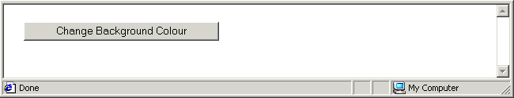
Click the ‘Change Background Colour’ button. Nothing happens because no event handler is attached to the button.
- Edit the <BUTTON> tag as shown below.
<BODY>
<BUTTON onclick=”setBgGreen()”>Change Background Colour</BUTTON>
- Resave the file and reload your browser.
Click the button again. This time the background colour does change because the event handler has successfully called the function. You can close the file when finished.

About the <BUTTON>…</BUTTON>Tag
In Exercise 5.12 and in various future exercises the HTML <BUTTON> tag is used to create a button element. Earlier versions of HTML did not support this tag and older web browsers may not display it correctly.
If you want buttons to display in older browsers you use a <FORM>…</FORM> tag pair and a form field with a TYPE of BUTTON as follows.
<FORM>
<INPUT TYPE=’BUTTON’ VALUE=’Click Me Please’ onclick=”setBgGreen()”>
</FORM>

Working With Event Handlers
A function within the <HEAD>…</HEAD> tag pair waits there passively until it is called into action by an event handler. In the most typical case the user activates the event handler, and the event handler calls the function into action.
Event Handler
A HTML command in a web page that calls or triggers a function into action whenever a specific type of event is performed in or with HTML document.
Three common events handlers are set out in the following table.
Event Handler | Description
onclick | This triggers a function when the page visitor clicks once on a HTML element such as a button, image or item of text.
ondblclick | This triggers a function when the page visitor clicks twice on a HTML element such as a button, image or item of text.
onmouseover | This triggers a function when the page visitor holds the mouse pointer over a HTML element such as a button, image or item of text.

Event handlers are usually attached to buttons, but you can also associate an event handler with an image or some text as shown in the examples below.
<IMG SRC =’button12.gif’ WIDTH=’80’ HEIGHT=’24’ onclick="doSomething()">
<P onclick="setBackgroundBlue()">Some text here</P>
You will sometimes see event handlers written in mixed case. For example, onClick() and onDblclick(). Event handlers are part of HTML, not JavaScript, so you can write them any way that you want – oNcLiCk, onMOUSEovER or whatever.

Exercise 5.13: Changing Event Handler Types
- Open the following file in your text editor and web browser:
exercise_5-13_before.htm
In the head section you can see three functions, each one of which can set the page background colour to a different value.
In the body section are three HTML page elements: text, a button, and an image. Each element has an event handler attached to it.
Click the buttons to verify that they work correctly.
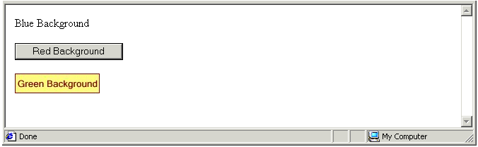
- Change the event handler for the second button as shown.
<P><BUTTON ondblclick="setBackgroundRed()">Red Background</BUTTON></P>
- Change the event handler for the third button as shown.
<BUTTON onmouseover="setBackgroundBlue ()">Blue Background</BUTTON>
- Save your file with the following name and reload your web browser.
exercise_5-13_after.htm
Click the second button once. Notice that nothing happens. Now double-click it to change the background colour. Move the mouse pointer over the third button and watch the background colour change without any mouse click. You can close the file when finished.

Document-level Event Handlers
Two event handlers require no separate action by the web page visitor. They are inserted as attributes of the <BODY> tag.
Event Handler | Description
onload | Calls a function when the visitor loads the web page in the web browser window.
onunload | Calls a function when the page visitor leaves the web page. That is, when the visitor unloads the web page from the browser window.
Exercise 5.14 takes you through the steps of calling a function through event handlers that are associated with the web page as a whole rather than with a particular element in a web page.

Exercise 5.14: Using the onload and onunload Event Handlers
- Open the following file in your text editor and web browser:
exercise_5-14_before.htm
When you open this file in your browser a separate alert box opens at the same time containing a short welcome message. Click OK to close the alert box before continuing.
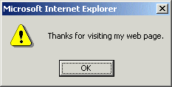
- In the document head section you can see a function named sayThankYou(). The <BODY> tag contains the onload event handler that calls the function.
<BODY onload=”sayThankYou()”>
- Edit the <BODY> attribute as shown below.
<BODY onunload=”sayThankYou()”>
- Save your file with the following name and reload your web browser.
exercise_5-14_after.htm
The alert box no longer displays when you load the page. Instead it is the unloading of the page from the browser window that causes the box to display. Try it and see. You can close the file when finished.

Multiple Functions, Multiple Event Handlers
You can imagine that the same function may be called by different event handlers. You simply insert the relevant event handler wherever in the web page you need to call the function.
The opposite is also true. An event handler may call more than one function, as shown in the following example. A semicolon (;) and a single space separates the event handlers.
<P onclick =”doThis (); doThat(); doSomethingElse”>Click Here to Add</P>
Finally, a single HTML element may contain more than one event handler.
<BUTTON onclick =”doThis ()”; ondblclick=”doSomethingElse()”>Button </BUTTON>

More Complex Functions
In Chapter 7 of this book you will meet other, more complex types of functions:
- Functions to which you pass parameters: A parameter is information that is passed to a function for the function to work on. The function may use the information to perform a calculation, or to decide which of a number of possible instructions to perform. The parameter name is typed inside the function’s parenthesis.
- Functions that return values: A function can pass a value back to the place from which the function was called. This action is described as the function returning a value.

Chapter Summary
A function is a named script that performs a particular action when called, typically by an event handler.
Functions are located in the head section of the web page. Function names begin with the word ‘function’, must be unique in the web page, are case-sensitive and may not contain spaces. You can combine upper and lowercase letters in a function name to make it easier to read. Like methods, function names always end with a parenthesis.
Statements within a function are enclosed with curly braces {}, and are usually indented from the left to make them easier to read. A simple function is shown below.
/* display an alert box with some welcome text */
function sayThankYou() {
window.alert(“Thanks for visiting my web page.”);
}
Functions are called or invoked when needed, typically by HTML commands called event handlers. An event handler is a HTML command in a web page that calls or triggers a function into action whenever a specific type of event is performed in or with the web page. Three common events handlers are onclick, ondblclick and onmouseover.
Event handlers are usually attached to buttons, but they can also be associated with an image or some text as shown in the examples below.
<BUTTON onmouseover="setBackgroundBlue ()">Blue Background</BUTTON>
<IMG SRC =’button12.gif’ WIDTH=’80’ HEIGHT=’24’ onclick="doSomething()">
<P ondblclick="setBackgroundBlue()">Some text here</P>
Two event handlers require no separate action by the web page visitor and are inserted as attributes of the <BODY> tag: onload and onunload. The first calls a function when the visitor loads the web page in the web browser window. The second calls a function when the page visitor leaves the web page.

JavaScript Variables and Operators

Objectives
In this Chapter you will learn how to:
- Declare and assign values to JavaScript string variables
- Declare and assign values to JavaScript numeric variables
- Apply the correct variable naming standards
- Perform addition, subtraction, multiplication and division on numeric variables
- Follow the rules of operator precedence in arithmetic statements
- Apply the assignment operator correctly in statements that contain variables and values, and variables only
- Reveal a variable’s type using the typeof operator.

Vocabulary
In this chapter you will meet the following terms:
- Variable
- String variable
- Numeric variable
- Assignment statement

Exercise Files
In this chapter you will work with the following HTML files:
- exercise_5-15_before.htm
- exercise_5-16_before.htm
- exercise_5-17_before.htm
- exercise_5-18_before.htm

About Variables
You can think of a variable as a box or container for a value that may be different each time the script is run. A website login page, for example, may have a variable named Surname. The value of the variable may be Smith, Jones, Higgins or whoever is attempting to log in at any particular time.
In JavaScript the first thing you do with a variable is declare it. The following code declares the variable named FirstName.
var FirstName;
The declaration begins with the word var. This so-called keyword allocates memory storage space for new data and tells JavaScript that a new variable name is in use.
When you have declared a variable you will typically want to assign data to it. The following two statements assign values to the variables named userName and userRegion.
userName =”Sheila”;
userRegion =”Australia”;
You can minimise typing effort by declaring a variable and assigning a value to it in the same statement on the same line. Here’s two examples.
var UserID = “289849”;
var Password = “banana42”;
In Exercise 5.15 you will declare two variables, assign values to them, and then write the variable names and values to the web page.

Exercise 5.15: Working With Variables
- Open the following file in your text editor and web browser:
exercise_5-15_before.htm
- In the empty <SCRIPT> tag in the document body insert the two variable declarations and assignments shown below, and follow them with two document.write() statements.
var FirstName = "Eddie";
var Surname = "Hamilton";
document.write("<I>First Name:<\/I> "+FirstName+"<BR>");
document.write("<I>&nbsp;&nbsp;&nbsp;&nbsp;Surname:<\/I> "+Surname);
- Save your file with the following name and reload your web browser.
exercise_5-15_after.htm
It should look as shown. You can close the file when finished.
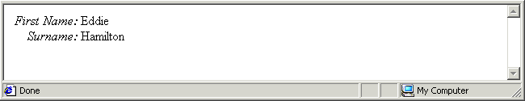

Variable Types in JavaScript
The variables you have worked with so far have all been of one type: the string variable. This is a variable type that holds letters, numbers, white (blank) spaces or punctuation symbols. Other variables types are numeric variables (which hold numbers) and Boolean variables (which hold a true or false value).
Variable
A container that can store a changing value. A variable may contain strings, numbers or a true/false value. Variable names must be unique, are case sensitive and cannot contain spaces.
When creating a variable you don’t need to tell JavaScript whether the variable is to be string, numeric or Boolean variable. JavaScript determines the type of variable you want to create from the value that you first assign to it. When you enclose the value in quotes JavaScript assumes that you want to create a string variable. For example:
var FirstName = “Peter”;
var PhoneNumber = “045 45773758752”;
Don’t assign a number to a string variable if you intend using that number in a calculation because the number is stored within JavaScript as a string of characters rather than a numeric value.
String Variable
A variable that can contain any keyboard characters, whether letters, numbers, punctuation symbols or white spaces, or any combination of these. Only assign a number to a string variable when you do not plan to use it in a calculation.
Let’s review a few points about variable names and string variables in particular.

Variable Names
Here are a few points to remember about variable names:
- Uniqueness: Don’t use the same name for two different variables within the same web page.
- No spaces: Variable names cannot contain spaces. ‘Credit Limit’ and ‘Sub Total’ are invalid variable names.
- Mixed character case: You can combine upper and lowercase letters in a variable name to make it easier to read. For example, ‘PostCode’ and ‘AccountStatus’.
- Case sensitivity: Variable names are case-sensitive. ‘Fname’ is not the same as ‘fName’.

JavaScript Numeric Variables
So far you worked with string variables that contained or more characters. To write scripts that perform arithmetic calculations you need to learn about another type of variable, the numeric variable.
- When you assign ‘15’ as a string variable JavaScript stores the ‘1’ and the ‘5’ as keyboard characters in the same way as it would store the characters ‘a’, ‘z’ or ‘@’.
- When you assign ‘15’ as a numeric variable, however, JavaScript stores ‘15’ as a number that can be manipulated by a script in combination with other numeric variables.
JavaScript decides which type of variable you want to create by the way that you first assign a value to it. When you enclose the value within quotes JavaScript makes the variable a string variable. For example.
StreetAddress = “42 Green Avenue”;
When you omit the quotes JavaScript makes the variable a numeric variable. For example.
OrderQty = 4;
Unlike most programming languages JavaScript does not have different types of variables for different types of numbers. All numbers, whether integers (whole numbers) or floating point number (numbers with decimal places) are accommodated within the one type of numeric variable.
Here are three values that JavaScript will accept as valid numbers.
12
-6.3456
.2727
And here are two values that are not valid numbers in JavaScript.
34,000
645w29
Numeric Variable
A variable that stores a number, whether an integer or a floating point number. Values stored in numeric variables can be used in arithmetic calculations.

Arithmetic Operators
You can perform arithmetic with numeric variable using the arithmetic operators set out in the table below.
Operator | Operator Key Used | Description
x+y | The plus key | Adds the value of x and the value of y.
x-y | The dash key | Subtracts the value of y from the value of x.
x*y | The asterisk key | Multiplies the value of x by the value of y.
x/y | The forward slash key | Divides the value of x by the value of y.
In Exercise 5.16 you will declare three variables, assign numeric values to the first two, add the values together and assign the result to a third variable, and then write all the numbers to the web page.

Exercise 5.16: Creating a Simple Arithmetic Script
- Open the following file in your text editor and web browser:
exercise_5-16_before.htm
- In the empty <SCRIPT> tag in the document body insert the declarations and assignments shown below, and follow them with the three document.write() statements.
var FirstNumber = 36;
var SecondNumber = 12;
var SumResult;
SumResult = FirstNumber+SecondNumber;
document.write("First Number: "+FirstNumber+"<BR>");
document.write("Second Number: "+SecondNumber+"<BR>");
document.write("Result:<B> "+SumResult+”<\/B>”);
- Save your file with the following name and reload your web browser.
exercise_5-16_after.htm
It should look as shown.
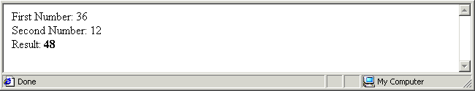
Experiment with the file by changing the first and second number values, and by changing the arithmetic operator. You can close the file when finished.

Operator Precedence
JavaScript follows the rules of arithmetic when working with numeric variables and numbers:
- Division first, followed by multiplication, then addition and finally subtraction.
For example, the following series of statements gives a result of 11 because JavaScript first multiplies 2 by 3 (resulting in 6) and then adds 5.
var x = 5;
var y = 2;
var z = 3;
var answer = x + y * z;
- You can force JavaScript to perform calculations in a particular order by using parentheses.
For example, the following calculation gives a result of 21. JavaScript first adds 5 and 2 (because they are within parentheses) and then multiplies that result by 3 to give 21.
var x = 5;
var y = 2;
var z = 3;
var answer = (x + y) * z;
Ensure that you follow every opening bracket with a matching closing bracket. For example.
var result = ((8 * distance) + tax) / (volume - 7)
In Exercise 5.17 you will use parentheses in a calculation that converts between temperature scales.

Exercise 5.17: Using Parentheses in Calculations
- Open the following file in your text editor and web browser:
exercise_5-17_before.htm
- In the empty <SCRIPT> tag in the document body insert the declarations and assignments shown below, and follow them with the document.write() statements.
/* declare variables */
var fahrenheit;
var celsius;
/* assign input temperature */
celsius = 220;
- Insert the arithmetic statement that performs the temperature conversion calculation.
/* Perform calculation */
fahrenheit = ((9/5) * celsius ) + 32;
- Insert two statements that write the calculation input and output to the browser window.
/* Write input and result */
document.write("Temperature (<I>Celsius<\/I>): "+celsius+"&deg;<BR>");
document.write("Temperature (<I>Fahrenheit<\/I>): "+fahrenheit+"&deg;");
- Save your file with the following name and view it in your web browser.
exercise_5-17_after.htm
It should look as shown.
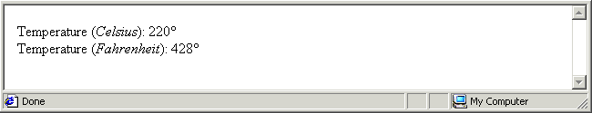
Experiment with the file by changing the input (Fahrenheit) temperature value. You can close the file when finished.

About The Assignment Operator
Putting a value into a variable is known as assignment, and is achieved though the use of the assignment operator (=). For example:
fruit = “apple”;
This places the value of ‘apple’ inside the variable named ‘fruit’. Switching around this assignment statement results in the value of ‘fruit’ being placed inside the variable named ‘apple’.
apple = “fruit”;
In JavaScript the equals sign does not mean ‘equal to’ as it does in arithmetic or algebra. It means as follows: ‘Take whatever is on the right of the equals sign and place it in variable on the left hand side.’
JavaScript treats the left-hand side (LHS) as a variable, but the right-hand side (RHS) may be a value, another variable, or an object property. In the example below the RHS contains a value.
country = “Bermuda”;
Consider the next example. Here the RHS contains another variable. What this assignment does is copy whatever value is in the ‘cost’ variable to the ‘price’ variable.
price = cost;
It’s perfectly valid to place the same variable on both sides of the assignment operator. The following example puts the current content of the StreetAddress variable inside the StreetAddress variable. Nothing is changed as a result of this statement but no syntax rule is broken either.
StreetAddress = StreetAddress;
Sometimes you may want to change a variable’s value by a fixed amount. The following would make no sense if it where algebra.
SalePrice = SalePrice+20;
But in JavaScript it means ‘jack up the sale price by 20’. That is, insert in the sale price variable whatever is currently in that variable already plus 20.
JavaScript does not accept an assignment statement with a value on both sides. The LHS must always be a variable or an object property. Running the following statement generates an error in the web browser window.
32 = 32;
Assignment Statement
A JavaScript statement in which a variable or object property on the left of the equal sign (=) is given the value of whatever is on the right of the equals sign.

Automatic Variable Retyping
JavaScript, as you have learnt, decides which type of variable you want to create by the way that you first assign a value to it. When you enclose the value within quotes, JavaScript makes the variable a string variable; when you omit the quotes, JavaScript makes it a numeric variable.
JavaScript can also change the type of a variable when you assign a value of a different type to that variable. It’s called automatic type conversion. Consider the following two statements.
var myvar = “12.34”;
myvar = 43;
In the first statement JavaScript makes the variable named ‘myvar’ a string variable. In the second statement JavaScript changes the variable type to numeric because a number was assigned to it.
Automatic variable type conversion is a powerful feature of JavaScript, but its very power can result in scripting errors or in scripts that produce unexpected results. You need to be particularly careful with variables types when dealing with HTML forms that accept input from web page visitors. Because forms accept input as strings you need to convert such strings to numbers when you want to include them in arithmetic calculations.

The typeof Operator
When you are unsure about variable type at any some point in a script you can use the typeof operator to reveal the variable type. You insert the typeof operator directly before the variable. Here are three statements in which the typeof operator is used within a document.write() statement.
document.write(typeof sales price);
document.write(typeof x);
document.write(typeof email_address);
Exercise 5.18 takes you through the steps setting, changing and displaying a variable’s type.

Exercise 5.18: Investigating a Variable’s Type
- Open the following file in your text editor and web browser:
exercise_5-18_before.htm
Immediately beneath the <BODY> tag you can see a line that looks like a JavaScript statement.
<P><I>var firstVar;</I><BR>
But because it is not within a <SCRIPT>...</SCRIPT> tag pair the browser treats this line just as would any HTML text: it simply displays it in the browser window.
Beneath that you can see two JavaScript statements. The first declares a variable, and the second writes the variable’s type to the browser window.
<P><I>var firstVar;</I><BR>
<SCRIPT LANGUAGE="JavaScript" TYPE="text/javascript">
var firstVar;
document.write("<B>Variable Type: <\/B>"+typeof firstVar);
</SCRIPT></P>
In the browser window you can see that the variable type is ‘undefined’. This is because you have not assigned a value to it.
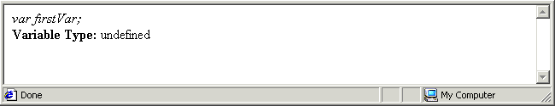
- Copy everything within the document body, and paste it three times beneath the existing lines as shown below.
<P><I>var firstVar;</I><BR>
<SCRIPT LANGUAGE="JavaScript" TYPE="text/javascript">
var firstVar;
document.write("<B>Variable Type: <\/B>"+typeof firstVar);
</SCRIPT></P>
<P><I>var firstVar;</I><BR>
<SCRIPT LANGUAGE="JavaScript" TYPE="text/javascript">
var firstVar;
document.write("<B>Variable Type: <\/B>"+typeof firstVar);
</SCRIPT></P>
<P><I>var firstVar;</I><BR>
<SCRIPT LANGUAGE="JavaScript" TYPE="text/javascript">
var firstVar;
document.write("<B>Variable Type: <\/B>"+typeof firstVar);
</SCRIPT></P>
<P><I>var firstVar;</I><BR>
<SCRIPT LANGUAGE="JavaScript" TYPE="text/javascript">
var firstVar;
document.write("<B>Variable Type: <\/B>"+typeof firstVar);
</SCRIPT></P>
- In the first section that you pasted replace the variable declaration with an assignment statement as shown below.
var firstVar=12;
In the second section that you pasted replace the variable declaration with an assignment statement as shown below.
var firstVar=”12”;
And in the third pasted section replace the variable declaration with an assignment statement as shown below.
var firstVar=12;
What you have done in this step is set the variable type as a string, changed it to a number, and changed it back to a string again.
- Save your file with the following name and view it in your web browser.
exercise_5-18_after.htm
It should look as shown. You can see how the variable’s type changed during the script: from undefined (no type), to numeric, then to string, and finally back to numeric again.
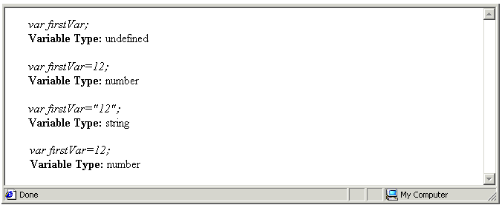
You can close the file when finished.

Chapter Summary
You can think of a variable as a container for a value that can change. Variable names must be unique, are case sensitive and cannot contain spaces.
A string variable can contain any keyboard characters, whether letters, numbers, punctuation symbols or white spaces, or any combination of these. A numeric variable stores a number, whether an integer or a floating point number.
Values stored in numeric variables can be used in arithmetic calculations. You can store a number in a string variable, but it cannot be used in a calculation.
In JavaScript the first thing you do with a variable is declare it. The following code declares the variable named FirstName. The declaration begins with the word var.
var FirstName;
JavaScript decides which type of variable you want to create by the way that you first assign a value to it. When you enclose the value within quotes JavaScript makes the variable a string variable. For example.
StreetAddress = “42 Green Avenue”;
When you omit the quotes JavaScript makes the variable a numeric variable. For example.
OrderQty = 4;
You can declare a variable and assign a value to it in a single statement as follows.
userName =”Sheila”;
userID=634634;
Putting a value into a variable is known as assignment, and is achieved though the use of the assignment operator (=). JavaScript does not accept an assignment statement with a value on both sides. The left hand side must always be a variable or an object property. The right hand side can be a value, a variable or an object property. It’s perfectly valid to place the same variable on both sides of the assignment operator.
JavaScript’s automatic type conversion feature mans that you can change the type of a variable by assigning a different type of value to it. In the first of the two statements below JavaScript makes the variable named ‘myvar’ a string variable. In the second statement JavaScript changes the variable type to numeric because a number is assigned to it.
var myvar = “12.34”;
myvar = 43;
Because HTML forms accepts user input as strings you need to convert such strings to numbers if you want to use them in arithmetic calculations. You can use the typeof operator to reveal a variable’s type. The following example shows the typeof operator used within a document.write() statement.
document.write(typeof sales price);
You can use the addition (+), subtraction (-), multiplication (*) and division (/) operators to perform arithmetic with numeric variables. JavaScript follows the rules of arithmetic when working with numeric variables and numbers: division first, followed by multiplication, then addition and finally subtraction. You can force JavaScript to perform calculations in a particular order by using parentheses as shown in the example below.
var result = ((8 * distance) + tax) / (volume - 7)
Ensure that you follow every opening bracket with a matching closing bracket.

JavaScript Variables and HTML Text Form Fields

Objectives
In this chapter you will learn how to:
- Create a dialog box with the window.prompt method()
- Assign to a variable a value entered in a window.prompt() dialog box
- Assign to a variable a value entered in a TEXT field of a HTML form
- Write a variable value to an TEXT field of a HTML form
- Write a variable value to a TEXT AREA field of a HTML form
- Convert a string variable to a numeric variable with a integral or floating point value using the parseInt() or parseFloat() method
- Format the number of decimal places in a numeric variable using the toFixed() method
- Submit and reset a form with the submit() and reset() methods of the forms object

Vocabulary
- There are no new terms in this Chapter.

Exercise Files
In this chapter you will work with the following HTML files:
- exercise_5-19_before.htm
- exercise_5-20_before.htm
- exercise_5-21_before.htm
- exercise_5-22_before.htm
- exercise_5-23_before.htm
- exercise_5-24_before.htm

Variables: Your Values or Mine?
In Chapter 5 you learnt how to assign values to string and numeric variables with JavaScript statements such as the following.
var username=”Pamela”;
var profit = 12000;
In the above examples the values were assigned to the variables by you, the creator of the web page. The real usefulness of JavaScript, however, is its ability to capture and manipulate values entered by the visitor to a web page. There are two ways to capture user-entered values:
- With window.prompt() statements
- With HTML form fields
Let’s examine each approach in turn.

Obtaining Values From a window.prompt() Box
Remember the window.alert() and window.confirm() methods from Chapter 2? Each displays a dialog box in front of the web browser window. The window.alert() dialog box has just an OK button. The window.confirm() dialog box has two buttons: OK and Cancel.
A third method of the window object, the window.prompt() method, creates a dialog box with an important additional element: an input area in which the page visitor can enter a value. Internet Explorer displays a window.prompt() box as shown below.
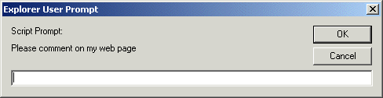
Netscape Navigator displays window.prompt() boxes slightly differently.
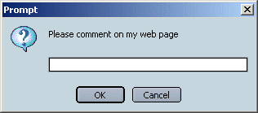
The general format for creating a window.prompt() box is as follows.
window.prompt("Prompt text goes here","Default response text goes here");
Only type text within the second pair of quotes if you want a default response to appear in the entry area of window.prompt() box. Here’s a statement that does not offer any default text.
window.prompt("Prompt text goes here","");
The capture of information from a web page visitor is just the first step of a two-step process. The second is the assignment of that user-entered information to a variable in a script. You can assign the text typed in a window.prompt() box to a variable as shown below.
var userName;
userName = prompt(“Please enter your User Name”, “”);
Alternatively, write the declaration and assignment on the same line within a single statement.
var userName = prompt(“Please enter your User Name”, “”);
You can see that the above two statements follow an important rule governing all use of the assignment operator (=): the variable goes on the left hand side, and the value for assignment to the variable goes on the right hand side.
Exercise 5.19 takes you through the steps of assigning user input from a window.prompt() box to a variable, and then writing the value of that variable back to the web browser window.

Exercise 5.19: Capturing a Value From a window.prompt() Box
- Open the following file in your text editor and web browser:
exercise_5-19_before.htm
- A window.prompt() box opens in front of the browser window. Click Cancel to close it. In your text editor you can see that the document body contains a variable whose value will be whatever the web page visitor enters in the window.prompt() box.
var userName = window.prompt("Please enter your User Name:", "");
- Insert the following line of code beneath the line shown above. It’s a single instruction that writes the user’s prompt box entry, now stored in a variable, to the body of the web page.
document.write("You entered:<B> "+userName+"<\/B>");
- Save your file with the following name and reload your web browser.
exercise_5-19_after.htm
- Enter some text in the box when prompted and click OK.
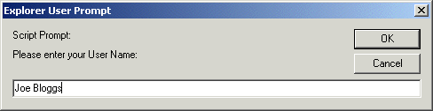
You can see your entered text displayed in the browser window. You can close the file when finished.
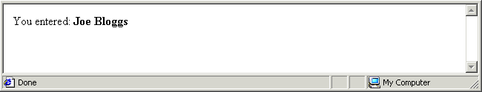

Using Forms with JavaScript
A window.prompt() box is a somewhat crude way of gathering names, addresses and other details from web page visitors. A more friendly approach is through the use of HTML forms. In Module 2 you learnt a lot about HTML forms and the various attributes of the <FORM> tag. In JavaScript the NAME attribute assumes a particular importance as it makes it possible for a JavaScript to:
- Read the user-entered value in a form field. In the example below ‘myform’ is the value of the NAME attribute in the <FORM> tag, and ‘usernamefield’ is the name of the single-line text box field within the form.
<FORM NAME = “myform”>
User Name: <INPUT TYPE = TEXT NAME = ‘usernamefield’ SIZE=’20’>
</FORM>
The above HTML code produces a text box similar to the following.
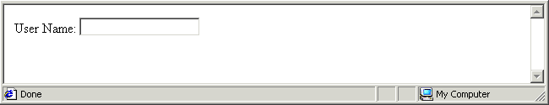
The JavaScript statement below assigns the user-entered content of this text box field to the variable called ‘userName’.
userName = document.forms.myform.usernamefield.value;
- Write a value to a form field. JavaScript can do more than just read what has been typed in a text box form field. It can also write a value to the field. The value, for example, might be the result of a calculation carried out by a function.
In the example below the value of the variable named SumTotal is assigned to the form field named ‘total’ that is located within the form named ‘calcform’.
document.forms.calcform.total.value = SumTotal;
In Exercise 5.20 you will capture the value entered to a form field, assign it to a variable, and write the value of that variable to the web browser window.

Exercise 5.20: Building a Simple JavaScript-controlled Form
- Open the following file in your text editor and web browser:
exercise_5-20_before.htm
In the document body is a form called ’NameForm’. It contains a single form field called ‘UserNameField’.
In the document head is a function called showName() that contains only comment lines. The function can be called at any stage by a button with an attached onclick event handler
- Insert the following variable declaration in the function.
/* declare variable */
var UserNameVariable;
- Write a statement that assigns to this variable the value of the form field.
/* place the user name from the form in the variable */
UserNameVariable = document.forms.NameForm.UserNameField.value;
- Insert a statement that writes the variable’s value to the web page.
/* write the variable’s value to the web page */
document.write("You Entered: <B>"+UserNameVariable+"<\/B>");
- Save your file with the following name and realod your web browser.
exercise_5-20_after.htm
The result should look as shown.
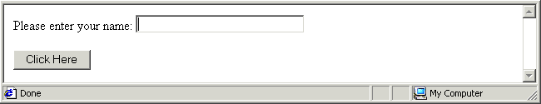
- Type some text in the form field box, click the button, and watch your entry displayed in the web browser window. You can close the file when finished.
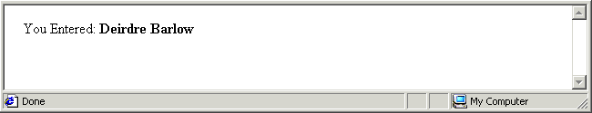

About the Forms Object
In Exercise 5.20 you were introduced to the forms object, which is contained within the document object. Consider the following code.
document.forms.NameForm.UserNameField.value;
When a HTML document contains a form, that is, a <FORM>…</FORM> tag pair, JavaScript treats the form as an object in its own right. In JavaScript terms the forms object is a child object of the document object. Just as the document object has various properties (features) and methods (actions), so too does the forms object.
Examining the above syntax you can see that it contains the following components, each one separated from the next by a full stop. As you might expect, the value property of the form field holds whatever content is in that field.
Document Object | Forms Object | HTML form name (from NAME attribute for <FORM> tag). | HTML form file name (from NAME attribute of <INPUT> tag). | Value property
document | forms | NameForm | UserNameField | value
The JavaScript forms object has two methods that mimic the actions performed by HTML buttons with an INPUT TYPE attribute of SUBMIT and RESET.
Forms Object Method | Description
submit() | Submits the form for processing to the script or program specified in the ACTION attribute of the HTML <FORM> tag. For example:  document.forms.myform.submit();
reset() | Resets all fields in the form to the values they contained at the time when the form was loaded in the browser window. For example:  document.forms.calcform.reset();

Reading a User-entered Text Box Value with JavaScript
You can read the information that a web page visitor types into a text box form field, and assign the information to a variable, with the following code.
myVar = document.forms.form_name.form_field_name.value
In this assignment statement the value of the field within the forms object on the right hand side is placed within the variable on the left hand side.

Writing a Script-generated Value to a Text Box JavaScript
To set the value of a text box form field, use code similar to the following.
document.forms.form_name.form_field_name.value = myVar;
In this assignment statement the value of the variable on the right hand side is placed within the forms object property on the left hand side. But aren’t text boxes for inputting data, not outputting it? Yes. With JavaScript, however, you can uses text boxes in a HTML form for both purposes. In JavaScript terms the value of a text box in a HTML form is scriptable – its value can set by a script.
A well-designed HTML form should provide web page visitors with some feedback on what they have entered, and, ideally, the ability to amend their form entries before submitting them to the web site.
In Exercise 4.20 a document,write() statement writes to the web page the user’s form field entry. Unfortunately, when a document.write() statement is called from a function it replaces all other content on the web page, including the HTML form. A more elegant method of providing user feedback is to write that information to a text box field within a HTML form.
In Exercise 5.21 you will capture details that a web page visitor enters to two form fields, assign the details to two variables, concatenate (‘join’) the variables together, assign the value in the concatenated variable to a third variable, and then write the value in that variable to a third box in the form where it is visible in the browser window.

Exercise 5.21: Manipulating Values Captured in a Form
- Open the following file in your text editor and web browser:
exercise_5-21_before.htm
In the document body is a form called ’myform’. It contains three text boxes, called 'FirstName', ‘Surname’ and ‘FullName’. Note that these are the names of HTML form fields – not names of JavaScript variables.
In the document head is a function called showFullName() that contains only comment lines. The function can be called at any stage by a button with an attached onclick event handler in the HTML form.
- Insert the following three variable declarations in the function.
/* declare three variables */
var fName;
var sName;
var fullName;
- Assign to the first two variables the content of the first two HTML form fields.
/* Place the first name from the form in a variable */
fName = document.forms.myform.FirstName.value;
/* Place the second name from the form in a variable */
sName = document.forms.myform.Surname.value;
- Assign to the third variable the concatention of the first two variables, with a single blank space in between.
/* Concatenate the first and second names into a full name */
fullName = fName+" "+sName;
- Finally, write to the third form field box whatever content is in the fullName variable.
/* Write value of full name variable to third form field */
document.forms.myform.FullName.value = fullName;
- Save your file with the following name and reload your web browser.
exercise_5-21_after.htm
- The result should look as shown. Type some text in the First Name and Surname boxes, click the button, and watch your entries display in the third form field.
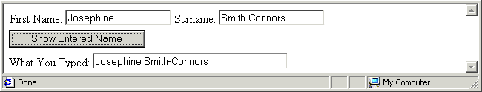
You can enter text in the third field at any stage, but it will be overwritten when you click the Show Entered Name button. You can close the file when finished.

Making the Connection: HTML Form Field Names and JavaScript Variable Names
Forms such as the one you worked with in Exercise 5.21 are a very common application of JavaScript programming. One area that many find confusing is the relationship between form field names and variable names.
- HTML form field names: Every field in a HTML form has a name, whether the web page contains any JavaScript or not. Form field names are part of HTML and exist independently of any scripts.
Some web page creators like to give expressive names to their forms fields, such as TelephoneNumber or ProductCode as follows.
<INPUT TYPE=TEXT NAME='TelephoneNumber' SIZE='20'>
<INPUT TYPE=TEXT NAME='ProductCode' SIZE='12'>
Others prefer shorthand names like B2 or D4.
<INPUT TYPE=TEXT NAME='B2' SIZE='20'>
<INPUT TYPE=TEXT NAME='D4' SIZE='12'>
Form field names may not contain spaces, but remember that is a HTML rule and not a JavaScript one.
- JavaScript variable names: These names exist only within scripts.
When you assign a form field’s value to the variable, or write a variable’s value to a form field, you are making a connection between a form field that is part of HTML and a variable that is part of JavaScript.
In these situations some programmers like to give the same name to the form field and the variable, because it helps them remember which HTML form field is related to which JavaScript variable. The result is code such as the following.
fName = document.forms.myform.fName.value;
Or, alternatively.
document.forms.myform.fName.value= fName;
Other programmers prefer to give different names to the variable and the form field, because it helps keep the two separate in their minds. The result is code such as the following.
fName = document.forms.myform.FirstName.value;
Or, alternatively.
document.forms.myform.FirstName.value= fName;
The HTML form and the JavaScript code will work equally well whichever approach you take.

Displaying Form Values in Scrolling Text Boxes
HTML form fields with an INPUT TYPE of TEXT are a good choice for accepting short text strings such as names and contact details, and numbers such age and order quantity. The two attributes you are most likely to use with these single-line text box fields are NAME and SIZE. The second sets the displayed with of the field in characters. It does not limit the number of characters that a web page visitor can input to such a field, however. The following HTML code creates a text box named ‘email’ that displays as 28 characters wide.
<INPUT TYPE=TEXT NAME=’email’ SIZE=’28’>
For collecting longer text strings such as visitor comments, suggestions or other feedback, a better choice is the multi-line scrolling text box field. In addition to NAME, its most commonly used attributes are ROWS, which sets the displayed number of lines, and COLS, which sets box’s displayed width in numbers of characters.
The following HTML code creates a scrolling text box named ‘userComments’ that displays as 20 characters wide and 4 lines high in the browser window.
<TEXTAREA NAME=userComments’ ROW=’4’ COLS=’20’></TEXTAREA>
Note that scrolling text boxes are not created by a TYPE attribute of the <INPUT> tag, but by an opening and closing <TEXTAREA>…</TEXTAREA> tag pair.
In Exercise 5.22 you will work with a form similar to the one in the previous exercise. The difference is that you will output the result of the form’s function to a multi-line scrolling text box rather than a single-line text box.

Exercise 5.22: Displaying Form Values in a Scrolling Text Box
- Open the following file in your text editor and web browser:
exercise_5-22_before.htm
In the document body is a form called ’myform’. It contains three text boxes, called 'FirstName', ‘Surname’ and ‘FullName’, and a form button. In the document head is a function called showFullName().
Test the form by typing some text in the First Name and Surname boxes, click the button, and watch your entries displayed in the third form field.
- The HTML code for the third form field is as follows.
<P>What You Typed: <INPUT TYPE=TEXT NAME='FullName' SIZE='40'></P>
- Amend the code to that for a multi-line scrolling text box as shown.
<P>What You Typed:<BR>
<TEXTAREA NAME='FullName' ROWS='3' COLS='40'></TEXTAREA></P>
- Save your file with the following name and reload your web browser.
exercise_5-22_after.htm
- The result should look as shown. Type some text in the First Name and Surname boxes, click the button, and watch your entries displayed in the third form field.
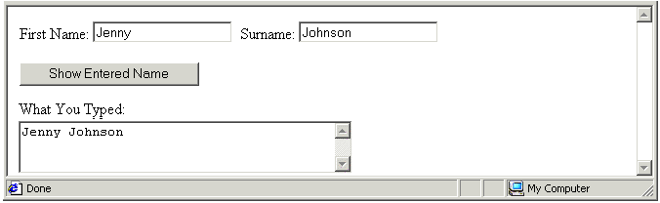
You can enter text in the scrolling text box field at any stage, but it will be overwritten when you click the Show Entered Name button. You can close the file when finished.

Handling User-entered Numbers in HTML Order Forms
It is not only strings such as names or email addresses that you will want to capture in HTML forms. You will also want to capture order quantities, financial amounts and other numbers.
Because a HTML text box regards everything entered to it as a string, you need to convert string variables containing numbers to actual numeric variables before using the user-entered values in calculations.

The parseInt() and parseFloat Methods
JavaScript offers two methods for converting string variables to numeric variables.
Method | Description
parseInt() | Converts string variable to a numeric variable. The result is an integer (whole number). Anything after the decimal point is discarded.  myVar= parseInt(myVar);
parseFloat() | Converts string variable to a numeric variable. The result is a floating point number. Anything after the decimal point is preserved.  myVar= parseFloat(myVar);
Neither method checks whether the variable actually contains a number or not. Even if the variable contains a string each method still performs the variable type conversion.

Setting Decimal Places With The toFixed(n) Method
When displaying financial amounts on screen it is conventional to format them so that they have a fixed number of decimal places. Values such as 12.80 and 45.00 look much better than 12.8 and 45. JavaScript provides a toFixed() method for this purpose. You enter the number of decimal places you require in the method’s parenthesis. It works only with numeric variables.
If the variable named ‘myNum’ contains 123.5, for example, the following statement reformats the value in the variable to 123.50.
myNum = myNum.toFixed(2);

Exercise 5.23: Converting User-entered Values to Numbers
- Open the following file in your text editor and web browser:
exercise_5-23_before.htm
In the document body is a form called ’myform’. It contains three text boxes called 'T1’, ‘T2’ and ‘T3’, and a form button and event handler. In the document head is a function named examineInput().
Test the form by typing some text in the Enter a Value Here box, click the button, and note the responses displayed in the second and third form fields.
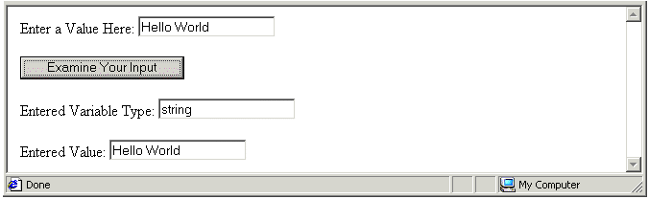
- Enter another value in the first field – this time, a number. Click the button again and note that JavaScript regards your entered number as a string.
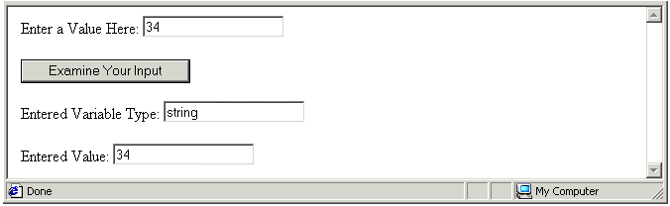
- Insert a new statement in the function that uses the parseInt() method to convert the variable holding the user-entered value to a numeric variable as shown below.
userInput = document.forms.myform.T1.value;
userInput = parseInt(userInput);
varType = typeof userInput;
- Save your file with the following name and view it in your web browser.
exercise_5-23_after.htm
- Enter an integer to the first form field, click the button and note the responses displayed in the second and third form fields. You browser window should look like that below.
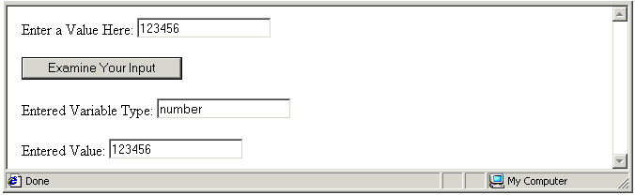
- Enter a floating point number (a number with decimal places) to the first form field, click the button and note the responses displayed in the second and third form fields.
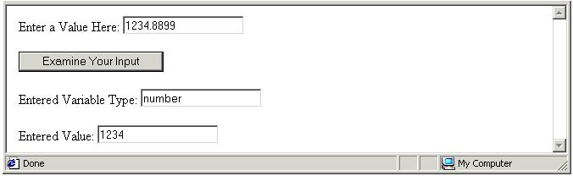
You can see in your browser window that the parseInt() method truncates (‘chops off’) anything after the decimal point.
- Replace the parseInt() method with the parseFloat() method as shown below, resave your file, and refresh/reload your web browser.
userInput = document.forms.myform.T1.value;
userInput = parseFloat(userInput);
varType = typeof userInput;
- Enter a floating point number (a number with decimal places) to the first form field, click the button and note the responses displayed in the second and third form fields.
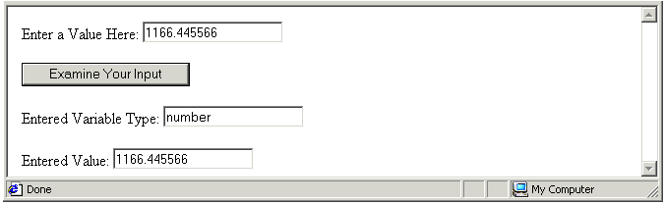
- What happens if you enter a string to the first form field and click the button? Try it and see. You web browser window should produce a result similar to the following.
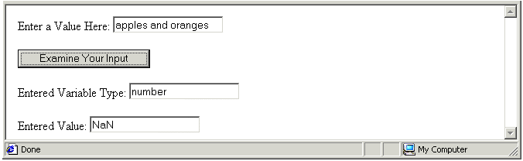
You can see that parseFloat() converted the variable type to numeric, but that the variable’s value is ‘NaN’. This is JavaScript’s way of saying ‘not a number’. The parseInt() method would have produced the same result. You can close the file when finished.
In summary, the parseInt() and parseFloat() methods convert string variables to numeric ones, but they do not test whether the variables they convert actually contain numbers or not. You will learn how to test variable values later in this book.
In Exercise 5.24 you will build a web-based order form that accepts order quantities entered by a customer, and then performs arithmetic to generate the total financial value of the customer’s order.

Exercise 5.24: Building a Web-based Order Form
- Open the following file in your text editor and web browser:
exercise_5-24_before.htm
In the document body is a form named ’orderform’. It contains four text boxes named 'T1’ to ‘T4’, a form button and an event handler. In the document head is a function named calcOrderTotal(). There are no statements in the function, just comment lines.
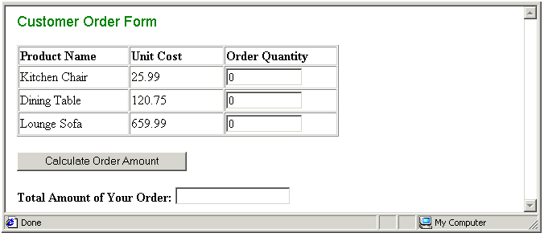
- Insert the following declaration statements in the function.
/* Variable declarations */
var qty_chair;
var qty_table;
var qty_sofa;
var total_amount;
- Insert the following assignment statements in the function.
/* Assignments of form field values to variables */
qty_chair=document.forms.OrderForm.T1.value;
qty_table=document.forms.OrderForm.T2.value;
qty_sofa=document.forms.OrderForm.T3.value;
- Insert the following variable type conversion statements in the function.
/* Conversion of variables to numeric variables */
qty_chair=parseInt(qty_chair);
qty_table=parseInt(qty_table);
qty_sofa=parseInt(qty_sofa);
- Complete your function by entering the following two arithmetic calculation statements.
/* Calculation and display of total order value */
total_amount=(qty_chair*25.99)+(qty_table*120.75)+(qty_sofa*659.99);
document.forms.OrderForm.T4.value=total_amount;
- Save your file with the following name and reload your web browser.
exercise_5-24_after.htm
- Test your function by entering order quantities in the top three form fields, clicking the button, and viewing the result in the fourth form field. You web browser window should look similar to that shown below.
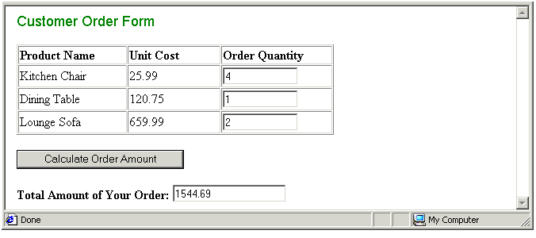
- Improve your form by offering the web age visitor a reset button. Edit the HTML code as shown below.
<P><BUTTON onclick="calcOrderTotal()">Calculate Order Amount</BUTTON>&nbsp;
<INPUT TYPE='RESET' VALUE='Reset Form'></P>
This inserts a reset button by using the RESET attribute of the <INPUT> form field tag. Another approach is to use a <BUTTON>…</BUTTON> tag pair along with an event handler that uses the JavaScript reset() method to reset the form. Here’s the code.
<P><BUTTON onclick="calcOrderTotal()">Calculate Order Amount</BUTTON>&nbsp;
<BUTTON onclick="document.forms.OrderForm.reset()">Reset Form</BUTTON></P>
Resave your file, reload your web browser, and verify that the Reset Form button works correctly.
- Let’s make one further improvement. To encourage your web page visitors to make a purchase, change the default values of the first three form field as shown below.
<TD WIDTH=’140’><INPUT TYPE='TEXT' NAME='T1' SIZE='12' VALUE='4'></TD>
<TD WIDTH=’140’><INPUT TYPE='TEXT' NAME='T2' SIZE='12' VALUE='1'></TD>
<TD WIDTH=’140’><INPUT TYPE='TEXT' NAME='T3' SIZE='12' VALUE='1'></TD>
Resave your file and reload your web browser. Your form should now look as shown.
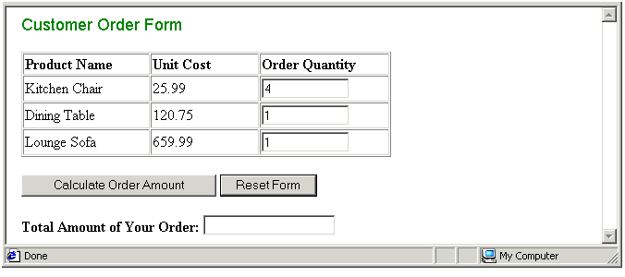
- Oops! As you can see 4 chairs, a table and a sofa are about to be ordered, but the order amount form field at the bottom of the form is empty.
Correct this problem by calling the calcOrderTotal() function as soon as the web page loads. Insert an onload event handler in the <BODY> tag as follows.
<BODY onload="calcOrderTotal()">
- Resave your file and reload your web browser. An amount of ‘884.7’ should now appear in the text box at the bottom of the form.
- Insert a statement that applies the toFixed() method to the total_amount numeric variable on the second last line of the script as shown below.
total_amount = total_amount.toFixed(2);
document.forms.OrderForm.T4.value=total_amount;
- Resave your file and reload your web browser. An amount of ‘884.70’ should now appear in the text box at the bottom of the form. You can close the file when finished.
This form provides an example of the same function being called more than once by different event handlers within the same HTML document.

Chapter Summary
You can capture a user-entered value from a window.prompt() dialog box and assign the value to a variable with a statement such as the following.
var userName = prompt(“Please enter your User Name”, “”);
A more friendly approach is through the use of HTML forms. When a HTML document contains a form, JavaScript treats the form as an object in its own right. In JavaScript terms the forms object is a child object of the document object. The JavaScript forms object has two methods that mimic the actions performed by HTML buttons with a TYPE attribute of SUBMIT and RESET. They are submit() and reset().
The statement below submits a form named ‘myform’ for processing to the script or program specified in the ACTION attribute of the HTML <FORM> tag.
document.forms.myform.submit();
The statement below all fields in the form named ‘calcform’ to the values they contained at the time when the form was loaded in the browser window.
document.forms.calcform.reset();
You can read the information that a web page visitor types into a text box form field, and assign the information to a variable, with the following code.
myVar = document.forms.form_name.form_field_name.value
To set the value of a text box form field, use code similar to the following.
document.forms.form_name.form_field_name.value = myVar;
Because a HTML text box regards everything entered to it as a string, you need to convert string variables containing numbers to actual numeric variables before using the user-entered values in calculations.
JavaScript offers two methods for converting string variables to numeric variables: parseInt() and parseFloat(). The first discards anything after the decimal point. The second preserves any decimal fractions. Here are examples of the two methods in use.
myVar= parseInt(myVar);
myVar= parseFloat(myVar);
Neither method checks whether the variable actually contains a number or not. Even if the variable contains a string each method still performs the variable type conversion.
When displaying financial amounts in a form it is conventional to format them so that they have a fixed number of decimal places. JavaScript provides a toFixed(n) method for this purpose, where n is the required number of decimal places. If the variable named ‘myNum’ contains 123.5, the following statement reformats the value in the variable to 123.50.
myNum = myNum.toFixed(2);

More About Functions

Objectives
In this chapter you will learn how to:
- Pass one or more parameters to a function
- Return a value from a function
- Call functions with keyboard-based event handlers

Vocabulary
In this chapter you will meet the following terms:
- Function parameter
- Literal

Exercise Files
In this chapter you will work with the following HTML files:
- exercise_5-25_before.htm
- exercise_5-26_before.htm
- exercise_5-27_before.htm
- exercise_5-28_before.htm
- exercise_5-29_before.htm

Functions That Need Parameters
Sometimes you will want to function to perform a task that requires some ‘raw material’. Providing information to a function that is then manipulated in some way is known in JavaScript terms as passing a parameter to a function. A function may be designed to accept several parameters.
Function Parameter
Information that is passed to a function for the function to work on. The function may use the information to perform a calculation, or to decide which of a number of possible instructions to perform.
Back in Exercise 5.12 of Chapter 4 you worked with a web page that contained three buttons and three event handlers that triggered three separate functions.
The simplified HTML BUTTON code and the event handlers are as follows.
<BUTTON onclick =”setBackgroundBlue()”>Blue Background</BUTTON>
<BUTTON onclick=”setBackgroundRed()”>Red Background</BUTTON>
<BUTTON onclick=”setBackgroundGreen()”>Red Background </BUTTON>
The three functions that perform the required change to the web page’s background colour are as follows.
function setBackgroundRed() {
document.bgColor='#FF0000';
}
function setBackgroundGreen() {
document.bgColor='#00FF00';
}
function setBackgroundBlue() {
document.bgColor='#0000FF';
}
That’s a lot of scripting. Is there a shorter, alternative way to achieve the same result? Yes. Start by taking the particular colours out of the functions and placing them inside the event handlers. Also rename the function called by the event handlers as shown below.
<BUTTON onclick =”setBackground(‘#FF0000')”>Blue Background</BUTTON>
<BUTTON onclick=”setBackground(‘#FF0000')”>Red Background</BUTTON>
<BUTTON onclick=”setBackground(‘#FF0000')”>Red Background </BUTTON>
The above three event handlers don’t just call the function; they also give the function the information it needs to do its job.
With the colours in the individual event handlers, you can rewrite the three functions into a single function that accepts a parameter of colour from the event handlers.
function setBackground(colour) {
document.bgColor=colour;
}
Whenever the web page visitor clicks a button the colour within parenthesis is passed to the function as a parameter. The parameter name is typed inside the function’s parenthesis. This information is then used by the function to set the web page background colour.
In Exercise 5.25 you will pass hex colour codes as parameters from three different event handlers to a single function.

Exercise 5.25: Passing a Colour Code Parameter to a Function
- Open the following file in your text editor and web browser:
exercise_5-25_before.htm
Examine the file in your text editor. In the head section you can see a function that accepts a parameter named ‘textcolour’. In the body section are three buttons.
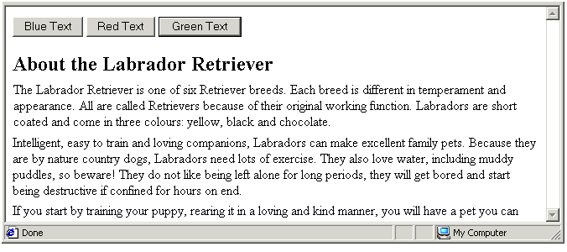
- There is no connection between the buttons in the <BODY> and the function in the <HEAD>. Clicking on these buttons does not trigger any action.
- Insert the following event handlers and colour codes within the three event handlers.
<BUTTON onclick="setTextColour('#000080')">Blue Text</BUTTON>
<BUTTON onclick="setTextColour('#CC3300')">Red Text</BUTTON>
<BUTTON onclick="setTextColour('#008000')">Green Text</BUTTON>
- Save your file with the following name and reload your web browser.
exercise_5-25_after.htm
Click the buttons to verify that event handlers successfully pass to the text colour codes to the function. You can close the file when finished.
In Exercise 5.26 you will pass a text strings as parameters from three different event handlers to a single function.

Exercise 5.26: Passing a String Parameter to a Function
- Open the following file in your text editor and web browser:
exercise_5-26_before.htm
Examine the file in your text editor. In the head section you can see a function that accepts a parameter named ‘textmsg’. In the body section are three buttons.
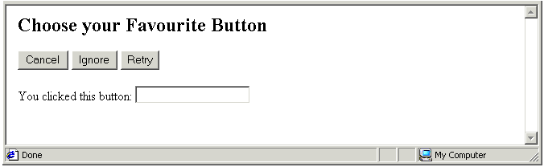
- There is no connection between the buttons in the <BODY> and the function in the <HEAD>. Clicking on these buttons does not trigger any action.
- Insert the following event handlers and colour codes within the three event handlers.
<BUTTON onclick=" showMessage(‘Cancel')">Cancel </BUTTON>
<BUTTON onclick=" showMessage('Ignore')">Ignore</BUTTON>
<BUTTON onclick=" showMessage('Retry')">Retry</BUTTON>
- Save your file with the following name and reload your web browser.
exercise_5-26_after.htm
Click the three buttons in turn. The buttons now work because they are connected, through the onclick event handler, to the function in the document head. Also each button passes a string to the function. You can close the file when finished.

About Literals
You have learnt that a variable can hold a value that changes. A literal is the opposite of a variable. It’s a string or number that does not change, but retains a constant value. Consider the following JavaScript statement that contains both a literal (‘Your Name’) and a variable (‘user_name’).
document.write("Your Name: "+user_name);
In Exercises 5.25 and 5.26 the details passed from the event handlers to the functions are literals. In Exercise 5.25 the literals were hex colour codes such as '#CC3300'. In Exercise 5.26 the literals were text items such as 'Cancel'. In both cases the literals were strings as they were enclosed within quotes.
Literal
A data value that is placed directly in a script. It can be a string within single or double quotes, or a number without quotes.

The Passing of Parameters: A Review
Let’s sum up what you have covered about functions and parameter-passing:
- Event handlers: A literal can be stored within the parenthesis of an event handler. In the example below the literal is the string ‘Say Hello World’.
onclick="saySomething('Hello World’)”
- Parameter-passing: When an event handler is triggered by a user action such as clicking, its literal value can be passed to the function specified in the event handler.
In the example above the literal value of ‘Hello World’ is passed to the function named ‘saySomething’.
- Function variable: A variable can be declared within the parenthesis of a function. In the example below the function ‘saySomething’ contains the variable ‘message’.
function saySomething(message)
- When the function is triggered by an event handler containing a literal value, that literal is assigned as the value of that variable. The variable can then be manipulated within the function.
function saySomething(message) {
window.alert(message);
}

Passing Multiple Parameters
You can pass multiple literals as parameters to a function, and a function’s parenthesis can contain multiple variables. The only rule is this: The number of variables in the parenthesis of the function must match the number of literals in the event handler that calls the function.
Exercise 5.27 provides an example of multiple parameter-passing to a arithmetic function.

Exercise 5.27: Passing Multiple Parameters to a Function
- Open the following file in your text editor and web browser:
exercise_5-27_before.htm
Examine the file in your text editor. In the head section you can see a function that calculates the average value of three numbers. In the body section is single button with an event handler that contains three literals. The literals are separated by commas.
<BUTTON onclick="findAverage(12,36,48)">Click Here</BUTTON>
Click the button and you web browser will display and error message. That is because there are no variables within the parenthesis of the called function to accept the three literals passed to it by the button’s event handler.
- Insert three variables inside the parenthesis of the function as shown below. The variable names are separated by commas.
function findAverage(firstNo,secondNo,thirdNo)
- Save your file with the following name and reload your web browser.
exercise_5-27_after.htm
Click the button to view a dialog box containing the average calculated by the function based on the three parameters that the event handler passed to it.

Functions That Return Values
You have seen how an event handler can pass a parameter to a function. The opposite is also true: a function can pass a value back to the place from which the function was called. This action is described as the function returning a value.
Until now you have only called functions through event handlers such as onclick and onload. You can also call a function directly from a statement. The following two statements call two different functions. The first function call does not pass a parameter. The second function call passes the parameter named ‘temperature’.
myvar = doSomething();
temperature = updateNow(temperature);
The statement that calls the function may be in another function in the head of the HTML document, or it may be located somewhere of the document body.
Consider the following script in which a number is assigned to a variable and the variable’s value to written to the browser window. The function named doubleIt() is then called and applied to the numeric variable, and its amended value is written to the browser window.
var mynum = 24;
document.write("Number is: "+mynum+"<BR>");
mynum = doubleIt(mynum);
document.write("Number after <I>doubleIt()<\/I> function applied: "+mynum);
The code for the doubleIt() function is as follows.
function doubleIt(mynum) {
mynum = mynum*2;
}
What happens when the doubleIt() function and the script that calls it are placed within a web page? The result is as shown below.
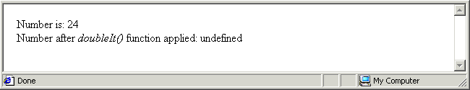
The cause of the error is as follows: after the doubleIt() performs its instruction, there is no mechanism for the function to send its answer back to the script from which the function was called. You can correct this problem by insert a return command that sends the ‘mynum’ variable back to the calling script as shown below.
function doubleIt(mynum) {
mynum = mynum*2;
return mynum;
}
When you reload the web browser the output now looks like that shown below. As you can see, the result of the function has been successfully returned to the scripting the document body.
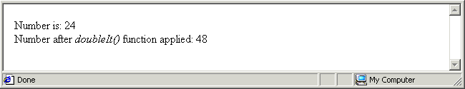
Another feature of the return command is that it halts any further execution of the function. That is, any instructions located after the return command in the function are ignored. In the example below, only the first window.alert() instruction is actually performed. JavaScript ignores the three other window.alert() instructions because they occur after a return command.
function hello() {
window.alert(“Before return statement”);
return;
window.alert(“After return statement”);
window.alert(“Also after return statement”);
window.alert(“And another one after the return statement”);
}
Exercise 5.28 provides an example of function returning a value back to the script that called it.

Exercise 5.28: Returning a Value from a Function
- Open the following file in your text editor and web browser:
exercise_5-28_before.htm
Examine the file in your text editor. In the head section you can see a function that converts a temperature in Fahrenheit to its value in Celsius.
function toCelsius(mytemp) {
mytemp = ((5/9) * mytemp ) - 32;
}
- Within the <SCRIPT> tag in the document body insert statements that assign a value for conversion, that call the conversion function, and that write the ‘before’ and ‘after’ temperature values to the browser window.
var mytemp = 18;
document.write("Temperature in Fahrenheit is: "+mytemp+"&deg;<BR>");
mytemp = toCelsius(mytemp);
document.write("Temperature in Celsius: "+mytemp+"&deg;");
- Save your file with the following name and reload your web browser.
exercise_5-28_after.htm
The result should look as shown. The error arises from the fact that, although the function performs the temperature conversion correctly, it does not return the result back to the script that called it.
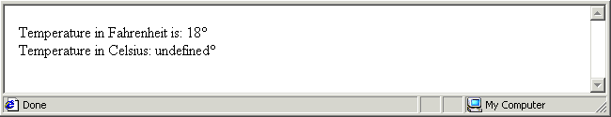
- Insert a return command in the function as shown below.
mytemp = ((5/9) * mytemp ) - 32;
return mytemp;
}
- Resave your file, reload your web browser, and verify that the converted temperature value is returned correctly and displayed in the browser window. You can close the file when finished.
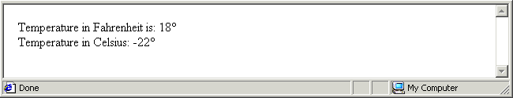

Calling Functions With Keyboard Events
Mouse movements and clicks are not the only user actions that can call a function. Web page visitors can also call functions with key presses. The event handler is onkeypress, following by the ASCII code for the relevant key. There are two benefits from offering onkeypress event handlers on your web pages:
- Speed of use: It is generally faster for a user to perform an action by pressing a key than to reach for and move the mouse.
- Accessibility: Keyboard-based actions make your web pages more accessible to users with disabilities.
In Exercise 5.29 you will create a form that displays the code of whichever keys are pressed by the web page visitor.

Exercise 5.29: Displaying Keypress Events
- Open the following file in your text editor and web browser:
exercise_5-29_before.htm
- In the document body is a form named ‘form1’ that contains a single-line text box called ’text1’. Attached to the text box is an onkeypress event handler that calls the userPress() function.
- Within the <SCRIPT> tag in the document head insert the following statements.
function userPress() {
userkey = window.event.keyCode;
document.forms.form1.text1.value="You pressed the "+userkey+" key";
}
- Save your file with the following name and reload your web browser.
exercise_5-29_after.htm
Press a number of keys in turn. In the form’s text box you can see the letter, number or symbol that you typed, along with the corresponding ASCII keycode. The result should look as shown. You can close the file when finished.
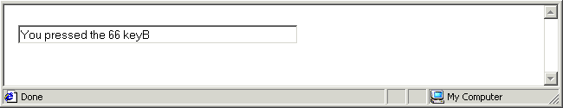

Chapter Summary
Sometimes you will want to function to perform a task that requires some ‘raw material’. Providing information to a function that is then manipulated in some way is known in JavaScript terms as passing a parameter to a function. A function may be designed to accept several parameters. The function may use the information to perform a calculation, or to decide which of a number of possible instructions to perform.
In the example below three onclick event handlers pass hex colour codes to the function named ‘setBackground()’. These event handlers don’t just call the function; they also give the function the information it needs to do its job.
Whenever the web page visitor clicks a button the colour within parenthesis is passed to the function as a parameter. The parameter name is typed inside the function’s parenthesis. This information can then be used by the function to set the web page background colour.
function setBackground(colour) {
document.bgColor=colour;
}
A literal is the opposite of a variable. It’s an item of data that does not change, but retains a constant value, and is placed directly in a script. In the above function the literals are hex colour codes. A literal can be a string within single or double quotes, or a number without quotes.
You can pass multiple literals as parameters to a function, and a function’s parenthesis can contain multiple variables. The only rule is this: The number of variables in the parenthesis of the function must match the number of literals in the event handler that calls the function.
Event handlers are not the only way to call a function. You can also call a function directly from a statement. The following two statements call two different functions. The first function call does not pass a parameter. The second function call passes the parameter named ‘temperature’.
myvar = doSomething();
temperature = updateNow(temperature);
The statement that calls the function may be in another function in the head of the HTML document, or it may be located somewhere of the document body.
When a statement calls a function directly, there must be a mechanism for the function to send its result back to the location from which the function was called. JavaScript offers a return command for this purpose. An example is shown below.
function doubleIt(mynum) {
mynum = mynum*2;
return mynum;
}
Another feature of the return command is that it halts any further execution of the function. That is, any instructions located after the return command in the function are ignored.
Mouse movements and clicks are not the only user actions that can call a function. Web page visitors can also call functions with key presses. The event handler is onkeypress, following by the ASCII code for the relevant key.

Making Decisions With JavaScript

Objectives
In this chapter you will learn how to:
- Create decision-making structures with single and multiple if commands
- Create decision-making structures with an if command and one or more else if commands
- Follow if or else if commands with the else command
- Apply the switch…case decision-making structure to test the value of a single variable
- Change the character case of a string variable with the toUpperCase() and toLowerCase methods.

Vocabulary
In this chapter you will meet the following terms:
- Comparison operator
- Logical operator

Exercise Files
In this chapter you will work with the following HTML files:
- exercise_5-30_before.htm
- exercise_5-31_before.htm
- exercise_5-32_before.htm
- exercise_5-33_before.htm
- exercise_5-34_before.htm
- exercise_5-35_before.htm

Decision-making With The if Command
Can computers make decisions? Or can they do only what they are told? The answer to both questions is: ‘yes’. A computer can make decisions if that’s what the software tells it to do. In JavaScript as in other programming and scripting languages the if command is at the basis of most decision-making. The syntax is as follows:
if (condition is true) {
perform instruction;
}
Note the following points about the if syntax:
- The statement begins with the word if – not IF or If or iF.
- The condition tested by the if command is enclosed within parenthesis ().
- The statement that is performed if the condition is true is written within curly braces {}.
What is meant by the word ‘condition’ in this context? A condition is a combination of:
- A literal value or variable, or two variables, and
- An operator such as ‘equal to’ or ‘greater than’ that defines the relationship between the two.

The if Command In Action
Consider the following example that tests the value in the variable named ‘temperature’. If the value in the variable exceeds a certain amount, the condition is met and the script shows an alert box. The right angle bracket (>) is the JavaScript ‘greater than’ operator.
var temperature = 21;
if (temperature > 15) {
window.alert(“Temperature is greater than 15 degrees”);
}
Here are some other possible conditions that a script could test. The first example tests if the temperature variable is less than the value of 15.
if (temperature < 15)
The condition below tests if the temperature variable is equal to the value of 15.
if (temperature == 15)
The next example tests if the temperature variable is greater than or equal to the value of 15.
if (temperature >= 15)
This example below tests if the temperature variable is less than or equal to than the value of 15.
if (temperature <= 15)
Finally, the example below tests if the temperature variable is not equal to the value of 15.
if (temperature != 15)
In Exercise 5.30 you will create a simple script that accepts a user-entered number in a window.prompt() box, assigns it to a variable, tests the value of a variable, and writes a text message to a window.alert() box if the variable satisfies a particular condition.

Exercise 5.30: Using a Simple if Structure
- Open the following file in your text editor and web browser:
exercise_5-30_before.htm
- After the opening <SCRIPT> tag enter the following code.
var userNumber;
userNumber = window.prompt("Please enter a number between 1 and 100.","");
- Beneath the above two lines enter the following if statement.
if (userNumber < 50 ) {
window.alert("Your entered number is less than 50.");
}
- Save your file with the following name and view it in your web browser.
exercise_5-30_after.htm
- Enter text in the box when prompted, click OK, and note that the result shown in the window.alert() box.
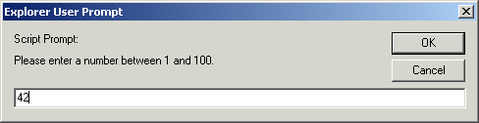
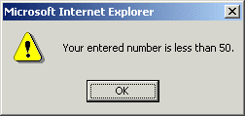
You can close the file when finished.

Comparison Operators
When testing a condition in JavaScript a comparison operator is used to make some kind of comparison between two values. The following table describes the main comparison operators.
Operator Symbol | Description
== | Tests if the two values are the same.
!= | Tests if the two values are not the same.
> | Tests if the first value is greater than the second.
>= | Tests if the first value is greater than or equal to the second.
< | Tests if the first value is less than the second.
<= | Tests if the first value is less than or equal to the second.
Comparison Operator
An operator that can compare two values. Such operators are typically used to control script flow as part of if statements.

Multiple if Commands
A limitation of the script you created in Exercise 5.30 is that it provides feedback to the web page visitor only when the entered a number that is less than the tested value – that is, when the number is less than 50. It is good practice to provide user feedback in all situations.
In Exercise 5.31 you will improve the script by adding a second if command.

Exercise 5.31: Using a Multiple if Structure
- Open the following file in your text editor and web browser:
exercise_5-31_before.htm
It is a script similar to the one you created in the previous exercise, and contains a single if command.
- Add a second if command beneath the first as shown below. It too contains an instruction to display a window.alert() box, but with a different message.
if (userNumber < 50 ) {
window.alert("Your entered number is less than 50.");
if (userNumber > 50 ) {
window.alert("Your entered number is greater than 50.");
}
- What happens if a visitor to the web page enters the number ‘50’? Add a third if command and associated statement to cope with this situation as follows.
if (userNumber < 50 ) {
window.alert("Your entered number is less than 50.");
}
if (userNumber > 50 ) {
window.alert("Your entered number is greater than 50.");
}
if (userNumber == 50 ) {
window.alert("Your entered number is exactly 50.");
}
- Save your file with the following name and view it in your web browser.
exercise_5-31_after.htm
- Test your script by entering various numbers in the box when prompted, click OK, and note the results displayed in the window.alert() box. You can close the file when finished.
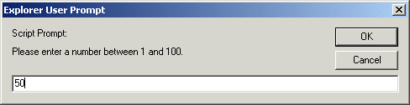
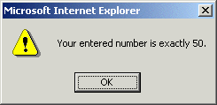

The All-purpose else Command
If you have ever organised physical items in a room or workplace you probably ended up with a drawer or shelf called ‘miscellaneous’ or ‘other stuff’. Similarly, there are many scripting situations where no amount of if statements is enough to cope with every possible value that may be entered by a web page visitor. Consider the following example:
- You create a web page that prompts visitors to type their country name in a text box.
- Your script assigns the entered country name to a variable named ‘country’.
var country = document.forms.myform.T1.value;
- Your web page displays an appropriate greeting in response.
if country == “Italy”) {
window.alert(“Ciao”);
}
if country == “Germany”) {
window.alert(“Guten tag”);
}
if country == “France”) {
window.alert(“Bonjour”);
}
The code is perfectly valid. But what if someone enters the name of a country that is not one of the above – that is, not Italy, Germany or France? The script has no ways of handling that situation.
The remedy is to use the else command. This is JavaScript’s way handling values that fall in the category of ‘other’ or ‘miscellaneous’.
In this example you could insert the following code after the multiple if statements.
else {
window.alert(“Wherever you are from, welcome to my website”);
}
The general form of the if…else decision-making structure is as follows.
if (condition is true) {
perform instruction;
}
else {
perform other instruction;
}

Linking Conditions With Logical Operators
There are times when one condition is not enough. You can join multiple conditions together to form a single statement using the so-called logical operators. The following code tests both temperature and humidity with the AND (&&) operator.
var temperature = 21;
var humidity = 61;
if ( (temperature > 15) && (humidify > 50) ) {
window.alert(“Temperature and humidity conditions are met”);
}
The following code is satisfied if either one condition or both conditions are met.
var temperature = 21;
var humidity = 61;
if ( (temperature > 15) || (humidity < 40) ) {
window.alert(“Yes. One or both are met”);
}
The following table describes the two logical operators.
Operator Symbol | Description
&& | The AND operator. Joins multiple conditions in such a way that the output is true only if all the individual conditions are true.
|| | The OR operator. Joins multiple conditions in such a way that the output is true if any one (or more or all) of the individual conditions is true.
Logical Operator
An operator that can compare two values. Such operators typically used to control script flow as part of if statements.
In Exercise 5.32 you will use the AND logical operator to test the username and password entered by a web page visitor. Please note that is script is only for demonstration. It is not secure because the correct values are visible to anyone who reads the script.

Exercise 5.32: Building a Simple User Access Web Page
- Open the following file in your text editor and web browser:
exercise_5-32_before.htm
In the document head is a function named checkUser() that contains only comments. In the document body are a button with an event handler, and three text boxes The first two are for user input. The third is for displaying feedback messages.
- Insert the following variable declarations.
/* Declare variables */
var userName = "patrick99";
var userPwd = "tulip";
var inputName;
var inputPwd;
var message;
- Insert the following statements that assign user-entered form field values to JavaScript variables.
/* Assign forms inputs to variables */
inputName = document.forms.myform.T1.value;
inputPwd = document.forms.myform.T2.value;
- Insert the following if...else structure with the AND statement.
/* Test if inputs correct */
if ( ( inputName == userName ) && ( inputPwd == userPwd) ) {
message = "Details correct. Please continue.";
document.forms.myform.T3.value=message;
}
/* If inputs incorrect */
else {
message = "Details incorrect. Please try again.";
document.forms.myform.T3.value=message;
}
- Save your file with the following name and view it in your web browser.
exercise_5-32_after.htm
Test your script by entering various combinations of correct and incorrect usernames and passwords. You can close the file when finished.
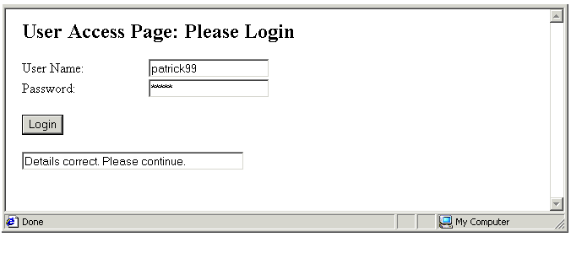
In Exercise 5.33 you will use the if...else structure in combination with an AND operator to improve the script you created in Exercise 5.31.

Exercise 5.33: Building an User Input Test Web Page
- Open the following file in your text editor and web browser:
exercise_5-33_before.htm
It is a script similar to the one you created in Exercise 5.31, and contains multiple if commands. Visitors to this web page are asked to enter a number in the range 1 to 100, and the script can display one of three messages in response.
But what if someone enters 110, 456768 or -24.4?
- Insert a new if statement before the existing ones as shown.
userNumber = window.prompt("Please enter a number between 1 and 100.","");
if ( (userNumber < 0 ) || (userNumber > 100 ) ) {
window.alert("Your entered number is not within the allowed range.");
}
- Save your file with the following name and view it in your web browser.
exercise_5-33_after.htm
- When the window.prompt() box is displayed, type a number greater than 100. Notice that the script responds by displaying not one but two window.alert() boxes in turn.
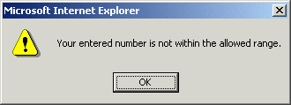
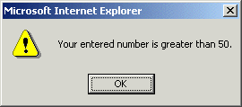
What went wrong? Nothing: your script is behaving exactly as you told it. The entered number satisfies two of the if statements. In addition to satisfying the new statement that you inserted in Step 2 of this Exercise, it also meets the condition set out in the following statement. That is why your scripts displays the sequence of two window.alert() boxes.
if (userNumber > 50 ) {
window.alert("Your entered number is greater than 50.");
}
- For your script to operate sensibly, edit the above if statement as follows.
if (userNumber > 50 ) && (userNumber <= 100 ) {
window.alert("Your entered number is greater than 50.");
}
- One more change to make: edit the ‘less than 50’ if statement so that it correctly responds to the entry of a negative number to a window.prompt() box.
if ( (userNumber < 50 ) && (userNumber >= 0 ) ) {
window.alert("Your entered number is less than 50.");
}
- Resave your file, and refresh/reload your web browser. Verify that your script can now respond appropriately to the input of numbers less than 0 and greater than 100. Try entering a number that contains a comma separator (such as 12,500) and note that the script does not respond. That is because such a number is treated as a string. You can close the file when finished.

The Alternative else if Approach
A series of if commands, perhaps combined with logical AND or OR operators, and typically ending with a ‘catch all’ else command, can cope with every decision-making requirement that you are likely to ask JavaScript to perform. There is a closely-related alternative approach, however, that is provided by the else if command. The general syntax is as follows.
if (first condition true) {
perform first instruction;
}
else if (second condition true) {
perform second other instruction;
}
else if (third condition true) {
perform third instruction;
}
else {
perform some other instruction;
}
Is there any difference between a series of if commands which might with an else command, and one if command, a series of else if commands, and a perhaps a final else command? Not really. They both perform the same job. The difference lies in the scripting logic: a series of if statements is considered by JavaScript as a series of separate, individual statements, while an if followed by a number of else if commands is regarded as one, large, single command.
In Exercise 5.34 you will rewrite the script you created in Exercise 5.33 to include a series of else if commands.

Exercise 5.34: Using an else if Structure
- Open the following file in your text editor and web browser:
exercise_5-34_before.htm
It is a script similar to the one you created in Exercise 5.33, and contains multiple if commands.
- Replace the second, third and forth if commands with else if commands as shown below.
else if ( (userNumber < 50 ) && (userNumber >= 0 ) ) {
window.alert("Your entered number is less than 50.");
}
else if ( (userNumber > 50 ) && (userNumber <= 100 ) ) {
window.alert("Your entered number is greater than 50.");
}
else if (userNumber == 50 ) {
window.alert("Your entered number is exactly 50.");
}
- Save your file with the following name and view it in your web browser.
exercise_5-34_after.htm
- Verify that your script can respond appropriately to user input. You can close the file when finished.

The switch and case Commands
Typing a series of if or else if commands can quickly become tedious task and, more importantly, one prone to errors. For situations where you want to test the value of a single variable against a variety of conditions JavaScript offers another decision-making structure based on the following two commands:
- switch: This command holds the variable that you wanted to test: For example:
switch (userInput);
- case. After the switch command you type a series of case commands, one for each value that you want to test the variable against. For example.
case ‘IRL’: alert(“You are from Ireland”);
break;
A break statement follows each case command, causing the switch sequence to end whenever a particular case condition is satisfied. You will learn about the break statements when you work with loops in Chapter 9.
If no match is found among the list of case statements a default condition is used. This has the same role as the else command in if and else if structures. The general syntax of the switch and case structure is as shown below.
var = myVar;
switch (myVar)
{
case 1: instruction;
break;
case 1: instruction;
break;
case 1: instruction;
break;
default: instruction;
}
In Exercise 5.35 you will rewrite the script you created in Exercise 5.33 to replace the if and else if commands with switch and case commands.

Exercise 5.35: Using a case and switch Structure
- Open the following file in your text editor and web browser:
exercise_5-35_before.htm
In the document body is a form with two text boxes, a button with an attached event handler, and a form reset button. In the document head is a function named rateScore() that contains only comments.
- Insert the following variable declarations and assignment.
/* Declare variables */
var userGrade;
var userTxt;
/* Assign user input from text box */
userGrade = document.forms.myform.T1.value;
- Next insert the case…switch decision-making structure as shown below
switch (userGrade)
{
case 'F': userTxt = "Terrible result. See me in my office.";
document.forms.myform.T2.value=userTxt;
break;
case 'E': userTxt = "Poor performance.";
document.forms.myform.T2.value=userTxt;
break;
case 'D': userTxt = "Fair result. Room for improvement.";
document.forms.myform.T2.value=userTxt;
break;
case 'C': userTxt = "Satisfactory result.";
document.forms.myform.T2.value=userTxt;
break;
case 'B': userTxt = "Very good result. Well done.";
document.forms.myform.T2.value=userTxt;
break;
case 'A': userTxt = "Excellent. First class marks.";
document.forms.myform.T2.value=userTxt;
break;
default: userTxt = "Invalid grade entered.";
document.forms.myform.T2.value=userTxt;
}
}
- Save your file with the following name and view it in your web browser.
exercise_5-35_after.htm
Verify that your script can respond appropriately to user input.
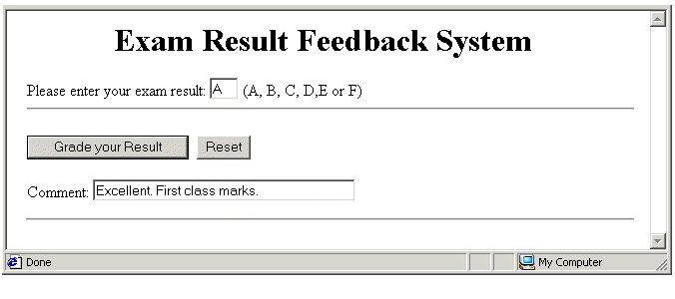
- Try typing a lower-case letter such as ‘a’ or ‘d’ in the text box and clicking the ‘Grade your Result’ button. Your entry will be rejected as invalid input.
- You can remedy this case sensitivity restriction by inserting a new line of code beneath the assignment statement as shown below.
userGrade = document.forms.myform.T1.value;
userGrade = userGrade.toUpperCase();
Resave your file, refresh/reload your browser and verify that the text box now accepts both upper and lowercase versions of the permitted characters. You can close the file when finished.

The toUpperCase() and toLowerCase() Methods
A method, as you will recall from Chapter 3 is an action that can be performed on an object. The toLowerCase() and toUpperCase() methods can be applied to string objects or variables with the effect of setting their character case to the required type.

Chapter Summary
In JavaScript as in other programming and scripting languages the if command is at the basis of most decision-making. The syntax is as follows:
if (condition is true) {
perform instruction;
}
The condition is a combination of a literal value or variable, or two variables, and a comparison operator such as ‘equal to’ or ‘greater than’ that defines the relationship between the two. For situations where multiple if statements cannot cope with all possible variable values, JavaScript provides an else command. Its syntax is as follows.
if (condition is true) {
perform instruction;
}
else {
perform other instruction;
}
You can join multiple conditions together to form a single statement using the so-called logical operators, AND (&&) and OR (||). An alternative to using one or more if commands, perhaps ending with a ‘catch all’ else command, is provided by the else if command. The general syntax is as follows.
if (first condition true) {
perform first instruction;
}
else if (second condition true) {
perform second other instruction;
}
else if (third condition true) {
perform third instruction;
}
else {
perform some other instruction;
}
For situations where you want to test the value of a single variable against a variety of conditions JavaScript offers another decision-making structure based on the switch and case commands. The switch command holds the variable that you wanted to test: For example:
switch (userInput);
After the switch command you type a series of case commands, one for each value that you want to test the variable against. For example.
case ‘IRL’: alert(“You are from Ireland”);
break;
A break statement follows each case command, causing the switch sequence to end whenever a particular case condition is satisfied.
The toLowerCase() and toUpperCase() methods can be applied to string objects or variables with the effect of setting their character case to the required type.

Looping in JavaScript

Objectives
In this chapter you will learn how to:
- Create a for loop in JavaScript with a counter variable, a starting value, a loop condition and an increment or decrement operator
- Create a while loop with a counter variable that runs only when a tested condition is satisfied
- Create a do…while loop that runs once, and runs again only when a tested condition is satisfied
- Interrupt any of the three loop types with a break command that, when the counter variable reaches a specified value, tells JavaScript to exit the loop
- Interrupt any of the three loop types with a continue command that, when the counter variable reaches a specified value, tells JavaScript to return to the top of the loop as if all the statements have been performed.

Vocabulary
In this chapter you will meet the following terms:
- JavaScript loop
- Iteration
- Loop counter variable

Exercise Files
In this chapter you will work with the following HTML files:
- exercise_5-36_before.htm
- exercise_5-37_before.htm
- exercise_5-38_before.htm
- exercise_5-39_before.htm
- exercise_5-40_before.htm

Going On and On: JavaScript Loops
The word ‘loop’ suggests a circle. Similarly, the term ‘looping’ in a script implies that an instruction or set of instructions that repeat forever. Well, looping can mean that. But only if the loop is written incorrectly.
Properly used, a loop is a very useful programming structure that repeats an instruction or series of instructions when certain conditions are satisfied, and then stops. JavaScript offers three types of loops:
- The for loop: This is the most common loop in JavaScript, and the one that offers the most control to the JavaScript programmer. Use this loop when:
- You know in advance how many times you want the loop to repeat, and
- You want the loop condition tested before the loop runs.
- The while loop: This is JavaScript’s simplest loop structure. Use a while loop when:
- You don’t know in advance how many times you want the loop to repeat, but
- You want the loop condition tested before the loop runs.
- The do…while loop: A variation on the while loop. Use this loop when:
- You don’t know in advance how many times you want the loop to repeat, and
- You don’t want the loop condition tested before the loop runs.
Unlike the similar-sounding while loop the do..while loop is always performed at least once, because JavaScript tests the required condition only after the first loop occurrence.
JavaScript Loop
A script that performs a statement or series of statements repeatedly until a certain condition is satisfied. The loop then stops and the next statement in the script after the loop is performed.

About Loop Conditions
Every loop type contains some kind of condition statement. As with the if command, condition statements in loops include comparison operators such as greater than (>) equal to (==).
- When the condition is tested and satisfied, the loop runs.
- After every time that the loop runs, it tests the condition again. The loop will keep repeating until the condition is no longer satisfied.
Before discovering more about these loop types and putting your knowledge in practice you need to learn about two new assignment operators: increment (++) and decrement (--).

About the Increment and Decrement Operators
In programming the word ‘increment’ means ‘make larger by one’ and its converse of ‘decrement’ means ‘make smaller by one’. You have met only one type of assignment operator so far, an example of which is shown below.
myvar = 42;
As you can see it has two terms, one on each side of the equals (=) sign. Below are examples of the increment and decrement operators. These contain only a single term and do not require an equals sign.
firstNumber++;
/* Above has the same effect as writing firstNumber=firstNumber + 1 */
secondNumber--;
/* Above has the same effect as writing firstNumber=firstNumber - 1 */
These operators work only with numeric variables. They are really just a convenient shorthand notation. Now let’s move on to the for looping structure.

The for Loop Structure
A basic for loop in JavaScript would look as shown below.
for (i=1; i<=5; i++) {
perform instruction(s);
}
Let’s examine each element in detail.
- for: Always type ‘for’, not ‘FOR’ or ‘For’. The for command name is case sensitive.
- i: Every loop has a counter variable that keeps track of how many times the loop has been performed. By convention, the counter variable is designated by the lower-case letter ‘i’. Some programmers prefer the letter ‘n’, while others use the word ‘count’ or ‘counter’ .
- i=1: The loop has to start somewhere. In this example the starting point is when the counter variable has a value of 1. It could also be 12, 56 or -78.
- i<=5: You don’t want a loop to run indefinitely, so you set an upper limit. In this case, the loop stops when the counter variable reaches the number 5.
- i++: This tells JavaScript to add 1 repeatedly to the counter variable until the variable reaches the upper loop limit (in this case, 5). It does not have to be the increment operator. A loop can contain the decrement operator, i--.
Programmers use a special term to describe the performance of a loop: iteration.
Iteration
A single performance of a loop. If a loop runs fives it is said to have done five iterations.
Loop Counter Variable
The variable in a loop structure that keep track of how many loop iterations have been performed. The variable is typically named ‘i’. Alternative names include ‘n’, ‘count’ or ‘counter’.
In Exercise 5.36 you will create a simple for loop structure.

Exercise 5.36: Building a Simple for Loop
- Open the following file in your text editor and web browser:
exercise_5-36_before.htm
- After the opening <SCRIPT> tag type the following for lop structure
<SCRIPT LANGUAGE="JavaScript" TYPE="text/javascript">
var i;
for (i=1; i<=5; i++)
document.write("This is loop step number: "+i+"<BR>");
}
- Save your file with the following name and view it in your web browser.
exercise_5-36_after.htm
The result should look as shown.
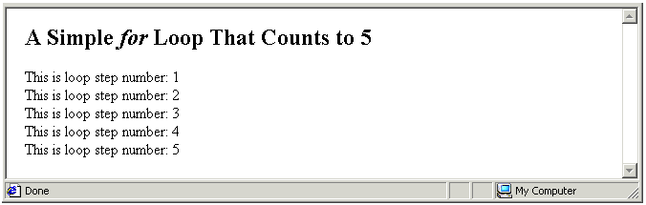
- Edit the loop code as shown below, resave your file, and refresh/reload your web browser.
<SCRIPT LANGUAGE="JavaScript" TYPE="text/javascript">
for (var i=-1; i>=-5; i--)
The result should look as shown. You can close the file when finished.
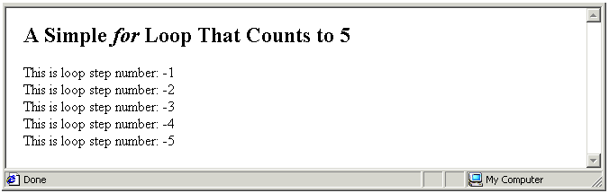

More About for Loops
Here are three points to remember about the for loop structure in JavaScript:
- Initial and upper values: Unlike the other two loop types, the initial and upper values of a for loop are included within the loop structure itself. These do not have to be literals, such as ‘3’ or ‘-42’. They can also be variables whose values come from elsewhere in the script or from a user input. For example:
for ( i=baseTemperature; i <= userTemperature; i++);
In the other two loop types, the initial and upper values are not including in the loop structure, but always come from other statements in the script.
- Curly braces: The for loop does not require curly braches {} if the loop contains only a single instruction. You can include them if you want: they won’t cause an error; they are just unnecessary. If the loop contains multiple instructions they must be enclosed within curly braces.
for ( var i=1; i<=5; i++) {
document.write("This is the loop step number: "+i+"<BR>");
document.write("This is the loop step multiplied by 4: "+i*4+"<BR>");
document.write("This is the loop step divided by 2: "+i/2+"<BR>");
document.write("Still looping<BR>");
}
By convention loop statements are indented. This is for one reason only: to make them easier to read.
- Statement terminator: Do not type a semi-colon after the loop condition as shown below. This will produce an error.
for (var i=10; i>=20; i++);
The general syntax of a for loop is shown below.
for (initialisation; condition statement; counter variable update) {
statements(s) containing counter variable;
}
In Exercise 5.37 you will create a simple for loop in which the number of iterations is not a fixed literal by a variable value input by the web page visitor.

Exercise 5.37: Building a User-controlled for Loop
- Open the following file in your text editor and web browser:
exercise_5-37_before.htm
It is similar to the incrementing loop that you worked on in the previous exercise.
- After the opening <SCRIPT> tag type the following window.prompt() statement on a single line.
var userCount = window.prompt("Please enter your desired number of loop
steps","");
- Edit the loop command as follows.
for (var i=1; i<=userCount; i++)
- Save your file with the following name and view it in your web browser.
exercise_5-37_after.htm
Type a positive number in the window.prompt() box, click OK and view the output in the web browser window. You can close the file when finished.
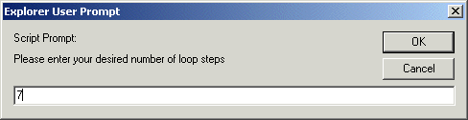
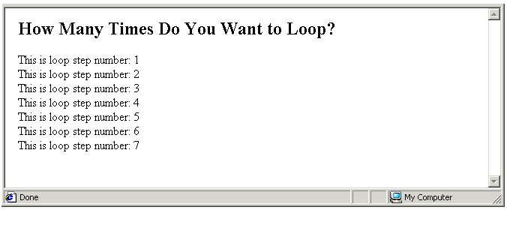

The while Loop
This is the most basic loop in JavaScript. A simple while loop is shown below.
var i = 1;
while (i < 5)
{
perform instruction(s);
i++;
}
Let’s examine each element in detail.
- i=1: Before running the loop the counter variable is set to an initial value. In this case it is 1, but it could also be 0, 410 or -20.
Note that the initial counter value is set outside the loop and not within it.
- while: The while command name is case sensitive.
- i < 5: This is the test condition, enclosed within parenthesis. Like for loops, the condition is tested before the loop is run.
- {}: The statements to be performed are enclosed within curly braces.
- i++ : The statement that increments (or decrements) the counter variable is enclosed within the curly braces.
In Exercise 5.38 you will create and modify a simple while loop.

Exercise 5.38: Building a Simple while Loop
- Open the following file in your text editor and web browser:
exercise_5-38_before.htm
- After the opening <SCRIPT> tag type the following code.
var i =1;
while (i <= 5)
{
document.write("This is loop step number: "+i+"<BR>");
i++;
}
- Save your file with the following name and view it in your web browser.
exercise_5-38_after.htm
The loop should run as shown below.
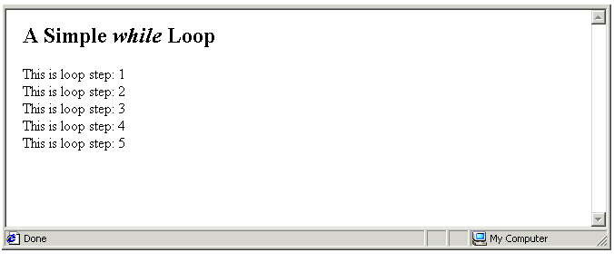
- Edit the loop code as shown below, so that the loop counter variable counts downwards rather than upwards.
var i =10;
while (i >= 1)
{
document.write("This is loop step number: "+i+"<BR>");
i--;
}
Resave your file and refresh/reload your web browser. The result should look as shown below. You can close the file when finished.
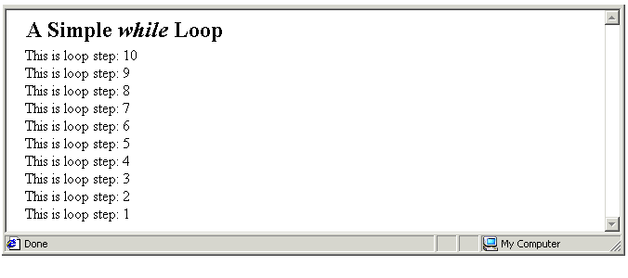

More About while Loops
Here are four points to remember about the while loop structure in JavaScript:
- No initial value: No start value of the counter variable is contained within the while loop structure. You must set this value in a preceding line of the script.
- No upper value: No ending value of the counter variable is contained within the while loop. Something must happen elsewhere in the script in the HTML document that causes the condition statement to become untrue at some point. Otherwise the loop will run indefinitely.
- Curly braces: The statement(s) to be performed on each loop iteration are enclosed within curly braces. By convention these statement are indented to make them easier to read.
- Increment/decrement: This is always the final instruction within the curly braces of a while loop.
The general syntax of a while is as shown below.
while (condition statement) {
statements(s);
counter variable update;
}

The do…while Loop
An important difference between do..while and while loops is that condition test happens at the end of a do..while loop rather than at the beginning. This means that a do…while loop and the statements(s) it contains are always run at least once.
A simple do…while loop is shown below.
var i = 1;
do
{
perform instruction(s);
i++;
}
while (i <= 5);
Let’s examine each element in detail.
- i=1: The counter variable is set to an initial value before the loop is run. It can be any number. The value is set outside the loop and not within it.
- do: The do command name is case sensitive.
- {}: The statements to be performed are enclosed within curly braces.
- i++ : The statement that increments (or decrements) the counter variable is enclosed within the curly braces.
- while i < 5: This is the test condition, enclosed within parenthesis. Unlike for loops, the condition is not tested before the loop is run.
In Exercise 5.39 you will create and modify a simple do…while loop.

Exercise 5.39: Building a Simple do…while Loop
- Open the following file in your text editor and web browser:
exercise_5-39_before.htm
- After the opening <SCRIPT> tag type the following code.
var i = 1;
do
{
document.write("This is loop step: "+i+"<BR>");
i++;
}
while (i <= 5);
- Save your file with the following name and view it in your web browser.
exercise_5-39_after.htm
The loop should run as shown below.
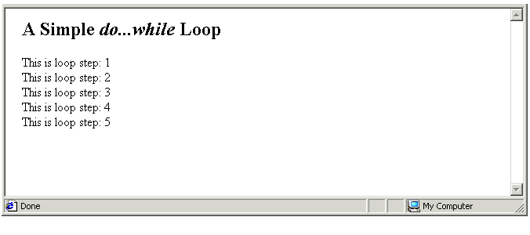
- Edit the loop condition code as shown below, so that the test condition is never met by the loop counter variable.
while (i < -10);
- Resave your file and refresh/reload your web browser. The result should look as shown below. You can see that the do…while loop still runs once. You can close the file when finished.
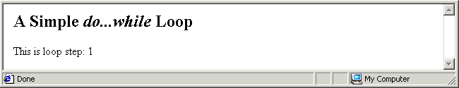

More About while Loops
Here are fiver points to remember about the while loop structure in JavaScript:
- No initial value: No start value of the counter variable is contained within the do…while loop structure. You must set this value in a preceding line of the script.
- No upper value: No ending value of the counter variable is contained within the do…while loop. Something must happen elsewhere in the script in the HTML document that causes the condition statement to become untrue at some point. Otherwise the loop will run indefinitely.
- Curly braces: The statement(s) to be performed on each loop iteration are enclosed within curly braces. By convention these statement are indented to make them easier to read.
- Increment/decrement: This is always the final instruction within the curly braces of a do…while loop.
- Condition statement: This is located at the lend of the loop, with the result that the loop and its statements(s) are always run at least once.
The general syntax of a do…while loop is as shown below.
do
{
statements(s);
counter variable update;
}
while (condition statement)
Here is a while and a do…while loop shown side by side. You can see that one is essentially the other turned upside down.
while (condition statement) do
{ {
statements(s); statements(s);
counter update variable; counter variable update
} }
while (condition statement)

Interrupting Loops with break and continue
All three JavaScript loops can include break and/or continue commands with the ability to interrupt loops when the counter variables reaches a certain value.

About the break Command
The break command sends the following message to JavaScript: when the counter variable reaches a specified value, exit the loop, and move on the next statement in the script after the loop.
The loops below run only when the counter variable has values of 1, 2 and 3. When the counter variable reaches a value of 4, the loops stop.
A for loop |  | A while loop |  | A do…while loop
for (var i=1; i<=5; i++ )  {  if (i == 4)  break;  document.write(i+"<BR>");  } |  | var i=1;  while (i <= 5)  {  if (i == 4)  break;  document.write(i+"<BR>");  i++;  } |  | var i=1;  do  {  if (i == 4)  break;  document.write(i+"<BR>");  i++;  }  while (i <= 5)
The break command comes before the statement that is performed within the loop – in these three examples, a simple document.write() statement. All three interrupted loops generate the following output in a web browser window.
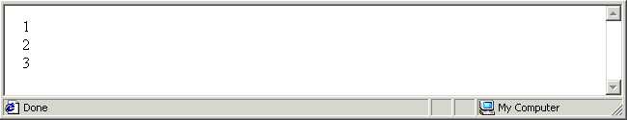

About the continue Command
The continue command also interrupts the running of a loop, but it the message it sends to JavaScript is slightly different: when the counter variable reaches a specified value, don’t perform the statement(s) in the loop, but return to the top of the loop as if all the statements have been performed. The loop then continues on as normal. You typically use the continue command to handle special or exceptional values of the counter variable.
The loops below run only when the counter variable has values of 1, 2, 3 and 5. When the counter variable reaches a value of 4, the loops stop, return to the top, and then continue on.
A for loop |  | A while loop |  | A do…while loop
for (var i=1; i<=5; i++ )  {  if (i == 4)  continue;  document.write(i+"<BR>");  } |  | var i=0;  while (i <= 4)  {  i++;  if (i == 4)  continue;  document.write(i+"<BR>");  } |  | var i=0;  do  {  i++;  if (i == 4)  continue;  document.write(i+"<BR>");  }  while (i <= 4)
Compare the position of the break and continue commands within the three different loop types.

- for loop: The break and continue commands are located at similar locations – before the loop statements. It is easy to see why. The break and continue conditions are tested before the loop statements are run.
- while and do...while loops: The break and continue commands are located at similar locations – before the loop statements.
But when the continue command is present in either loop type, the update counter variable statement (i++) is the first rather than the last statement within the curly braces. To compensate, the initial value is 0 rather than 1, and the upper value is 4 rather than 5.
Consider a for loop that counts from 1 to 20. Number 13 is considered unlucky. In Exercise 5.40 your task is to amend such a loop so that it skips the 13th iteration and restarts at number 14.

Exercise 5.40: Skipping Unlucky 13
- Open the following file in your text editor and web browser:
exercise_5-40_before.htm
In the document body is a for loop that begins at 1 and terminates at 20.
- Edit the loop code as shown below.
for (var i=1; i <=20; i++)
{
if (i==13)
continue;
document.write(i+" ");
}
- Save your file with the following name and view it in your web browser.
exercise_5-40_after.htm
The loop should run as shown below. You can close the file when finished.
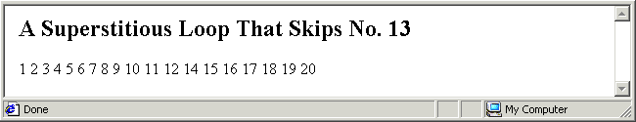

Chapter Summary
A loop is a script that performs a statement or series of statements repeatedly until a certain condition is satisfied. The loop then stops and the next statement in the script after the loop is performed. A basic for loop in JavaScript looks as shown below.
for (i=1; i<=5; i++) {
perform instruction(s);
}
Every loop has a counter variable (typically denoted y the letter ‘i’) that keeps track of how many times the loop has been performed, a starting or initial value, an upper limit, and an increment (i++) or decrement (i--) operator that increases or decreases the loop counter variable by one on each iteration of the loop. The for loop does not require curly braches {} if the loop contains only a single instruction. If the loop contains multiple instructions they must be enclosed within curly braces.
Two other types of loops are the while and a do…while loops, which are shown side-by-side below. You can see that one is essentially the other turned upside down.
while (condition statement) do
{ {
statements(s); statements(s);
counter update variable; counter variable update
} }
while (condition statement)
In each loop the initial loop counter value is set outside the loop and not within it. The test condition is enclosed within parenthesis, the statement(s) to be performed are enclosed within curly braces, as is the increment or decrement operator.
An important difference between do..while and while loops is that condition test happens at the end of a do..while loop rather than at the beginning. This means that a do…while loop and the statements(s) it contains are always run at least once.
while (i < 5) do
{ {
window.alert(Helllo”); window.alert(Helllo”);
i++; i++;
} }
while (i < 5)
All three JavaScript loops can include break and/or continue commands with the ability to interrupt loops when the counter variables reaches a certain value. The break command tells JavaScript that, when the counter variable reaches a specified value, to exit the loop, and move on the next statement in the script after the loop. The break command comes before the statement(s) that are performed within the loop.
The continue command also interrupts the running of a loop, but it the message it sends to JavaScript is slightly different: when the counter variable reaches a specified value, don’t perform the statement(s) in the loop, but return to the top of the loop as if all the statements have been performed. The loop then continues on as normal. You typically use the continue command to handle special or exceptional values of the counter variable.

Working With Arrays

Objectives
In this chapter you will learn how to:
- Declare an array
- Populate an array with a series of comma-delimited values on a single line
- Populate an array with a series of one-line values and index numbers
- Access the value a particular element in an array
- Use a for loop to read all the elements of an array
- Find the length of an array
- Use the length property of an array as the upper limit of the counter variable in a for loop
- Add, modify and delete individual array elements
- Sort and reverse array elements
- Convert an array to a string variable

Vocabulary
In this chapter you will meet the following terms:
- Array
- Populating an array
- Array length property

Exercise Files
In this chapter you will work with the following HTML files:
- exercise_5-41_before.htm
- exercise_5-42_before.htm
- exercise_4-43_before.htm
- exercise_5-44_before.htm
- exercise_5-45_before.htm
- exercise_5-46_before.htm

Arrays: When Variables Are Not Enough
A variable, as you have learnt, can store a value that may change over time. Think of a variable as a box, in which you can place a single value. At any stage in the script you can change the value in the box. A variable can be declared, and a value assigned to it, in a single statement as shown below.
var userName = “Bridget”;
You can think of this variable as a single-compartment box that contains just one value.
Bridget
But suppose you want to store several values in a box? You need a different kind of box: an array. You can declare and assign several values to an array as follows.
var userNames = new Array (“Bridget”,“Carol”,“Christine”,“Deborah”);
The individual array elements are separated by commas. You can also include single blank spaces after the commas as shown below.
var userNames = new Array (“Bridget”, “Carol”, “Christine”, “Deborah”);
This array or multi-compartment box has four values.
Bridget | Carol | Christine | Deborah
Each array element has an identifying number known as an index. Index values always begin at zero. An array with 4 elements, therefore, has the following index values: [0], [1], [2] and [3].
[0] | [1] | [2] | [3]
Bridget | Carol | Christine | Deborah
You must follow the same rules when naming arrays as you do when naming variables: don’t use the same name for two different arrays within the same web page, and don’t insert spaces within array names. You can combine upper and lowercase letters in an array names to make them easier to read, but beware that array names are case-sensitive: ‘myArray’ is not the same as ‘myarray’.
Assigning values to the elements of an array is known as populating the array.
Array
A variable that can hold multiple values. Array names follow the same rules as variable names. Each element in an array is identified by an index number, beginning with zero.
The benefit of using arrays is that you can manipulate a large range of values with just a single name and an index number. For example, instead of assigning the twelve months of the year to twelve different variables, you could assign them to a single array.
In Exercise 4.41 you declare and populate an array using a series of comma-separated individual values on a single line. This is just one of the two methods of populating an array.

Exercise 5.41: Creating a Simple Array: Single Line Method
- Open the following file in your text editor and web browser:
exercise_5-41_before.htm
- In the empty <SCRIPT> tag pair in the document body declare a variable called ‘authors’, create an array with this name, and populate the array with six values as shown below.
var authors;
authors = new Array("Goddard","Grisham","Christie","Bryson","Heller","Jerome");
- Save your file with the following name and view it in your web browser.
exercise_5-41_after.htm
You can close the file when finished.
A second method of populating an array is to write, on a series of different lines, each element’s value and its associated index number. For example.
var userNames = new Array;
userNames[0] = “Bridget”;
userNames[1] = “Carol”;
userNames[2] = “Christine”;
userNames[3] = “Deborah”;
The two approaches produce the same result.
- Single line method: For two or more arrays, one positioned beneath the other, the single-line method makes it easier to compare the different sets of array elements. An example is shown below.
var fNames = new Array("John","Kylie","Elton","Dianna");
var sNames = new Array("Lennon","Minogue","John","Ross");
- Multi-line method: For a single array with a large number of elements, the multi-line method makes it easier to read which element is located at which index value.
In Exercise 4.42 you declare and populate an array using the one element per line method.

Exercise 5.42: Creating a Simple Array: Method 2
- Open the following file in your text editor and web browser:
exercise_5-42_before.htm
- In the empty <SCRIPT> tag pair in the document body declare a variable called ‘authors’, create an array with this name, and populate the array with six values as shown below.
var authors;
authors = new Array;
authors[0] = "Goddard";
authors[1] = "Grisham";
authors[2] = "Christie";
authors[3] = "Bryson";
authors[4] = "Heller";
authors[5] = "Jerome";
- Save your file with the following name and view it in your web browser.
exercise_5-42_after.htm
You can close the file when finished.

Reading Values from an Array
Now you know how to populate an array. But how do you read what’s stored in an array? There are two situations when you want to access or ‘get at’ array values:
- When you want to write the values to the browser window, typically with a document.write() statement or using an element in a HTML form.
The following example writes the 34th index value from the array named ‘email_addr’ to the browser window.
document.write(“Email Address: “+email_addr[34]+”<BR>”);
The statement below assigns the same value to the text box named ‘T1’ in the HTML form named ‘myform’.
document.forms.myformT1.value = email_addr[34];
- When you want to copy the current value of an array element to a variable, or even to an element within a different array.
To copy an element’s value to variable, use an assignment statement such as the one shown below.
var customer21_id = customer_ids[21];
In the above example, the value of the 21st element in the array named ‘customer_ids’ is copied to the variable named ‘customer_21’. The array remains unchanged.
Copying values from one array another to another is easy. Just use an assignment statement similar to the one below.
new_films[46] = old_films[187];
In this example the value of the 187th element in the array named ‘old_films’ is copied to the 46th element of the array named ‘new_films’.

Reading Array Values With Loops
Suppose your script contains an array named ‘fruit’ with six elements. You could write the values of the array’s six elements to the browser window with six separate document.write() statements as shown below.
document.write(“Array Element 0: ”+fruit[0]+”<BR>”);
document.write(“Array Element 1: ”+fruit[1]+”<BR>”);
document.write(“Array Element 2: ”+fruit[2]+”<BR>”);
document.write(“Array Element 3: ”+fruit[3]+”<BR>”);
document.write(“Array Element 4: ”+fruit[4]+”<BR>”);
document.write(“Array Element 5: ”+fruit[5]+”<BR>”);
Here’s an easier way: use a for loop containing a single document.write() statement as shown below.
for (i=0; i <=5; i++)
document.write("Array Element "+i+": "+fruit[i]+"<BR>");
There are six elements in the array, but the initial value of the counter variable is set to 0 and the upper value is set to 5. This is because the array’s index numbering runs from [0] to [5] and not from [1] to [6].

The Array Length Property
To use a for loop to read all the values from an array, the number of loop iterations must be the same as the number of elements in the array. That way a document.write() statement is performed for each individual array element. But the number of array elements may change during the script, so how can you set the upper value for the counter variable?
The solution is to use the length property of the array object. This is the index number of the next empty element after highest occupied element in the array. The following statement assigns the length of the array named ‘towns’ to a variable called ‘myVar’.
myVar = towns.length;
You can use an array length property as the upper limit of a for loop as follows.
for (i=0; i < fruit.length; i++)
document.write(“Array element “+i+:” fruit[i];
Notice that the comparison operator for the upper value of the counter variable is ‘less than’ (<) and not ‘less than or equal to’ (<=). Why? Because the array length is always one greater than the index number of the highest array element. When an array has six elements, its index numbers run from [0] to [5], and its length property contains the value of 6.
In Exercise 5.43 you will use a for loop to write the elements of an array to a HTML table in a web browser window.

Exercise 5.43: Reading Array Values With a for Loop
- Open the following file in your text editor and web browser:
exercise_5-43_before.htm
You can see the array that you created and populated with six values from Exercise 5.42.
- Beneath the final array population statement type a single document.write() statement as shown below.
authors[5] = "Jerome";
document.write(authors[0]”);
- Save your file with the following name and view it in your web browser.
exercise_5-43_after.htm
You should see the content of the first value in the array (“Goddard”).
- Above the document.write() statement insert the following HTML table tags and attributes.
document.write("<TABLE BORDER='1' WIDTH='100' CELLPADDING='2'
CELLSPACING='2'>");
(All the code should go on a single line.)
- Beneath he document.write() statement insert the closing HTML table.
document.write("<\/TABLE>");
- Replace your single document.write() statement with a for loop as follows.
for (i=0;i<=5; i++)
{
document.write("<TR>");
document.write("<TD>");
document.write(authors[i]);
document.write("<\/TR>");
document.write("<\/TD>");
}
- Resave your file, and refresh/reload your browser. The result should look as shown. You can close the file when finished.
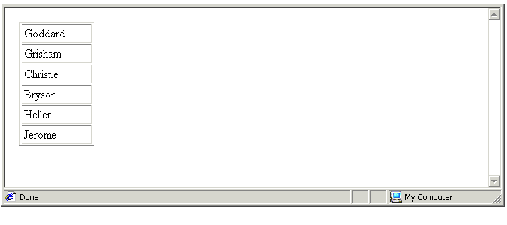

Adding, Modifying and Deleting Array Values
Up to now you have populated array elements only at the time that you have created the array. But you can insert values into an array at any stage.

Adding Array Values
Remember the multi-line method for populating a new array that you used in Exercise 5.42. You use a similar syntax for assigning a value to a single array element as follows.
array_name[index_number] = element_value;
The following code assigns the number 34 to the 20th index position of the array named myArray.
myArray[20] = 34;
You don’t need to populate array elements in consecutive order. Imagine that you have an array called ‘userNames’. It contains 10 elements, indexed from [0] to [9]. The following three statements are all valid.
userNames[10]=”Murphy”;
userNames[11]=”Jones”;
userNames[20]=”Collins”;}
In other words, JavaScript allows you to have ‘gaps’ or unfilled elements in an array. An array with such non-contiguous values is said to be sparsely populated. As you will discover in Exercise 5.44, the value of an unfilled array element is shown as ‘underfined’ in the browser window.

Modifying Array Values
You change the value of a single array element in exactly the same way as you first assign a value to that element. If your ‘userNames’ array currently has values at locations [8], [9] and [56], the following statements overwrite those values with the new ones.
userNames[8]=”Harper”;
userNames[9]=”Wallace”;
userNames[56]=”Johnson”;

Deleting Array Values
You can remove the contents of an individual array element with the delete command.
delete userNames[67];
This does not actually delete the element from the array; it just sets its value as ‘undefined’. The length of the array in unaffected.
In Exercise 5.44 you will add values to, modify and remove values from an array. In each case you will note the effect of the operation on the array’s length.

Exercise 5.44: Manipulating and Array
- Open the following file in your text editor and web browser:
exercise_5-44_before.htm
You can see the ‘authors’ array that you worked with in the previous exercises of this chapter. After the array population statements is a document.write() statement that displays the array’s length (strictly speaking, the current value of the array object’s length property) in the browser window.
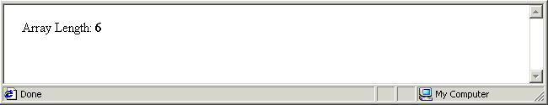
- After the document.write() statement add the two new statements. The first declares a new variable ‘aLength’ and assigns to that variable the array’s length. The second writes the value in that array element to the browser window.
var aLength = authors.length;
document.write("Top Element: <B>"+authors[aLength]+"</B>");
- Save your file with the following name and view it in your web browser.
exercise_5-44_after.htm
You should the following output in the browser window.
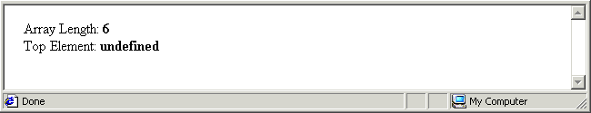
What went wrong? The answer is that the array.length property holds the index of the next unfilled location after the currently highest or ‘top’ element. Your array has six elements, indexed from [0] to [5]. The next highest element is therefore at location [6]. But there is no value currently stored at location [6]. That is why you are seeing the value of ‘undefined’.
- Correct this situation by decrementing the variable that stores the array length as shown below.
var aLength = authors.length;
aLength--;
document.write("Top Element: <B>"+authors[aLength]+"</B>");
You can achieve exactly the same effect by writing.
var aLength = authors.length;
aLength = aLength - 1;
document.write("Top Element: <B>"+authors[aLength]+"</B>");
The variable aLength now contains the number ‘5’ rather than the number ’6’. The index of the highest filled array element is always one less than the value of the array length property.
- Resave your file, and refresh/reload your browser. The result should look as shown.
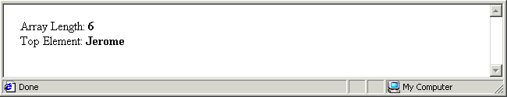
- After the existing six array population statements insert a new statement that adds an array value at index location 100 as shown below..
authors[5] = "Jerome";
authors[100]="Joyce";
- Resave your file, and refresh/reload your browser. The result should look as shown.
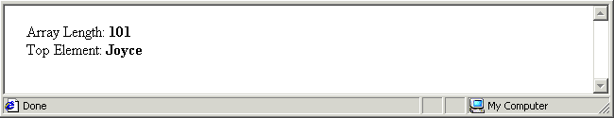
- Insert a delete statement to remove the value from array location [100] as shown below.
authors[100]=" Joyce";
delete authors[100];
- Resave your file, and refresh/reload your browser. The result should look as shown.
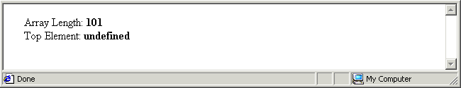
Deleting the top array element did not change the array’s length. It only removed the value “Joyce” from element [100]. That element still exists, but is value is now ‘undefined’.
- The array element at index location [3] currently contains the value “Bryson”. Insert a new statement that modifies this value to “King” as shown below.
authors[100]=" Joyce";
delete authors[100];
authors[3] = “King”;
- Edit the document.write() statement that outputs the top element to include a line break, and follow it with a new statement that displays the value at location [3].
document.write("Top Element: <B>"+authors[aLength]+"<\/B><BR>");
document.write("Element [3]: <B>"+authors[3]+"<\/B>");
- Resave your file, and refresh/reload your browser. The result should look as shown. You can close the file when finished.
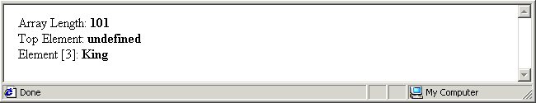
Array Length
The property of an array object that holds the index number of the next unfilled location after the currently highest or ‘top’ array element. It is one greater than the index of the highest filled array element.

Copying Array Values to a String
You can copy the elements from an array into a single string using the join() method. The syntax is as follows.
myString = myArray.join(‘separator_character’);
If you omit the separator character, JavaScript separates the array elements in the string with commas. Here’s a simple example:
var UserNames = new Array(“Smith”,“Higgins”,”Jones”);
var strUserNames = UserNames.join;
The result is a string variable with the following content “Smith,Higgins,Jones”.
Note that only a copy of the array’s values are placed in the single string variable. The original array is unaffected. In Exercise 5.45 you will copy an array’s contents to a string variable and write the result to the browser window.

Exercise 5.45: Copying Values From an Array to a String Variable
- Open the following file in your text editor and web browser:
exercise_5-45_before.htm
It contains the ‘authors’ array that you worked on in previous exercises. There is also a for loop and a document.write() statement that outputs the array’s values to the browser window as shown below.
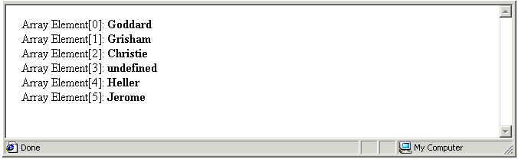
No value is assigned to array location [3]. It’s shown on the browser window as ‘undefined’.
- After the document.write() statement declare a new variable, assign to it the values of the array, and write the variable’s value to the browser window.
var str_authors;
str_authors = authors.join();
document.write("Array as String Variable: <B>"+str_authors+"</B><BR>");
- Save your file with the following name and view it in your web browser.
exercise_5-45_after.htm
You can see that presence of the unfilled array element at location [3] is shown in the string only by a comma.
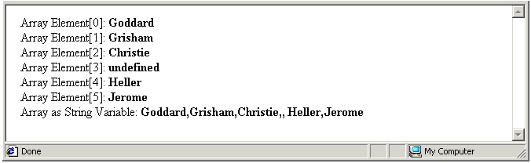
- Edit the join() method code to include a non-default separator character within quotes as shown below.
str_authors = authors.join('/');
- To confirm that the copying the array’s values to a string variable has no effect on the array itself, reverse the order of the script’s statements as shown below.
var str_authors;
str_authors = authors.join();
document.write("Array as String Variable: <B>"+str_authors+"<\/B><BR>");
for (i = 0; <=authors.length; i++)
{
document.write("Array Element["+i+"]: <B>"+authors[i]+"<\/B><BR>");
}
document.write("<B>Author Name: ("+i+") <\/B>"+authors[i]+"<BR>");
- Resave your file, and refresh/reload your browser. The result should look as shown. You can close the file when finished.
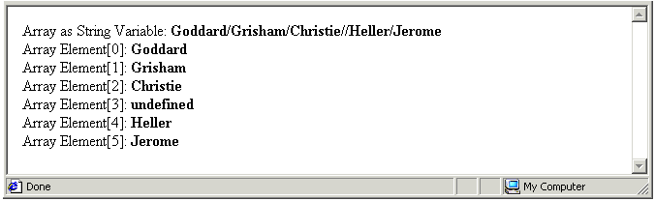

Sorting the Values of an Array
You cannot sort or rearrange an array’s elements in the same way as you can the rows in a spreadsheet. JavaScript does offer a sort() method, however that enables you to achieve a broadly similar effect. Array sorting in JavaScript is a two-step process:
- First, JavaScript copies the array’s values to a string.
- Second, JavaScript orders the string contents alphabetically.
Here’s a simple example:
var UserNames = new Array(“Smith”,“Higgins”,”Jones”);
var strUserNames = UserNames.sort();
The result is an alphabetically sorted string variable with the following content: “Jones,Higgins,Smith”.
When the array contains numbers rather than text, the result of the sort() method will not be what you might expect. Consider the following example.
var UserIDs = new Array(8,14,2,23);
var strUserNames = UserNames.sort();
The result is a string variable with the following content “14,2,23,8”. The reason for this is that the result of a sort() method is always a string variable, and 14 comes before 2 alphabetically.
In Exercise 4.46 you will apply the sort() method to two arrays, one containing strings and the other containing numbers, and output the results to the browser window.

Exercise 5.46: Copying Values From an Array to a Sorted String Variable
- Open the following file in your text editor and web browser:
exercise_5-46_before.htm
It contains two arrays, and two for loops with document.write() statements that output the arrays’ values to the browser window as shown below.
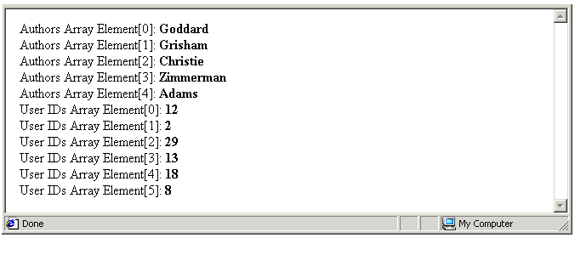
- After the document.write() statement that outputs the first array’s values to the browser window insert the following three statements.
var str_authors;
str_authors = authors.sort();
document.write("<BR><I>Sorted<\/I> Authors Array: <B>"+str_authors+"<\/B><BR><BR>");
(Type the third statement on a single line.)
- After the document.write() statement that outputs the second array’s values to the browser window, insert the following three statements.
var str_userIDs;
str_userIDs = userIDs.sort();
document.write("<BR><I>Sorted</I> User IDs Array: <B>"+str_userIDs+"</B><BR>");
(Type the third statement on a single line.)
- Save your file with the following name and view it in your web browser.
exercise_5-46_after.htm
- The result should look as shown. You can close the file when finished.
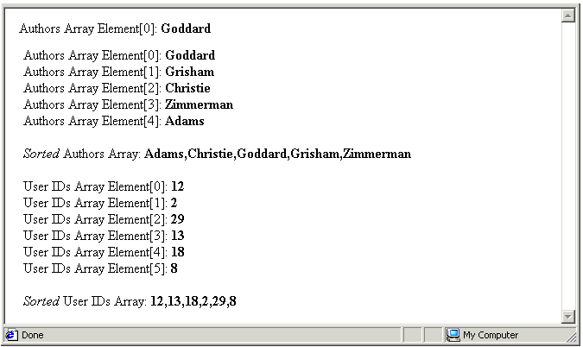

Chapter Summary
An array is a type of variable that can hold multiple values. Each element in an array is identified by an index number, beginning with zero. You can declare and assign several values to an array as follows.
var userNames = new Array (“Bridget”,“Carol”,“Christine”,“Deborah”);
The individual array elements are separated by commas. A second method of declaring and populating (assigning values to) an array is to write, on a series of different lines, each element’s value and its associated index number. For example.
var userNames = new Array;
userNames[0] = “Bridget”;
userNames[1] = “Carol”;
userNames[2] = “Christine”;
userNames[3] = “Deborah”;
You can write a value from an array element to the browser window with a statement such as the following.
document.write(“Email Address: “+email_addr[34]+”<BR>”);
To assign an element’s value to variable, use an assignment statement such as the one shown below.
var customer21_id = customer_ids[21];
Copying values from one array another to another is easy. Just use an assignment statement similar to the one below.
new_films[46] = old_films[187];
You can read all values from an array using a for loop such as that shown below.
for (i=0; i <=5; i++)
document.write("Array Element "+i+": "+fruit[i]+"<BR>");
You can use the length property of the array object as the upper value of the loop counter variable. This is the index number of the next empty element after highest occupied element in the array as follows.
for (i=0; i < fruit.length; i++)
document.write(“Array element “+i+:” fruit[i];
Notice that the comparison operator for the upper value of the counter variable is ‘less than’ (<) and not ‘less than or equal to’ (<=). This is because the array length is always one greater than the index number of the highest array element. When an array has six elements, its index numbers run from [0] to [5], and its length property contains the value of 6.
You don’t need to populate array elements in consecutive order. JavaScript allows you to have ‘gaps’ or unfilled elements in an array. An array with such non-contiguous values is said to be sparsely populated. The value of an unfilled array element is shown as ‘underfined’ in the web browser window. You can remove the contents of an individual array element with the delete command.
delete userNames[67];
This does not actually delete the element from the array; it just sets its value as ‘undefined’. The length of the array in unaffected.

Working With Clickable Form Elements

Objectives
In this chapter you will learn how to:
- Capture the option clicked in a SELECT list of a HTML form
- Set an option as selected in a SELECT list of a HTML form
- Capture the check box or boxes clicked in a HTML form
- Set a checkbox box or boxes as selected in a HTML form
- Capture the radio button clicked in a HTML form
- Set a radio button as selected in a HTML form.

Vocabulary
There are no new terms in this chapter.

Exercise Files
In this chapter you will work with the following HTML files:
- exercise_5-47_before.htm
- exercise_5-48_before.htm
- exercise_5-49_before.htm
- exercise_5-50_before.htm
- exercise_5-51_before.htm
- exercise_5-52_before.htm
- exercise_5-53_before.htm
- exercise_5-54_before.htm

Capturing User Choices
Single-line text boxes and multi-line scrolling text areas are the only two HTML form elements that you have so far written scripts for. You can create such form elements with code similar to the following.
<INPUT TYPE='TEXT' NAME='T1' SIZE='12' VALUE='4'>
<TEXTAREA NAME=’userComments’ ROW=’4’ COLS=’20’></TEXTAREA>
Both types of form field elements have a property called value. As its name suggests, this holds the value that the web page visitor enters into the single- or multi-line box.
You can capture the value typed by the web page visitor by assigning the value property to a variable with code such as the following.
userFeedBack = document.forms.myform.TB1.value;
Conversely, you can use code such as the following to set a box to a particular value.
document.forms.myform.OrdQty.value=12;
HTML forms offer the user three other elements for passing information to the web page: SELECT lists, checkboxes, and radio button groups. All three enable the user to click or otherwise select an option from a list rather than type text or numbers directly.

Working With SELECT Form Elements
This presents the form user with a list of choices on a pull-down menu. You create SELECT lists with code similar to that shown below left. The resulting list is shown below right.
<SELECT SIZE='1' NAME='D1'>  <OPTION>Monday  <OPTION>Tuesday  <OPTION>Wednesday  <OPTION>Thursday  <OPTION>Friday  <OPTION>Saturday  <OPTION>Sunday  </SELECT> | 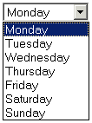
Notice that the entire list of items is denoted by a single name.
The property of a SELECT list that corresponds to the value property of single and multi-line text boxes is called selectedIndex. You assign this property to a variable with code such as the following.
deliveryMethod = document.forms.myform.D1.selectedIndex;
Conversely, you use code such as that below to set a SELECT list to a particular value.
document.forms.myform.D1.selectedIndex=2;
The value in the selectedIndex property is not the name of the item selected by the form user, but a number that corresponds to the item’s location in the list. Like arrays, the location numbers of list items begin with zero.
In the case of a SELECT list that holds the seven days of the week, beginning with Monday, that day has a selectedIndex property of 0. If the form user clicks Tuesday, selectedIndex has a value of 1. And so on. In Exercise 4.47 you capture a form’s user choice from a SELECT list and display that choice in a text box.

Exercise 5.47: Capturing a Form SELECT Option
- Open the following file in your text editor and web browser:
exercise_5-47_before.htm
You can see a SELECT list, a text box, two form buttons, and an event handler that calls a function named showFilm(). The function contains no statements.
- After the function name type a variable declaration and an assignment statement that uses the selectedIndex property to place the form user’s selection in the variable.
var filmSelection;
filmSelection = document.forms.myform.D1.selectedIndex;
- After that, insert a statement that displays the value of the variable in the form’s text box.
document.forms.myform.T1.value = filmSelection;
- Save your file with the following name and view it in your web browser.
exercise_5-47_after.htm
When you select a film title from the drop-down list and click the Continue button, you will see the selectedIndex number for that film choice shown in the text box.
- Let’s improve the form so that the text box shows the actual title of the selected film. Beneath the statement that assigns the selectedIndex property to the filmSelection variable, type the following if statement.
if (filmSelection == 0) {
filmSelection = "The Godfather I";
}
Repeat this statement, with appropriate film titles and selectedIndex numbers, for the other films in the list.
- Resave your, refresh/reload your browser, and test your form. The result should look as shown. You can close the file when finished.
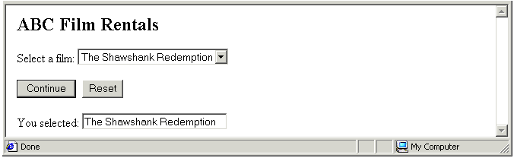

Setting a Default List Option
Using HTML you can set a default option for a SELECT list with the result that the option is shown as selected when the form user loads the web page in the web browser window. In the example below Wednesday is set as the default option.
<SELECT SIZE='1' NAME='D1'>
<OPTION>Monday
<OPTION>Tuesday
<OPTION SELECTED>Wednesday
<OPTION>Thursday
<OPTION>Friday
<OPTION>Saturday
<OPTION>Sunday
</SELECT>
Because the selectedIndex property is scriptable, you can also use JavaScript to force an item in a SELECT list to appear as selected. In Exercise 5.48 you create a function that does just that.

Exercise 5.48: Setting a Form SELECT Option
- Open the following file in your text editor and web browser:
exercise_5-48_before.htm
You can see that it is similar to the HTML form that you worked on in the previous exercise.
- Immediately beneath the <SCRIPT> tag in the document head insert the following function.
function setDefaultSelection() {
document.forms.myform.D1.selectedIndex=2;
}
- Edit the document’s <BODY> tag to include the following event handler.
<BODY onload="setDefaultSelection()">
- Save your file with the following name and view it in your web browser.
exercise_5-48_after.htm
- Refresh/reload your browser, and test your form. You can see that the ‘The Godfather III’ which has a selectedIndex property of ‘2’ is preselected. You can close the file when finished.

SELECT Lists and the onchange() Event Handler
A special event handler named onchange() is available for SELECT lists that can trigger a function into action as soon as the form user selects an item in the list. So called ‘click-and-go’ lists are commonly used to provide quick navigation shortcuts on web sites. Exercise 5.49 provides an example.

Exercise 5.49: Building a Click-and-Go SELECT List
- Open the following file in your text editor and web browser:
exercise_5-49_before.htm
In the document body you can see a SELECT list with web addresses. Each item listed uses the location object to redirect the form user. You will learn more about web browser redirection in Chapter 13.
For demonstration purposes the web addresses listed are all external links. In a real website, however the links would be to other pages on the same website – ‘page1.htm’, ‘page2.htm’ and so on. The document body also contains a button with an attached onclick event handler.
In the document head is a function that, when called by the event handler, redirects the user according to which link has been clicked on in the SELECT list.
- Insert an event handler and function name in the <SELECT> tag as shown below.
<SELECT SIZE='1' NAME='D1' onChange="goPage()">
This event handler calls the same function as the handler attached to the Go! Button. You can delete the Go! Button and its onClick event hander. It is no longer necessary.
- Save your file with the following name and view it in your web browser.
exercise_5-49_after.htm
- Test your form. You can see that the act of clicking on an item in the SELECT list is enough to trigger the browser redirection function. You can close the file when finished.
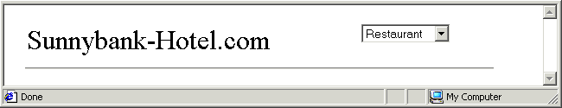

Working With Checkbox Form Elements
Sometimes you may want to offer visitors to your web page a range of options from which they may select more than one. Use checkboxes for such situations. Checkboxes are created with code similar to the following.
<INPUT TYPE=CHECKBOX NAME=CB1>Apples
<INPUT TYPE=CHECKBOX NAME=CB2>Oranges
<INPUT TYPE=CHECKBOX NAME=CB3>Pears
<INPUT TYPE=CHECKBOX NAME=CB4>Bananas
Checkboxes may exist singly or in groups. Notice that each individual checkbox is denoted by a unique name.
The critical property of checkbox form elements is named checked. It may have one of two possible values: true or false. You capture the user actions with checkboxes using code similar to the following.
if (document.forms.myform.CB1.checked==true) {
extras1 = "Cheese Topping";}
To select or ‘tick’ a checkbox from a script, use code such as the following.
document.forms.myform.CB4.checked=true;

Exercise 5.50: Capturing Checkbox Options
- Open the following file in your text editor and web browser:
exercise_5-50_before.htm
In the document body is a form with four checkboxes, a text box that you will use for displaying the user’s choices, a button with an attached event handler, and a form reset button.
In the document head is a function named ‘showFruit()’ that is called by the event handler. The function is currently empty.
- Insert the following declarations and assignments in the function as shown below. You assign each a variable a blank text string because otherwise their value will be ‘undefined’.
var fruit1="";
var fruit2="";
var fruit3="";
var fruit4="";
- Next, type the statements below to capture the form users’ checkbox selections, and to assign the selections to the relevant variables.
if (document.forms.myform.CB1.checked==true) {
fruit1 = "Apples";}
if (document.forms.myform.CB2.checked==true) {
fruit2 = "Oranges";}
if (document.forms.myform.CB3.checked==true) {
fruit3 = "Pears";}
if (document.forms.myform.CB4.checked==true) {
fruit4 = "Bananas";}
- Beneath the series of if statements insert a line of code that copies to the form’s text box the complete, concatenated list of user selections.
document.forms.myform.T1.value=fruit1+" "+fruit2+" "+fruit3+" "+fruit4;
- Save your file with the following name and view it in your web browser.
exercise_5-50_after.htm
- Test your form by selecting some checkboxes, clicking the Continue button, and viewing the output displayed in the text box. You can close the file when finished.
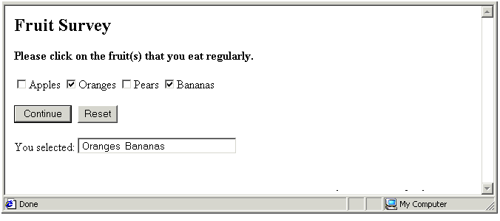

Setting a Default Checkbox Option
By default checkboxes are deselected. Using HTML code such as the following you can set a checkbox so that it displays as ‘ticked’ when the web page loads in the browser window.
<INPUT TYPE=CHECKBOX NAME=CB1 CHECKED>Apples
Because the checked property is scriptable, you can also use JavaScript to force a checkbox to appear as selected. In Exercise 5.51 you create a function that does just that.

Exercise 5.51: Setting a Checkbox Option
- Open the following file in your text editor and web browser:
exercise_5-51_before.htm
You can see that it is similar to the HTML form that you worked on in the previous exercise.
- Immediately beneath the <SCRIPT> tag in the document head insert the following function.
function setDefaultSelection() {
document.forms.myform.CB1.checked=true;
}
- Edit the document’s <BODY> tag to include the following event handler.
<BODY onload="setDefaultSelection()">
- Save your file with the following name and view it in your web browser.
exercise_5-51_after.htm
- Refresh/reload your browser, and test your form. You can see that the ‘Apples’ checkbox is preselected. You can close the file when finished.

Working With Radio Button Form Elements
Sometimes you may want to offer visitors to your web page a range of options from which they may select only one. Use these when the web page visitor may select only one option from the range available. Radio buttons always come in groups of two or more. Radio button groups are created with code similar to the following.
<INPUT TYPE=RADIO NAME=RB1>Overnight Express
<INPUT TYPE=RADIO NAME=RB1>Two-day Courier
<INPUT TYPE=RADIO NAME=RB1>Regular Postage
<INPUT TYPE=RADIO NAME=RB1>Will Collect
As with SELECT lists, a single name denotes an entire group of radio buttons. In Exercise 5.52 you capture a form’s user choice from a radio button group and display that choice in a text box.

Exercise 5.52: Capturing a Form Radio Button Option
- Open the following file in your text editor and web browser:
exercise_5-52_before.htm
In the document body is a form with a group of four radio buttons, a text box that you will use for displaying the user’s choice, a button with an attached event handler, and a form reset button.
In the document head is a function named ‘showMedium()’ that is called by the event handler. The function is currently empty.
- After the <SCRIPT> tag insert the following variable declaration and four if statements that assign the user’s button selection to the ‘medium’ variable.
var medium;
if (document.forms.myform.RB1[0].checked==true) {
medium = "CD";}
if (document.forms.myform.RB1[1].checked==true) {
medium = "Mini disc";}
if (document.forms.myform.RB1[2].checked==true) {
medium = "DVD";}
if (document.forms.myform.RB1[3].checked==true) {
medium = "Tape cassette";}
- Beneath the series of if statements insert a line of code that copies the value of the ‘medium’ variable to the form’s text box.
document.forms.myform.T1.value=medium;
- Save your file with the following name and view it in your web browser.
exercise_5-52_after.htm
- Test your form by selecting a radio button, clicking the Continue button, and viewing the output displayed in the text box. You can close the file when finished.
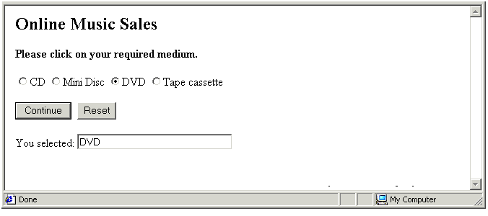

Setting a Default Button Option
You can use HTML code such as the following to set a radio button with a group as selected by default.
<INPUT TYPE=RADIO NAME=R1 CHECKED>Apples
Because the checked property is scriptable, you can also use JavaScript to force a radio button to appear as selected. In Exercise 5.53 you create a function that does just that.

Exercise 5.53: Setting a Form Radio Button Option
- Open the following file in your text editor and web browser:
exercise_5-53_before.htm
You can see that it is similar to the HTML form that you worked on in the previous exercise.
- Immediately beneath the <SCRIPT> tag in the document head insert the following function.
function setDefaultSelection() {
document.forms.myform.RB1[0].checked=true;
}
- Edit the document’s <BODY> tag to include the following event handler.
<BODY onload="setDefaultSelection()">
- Save your file with the following name and view it in your web browser.
exercise_5-53_after.htm
- Refresh/reload your browser, and test your form. You can see that the ‘CD’ radio button is preselected. You can close the file when finished.
In Exercise 5.54 you will create a web-based flight booking form that includes the three types of HTML form elements that you have worked on in the Chapter

Exercise 5.54: Building a Web-based Booking Form
- Open the following file in your text editor and web browser:
exercise_5-54_before.htm
In the document body is a form with a SELECT list, a group of three radio buttons, three text checkboxes, a button with an event handler, a reset button, and a text box for displaying the total cost of the flight.
In the document head is a function named ‘showFare()’ that is called by the event handler. The function currently contains only comments.
- After the <SCRIPT> tag insert the two variable declarations below.
var route;
var fare_total;
- Beneath the first comment line insert the code that handles the user’s selection of flight route.
/* Calculate fare from selected route */
if (route == 0) {
fare_total = 0;
}
if (route == 1) {
fare_total = 65;
}
if (route == 2) {
fare_total = 70;
}
if (route == 3) {
fare_total = 55;
}
if (route == 4) {
fare_total = 60;
}
- Beneath the second comment line insert the code that handles the user’s selection of flight class. In the form’s HTML code the ‘Standard’ class radio button is selected by default.
/* Update fare to include selected flight class */
if (document.forms.myform.RB1[0].checked==true) {
fare_total = fare_total; }
if (document.forms.myform.RB1[1].checked==true) {
fare_total = fare_total+(fare_total*0.1); }
if (document.forms.myform.RB1[2].checked==true) {
fare_total = fare_total+(fare_total*0.25); }
- Beneath the third comment line insert the code that handles the user’s selection of flight class. In the form’s HTML code the ‘Standard’ class radio button is selected by default.
/* Update fare to include any selected optional extras */
if (document.forms.myform.CB1.checked==true) {
fare_total = fare_total + 12.50;}
if (document.forms.myform.CB2.checked==true) {
fare_total = fare_total + 2.50;}
if (document.forms.myform.CB3.checked==true) {
fare_total = fare_total; }
- Beneath the fourth comment line insert a line of code that formats the total fare amount to two places of decimals.
/* Show total fare amount to 2 decimal places */
fare_total = fare_total.toFixed(2);
- Next, insert a line of code that copies the value of the ‘fare_total’ variable to the form’s text box.
/* Display total fare */
document.forms.myform.T1.value=fare_total;
- Save your file with the following name and view it in your web browser.
exercise_5-54_after.htm
- Test your form by selecting a a series of flight routes, flight classes and optional extras, clicking the ‘Show Total Fare’ button, and viewing the results displayed in the text box. You can close the file when finished.
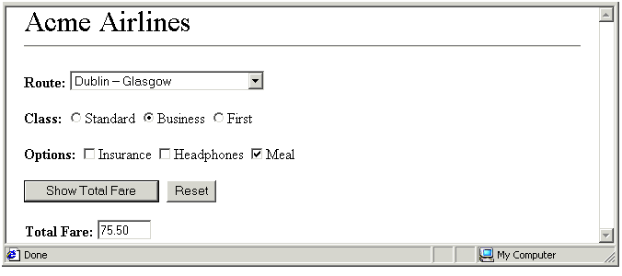

Setting Focus to a Text Box
When a visitor loads a web page containing a form, they typically begin entering the relevant details by clicking in the first of the form’s text boxes. You can use the focus() method to give ‘focus’ to a text box with the result that the cursor appears in the first (or any other text box) as soon as the web page is loaded in the browser window.
A function that gives focus to a text box might look as follows, where the NAME attribute in the <FORM> tag is ‘myform’ and the text box NAME attribute is ‘T1’.
function setFocus() {
document.forms.myform.T1.focus();
}
This function could be called by the onload event handler as shown below.
<BODY onload =”setFocus();”>

Chapter Summary
A SELECT list presents the HTML form user with a list of choices on a pull-down menu. The property of a SELECT list that corresponds to the value property of single and multi-line text boxes is called selectedIndex. You assign this property to a variable with code such as the following.
deliveryMethod = document.forms.myform.D1.selectedIndex;
Because the selectedIndex property is scriptable, you can also use JavaScript to force an item in a SELECT list to appear as selected with code such as the following.
document.forms.myform.D1.selectedIndex=2;
The value in the selectedIndex property is not the name of the item selected by the form user, but a number that corresponds to the item’s location in the list. Like arrays, the location numbers of list items begin with zero.
Use checkboxes when you want to offer visitors to your web page a range of options from which they may select more than one option. Checkboxes may exist singly or in groups. Each individual checkbox is denoted by a unique name. The critical property of checkbox form elements is named checked. It may have one of two possible values: true or false. You capture the user actions with checkboxes using code similar to the following.
if (document.forms.myform.CB1.checked==true) {
extras1 = "Cheese Topping";}
To select or ‘tick’ a checkbox from a script, use code such as the following.
document.forms.myform.CB4.checked=true;
Use a radio button group when you want to offer visitors to your web page a range of options from which they may select only one. As with SELECT lists, a single name denotes an entire group of radio buttons. As with checkboxes, radio buttons may have one of two possible values: true or false. You capture the user actions with a radio button group using code similar to the following.
var medium;
if (document.forms.myform.RB1[0].checked==true) {
medium = "CD";}
if (document.forms.myform.RB1[1].checked==true) {
medium = "Mini disc";}
To select or ‘tick’ a radio button in a group from a script, use code such as the following.
function setDefaultSelection() {
document.forms.myform.RB1[0].checked=true;
}

Controlling Window Behaviour

Objectives
In this chapter you will learn how to:
- Distinguish between directly opened windows and child windows opened by a script
- Distinguish between pop-up child windows and those opened as the result of a user action
- Write plain-text messages to the status bar of a browser window use the window.status property
- Capture a user’s interaction with a window.confirm() dialog box.
- Open the Print dialog box in a web browser use the window.print() method
- Open child window and specify its location, name and features using the window.open() method
- Close a child window using the window.close() method.

Vocabulary
In this chapter you will meet the following terms:
- Child window
- Status bar message

Exercise Files
In this chapter you will work with the following HTML files:
- exercise_5-55_before.htm
- exercise_5-56_before.htm
- exercise_5-57_before.htm

About the Window Object
The window object in JavaScript represents the web browser window in which the current HTML document is loaded. Like other objects, the window object possesses certain features and offers a number of methods. Your scripting options with a window object vary depending on how the window is loaded in the visitor’s web browser.
- Directly loaded window: When someone loads your web page after typing its address directly in their browser, or after clicking on a HTML hyperlink, your page is loaded directly in their browser window.
There is very little that JavaScript can do – or that you would want it to do – when the visitor displays a window in this way. It is possible, for example, to reposition visitor’s browser window on their computer screen as soon as your page loads, but this and similar effects typically have the effect of only distracting or annoying your visitors.
- Windows loaded by a script: JavaScript’s window.open() method enables you to create secondary or child windows from your web pages. These are usually smaller than the main or ‘parent’ window from which they are opened. Such child windows fall into two categories:
- User-triggered: You can give your visitors the choice of whether or not they view the contents of a child window by offering a button in the page with an attached onclick() event handler.
- Pop-up: Alternatively, a child window can display automatically as a result of an onload() event handler in the web page’s <BODY> tag. The second type of child window is known as a pop-up window, and is almost universally detested.
Because child windows are created by JavaScript, you have total control over their appearance, and can apply a wide range of methods to them.
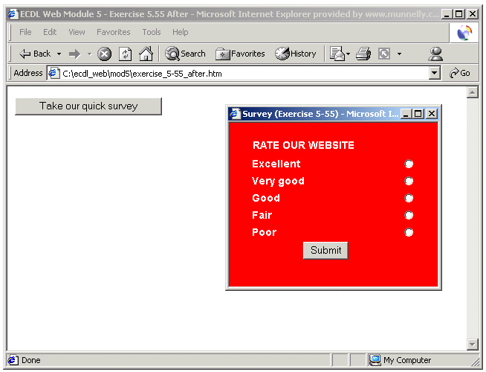
Child window
A secondary window that is opened as the result of a script, and whose appearance can be controlled by that script. The event handler that opens the window can be triggered by a user action or by on onload() event handler that opens the secondary window automatically. An automatically opened window is known as a pop-up window.

Working With the Status Bar
One property of the window object that can be manipulated in both directly opened and child windows is the content of the status bar along the bottom of the window. You can place a plain-text message in the status bar by inserting text in the status property of the window object. Status bar messages are commonly used to:
- Annotate page elements: When a visitor holds the mouse over an element on a web page, a script can write additional information about that element in the status bar. The element can be anything – a paragraph of text, an item in a bulleted list, or a hyperlink. Such messages are typically called by the onmouseover() and onmouseout() event handlers.
In the example below two functions write messages to the status bar: one contains a message; the other is blank.
function sayLondon() {
window.status="Centrally located hotels at affordable prices";
}
function sayNothing() {
window.status="";
}
The functions are called by the following two event handlers.
<P onmouseover="sayLondon ()"; onmouseout="sayNothing()">London breaks</P>
The sayLondon() function is called whenever the page visitor holds the mouse over the word ‘London’. You can see the visual effect below.
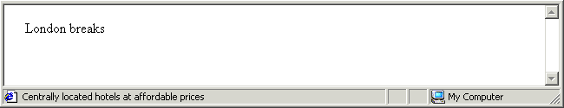
The sayNothing() function is called when the mouse is moved away to another part of the page.
- Prove form field help: Elements within HTML forms have two event handlers called onfocus() and onblur() that can call functions depending on which the form field has ‘focus’ or not. A text box, radio button or other form elements has focus when the user is interacting with it.
In the example below two functions write messages to the status bar: one contains a message; the other is blank.
function saySomething() {
window.status=" Please enter your full name";
}
function sayNothing() {
window.status="";
}
The functions are called by the following two event handlers. All the code is written on a single line.
<INPUT TYPE='TEXT' NAME='User' SIZE='30' onfocus="saySomething()";
onblur="sayNothing()">
The saySomething() function is called whenever the page visitor clicks in the text box. You can see the visual effect below.
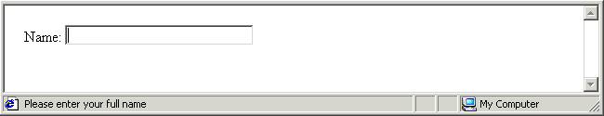
The sayNothing() function is called when the user interacts with a different element in the HTML form.
You can also display a text message in the status bar using a function triggered by an onload() event handler in the <BODY> tag.
Status Bar Message
A plain-text message that is displayed in the status bar along the bottom of the web browser window. The text is inserted in the status property of the window object.

Methods of the Window Object
You have already met the dialog boxes that are created by the three different methods of the window object. The window.alert() dialog box offers just a single button: an OK button.
The window.confirm() dialog box offers two buttons: OK and Cancel.
You can capture and respond to a user’s interaction with a window.confirm() dialog box. In the script below one of two messages is written to the page depending on whether the OK (true) or Cancel (false) button is clicked by the web page visitor.
var response;
response = window.confirm("Do you wish to continue?");
if (response==true)
{
document.write("Excellent. Please continue.");
}
else {document.write("Leaving already? Sorry to hear that.");
}
The window.confirm() dialog box includes an input area in which the page visitor can enter a value.
You learnt how to capture a user’s input to a window.prompt() box and assign it to a variable in Exercise 5.19.
When visitors want to print a web page they typically choose the relevant command or button in their web browser software. JavaScript offers a window.print() method that you can attach to a button or other page element as shown in the example below.
<BUTTON onClick=”window.print()”>Print this page</BUTTON>
Clicking the above button displays the web browser’s Print dialog box, in which the visitor can select options such as the printer, number of copies and so on.

Working With Child Windows
A child window is a window opened in the web browser as the result of a script that contains the window.open() method. Child windows are typically smaller than the ‘parent’ windows from which they are opened, and are usually trigged by the onclick or onload event handler. The general syntax of the window.open() method is as follows.
window.open(url,name,features);
Let’s look at this syntax in detail:
- url: This is the address of the web page that displays within the child window. The window.open() method cannot create a new web page: it can only display a page that already exists.
Typically the url will be that of another page on the same website, such as ‘sitemap.htm’ or ‘/resources/quiz.htm’. It can also be a full web address, for example ‘http://www.microsoft.com/support/index.asp’.
- name: Every web page loaded in the window object has a name. A directly opened window has the default name of ‘main’. You can choose the name you want applied to your child window. There is no relationship between the actual file name of the secondary window and the name you give it. Window names follow the same rules as variable names.
- features: These control the appearance and positioning of the child window. They may seem like properties of the window object, and it may be helpful to think of them like that. But, technically, they are features of the window.open() method.
The features of the window.open() method fall into two categories.
- On/off features: These are interface items such the toolbar and status bar that you choose to display or not. By default, none of these elements are displayed. Unless you specify otherwise a secondary window contains just a title bar and what is known as the ‘inner window’, the rectangular space in which the web page is displayed.
- Features with values: These enable you to set the width, height and position of the child window on the user’s screen.

Child Window On/Off Properties
The main properties of a child window that are set on or off are listed in the table below.
Window Item | Description | Feature Name | Value
Toolbar | Contains the Back, Forward and other buttons that appear at the top of the browser window | toolbar | on or off
Menubar | Contains the File, Edit and other menu commands that appear just below the toolbar | menubar | on or off
Location | The address bar | location | on or off
Resizable | Determines whether or not the user can change the shape or size of the child window | resizable | on or off
Status | The status bar along the bottom of the browser window | status | on or off
Scrollbars | Vertical and horizontal scrollbars at the right and bottom of the browser window | scrollbars | on or off

Child Window Size
You control size of a child window with the four features set out in the following table.
Feature Name | Description | Example
width | The total width of the child window in pixels, including the vertical scrollbar if displayed. | width=240
height | The total height of the child window in pixels, including the toolbar, menubar, statusbar and horizontal scrollbar if displayed. | height=300
innerHeight | The height, in pixels, of the browser window in which the web page is displayed. | innerHeight=200
innerWidth | The width in pixels of the browser window in which the web page is displayed. | innerWidth=260
In the example below a new window is opened containing the HTML document in the file called ‘quiz.htm’. The name given to the window is ‘quiz_win’. The only interface elements displayed are the location bar, which contains the page’s address, and the status bar. The width of the new window is 200 pixels and its height is 100 pixels.
window.open(‘quiz.htm’, ‘quiz_win’, ‘width=200, height=100, location=yes, status=yes’);
Note the following syntax rules regarding the window.open() statement:
- Two pairs of single (or double) quotes surround the web page address and the child window.
- A single pair of single (or double) quotes enclose the child window’s features.
- Each feature is separated from the next by a comma and (optionally) a single space.

Child Window Position
Controlling the position of a child window on the user’s screen is a little more complex because the two most common web browsers rely on different features to achieve this effect. For Internet Explorer the relevant features are as set out in the table below.
Feature Name | Description | Example
top | The vertical position of the child window in pixels. | top=5
left | The horizontal position of the child window in pixels. | left=14
For Netscape Navigator the relevant features are as set out in the table below.
Feature Name | Description | Example
screeny | The vertical position of the child window in pixels. | screeny=5
screenx | The horizontal position of the child window in pixels. | screenx=14
Because each web browser ignores the other’s positioning features, the best option is to specify both within the window.open() command as shown in the example syntax below:
window.open(‘survey.htm’, ‘userSurvey’, ‘width=200, height=100, left=10, top=12,
screenx=10, screeny=12, location=yes, scrollbars=yes, resizable=yes’);
All the above code would be written on a single line. In Exercise 5.55 you will create a child window and configure its appearance and position with parameters of the window.open() method.

Exercise 5.55: Creating a User-opened Child Window
- Open the following file in your text editor and web browser:
exercise_5-55_before.htm
In the document body is a button with an attached onclick() event handler. In the document head is an empty function named showSurveyForm().
- Insert with following statements within the function.
function showSurveyForm() {
window.open('survey.htm', 'userSurvey', "width=280, height=220, left=10, top=12,
screenx=10, screeny=12, resizable=yes");
}
(The window.open() method and all its components are typed on a single line.)
- Save your file with the following name and view it in your web browser.
exercise_5-55_after.htm
- Click the button named ‘Take our quick survey’ to verify that the child window opens correctly.
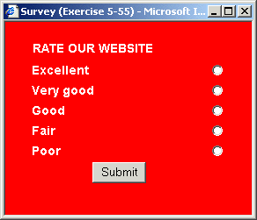
- Experiment with your child window by changing the parameters within the window.open() command. For example, change the values of the size and positioning parameters, and switch various interface elements on and off.
Note that a child window can only be opened once. You need to close it before you can open it again. You can close the file when finished.
In Exercise 5.56 you will use the onload event handler to open a child window automatically whenever the parent window is loaded in the browser window.

Exercise 5.56: Creating a Pop-Up Window
- Open the following file in your text editor and web browser:
exercise_5-56_before.htm
You can see that it is similar to the file that worked on in the previous exercise.
- Delete the line below from the body of the document..
<BUTTON onclick="showSurveyForm()">Take our quick survey</BUTTON>
- Edit the document’s <BODY> tag to include the following event handler.
<BODY onload="showSurveyForm()">
- Save your file with the following name and view it in your web browser.
exercise_5-56_after.htm
- Refresh/reload your browser, and verify that the child window automatically ‘pops up’. You can close the child and main windows when finished.

Closing Child Windows
When a child window is opened from an event handler, it must be closed before it can be opened again. You can offer your visitors the ability to close a child window with the window.close() method. Exercise 5.57 provides an example.

Exercise 5.57: Closing a Child Window
- Open the following file in your text editor and web browser:
exercise_5-57_before.htm
It is similar to the file that you worked on in Exercise 5.55. The only difference is that the child window file name is now ‘survey1.htm’.
- Open the following file in your text editor.
survey1.htm
- Near the bottom of the file is a HTML button tag surrounding the word ‘Close’.
<BUTTON>Close</BUTTON></TD>
- Edit the tag to include the following event handler.
<BUTTON onclick="window.close()">Close</BUTTON></TD>
- Save and close the survery1.htm file.
- Refresh/reload the exercise_5-57_before.htm file, click the ‘Take our quick quiz’ button to open the child window, and click the Close button in the child window to verify that it works correclty. You can close both files when finished.
You can include the window.close() method in a main window – that is, a window not opened by a script – and attach it to a button with code such as the following.
<BUTTON onclick="window.close()">Close</BUTTON>
When the button is clicked and the method is called, however, your web browser will display a confirmation message such as the following.
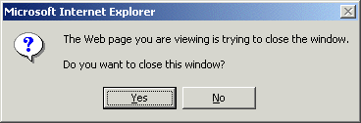

Chapter Summary
The window object in JavaScript represents the web browser window in which the current HTML document is loaded. A directly opened window is one that is opened when someone loads your web page after typing its address directly in their browser, or after clicking on a HTML hyperlink.
A child window is a window opened as the result of a script that contains the JavaScript’s window.open() method. Child windows are usually smaller than the main or ‘parent’ windows from which they are opened.
You can give your visitors the choice of whether or not they view the contents of a child window by offering a button in the page with an attached onclick() event handler. Alternatively, a child window can display automatically as a result of an onload() event handler in the web page’s <BODY> tag. The second type of child window is known as a pop-up window.
Because child windows are created by JavaScript, you have total control over their appearance, and can apply a wide range of methods to them. The general syntax of the window.open() method is as follows.
window.open(url,name,features);
The url is the address of the web page that displays within the child window. Every web page loaded in the window object has a name. A directly opened window has the default name of ‘main’. You can choose the name you want applied to your child window. Window names follow the same rules as variable names.
The features control the appearance and positioning of the child window and fall into two categories: on/off features that control whether interface items such the toolbar and status bar are displayed or not; and features with numeric values, such as the width, height and position of the child window on the user’s screen. Unless you specify otherwise a child window contains just a title bar and what is known as the ‘inner window’, the rectangular space in which the web page is displayed.
In the example below a new window is opened containing the HTML document in the file called ‘quiz.htm’. The name given to the window is ‘quiz_win’. The only interface elements displayed are the location bar, which contains the page’s address, and the status bar. The width of the new window is 200 pixels and its height is 100 pixels.
window.open(‘quiz.htm’, ‘quiz_win’, ‘width=200, height=100, location=yes, status=yes’);
Note that two pairs of single(or double) quotes surround the web page address and the child window, a single pair of single (or double) quotes enclose the child window’s features, and that each feature is separated from the next by a comma and (optionally) a single space.
You can offer your visitors the ability to close a child window with the window.close() method, and the window.print() method displays the Print dialog box of the web browser. Each method is typically called from a button with an attached onclick() event handler.
Status bar messages are commonly used to provide help or guidance to the web page visitor about the meaning or use of elements on the HTML page. You can place a plain-text message in the status bar by inserting text in the status property of the window object as follows.
function helpFullNameField () {
window.status=" Please enter your full name";
}
Status bar messages typically involve the use of event handlers such as onmouseover(), onmouseout() and, for HTML forms, onfocus() and onblur().

Controlling Browser Behaviour

Objectives
In this chapter you will learn how to:
- Access and manipulate the main properties of the document object
- Create page redirection and website navigation scripts base don the location object
- Use the length property of the history object to discover the number of pages previously viewed by the visitor in the current browsing session
- Use the go() method of the history object to create backward and forward buttons on a web page

Vocabulary
There are no new terms in t his chapter.

Exercise Files
In this chapter you will work with the following HTML files:
- exercise_5-58_before.htm
- exercise_5-59_before.htm
- exercise_5-60_before.htm

The Document Object
The document object is JavaScript’s representation of the HTML document that is loaded within the web browser. In Chapter 3 you were introduced to the document object and some of its properties. Throughout this book you have used the document.write() method to write information to the browser window.
As you can see from the table below, most of the document object properties in JavaScript are related to the attributes of the <BODY> tag in HTML.
Property Name | Description
bgColor | Background colour
fgColor | Text colour
linkColor | Unvisited link colour
alinkColor | Active link colour
vlinkColor | Visited link colour
title | Text displayed in browser title bar
lastModified | The date on which the document was last amended
With the exception of the lastModified property, which is read-only, all the others are scriptable. A common use of these properties is to enable web page customisation based on visitor preference or day of the week.
The lastModified property returns a string. Here’s a typical usage of this property that you might see near the bottom of a web page.
document.write(“<B>Page last updated:</B> “+document.lastModified);
The output from this code is shown below.
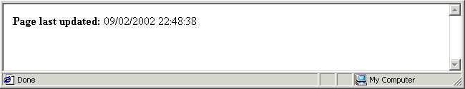

The URL and Referrer Properties
Two other document properties relate to HTML document addresses.
Property Name | Description
href | The web address of the currently loaded document in the browser window.
referrer | The web address of the previously loaded document in the browser window.
Both properties are read-only. The following two statements show typical uses of these properties.
document.write(“You are currently at: “+document.url);
document.write(“Hope you like this page better than: “+document.referrer);
Do not confuse the read-only url property of the document object with the scriptable location window.location property that is discussed in the next section of this Chapter.

The Location Object
The location object is JavaScript’s representation of the web address of the HTML document that is loaded within the web browser. You can create scripts that read or amend a web page’s location. Manipulating the location object make it possible to create various navigation systems, and guided slideshows and tutorials.
In Exercise 5.58 you will create a script that automatically redirects the visitor from the current page to another one.

Exercise 5.58: Redirecting the User
- Open the following file in your text editor and web browser:
exercise_5-58_before.htm
You can see that the document body contains an empty <SCRIPT> tag.
- Insert the following statement within the <SCRIPT> tag.
window.location="anotherpage.htm";
- Save your file with the following name and view it in your web browser.
exercise_5-58_after.htm
- Refresh/reload your browser, and verify JavaScript atttempts to redirect you to the specified alternative web page. You can close the file when finished.
Perhaps the most common usage of page redirection is in SELECT lists of the kind that you worked with in Exercise 5.49. The output from this exercise is shown below.
In this navigation scheme users are taken to a different location depending on which option they choose from the drop-down SELECT list. In Exercise 5.59 you will create a similar drop-down list of links.

Exercise 5.59: Building a Navigation Page List
- Open the following file in your text editor and web browser:
exercise_5-59_before.htm
In the document body is a SELECT list and an attached onChange() event handler. In the document head is an empty function named goPageNumber(). The event handler calls this function whenever the visitor clicks an item in the list; no button-clicking or other action is necessary.
- Beneath the function name insert the following variable declaration.
var pageSelection;
- Beneath the variable declaration insert the following code to capture the number corresponding to the visitor’s choice from the list.
pageSelection = document.forms.myform.LinkList.selectedIndex;
- On the next line insert the following relocation statement.
window.location = "page"+pageSelection+".htm";
When the first list item is selected, the above statement redirects the browser to page0.htm. When the second list item is selected, the above statement redirects the browser to page1.htm, and so on.
You can see that this redirection scheme works only when the web pages in the website following a consistent naming order.
- Save your file with the following name and view it in your web browser.
exercise_5-59_after.htm
Click on the various items in the SELECT list and verify that the brower attempts to redirect you to the appropriate web pages. You can close the file when finished.
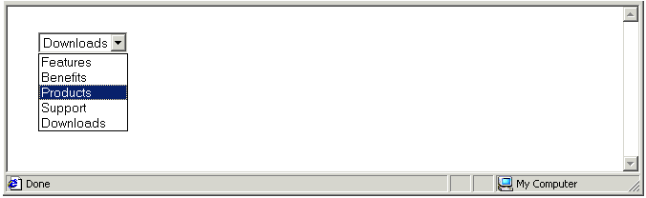

The History Object
What documents were opened recently in your web browser window? Your browser’s history list keeps a record of web pages that it has loaded. The History object is JavaScript’s representation of the web browser’s history list.

History Length Property
The History object has a length property that records the number of web page addresses that are stored in the browser’s history list. This is the number of pages that the visitor has loaded in the current browsing session. You can write the value of the length property to the browser window with a script such as the following.
document.write(history.length);

History Methods
The History object has a go() method as set out below, where n is a positive or negative integer such as 2 (forward two pages) or -1 (back to the previously displayed page).
history.go(n);
You can use the go() method of the History object to insert simple Forward and Back buttons as a navigational aids in web-based slideshows or tutorials. See the examples below
<P><BUTTON onClick="history.go(-1)">Back</BUTTON></P>
<P><BUTTON onClick="history.go(1)">Forward</BUTTON></P>
In Exercise 5.60 you will work with the length property and the go() method of the history object.

Exercise 5.60: Working With The History Object
- Open the following file in your text editor and web browser:
exercise_5-60_before.htm
- In the empty <SCRIPT> tag in the document head type the following code.
document.write("You visited <B>"+history.length+"</B> pages before this one.");
- In the document body edit the first HTML button to include the go() method of the history object as shown.
<BUTTON onClick="history.go(-1)">Back</BUTTON>
- Edit the second HTML button to include the go() method as shown.
<BUTTON onClick="history.go(1)">Forward</BUTTON>
- Save your file with the following name and view it in your web browser.
exercise_5-60_after.htm
Test your web page by clicking the Back and Forward buttons. You can close the file when finished.
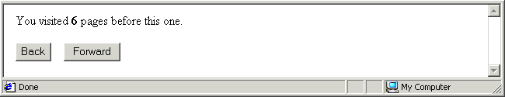

Chapter Summary
The document object is JavaScript’s representation of the HTML document that is loaded within the web browser. Most of the document object’s properties in JavaScript are related to the attributes of the <BODY> tag in HTML.
With the exception of the lastModified property, which is read-only, all the others are scriptable. A common use of these properties is to enable web page customisation based on visitor preference or day of the week.
The lastModified property returns a string. Here’s a typical usage of this property that you might see near the bottom of a web page.
document.write(“<B>Page last updated:</B> “+document.lastModified);
The output from this code is shown below.
Two other document properties relate to HTML document addresses: href and referrer. The first holds web address of the currently loaded document in the browser window. The second contains web address of the previously loaded document in the browser window. Both properties are read-only. The following two statements show typical uses of these properties.
document.write(“You are currently at: “+document.url);
document.write(“Hope you like this page better than: “+document.referrer);
Do not confuse the read-only url property of the document object with the scriptable location window.location property, an example of which is shown below.
window.location="anotherpage.htm";
Perhaps the most common usage of page redirection is in SELECT lists that offer shortcut navigation options to the web page visitor.
The History object is JavaScript’s representation of the web browser’s history list. This object has a length property that records the number of web pages that the visitor has loaded in the current browsing session. You can write the value of the length property to the browser window with a script such as the following.
document.write(history.length);
The History object has a go() method as set out below, where n is a positive or negative integer such as 2 (forward two pages) or -1 (back to the previously displayed page).
You can use the go() method of the History object to insert simple Forward and Back buttons as a navigational aids in web-based slideshows or tutorials. See the examples below
<P><BUTTON onClick="history.go(-1)">Back</BUTTON></P>
<P><BUTTON onClick="history.go(1)">Forward</BUTTON></P>

Working With String Objects

Objectives
In this chapter you will learn how to:
- Apply font effects such a bold and italic to a string
- Determine the length of a string
- Use the chartAt() method to identify the character located at a specified position a string
- Use the indexOf () method to determine whether a string contains a specified character or not
- Use the replace() method to replace occurrences of a particular character or characters in a string with specified alternatives
- Use the split() and substring() methods to extract parts of a string from the entire string.

Vocabulary
There are no new terms in this chapter.

Exercise Files
In this chapter you will work with the following HTML files:
- exercise_5-61_before.htm
- exercise_5-62_before.htm
- exercise_5-63_before.htm

About String Objects
JavaScript has a built-in object named String. Every time you declare a new string variable JavaScript creates a new instance of the string object. A string object has only one property – its length – but has a very wide range of methods that enable scripts to manipulate the string.
String methods fall into four categories:
- Formatting methods: You can apply font effects such a bold and italic to a string, and change the case of its characters from lower to upper, and vice versa.
- String analysis methods: You can examine a string to identify the character located at a specified position in the string, and you can examine a string to see whether it contains a specified character (such as ‘@’) or not.
- String manipulation methods: You can replace occurrences of a particular character or characters with specified alternatives.
- Substring extraction methods: You can extract parts of a string from the entire string. In the example of the email address ‘joe@bloggs.com’, you could extract the domain name of ‘bloggs.com’.
Whichever type of method you apply to a string, you must set the string equal to the result of the method operation. The following code declares a variable, assigns a value to it, and then applies a method to the variable that converts its content to uppercase characters.
var fName = “john”;
fName = fName.toUpperCase;
The result of the above code is that the variable content is set to ‘JOHN’. In contrast, the result of the code below is that the value of the variable is still ‘John’.
var fName = “john”;
fName.toUpperCase;

Formatting Strings
JavaScript offers a wide range of formatting methods that can be applied to strings. The main ones are set out in the table below.
String Method
bold()
italics()
big()
small()
strike()
toUpperCase()
toLowerCase()
fontsize(n)
fontcolor(colour)
In Exercise 5.61 you will assign a line of text to a string, apply various string formatting methods to it, and then write the formatted strings to the browser window.

Exercise 5.61: Modifying the Format of a String
- Open the following file in your text editor and web browser:
exercise_5-61_before.htm
In the document body you can see a <SCRIPT> tag containing nine string declaration and assignment statements.
- After the existing statements type the following lines of code.
strvar1 = strvar1.bold();
document.write(strvar1+"<BR>");
strvar2 = strvar2.italics();
document.write(strvar2+"<BR>");
strvar3 = strvar3.small();
document.write(strvar3+"<BR>");
strvar4 = strvar4.big();
document.write(strvar4+"<BR>");
strvar5 = strvar5.strike();
document.write(strvar5+"<BR>");
strvar6 = strvar6.toUpperCase();
document.write(strvar6+"<BR>");
strvar7 = strvar7.toLowerCase();
document.write(strvar7+"<BR>");
strvar8 = strvar8.fontsize('6');
document.write(strvar8+"<BR>");
strvar9 = strvar9.fontcolor('#FF0000');
document.write(strvar9+"<BR>");
- Save your file with the following name and reload your web browser.
exercise_5-61_after.htm
The browser window should look as shown below.
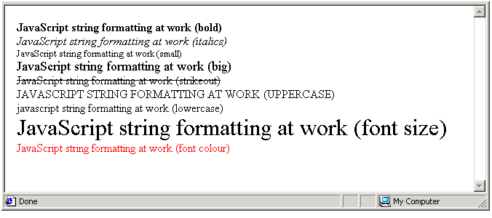
In this exercise you applied nine different string formatting methods to nine different strings. You can apply different formatting methods to the same string, one method after the other. The results, however, are unpredicable, and vary for different web browsers. You can close the file when finished.

Examining String Length
A string’s sole property is its length. You can write the length of a string named ‘address’ to the browser window with the following statement.
document.write(<B>String length is: </B>“+address.length);
String length is a read-only property; it cannot be changed by a script. The length property of a string is automatically updated whenever the value in the string changes. The length method is useful for handling information entered by users to a HTML form. For example, you can show an error message if the user-entered information is either too short or too long.

Examining String Content
JavaScript offers the following two methods for examining the contents of a string.
String Method | Description | Examples
charAt(n) | Use this method to find which character is located at a specified position within a string. You enter the position within the parenthesis and method returns the character at that position. | str=”Hello world”;  str=str.charAt(0);  /* returns ‘H’ */  str=str.charAt(5);  /* returns ‘ ’ */
indexOf(“a”) | Accepts a letter, number or punctuation symbol within the parenthesis and returns the location of the first occurrence of that character within the string. You are not limited to searching for a single character. If you search for a smaller string, the method returns the position at which the smaller string begins | str=”joe@bloggs.com”;  str=str.indexOf(“@”);  /* returns ‘4’ */  str=str.indexOf(“com”);  /* returns ‘11’ */

String Analysis With the charAt() Method
You can use the charAt() method in combination with the length property to find the last character in any string. In the code below the string length is reduced by one to provide the integer for the charAt() method. This is because the length property, in counting the number of characters in the string, starts from 1 but the charAt() method starts counting from 0.
var my_email="joe@smith.com.au";
var email_length=my_email.length;
var last_char=my_email.charAt(email_length-1);
alert('The last character is '+last_char+'.');
You can use the charAt() method in combination with a for loop to read through each character in a string. Add some if statements and you can test the value of each individual character in the string. Let’s see how this can be done.
In the two statements below two variables are declared, and a string value is assigned to one of them. The second variable named ‘oneChar’ will be used to store a single character from the string, one character at a time.
/* Declare and assign value to variable */
var mystring = “Monday”;
var oneChar;
In the next statement a for loop is created. The values of the counter variable range from zero to one less than the length of the string. As it happens the string in this example contains six characters, numbered zero to five. The last character in the string (‘y’) is therefore numbered five.
/* Define start and upper values of for loop */
for (i= 0; i < mystring.length; i++)
Now add a line of code that assigns a single character from the string to the oneChar variable in each iteration of the loop.
/* Extract one character from string in each loop iteration and assign to variable*/
oneChar = str.charAt(i)
The single character from the string that is assigned to the oneChar variable will be different on each iteration of the for loop. On the first iteration the character assigned will be ‘M’ because that character is a location zero in the string. On the second iteration it will be ‘o’, and so on. The loop terminates when the sixth character at location five is assigned to the oneChar variable.
Now you can use an if statement to test the character in the oneChar variable on each loop iteration.
/* Test value of single extracted character in variable*/
if (oneChar ==”y”) {
window.alert(“String contains the letter ‘y’.”);
}
else { window.alert(“String does contains the letter ‘y’.”); }
}
That’s it. You can use this combination of the charAt() method, a for loop and if statements to perform a variety of analyses on strings.

String Analysis With the indexOf() Method
Perhaps the most common use of the charAt() is to for check for invalid characters in HTML form entries. For example an email address should be restricted to letters, numbers, periods and an ‘@’ symbol. In the statement below the indexOf method searches through the ‘email’ string, and returns a value of 10. This is the location of the first occurrence of the ‘@’ symbol within the string.
email = john_smith@anywhere.com;
document.write(“<B>@ symbol is at position: </B>“+email.indexOf(“@”);
Two points to remember about the indexOf method:
- One instance only: The indexOf method shows only the first occurrence of the relevant character(s) within the string. If you want to find all occurrences, you need to repeat the method on the string.
- Returns -1 if no instance: What happens when the indexOf() method fails to find any instance of the relevant character(s)? Does it return ‘undefined’? No. Does it return ‘0’. No, because a zero would indicate that it has found the relevant at the first location in the string. It returns a -1.

Checking That a Character is Present
Sometimes you will want to ensure that certain characters are present in a string. For example, an email address should contain the @ symbol. The code below searches through the string. If an @ symbol is not found, a -1 is returned. Therefore any value returned other than -1 indicates that the string passes the syntax test and no error message is displayed.
var user_email;
user_email = document.forms.myform.email.value;
if (user_email.indexOf(“@”) == -1 ) {
window.alert(”You entered an invalid address. Please try again.”);
}

Checking That a Character is Absent
You can also check that certain characters are absent from a string. Commas are invalid characters in email addresses. A search of the string for a comma should fail. That is, it should return a -1. In the code below any value other than a -1 displays a window.alert() box to the web page visitor.
var user_email;
user_email = document.forms.myform.email.value;
if (user_email.indexOf(“,”) != -1 ) {
window.alert(”You entered an invalid address. Please try again.”);
}

Defining a Starting Parameter With The indexOf() Method
You can specify a second, optional parameter with the indexOf() method to define the location in the string at which the search should start. When you include this parameter, you type it within the method’s parenthesis, and separate it from the first parameter by a comma. For example.
var emailAddr = “joe_smith@sales.bloggs.com”;
emailAddr = emailAddr.indexOf(”bloggs”, 3);
The start location parameter can be
When you omit the starting location parameter, JavaScript begins searches the string from location zero – that is, from the start of the string. The following two statements produce the same result.
ProductDesc = ProductDesc.indexOf(”a”, 0);
ProductDesc = ProductDesc.indexOf(”a”);
In the following code the indexOf()method begins its search at the letter ‘d’ which is character number four. (Because JavaScript counts from zero, the letter ‘B’ is at location, 0, ‘r’ is a location 1, and so on.)
var mystring = “Brendan”;
mystring = mystring.indexOf(“n”,4);
One use of this starting location parameter is for checking that the string under examination contains one – and only one – occurrence of a letter, number or punctuation symbol. A valid email address, for example, should contain just a single @ symbol.
The following code, which you have met already, checks the ‘user_email’ variable to ensure that it contains an @ symbol. The indexOf() method only returns a -1 if the @ symbol is not found.
if (user_email.indexOf(“@”) == -1 ) {
window.alert(”You entered an invalid address. Please try again.”);
}
Let’s declare a new variable named ‘atPosition’ to store the location of the @ symbol found in the email address. Remember that the indexOf() method finds only the first occurrence of the specified character in a string variable. In the statement below the indexOf() method begins its search from the second character in the string, because a valid email address cannot begin with an @ symbol.
var atPosition = user_email.indexOf(“@”,1);
Knowing the location of the first @ symbol, you can now search for a second occurrence of the same symbol. You start your new search at the location immediately after the location where the first occurrence was found.
if (user_email.indexOf(“@”,atPosition+1) != -1 ) {
window.alert(”You entered an invalid address. Please try again.”);
}
Another application of this approach would be to ensure that there is at least one period (.) after the @ symbol in an email address. Assuming that the location of the @ symbol within the string is stored in the ‘atPosition’ variable, you could test for a period after this location with code such as the following.
if (user_email.indexOf(“.”,atPosition+1) == -1 ) {
window.alert(”You entered an invalid address. Please try again.”);
}
A related method called lastIndexOf() performs the same task as indexOf() – with one difference: its examines the string from the right rather than from the left.
In Exercise 5.62 you write a script that validates the syntax an entered email address. This script does not verify that the entered address actually exists, only that it follows certain rules governing the syntax of all email addresses.

Exercise 5.62: Validating an Email Address
- Open the following file in your text editor and web browser:
exercise_5-62_before.htm
In the document body is a HTML form with a text box named ‘T1’ and a button with an attached onclick() event handler. In the document head is the checkEmail() function containing only comments.
- Insert the following code at the beginning of the checkEmail() function.
/* Declare variables */
var userEmail = document.forms.myform.T1.value;
var atPosition = userEmail.indexOf("@",1);
- The first variable captures the user’s text box input. The second stores the position of the @ symbol within the user’s form entry. If the user fails to type the symbol, the variable stores a value of -1. No testing is performed at this stage.
- Enter the following code to ensure that the user’s entry is of a minimum length.
/* Check length of entered email address */
if (userEmail.length <=5) {
window.alert("Too short");
}
- Enter the following code to ensure that at least one @ symbol is present at a position other than the very start of the user-entered string.
/* Check for presence of @ symbol */
else if (userEmail.indexOf("@",1) == -1 ) {
window.alert("Missing or misplaced @ ");
}
- Enter the following code to ensure that a second @ symbol is not present after the first one.
/* Check that @ symbol is present only once */
else if (userEmail.indexOf("@",atPosition+1) != -1 ) {
window.alert("Too many @s");
}
- Enter the following code to ensure that a period (.) is present after the @ symbol.
/* Check that period present after @ symbol */
else if (userEmail.indexOf(".",atPosition+1) == -1 ) {
window.alert("No period after @" ");
}
- Finally, provide feedback to the form user that the entered email address is valid. The window.alert() box is displayed only if the entered email address has satisfied all the tests in the if else if decision-making structure.
/* Confirm email address is valid */
else if (userEmail.indexOf(".",atPosition+1) != -1 ) {
window.alert("Thank You");
}
- Save your file with the following name and refresh your web browser.
exercise_5-62_after.htm
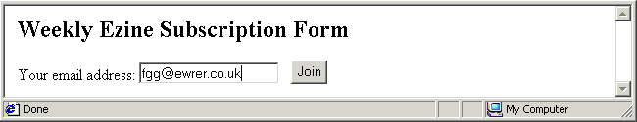
Enter some correctly and incorrectly formatted email addresses to verfiy that JavaScript code performs the relevant syntax checks. Note that the code does not catch all possible errors. For example, it does not test that there is at least two characters after the period (.). You can close the file when finished.

Searching and Replacing String Content
JavaScript’s search() method is similar to the indexOf() method, with one difference: you cannot specify a starting character position with search() like you can with indexOf(). All string analyses involving the search() method begin at the start of the string. If the character or characters or not found by the method, it returns a value of -1. The following code provides a simple example.
var mystring = “ECDL goes from strength to strength”;
var str_location = mystring.search(“ECDL”);
It returns a value of 0, which the position in the string where ‘ECDL’ starts. If you searched for the word ‘strength’ within the string the search() method would return a value of 15 because the first occurrence of this word starts at that location.
The replace() method, as its name suggests, replaces one character or series of characters with an alternative. It replaces only the first occurrence of the searched-for character(s) in the relevant string. Within the method’s parenthesis you first type the text to find, then a comma, and then the alternative text. Here is a simple example.
var mystring = “ECDL goes from strength to strength”;
var mystring = mystring.replace(“ECDL”, “ICDL”);
document.write(mystring);
The output from this code is as shown below.
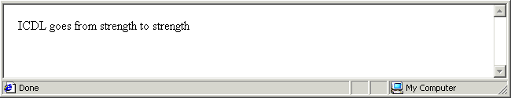
Suppose you use the replace() method to substitute the word ‘success’ for the word ‘strength’ as shown in the following code. What would the output be?
var mystring = mystring.replace(“strength”, “success”);
The answer is provided by the screenshot below. As you can see, only the first occurrence of the word ‘strength’ has been replaced.
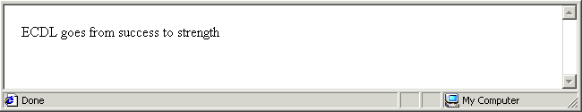

Converting Strings to Arrays
You can convert a string to an array with the split() method. In the parenthesis you enter the separator character present in the string. This tells JavaScript where one element of the array is to end and the next one is to begin. Obviously, this method provides a useful result only with strings that contain a consistent separator (delimiter) character.
The example below examines a comma-separated variable, creates a new array, converts the string’s content into array elements based on the comma separator, and writes each array element to the browser window.
var str_members = “Joanne,Sheila,Peter,Adam,Noelle”;
var array_members = str_members.split(“,“)
document.write(“First member: “+array_members[0]+”<BR>”);
document.write(“Second member: “+array_members[1] +”<BR>”);
document.write(“Third member: “+array_members[2] +”<BR>”);
document.write(“Fourth member: “+array_members[3]);
The output would look as shown below.
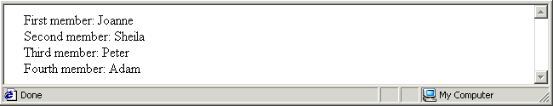
Sometimes you may not know how many elements the array will contain after the split is applied. In such situations you can use a for loop to display or otherwise work with all the array elements. For example.
for (i=1; i< array_members.length; i++)
document.write("Member Number: "+i+" - "+array_members[i]+"<BR>");

Substrings from Strings
JavaScript’s substring() method enables you to extract any portion of a string. It accepts two parameters:
- start: The position of the first character to return.
- end: The position of the first character after the portion to return. If you omit second parameter then the end point is taken to be the last character in the string.
The following code and accompanying table show the effect of the substring() method in action. All character positions are counted from zero.
var mystring = "This is a string";
Substring() Example | Result
mystring.substring(0, 4); | This
mystring.substring(1, 3); | hi
mystring.substring(8); | hi
mystring.substring(3, 3); | a string
The last example shows that when the start and end are equal, the method returns an empty string.

Exercise 5.63: Extracting Substrings from a String
- Open the following file in your text editor and web browser:
exercise_5-63_before.htm
In the document body you can see a HTML form that prompts the user for a string. When the user clicks the form button the attached event handler calls the ‘splitString’ function() in the document head. The function currently statements that capture the user’s entry and test its length.
- Insert the following code to create and display the required substrings.
/* Split string and display substrings*/
document.forms.myform.T2.value = user_string.substring(0,4);
document.forms.myform.T3.value = user_string.substring(0,10);
document.forms.myform.T4.value = user_string.substring(2,4);
document.forms.myform.T5.value = user_string.substring(3,8);
document.forms.myform.T6.value = user_string.substring(6,7);
document.forms.myform.T7.value = user_string.substring(2,16);
document.forms.myform.T8.value = user_string.substring(10,12);
document.forms.myform.T9.value = user_string.substring(13,20);
document.forms.myform.T10.value = user_string.substring(1);
document.forms.myform.T11.value = user_string.substring(10);
- Save your file with the following name and reload your web browser.
exercise_5-63_after.htm
- Test your script by entering some text and clicking the button. The browser window should look as shown below. You can close the file when finished.
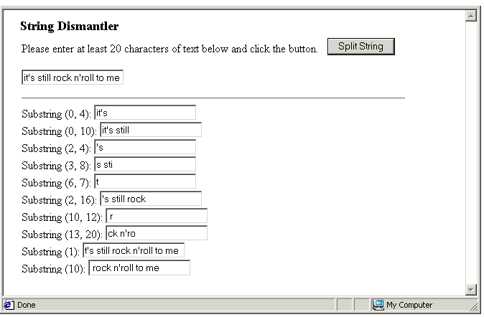

Chapter Summary
Every time you declare a new string variable JavaScript creates a new instance of its built-in String object. A string object has only one property – its length – but has a very wide range of methods that enable scripts to manipulate the string. Whichever type of method you apply to a string, you must set the string equal to the result of the method operation. The following code declares a variable, assigns a value to it, and then applies a method to the variable that converts its content to uppercase characters.
var fName = “john”;
fName = fName.toUpperCase;
String formatting methods enable you to apply font effects such a bold and italic to a string, and change the case of its characters from lower to upper, and vice versa.
String analysis methods allow you to examine the contents of a string. For example, the charAt() method enables you to identify the character located at a specified position a string. You can use charAt()in combination with a for loop to read through each character in a string. Add some if statements and you can test the value of each individual character in the string.
for (i= 0; i < mystring.length; i++)
oneChar = str.charAt(i)
if (oneChar ==”y”) {
window.alert(“String contains the letter ‘y’.”);
}
else { window.alert(“String does contains the letter ‘y’.”); }
}
The indexOf () method allows you to determine whether a string contains a specified character or not. It shows only the first occurrence of the relevant character(s) within the string. If it fails to find any instance of the relevant character(s), the indexOf() method returns a -1. The example below tests for the presence of the ‘@’ symbol.
if (user_email.indexOf(“@”) == -1 ) {
window.alert(”You entered an invalid address. Please try again.”);
}
JavaScript’s search() method is similar to the indexOf() method, with one difference: you cannot specify a starting character position with search() like you can with indexOf().The replace() method replaces one character or series of characters with an alternative. It replaces only the first occurrence of the searched-for character(s) in the relevant string. Here is a simple example.
var mystring = “ECDL goes from strength to strength”;
var mystring = mystring.replace(“ECDL”, “ICDL”);
document.write(mystring);
You can convert a string to an array with the split() method. In the parenthesis you enter the separator character present in the string. This tells JavaScript where one element of the array is to end and the next one is to begin. Obviously, this method provides a useful result only with strings that contain a consistent separator (delimiter) character.
With the substring() method you can extract parts of a string from the entire string. In the example of the email address ‘joe@bloggs.com’, you could extract the domain name of ‘bloggs.com’.

Working With the Math Object

Objectives
In this chapter you will learn how to:
- Create a new instance of the JavaScript Math object and assign its value to a variable
- Apply the main methods of the Math object, such as sqrt(), sin(), max() and pow(), to literals or numeric values
- Use the round() method to round floating point numbers to the nearest integer
- Use the random() method to generate random numbers
- Control the output of the random() method to produce only integers within a specified lower and upper range
- Recognise the circumstances in which JavaScript calculations can generate the following special numbers: Infinity, -Infinity and NaN.

Vocabulary
There are no new terms in this chapter.

Exercise Files
In this chapter you will work with the following HTML files:
- exercise_5-64_before.htm
- exercise_5-65_before.htm

Beyond Arithmetic
JavaScript’s Math objects holds a set of methods and constants (such as pi) to support operations that are more complex than simple addition, subtraction, multiplication and division.
Constants of the Math Object
To use a property that returns a constant value (such as pi), you would write something like the following.
var my_number=Math.property;
Replace the word ‘property’ with the property you want to use. So, if you want to use the value of pi in a variable, you would use the PI property of the Math object.
var my_pi=Math.PI;
This returns the pi constant, a number with lots of decimals, or 3.14...

Methods of the Math Object
To use a method, which performs a calculation, you would write something like this.
var my_house=Math.function(x);
Most of the Math methods have one or more parameters, represented above by ‘x’, and these can be literal numbers or variables. You would replace the word ‘function’ with the function you want to use. For instance, if you want the square root of a number, you can call the square root method of the Math object with the variable containing the number as the parameter.
var pocket_money = 12;
pocket_money=Math.sqrt(pocket_money);
document.write("<B>Pocket Money Squared: </B>"+pocket_money);
This calculates and displays the square root of 2, which is another number with lots of decimals, around 3.46...
The following table shows some commonly-used Math methods. Notice that the ‘M’ in Math is always capitalised. The word ‘Math’ is followed by the dot operator (.), and then the property or member function you want to use.
Method Function | What it Does
abs(x) | Returns the absolute (always positive) value of the variable x.
sqrt(x) | Returns the square root of the variable x.
cos(x) | Returns the cosine of the variable x.
sin(x) | Returns the sine of the variable x.
tan(x) | Returns the tangent of the variable x.
log(x) | Returns the natural log of the variable x.
max(x,z) | Returns the larger of the two variables x and z.
min(x,z) | Returns the smaller of the two variables x and z.
pow(x,z) | Returns the value of the variable x to the z^{th} power.
random() | Returns a random number between 0 and 1.
round(x) | Returns the variable x rounded to the nearest integer.

Exercise 5.64: Applying Math Methods
- Open the following file in your text editor and web browser:
exercise_5-64_before.htm
In the document body is a HTML form with a number of text boxes, and a button with an attached onclick() event handler that calls the calc() function in the document head. Various statements in the function capture and process the user’s number entries.
You need only to write the code for applying the Math object to the entered numbers.
- Insert the following code to find the larger of the two entered numbers.
/* Find larger number */
var larger_num = Math.max(first_num, second_num);
document.forms.myform.T3.value = larger_num;
- Insert the following code to find the smaller of the two entered numbers.
/* Find smaller number */
var smaller_num = Math.min(first_num, second_num);
document.forms.myform.T4.value = smaller_num;
- Insert the following code raise the first number to the power of the second.
/* Find first to power of second */
var xy_pow = Math.pow(first_num, second_num);
document.forms.myform.T5.value = xy_pow;
- Insert the following code raise the second number to the power of the first.
/* Find second to power of first */
var yx_pow = Math.pow(second_num, first_num);
document.forms.myform.T6.value = yx_pow;
- Insert the following code find the sine value of the third number.
/* Find sine */
var sin_value = Math.sin(trig_num);
document.forms.myform.T8.value = sin_value;
- Insert the following code find the cosine value of the third number.
/* Find cosine */
var cos_value = Math.cos(trig_num);
document.forms.myform.T9.value = cos_value;
- Insert the following code find the tangent value of the third number.
/* Find tangent */
var tan_value = Math.tan(trig_num);
document.forms.myform.T10.value = tan_value;
- Save your file with the following name and refresh your web browser.
exercise_5-64_after.htm
Enter various numbers and click the ‘Calculate Now!’ button to verfiy that JavaScript code performs correctly. You can close the file when finished.
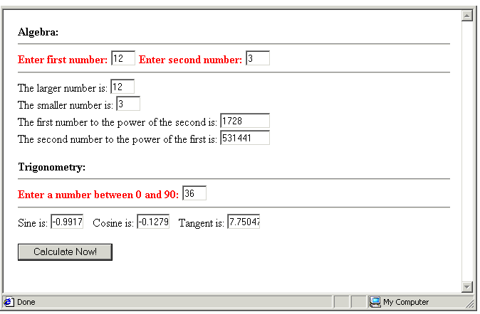

Rounding Number Values
There are two ways in which you may want to ‘fine-tune’ the numbers that you are working with in JavaScript.
- Displayed number of decimal places: When working with financial amounts, for example, you might want your numbers to be displayed in the browser window to two places of decimals. If the result of a calculation is ‘23.5’, you might prefer it to be displayed as ‘23.50’.
You can use the toFixed(n) method to display a number to n decimal places. The following code writes the numbers ‘19.74’ and ‘24.00’ respectively to the browser window.
var mynum = 19.74536363636;
var mynum1 = 24;
mynum = mynum.toFixed(2);
mynum1 = mynum1.toFixed(2);
document.write(“24 to two places of decimals: “+mynum);
document.write(“19.74536363636 to two places of decimals: “+mynum1);
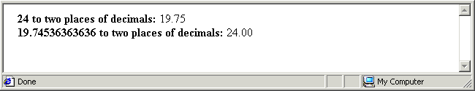
Because the toFixed() method has the effect of changing the variable type from a number to a string, you would use it only at the very end of a series of calculation statements.
- Value rounding: In calculations with floating point numbers you may want to round off the numbers so that your answer is shown to the nearest integer. If the decimal portion of the number is less than .5 (for example, 22.43), the number is rounded down (to 22). If greater than .5 (for example (21.66), it is rounded up (to 22).
The following code writes the number ‘20’ to the web browser window.
var num = 19.7;
num = Math.round(num);
document.write(num);

Generating Random Numbers
The random() method of the Math object returns a randomly generated number between 0 and 1. For example, 0.16275925357906878 or 0.8381539139574374. Note that neither 0 nor 1 is ever generated.
var random_num = Math.random();
You can adjust the output of the random() method to create a value within a number range that suits your needs. The following code, for example, returns a number in the range 0 to 999. For example, 591.5680951739324 or 11.370709206110163.
var random_num = Math.random() * 1000;

Returning Only Integers
To ensure that only integers are returned, apply the round() method to the output of the random method() as shown below. This statement produces numbers in the range 0 to 1000.
var random_num = Math.round(Math.random() * 1000);

Avoiding the Return of Zero
Sometimes you will want your random number to fall within a much smaller range. Suppose that you have three images, for example, named image1.gif to image3.gif. You can instruct JavaScript to select an image at random and display it in the browser window with the following code.
var random_pic = Math.round( (Math.random() * 3) );
document.write(“<IMG SRC='image"+random_pic+".gif+'”);
But wait: two problems exist with the first of the two above statements:
- It is possible that the integer produced by the above statement may be the integer 0. This will happen if the random() method produces a number such as 0.1111539139574374, which is multiplied by 3 and then rounded downwards to 0.
- The range of numbers that can be produced are 0, 1, 2 and 3. This is a set of four numbers. You only wanted a range of three numbers.
You can remedy these two problems by adding the number 1 before applying the round() method, and multiplying the output of the random method by 2 rather than by 3 as follows.
var random_pic = Math.round( (Math.random() * 2) + 1);
The number produced by this statement will always be 1, 2 or 3, and the image reference will consequently be image1.gif, image2.gif or image3.gif.

Exercise 5.65: Generating a Random Quote
- Open the following file in your text editor and web browser:
exercise_5-65_before.htm
In the document body is a HTML form with a single text box, and an onload() event handler that calls the showQuote () function in the document head. The function contains code that declares a new array, populates its with four elements, and writes a randomly-selected element to the form’s text box.
You need only to write the code generating the random number.
- Insert the following code.
/* Generate random number from 1 to 4 */
var rand_num = Math.round( (Math.random() * 3) );
- Save your file with the following name and refresh your web browser.
exercise_5-65_after.htm
Reload the web page to verfiy that JavaScript code performs correctly. You can close the file when finished.
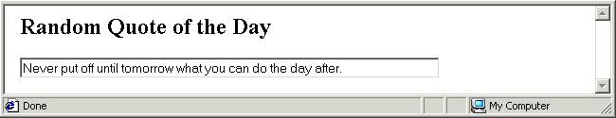

Special Numeric Values
There are several special numeric values used by JavaScript to represent numbers that are too large or small for scripts to handle, and for numbers that do not exist.

Numbers That Are Too Big or Too Small
When a floating-point number becomes too large in value for JavaScript to handle, the result is a special infinity value, which JavaScript displays as ‘Infinity’.
Conversely, when a negative value becomes more negative than JavaScript’s most negative representable number, the result is negative infinity, printed as ‘-Infinity’.
Numbers That Do Not Exist
Another special JavaScript numeric value is returned when a mathematical operation (such as division by zero) yields an undefined result or an error. In this case, the result is the special Not-a-Number value, displayed as ‘NaN’.
A special feature of the Not-a-Number value: it does not compare equally to any number, including itself! For this reason, a method named isNaN() is needed to test for occurrences of this value.

JavaScript Maths: A Warning
JavaScript was not designed for performing numerical analysis. Although it has improved with each release, its the precision is lower than that of other programming languages – even of Word or Excel.
When offering web pages that perform arithmetic calculations it is always a good idea to check JavaScript’s results against those obtained on an electronic calculator.

Chapter Summary
JavaScript’s Math objects holds a set of methods and constants (such as pi) to support operations that are more complex than simple addition, subtraction, multiplication and division. To assign the value of pi to a variable, you would use the PI property of the Math object as follows.
var my_pi=Math.PI;
Most of the Math methods have one or more parameters, which can be literal numbers or numeric variables. For example, if you want the square root of a number, you can call the square root method of the Math object with the variable containing the number as the parameter.
var pocket_money = 12;
pocket_money=Math.sqrt(pocket_money);
In calculations with floating point numbers you may want to use the round() method to round off the numbers so that your answer is shown to the nearest integer. If the decimal portion of the number is less than .5 (for example, 22.43), the number is rounded down (to 22). If greater than .5 (for example (21.66), it is rounded up (to 22).
The random() method of the Math object returns a randomly generated number between 0 and 1. For example, 0.16275925357906878. Note that neither 0 nor 1 is ever generated.
var random_num = Math.random();
You can adjust the output of the random() method to create a value within a number range that suits your needs. The following code, for example, returns a number in the range 0 to 999. For example, 591.5680951739324 or 11.370709206110163.
var random_num = Math.random() * 1000;
To ensure that only integers are returned, apply the round() method to the output of the random method() as shown below. This statement produces numbers in the range 0 to 1000, including 0 and 1000.
var random_num = Math.round(Math.random() * 1000);
The following statement produces any of the following numbers: 1, 2 or 3.
var random_num = Math.round( (Math.random() * 2) + 1);
JavaScript calculations can generate the following special numbers: Infinity (if the number is too large), -Infinity (number too small) and NaN (number does not exist).
JavaScript calculations are less precise than those performed by most other languages and by Microsoft Office applications.

Working With Dates and Times

Objectives
In this chapter you will learn how to:
- Create a new instance of the JavaScript date object and assign its value to a variable
- Extract the year, month, day of the month the day of the week, hours, minutes and seconds from a variable that contains a date
- Format the values in date variables to display month and day names
- Format the values in date variables to display times in terms of a 12-hour clock with AM and PM text
- Format the values in date variables to display minutes and seconds to two places of decimals
- Use the setTimeout() command to repeat a function continuously after a specified interval.
- Calculate the number of years, days or hours between any two specified events

Vocabulary
In this chapter you will meet the following terms:
- Universal Coordinated Time (UTC)

Exercise Files
In this chapter you will work with the following HTML files:
- exercise_5-66_before.htm
- exercise_5-67_before.htm
- exercise_5-68_before.htm

The Date Object
JavaScript’s Date object offers a range of methods for working with dates and times of the day. Here are three points to remember when manipulates dates and times in JavaScript:
- Milliseconds: JavaScript stores dates as the number of milliseconds that have passed since 1st January, 1970, Greenwich Mean Time (GMT).
- PC-based time: JavaScript takes the current date and time from the PC or other computer on which the visitor’s web browser is running. If a visitor’s date or time is incorrect, your script may still run without error but the values used by the script will be incorrect.
- Counting differences: JavaScript counts days of the week and months of the year from 0. For example, Sunday is day 0 and Wednesday is day 3. January is month 0 and October is month 9. Days of the month, however, are counted from 1.

Creating and Using Date Values
To work with a date in a script you must first create that date by creating a new instance of the Date object. Typically, you then assign that date to a variable. You can create a date in a number of ways. The simplest syntax is as follows.
var new_date = new Date();
document.write(“<B>Current Date and Time: </B>“+new_date);
JavaScript responds to these two statements by creating a variable called ‘new_date’, assigning the current date and time to the variable, and then writing the value of the variable to the browser window. It produces an output similar in format to the one shown below.
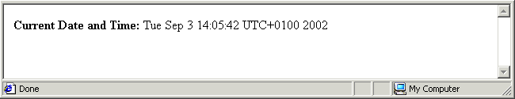
The value of the ‘new_date’ variable is fixed; it is not updated by JavaScript as times goes by. To view the latest date and time values, the web page visitor must refresh/reload the browser.
You can take control over the format and content of a date by inserting parameters within the parenthesis of the Date() object, and by applying methods to it.

Working With Date Components
Sometimes you will be interested only in part of a date. For example, you might be interested solely in the year, or the day of the month, or the hour of the day. JavaScript provides methods of the Date object that enable you extract this partial information and use it in your scripts.

Extracting the Year, Month, Day of the Month and Day of the Week
To extract the year, the month, the day of the month and the day of the week from a date, use the methods set out in the following table.

Date Method | Description
getFullYear() | This is a newer method that returns a four-digit year such as 1998. It is designed to replace the older getYear() method that returns only a two-digit year. The getFullYear() method may not work in older browsers.
getMonth() | January is counted as month 0. You may want to add 1 to this value so that January becomes month 1, February month 2, and so on.  For example:  curr_month = new_date.getMonth() + 1;
getDate() | Days of the month are counted from 1, so the 3rd of the month is counted by JavaScript as day 3.
getDay() | Days of the week are counted from 0. You may want to add 1 to this value so that Sunday becomes day 1, Monday day 2, and so on.  For example:  curr_day = new_date.getDay() + 1;

Extracting the Hours, Minutes and Seconds
To extract the hour of the day, minute of the hour, and seconds of the minute from a JavaScript date, use the methods set out in the following table. There is no need to adjust the output from any of these methods.
Date Method | Description
getHours() | Returns the hour of the day in 24-hour format, counting from 0 to 23.
getMinutes() | Returns the number of minutes in the hour counting from 0 to 59.
getSeconds() | Returns the number of seconds in the minutes counting from 0 to 59.

Exercise 5.66: Extracting Components From a JavaScript Date
- Open the following file in your text editor and web browser:
exercise_5-66_before.htm
In the file you can see that a new instance of the Date object is created and assigned to a variable named ‘new_date’.
var new_date = new Date();
document.write("<B>Current Date and Time: <\/B>"+new_date+"<BR><BR>");
Various date components are then assigned to different variables, and the values are output to the browser window with a series of document.write() statements.
- JavaScript counts the months of the year from 0. Edit the getMonth() method as shown below to count from 1 instead.
var current_month = new_date.getMonth()+1;
- JavaScript counts the days of the week from 0. Edit the getDay() method as shown below to count from 1 instead.
var current_day_week = new_date.getDay()+1;
- Save your file with the following name and reload your web browser.
exercise_5-66_after.htm
The output should look as shown below. You can close the file when finished.
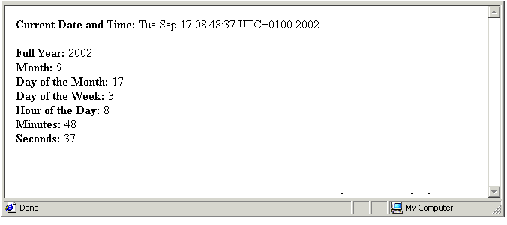

Creating JavaScript Clocks
The default output from JavaScript’s data object is not always the most user-friendly. By adding some statements you can produce attractive, continuously-updated on-screen clocks.

Formatting Months and Days
JavaScript’s getMonth() method returns the current month of the year as an integer. You can convert this integer to a friendlier month name with if statements such as those such below.
if (current_month == 0) {
current_month ="January";
}
if (current_month ==1) {
current_month ="February";
}
if (current_month ==2) {
current_month ="March";
}
…
Similar code can be used for converting the integer returned by the getDay() method to the name of the particular day of the week.
if (current_day == 0) {
current_day ="Sunday";
}
…

Formatting a 12-hour Clock
The getHours() method returns the number of hours in the day, counting from 0 to 23. To create a 12-hour clock, you need to subtract 12 from the variable that contains the number of hours in the day whenever the variable has a value greater than 12. For example.
if (current_hours >= 13) {
current_hours = current_hours - 12;
}
One hour of the day that this code does not cater for is midnight, which JavaScript shows as 0. So you need to change this occurrence of a 0 to a 12.
if (current_hours == 0) {
current_hours = 12;
}
The effect of these statements is to transform 14:30 to 2:30, and 18:15 to 6:15. Fifteen minutes after midnight is 12:15, as is fifteen minutes after midday.

Formatting AM and PM
The 12-hour clock formatted by the above code shows 3.15 for both mid afternoon and the small hours of the night. Is there a way to indicating whether the time shown is AM or PM? The solution is to define another variable and assign to it either ‘AM’ or ‘PM’ depending on the hour of the 24-hour day. In the example below the new variable is named ‘am_pm’.
var am_pm;
if (current_hours >= 12) {
var am_pm = “pm”;
}
else {
var am_pm = “am”;
}
You should place this code before the statements change the clock from a 24-hour to a 12-hour format. Otherwise, the hours will never get past 12, and the clock will always read AM.
Formatting Minutes and Seconds
Remember that when dealing with financial amounts you used the toFixed() method so that amounts were always shown to two places of decimals? A similar situation arises with the display of minutes and seconds. By default JavaScript displays three minutes past eleven as follows:
11:3
A friendlier clock would include a zero before the three, so that it displayed as follows:
11:03
You can achieve the desired effect with code such as the following.
if (current_minutes < 10) {
current_minutes = “0”+ current_minutes;
}
You can insert similar code to reformat the display of seconds.
if (current_seconds < 10) {
current_seconds = “0”+ current_seconds;
}

Formatting a Real-time Clock: The setTimeOut() Command
As you have learnt, a JavaScript variable containing a date or time is not updated continuously; in other words, it is not live. It simply shows the date and/or time when the web page was loaded, and remains static thereafter. Is there a way of displaying the latest date or time without the user reloading the page? Yes: the solution is to use the setTimeOut() command.
This is JavaScript’s way of continuously repeating a function. In the parenthesis you insert the name of the function you want to pause within double quotes, then a comma, and then the length of the pause between each repetition in milliseconds. For example:
setTimeout(“myfunction()”,1000);
This tells JavaScript to repeat the myfunction() indefinitely, pausing for one second between each repetition.
In Exercise 5.Date2 you will create a JavaScript clock that displays a live date and time within the text box of a HTML form.
Also, you can see that we use the setTimeout() function to run our startclock() function again after one second. In this way, the clock will refresh every second so that you get a constantly running clock with the seconds ticking away.

Exercise 5.67: Building a Live Clock and Calendar
- Open the following file in your text editor and web browser:
exercise_5-67_before.htm
In the file you can see that a new instance of the Date object is created and assigned to a variable named ‘new_date’. Various date components are then assigned to different variables.
The date variable is contained within a function named runClock() that is called by the web page’s onload event handler. A HTML form with text boxes is created in the document body to display the date and time information in the browser window.
- Insert the following code to append the text ‘am’ and ‘pm’ to the time information.
/* Prepare AM and PM values */
if (curr_hours>=12)
am_pm="pm";
else
am_pm="am";
- Insert the following code to translate the time from 24-hour to 12-hour format.
/* Convert 24-hour to 12-hour format */
if (curr_hours>=13)
curr_hours=curr_hours-12;
if (curr_hours==0)
curr_hours=12;
- Insert the following code to format the appearance of single-digit minutes and seconds.
/* Format minutes and seconds */
if (curr_seconds<10)
curr_seconds="0"+curr_seconds;
if (curr_minutes<10)
curr_minutes="0"+curr_minutes;
- Insert the following code to replace the first day of the week integer with its corresponding text name.
/* Show days of week as text */
if (curr_day_week==0) {
curr_day_week="Sunday"; }
Repeat this for the other six days of the week.
- Insert similar code for the months of the year. The code for the first month is as shown below.
/* Show months of year as text */
if (curr_month==0) {
curr_month_text="Janaury"; }
- JavaScript counts months from 0. Increment the month variable so that January is monht 1, February is month2, and so on.
/* Increment integer for current month */
curr_month=curr_month+1;
- Insert code to format the appearance of single-digit months.
/* Format months */
if (curr_month<=9) {
curr_month="0"+curr_month; }
if (curr_day_month<=9) {
curr_day_month="0"+curr_day_month; }
- Insert code to display the date and time details in the text boxes of the HTML form.
/* Show date, time in HTML text boxes */
document.forms.clockform.T1.value=curr_hours+": "+curr_minutes+
" : "+curr_seconds+" "+am_pm;
document.forms.clockform.T2.value=curr_day_week;
document.forms.clockform.T3.value=curr_month_text;
document.forms.clockform.T4.value=curr_day_month+"/"+curr_month+
"/"+curr_year;
- Ensure that the date and time details are updated every second (where one second is equal to one thousand milliseconds).
/* get fresh time every 1,000 milliseconds */
setTimeout("runClock()",1000);
- Save your file with the following name and reload your web browser.
exercise_5-67_after.htm
The output should look as shown below. You can close the file when finished.
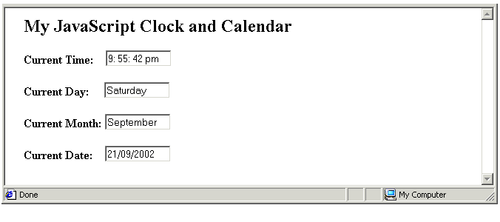

About Time Zones
By default JavaScript’s Date object shows times in terms of UTC and the local time zone. UTC or Universal Coordinated Time is the same is GMT or Greenwich Mean Time. The local time zone is set on the PC or other computer of the web page visitor. In the example below the ‘UTC+0100’ means that the local time, Irish daylight saving (summer time) is one hour ahead of GMT.
Universal Coordinated Time (UTC)
By default JavaScript stores date and time details in terms of UTC or Universal Coordinated, and the local time zone. UTC is the same as GMT or Greenwich Mean Time.

Working With Non-Current Dates and Times
The date and time that you may want to work with in script may not always be today’s date and the current time. For example you may want to calculate:
- How many years, days or hours before a specified future event
- How many years, days or hours since a specified past event
- How many years, days or hours between any two specified events
You can create a non-current date value in any one of three ways.
- Dates Only: The first format contains numbers, and includes only the year, month and day. See the example below.
myDate = new Date(2001, 12, 26);
This is referred to as the yyyy, mm, dd date format.
- Dates and Times: The second format contains includes hours, minutes and seconds. Again, a comma separates the different time components.
myDate_Time = new Date(1985, 10, 17, 11, 5, 0);
This is referred to as the yyyy, mm, dd, hh, mm, ss format.
- Dates and Times (text): The third format contains, within double quotes, the month name, day, year, hours, minutes and seconds as shown below. Note the comma after the month name and the colons between the hours and minutes, and minutes and seconds.
myDate_Time = new Date(“September 24, 1997 11:05:00”);
This is referred to as the month, dd, yyyy, hh:mm:ss date format.
A simple time difference application would be one that calculates the time gap between the loading of a web page and the moment when the visitor clicks a button on that page. This application requires two functions:
- The first function extracts the current time from the user’s PC, and assigns it to a variable.
function beginTimer() {
startTime = new Date();
}
It is called by the onload event handler. The time it records is therefore the time when the page loaded in the browser window.
<BODY onload="beginTimer()">
- The second function is called when the user clicks a button on the web page.
<BUTTON onclick="endTimer()">Purchase Now!</BUTTON>
This function extracts the current time from the user’s PC, assigns it to a second variable, calculates the difference between the two time variables, and then displays the result.
function endTimer() {
stopTime = new Date();
var elapsedTime = stopTime - startTime;
window.alert("You spent "+ (elapsedTime/1000)+" seconds viewing this
page.”)
}
What about the two variables that store the load and button-click times? Where are they declared? The answer is theta they must be declared before and outside both functions. If you declare them within either function, they will be available to that function only and not to any other part of the script.
<SCRIPT LANGUAGE="JavaScript" TYPE="text/javascript">
var startTime;
var stopTime;
Notice that the elapsed time is divided by 1000 before it is displayed on the window.alert() box. That is because JavaScript dates and times are stored in milliseconds. To express a variable that contains a date or time difference in days you would divide the relevant variable as follows.
elapsedDays = elapsedDays/(24*60*60*1000);
In Exercise 5.68 you will create a HTML form that accepts a date of birth from a web page visitor, and then displays the numbers of days since that entered date to the current date.

Exercise 5.68: Calculating the Days Since Birth
- Open the following file in your text editor and web browser:
exercise_5-68_before.htm
In the document head you can see a function named ‘carpeDiem()’ that captures details from the HTML form in the document body. The function also applies the parseInt() method to the variables to convert them to numbers. The web page visitor calls this function by clicking the form’s ’Calculate Now’ button.
- JavaScript counts the months of the year from 0. Given that users will enter January as month ’1’ and February as month ‘2’, you need to decrement the entered month number as follows.
/* Decrement month */
user_month = user_month-1;
- Insert a statement to create anew date from the user-entered details.
/* Create date of birth */
var date_dob = new Date(user_year, user_month, user_day);
- Insert a statement that retrieves the current date from the user’s PC.
/* Get current date */
var date_curr = new Date();
- Find the difference between the two dates, convert the answer to a number of days, and make the answer an integer.
/* Find difference */
var dateDiff = date_curr - date_dob;
dateDiff = dateDiff/(1000*60*60*24);
/* Remove decimal places */
dateDiff = Math.round(dateDiff);
- Insert a stamtnet that displasy the result of your calculation in a text box of the HTML form.
/* Display result */
document.forms.myform.T4.value = dateDiff;
- Save your file with the following name and reload your web browser.
exercise_5-68_after.htm
The output should look as shown below. You can close the file when finished.
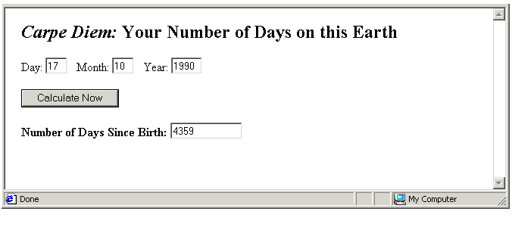

Chapter Summary
JavaScript’s Date object offers a range of methods for working with dates and times of the day. JavaScript stores dates as the number of milliseconds that have passed since 1st January, 1970, Greenwich Mean Time (GMT). JavaScript takes the current date and time from the PC or other computer on which the visitor’s web browser is running. JavaScript counts days of the week and months of the year from 0. Days of the month, however, are counted from 1.
To work with a date in a script you must first create that date by creating a new instance of the date object. Typically, you then assign that date to a variable. You can create a date in a number of ways. The simplest syntax is as follows.
var new_date = new Date();
JavaScript responds to this statement by creating a variable called ‘new_date’, and assigning the current date and time to the variable.
If you are interested in only part of the date – such as the year or the day of the month JavaScript provides methods of the date object that enable you extract this partial information and use it in your scripts. JavaScript’s getMonth() method returns the current month of the year as an integer. You can convert this integer to a friendlier month name with if statements such as those such below.
if (current_month == 0) {
current_month ="January";
}
Similar code can be used with the getDay() method.
if (current_day == 0) {
current_day ="Sunday";
}
A JavaScript variable containing a date or time is not ‘live’. It simply shows the date and/or time when the web page was loaded, and remains static thereafter. The setTimeOut() command enables you to repeat a function continuously after a specified interval, expressed in milliseconds. The following tells JavaScript to repeat the myfunction() indefinitely, pausing for one second between each repetition.
setTimeOut(“myfunction()”,1000);
You can create a non-current date value in a number of ways. For example, you can use the yyyy, mm, dd date format to specify only date information as follows.
myDate = new Date(2001, 12, 26);
Another option is to use the yyyy, mm, dd, hh, mm, ss format to include hours, minutes and seconds as follows.
MyDate = new Date(1985, 10, 17, 11, 5, 0);
When two dates are specified in a script – one of which might be the current date – you can then find the difference between the two with code such as that below.
var elapsedTime = stopTime - startTime;
To express a variable that contains a date or time difference in days you would divide the relevant variable as follows.
elapsedDays = elapsedDays/(24*60*60*1000);

Working With Images and Animations

Objectives
In this chapter you will learn how to:
- Create a new instance of the JavaScript image object and assign its value to a variable
- Read and apply the set properties methods of the Image object, such as src, width and height
- Create an image rollover
- Preload the images used in a rollover
- Create a scrolling text effect

Vocabulary
- Rollover

Exercise Files
In this chapter you will work with the following HTML files:
- exercise_5-69_before.htm
- exercise_5-70_before.htm
- exercise_5-71_before.htm
- exercise_5-72_before.htm

About the Image Object
JavaScript handles images as subobjects of the document object, which represents the document currently loaded in the web browser window. It creates a new image object for each <IMG> tag in the document. The entire set of images in a HTML document is referred to as the document’s image collection. You can refer to an image in a script in the following way.
document.images.imagename
Image Properties
The properties of an image object correspond largely to the attributes of the HTML <IMG> tag. The main ones are listed in the table below.
Image Property Name | Description
src | The absolute or relative URL of the image.
name | The value of the image’s HTML name attribute, if defined.
align | The alignment of the image, typically left or right.
height | The image’s height in pixels or percentage terms.
width | The image’s width in pixels or percentage terms.
border | The border surrounding the image, in pixels.
complete | A true or false value indicating whether or not the image is loaded in the browser window.
All the above image properties are scriptable – that is, they can be both read and modified by JavaScript statements. The following statement assigns the height of an image called ‘myimage.gif’ to the variable named ‘img_height’.
var img_height = document.images.myimage.gif;
The code below sets the height of the ‘myimage.gif’ image to whatever value is contained in the ‘img_height’ variable.
document.images.myimage.gif = var img_height;
Image Event Handlers
Images in JavaScript support the event handlers that you can attach to buttons, such as onclick, ondblclick, onmouseover and onmouseout. Images also support the onload event handler that you have previously used only with an entire web page.

Exercise 5.69: Scripting Image Width and Height
- Open the following file in your text editor and web browser:
exercise_5-69_before.htm
In the document body is a form with two text boxes, and a button with an attached onclick event handler that calls the ‘reSize()’ function in the document head. The function contains only comments.
- Enter the following variable declarations in the function.
/* Declare variables */
var img_height;
var img_width;
- Enter statements to capture the user’s entries as follows.
/* Capture user entries */
img_width = document.forms.myform.T1.value;
img_height = document.forms.myform.T2.value;
- Verify that the form user has entered values in both text boxes, and display an error message if not.
/* Check entries exist */
if ((img_width =="") && (img_height=="" )) {
window.alert("Please enter width and height values.");
}
- By default text box entries are string variables. Change these to numeric variables as shown below.
else {
/* Change strings to numbers */
img_height = parseInt(img_height);
img_width = parseInt(img_width);
- Enter the code that resizes the image, and close the else statement.
/* Resize image */
document.mypic.height = img_height;
document.mypic.width = img_width;
}
- Save your file with the following name and reload your web browser.
exercise_5-69_after.htm
Save the file and reload your web browser. Verify that your code works correctly by entering some size values and clicking the ‘Resize Image’ button. You can close the file when finished.
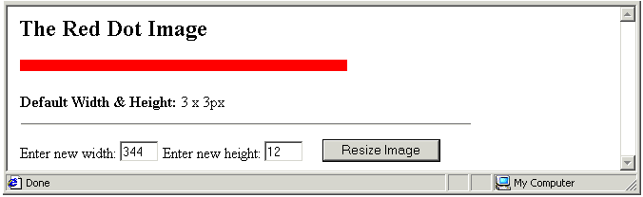

Working With Image Rollovers
Earlier web browsers allowed only one property of an image to be scripted: the src property, which contains the image’s URL. For this reason so-called image rollovers were the first image effects to be created with JavaScript. A rollover is an image (typically a navigation-related image) that changes when the user moves the mouse over it.
In the simplest case an <IMG> tag displays an image with a name property of ‘mypic’ and a URL property of ‘image1.gif’. When the web page visitor moves the mouse over it, this action calls a function that changes the src property of the image to the URL of a second image, say ‘image2.gif’.
Here are two functions that can create such as rollover effect.
/* Default image */
function mouseAway () {
document.images.mypic.src = ‘image1.gif’;
}
/* Rollover image */
function mouseOn() {
document.images.mypic.src = ‘image2.gif’;
}
The HTML and the event handler might look as follows. (All the code should be written on a single line.)
<IMG SRC =’image.gif’ NAME = ‘mypic’ WIDTH = ‘60’ HEIGHT =’48’
onmouseover=”mouseOn()”; onmouseout =”mouseAway()”>
Two points to note about image rollovers:
- Both the original and replacement images should have the same dimensions.
- If the images are GIFs, ensure that neither is transparent.
Image Rollover
An image that changes when the web page visitor moves the mouse over it. Rollover effects are most commonly used for images related to web site navigation.

Exercise 5.70: Creating a Simple Image Rollover
- Open the following file in your text editor and web browser:
exercise_5-70_before.htm
In the document body is an <IMG> tag with NAME, WIDTH and HEIGHT attributes, and two event handlers: onmouseover and onmouseout. In the document head are two empty functions.
- In the mouseAway() function insert the following statement.
document.images.mypic.src = 'sitemap_off.jpg';
- In the mouseOn() function insert the following statement.
document.images.mypic.src = 'sitemap_on.jpg';
- Save your file with the following name and reload your web browser.
exercise_5-70_after.htm
Verify your rollover code by moving the mouse over, and then away from, the button image. The output should look as shown below. You can close the file when finished.
mouseAway() mouseOn()

Preloading Images
A web browser, by default, retrieves an image from the web server only when it needs to display it for the first time. The replacement image in Exercise 5.70 is retrieved from the server when the user first moves the mouse over it. If the web page visitor has a slow Internet connection, there may be a noticeable delay in displaying the replacement image.
The solution is to preload all images by creating instances of the Image object, and then populate the instances with the names and URLs of the image files. You place the code for preloading the images in the head of the HTML document. Exercise 5.71 provides an example.

Exercise 5.71: Creating a Rollover with Preloaded Images
- Open the following file in your text editor and web browser:
exercise_5-71_before.htm
In the document body is an <IMG> tag with NAME, WIDTH and HEIGHT attributes, and two event handlers: onmouseover and onmouseout. In the document head is an empty script tag.
- After the opening <SCRIPT> tag in the document head insert the following two pairs of statements. Each pair assigns a new instance of the Image object to a variable, and then sets the src property of the variable to the URL of an image file.
var button_on = new Image;
button_on.src = 'sitemap_on.jpg'
var button_off = new Image;
button_off.src = 'sitemap_off.jpg'
- Insert the mouseAway() function as shown below.
function mouseAway() {
document.images.mypic.src = button_off.src;
}
- Insert the mouseOn () function as shown below.
function mouseOn () {
document.images.mypic.src = button_on.src;
}
- Save your file with the following name and reload your web browser.
exercise_5-71_after.htm
Verify your rollover code by moving the mouse over, and then away from, the button image. You can close the file when finished.

Animating Text with JavaScript
One of the more common animations created with JavaScript is scrolling text – that is text that moves left or rightwards across the browser window or status bar. In fact, scrolling text does not scroll at all – the underlying code simply extracts one character at a time from the string, and nudges it one position to the left or right. A setTimeout() method is applied to the scrolling function, so that it repeats indefinitely after a predefined interval defined in milliseconds. Exercise 5.72 provides an example.

Exercise 5.72: Creating Text That Scrolls
- Open the following file in your text editor and web browser:
exercise_5-72_before.htm
In the document body you can see a single text box. The <BODY> tag contains on onload event handler that calls the ‘scrollWords()’ function in the document head.
In the document head are two variable declarations: the first contains the text itself, and the second a number of spaces. The text and spaces are then concatenated.
- At the start of the scrollWords() function insert the following statement to extract the first character from the text string and store it in a variable.
/* Extract first character from text */
var temp = scroll_text.substring(0,1);
- Insert a statement to append the single extracted character at the end of the text string.
/* Include extracted character at end of text string */
scroll_text = scroll_text+temp;
- Insert a statement to extract all characters from the string except the first.
/* Extract characters from text string, except first */
scroll_text = scroll_text.substring(1,scroll_text.length);
The new string is similar to the original string but has one important difference: the first character has been removed and repositioned at the end of the string. This has the effect of creating a new string that is ‘nudged’ one position to the left.
- Insert a statement to display the new string in the form’s text box.
/* Display string in text box */
document.forms.myform.T1.value = scroll_text;
- Insert a setTimeout() command to repeat the scrolling action continuously after 50 millisecond intervals.
/* Repeat scrolling function */
setTimeout("scrollWords()", 50);
- Save your file with the following name and reload your web browser.
exercise_5-72_after.htm
View the scrolling text effect in your web browser. The output should look as shown below. You can close the file when finished.
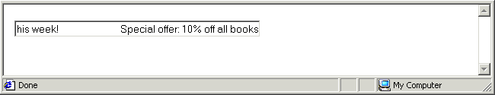

Chapter Summary
JavaScript handles images as subobjects of the document object, which represents the document currently loaded in the web browser window. It creates a new image object for each <IMG> tag in the document. The entire set of images in a HTML document is referred to as the document’s image collection. You can refer to an image in a script in the following way.
document.images.imagename
The properties of an image object correspond largely to the attributes of the HTML <IMG> tag. The main ones include src, width, height, border and align. All image properties are scriptable – that is, they can be both read and modified by JavaScript statements. The following statement assigns the height of an image called ‘myimage.gif’ to the variable named ‘img_height’. The code below sets the height of the ‘myimage.gif’ image to whatever value is contained in the ‘img_height’ variable.
document.images.myimage.gif = var img_height;
Images in JavaScript support the event handlers that you can attach to buttons, such as onclick, ondblclick, onmouseover and onmouseout. Images also support the onload event handler that you have previously used only with an entire web page.
A rollover is an image (typically a navigation-related image) that changes when the user moves the mouse over it. Rollover effects are most commonly used for images related to web site navigation. Both the original and replacement images should have the same dimensions. If the images are GIFs, ensure that neither is transparent.
A web browser, by default, retrieves an image from the web server only when it needs to display it for the first time. The replacement image in Exercise 5.70 is retrieved from the server when the user first moves the mouse over it. If the web page visitor has a slow Internet connection, there may be a noticeable delay in displaying the replacement image.
For a faster, smoother transition between images, preload all images by creating instances of the Image object, and then populate the instances with the names and URLs of the image files. You place the code for preloading the images in the head of the HTML document.
One of the more common animations created with JavaScript is scrolling text – that is text that moves left or rightwards across the browser window or status bar. In fact, scrolling text does not scroll at all – the underlying code simply extracts one character at a time from the string, and nudges it one position to the left or right. A setTimeout() method is applied to the scrolling function, so that it repeats indefinitely after a predefined interval defined in milliseconds.

