This is the Title

A Subtitle

This is a H1
The idea here is to export this to get an idea of the standard layout which a google doc uses, in order to produce something that generally looks like one.

This is a H2
The idea here is to export this to get an idea of the standard layout which a google doc uses, in order to produce something that generally looks like one.

This is a H3
As you can see.

This is a H4

This is a Subheading

This is a level below that
This is a test to see whether you can set different options for googdown, which might make images better looking, as currently they look pretty shite a lot of the time.
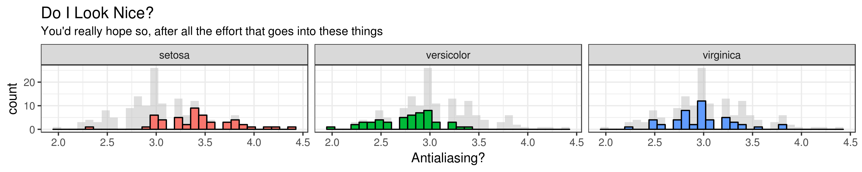
Figure 1. This is a thing right here. I'm writing a long caption to get an idea of how the text wraps, and things like that. This is going to be great.'
And this is some more text just below for reference. This is like a whole paragraph which could go on for a while.

