This is the Title

A Subtitle

## This is a H1

The idea here is to export this to get an idea of the standard layout which a google doc uses, in order to produce something that generally looks like one.

## This is a H2

The idea here is to export this to get an idea of the standard layout which a google doc uses, in order to produce something that generally looks like one.

### This is a H3

As you can see.

#### This is a H4

##### This is a H5

The idea here is to export this to get an idea of the standard layout which a google doc uses, in order to produce something that generally looks like one.

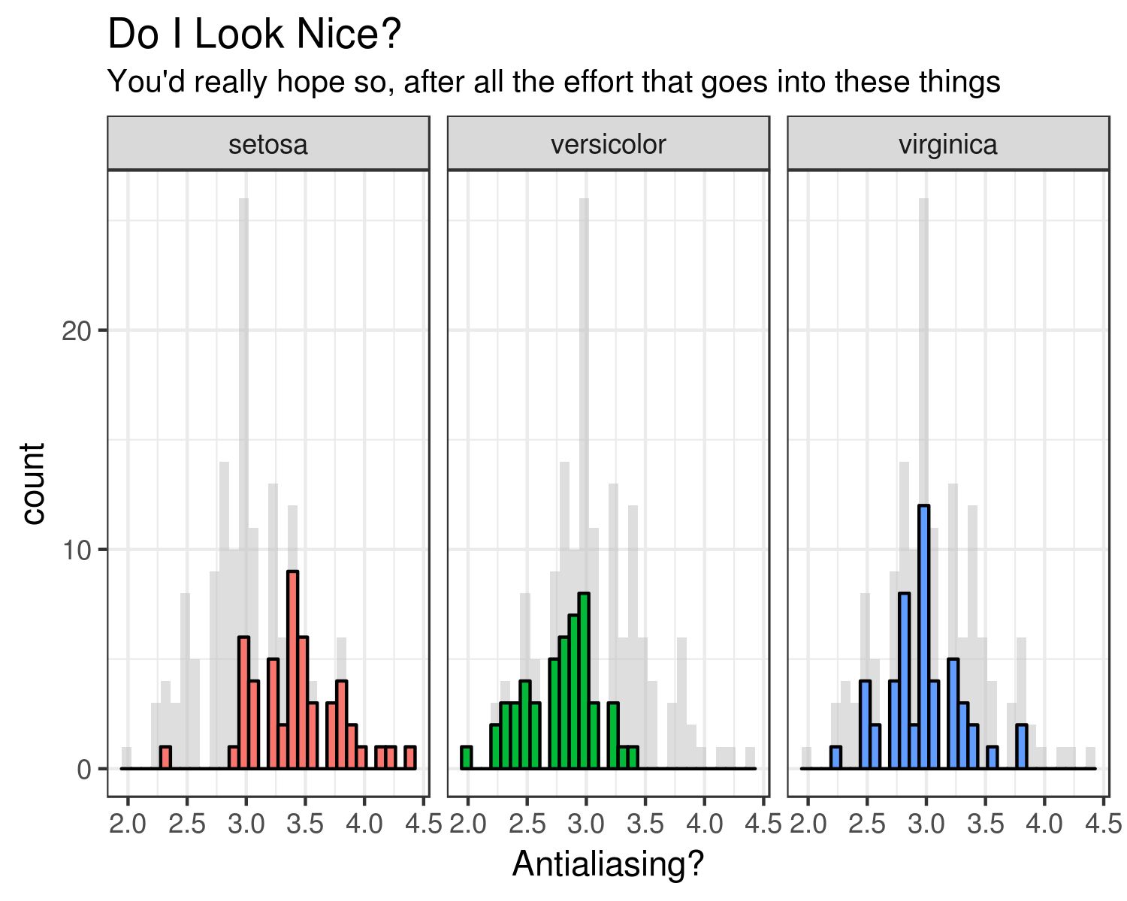

*Figure 1.* This is a thing right here. I'm writing a long caption to get an idea of how the text wraps, and things like that. This is going to be great.'

This is some regular text, just after that.