Cool file

*Jane Doe*

*December 26, 2016*

## Important Subheading

This is a sentence, which I've changed remotely. This is a new local sentence. My favorite number is 4.

Here's a plot:

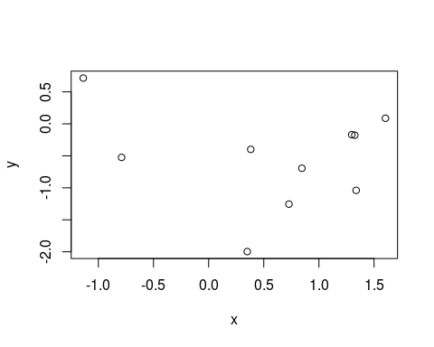

This is some new stuff which I've written right hurrrrr.

plot(d, main = "SECOND PLOT!?!?!")

