These are the CAN logs from a 2015 Volkswagen Golf GTE (Mk.7, MQB) gathered from the TIUL coupling point (Coupling Points). Each file is a log of separate CAN connection

Timeline: Vehicle sleep => IGN on => engine on => engine off => IGN off.

CAN connections
Connections tested, file timestamp from earliest:
T17e (upper pair)
Powertrain CAN - B384/B391
T17e (lower pair)
Running gear/dash panel insert CAN - B672/B676
T17d
Extended CAN - B108/B109
T17f
Infotainment / Hybrid CAN, not sure which one

The EPS (J500) is on the Running Gear CAN - connection B663 and B664, or Dash Panel Insert CAN - connection B672 and B676. (J500 Wiring Diagram)

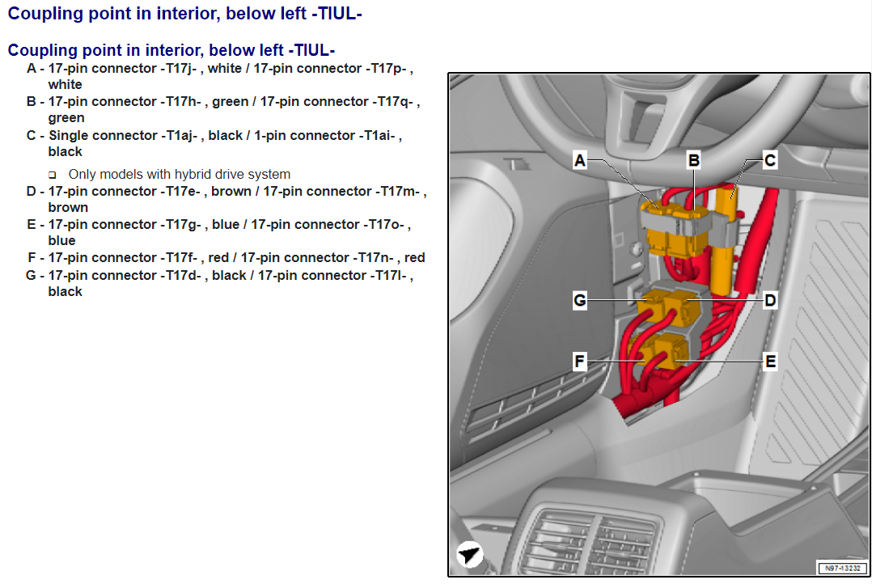

Connector PN

T17g/T17o (E in diagram)
Female - 4F0 972 575 D
Male - 4F0 972 483 D
Pinout
15 - +12V 10amp from Fuse 10 in Block B straight to J533, cable 1mm diameter

T17e/T17m (D in diagram)
Female - 4F0 972 575 A
Male - 4F0 972 483 A

Pinout
1 - CAN Drive HI B384
2 - CAN Drive LO B391
3 - CAN Chassis/IC HI B672
4 - CAN Chassis/IC LO B676
8 - Front Airbag Crash Sensor
9 - CAN ACC - HCA Direct
10 - Front Airbag Crash Sensor
11 - CAN ACC - HCA Direct
12 - +12V K15 a A38
15 - EPB Motor Connection 3 B791
17 - EPB Motor Connection 4 B792

T17d/T17l (G in diagram)
Female - 4F0 972 575
Male - 4F0 972 483

Pinout UNSURE
6 - CAN Convenience HI B398 / GND? UNSURE
9 - +12V K15a A20
11 - CAN Convenience LO B407
12 - CAN Extended HI B108
13 - CAN Extended LO B109

T17f/T17n (F in diagram)
Female - 4F0 972 575 B
Male - 4F0 972 483 B

EPS Connection
EPS connects to TML coupling point
Connector T6cj
Male - 4H0 973 713
Female - 3B0 973 813
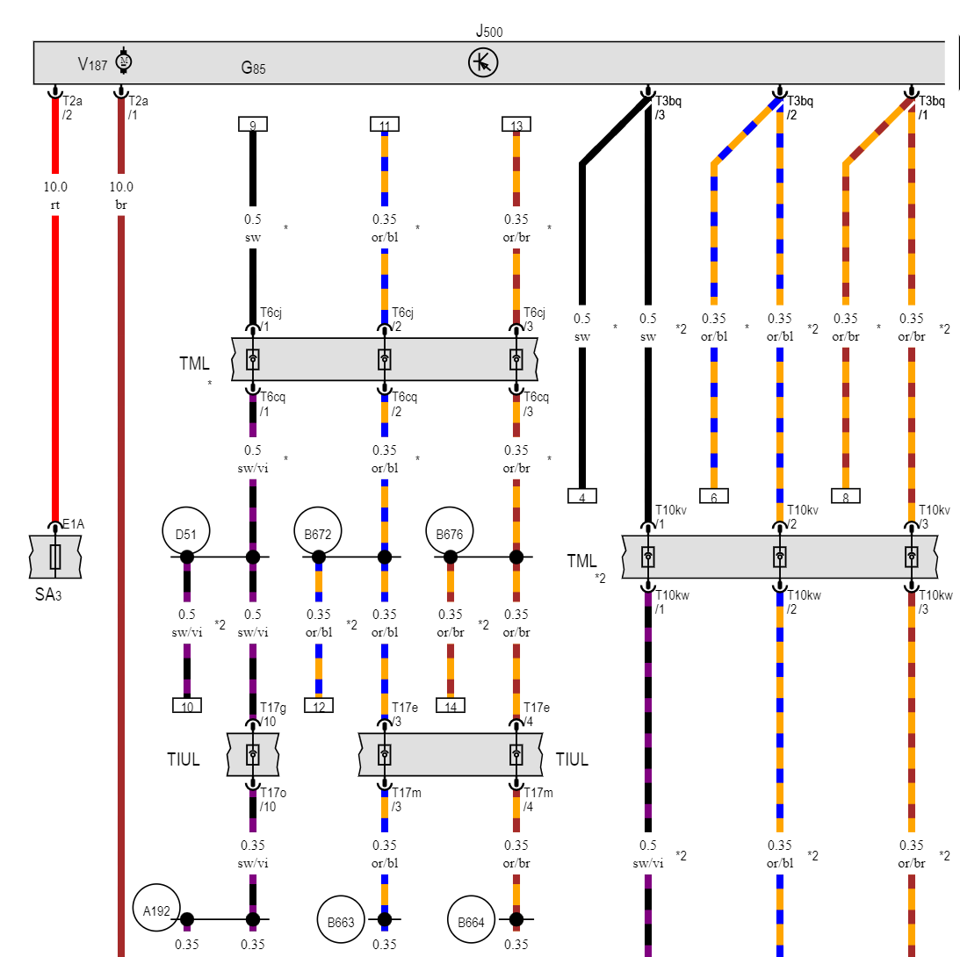
Coupling point in engine compartment, left -TML- , only models with hybrid drive system
A - 14-pin connector -T14q- , black / 14-pin connector -T14t- , black
B - 14-pin connector -T14z- , grey / 14-pin connector -T14v- , grey
C - 8-pin connector -T8au- , black / 8-pin connector -T8az- , black
D - 14-pin connector -T14aa- , grey / 14-pin connector -T14ab- , grey
E - 14-pin connector -T14ac- , black / 14-pin connector -T14ad- , black
