Software Requirements and Design Document

For

Group 9

Version 0.5 — Increment 2 (for team review)

Authors:
Olivia Anderson
Brendan Boedy
Gabriel Valladares-Ruiz
Jorge Fraile
William Brandon

DRAFT NOTES FOR THE TEAM — delete this block before submission
• v0.5 was drafted with AI assistance (Claude, by Anthropic) from the code on the main branch as of November 9, 2026 (commit 97791e3, after pull requests #25–#31), the ER model, RD v0.3, and Brendan’s RD v0.4 on main (LiftLog_RD_Draft_v0.4.docx, which also notes it was drafted with Claude). Every member should review and correct it before we submit, and the AI use must be recorded in our disclosure.
• v0.5 combines two v0.4 drafts. From Olivia’s draft: textual descriptions of all 29 use cases (Section 4), class and sequence diagrams (Section 5) and Sections 6–7. From Brendan’s draft on main (#30): the wording of FR-1, FR-4, FR-11, FR-13, FR-18, FR-21, FR-22, FR-24, FR-27, FR-32, FR-36, NFR-11 and NFR-13, and the Inc. column now showing when each requirement was delivered. New for #25 (Olivia): pages call templates “routines”, and the home page lists your routines. New for #26 and #28 (Brendan): the “Last time” hint and faster workout and history pages. Once this version is in the repository, LiftLog_RD_Draft_v0.4.docx can be removed.
• Each use case description has a Status row. “Built” means the feature is on main and covered by our automated tests; “Planned” means it is not built yet.
• Items highlighted in yellow still need a team decision.
• The diagrams are generated from text files in docs/requirements-design/diagrams/*.mmd. Edit them at mermaid.live and export a new PNG if the code changes.

Overview (5 points)
LiftLog is a web application for people who want to track their weight-training workouts, from beginners who need a place to start to experienced lifters with their own routines. Users create an account and build reusable workouts (workout templates) from a library of predefined exercises and exercises they create themselves, setting target sets and rep ranges for each one. Users can also start from a predefined workout, and can choose whether each of their own workouts is private or public. For users who are unsure where to start, LiftLog uses generative AI to suggest a workout based on information the user provides about themselves and their fitness level.
Each time users train, they log a workout session, usually started from one of their workouts, recording the weight and number of reps for every set. LiftLog keeps a clear distinction between a workout template (the plan) and a workout session (what was actually done on a given day), so users can change their plans without affecting their past records. Completed sessions form the user's workout history, and LiftLog displays charts of the user's progress on each exercise over time. Unlike many existing fitness apps, every feature is free, and each user's history is private.
In LiftLog’s pages, workout templates are called “routines” and workout sessions are called “workouts”. This document uses the technical terms, which match the database tables.

Functional Requirements (10 points)
Each requirement below is something the system shall do. Priority: High = required for a usable product; Medium = important but the product works without it; Low = desirable if time allows. “Inc.” is the increment in which the requirement was delivered. An asterisk (*) marks a requirement that is not built yet, with the increment it is planned for.
2.1 User accounts
ID | Requirement | Priority | Inc.
FR-1 | The system shall allow a visitor to create an account by providing a username and a password. The username must not already be in use. Usernames are 3–30 characters (letters, numbers, dots, dashes and underscores) and are compared without regard to upper or lower case. Passwords must be at least 8 characters and at most 72 bytes. | High | 1
FR-2 | The system shall allow a registered user to log in with their username and password, and shall show an error message without revealing which of the two was wrong when the credentials are invalid. | High | 1
FR-3 | The system shall allow a logged-in user to log out, after which private pages are no longer accessible until the user logs in again. | High | 1
FR-4 | The system shall allow a user to view and update their profile: goal type, experience level, body weight, age and gender. Decision: age and gender were added to the User table (they are not in the original ER model) because the AI suggestions (FR-33) use them. Every profile field is optional. | Medium | 2
FR-5 | The system shall allow a user to change their password after re-entering their current password. | Medium | 2
FR-6 | The system shall allow a user to permanently delete their account after confirming the action, which also deletes all of their custom exercises, workout templates, sessions and set entries. | Low | 3*

2.2 Exercises
ID | Requirement | Priority | Inc.
FR-7 | The system shall provide a library of predefined exercises, each with a name, muscle group, equipment type, movement type, difficulty and instructions. Predefined exercises are loaded into the database by the development team; there are no administrator accounts. | High | 2
FR-8 | The system shall allow a logged-in user to browse all predefined exercises together with the custom exercises they created. | High | 2
FR-9 | The system shall allow a user to view the full details of a single exercise. | Medium | 2
FR-10 | The system shall allow a user to search exercises by name and filter them by muscle group and equipment type. | Medium | 2
FR-11 | The system shall allow a user to create a custom exercise with the same details as a predefined exercise. A custom exercise shall be visible only to the user who created it. Decision: the Exercise table has an owner field (created_by), which is empty for predefined exercises. | High | 2
FR-12 | The system shall allow a user to edit the custom exercises they created. | Medium | 2
FR-13 | The system shall allow a user to archive a custom exercise they created. Archived exercises shall not be offered when adding exercises to a workout template or session, but shall still be displayed in existing templates and past sessions. A user can restore an archived exercise. | Medium | 2

2.3 Workout templates
ID | Requirement | Priority | Inc.
FR-14 | The system shall allow a user to create a workout template with a name, an optional description and a difficulty level. | High | 2
FR-15 | The system shall allow a user to add predefined or custom exercises to a template and set, for each one, a target number of sets and a rep range (minimum and maximum reps). | High | 2
FR-16 | The system shall display a list of the user's own templates and allow the user to open any of them to see its exercises in order. | High | 2
FR-17 | The system shall allow a user to edit a template's details and to change, remove or reorder the exercises in it. | Medium | 2
FR-18 | The system shall allow a user to delete one of their templates after confirming the action. Deleting a template shall delete its exercise entries but shall not delete past sessions that were started from it. Decision: confirmed. Sessions started from a deleted template are kept; their link to the template is cleared, and they keep their own copy of the template’s name. | Medium | 2
FR-19 | The system shall provide predefined workout templates that every user can view and use to start a session. | Medium | 2
FR-20 | The system shall allow a user to mark each of their templates as private or public. New templates shall be private by default. | Low | 2
FR-21 | The system shall allow a user to browse other users’ public templates and copy one into their own templates, where they can edit it. Decision: other users can view and copy a public template but never change it, and the creator’s username is shown. The copy is private to the user who made it, and any of the creator’s private custom exercises are left out of it. | Low | 2

2.4 Workout sessions
ID | Requirement | Priority | Inc.
FR-22 | The system shall allow a user to start a workout session from one of their own templates or a predefined template, and the new session shall contain that template’s exercises in the same order. A user can have only one session in progress at a time. Another user’s public template must be copied (FR-21) before a session can be started from it. | High | 2
FR-23 | The system shall allow a user to start an empty workout session and add exercises to it. | Medium | 2
FR-24 | The system shall allow a user to record a set for an exercise in the active session with a weight, a number of reps and optional notes. Set numbers shall be assigned in order starting from 1. Weights are recorded in pounds (lb). The set form is pre-filled with the user’s previous numbers for that exercise, and the page shows the last set from their most recent completed workout (“Last time”). | High | 2
FR-25 | The system shall allow a user to edit or delete a set they have recorded. | Medium | 2
FR-26 | The system shall allow a user to add, remove or reorder exercises in a session without changing the template it was started from. | Medium | 2
FR-27 | The system shall allow a user to mark a session as completed and to record its date, duration in minutes, energy rating and notes. Decision: energy is optional and rated from 1 (exhausted) to 5 (great). The duration is pre-filled with the minutes since the session started. | High | 2
FR-28 | The system shall allow a user to cancel an in-progress session, which discards it and its recorded sets after confirmation. | Low | 2

2.5 History and progress
ID | Requirement | Priority | Inc.
FR-29 | The system shall display the user's completed sessions with the most recent first. | High | 2
FR-30 | The system shall allow a user to open a past session and see each exercise performed and every set recorded for it. | High | 2
FR-31 | The system shall allow a user to delete a past session after confirmation, which also deletes its exercises and set entries. | Medium | 2
FR-32 | The system shall display a chart of the user’s progress on a selected exercise across their completed sessions, showing at least the heaviest weight lifted in each session and the total volume (weight × reps) per session. Decision: the chart shows the heaviest weight lifted and the total volume (weight × reps) for each completed session, and the same numbers are listed in a table. | High | 2

2.6 AI workout suggestions
ID | Requirement | Priority | Inc.
FR-33 | The system shall allow a user to request a suggested workout generated by an AI service, based on the user's goal type, experience level, body weight, age and gender. The suggestion shall list exercises from LiftLog's exercise library with target sets and rep ranges. [TEAM DECISION: choose the AI provider (Claude API or OpenAI API, per the proposal) and how its cost will be covered] | Medium | 3*
FR-34 | The system shall allow a user to save a suggested workout as one of their own workout templates, which they can then edit like any other template. | Medium | 3*
FR-35 | If the AI service is unavailable or returns an unusable response, the system shall tell the user that a suggestion could not be generated, and all other features shall continue to work. | Medium | 3*

2.7 Input validation
ID | Requirement | Priority | Inc.
FR-36 | The system shall reject invalid input with a message explaining the problem, including: empty required fields, reps that are not whole numbers of at least 1, negative weights, and rep ranges where the minimum is greater than the maximum. Limits: weight 0–2,000 lb; reps 1–100; target sets 1–20; duration 1–600 minutes; age 13–100; body weight 1–1,000 lb. | High | 1–2

Design rationale
FR-18, FR-22 and FR-26 keep templates and sessions separate: a session copies its exercises from the template when it starts, so later edits to either one do not change the other. This lets users keep an accurate history while still updating their plans. FR-33 limits AI suggestions to exercises in LiftLog's library so that a saved suggestion (FR-34) links to real exercise records and its progress can be tracked like any other workout.

Non-functional Requirements (10 points)
NFR-1 to NFR-6 exist because LiftLog stores personal account and fitness data and sends some of it to an outside AI service. NFR-7 and NFR-8 exist because users log sets on their phones between sets at the gym.
3.1 Security and privacy
ID | Requirement | Priority
NFR-1 | Passwords shall never be stored in plain text. They shall be stored only as salted hashes produced by a password-hashing algorithm designed for that purpose (the team plans to use bcrypt through Flask-Bcrypt). | High
NFR-2 | A user shall be able to view, change or delete only their own profile, custom exercises, templates, sessions and set entries, and shall be able to view another user's template only if it is public. This shall be checked by the server on every request, not only hidden in the user interface. | High
NFR-3 | Every page and request that involves private data shall require the user to be logged in; requests without a valid login shall be redirected to the login page or refused. | High
NFR-4 | All user input shall be validated on the server, database queries shall be parameterized so that user input cannot change a query, and every form that changes data shall be protected against cross-site request forgery (CSRF). | High
NFR-5 | Passwords, database credentials, secret keys and AI API keys shall be kept in environment variables and shall not be committed to the GitHub repository. | High
NFR-6 | When requesting an AI suggestion, the system shall send the AI service only the profile details needed for the suggestion (FR-33), never the user's username, password or workout history, and shall tell the user which details are sent. | High

3.2 Usability
ID | Requirement | Priority
NFR-7 | The pages used during a workout (active session and set logging) shall be usable on a phone screen 375 pixels wide without horizontal scrolling. | High
NFR-8 | From an active session, a user shall be able to record a new set with no more than three clicks or taps plus typing the weight and reps. | Medium
NFR-9 | Error messages shall say what went wrong and how to fix it, in plain language. | Medium

3.3 Reliability and data integrity
ID | Requirement | Priority
NFR-10 | A recorded set shall be saved to the database as soon as the user submits it, so that closing the browser does not lose sets already recorded. | High
NFR-11 | The database shall enforce the model’s referential integrity and uniqueness rules: an exercise’s position is unique within a template and within a session, and a set number is unique within a session exercise. Status: not met yet. The application keeps positions and set numbers in order, but the database does not enforce the uniqueness rules yet. A fix is planned. | High
NFR-12 | Archiving an exercise shall never delete or change any existing template or session data. | Medium

3.4 Performance
ID | Requirement | Priority
NFR-13 | When the system runs on a typical developer laptop or the demo server, each page shall load in under 2 seconds for a user with up to 500 recorded sessions. AI suggestions are excluded from this limit. Status: the workout page and the history page no longer run extra database queries for each past workout (#26, #28). With 200 past workouts, the workout page went from 1,014 queries to 18 and the history page from 1,202 to 5. | Medium
NFR-14 | The system shall show that an AI suggestion is loading, and shall stop waiting and show the message in FR-35 if no response arrives within 30 seconds. | Medium

3.5 Maintainability, portability and cost
ID | Requirement | Priority
NFR-15 | The system shall work in the current versions of Chrome, Firefox, Safari and Edge. | Medium
NFR-16 | The repository README shall contain setup steps that let a team member run the system locally, and every change to the main branch shall come through a pull request linked to a GitHub issue. | Medium
NFR-17 | All features shall be free for users. The system shall use free and open-source software; the only paid service may be the AI API. [TEAM DECISION: confirm whether the team will pay for AI API use, use a free tier, or limit the number of suggestions per user] | Medium

Use Case Diagram (10 points)
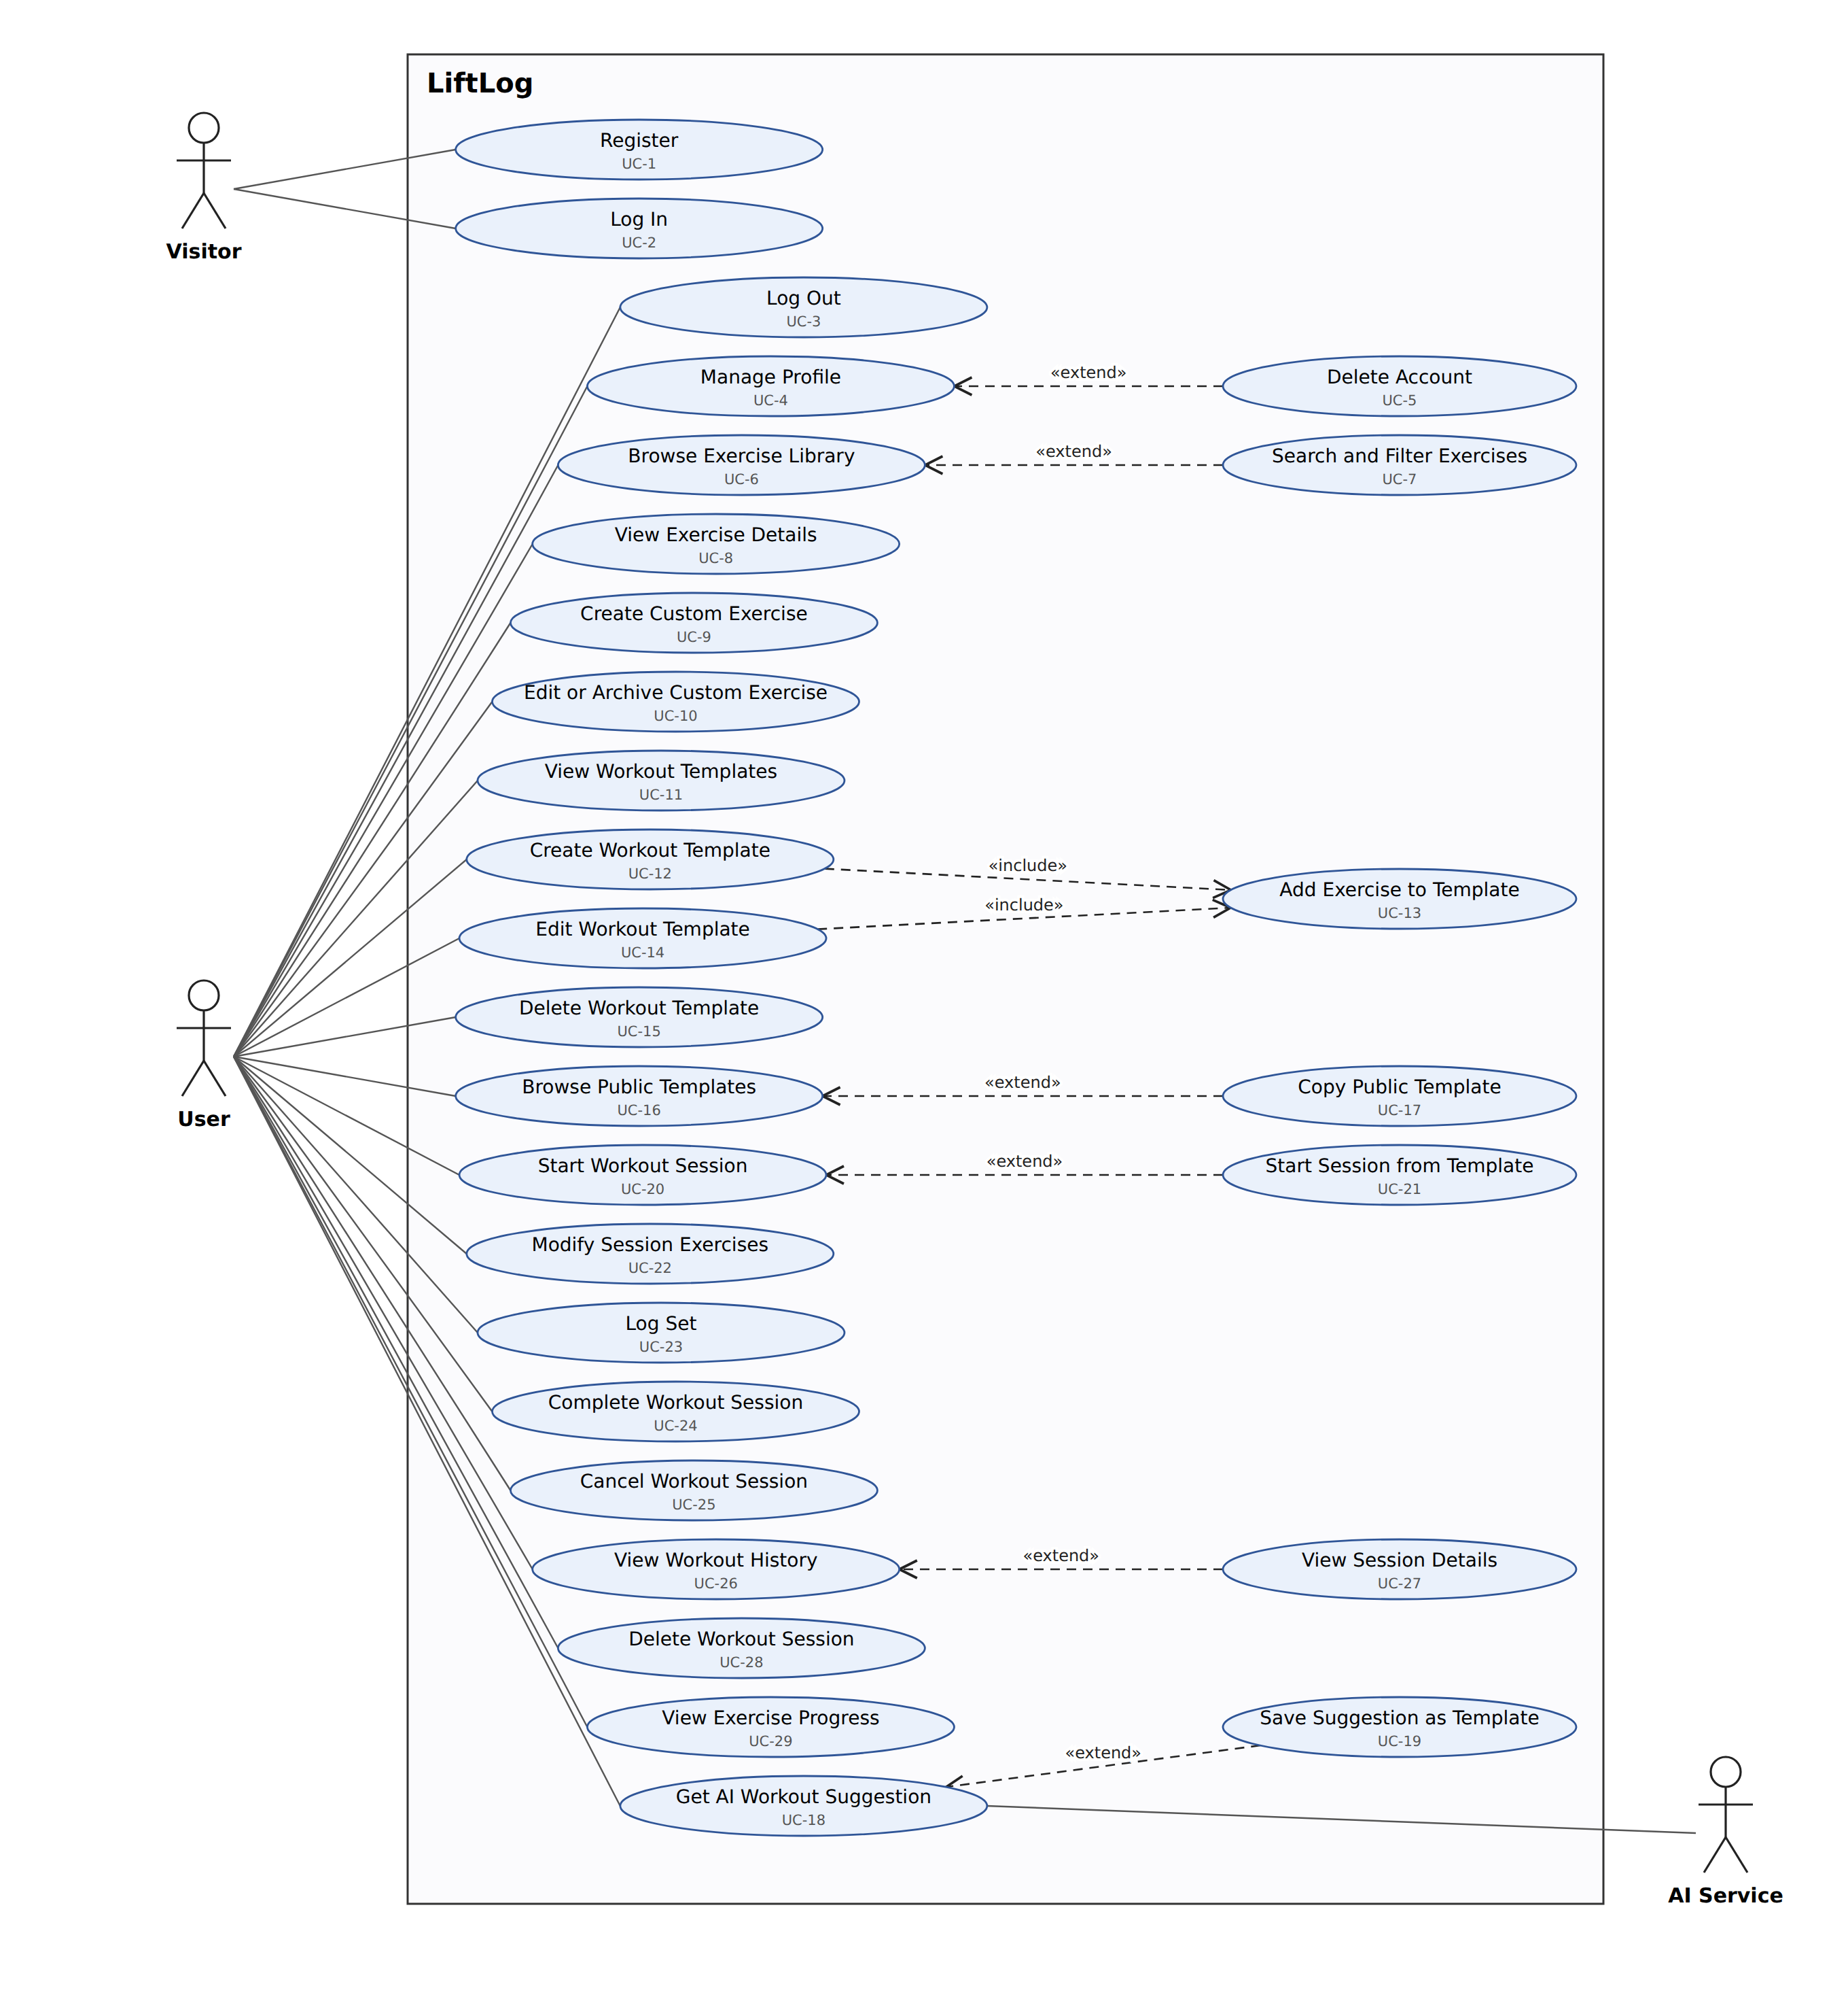
Figure 1. LiftLog use case diagram (unchanged since Increment 1)
The Visitor actor can register and log in; after logging in, the Visitor becomes a User, who can use every other use case. The AI Service is an outside system that takes part in getting an AI workout suggestion. A dashed «include» arrow means the base use case always performs the included one; for example, creating or editing a template always involves adding exercises to it. A dashed «extend» arrow means the extending use case is optional behavior added to the base use case; for example, a user browsing the exercise library may also search and filter it. Each use case is labeled with its ID from the table below.
Actors
• Visitor: someone using LiftLog who is not logged in.
• User: a registered, logged-in LiftLog user. There are no administrator accounts; predefined exercises and templates are loaded by the development team.
• AI Service: the external generative AI service that produces workout suggestions (secondary actor).
Use cases
ID | Use case | Actor | Requirements | Relationships
UC-1 | Register | Visitor | FR-1, FR-36
UC-2 | Log In | Visitor | FR-2
UC-3 | Log Out | User | FR-3
UC-4 | Manage Profile | User | FR-4, FR-5 | Extended by UC-5
UC-5 | Delete Account | User | FR-6 | Extends UC-4
UC-6 | Browse Exercise Library | User | FR-8, FR-13 | Extended by UC-7
UC-7 | Search and Filter Exercises | User | FR-10 | Extends UC-6
UC-8 | View Exercise Details | User | FR-9
UC-9 | Create Custom Exercise | User | FR-11, FR-36
UC-10 | Edit or Archive Custom Exercise | User | FR-12, FR-13
UC-11 | View Workout Templates | User | FR-16, FR-19
UC-12 | Create Workout Template | User | FR-14, FR-15, FR-20, FR-36 | Includes UC-13
UC-13 | Add Exercise to Template | User | FR-15 | Included by UC-12, UC-14
UC-14 | Edit Workout Template | User | FR-17, FR-20 | Includes UC-13
UC-15 | Delete Workout Template | User | FR-18
UC-16 | Browse Public Templates | User | FR-21 | Extended by UC-17
UC-17 | Copy Public Template | User | FR-21 | Extends UC-16
UC-18 | Get AI Workout Suggestion | User, AI Service | FR-33, FR-35 | Extended by UC-19
UC-19 | Save Suggestion as Template | User | FR-34 | Extends UC-18
UC-20 | Start Workout Session | User | FR-22, FR-23 | Extended by UC-21
UC-21 | Start Session from Template | User | FR-22 | Extends UC-20
UC-22 | Modify Session Exercises | User | FR-26
UC-23 | Log Set | User | FR-24, FR-25, FR-36
UC-24 | Complete Workout Session | User | FR-27
UC-25 | Cancel Workout Session | User | FR-28
UC-26 | View Workout History | User | FR-29 | Extended by UC-27
UC-27 | View Session Details | User | FR-30 | Extends UC-26
UC-28 | Delete Workout Session | User | FR-31
UC-29 | View Exercise Progress | User | FR-32

Use case descriptions
Each description below lists the actor, the requirements it covers, what must be true before it starts, the main steps, what happens when something goes differently, and what is true afterwards. “Not Found” means the system answers as if the item does not exist, so users cannot discover other users’ private data (NFR-2).
UC-1: Register
Actor | Visitor
Requirements | FR-1, FR-36, NFR-1, NFR-4
Preconditions | The visitor is not logged in.
Main flow | 1. The visitor opens the Register page.  2. The visitor enters a username, a password and the password again.  3. The system checks the input: the username is 3–30 characters of letters, numbers, dots, dashes or underscores and is not already used (ignoring upper/lower case); the password has at least 8 characters and at most 72 bytes; the two passwords match.  4. The system saves the account, storing only a bcrypt hash of the password.  5. The system logs the new user in and shows their dashboard.
Alternative flows | 3a. Any check fails: the system shows a message next to each problem field and saves nothing.  4a. Someone else registers the same username at the same moment: the system shows “That username is already taken.” instead of an error page.
Postconditions | A new account exists and the user is logged in.
Status | Built (Increment 1)

UC-2: Log In
Actor | Visitor
Requirements | FR-2, NFR-3
Preconditions | The visitor has an account and is not logged in.
Main flow | 1. The visitor opens the Log in page (or is sent there after trying to open a private page).  2. The visitor enters their username and password.  3. The system checks the password against the stored hash.  4. The system logs the user in and opens the page they were trying to reach, or the dashboard.
Alternative flows | 3a. The username or password is wrong: the system shows “Incorrect username or password.” without saying which one was wrong, and takes the same time either way.  4a. The “next page” in the address points to another website: the system ignores it and opens the dashboard.
Postconditions | The user is logged in.
Status | Built (Increment 1)

UC-3: Log Out
Actor | User
Requirements | FR-3
Preconditions | The user is logged in.
Main flow | 1. The user clicks Log out in the header.  2. The system ends the login session and shows the home page with “You have been logged out.”
Alternative flows | None.
Postconditions | Private pages send the user to the Log in page until they log in again.
Status | Built (Increment 1)

UC-4: Manage Profile
Actor | User
Requirements | FR-4, FR-5
Preconditions | The user is logged in.
Main flow | 1. The user opens My profile. The form shows the saved values.  2. The user chooses a goal and an experience level from lists and may enter body weight (1–1000 lb), age (13–100) and gender (from a list). All are optional.  3. The system checks the input and saves the profile.  4. To change the password, the user opens Change password and enters the current password and the new one twice; the system checks them and stores the new bcrypt hash.
Alternative flows | 3a. A value is out of range or not in the list: the system shows a message next to the field and saves nothing.  4a. The current password is wrong, the new one is shorter than 8 characters, or the two new ones don’t match: the system shows a message and keeps the old password.
Postconditions | The profile or password is updated.
Status | Built (Increment 2)

UC-5: Delete Account
Actor | User
Requirements | FR-6
Preconditions | The user is logged in and on their profile page.
Main flow | 1. The user chooses Delete account.  2. The system asks the user to confirm and explains that all their data will be deleted.  3. The user confirms.  4. The system deletes the account and all of the user’s custom exercises, templates, sessions and sets, then logs them out.
Alternative flows | 3a. The user cancels: nothing is deleted.
Postconditions | The account and its data no longer exist.
Status | Planned (Increment 3).

UC-6: Browse Exercise Library
Actor | User
Requirements | FR-8, FR-13
Preconditions | The user is logged in. The predefined exercises have been loaded with flask --app run seed-exercises.
Main flow | 1. The user opens the Exercise library (linked from the Routines page).  2. The system lists the predefined exercises and the user’s own custom exercises in alphabetical order, with muscle group and equipment, and shows how many there are. Archived exercises are left out.  3. The user opens an exercise to see its details (UC-8).
Alternative flows | 2a. The user ticks “Show my archived exercises”: the list also includes their archived custom exercises, marked Archived.
Postconditions | None (nothing is changed).
Status | Built (Increment 2)

UC-7: Search and Filter Exercises
Actor | User
Requirements | FR-10
Preconditions | The user is on the exercise library page (extends UC-6).
Main flow | 1. The user types part of a name and/or chooses a muscle group and/or an equipment type.  2. The user clicks Search.  3. The system shows only the matching exercises. The search ignores upper/lower case and treats symbols such as % as plain text.  4. The user clicks Clear to see the whole library again.
Alternative flows | 3a. Nothing matches: the system says so and links to creating a custom exercise.
Postconditions | None.
Status | Built (Increment 2)

UC-8: View Exercise Details
Actor | User
Requirements | FR-9
Preconditions | The user is logged in.
Main flow | 1. The user opens an exercise.  2. The system shows its name, muscle group, equipment, movement type, difficulty, instructions and whether it is predefined, custom or archived.  3. If the user created it, the system also shows Edit and Archive (or Restore).
Alternative flows | 1a. The exercise does not exist or is another user’s custom exercise: the system shows “Not Found”, so it does not reveal that the exercise exists.
Postconditions | None.
Status | Built (Increment 2)

UC-9: Create Custom Exercise
Actor | User
Requirements | FR-11, FR-36
Preconditions | The user is logged in.
Main flow | 1. The user clicks New custom exercise.  2. The user enters a name and chooses the muscle group, equipment, movement type and difficulty from lists, and may add instructions.  3. The system checks the input.  4. The system saves the exercise with the user as its owner and shows its details.
Alternative flows | 3a. A required field is empty, a value is not in the list, or the name is over 100 characters: the system shows a message next to the field.  3b. The user can already see an exercise with the same name (ignoring case), predefined or their own: the system asks for a different name.
Postconditions | The exercise exists and only its creator can see it.
Status | Built (Increment 2)

UC-10: Edit or Archive Custom Exercise
Actor | User
Requirements | FR-12, FR-13, NFR-12
Preconditions | The user is viewing a custom exercise they created.
Main flow | 1. To edit: the user clicks Edit, changes the details and saves; the system checks them as in UC-9 and saves.  2. To archive: the user clicks Archive; the system marks the exercise archived.  3. An archived exercise is hidden from the library and from the lists used to add exercises to templates and sessions, but still appears in templates and past sessions that already use it.  4. To undo, the user clicks Restore.
Alternative flows | 1a. The exercise is predefined: editing and archiving are refused (403 Forbidden).  1b. The exercise belongs to another user: the system shows “Not Found”.
Postconditions | The exercise is updated or archived. No template or session data changes.
Status | Built (Increment 2)

UC-11: View Workout Templates
Actor | User
Requirements | FR-16, FR-19
Preconditions | The user is logged in.
Main flow | 1. The user opens Routines (the page is titled “My workout routines”).  2. The system lists the user’s own templates in alphabetical order with difficulty, number of exercises and whether each is public, and below them the ready-made (predefined) templates. The home page also lists the user’s templates, each with a Start workout button, or the ready-made ones if the user has none yet.  3. The user opens a template; the system shows its description and its exercises in order with target sets and rep range. Editing controls appear only after the user clicks Edit routine.
Alternative flows | 2a. The user has no templates: the system offers to try a ready-made routine or create their first routine.  3a. The template is another user’s private template: the system shows “Not Found”.  3b. The template is ready-made: it is shown without editing controls.
Postconditions | None.
Status | Built (Increment 2)

UC-12: Create Workout Template
Actor | User
Requirements | FR-14, FR-15, FR-20, FR-36
Preconditions | The user is logged in.
Main flow | 1. The user clicks New routine on the Routines page (or Create a routine on the home page).  2. The user enters a name, an optional description and a difficulty.  3. The system checks the input and saves the template as private, owned by the user.  4. The system opens the template so the user can add exercises (includes UC-13).
Alternative flows | 3a. The name is empty or too long, or no difficulty is chosen: the system shows a message next to the field.
Postconditions | A new, private template exists.
Status | Built (Increment 2)

UC-13: Add Exercise to Template
Actor | User
Requirements | FR-15, FR-36
Preconditions | The user is viewing one of their own templates (included in UC-12 and UC-14).
Main flow | 1. The user chooses an exercise from the list, which contains the predefined exercises and the user’s own custom exercises, minus archived ones.  2. The user enters the target sets (1–20) and the minimum and maximum reps (1–100).  3. The system checks the input.  4. The system adds the exercise at the end of the template.
Alternative flows | 3a. No exercise is chosen, a number is missing, not a whole number or out of range, or the minimum is greater than the maximum: the system shows a message and adds nothing.  3b. The chosen exercise is not one the user may use (another user’s custom exercise or an archived one): the system refuses it.
Postconditions | The template has one more exercise. The same exercise may appear more than once (for example warm-up and working sets).
Status | Built (Increment 2)

UC-14: Edit Workout Template
Actor | User
Requirements | FR-17, FR-20
Preconditions | The user is viewing one of their own templates.
Main flow | 1. The user clicks Edit routine to show the editing controls, and can then edit the template’s name, description and difficulty (Edit details).  2. The user can change an exercise’s target sets and rep range.  3. The user can move an exercise up or down one place.  4. The user can remove an exercise; the rest are renumbered.  5. The user can add more exercises (includes UC-13).  6. The user can click Make public or Make private (FR-20). New templates are private.
Alternative flows | Any action on another user’s template: the system shows “Not Found” and changes nothing.  Moving the first exercise up or the last one down: nothing changes.
Postconditions | The template is updated. Past sessions started from it do not change.
Status | Built (Increment 2)

UC-15: Delete Workout Template
Actor | User
Requirements | FR-18
Preconditions | The user is viewing one of their own templates.
Main flow | 1. The user clicks Edit routine and then Delete.  2. The system asks “Delete <name>?” and shows how many exercises the template has.  3. The user confirms.  4. The system deletes the template and its list of exercises. The exercises stay in the library. Past sessions started from the template keep their own copy of the exercises and the template’s name; their link to the template is cleared.
Alternative flows | 3a. The user clicks Cancel: nothing is deleted.
Postconditions | The template no longer exists.
Status | Built (Increment 2)

UC-16: Browse Public Templates
Actor | User
Requirements | FR-21
Preconditions | The user is logged in.
Main flow | 1. The user clicks Browse public routines on the Routines page.  2. The system lists other users’ public templates by name, with difficulty, number of exercises and the creator’s username. The user’s own public templates and the ready-made ones are not repeated here.  3. The user opens one to see its exercises. Exercises that are private to the creator are shown by name only.
Alternative flows | 2a. No other user has a public template: the system says so.
Postconditions | None.
Status | Built (Increment 2)

UC-17: Copy Public Template
Actor | User
Requirements | FR-21
Preconditions | The user is viewing another user’s public template (extends UC-16).
Main flow | 1. The user clicks Copy to my routines.  2. The system creates a private copy owned by the user, with the same name, description, difficulty, exercises and targets.  3. The system opens the copy, which the user can edit and start like any of their templates.
Alternative flows | 1a. The template is not public, is the user’s own, or is ready-made: the system shows “Not Found”.  2a. Some exercises are private custom exercises of the creator: they are left out of the copy and the system says how many.
Postconditions | The user has a new private template. The original is unchanged, and later changes to either do not affect the other.
Status | Built (Increment 2)

UC-18: Get AI Workout Suggestion
Actor | User, AI Service
Requirements | FR-33, FR-35, NFR-6, NFR-14
Preconditions | The user is logged in and has filled in the profile details the suggestion needs.
Main flow | 1. The user asks for a suggested workout.  2. The system tells the user which profile details will be sent and shows that the suggestion is loading.  3. The system sends only those details and the list of library exercises to the AI Service.  4. The AI Service returns a suggested workout.  5. The system keeps only exercises that exist in the library and shows the suggestion with target sets and rep ranges.
Alternative flows | 4a. The AI Service is unavailable, gives no answer within 30 seconds, or returns something unusable: the system says a suggestion could not be generated. Everything else keeps working.
Postconditions | A suggestion is shown (nothing is saved yet).
Status | Planned (Increment 3). AI provider and cost not decided (FR-33, NFR-17).

UC-19: Save Suggestion as Template
Actor | User
Requirements | FR-34
Preconditions | The user is viewing an AI suggestion (extends UC-18).
Main flow | 1. The user chooses Save as template.  2. The system creates a private template with the suggested exercises, sets and rep ranges.  3. The system opens the new template, which the user can edit like any other.
Alternative flows | None.
Postconditions | The user has a new template.
Status | Planned (Increment 3).

UC-20: Start Workout Session
Actor | User
Requirements | FR-22, FR-23
Preconditions | The user is logged in and has no workout in progress.
Main flow | 1. The user clicks Start without a routine on the home page, or Start an empty workout on the History page.  2. The system creates an in-progress session called “Quick workout” and opens it.  3. The user adds exercises as they go (UC-22) and logs sets (UC-23).
Alternative flows | 1a. The user already has a workout in progress: the system opens that workout with the message “Finish or cancel this workout before starting another one.”
Postconditions | An in-progress session exists.
Status | Built (Increment 2)

UC-21: Start Session from Template
Actor | User
Requirements | FR-22
Preconditions | The user is viewing one of their own templates or a ready-made template that has at least one exercise (extends UC-20).
Main flow | 1. The user clicks Start this workout on the template’s page, or Start workout next to it on the home page.  2. The system creates an in-progress session with the template’s name and copies each of the template’s exercises, in order, with its target sets and rep range.  3. The system opens the workout page, which shows each exercise, its target and a form to log a set.
Alternative flows | 1a. The user already has a workout in progress: as in UC-20, alternative 1a.  1b. The template is another user’s template or does not exist: the system shows “Not Found” (another user’s public template has no Start button).
Postconditions | An in-progress session with the template’s exercises exists. Later changes to the template do not affect it.
Status | Built (Increment 2). Works for the user’s own and ready-made templates; another user’s public template must be copied first (UC-17).

UC-22: Modify Session Exercises
Actor | User
Requirements | FR-26
Preconditions | The user has a workout in progress.
Main flow | 1. To add: the user chooses an exercise (predefined or their own, not archived) and clicks Add exercise; it is added at the end.  2. To remove: the user clicks Remove on an exercise; it and any sets logged for it are removed and the rest are renumbered.  3. To reorder: the user clicks the up or down arrow on an exercise to swap it with its neighbour.  4. The template the session came from is not changed.
Alternative flows | Any change to a finished session is refused (400 Bad Request).  Any change to another user’s session: the system shows “Not Found”.
Postconditions | The session’s exercise list is updated.
Status | Built (Increment 2)

UC-23: Log Set
Actor | User
Requirements | FR-24, FR-25, FR-36, NFR-8, NFR-10
Preconditions | The user has a workout in progress with at least one exercise.
Main flow | 1. Under each exercise, the page shows the last set from the user’s most recent completed workout that included it (for example “Last time: 135 lb × 8 reps”), and the weight and reps boxes start with those numbers. The user enters or adjusts the weight in pounds (0 for bodyweight exercises), the reps and optional notes.  2. The user clicks Log set.  3. The system checks the input and saves the set straight away with the next set number (1, 2, 3, …).  4. The system shows the updated table of sets and fills the next set’s boxes with the numbers just entered.  5. To fix a set, the user clicks Edit, changes it and saves; to remove one, the user clicks Delete and the later sets are renumbered.
Alternative flows | 3a. The weight is missing, not a number, negative or over 2000, or the reps are not a whole number from 1 to 100: the system shows a message under that exercise’s boxes and saves nothing.  Any change to a finished session is refused (400 Bad Request).
Postconditions | The set is stored in the database.
Status | Built (Increment 2)

UC-24: Complete Workout Session
Actor | User
Requirements | FR-27
Preconditions | The user has a workout in progress.
Main flow | 1. The user clicks Finish workout.  2. The system shows how many sets were logged and suggests the duration from the time since the workout started.  3. The user confirms the date (today by default) and may change the duration, choose an energy rating from 1 to 5 and add notes.  4. The system checks the input, marks the session completed and shows its summary.
Alternative flows | 4a. The date is missing or in the future, or the duration is not a whole number from 1 to 600: the system shows a message and the workout stays in progress.
Postconditions | The session is completed, appears in the history and can no longer be changed (only deleted).
Status | Built (Increment 2)

UC-25: Cancel Workout Session
Actor | User
Requirements | FR-28
Preconditions | The user has a workout in progress.
Main flow | 1. The user clicks Cancel workout.  2. The system asks “Cancel <name>?” and shows how many sets would be lost.  3. The user confirms.  4. The system deletes the session with its exercises and sets and opens the history.
Alternative flows | 3a. The user clicks Keep it: nothing is deleted.
Postconditions | The session no longer exists. Templates and exercises are not affected.
Status | Built (Increment 2)

UC-26: View Workout History
Actor | User
Requirements | FR-29
Preconditions | The user is logged in.
Main flow | 1. The user opens History.  2. The system lists the user’s completed sessions, most recent date first, with the date, number of exercises, number of sets and duration.  3. If a workout is in progress, the system shows it at the top with Continue workout; otherwise it offers to start one.
Alternative flows | 2a. No completed sessions yet: the system says finished workouts will appear here.
Postconditions | None.
Status | Built (Increment 2)

UC-27: View Session Details
Actor | User
Requirements | FR-30
Preconditions | The user is viewing their history (extends UC-26).
Main flow | 1. The user opens a completed session.  2. The system shows the date, duration, energy rating, notes and the template it came from (or None if the template was deleted).  3. For each exercise, the system shows its target and every set with weight, reps and notes.
Alternative flows | 1a. The session belongs to another user: the system shows “Not Found”.
Postconditions | None.
Status | Built (Increment 2)

UC-28: Delete Workout Session
Actor | User
Requirements | FR-31
Preconditions | The user is viewing one of their completed sessions.
Main flow | 1. The user clicks Delete.  2. The system asks “Delete <name>?” and shows how many sets it has.  3. The user confirms.  4. The system deletes the session with its exercises and sets and returns to the history.
Alternative flows | 3a. The user clicks Keep it: nothing is deleted.
Postconditions | The session no longer appears in the history. Templates and exercises are not affected.
Status | Built (Increment 2)

UC-29: View Exercise Progress
Actor | User
Requirements | FR-32
Preconditions | The user has completed sessions that include the exercise.
Main flow | 1. The user opens Progress.  2. The system offers the exercises the user has logged in completed workouts (including archived ones).  3. The user chooses one.  4. The system shows two charts across the user’s completed workouts, oldest first: the heaviest weight lifted and the total volume (weight × reps). The same numbers are listed in a table.
Alternative flows | 2a. The user has no completed workouts with sets: the system explains that progress appears after the first finished workout.  3a. The address names an exercise the user hasn’t logged (or another user’s): no chart is shown.  4a. The chart library can’t load: the table still shows the numbers.
Postconditions | None.
Status | Built (Increment 2)

Class Diagram and/or Sequence Diagrams (15 points)
LiftLog is written in Python with Flask and is object oriented: each table in the database is a Python class (a SQLAlchemy model), and each form is a class built on Flask-WTF. Figure 2 shows every model class with its attributes, methods and relationships; Figure 3 shows the form classes. Figures 4–6 are sequence diagrams for the three most important use cases: starting a workout from a template, logging a set, and adding an exercise to a template.
The class diagram is on the next page, which is turned sideways so the diagram is large enough to read.

5.1 Class diagram
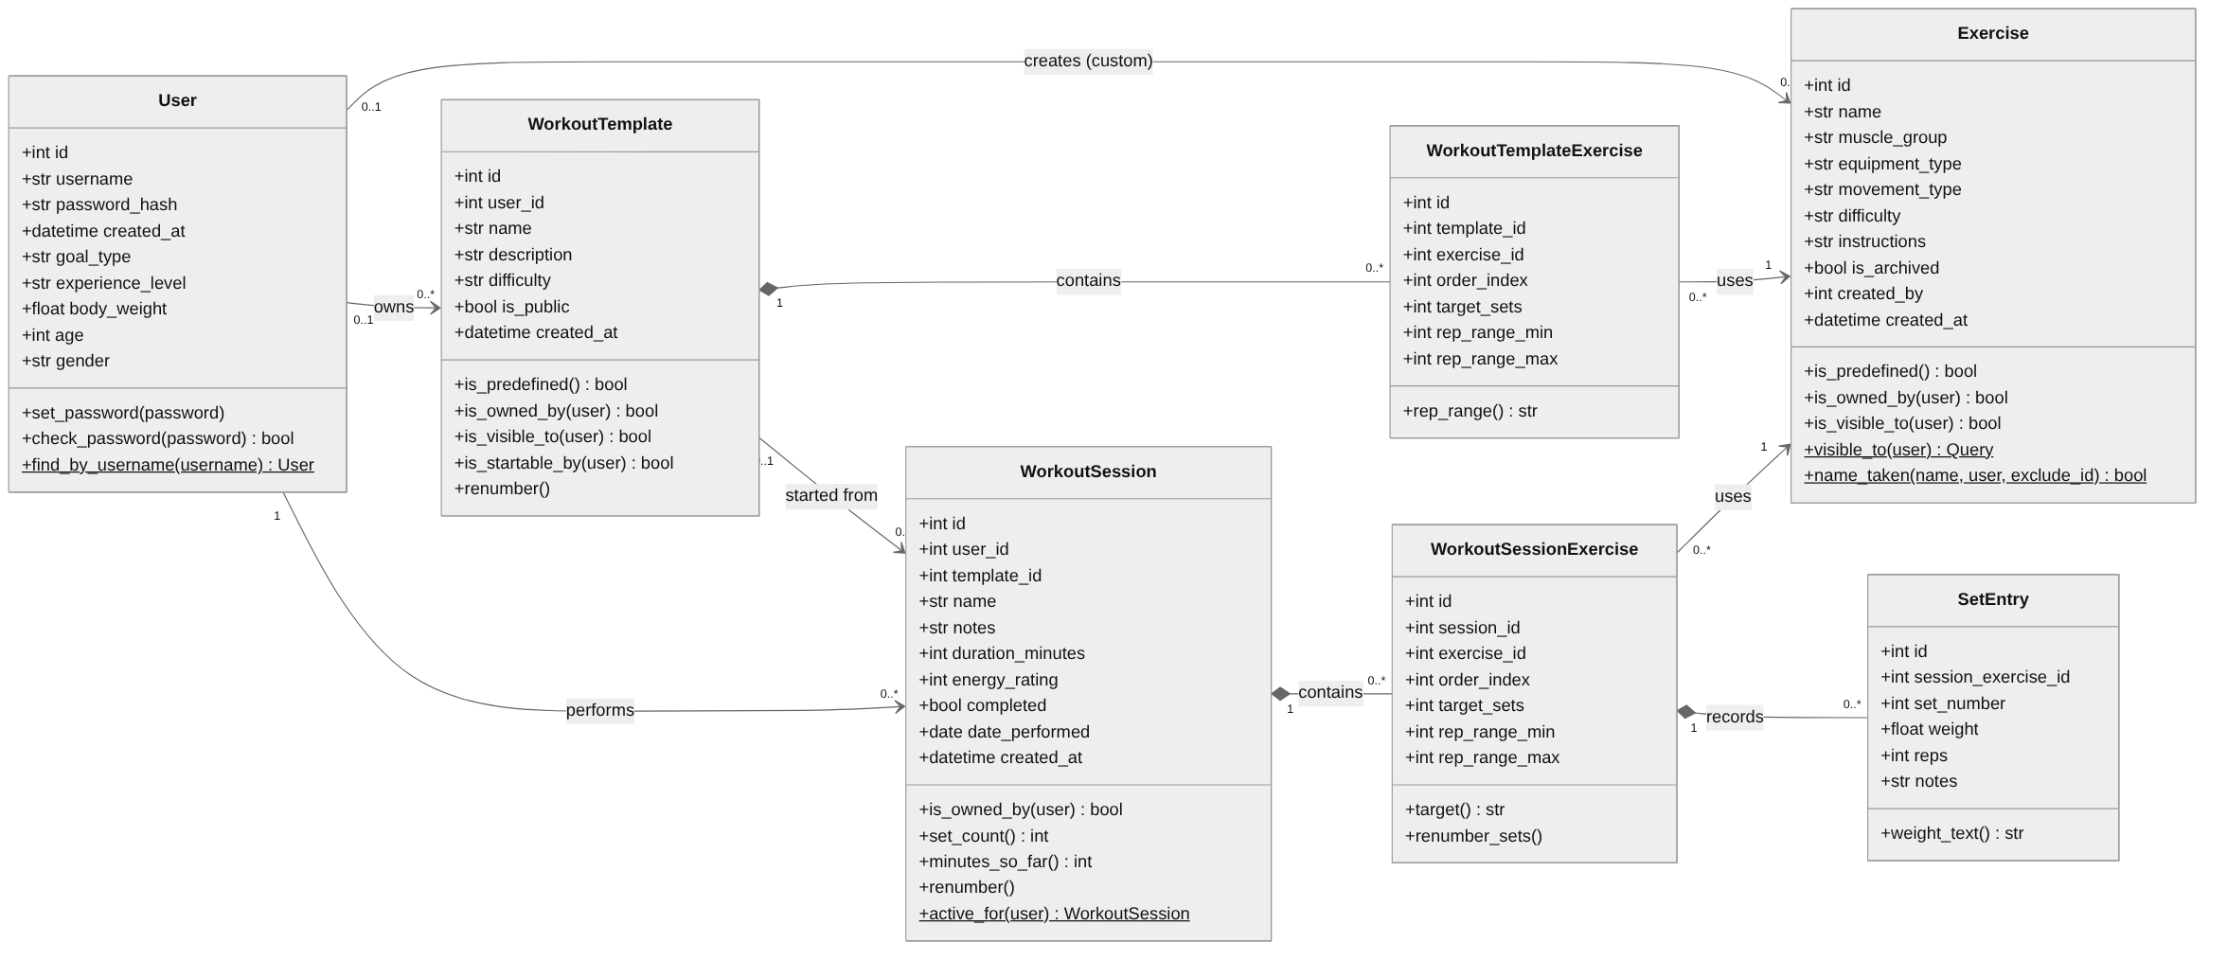
Figure 2. Class diagram of LiftLog’s data model (Increment 2)

Methods marked with an underline are static (they belong to the class, not to one object). A filled diamond means composition: deleting the whole deletes its parts (for example, deleting a WorkoutSession deletes its WorkoutSessionExercise rows and their SetEntry rows). A plain arrow is an association. Multiplicities: one User owns 0..* templates and 0..* sessions and creates 0..* custom exercises; a predefined Exercise and a ready-made WorkoutTemplate have no owner (0..1). A WorkoutSession may come from 0..1 WorkoutTemplate, and the link is cleared if the template is deleted.
5.2 Differences from the ER/relational model
Change | Reason
Exercise.created_by (User-ID, may be empty), Exercise.created_at | FR-11: a custom exercise must belong to the user who made it; empty means predefined.
WorkoutSession.name | Keeps the template’s name (or “Quick workout”) so the history still makes sense after the template is deleted (FR-18).
WorkoutSession.created_at | When the workout started; used to suggest its duration (FR-27).
WorkoutSessionExercise.target_sets, rep_range_min, rep_range_max | Copied from the template when the session starts, so the workout page can show the plan without depending on the template.
WorkoutTemplate.user_id may be empty (instead of is_prebuilt) | FR-19: a template with no owner is a ready-made template, the same way predefined exercises have no creator. This replaces the ER model’s is_prebuilt column and its rule that every template has an owner.
User.age, User.gender | FR-4 and FR-33: optional details for AI workout suggestions; not in the ER model.

5.3 Form classes
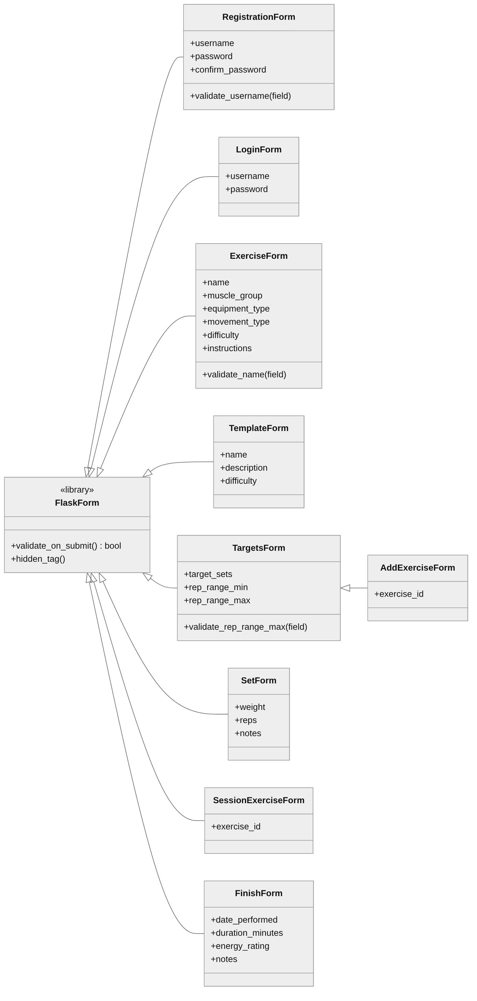
Figure 3. Form classes (each checks one page’s input before anything is saved)
5.4 Sequence diagram: Start Session from Template (UC-21)
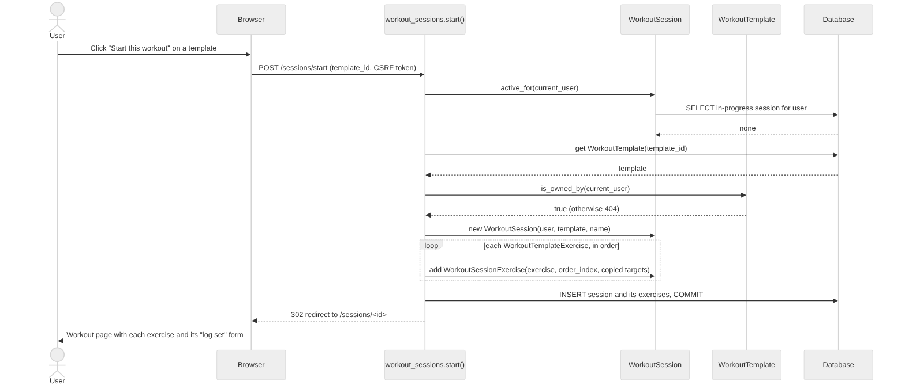
Figure 4. Starting a workout session from a template
5.5 Sequence diagram: Log Set (UC-23)
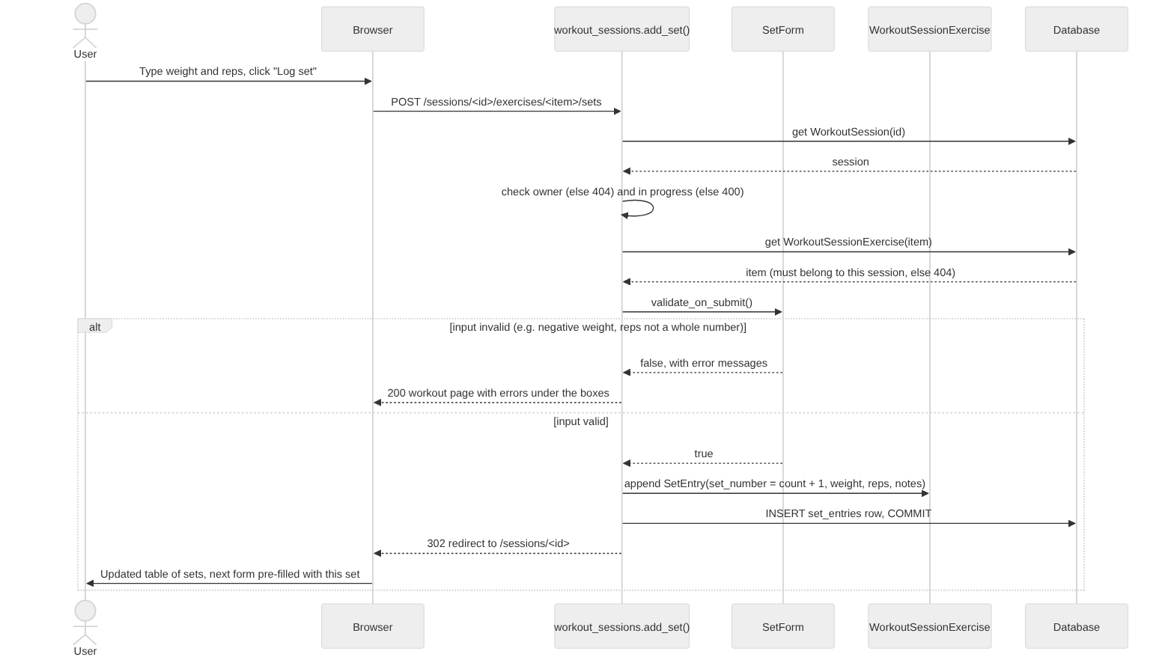
Figure 5. Logging a set during a workout
5.6 Sequence diagram: Add Exercise to Template (UC-13)
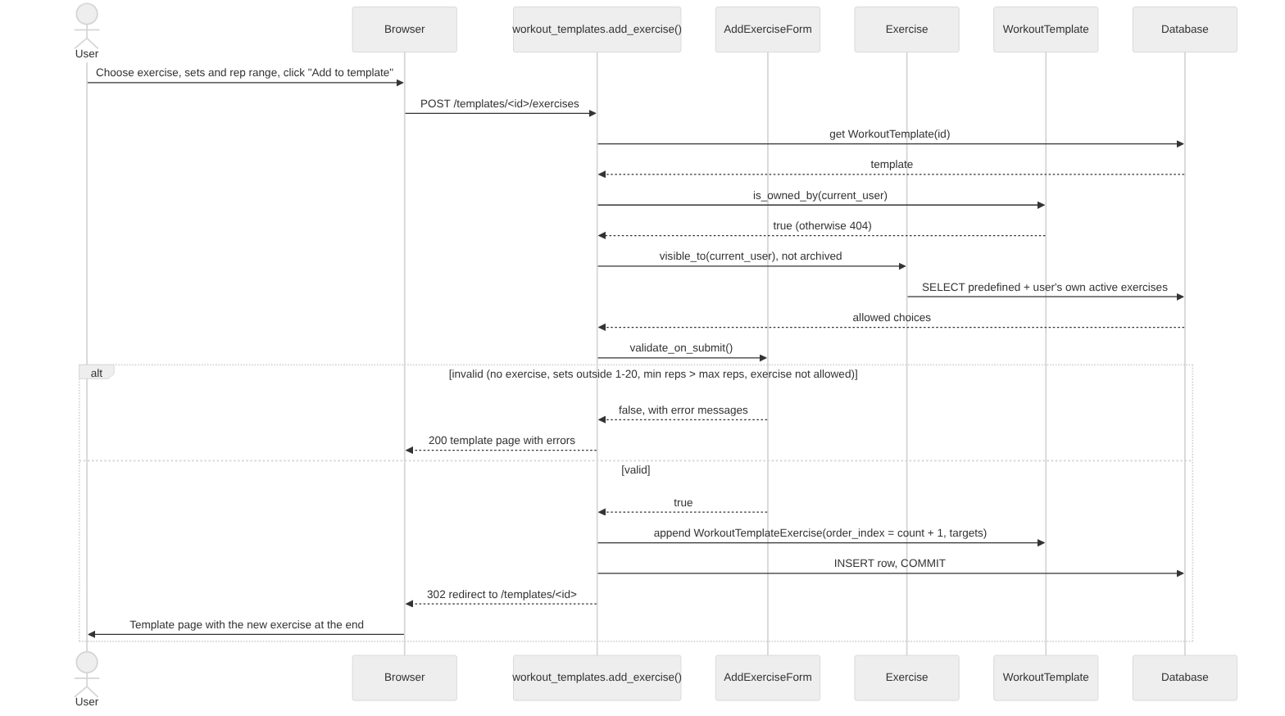
Figure 6. Adding an exercise to a workout template

Operating Environment (5 points)
LiftLog is a web application. It runs on a server and is used through a web browser on a computer or phone.
6.1 Server
• Python 3.11 or newer. The team develops on Windows 11 with Python 3.14; Flask also runs on macOS and Linux.
• Flask 3.1 with the Python packages listed in requirements.txt (Section 7).
• During development the app runs on each member’s computer with Flask’s built-in server (python run.py) at http://127.0.0.1:5000.
• Hosting for the final demonstration has not been chosen. [TEAM DECISION: where to host the demo, e.g. a free hosting tier or a member’s laptop.]
6.2 Database
• By default the app stores data in a SQLite file (instance/liftlog.db), so nothing extra has to be installed to develop or test.
• The proposal’s target database is MySQL 8. The app connects to MySQL when DATABASE_URL is set in the .env file (driver: PyMySQL). This has not been tested against a MySQL server yet.
• Database tables are created and updated with Flask-Migrate (flask --app run db upgrade). The automated tests use a temporary in-memory SQLite database.
6.3 Client
• Current versions of Chrome, Firefox, Safari and Edge on desktop and phone (NFR-15). JavaScript is used only to draw the progress charts; the same numbers are shown in a table without it.
• Screens at least 375 pixels wide (NFR-7).
• An internet connection to load the Barlow font from Google Fonts; without it the browser’s own font is used and the app still works.
6.4 Other software it must work alongside
• Google Fonts (the font) and the cdnjs content network, which serves Chart.js for the progress charts.
• Planned: an external AI API for workout suggestions (FR-33).

Assumptions and Dependencies (5 points)
7.1 Assumptions
• Users have a modern browser and an internet connection, and use LiftLog on their own device (there is no shared-device mode).
• Users enter weights in pounds. The app does not convert units; a user who enters kilograms sees the same numbers labelled lb.
• A user does one workout at a time, so only one session can be in progress per user.
• There are no administrator accounts. The development team maintains the predefined exercises and ready-made templates in app/exercises/seed_data.py and app/workout_templates/seed_data.py, and loads them with flask --app run seed-exercises and then seed-templates.
• SQLite behaves like MySQL for the queries LiftLog uses. This must be checked before the team switches to MySQL.
• A free tier or a small paid budget will be available for the AI API in Increment 3. [TEAM DECISION: NFR-17]
• Team members can review and test each other’s pull requests before merging.
7.2 Dependencies
Component | Used for
Flask | Web framework: pages, routing, templates (Jinja).
Flask-SQLAlchemy, SQLAlchemy | Database models and queries (parameterized, NFR-4).
Flask-Migrate (Alembic) | Creating and updating database tables.
Flask-Login | Keeping users logged in and protecting private pages (NFR-3).
Flask-Bcrypt | Hashing passwords (NFR-1).
Flask-WTF, WTForms | Forms, input checks and CSRF protection (FR-36, NFR-4).
PyMySQL, cryptography | Connecting to MySQL 8.
python-dotenv | Reading secrets from the .env file, which is kept out of GitHub (NFR-5).
pytest | Automated tests.
Google Fonts (Barlow) | The app’s font.
Chart.js 4.4 (from cdnjs) | Drawing the progress charts in the browser (FR-32).
GitHub | Source code, issues and pull requests (NFR-16).
Planned: an LLM API (Claude API or OpenAI API, per the proposal) | AI workout suggestions (FR-33).

If any of these assumptions turns out to be wrong (for example, if MySQL behaves differently, or no AI API budget is available), the affected requirements will be revisited in the next increment.

