Software Requirements and Design Document

For

Group 9

Version 0.3 — INTERIM DRAFT (not for submission)

Authors:
Olivia Anderson
Brendan Boedy
Gabriel Valladares-Ruiz
Jorge Fraile
William Brandon

DRAFT NOTES FOR THE TEAM — delete this block before submission
• This draft was prepared with AI assistance (Claude, by Anthropic) from our project proposal, README and ER/relational model. The team must review, correct and approve every requirement before submission, and record the AI use in our disclosure.
• v0.3 aligns the draft with the proposal: custom exercises, public/private workouts, no admin users, AI workout suggestions, progress charts, and the Flask/MySQL stack. Requirement and use case numbers changed from v0.2.
• Priorities (High/Medium/Low) and the suggested target increments are recommendations, not team decisions.
• Items highlighted in yellow need a team decision.
• Sections 5–7 (class/sequence diagrams, operating environment, assumptions) are not drafted yet. The template instructions have been left in place there.

Overview (5 points)
LiftLog is a web application for people who want to track their weight-training workouts, from beginners who need a place to start to experienced lifters with their own routines. Users create an account and build reusable workouts (workout templates) from a library of predefined exercises and exercises they create themselves, setting target sets and rep ranges for each one. Users can also start from a predefined workout, and can choose whether each of their own workouts is private or public. For users who are unsure where to start, LiftLog uses generative AI to suggest a workout based on information the user provides about themselves and their fitness level.
Each time users train, they log a workout session, usually started from one of their workouts, recording the weight and number of reps for every set. LiftLog keeps a clear distinction between a workout template (the plan) and a workout session (what was actually done on a given day), so users can change their plans without affecting their past records. Completed sessions form the user's workout history, and LiftLog displays charts of the user's progress on each exercise over time. Unlike many existing fitness apps, every feature is free, and each user's history is private.

Functional Requirements (10 points)
Each requirement below is something the system shall do. Priority: High = required for a usable product; Medium = important but the product works without it; Low = desirable if time allows. “Inc.” is the suggested target increment.
2.1 User accounts
ID | Requirement | Priority | Inc.
FR-1 | The system shall allow a visitor to create an account by providing a username and a password. The username must not already be in use. | High | 1
FR-2 | The system shall allow a registered user to log in with their username and password, and shall show an error message without revealing which of the two was wrong when the credentials are invalid. | High | 1
FR-3 | The system shall allow a logged-in user to log out, after which private pages are no longer accessible until the user logs in again. | High | 1
FR-4 | The system shall allow a user to view and update their profile: goal type, experience level, body weight, age and gender. [TEAM DECISION: age and gender are used by the AI suggestions in the proposal but are not in the ER model's User table; add them or drop them] | Medium | 2
FR-5 | The system shall allow a user to change their password after re-entering their current password. | Medium | 2
FR-6 | The system shall allow a user to permanently delete their account after confirming the action, which also deletes all of their custom exercises, workout templates, sessions and set entries. | Low | 3

2.2 Exercises
ID | Requirement | Priority | Inc.
FR-7 | The system shall provide a library of predefined exercises, each with a name, muscle group, equipment type, movement type, difficulty and instructions. Predefined exercises are loaded into the database by the development team; there are no administrator accounts. | High | 1
FR-8 | The system shall allow a logged-in user to browse all predefined exercises together with the custom exercises they created. | High | 1
FR-9 | The system shall allow a user to view the full details of a single exercise. | Medium | 1
FR-10 | The system shall allow a user to search exercises by name and filter them by muscle group and equipment type. | Medium | 2
FR-11 | The system shall allow a user to create a custom exercise with the same details as a predefined exercise. A custom exercise shall be visible only to the user who created it. [TEAM DECISION: the ER model's Exercise table needs an owner field (User-ID, empty for predefined exercises) to support this] | High | 2
FR-12 | The system shall allow a user to edit the custom exercises they created. | Medium | 2
FR-13 | The system shall allow a user to archive a custom exercise they created. Archived exercises shall not be offered when adding exercises to a workout template or session, but shall still be displayed in existing templates and past sessions. | Medium | 2

2.3 Workout templates
ID | Requirement | Priority | Inc.
FR-14 | The system shall allow a user to create a workout template with a name, an optional description and a difficulty level. | High | 1
FR-15 | The system shall allow a user to add predefined or custom exercises to a template and set, for each one, a target number of sets and a rep range (minimum and maximum reps). | High | 1
FR-16 | The system shall display a list of the user's own templates and allow the user to open any of them to see its exercises in order. | High | 1
FR-17 | The system shall allow a user to edit a template's details and to change, remove or reorder the exercises in it. | Medium | 2
FR-18 | The system shall allow a user to delete one of their templates after confirming the action. Deleting a template shall delete its exercise entries but shall not delete past sessions that were started from it. [TEAM DECISION: confirm this behavior; the ER model does not yet say what happens to sessions linked to a deleted template] | Medium | 2
FR-19 | The system shall provide predefined workout templates that every user can view and use to start a session. | Medium | 2
FR-20 | The system shall allow a user to mark each of their templates as private or public. New templates shall be private by default. | Low | 3
FR-21 | The system shall allow a user to browse other users' public templates and copy one into their own templates, where they can edit it. [TEAM DECISION: confirm what "public" means: can others only view and copy it? Should the creator's username be shown?] | Low | 3

2.4 Workout sessions
ID | Requirement | Priority | Inc.
FR-22 | The system shall allow a user to start a workout session from one of their own templates or a predefined template, and the new session shall contain that template's exercises in the same order. | High | 2
FR-23 | The system shall allow a user to start an empty workout session and add exercises to it. | Medium | 2
FR-24 | The system shall allow a user to record a set for an exercise in the active session with a weight, a number of reps and optional notes. Set numbers shall be assigned in order starting from 1. | High | 2
FR-25 | The system shall allow a user to edit or delete a set they have recorded. | Medium | 2
FR-26 | The system shall allow a user to add, remove or reorder exercises in a session without changing the template it was started from. | Medium | 2
FR-27 | The system shall allow a user to mark a session as completed and to record its date, duration in minutes, energy rating and notes. [TEAM DECISION: energy rating scale, e.g., 1–5] | High | 2
FR-28 | The system shall allow a user to cancel an in-progress session, which discards it and its recorded sets after confirmation. | Low | 2

2.5 History and progress
ID | Requirement | Priority | Inc.
FR-29 | The system shall display the user's completed sessions with the most recent first. | High | 2
FR-30 | The system shall allow a user to open a past session and see each exercise performed and every set recorded for it. | High | 2
FR-31 | The system shall allow a user to delete a past session after confirmation, which also deletes its exercises and set entries. | Medium | 2
FR-32 | The system shall display a chart of the user's progress on a selected exercise across their completed sessions, showing at least the heaviest weight lifted in each session and the total volume (weight × reps) per session. [TEAM DECISION: confirm which measures to chart] | High | 3

2.6 AI workout suggestions
ID | Requirement | Priority | Inc.
FR-33 | The system shall allow a user to request a suggested workout generated by an AI service, based on the user's goal type, experience level, body weight, age and gender. The suggestion shall list exercises from LiftLog's exercise library with target sets and rep ranges. [TEAM DECISION: choose the AI provider (Claude API or OpenAI API, per the proposal) and how its cost will be covered] | Medium | 3
FR-34 | The system shall allow a user to save a suggested workout as one of their own workout templates, which they can then edit like any other template. | Medium | 3
FR-35 | If the AI service is unavailable or returns an unusable response, the system shall tell the user that a suggestion could not be generated, and all other features shall continue to work. | Medium | 3

2.7 Input validation
ID | Requirement | Priority | Inc.
FR-36 | The system shall reject invalid input with a message explaining the problem, including: empty required fields, reps that are not whole numbers of at least 1, negative weights, and rep ranges where the minimum is greater than the maximum. | High | 1

Design rationale
FR-18, FR-22 and FR-26 keep templates and sessions separate: a session copies its exercises from the template when it starts, so later edits to either one do not change the other. This lets users keep an accurate history while still updating their plans. FR-33 limits AI suggestions to exercises in LiftLog's library so that a saved suggestion (FR-34) links to real exercise records and its progress can be tracked like any other workout.

Non-functional Requirements (10 points)
NFR-1 to NFR-6 exist because LiftLog stores personal account and fitness data and sends some of it to an outside AI service. NFR-7 and NFR-8 exist because users log sets on their phones between sets at the gym.
3.1 Security and privacy
ID | Requirement | Priority
NFR-1 | Passwords shall never be stored in plain text. They shall be stored only as salted hashes produced by a password-hashing algorithm designed for that purpose (the team plans to use bcrypt through Flask-Bcrypt). | High
NFR-2 | A user shall be able to view, change or delete only their own profile, custom exercises, templates, sessions and set entries, and shall be able to view another user's template only if it is public. This shall be checked by the server on every request, not only hidden in the user interface. | High
NFR-3 | Every page and request that involves private data shall require the user to be logged in; requests without a valid login shall be redirected to the login page or refused. | High
NFR-4 | All user input shall be validated on the server, database queries shall be parameterized so that user input cannot change a query, and every form that changes data shall be protected against cross-site request forgery (CSRF). | High
NFR-5 | Passwords, database credentials, secret keys and AI API keys shall be kept in environment variables and shall not be committed to the GitHub repository. | High
NFR-6 | When requesting an AI suggestion, the system shall send the AI service only the profile details needed for the suggestion (FR-33), never the user's username, password or workout history, and shall tell the user which details are sent. | High

3.2 Usability
ID | Requirement | Priority
NFR-7 | The pages used during a workout (active session and set logging) shall be usable on a phone screen 375 pixels wide without horizontal scrolling. | High
NFR-8 | From an active session, a user shall be able to record a new set with no more than three clicks or taps plus typing the weight and reps. | Medium
NFR-9 | Error messages shall say what went wrong and how to fix it, in plain language. | Medium

3.3 Reliability and data integrity
ID | Requirement | Priority
NFR-10 | A recorded set shall be saved to the database as soon as the user submits it, so that closing the browser does not lose sets already recorded. | High
NFR-11 | The database shall enforce the model's referential integrity and uniqueness rules: an exercise's position is unique within a template and within a session, and a set number is unique within a session exercise. | High
NFR-12 | Archiving an exercise shall never delete or change any existing template or session data. | Medium

3.4 Performance
ID | Requirement | Priority
NFR-13 | When the system runs on a typical developer laptop or the demo server, each page shall load in under 2 seconds for a user with up to 500 recorded sessions. AI suggestions are excluded from this limit. | Medium
NFR-14 | The system shall show that an AI suggestion is loading, and shall stop waiting and show the message in FR-35 if no response arrives within 30 seconds. | Medium

3.5 Maintainability, portability and cost
ID | Requirement | Priority
NFR-15 | The system shall work in the current versions of Chrome, Firefox, Safari and Edge. | Medium
NFR-16 | The repository README shall contain setup steps that let a team member run the system locally, and every change to the main branch shall come through a pull request linked to a GitHub issue. | Medium
NFR-17 | All features shall be free for users. The system shall use free and open-source software; the only paid service may be the AI API. [TEAM DECISION: confirm whether the team will pay for AI API use, use a free tier, or limit the number of suggestions per user] | Medium

Use Case Diagram (10 points)
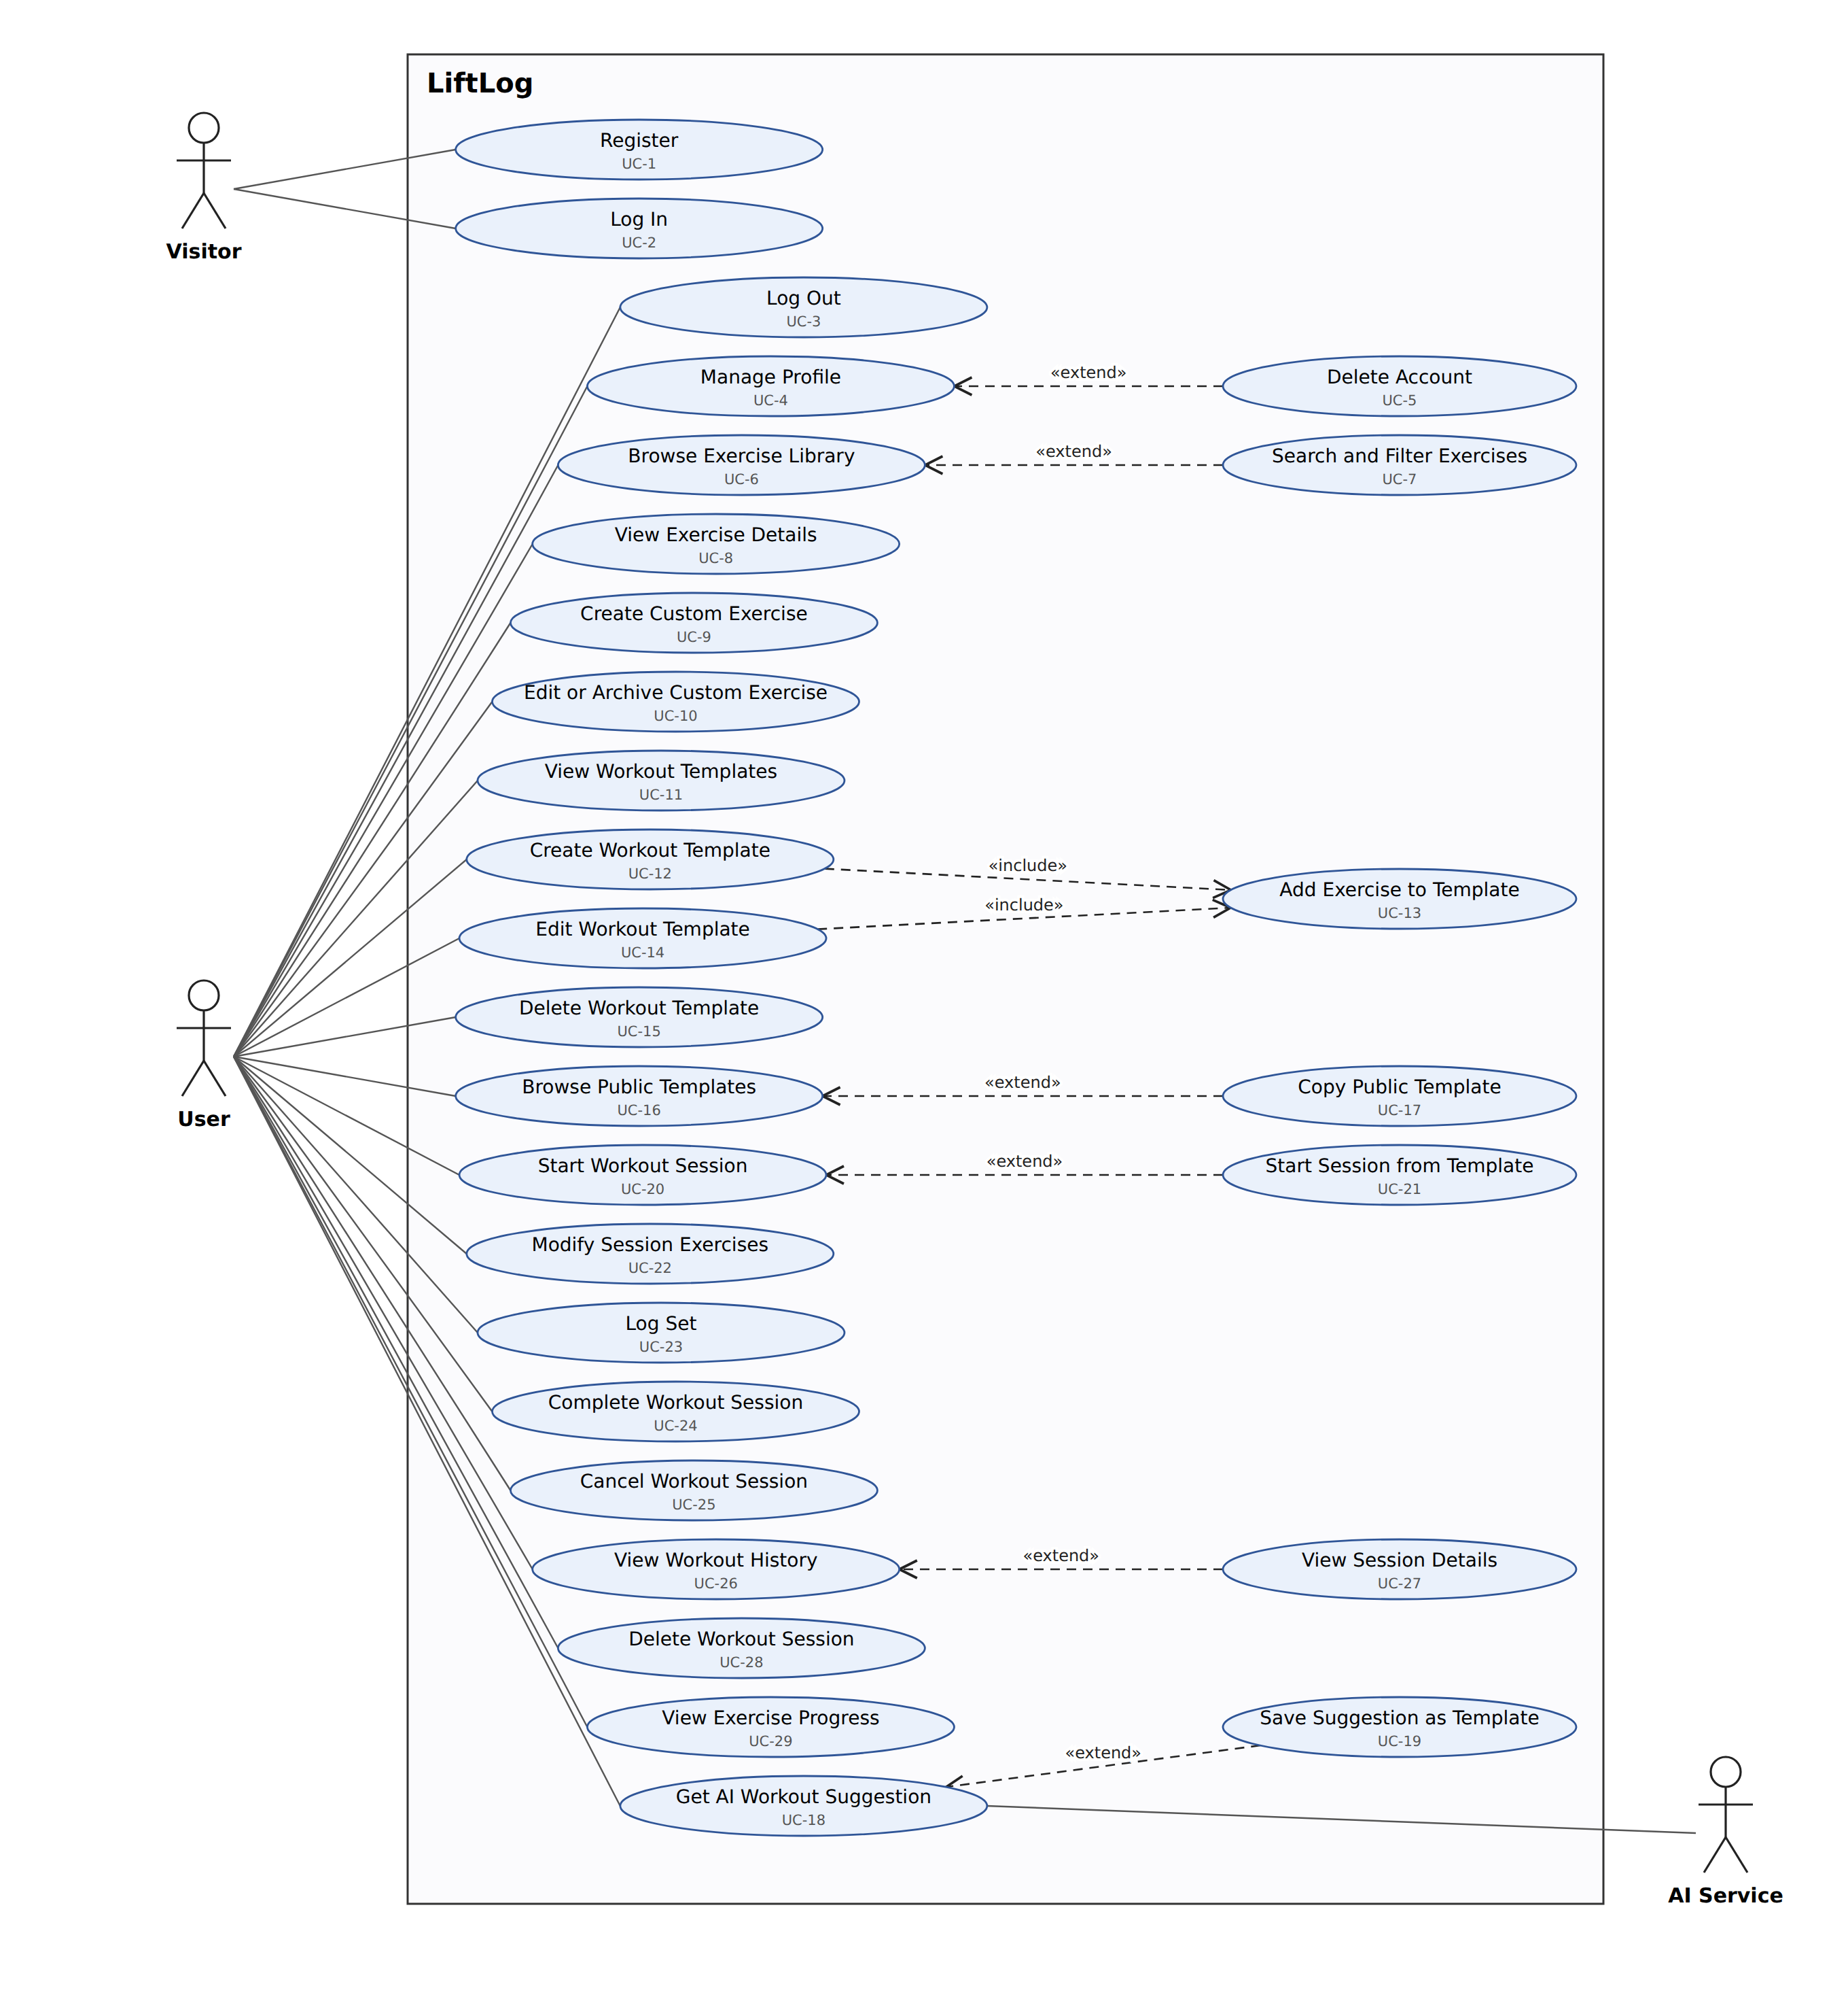
Figure 1. LiftLog use case diagram (Increment 1)
The Visitor actor can register and log in; after logging in, the Visitor becomes a User, who can use every other use case. The AI Service is an outside system that takes part in getting an AI workout suggestion. A dashed «include» arrow means the base use case always performs the included one; for example, creating or editing a template always involves adding exercises to it. A dashed «extend» arrow means the extending use case is optional behavior added to the base use case; for example, a user browsing the exercise library may also search and filter it. Each use case is labeled with its ID from the table below.
Actors
• Visitor: someone using LiftLog who is not logged in.
• User: a registered, logged-in LiftLog user. There are no administrator accounts; predefined exercises and templates are loaded by the development team.
• AI Service: the external generative AI service that produces workout suggestions (secondary actor).
Use cases
ID | Use case | Actor | Requirements | Relationships
UC-1 | Register | Visitor | FR-1, FR-36
UC-2 | Log In | Visitor | FR-2
UC-3 | Log Out | User | FR-3
UC-4 | Manage Profile | User | FR-4, FR-5 | Extended by UC-5
UC-5 | Delete Account | User | FR-6 | Extends UC-4
UC-6 | Browse Exercise Library | User | FR-8, FR-13 | Extended by UC-7
UC-7 | Search and Filter Exercises | User | FR-10 | Extends UC-6
UC-8 | View Exercise Details | User | FR-9
UC-9 | Create Custom Exercise | User | FR-11, FR-36
UC-10 | Edit or Archive Custom Exercise | User | FR-12, FR-13
UC-11 | View Workout Templates | User | FR-16, FR-19
UC-12 | Create Workout Template | User | FR-14, FR-15, FR-20, FR-36 | Includes UC-13
UC-13 | Add Exercise to Template | User | FR-15 | Included by UC-12, UC-14
UC-14 | Edit Workout Template | User | FR-17, FR-20 | Includes UC-13
UC-15 | Delete Workout Template | User | FR-18
UC-16 | Browse Public Templates | User | FR-21 | Extended by UC-17
UC-17 | Copy Public Template | User | FR-21 | Extends UC-16
UC-18 | Get AI Workout Suggestion | User, AI Service | FR-33, FR-35 | Extended by UC-19
UC-19 | Save Suggestion as Template | User | FR-34 | Extends UC-18
UC-20 | Start Workout Session | User | FR-22, FR-23 | Extended by UC-21
UC-21 | Start Session from Template | User | FR-22 | Extends UC-20
UC-22 | Modify Session Exercises | User | FR-26
UC-23 | Log Set | User | FR-24, FR-25, FR-36
UC-24 | Complete Workout Session | User | FR-27
UC-25 | Cancel Workout Session | User | FR-28
UC-26 | View Workout History | User | FR-29 | Extended by UC-27
UC-27 | View Session Details | User | FR-30 | Extends UC-26
UC-28 | Delete Workout Session | User | FR-31
UC-29 | View Exercise Progress | User | FR-32

Textual descriptions of use cases are not required for Increment 1. They will be added for Increment 2.

Class Diagram and/or Sequence Diagrams (15 points)
[Not yet drafted. Template instructions kept below.]
This section presents a high-level overview of the anticipated system architecture using a class diagram and/or sequence diagrams.

If the main paradigm used in your project is Object Oriented (i.e., you have classes or something that acts similar to classes in your system), then draw the Class Diagram of the entire system and Sequence Diagrams for the three (3) most important use cases in your system.

If the main paradigm in your system is not Object Oriented (i.e., you do not have classes or anything similar to classes in your system) then only draw Sequence Diagrams, but for all the use cases of your system. In this case, we will use a modified version of Sequence Diagrams, where instead of objects, the lifelines will represent the functions in the system involved in the action sequence.

Class Diagrams show the fundamental objects/classes that must be modeled with the system to satisfy its requirements and the relationships between them. Each class rectangle on the diagram must also include the attributes and the methods of the class (they can be refined between increments). All the relationships between classes and their multiplicity must be shown on the class diagram.

A Sequence Diagram simply depicts interaction between objects (or functions - in our case - for non-OOP systems) in a sequential order, i.e. the order in which these interactions take place. Sequence diagrams describe how and in what order the objects in a system function.

Operating Environment (5 points)
[Not yet drafted. Template instructions kept below.]
Describe the environment in which the software will operate, including the hardware platform, operating system and versions, and any other software components or applications with which it must peacefully coexist.

Assumptions and Dependencies (5 points)
[Not yet drafted. Template instructions kept below.]
List any assumed factors (as opposed to known facts) that could affect the requirements stated in this document. These could include third-party or commercial components that you plan to use, issues around the development or operating environment, or constraints. The project could be affected if these assumptions are incorrect, are not shared, or change. Also identify any dependencies the project has on external factors, such as software components that you intend to reuse from another project.

