# General things

* Each player’s hand holds five cards, and each player’s deck consists of 27 cards.
* When a player holds less than five cards, one card is drawn from their deck into their hand.
* Playing a card means you can’t move a piece that turn.
* When a card is played, its point value is subtracted from the player’s bank.
* Each player’s bank begins with 9 points in it and increases by 0.5 after their turn, as well as by half of any captured enemy piece’s value.
* Most of the unfamiliar pieces in this batch of cards are taken from historical chess variants—primarily [shatranj](https://en.wikipedia.org/wiki/Shatranj), a predecessor game from ancient Persia—and from the oddball multi-variation chess expansion set known as [fairy pieces](https://en.wikipedia.org/wiki/Fairy_chess_piece).

# Types of cards

## Piece cards

**Piece cards** are the yellowish ones. They can only be played in a player’s back rank, as below:

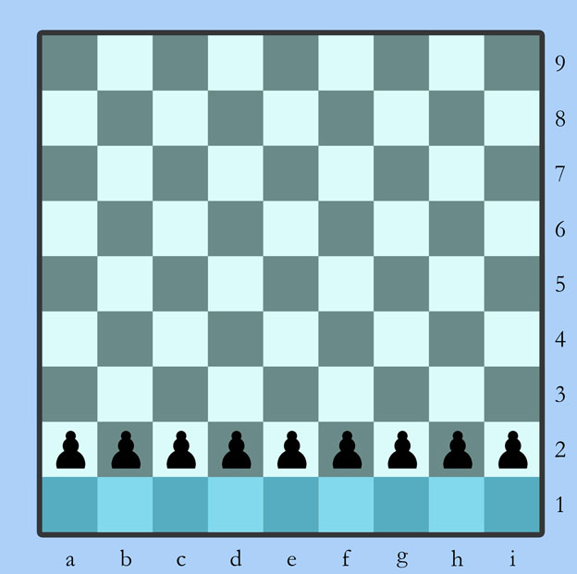

**Minor pieces**—those worth less than 5 points—can be played at any point in the game. **Major pieces**—worth 5 points or more—can only be played if the point total of a player’s minor pieces on the board adds up to more than the point value of the major piece being played.

Pieces can belong to several different **types**. Two of those types are included in this set: **Massive** pieces interact differently with effect cards than others, and **Royal** pieces can confer certain special advantages on other Royal pieces.

A piece card may be played when a King is in check, if the piece’s placement blocks the path of the check.

## Effect cards

**Effect cards** are the blue ones. They can be played either on an active piece or directly onto the board, depending on the effect.

**Piece effects** can be played on pieces occupying any square anywhere on the board. **Board effects** can be played on any square other than those in the three ranks closest to the opponent, like so:

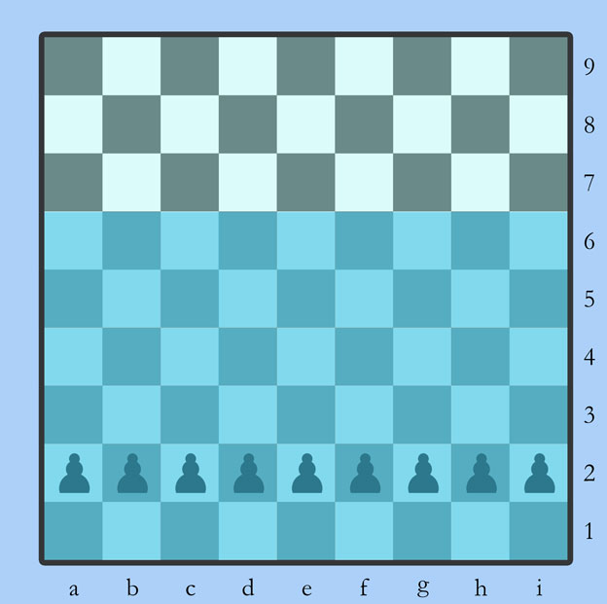

Most board effects remain in place and visible to both players once placed on a square. Some, although few, may be played on squares already occupied by pieces or pawns.

## Pawn cards

Players begin the game with a full second rank of **simple pawns**, which cannot take two steps on their first move and do not promote when they reach the far end of the board. **Pawn cards**, colored pale green, are played on these basic pawns to give them more favorable characteristics.

Pawn cards can only be played on simple pawns standing in the second or first ranks, like so:

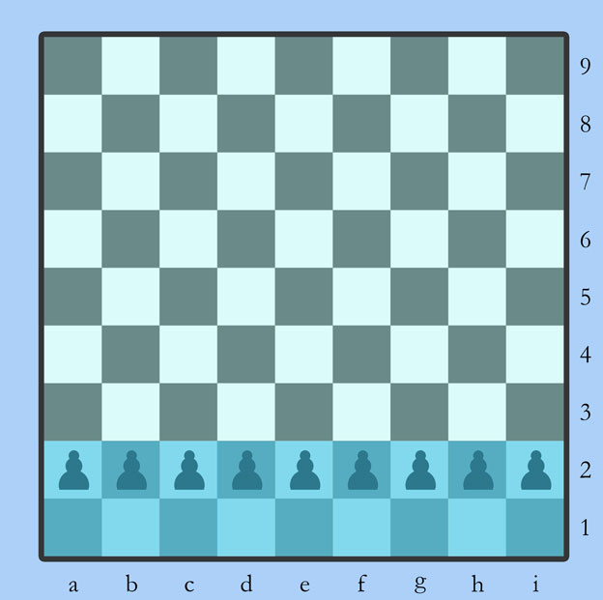

It’s possible for players to replace lost pawns from the original nine by including Simple Pawn cards in their deck. Simple Pawn cards are classified as piece cards because they place a new piece on the board, but they may be played in any empty square on the player’s first or second rank.

There will ultimately be a secondary deck of just pawn cards that players use alongside their deck of pieces and effects. Feel free to mix the pawn mechanics into the regular deck for prototype purposes, or to keep them out altogether until you’ve got a handle on the piece/effect stuff, whatever seems best.