**Computation Set 05 Solution**

*AAE 440: Spacecraft Attitude Dynamics*

*Spring 2022*

*Due Date: April 20, 2022*

*Brendan Gillis*

**Problem 01: Problem Statement**

**Problem 01: Problem Solution**

Part (a):

We know that a body is centrobaric if it has the same moment of inertia about every line that passes through the CoM; for any body frame. Because this spacecraft has three unique principal moments of inertia we can confidently say that this satellite is **not** centrobaric.

Part (b):

Starting with the definition of CoG, we know that the gravity force on a body can be expressed in terms of . We can then take the norm of the gravity force and solve for

Part (c):

Part (c.1):

Before we can compute Eq. (1) we must first determine . This can be done using .

Next we can compute the following e equations:

Part (c.2):

We can compare the first order and second order approximations for the gravitation force and as shown below, confirm that the difference is extremely small.

Part (c.3):

Using the equations determined in Part (a) we can apply the following relation using the second order approximation for gravitational force. Note all vectors we expressed in the B frame for these calculations.

Part (d):

Using the same calculations and code as in Part (c), we find that:

Part (e):

Using the same calculations and code as in Part (c), we find that:

Part (f):

* Comparing systems in (c) to (d) we can see that those in (d) have roughly 4500x larger gravitational force, 1 million times larger torque, and 2200x larger distance between CoM and CoG.
* Comparing systems in (d) to (e) we can see that those in (d) have roughly 30x larger gravitational force, 160x larger torque, and 5x larger distance between CoM and CoG.
* Broadly speaking, we can notice that increasing the length of the object increases the torque and distance between CoM and CoG. Additionally increasing mass increases the gravitational force. Finally, increasing radius will reduce all 3 terms (with the largest impact on torque). These relations align with the structure of Eq. (1).
* How negligible the term is may depend on the specific application. However, in these 3 examples we see that the second order terms contribution is billions of times smaller than the first order term. For the vast majority of use cases this means the second order term is effectively negligible for Earth orbit.
* One case where the second order term may become significant is when becomes large. This can occur when the spacecraft is very close to the center of mass of a body such as a satellite orbiting an asteroid, where the relative size of the satellite compared to its distance from the center of the asteroid is quite large.

**Problem 02: Problem Statement**

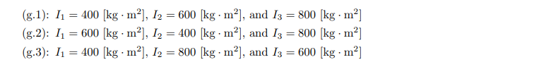

**Problem 02: Problem Solution**

Part (a):

Starting with Eq. (5), we can expand the gravity gradient term using Eq. (6) then elementwise divide by the principal moments of inertia and simplify using the values

Part (b):

First, we can show that the solution given in MRP is equivalent to the one derived in class. Then we can plug the solution into Eq. (4) and Eq. (7) and demonstrate their validity.

Because  **=** 0,we know that

Part (c):

To confirm our linearized equations, we can write our and in terms of the particular solution and perturbation, then substitute into Eq. (4) and Eq. (7), and neglect 2nd or higher order terms.

Next we determine our after the perturbation by calculating the DCM using our perturbed state:

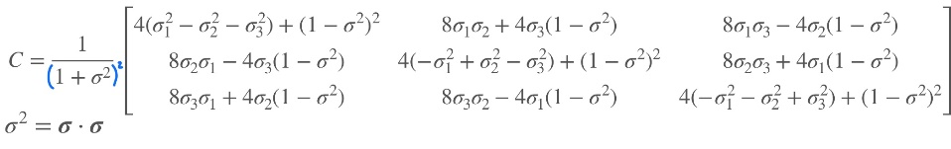

Part (d):

To find the characteristic equations for this system we can first identify that and are decoupled from the rest of the system. We can separate and combine those. For the other 4 state variables we can write the system of ODEs in the form and solve for its eigenvalues.

For clarity’s sake, let us define:

To find where the linearized system is unstable, we must determine the K values such that the real component of is

We find that the system is unstable if any of the following holds:

Part (e):

Part (e.1):

For this part, the initial conditions given represent a perturbation in initial orientation of the spacecraft. Specifically, by a 3-degree rotation about the axis ­

Part (e.2):

Several steps must be taken to numerically integrate the system. First, I calculate the radius vector in the B frame . Next, I calculate **.** Finally, we can construct a state variable and integrate the orientation and angular velocity using Eq. (4) and Eq. (7).

Part (e.3):

Here in order to compute the angle associated with the principle axis of rotation I calculate the DCM, then the PRP from the DCM.

Part (e.4):

* This simulation corresponds to the stable Region 1,
* all remain very close to their initial values. Additionally both appear periodic however do not follow a simple sinusoid.
* The maximum value of is 6% higher than the initial perturbation.
* From the numerical simulation, we can say that this system agrees with our linear stability analysis which predicted that the system would be stable.

Part (f):

Part (f.1):

* This simulation corresponds to the unstable Region 2
* **,** , and all vary significantly from their initial values and generally appear periodic. **,** remain very close to their initial values but do not show clear periodicity
* The maximum value of is 5900% higher than the initial perturbation.
* From the numerical simulation, we can say that this system agrees with our linear stability analysis which predicted that the system would be unstable.

Part (f.2):

* This simulation corresponds to the unstable Region 3
* all vary significantly from their initial perturbation, and none demonstrate periodicity.
* The maximum value of is 4300% higher than the initial perturbation.
* From the numerical simulation, we can say that this system agrees with our linear stability analysis which predicted that the system would be unstable and chaotic.

Part (g):

Part (g.1):

* This simulation corresponds to the stable Region 1,
* all remain very close to their initial values. Additionally both appear oscillatory however do not follow a simple sinusoid.
* The maximum value of is 10% higher than the initial perturbation.
* From the numerical simulation, we can say that this system agrees with our linear stability analysis which predicted that the system would be stable.

Part (g.2):

* This simulation corresponds to the unstable Region 2
* **,** , and all vary significantly from their initial values and generally appear oscillatory. **,** remain very close to their initial values but do not show clear periodicity
* The maximum value of is 5940% higher than the initial perturbation.
* From the numerical simulation, we can say that this system agrees with our linear stability analysis which predicted that the system would be unstable.

Part (g.3):

* This simulation corresponds to the unstable Region 3
* all vary significantly from their initial perturbation, and none demonstrate periodicity.
* The maximum value of is 4742% higher than the initial perturbation.
* From the numerical simulation, we can say that this system agrees with our linear stability analysis which predicted that the system would be unstable and chaotic.

