Brendan Lauterborn
COSC 501
Lab 1
Program 1
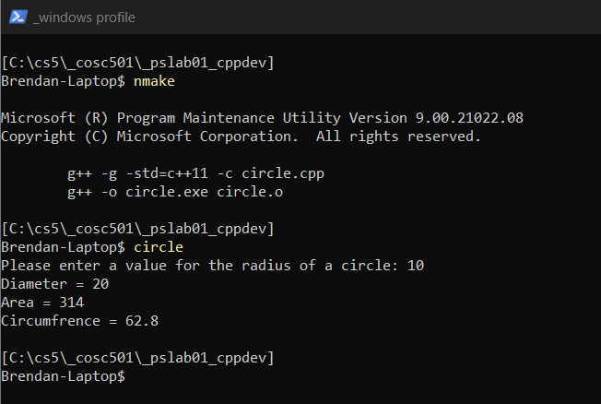
Program 2
