Brendan Lauterborn
Math 417
Final Exam
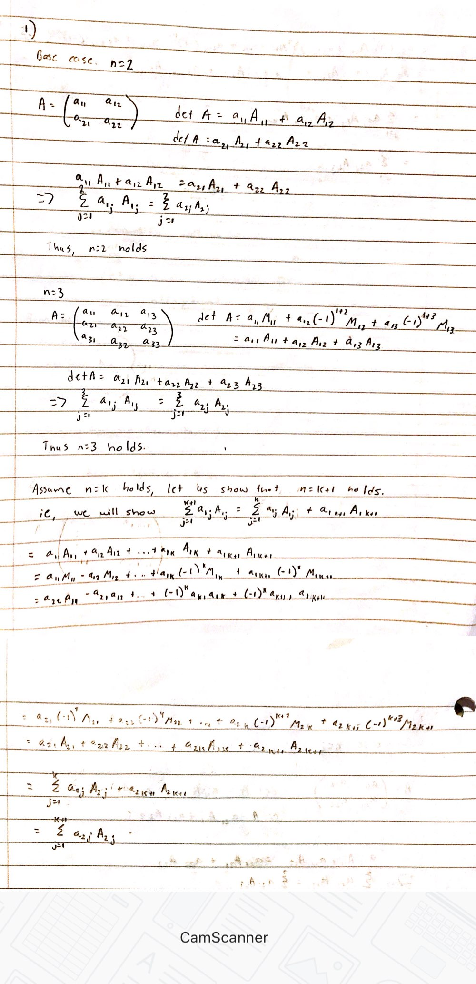
1

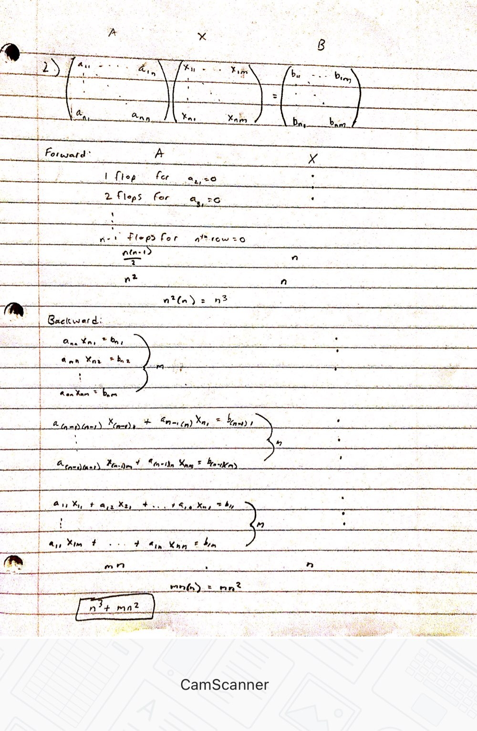
2

3.
Since each pivot element is positive
Take, A=LDU to be LDU decomposition of A
A=A^{T}, which implies
LDU=U^{T}DL^{T}, which implies
U=L^{T}
Then,
A=LDL^{T}=LD^{.5}D^{.5}L^{T}=S^{T}S , where S =D^{.5}L^{T}
X^{T}Ax=x^{T}S^{T}Sx=(Sx)^{T}(Sx)
= ||Sx||² >0
Thus, A is positive definite

4.
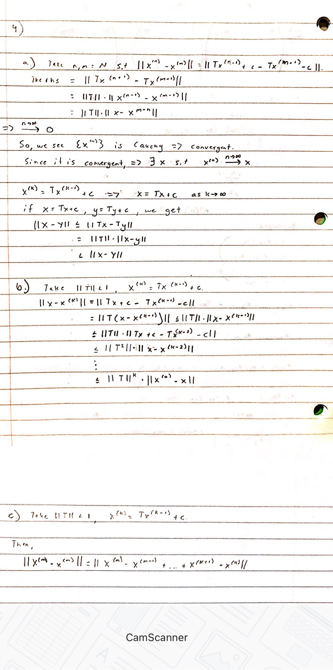

5?
6??

