Brendan Lauterborn
Math 417
HW 3
1).
2). f(x)= blue, P(x) = orange
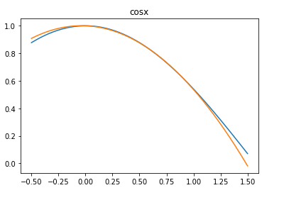
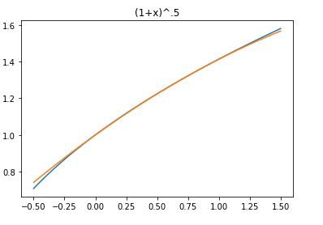

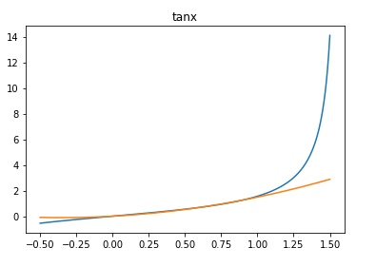
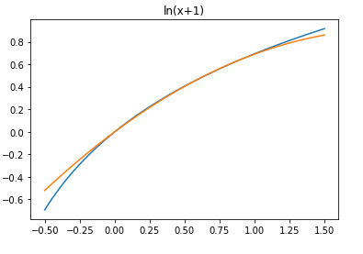

3).
- P₂: (1/.75-.5)[(.4-.5)8 – (.4-.75)P₂]=2.4
P₂=4
- P_{1,2}: (1/.5-0)[(.4-0)P_{1,2} – (.4-.5)2.6] = 3.08
P_{1,2} =3.2
- P_{0,1,2}: (1/.75-0)[(.4-0)2.96 – (.4-.75)P_{0,1,2}]=2.4
P_{0,1,2}=3.08

4)

