Brendan Lauterborn
Math 417
HW 4
1)
a) we have,
S(x₀) = f(x₀); a₀= f(x₀)
S(x₁) = f(x₁); a₁= f(x₁)
S(x₂) = f(x₂); a₁+b₁(x₂-x₁)+c₁(x₂-x₁)²=f(x₂)
and
S₀(x₁)=S₁(x₁)
S’₀(x₁)= S’₁(x₁)
Which gives us
a₀+b₀(x₁-x₀)+c₀(x₁-x₀)²=a₁
b₀+2c₀(x₁-x₀)=b₁
b) Yes, it is meaningful because it will give us another equation which allows us to solve for the
6th unknown

2)
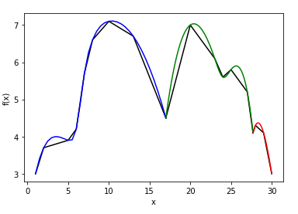
a)

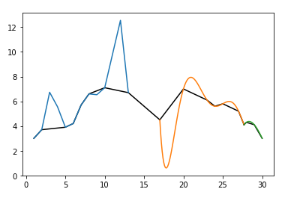
b) ?

3)
a)
f’(-.3) = (1/.2)[-3(-.27652)+4(-.25074)-(-.16134)] =-.0603
f’(-.2)= (1/.2)[-.16134+.27652] = .5759
f’(-.1) = (1/.2)[0+.25074] =1.2537
b)
f’(7.4)=(1/.4)[-3(-68.3193)+4(-71.6982)+75.1576] = -16.6933
f’(7.6)=(1/.4)[-75.1576+68.3193]=-17.0958
f’(7.8) = (1/.4)[-78.6974+71.6982]=-17.498
f’(8) =(1/.4)[-3(-78.6974)+4(-75.1576)+71.6982]=-17.9

4)?

