Brendan Lauterborn

726004578
Math 417
HW 8

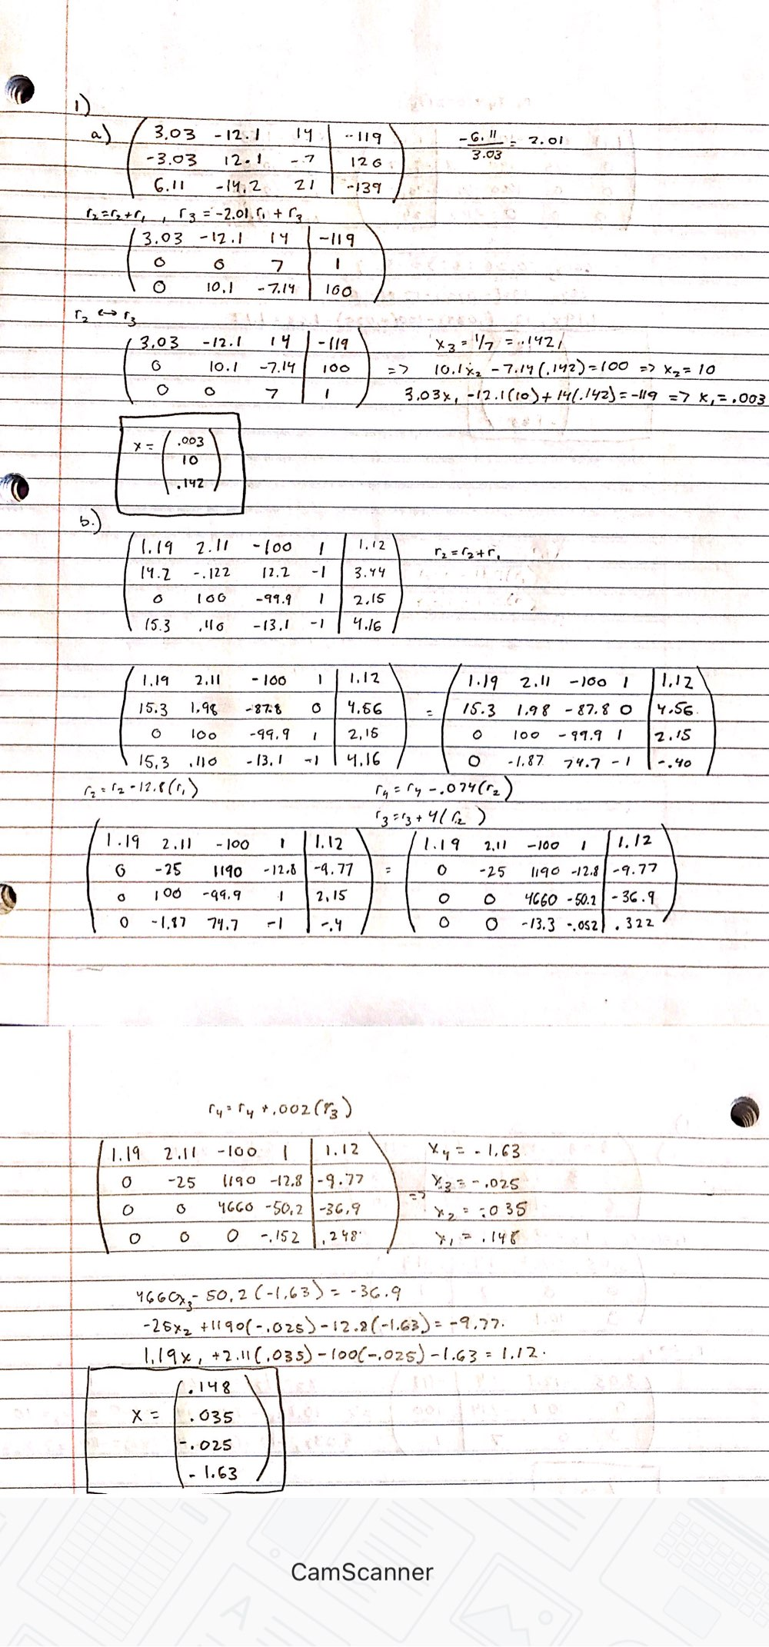
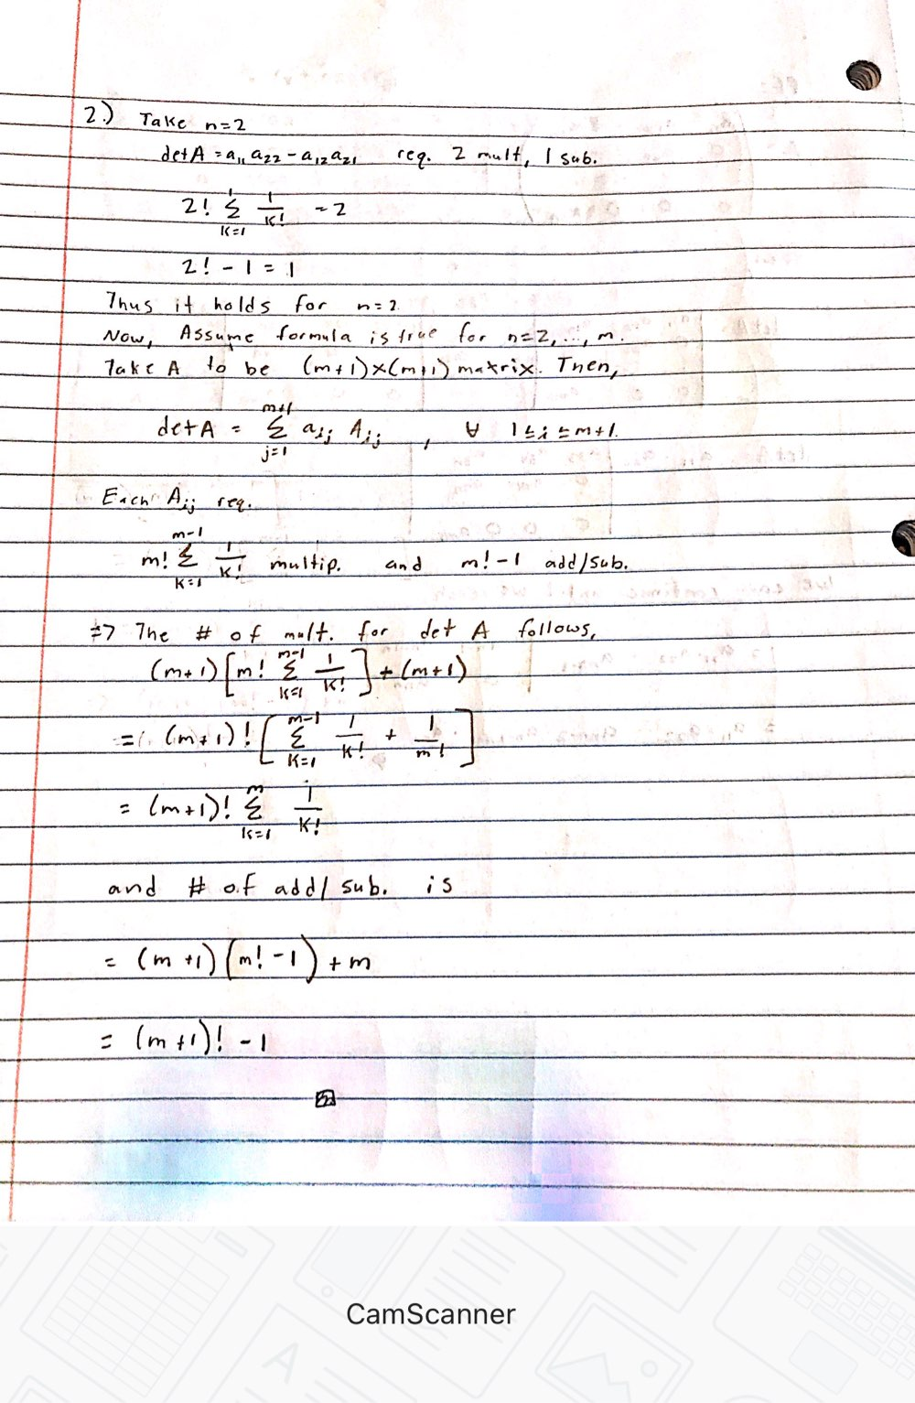
3)
A and B are invertibe, thus A⁻¹ and B⁻¹ exist.
(AB)(B⁻¹A⁻¹) = A(BB⁻¹)A⁻¹=AA⁻¹= I
Thus AB has inverse, which means that AB is nonsingular
4)