

**Athlone Institute of Technology**



**COURSE:** Higher Diploma In Computing

**COURSE ID:** Al_Kcomp_G

**SUBJECT:** Database Applications

**YEAR:** 5

**LECTURER**: Mr. Noel Tierney

**SUBJECT:** PL/SQL

**PROJECT TITLE:** Farm Rental Agreements

|  |  |  |
| --- | --- | --- |
| Student Number | Student Name | Signature (for hardcopy) |
| A00037189 | Brendan Kenny |  |

***Contents***

***Introduction*** 3

***Entity Relationship Diagrams*** 4

***Entity Relationship Diagram (ERD) Overview*** 4

***Extended ERD with Table Column Names:*** 4

***Q.1 Before Insert Trigger*** 5

***Q.2 Before Update Trigger*** 9

***Q.3 After Insert Trigger*** 14

***Q.4 After Update Trigger*** 23

***Q.5 Before Insert, Update, Delete Trigger*** 27

***Q.6 After Insert Update Delete On Rental Contract*** 31

***Q.7 Before Insert/Update/Delete Table Level Trigger*** 39

***Q.8 Procedure without Cursor*** 45

***Q.9 Procedure With Cursor*** 48

***Q.10 Procedure with Cursor to Retrieve, Display and Delete*** 52

***Q.11 Package with Three Procedures*** 59

***Appendix*** 69

***Q.17 Package with Insert, Update And Delete Procedures*** 69

***Q.19 Trigger That Uses a Cursor*** 72

***Q.18 Trigger that Calls a Procedure*** 75

***Q.14 Table Level Trigger Before Delete*** 79

## ***Introduction***

The following database was created to facilitate farm rental agreements between the relevant parties that would be party to such agreements, namely Farmers, Landlords, Auctioneers and Solicitors. The resulting agreements are recorded in the Rental Contract table and relate to the relevant Farms as recorded in the Farm table. The relationships between the relevant tables are displayed in the ERD diagrams and were an aid to me in the creation of the database, when creating the user constraints and in the subsequent queries, procedures, triggers and packages in later stages of my project.

The following pages will illustrate the various Triggers, Procedures and Packages that are used in PL/SQL.

Brendan Kenny

29 March 2015

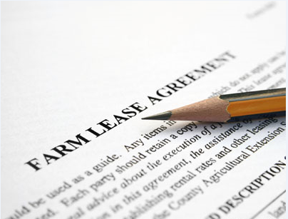

## ***Entity Relationship Diagrams***

### ***Entity Relationship Diagram (ERD) Overview***

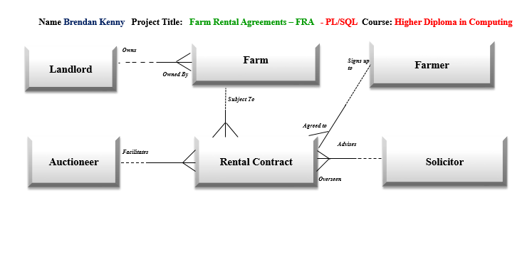

### ***Extended ERD with Table Column Names:***

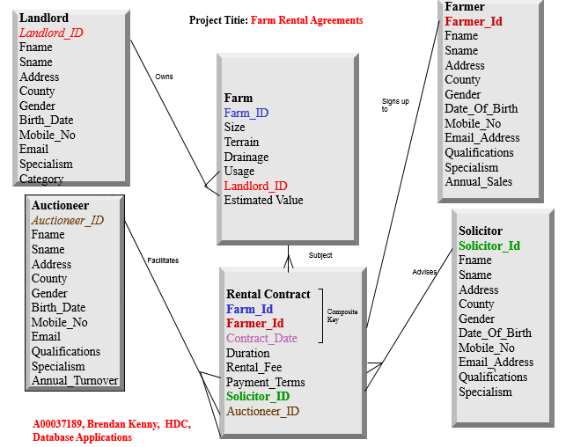

## ***Q.1 Before Insert Trigger***

***A Rental Contract can be added to the Database provided certain conditions are met. The details are :***

***(a)*** ***New Contracts can only be added to this table for Farmers who do not have the Farming Cert Qualification whose payment terms are not in monthly instalments.***

***(b)*** ***New Contracts can only be added to this table Solicitors who are from counties other than Longford or Westmeath and are party to contracts of not less than six months duration.***

***(c)*** ***New Contracts can only be added to this table for Auctioneers Solicitors whose specialism is either Housing or Retail Units and are party to Contracts of not less than €5000.***

*****************************************************************************************************************

**Drop Trigger** **Q1BeforeInsert;**

**Set** **Serveroutput** **On** **Size** 1000000;

**Create** **or** **Replace** **Trigger Q1BeforeInsert**

**Before** **Insert** **On** **Rental_Contract**

**For** **Each** **Row**

**Declare**

**V_Qualifications** **Farmer.Qualifications%Type;**

**V_County** **Solicitor.County%Type;**

**V_Specialism** **Auctioneer**.**Specialism%Type;**

**Begin**

**SELECT** **Qualifications** into **V_Qualifications**

**FROM** **Farmer**

**WHERE** **Farmer.Farmer_Id** **=** **:new.Farmer_Id**;

**SELECT** **County** into **V_County**

**FROM** **Solicitor**

**WHERE** **Solicitor.Solicitor_Id** **=** **:new.Solicitor_Id**;

**SELECT** **Specialism** into **V_Specialism**

**FROM** **Auctioneer**

**WHERE** **Auctioneer.Auctioneer_Id** **=** **:new.Auctioneer_Id;**

**If:new.Payment_Terms** **Not In** **(‘Monthly Instalments’**)**And** **V_Qualifications** =‘**Farming** **Cert’ Then**

**Raise_Application_Error(**-20101**,** *'****New Contracts can only be added to this table for Farmers who do not have the Farming Cert Qualification whose payment terms are not in monthly instalments’*);**

**End If;**

**If** **:new.Duration** < 6 **And** **V_County** **In** **(‘Longford’, ‘Westmeath’**) **Then**

**Raise_Application_Error(**-20101**,** ***'New Contracts can only be added to this table Solicitors who are from counties other than Longford or Westmeath and are party to contracts of not less than six months duration’*);**

**End If;**

**If** **:new.Rental_Fee** < 5000 **And** **V_Specialism** **In** **(‘Housing’, ‘Retail Units’) Then**

**Raise_Application_Error(-20101,** ***'New Contracts can only be added to this table for Auctioneers Solicitors whose specialism is either Housing or Retail Units and are party to Contracts of not less than €5000'*);**

**End If;**

**End;**

**/**

**Sho Err**

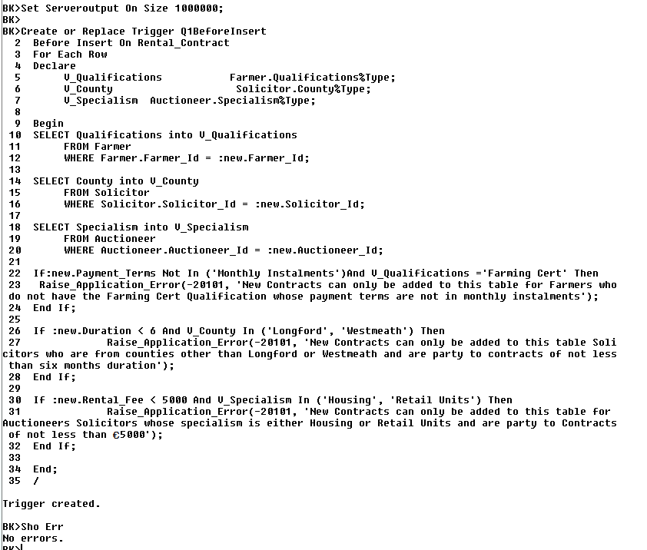

**\*\*\*\*\*\*\*\*\*\*\*\*\*\*\*\*\*\*\*\*\*\*\*\*\*\*\*\*\*\*\*\*\*\*\*\*\*\*\*\*\*\*\*\*\*\*\*\*\*\*\*\*\*\*\*\*\*\*\*\*\*\*\*\*\*\*\*\*\*\*\*\*\*\*\*\*\*\*\*\*\*\*\*\*\*\*\*\*\*\*\*\*\***

***(a)*** ***New Contracts can only be added to this table for Farmers who do not have the Farming Cert Qualification whose payment terms are not in monthly instalments.***

**Invalid Insert:**

Insert into Rental_Contract values (1060,**3190**,'12-Feb-07',15,6000,'Quarterly Instalments', 5130, 7030);

Rollback;

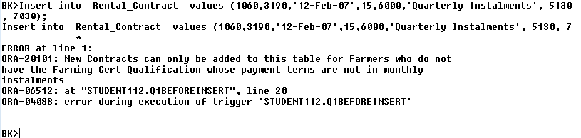

**Valid Insert:**

Insert into Rental_Contract values (1060,**3190**,'12-Feb-07',15,6000,**'Monthly Instalments**', 5130, 7030);

Rollback;

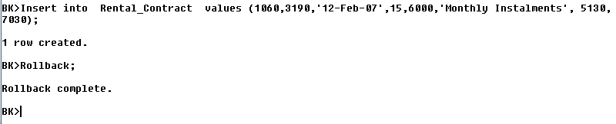

**\*\*\*\*\*\*\*\*\*\*\*\*\*\*\*\*\*\*\*\*\*\*\*\*\*\*\*\*\*\*\*\*\*\*\*\*\*\*\*\*\*\*\*\*\*\*\*\*\*\*\*\*\*\*\*\*\*\*\*\*\*\*\*\*\*\*\*\*\*\*\*\*\*\*\*\*\*\*\*\*\*\*\*\*\*\*\*\*\*\*\*\*\*\*\*\*\*\*\*\*\*\*\*\*\*\*\*\*\*\*\*\***

***(b)*** ***New Contracts can only be added to this table Solicitors who are from counties other than Longford or Westmeath and are party to contracts of not less than six months duration.***

**Invalid Insert:**

**Insert into Rental_Contract values (1060,3190,'12-Feb-07',5,6000, 'Monthly Instalments',5130,7120);**

**Rollback;**

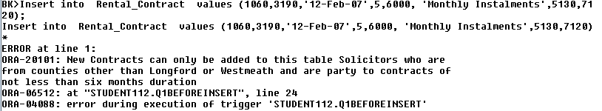

**Valid Insert:**

**Insert into Rental_Contract values (1060,3190,'12-Feb-07',15,6000,'Monthly Instalments',5130,7120);**

**Rollback;**

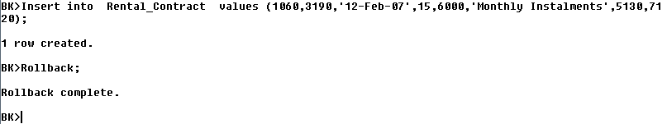

**\*\*\*\*\*\*\*\*\*\*\*\*\*\*\*\*\*\*\*\*\*\*\*\*\*\*\*\*\*\*\*\*\*\*\*\*\*\*\*\*\*\*\*\*\*\*\*\*\*\*\*\*\*\*\*\*\*\*\*\*\*\*\*\*\*\*\*\*\*\*\*\*\*\*\*\*\*\*\*\*\*\*\*\*\*\*\*\*\*\*\*\*\*\**(c)*** ***New Contracts can only be added to this table for Auctioneers Solicitors whose specialism is either Housing or Retail Units and are party to Contracts of not less than €5000.***

**Invalid Insert:**

**Insert into Rental_Contract values (1060,3190,'12-Feb-07',10,1000,'Monthly Instalments',5130,7030);**

**Rollback;**

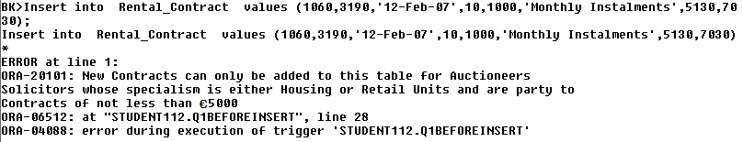

**Valid Insert:**

**Insert into Rental_Contract values (1060,3190,'12-Feb-07',15,6000,'Monthly Instalments',5130,7030);**

**Rollback;**

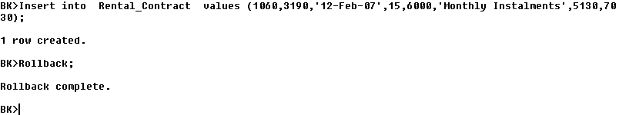

**Drop Trigger Q1BeforeInsert;**



**\*\*\*\*\*\*\*\*\*\*\*\*\*\*\*\*\*\*\*\*\*\*\*\*\*\*\*\*\*\*\*\*\*\*\*\*\*\*\*\*\*\*\*\*\*\*\*\*\*\*\*\*\*\*\*\*\*\*\*\*\*\*\*\*\*\*\*\*\*\*\*\*\*\*\*\*\*\*\*\*\*\*\*\*\*\*\*\*\*\*\*\*\*\*\*\*\*\*\*\*\*\*\*\*\*\*\*\*\*\*\*\*\***

## ***Q.2 Before Update Trigger***

***Before an Update can be made to the Farm table, the following conditions must be met :***

***(a)* *Farms belonging to Longford farmers may not be increased by less than €10000 in value.***

***(b)* *Only Farms that have been rented out more than once may be updated by amounts in excess of €10000***

***\*\*\*\*\*\*\*\*\*\*\*\*\*\*\*\*\*\*\*\*\*\*\*\*\*\*\*\*\*\*\*\*\*\*\*\*\*\*\*\*\*\*\*\*\*\*\*\*\*\*\*\*\*\*\*\*\*\*\*\*\*\*\*\*\*\*\*\*\*\*\*\*\*\*\*\*\*\*\*\*\*\*\*\*\*\*\*\*\*\*\*\*\*\*\*\*\*\*\*\*\*\*\*\*\*\*\*\*\*\*\*\*\*\*\*\*\*\*\*\*\*\*\*\*\*\*\*\*\*\*\*\*\*\*\*\*\*\****

**Drop Trigger** **Farm_Est_Value;**

**Set** **Serveroutput On Size** 1000000**;**

**Create** **or** **Replace** **Trigger** **Farm_Est_Value**

**Before** **Update** **On** **Farm**

**For** **Each** **Row**

**Declare**

**V_Count_Farm** **Number(2);**

**V_County_Landlord** **Landlord.County%Type**;

**Begin**

**Select** **NVL(Count(*),0)** into **V_Count_Farm**

**From** **Rental_Contract**

**Where** **Rental_Contract.Farm_Id** = :**new**.**Farm_Id;**

**Select** **Landlord.County** into **V_County_Landlord**

**From** **Landlord**

**Where** **Landlord.Landlord_Id**=:**new**.**Landlord_Id;**

**If**(:**New**.**Estimated_Value**-:**Old**.**Estimated_Value**)<10000 **And V_County_Landlord** = ‘**Longford**’**Then**

**Raise_Application_Error**(**-20101**, **‘Farms belonging to Longford Landlords may not be increased by less than €10000 in value’**);

**End If;**

**If(:New**.**Estimated_Value** -:**Old**.**Estimated_Value**)>10000 **And** (**V_Count_Farm**<2) **Then**

**Raise_Application_Error**(**-20101**, **‘Only Farms that have been rented out more than once may be updated’);**

**End If;**

**End;**

**/**

**Sho Err**

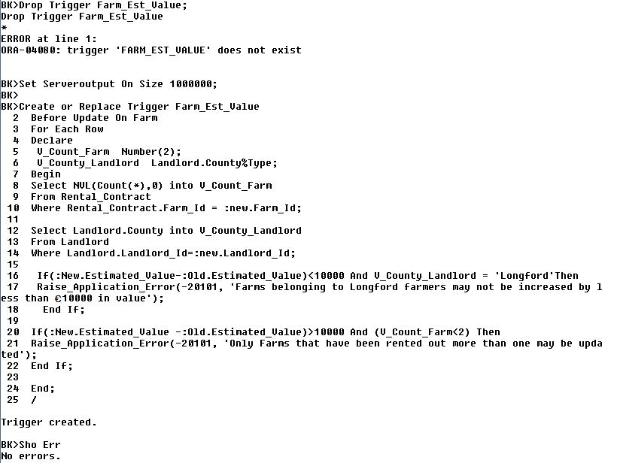

**Select Farm_Id, Count(*)**

**From Rental_Contract**

**Group by Farm_Id;**

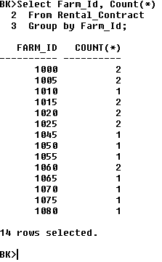

***\*\*\*\*\*\*\*\*\*\*\*\*\*\*\*\*\*\*\*\*\*\*\*\*\*\*\*\*\*\*\*\*\*\*\*\*\*\*\*\*\*\*\*\*\*\*\*\*\*\*\*\*\*\*\*\*\*\*\*\*\*\*\*\*\*\*\*\*\*\*\*\*\*\*\*\*\*\*\*\*\*\*\*\*\*\*\*\*\*\*\*\*\*\*\*\*\*\*\*\*\*\*\*\*\*\*\*\*\*\*\*\*\****

1. ***Farms belonging to Longford farmers may not be increased by less than €10000 in value.***

***This Update will fail because the new update is less than €10000***

**Select Farm_Id, Estimated_Value**

**From Farm**

**Where Farm_Id =1020;**

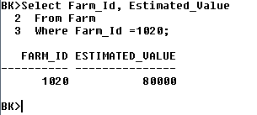

**Update Farm**

**Set Estimated_Value = Estimated_Value + 8000**

**Where Farm_Id =1020;**

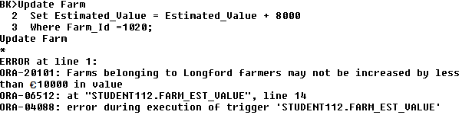

***This Update will suceed because the new update is in excess of €10000.***

**Select Farm_Id, Estimated_Value**

**From Farm**

**Where Farm_Id =1020;**

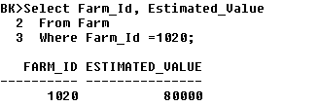

**Update Farm**

**Set Estimated_Value = Estimated_Value + 18000**

**Where Farm_Id =1020;**

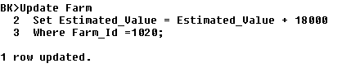

**Select Farm_Id, Estimated_Value**

**From Farm**

**Where Farm_Id =1020;**

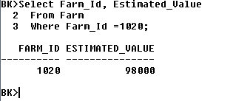

**Rollback;**

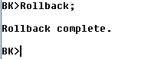

**\*\*\*\*\*\*\*\*\*\*\*\*\*\*\*\*\*\*\*\*\*\*\*\*\*\*\*\*\*\*\*\*\*\*\*\*\*\*\*\*\*\*\*\*\*\*\*\*\*\*\*\*\*\*\*\*\*\*\*\*\*\*\*\*\*\*\*\*\*\*\*\*\*\*\*\*\*\*\*\*\*\*\*\*\*\*\*\*\*\*\*\*\*\*\*\*\*\*\*\*\*\*\*\*\*\*\*\*\*\*\*\*\***

1. ***Only Farms that have been rented out more than once may be updated by more than €10000.***

***This Update will fail because the update is less than €10000.***

**Select Farm_Id, Estimated_Value**

**From Farm**

**Where Farm_Id =1000;**

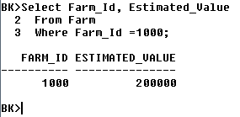

**Update Farm**

**Set Estimated_Value = Estimated_Value + 8000**

**Where Farm_Id =1000;**

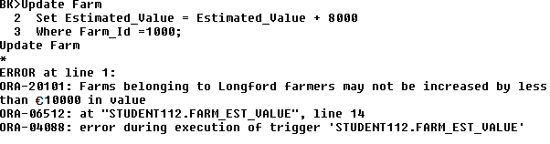

***This Update will Succeed because the update is greater than €10000.***

**Update Farm**

**Set Estimated_Value = Estimated_Value + 18000**

**Where Farm_Id =1000;**

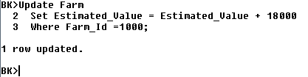

**Select Farm_Id, Estimated_Value**

**From Farm**

**Where Farm_Id =1000;**

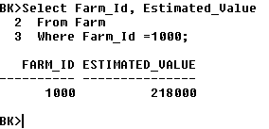

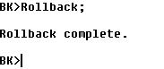

***\*\*\*\*\*\*\*\*\*\*\*\*\*\*\*\*\*\*\*\*\*\*\*\*\*\*\*\*\*\*\*\*\*\*\*\*\*\*\*\*\*\*\*\*\*\*\*\*\*\*\*\*\*\*\*\*\*\*\*\*\*\*\*\*\*\*\*\*\*\*\*\*\*\*\*\*\*\*\*\*\*\*\*\*\*\*\*\*\*\*\*\*\*\*\*\*\*\*\*\*\*\*\*\*\*\*\*\*\*\*\*\*\****

1. ***Only Farms that have been rented out more than once may be updated by more than €10000.***

***This update will succeed because the farm in question has been rented out less than twice and the amount of the update is less than €10000***

**Select Farm_Id, Estimated_Value**

**From Farm**

**Where Farm_Id =1045;**

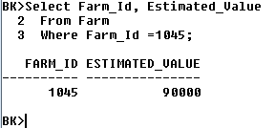

**Update Farm**

**Set Estimated_Value = Estimated_Value + 5000**

**Where Farm_Id =1045;**

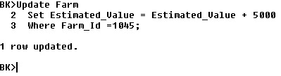

**Select Farm_Id, Estimated_Value**

**From Farm**

**Where Farm_Id =1045;**

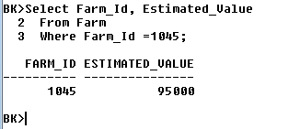

***This update will fail because the farm in question has been rented out less than twice and the amount of the update is greater than €10000***

**Select Farm_Id, Estimated_Value**

**From Farm**

**Where Farm_Id =1045;**



**Update Farm**

**Set Estimated_Value = Estimated_Value + 15000**

**Where Farm_Id =1045;**

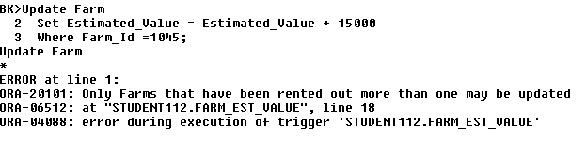

**Drop Trigger Farm_Est_Value;**

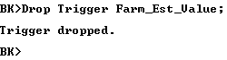

## ***Q.3 After Insert Trigger***

***After a successful insert has been made to the Rental Contract table, the following changes to the Database should be made :***

***1.***

***(a)* *A new Rental Contract of a duration of between 6 and 12 months should result in an increase of €2000 in the associated farms estimated value if that farm is used for tillage.***

***(b)* *A new Rental Contract of a duration of more than 12 months should result in an increase of €1500 in the associated farms estimated value if that farm is used for grazing.***

***2.***

***(a)* *A new Rental Contract with a rental fee in excess of €5000 will result in an increase in annual turnover of €800 for the associated Auctioneer provided that Auctioneer specialises in Land.***

***(b)* *A new Rental Contract with a Rental Fee less than €5000 will result in an increase in annual turnover of €500, if the associated Auctioneer specialises in anything other than land.***

***3.***

***(a)* *A new Rental Contract with Payment Terms in ‘Monthly Instalments’ will result in an increase in the associated Farmer’s Annual Sales of €800, provided the farmer in question is from Dublin.***

***(b)* *A new Rental Contract with Payment Terms in ‘Quarterly Instalments’ will result in an increase in the associated Farmer’s Annual Sales of €200 if the Farmer in question is from Louth.***

**\*\*\*\*\*\*\*\*\*\*\*\*\*\*\*\*\*\*\*\*\*\*\*\*\*\*\*\*\*\*\*\*\*\*\*\*\*\*\*\*\*\*\*\*\*\*\*\*\*\*\*\*\*\*\*\*\*\*\*\*\*\*\*\*\*\*\*\*\*\*\*\*\*\*\*\*\*\*\*\*\*\*\*\*\*\*\*\*\*\*\*\*\*\*\*\*\*\*\*\*\*\*\*\*\*\*\*\*\*\*\*\***

**Set** **Serveroutput** **On** **Size** 1000000**;**

**Drop Table New_Contracts_Log;**

**Create Table New_Contracts_Log** (User_Involved Varchar2 (10), Date_Added Date, Farm_No Number (4), Duration Number (7));

**Create or Replace** Trigger **New_Contracts**

**After Insert** on **Rental_Contract**

**For Each Row**

Declare

**V_Usage** **Farm**.**Usage%Type;**

**V_Specialism Auctioneer.Specialism%Type;**

**V_County Farmer.County%Type;**

**Begin**

**Insert** into **New_Contracts_Log** Values (User, Sysdate,:New.Farm_Id,:New.Duration);

**Select** **Usage** Into **V_Usage**

**From** **Farm**

**Where** **Farm.Farm_Id** = **:New.Farm_Id;**

**Select** **Specialism** Into **V_Specialism**

**From** **Auctioneer**

**Where** **Auctioneer.Auctioneer_Id** = **:New.Auctioneer_Id;**

**Select** **County** Into **V_County**

**From** **Farmer**

**Where** **Farmer.Farmer_Id** = **:New.Farmer_Id;**

**If :New**.**Duration Between 6 And 12** **And** (**V_Usage** = ‘**Tillage**’) **Then**

**Update** **Farm**

**Set Estimated_Value** = **Estimated_Value**+**2000**

**Where Farm_Id** = **:New.Farm_Id**;

**End If;**

**If** **:New.Duration** **> 12** **And** (**V_Usage** = ‘**Grazing**’) **Then**

**Update** **Farm**

**Set Estimated_Value** = **Estimated_Value**+**1500**

**Where Farm_Id** = **:New.Farm_Id;**

**End If;**

**If** **:New.Rental_Fee> 5000** **And** (**V_Specialism** = ‘**Land**’) **Then**

**Update** **Auctioneer**

**Set Annual_Turnover** = **Annual_Turnover**+**800**

**Where Auctioneer_Id** = **:New.Auctioneer_Id;**

**End If;**

**If** **:New.Rental_Fee** **< 5000** **And** (**V_Usage** <>‘**Land**’) **Then**

**Update** **Auctioneer**

**Set Annual_Turnover = Annual_Turnover**+**500**

**Where Auctioneer_Id** = **:New.Auctioneer_Id;**

**End If;**

**If** **:New.Payment_Terms**=**’Monthly Instalments’** **And** (**V_County** = ‘**Dublin**’) **Then**

**Update** **Farmer**

**Set Annual_Sales** = **Annual_Sales**+**800**

**Where Farmer_Id** = **:New.Farmer_Id;**

**End If;**

**If** **:New.Payment_Terms**= ‘**Quarterly Instalments’** **And** (**V_County** = ‘**Louth**’) **Then**

**Update** **Farmer**

**Set Annual_Sales** = **Annual_Sales**+**200**

**Where Farmer_Id** = **:New.Farmer_Id;**

**End If;**

**End;**

/

**Sho err**

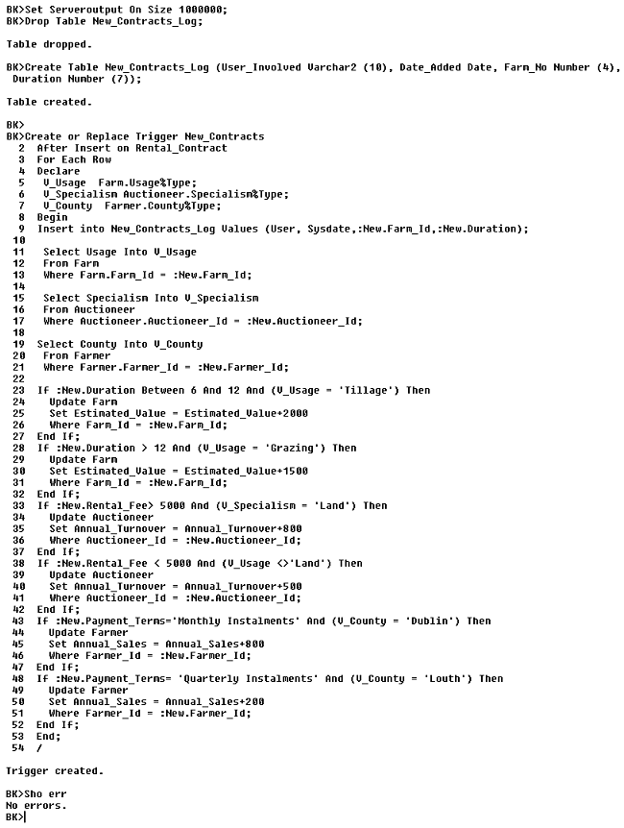

**\*\*\*\*\*\*\*\*\*\*\*\*\*\*\*\*\*\*\*\*\*\*\*\*\*\*\*\*\*\*\*\*\*\*\*\*\*\*\*\*\*\*\*\*\*\*\*\*\*\*\*\*\*\*\*\*\*\*\*\*\*\*\*\*\*\*\*\*\*\*\*\*\*\*\*\*\*\*\*\*\*\***

1. ***(a)* *A new Rental Contract of a duration of between 6 and 12 months should result in an increase of €2000 in the associated farms estimated value if that farm is used for tillage.***

***Before Update:***

**Select Estimated_Value**

**From Farm**

**Where Farm_Id = 1095;**

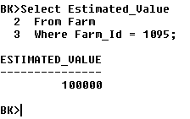

**Insert into Rental_Contract values (1095,3000,'12-Dec-06',12,5000,'Full Amount In Advance',5090,7080);**

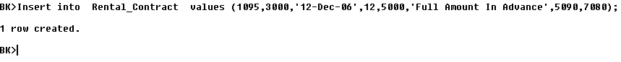

***After Update:***

**Select Estimated_Value**

**From Farm**

**Where Farm_Id = 1095;**

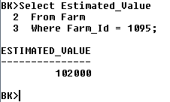

**\*\*\*\*\*\*\*\*\*\*\*\*\*\*\*\*\*\*\*\*\*\*\*\*\*\*\*\*\*\*\*\*\*\*\*\*\*\*\*\*\*\*\*\*\*\*\*\*\*\*\*\*\*\*\*\*\*\*\*\*\*\*\*\*\*\*\*\*\*\*\*\*\*\*\*\*\*\*\*\*\*\***

***\*\*\*\*\*\*\*\*\*\*\*\*\*\*\*\*\*\*\*\*\*\*\*\*\*\*\*\*\*\*\*\*\*\*\*\*\*\*\*\*\*\*\*\*\*\*\*\*\*\*\*\*\*\*\*\*\*\*\*\*\*\*\*\*\*\*\*\*\*\*\*\*\*\*\*\*\*\*\*\*\*\*\*\*\*\*\*\*\*\*\*\*\*\*\*\*\*\*\*\*\*\*\*\*\*\*\*\*\*\*\*\*\****

***1.* *(b)* *A new Rental Contract of a duration of more than 12 months should result in an increase of €1500 in the associated farms estimated value if that farm is used for grazing.***

***Before Update***

**Select Estimated_Value**

**From Farm**

**Where Farm_Id = 1090;**

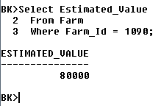

**Insert into Rental_Contract values (1090,3010,'10-Feb-07',15,7000,'Monthly Instalments',5010,7090);**

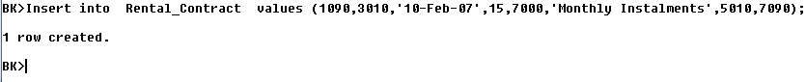

***After Update***

**Select Estimated_Value**

**From Farm**

**Where Farm_Id = 1090;**

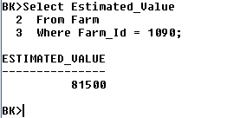

**\*\*\*\*\*\*\*\*\*\*\*\*\*\*\*\*\*\*\*\*\*\*\*\*\*\*\*\*\*\*\*\*\*\*\*\*\*\*\*\*\*\*\*\*\*\*\*\*\*\*\*\*\*\*\*\*\*\*\*\*\*\*\*\*\*\*\*\*\*\*\*\*\*\*\*\*\*\*\*\*\*\***

**\*\*\*\*\*\*\*\*\*\*\*\*\*\*\*\*\*\*\*\*\*\*\*\*\*\*\*\*\*\*\*\*\*\*\*\*\*\*\*\*\*\*\*\*\*\*\*\*\*\*\*\*\*\*\*\*\*\*\*\*\*\*\*\*\*\*\*\*\*\*\*\*\*\*\*\*\*\*\*\*\*\***

***2. (a)* *A new Rental Contract with a rental fee in excess of €5000 will result in an increase in annual turnover of €800 for the associated Auctioneer provided that Auctioneer specialises in Land.***

***Before Update:***

**Select Annual_Turnover**

**From Auctioneer**

**Where Auctioneer_Id = 7000;**

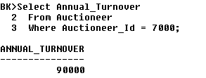

**Insert into Rental_Contract values** (1045,3140,'12-Dec-06',18,**6000**,'Quarterly Instalments',5060,**7000**);



***After Update:***

**Select Annual_Turnover**

**From Auctioneer**

**Where Auctioneer_Id = 7000;**

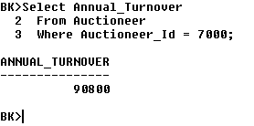

**\*\*\*\*\*\*\*\*\*\*\*\*\*\*\*\*\*\*\*\*\*\*\*\*\*\*\*\*\*\*\*\*\*\*\*\*\*\*\*\*\*\*\*\*\*\*\*\*\*\*\*\*\*\*\*\*\*\*\*\*\*\*\*\*\*\*\*\*\*\*\*\*\*\*\*\*\*\*\*\*\*\*\*\*\*\*\*\*\*\*\*\*\*\*\*\*\*\*\*\*\*\*\*\*\*\*\*\*\*\*\*\*\***

**********************************************************************************

1. ***(b)* *A new Rental Contract with a Rental Fee less than €5000 will result in an increase in annual turnover of €500, if the associated Auctioneer specialises in anything other than land.***

***Before Update:***

**Select Annual_Turnover**

**From Auctioneer**

**Where Auctioneer_Id = 7060;**

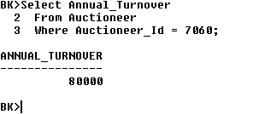

**Insert into Rental_Contract values** (1050,3000,'11-Feb-07',6,**4000**,'Quarterly Instalments',5110,**7060**);

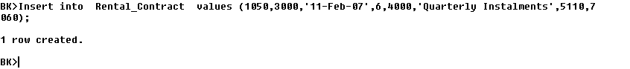

***After Update:***

**Select Annual_Turnover**

**From Auctioneer**

**Where Auctioneer_Id = 7060;**

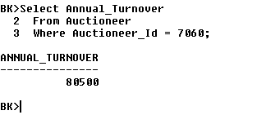

**\*\*\*\*\*\*\*\*\*\*\*\*\*\*\*\*\*\*\*\*\*\*\*\*\*\*\*\*\*\*\*\*\*\*\*\*\*\*\*\*\*\*\*\*\*\*\*\*\*\*\*\*\*\*\*\*\*\*\*\*\*\*\*\*\*\*\*\*\*\*\*\*\*\*\*\*\*\*\*\*\*\***

**********************************************************************************

1. ***(a)* *A new Rental Contract with Payment Terms in ‘Monthly Instalments’ will result in an increase in the associated Farmer’s Annual Sales of €800, provided the farmer in question is from Dublin.***

***Before Update:***

**Select Annual_Sales**

**From Farmer**

**Where Farmer_Id = 3110;**

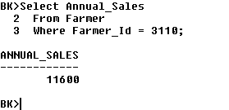

**Insert into Rental_Contract values** (1045,**3110**,'12-Dec-14',18,6000,**'Monthly Instalments'**,5060,7120);



***After Update:***

**Select Annual_Sales**

**From Farmer**

**Where Farmer_Id = 3110;**

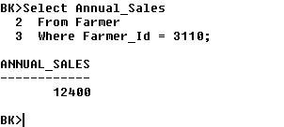

**\*\*\*\*\*\*\*\*\*\*\*\*\*\*\*\*\*\*\*\*\*\*\*\*\*\*\*\*\*\*\*\*\*\*\*\*\*\*\*\*\*\*\*\*\*\*\*\*\*\*\*\*\*\*\*\*\*\*\*\*\*\*\*\*\*\*\*\*\*\*\*\*\*\*\*\*\*\*\*\*\*\***

**\*\*\*\*\*\*\*\*\*\*\*\*\*\*\*\*\*\*\*\*\*\*\*\*\*\*\*\*\*\*\*\*\*\*\*\*\*\*\*\*\*\*\*\*\*\*\*\*\*\*\*\*\*\*\*\*\*\*\*\*\*\*\*\*\*\*\*\*\*\*\*\*\*\*\*\*\*\*\*\*\*\***

1. ***(b)* *A new Rental Contract with Payment Terms in ‘Quarterly Instalments’ will result in an increase in the associated Farmer’s Annual Sales of €200 if the Farmer in question is from Louth.***

***Before Update:***

**Select Annual_Sales**

**From Farmer**

**Where Farmer_Id = 3180;**

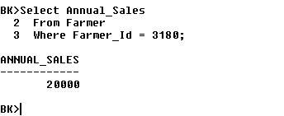

**Insert into Rental_Contract values** (1045,**3180**,'27-Feb-12',18,6000, **‘Quarterly Instalments'**,5060,7120);



***After Update:***

**Select Annual_Sales**

**From Farmer**

**Where Farmer_Id = 3180;**

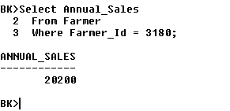

**\*\*\*\*\*\*\*\*\*\*\*\*\*\*\*\*\*\*\*\*\*\*\*\*\*\*\*\*\*\*\*\*\*\*\*\*\*\*\*\*\*\*\*\*\*\*\*\*\*\*\*\*\*\*\*\*\*\*\*\*\*\*\*\*\*\*\*\*\*\*\*\*\*\*\*\*\*\*\*\*\*\***

**\*\*\*\*\*\*\*\*\*\*\*\*\*\*\*\*\*\*\*\*\*\*\*\*\*\*\*\*\*\*\*\*\*\*\*\*\*\*\*\*\*\*\*\*\*\*\*\*\*\*\*\*\*\*\*\*\*\*\*\*\*\*\*\*\*\*\*\*\*\*\*\*\*\*\*\*\*\*\*\*\*\***

**Select * From** **New_Contracts_Log;**

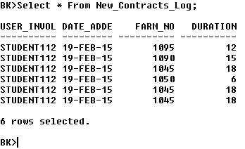

**Rollback;**

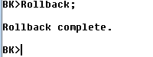

**Drop Trigger** **New_Contracts;**

**Drop Table New_Contracts_Log;**

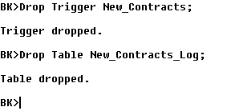

**\*\*\*\*\*\*\*\*\*\*\*\*\*\*\*\*\*\*\*\*\*\*\*\*\*\*\*\*\*\*\*\*\*\*\*\*\*\*\*\*\*\*\*\*\*\*\*\*\*\*\*\*\*\*\*\*\*\*\*\*\*\*\*\*\*\*\*\*\*\*\*\*\*\*\*\*\*\*\*\*\*\***

## ***Q.4 After Update Trigger***

**After a successful update on the Farm table, the following changes to the database should be made:**

**1. If the Estimated Value of a Farm has been updated and the Rental Fee for the associated Farm is under €3000:**

**Payment Terms for that Farm should be updated to 'Full Amount in Advance'.**

**2. If the Size of a Farm has been updated and the Rental Fee for the associated Farm is under €3000:**

**The Contract Duration for that Farm should be increased by the minimum duration length (six months).**

***Updates to the Farm table should be reflected in a table called Farm_Adjustments.***

**\*\*\*\*\*\*\*\*\*\*\*\*\*\*\*\*\*\*\*\*\*\*\*\*\*\*\*\*\*\*\*\*\*\*\*\*\*\*\*\*\*\*\*\*\*\*\*\*\*\*\*\*\*\*\*\*\*\*\*\*\*\*\*\*\*\*\*\*\*\*\*\*\*\*\*\*\*\*\*\*\*\*\*\*\*\*\*\*\*\*\*\*\*\*\*\*\*\*\*\*\*\*\*\*\*\*\*\*\*\*\*\***

**Set** **Serveroutput** **On** **Size** 1000000**;**

**Drop Table** **Farm_Adjustments;**

**Create Table** **Farm_Adjustments** **(Oracle_User Varchar2(10), Date_Changed Date, Farm_No Number(4), New_Esimated_Value Number(6));**

**Create or Replace Trigger** **New_Farm_Updates**

**After Update** **on** **Farm**

**For Each Row**

**Declare**

**V_Rental_Fee Rental_Contract.Rental_Fee%Type;**

**V_Min_Duration Rental_Contract.Duration%Type;**

**Begin**

**Select Rental_Fee into V_Rental_Fee**

**From Rental_Contract**

**Where Rental_Contract.Farm_Id = :Old.Farm_Id;**

**If:Old.Estimated_Value<>:New.Estimated_Value And (V_Rental_Fee >3000) Then**

**Update** **Rental_Contract**

**Set Payment_Terms = ‘Full amount in Advance’**

**Where Rental_Contract**.**Farm_Id**=**:Old.Farm_Id**;

**End If;**

**If :Old.Size_**<>**:New**.Size_ **Then**

**Select Min(Duration) into V_Min_Duration**

**From Rental_Contract**

**Where Rental_Contract.Farm_Id = :Old.Farm_Id;**

**Update** **Rental_Contract**

**Set Duration = Duration + V_Min_Duration**

**Where Rental_Contract.Farm_Id** = **:Old.Farm_Id**;

**End If;**

**Insert into** **Farm_Adjustments** **Values** **(User, Sysdate,:New.Farm_Id,:New.Estimated_Value);**

**End;**

**/**

**Sho Err**

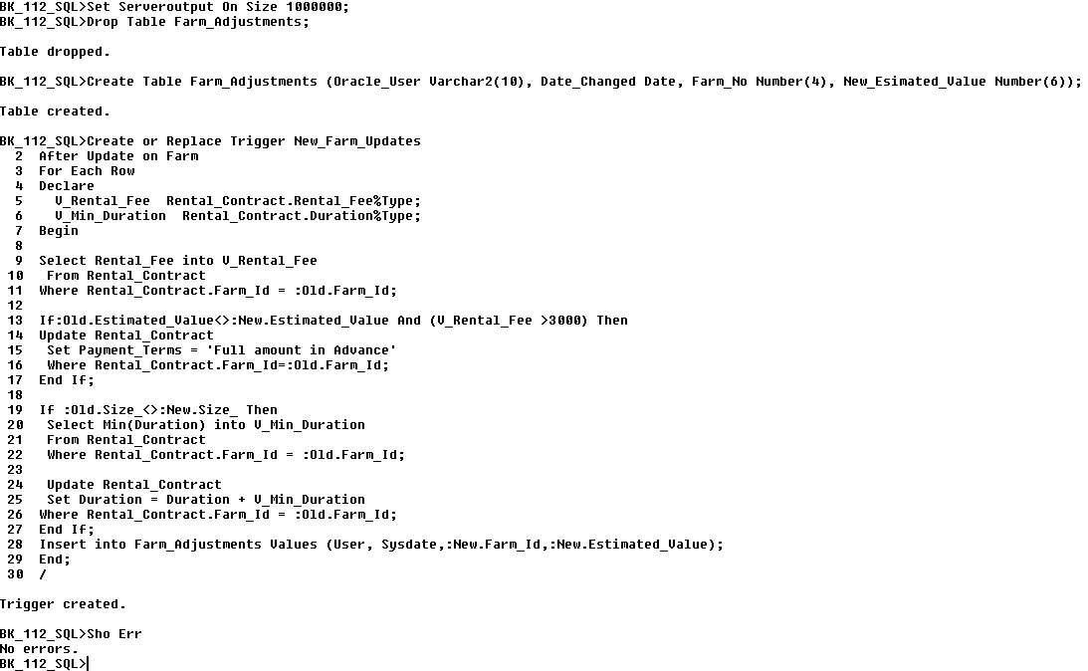

**1. If the Estimated Value of a Farm has been updated and the Rental Fee for the associated Farm is under €3000:**

**Payment Terms for that Farm should be updated to 'Full Amount in Advance'.**

***Before Update:***

**Select Payment_Terms**

**From Rental_Contract**

**Where Farm_Id=1080;**

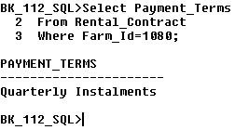

**Update Farm**

**Set Estimated_Value =Estimated_Value + 2000**

**Where Farm_Id = 1080;**

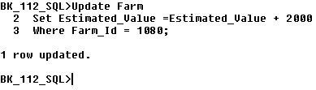

***After Update:***

**Select Payment_Terms**

**From Rental_Contract**

**Where Farm_Id = 1080;**

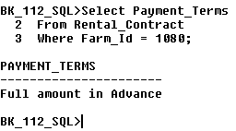

**\*\*\*\*\*\*\*\*\*\*\*\*\*\*\*\*\*\*\*\*\*\*\*\*\*\*\*\*\*\*\*\*\*\*\*\*\*\*\*\*\*\*\*\*\*\*\*\*\*\*\*\*\*\*\*\*\*\*\*\*\*\*\*\*\*\*\*\*\*\*\*\*\*\*\*\*\*\*\*\*\*\*\*\*\*\*\*\*\*\*\*\*\*\*\*\*\*\*\*\*\*\*\*\*\*\*\*\*\*\*\*\*\***

**2. If the Size of a Farm has been updated and the Rental Fee for the associated Farm is under €3000:**

**The Contract Duration for that Farm should be increased by the minimum duration length (six months).**

***Before Update:***

**Select Duration**

**From Rental_Contract**

**Where Farm_Id = 1075;**

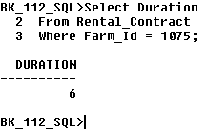

**Update Farm**

**Set Size_=Size_+100**

**Where Farm_Id = 1075;**

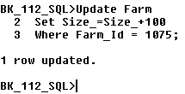

***After Update:***

**Select Duration**

**From Rental_Contract**

**Where Farm_Id = 1075;**

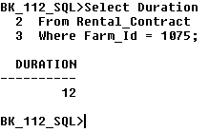

**\*\*\*\*\*\*\*\*\*\*\*\*\*\*\*\*\*\*\*\*\*\*\*\*\*\*\*\*\*\*\*\*\*\*\*\*\*\*\*\*\*\*\*\*\*\*\*\*\*\*\*\*\*\*\*\*\*\*\*\*\*\*\*\*\*\*\*\*\*\*\*\*\*\*\*\*\*\*\*\*\*\*\*\*\*\*\*\*\*\*\*\*\*\*\*\*\*\*\*\*\*\*\*\*\*\*\*\*\*\*\*\*\*\*\*\*\*\*\*\*\*\*\*\*\*\*\*\*\*\*\*\*\*\*\*\*\*\*\*\*\*\*\*\*\*\*\*\*\*\*\*\*\*\*\*\*\*\*\*\*\*\*\*\*\*\*\*\*\*\*\*\*\*\*\*\*\*\*\*\*\*\*\*\*\*\*\*\*\*\*\*\*\*\*\*\*\*\*\*\*\*\*\*\*\*\*\*\*\*\*\*\*\*\*\*\*\*\*\*\*\*\*\*\*\*\***

**Select * From Farm_Adjustments;**

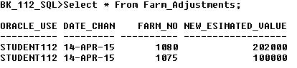

**\*\*\*\*\*\*\*\*\*\*\*\*\*\*\*\*\*\*\*\*\*\*\*\*\*\*\*\*\*\*\*\*\*\*\*\*\*\*\*\*\*\*\*\*\*\*\*\*\*\*\*\*\*\*\*\*\*\*\*\*\*\*\*\*\*\*\*\*\*\*\*\*\*\*\*\*\*\*\*\*\*\*\*\*\*\*\*\*\*\*\*\*\*\*\*\*\*\*\*\*\*\*\*\*\*\*\*\*\*\*\*\*\*\*\*\*\*\*\*\*\*\*\*\*\*\*\*\*\*\*\*\*\*\*\*\*\*\*\*\*\*\*\*\*\*\*\*\*\*\*\*\*\*\*\*\*\*\*\*\*\*\*\*\*\*\*\*\*\*\*\*\*\*\*\*\*\*\*\*\*\*\*\*\*\*\*\*\*\*\*\*\*\*\*\*\*\*\*\*\*\*\*\*\*\*\*\*\*\*\*\*\*\*\*\*\*\*\*\*\*\*\*\*\*\*\***

**Rollback;**

**Drop Table** **Farm_Adjustments;**

**Drop Trigger New_Farm_Updates;**

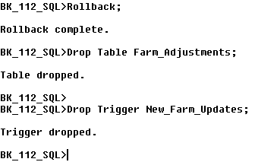

**\*\*\*\*\*\*\*\*\*\*\*\*\*\*\*\*\*\*\*\*\*\*\*\*\*\*\*\*\*\*\*\*\*\*\*\*\*\*\*\*\*\*\*\*\*\*\*\*\*\*\*\*\*\*\*\*\*\*\*\*\*\*\*\*\*\*\*\*\*\*\*\*\*\*\*\*\*\*\*\*\*\*\*\*\*\*\*\*\*\*\*\*\*\*\*\*\*\*\*\*\*\*\*\*\*\*\*\*\*\*\*\*\*\*\*\*\*\*\*\*\*\*\*\*\*\*\*\*\*\*\*\*\*\*\*\*\*\*\*\*\*\*\*\*\*\*\*\*\*\*\*\*\*\*\*\*\*\*\*\*\*\*\*\*\*\*\*\*\*\*\*\*\*\*\*\*\*\*\*\*\*\*\*\*\*\*\*\*\*\*\*\*\*\*\*\*\*\*\*\*\*\*\*\*\*\*\*\*\*\*\*\*\*\*\*\*\*\*\*\*\*\*\*\*\*\***

## ***Q.5 Before Insert, Update, Delete Trigger***

***In advance of a row being added, modified or removed from the Rental Contract table, certain conditions must be met with respect to those modifications. They are:***

***(a) New Contracts can only be added to this table for Farmers who do not have the Farming Cert Qualification whose payment terms are not in monthly instalments.***

***(b) Contract Duration may not be increased in value if the auctioneer does not specialise in Land*.**

***(c) Contract cannot be deleted as the rental fee is less than €8000, the solicitor is not from* *Galway*.**

***\*\*\*\*\*\*\*\*\*\*\*\*\*\*\*\*\*\*\*\*\*\*\*\*\*\*\*\*\*\*\*\*\*\*\*\*\*\*\*\*\*\*\*\*\*\*\*\*\*\*\*\*\*\*\*\*\*\*\*\*\*\*\*\*\*\*\*\*\*\*\*\*\*\*\*\*\*\*\*\*\*\*\*\*\*\*\*\*\*\*\*\*\*\*\*\*\*\*\*\*\*\*\*\*\*\*\*\*\*\*\*\*\*\*\*\*\*\*\*\*\*\*\*\*\*\*\*\*\****

**Set Serveroutput on Size 1000000;**

**Drop Trigger RC_IUD_Approval;**

**Create or Replace Trigger RC_IUD_Approval**

**Before Insert Or Update Or Delete On Rental_Contract**

**For Each Row**

**Declare**

**V_Qualifications** **Farmer.Qualifications%Type;**

**V_Specialism Auctioneer.Specialism%Type;**

**V_County Solicitor.County%Type;**

**Begin**

**/*(a) *New Contracts can only be added to this table for Farmers who do not have the Farming Cert Qualification whose payment terms are not in monthly instalments.*/***

**If Inserting Then**

**SELECT** **Qualifications** into **V_Qualifications**

**FROM** **Farmer**

**WHERE** **Farmer.Farmer_Id** **=** **:new.Farmer_Id**;

**If:new.Payment_Terms** **Not In** **(‘Monthly Instalments’**)**And** **V_Qualifications** =‘**Farming** **Cert’ Then**

**Raise_Application_Error(**-20101**,** *'****New Contracts can only be added to this table for Farmers who do not have the Farming Cert Qualification whose payment terms are not in monthly instalments’*);**

**End If;**

**/*(b) *Contract Duration may not be increased in value if the auctioneer does not specialise in Land*\*/**

**Elsif Updating Then**

**Select Specialism into V_Specialism**

**From Auctioneer**

**Where Auctioneer.Auctioneer_Id = :New.Auctioneer_Id;**

**If:New.Duration > :Old.Duration And V_Specialism<> ('LAND') Then**

**Raise_Application_Error** (**-20101**, **‘Contracts may not be increased in duration, auctioneers must specialise in land'**);

**End If;**

**/*(c*) Contract cannot be deleted as the rental fee is less than €8000, the solicitor is not from* *Galway* */**

**Elsif Deleting Then**

**Select County into V_County**

**From Solicitor**

**Where Solicitor.Solicitor_Id =:Old.Solicitor_Id;**

**If:Old.Rental_Fee < 8000 And V_County<> ('GALWAY') Then**

**Raise_Application_Error** (**-20101**, **‘This Contract cannot be deleted as the rental fee is less than €8000, the solicitor is not from Galway'**);

**End If;**

**End If;**

**End;**

**/**

**Sho Err**

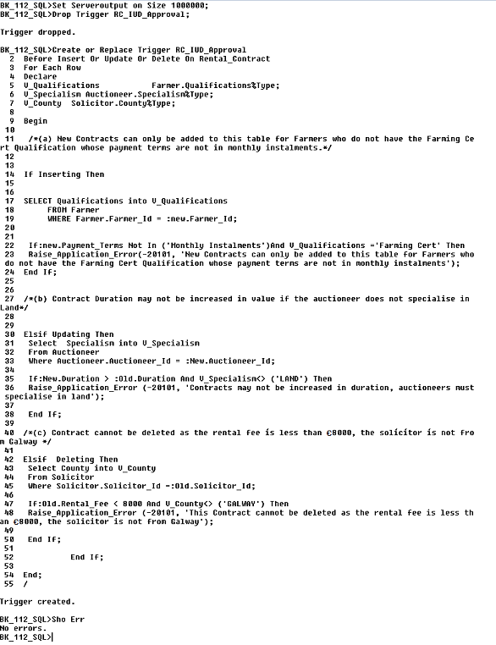

**\*\*\*\*\*\*\*\*\*\*\*\*\*\*\*\*\*\*\*\*\*\*\*\*\*\*\*\*\*\*\*\*\*\*\*\*\*\*\*\*\*\*\*\*\*\*\*\*\*\*\*\*\*\*\*\*\*\*\*\*\*\*\*\*\*\*\*\*\*\*\*\*\*\*\*\*\*\*\*\*\*\***

***(a)*** ***New Contracts can only be added to this table for Farmers who do not have the Farming Cert Qualification whose payment terms are not in monthly instalments.***

**--Invalid Insert:**

Insert into Rental_Contract values (1060,**3190**,'12-Feb-07',15,6000,'Quarterly Instalments', 5130, 7030);

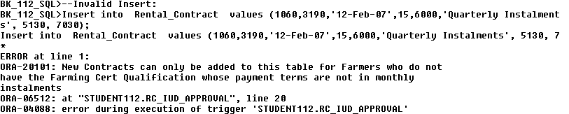

**--Valid Insert:**

Insert into Rental_Contract values (1060,**3190**,'12-Feb-07',15,6000,**'Monthly Instalments**', 5130, 7030);

Rollback;

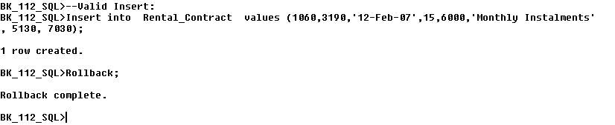

***(b) Contract Duration may not be increased in value if the auctioneer does not specialise in Land*.**

**--Invalid Update**

Update Rental_Contract

Set Duration = Duration+2

Where Auctioneer_Id = 7090;

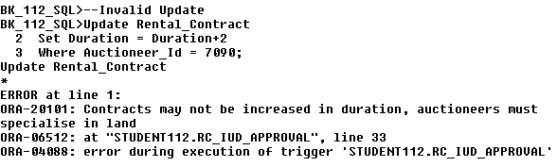

**--Valid Update**

Update Rental_Contract

Set Duration = Duration-2

Where Auctioneer_Id = 7080;

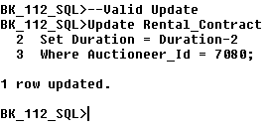

**\*\*\*\*\*\*\*\*\*\*\*\*\*\*\*\*\*\*\*\*\*\*\*\*\*\*\*\*\*\*\*\*\*\*\*\*\*\*\*\*\*\*\*\*\*\*\*\*\*\*\*\*\*\*\*\*\*\*\*\*\*\*\*\*\*\*\*\*\*\*\*\*\*\*\*\*\*\*\*\*\*\***

***(c) Contracts cannot be deleted if the rental fee is less than €8000 and the solicitor is not from* *Galway*.**

Insert into Rental_Contract values (1060,3160,'12-Feb-07',15,**6000**,'Monthly Instalments', **5130**, 7030);

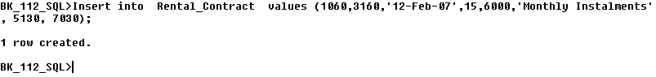

**Delete**

**From Rental_Contract**

**Where Solicitor_Id = 5130;**

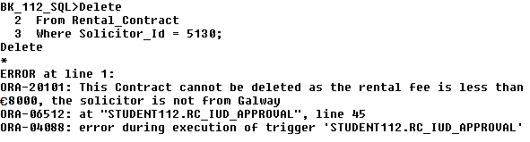

**Insert into Rental_Contract values** (**1075,3160,'05-Feb-07',15**,**9000**,**'Monthly Instalments',** **5000**, **7130);**



**Delete**

**From Rental_Contract**

**Where Contract_Date = '05-Feb-07';**

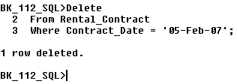

**Rollback;**

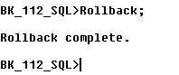

**Drop Trigger RC_IUD_Approval;**

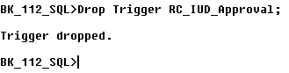

## ***Q.6 After Insert Update Delete On Rental Contract***

1. **After a Successful insert has been made to the Rental Contract table, the following changes to the Database should be made:**

**(i) The relevant farm should have it’s size increased by 100 acres. This change should be reflected in the Farm table.**

1. **After a Successful Deletion has been made to the Rental Contract table, the following changes to the Database should be made:**

**(i) The relevant farm should have in size decreased by 100 acres. This change should be reflected in the Farm table.**

1. **After a Successful update has been made to the Rental Contract table, the following changes to the Database should be made:**
2. **If there is an increase in the duration of the updated Rental Contract then:**
3. **The associated farm should have it’s size increased by 100 acres.**
4. **If the updated Rental Contracts duration is reduced:**
5. **The associated farm should have it’s size decreased by 100 acres.**
6. **If there is no change in the updated Rental Contract’s duration:**
7. **There should be no change in the associated farm’s size.**

**\*\*\*\*\*\*\*\*\*\*\*\*\*\*\*\*\*\*\*\*\*\*\*\*\*\*\*\*\*\*\*\*\*\*\*\*\*\*\*\*\*\*\*\*\*\*\*\*\*\*\*\*\*\*\*\*\*\*\*\*\*\*\*\*\*\*\*\*\*\*\*\*\*\*\*\*\*\*\*\*\*\*\*\*\*\*\*\*\*\*\*\*\*\*\*\*\*\*\*\*\*\*\*\*\*\*\*\*\*\*\*\*\***

**Drop Trigger Add_Remove_Inc_Dec_Contract;**

**Create Or Replace Trigger Add_Remove_Inc_Dec_Contract**

After **Insert** Or **Update** Or **Delete** On **Rental_Contract**

For Each Row

**Begin**

**If Inserting** Then

**Update** Farm

**Set** Size_=Size_+100

**Where** Farm.Farm_Id = **:New**.Farm_Id;

**Elsif** **Deleting** Then

**Update** Farm

**Set** Size_ = Size_-100

**Where** Farm.Farm_Id=**:Old**.Farm_Id;

**Elsif** **Updating** Then

**If:New.**Duration**>:Old.**Duration **Then**

**Update** Farm

**Set** Size_= Size_+100

**Where** Farm.Farm_Id = **:New**.Farm_Id;

**Elsif:New.**Duration<:**Old**.Duration **Then**

**Update** Farm

**Set** Size_ = Size_-100

**Where** Farm.Farm_Id=**:New**.Farm_Id;

**Elsif:New**.Duration = **:Old**.Duration **Then**

**Update** Farm

**Set** Size_ = Size_+0

**Where** Farm.Farm_Id = **:New**.Farm_Id;

**End If;**

**End If;**

**End;**

**/**

**Sho Err**

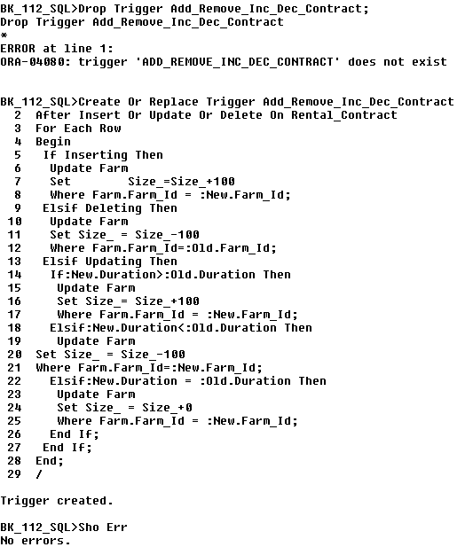

1. **After a Successful insert has been made to the Rental Contract table, the following changes to the Database should be made:**
2. **The relevant farm should have it’s size increased by 100 acres. This change should be reflected in the Farm table.**

***--Before Insert:***

**Select** **Size_**

**From** **Farm**

**Where Farm_Id** = **1030**;

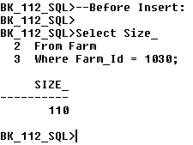

**Insert** into **Rental_Contract** **values** (**1030**,3000,**'12-Mar-07'**,6,2000,'Monthly Instalments’,5150,7080);

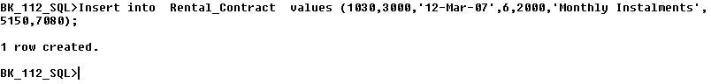

***--After Insert:***

**Select** **Size_**

**From** **Farm**

**Where Farm_Id** = **1030**;

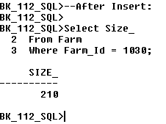

**\*\*\*\*\*\*\*\*\*\*\*\*\*\*\*\*\*\*\*\*\*\*\*\*\*\*\*\*\*\*\*\*\*\*\*\*\*\*\*\*\*\*\*\*\*\*\*\*\*\*\*\*\*\*\*\*\*\*\*\*\*\*\*\*\*\*\*\*\*\*\*\*\*\*\*\*\*\*\*\*\*\***

1. **After a Successful Deletion has been made to the Rental Contract table, the following changes to the Database should be made:**
2. **The relevant farm should have in size decreased by 100 acres. This change should be reflected in the Farm table.**

***--Before Delete:***

**Select** **Size_**

**From** **Farm**

**Where Farm_Id** = **1030**;

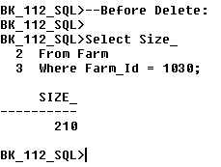

**Delete**

**From** **Rental_Contract**

**Where** **Contract_Date** **= '12-Mar-07'**

**And** **Farm_Id** **= 1030;**

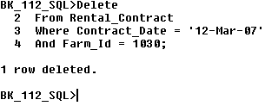

***--After Delete:***

**Select** **Size_**

**From** **Farm**

**Where Farm_Id** = **1030**;

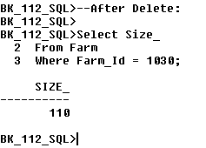

**\*\*\*\*\*\*\*\*\*\*\*\*\*\*\*\*\*\*\*\*\*\*\*\*\*\*\*\*\*\*\*\*\*\*\*\*\*\*\*\*\*\*\*\*\*\*\*\*\*\*\*\*\*\*\*\*\*\*\*\*\*\*\*\*\*\*\*\*\*\*\*\*\*\*\*\*\*\*\*\*\*\***

1. **After a Successful update has been made to the Rental Contract table, the following changes to the Database should be made:**
2. **If there is an increase in the duration of the updated Rental Contract then:**
3. **The associated farm should have it’s size increased by 100 acres.**

***--Before Update:***

**Select** **Size_**

**From** **Farm**

**Where Farm_Id** = **1005**;

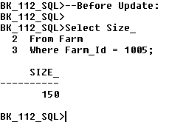

**Update Rental_Contract**

**Set Duration=Duration+4**

**Where Contract_Date** =**'10-Feb-07'**

**And** **Farm_Id** **= 1005;**

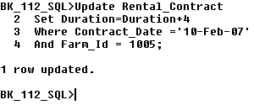

***--After Update:***

**Select** **Size_**

**From** **Farm**

**Where Farm_Id** = **1005**;

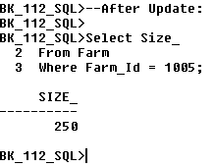

**\*\*\*\*\*\*\*\*\*\*\*\*\*\*\*\*\*\*\*\*\*\*\*\*\*\*\*\*\*\*\*\*\*\*\*\*\*\*\*\*\*\*\*\*\*\*\*\*\*\*\*\*\*\*\*\*\*\*\*\*\*\*\*\*\*\*\*\*\*\*\*\*\*\*\*\*\*\*\*\*\*\*\*\*\*\*\*\*\*\*\*\*\*\*\*\*\*\*\*\*\*\*\*\*\*\*\*\*\*\*\*\*\*\*\*\*\*\*\*\*\*\*\*\*\*\*\*\*\*\*\*\*\*\*\*\*\*\*\*\*\*\*\*\*\*\*\*\*\*\*\*\*\*\*\*\*\*\*\*\*\*\*\*\***

**3. After a Successful update has been made to the Rental Contract table, the following changes to the Database should be made:**

1. **If there is an increase in the duration of the updated Rental Contract then:**

**i. The associated farm should have it’s size increased by 100 acres.**

***--Before Update***

**Select** **Size_**

**From** **Farm**

**Where Farm_Id** = **1005**;

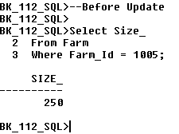

**Update Rental_Contract**

**Set Duration=Duration-4**

**Where Contract_Date** =**'10-Feb-07'**

**And** **Farm_Id** **= 1005;**

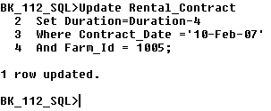

***--After Update:***

**Select** **Size_**

**From** **Farm**

**Where Farm_Id** = **1005**;

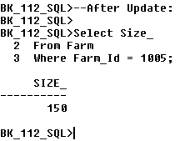

**\*\*\*\*\*\*\*\*\*\*\*\*\*\*\*\*\*\*\*\*\*\*\*\*\*\*\*\*\*\*\*\*\*\*\*\*\*\*\*\*\*\*\*\*\*\*\*\*\*\*\*\*\*\*\*\*\*\*\*\*\*\*\*\*\*\*\*\*\*\*\*\*\*\*\*\*\*\*\*\*\*\*\*\*\*\*\*\*\*\*\*\*\*\*\*\*\*\*\*\*\*\*\*\*\*\*\*\*\*\*\*\*\*\*\*\*\*\*\*\*\*\*\*\*\*\*\*\*\*\*\*\*\*\*\*\*\*\*\*\*\*\*\*\*\*\*\*\*\*\*\*\*\*\*\*\*\*\*\*\*\*\*\*\***

**3. After a Successful update has been made to the Rental Contract table, the following changes to the Database should be made:**

**(c) If there is no change in the updated Rental Contract’s duration:**

**i. There should be no change in the associated farm’s size.**

***--Before Update:***

**Select** **Size_**

**From** **Farm**

**Where Farm_Id** = **1005**;

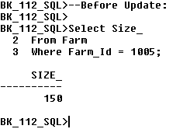

**Update Rental_Contract**

**Set Rental_Fee=Rental_Fee+1000**

**Where Contract_Date** =**'10-Feb-07'**

**And** **Farm_Id** **= 1005;**

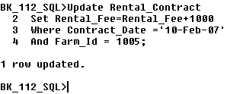

***--After Update:***

**Select** **Size_**

**From** **Farm**

**Where Farm_Id** = **1005**;

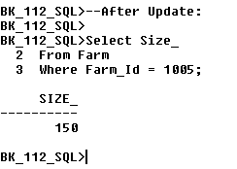

**\*\*\*\*\*\*\*\*\*\*\*\*\*\*\*\*\*\*\*\*\*\*\*\*\*\*\*\*\*\*\*\*\*\*\*\*\*\*\*\*\*\*\*\*\*\*\*\*\*\*\*\*\*\*\*\*\*\*\*\*\*\*\*\*\*\*\*\*\*\*\*\*\*\*\*\*\*\*\*\*\*\*\*\*\*\*\*\*\*\*\*\*\*\*\*\*\*\*\*\*\*\*\*\*\*\*\*\*\*\*\*\*\*\*\*\*\*\*\*\*\*\*\*\*\*\*\*\*\*\*\*\*\*\*\*\*\*\*\*\*\*\*\*\*\*\*\*\*\*\*\*\*\*\*\*\*\*\*\*\*\*\*\*\***

**Rollback;**



**Drop Trigger Add_Remove_Inc_Dec_Contract;**



**\*\*\*\*\*\*\*\*\*\*\*\*\*\*\*\*\*\*\*\*\*\*\*\*\*\*\*\*\*\*\*\*\*\*\*\*\*\*\*\*\*\*\*\*\*\*\*\*\*\*\*\*\*\*\*\*\*\*\*\*\*\*\*\*\*\*\*\*\*\*\*\*\*\*\*\*\*\*\*\*\*\*\*\*\*\*\*\*\*\*\*\*\*\*\*\*\*\*\*\*\*\*\*\*\*\*\*\*\*\*\*\*\*\*\*\*\*\*\*\*\*\*\*\*\*\*\*\*\*\*\*\*\*\*\*\*\*\*\*\*\*\*\*\*\*\*\*\*\*\*\*\*\*\*\*\*\*\*\*\*\*\*\*\***

## ***Q.7 Before Insert/Update/Delete Table Level Trigger***

**Any changes to the database, whether update, insert or delete, are only permitted during normal working hours - Monday to Friday, 8am to 4pm.**

**\*\*\*\*\*\*\*\*\*\*\*\*\*\*\*\*\*\*\*\*\*\*\*\*\*\*\*\*\*\*\*\*\*\*\*\*\*\*\*\*\*\*\*\*\*\*\*\*\*\*\*\*\*\*\*\*\*\*\*\*\*\*\*\*\*\*\*\*\*\*\*\*\*\*\*\*\*\*\*\*\*\*\*\*\*\*\*\*\*\*\*\*\*\*\*\*\*\*\*\*\*\*\*\*\*\*\*\*\*\*\*\*\***

**Set Serveroutput on Size 1000000;**

**Create** **Or** **Replace** **Trigger** **Secure_Farm**

**Before** **Insert** **Or Update Or Delete On** **Farm**

**Begin**

**/*Changes to the database are not permitted outside normal working hours*/**

**If** (**To_Char**(**Sysdate,’DY’**) **In (‘Sat’,’Sun’))** **Or (To_Char**(**sysdate,’HH24’**) **Not Between** ‘**08**’ **AND** ‘**18**’) **Then**

**If Deleting Then**

**Raise_Application_Error**(**-20500**, ‘**You may only delete from Farm during normal hours – Mon to Fri 8am to 6pm.’);**

**Elsif Inserting Then**

**Raise_Application_Error**(**-20500**, ‘**You may only insert into Farm during normal hours – Mon to Fri 8am to 6pm.’);**

**Elsif Updating Then**

**Raise_Application_Error**(**-20500**, ‘**You may only update Farm during normal hours – Mon to Fri 8am to 6pm.’);**

**End If;**

**End If;**

**End;**

**/**

**Sho Err**

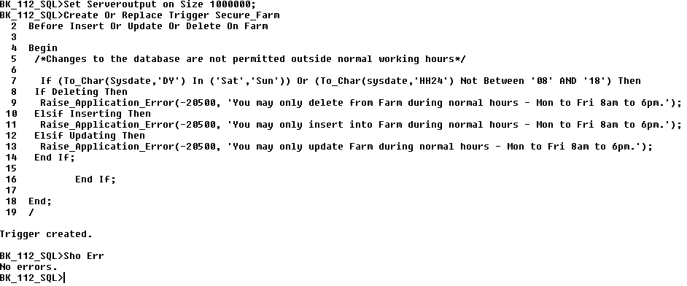

**--Invalid Insert** **(attempted outside normal working hours)**

**Insert** **into** **Farm** **values (1100,120,'Flat','Wet','Grazing',10,200000);**

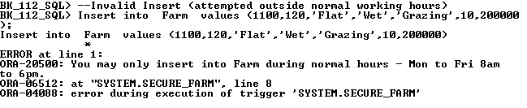

**--Valid Insert** **(attempted during normal working hours)**

**Insert** **into** **Farm** **values (1100,120,'Flat','Wet','Grazing',10,200000);**

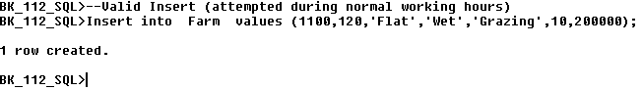

**Rollback;**



**--Invalid Insert** **(attempted outside normal working hours)**

**Insert** **into** **Farm** **values (1110,120,'Flat','Dry','Tillage',10,100000);**

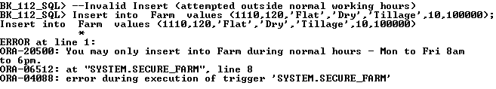

**--Valid Insert** **(attempted during normal working hours)**

**Insert** **into** **Farm** **values (1110,120,'Flat','Dry','Tillage',10,100000);**

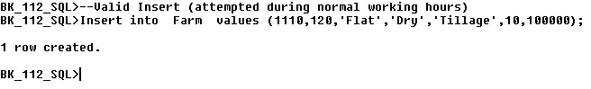

**Rollback;**

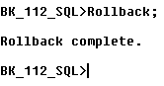

**--Invalid Delete: (attempted outside normal working hours)**

**Delete** **From Farm** **Where** **Farm**_Id **= 1000;**

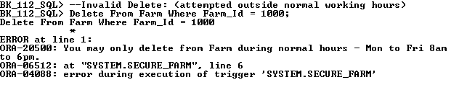

**--Valid Delete: (attempted during normal working hours)**

**Delete** **From Farm** **Where** **Farm**_Id **= 1000;**

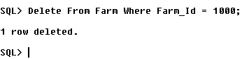

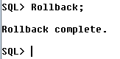

**--Invalid Delete: (attempted outside normal working hours)**

**Delete** **From Farm** **Where** **Farm**_Id **= 1010;**

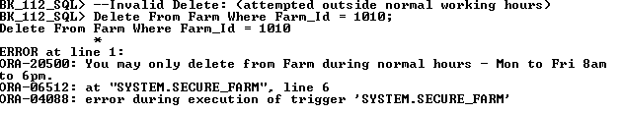

**--Valid Delete: (attempted during normal working hours)**

**Delete** **From Farm** **Where** **Farm**_Id **= 1010;**

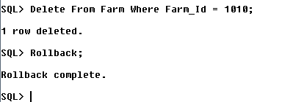

**--Invalid Update: (attempted outside normal working hours)**

**Update Farm**

**Set** **Size_=Size_+50**

**Where** **Farm_Id** **=** **1015;**

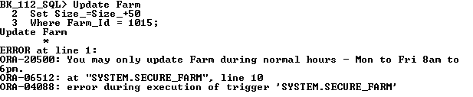

**--Valid Update: (attempted during normal working hours)**

**Update Farm**

**Set** **Size_=Size_+50**

**Where** **Farm_Id** **=** **1015;**

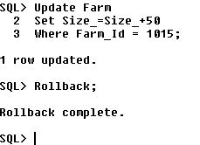

**--Invalid Update: (attempted outside normal working hours)**

**Update Farm**

**Set** **Size_=Size_+50**

**Where** **Farm_Id =** **1090;**

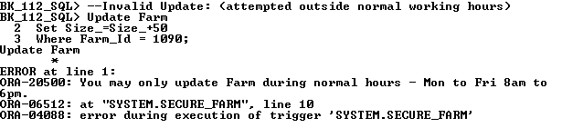

**--Valid Update: (attempted during normal working hours)**

**Update Farm**

**Set** **Size_=Size_+50**

**Where** **Farm_Id =** **1090;**

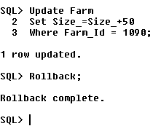

**Rollback;**

**Drop Trigger Secure_Farm;**

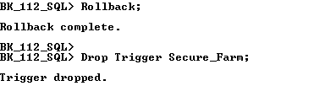

## ***Q.8 Procedure without Cursor***

*********************************************************************************

***The below Procedure allows the user to specify a Farm ID and an amount by which to increase the Farm Size of the Specified Farm. Use of an Out Variable is demonstrated here to count the number of Rental Contracts associated with the Farm in question.***

**********************************************************************************

**Set serveroutput on size 1000000;**

**Create Table Farm_Size_Failures**

**(Farm_No number(4),**

**New_Size number(5),**

**Error_Msg Varchar2(25),**

**User_Name Varchar2(10),**

**System_Date Date);**

**Variable NumOfContracts NUMBER**

**PRINT NumOfContracts**

**Create or Replace Procedure Find_Single_Farm**(**Farmno IN** **integer,New_Size IN integer, No_Contracts OUT Number) is**

**V_Farm_Id Farm.Farm_Id%Type;**

**V_Size_ Farm.Size_%Type;**

**V_Terrain Farm.Terrain%Type;**

**V_Count_Contracts Number(**30**):=**0**;**

**Min_Size_Inc Exception;**

**Max_Size_Inc Exception;**

**Begin**

**If New_Size<50 Then**

**Raise Min_Size_Inc;**

**End if;**

**If New_Size>150 Then**

**Raise Max_Size_Inc;**

**End if;**

**Select Farm_Id,Size_,Terrain Into V_Farm_Id,V_Size_,V_Terrain**

**From Farm**

**Where Farm.Farm_Id =** **Farmno;**

**DBMS_Output.Put_Line(‘Here is the farm number: ’|| V_Farm_Id);**

**DBMS_Output.Put_Line(‘Here is the farm size: ’|| V_Size_);**

**DBMS_Output.Put_Line(‘Here is the farm terrain: ’|| V_Terrain);**

**DBMS_Output.Put_Line(‘Total number of contracts: ’|| V_Count_Contracts);**

**Select Count(*) into V_Count_Contracts**

**From Rental_Contract**

**Where Farm_Id = Farmno;**

**Update Farm**

**Set Size_= Size_+ New_Size**

**Where Farm.Farm_Id=Farmno;**

**No_Contracts :=V_Count_Contracts;**

**Select Farm_Id,Size_,Terrain Into V_Farm_Id,V_Size_,V_Terrain**

**From Farm**

**Where Farm.Farm_Id =** **Farmno;**

**DBMS_Output.Put_Line(‘Here is the farm number: ’|| V_Farm_Id);**

**DBMS_Output.Put_Line(‘Here is the farm size: ’|| V_Size_);**

**DBMS_Output.Put_Line(‘Here is the farm terrain: ’|| V_Terrain);**

**DBMS_Output.Put_Line(‘Total number of contracts: ’|| V_Count_Contracts);**

**Exception**

**When Min_Size_Inc Then**

**Insert into Farm_Size_Failures values (Farmno,New_Size, ‘Min Increase is 50’,User,SysDate);**

**When Max_Size_Inc Then**

**Insert into Farm_Size_Failures values (Farmno,New_Size, ‘Max Increase is 150’,User,SysDate);**

**When No_Data_Found Then**

**Insert into Farm_Size_Failures values (Farmno,New_Size, ‘No Such Farm’,User,SysDate);**

**When Others Then**

**Insert into Farm_Size_Failures values (Farmno,New_Size, ‘Unforseen Problem’,User,SysDate);**

**End;**

**/**

**Sho err**

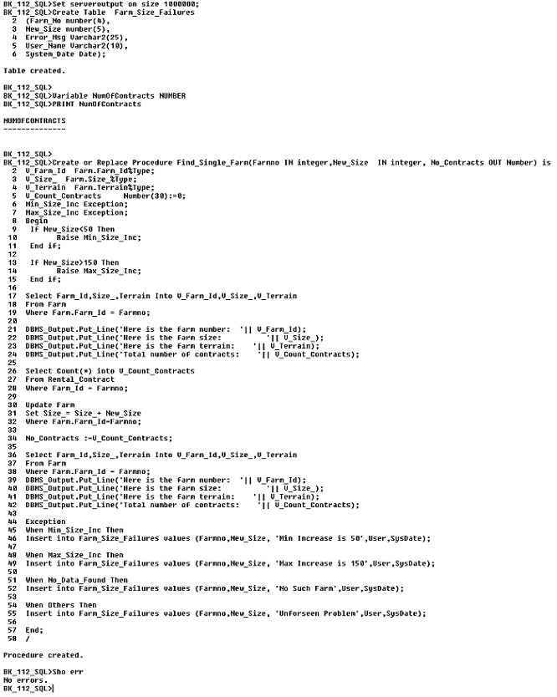

**--Successful Update:**

**Execute Find_Single_Farm(1015,140, :NumOfContracts);**

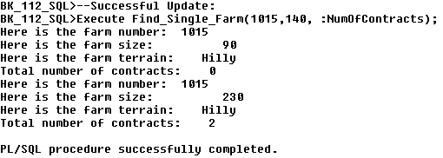

**--Unsuccessful Update:**

**Execute Find_Single_Farm(1030,40, :NumOfContracts);**

**Select * From Farm_Size_Failures;**

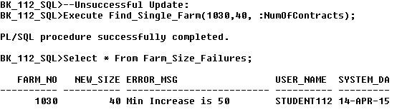

**Rollback;**

**Drop Procedure Find_Single_Farm;**

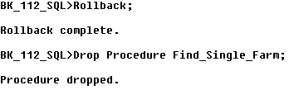

**Drop Table Farm_Size_Failures;**



********************************************************************************************************************************************************************

## ***Q.9 Procedure With Cursor***

***This Procedure will display the Rental Contracts with the lowest rental fees. It will allow the User to specify a fee increase and then proceed to display relevant information of the Rental Contracts in question. An IN parameter* along with an *If-Else-Then structure* and System/User defined *Exceptions* are included in this Procedure. After execution, the audit log will be updated to reflect the number of changes made.**

**\*\*\*\*\*\*\*\*\*\*\*\*\*\*\*\*\*\*\*\*\*\*\*\*\*\*\*\*\*\*\*\*\*\*\*\*\*\*\*\*\*\*\*\*\*\*\*\*\*\*\*\*\*\*\*\*\*\*\*\*\*\*\*\*\*\*\*\*\*\*\*\*\*\*\*\*\*\*\*\*\*\*\*\*\*\*\*\*\*\*\*\*\*\***

**Set serveroutput on size 1000000;**

**Drop Table Fee_Change_Log;**

**Create Table Fee_Change_Log(**Ora_User **Varchar2(**20**),** Change_Date **Date,**  Rows_Changed **Number(**3**),** Details **Varchar(**40**));**

**Drop** **Procedure Increase_Lowest_Fees;**

**Create or Replace Procedure Increase_Lowest_Fees(Increase** **IN** **Integer) As**

**Cursor** **Rentalcur** Is **Select Rental_Fee, Payment_Terms, Contract_Date**

**From Rental_Contract**

**Order by Rental_Fee Asc**

**For Update;**

**V_Rental_Fee** **Rental_Contract**.**Rental_Fee%Type;**

**V_Payment_Terms** **Rental_Contract**.**Payment_Terms%Type;**

**V_Contract_Date** **Rental_Contract**.**Contract_Date%Type;**

**V_Rows_Changed** **Number(3) :=0;**

**Increase_Too_High Exception;**

**Increase_Too_Low Exception;**

**Increase_Denied Exception;**

**Begin**

**Open** **Rentalcur;**

**DBMS_Output.Put_Line(‘Here are the five contracts with the lowest fees in sequence’);**

**For V_Count in 1..5**

**Loop**

**Fetch Rentalcur Into** **V_Rental_Fee, V_Payment_Terms,V_Contract_Date;**

**Exit** **When** **Rentalcur** **%Notfound**;

**Dbms_output.Put_line(chr(**10**));**

**DBMS_Output.Put_Line('The User Specified Increase for Fee increase is : '** **||** **Increase);**

**DBMS_Output.Put_Line(‘The Contract Fee is: ’ || V_Rental_Fee**);

**DBMS_Output.Put_Line(‘The Payment Terms are: ’ || V_Payment_Terms**);

**DBMS_Output.Put_Line(‘The Contract date is: ’** || **V_Contract_Date**);

**DBMS_Output.Put_Line(‘***********************************************’);**

**If Increase>1500** **Then**

**Raise** **Increase_Too_High;**

**ElsIf Increase<1000** **Then**

**Raise** **Increase_Too_Low;**

**Else**

**If V_Payment_Terms = ‘Monthly Instalments’ Then**

**Raise** **Increase_Denied;**

**Else**

**Update Rental_Contract**

**Set Rental_Fee = Rental_Fee+Increase**

**Where Current Of Rentalcur;**

**End If;**

**End If;**

**V_Rows_Changed :=V_Rows_Changed+1;**

**End Loop;**

**Insert** **Into** **Fee_Change_Log** **Values(User,** **Sysdate,** **V_Rows_Changed, ‘Fee Increased’);**

**Close** **Rentalcur;**

**Exception**

**When** **Increase_Too_High** **Then**

**Insert** **into** **Fee_Change_Log Values** **(User,** **Sysdate,** **V_Rows_Changed,** **'Increase Too High!');**

**When** **Increase_Too_Low Then**

**Insert** **into** **Fee_Change_Log Values** **(User,** **Sysdate,** **V_Rows_Changed,** **'Increase Too Low!');**

**When** **Increase_Denied Then**

**Insert** **into** **Fee_Change_Log Values** **(User,** **Sysdate,** **V_Rows_Changed,** **‘Increase_Denied!');**

**When** **Dup_Val_On_Index** **Then**

**Insert** **into** **Fee_Change_Log Values(User,** **Sysdate,** **V_Rows_Changed,** **'Duplicate Entry Found!**'**);**

**When** **Others** **Then**

**Insert** **into** **Fee_Change_Log Values(User,** **Sysdate,** **V_Rows_Changed,** **'Unforseen Error!');**

**End Increase_Lowest_Fees;**

**/**

**Sho err**

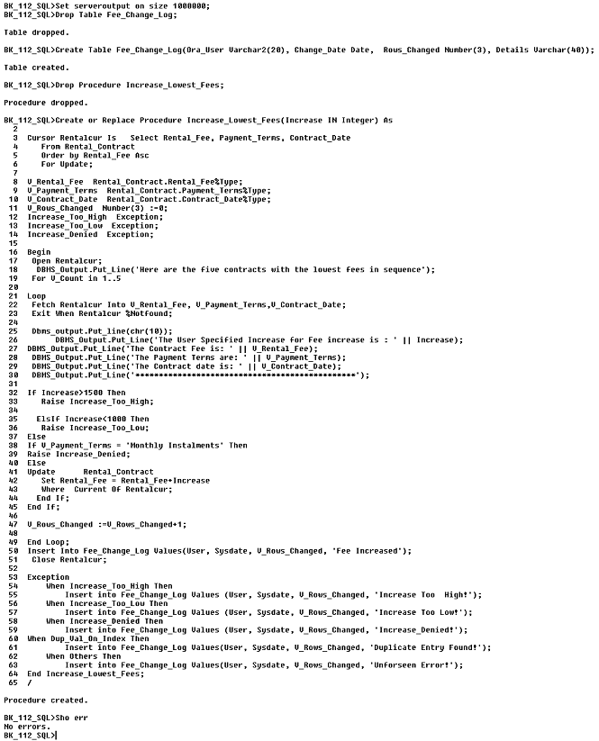

**Execute** **Increase_Lowest_Fees(1700);**

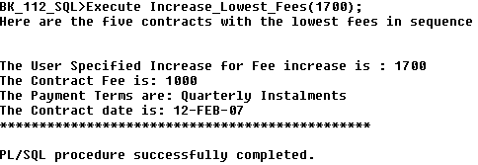

**Execute** **Increase_Lowest_Fees(900);**

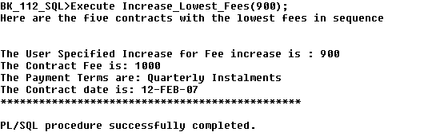

**Execute** **Increase_Lowest_Fees(1000);**

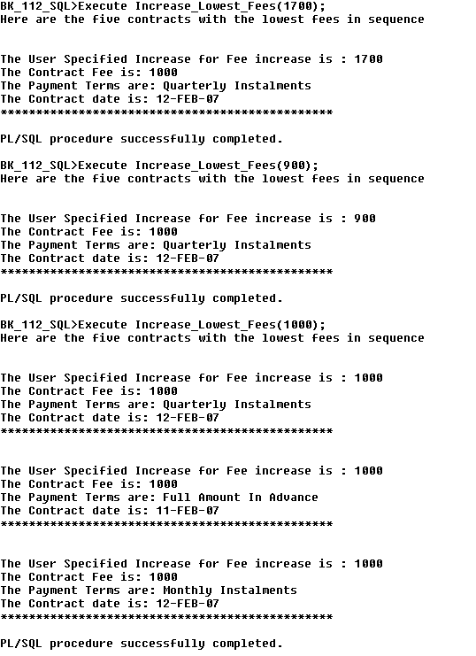

**Select * From Fee_Change_Log;**

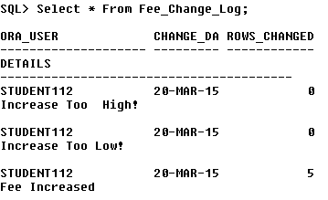

**Rollback;**



**Drop Table Fee_Change_Log;**



**Drop Procedure Increase_Lowest_Fees;**



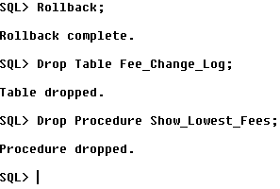

## ***Q.10 Procedure with Cursor to Retrieve, Display and Delete***

***This Procedure will allow the User to specify a number of Farms, that have the Lowest Estimated Value, that are to be deleted from the Farm Table. The number Specified must not exceed 5 and must not be less than 3. Exception handling was implemented into the code to ensure that these conditions are met.***

***\*\*\*\*\*\*\*\*\*\*\*\*\*\*\*\*\*\*\*\*\*\*\*\*\*\*\*\*\*\*\*\*\*\*\*\*\*\*\*\*\*\*\*\*\*\*\*\*\*\*\*\*\*\*\*\*\*\*\*\*\*\*\*\*\*\*\*\*\*\*\*\*\*\*\*\*\*\*\*\*\*\*\*\*\*\*\*\*\*\*\*\*\*\*\*\*\*\*\*\*\*\*\*\*\*\*\*\*\*\*\*\*\*\*\*\*\*\*\*\*\*\*\*\*\*\*\*\*\*\*\*\*\*\*\*\*\*\*\*\*\*\*\*\*\*\*\*\*\*\****

**Set** ServerOutput **On** **Size** **1000000;**

**Set** Linesize **30000;**

**Drop** **Table** **Farm_DeleteLog;**

**Create** **Table** **Farm_DeleteLog(**Oracle_User **Varchar2(30),** Deletion_Date **Date,** Farm_ID **Number(30),** Usage **Varchar2(30),** Terrain **Varchar2(30),** Farm_EstValue **Number(30),** Sum_Est_Value **Number(30));**

**Drop** **Table** **Farm_AuditLog;**

**Create** **Table** **Farm_AuditLog(**Oracle_User **Varchar2(30),** Log_Date **Date,** Exception_Info **Varchar2(50));**

**Variable TotalValue** **NUMBER**

**Variable** **NumOfDeletes** **NUMBER**

**PRINT TotalValue**

**PRINT** **NumOfDeletes**

**Drop** **Procedure** **FarmDelete;**

**Create** **or** **Replace** **Procedure** **FarmDelete(**Num_To_Delete **In** **Integer,** Sum_Value **Out** **Integer,** No_Of_Deletes **Out** **Integer)** **As**

**Cursor** **FarmCursor** **Is** **SELECT** **Farm_ID, Usage, Terrain, Estimated_Value**

**FROM** **Farm**

**ORDER** **BY** **Estimated_Value**

**FOR** **UPDATE;**

**V_Total_Estimated_Value** **Number(10,2):=0;**

**V_Total_Est_Val_Bottom5** **Number(10,2):=0;**

**V_DeleteCounter** **Number(10,2):=0;**

**V_Farm_Id Farm.Farm_Id%Type;**

**V_Usage Farm.Usage%Type;**

**V_Terrain** **Farm.Terrain%Type;**

**V_Estimated_Value** **Farm.Estimated_Value%Type;**

**NumToDeleteTooSmall** **Exception;**

**NumToDeleteTooBig** **Exception;**

**ResaleValueMissing** **Exception;**

**BEGIN**

**IF** **Num_To_Delete** **<=** **2** **Then**

**Raise** **NumToDeleteTooSmall;**

**ElsIf** **Num_To_Delete** **>=** **6** **Then**

**Raise** **NumToDeleteTooBig;**

**Else**

**OPEN** **FarmCursor;**

**SELECT** **SUM(Estimated_Value)** **into** **V_Total_Estimated_Value**

**FROM** **Farm;**

**DBMS_Output.Put_line(chr(10));**

**DBMS_Output.Put_Line('Total Resale Value of all Farms BEFORE Deletions** : ' **||**

**V_Total_Estimated_Value);**

**DBMS_Output.Put_line(chr(10));**

**FOR** V_Count **in** **1..Num_To_Delete**

**LOOP**

**FETCH** **FarmCursor** **Into** V_Farm_ID**,** V_Usage**,** V_Terrain**,**V_Estimated_Value**;**

**EXIT** **When** **FarmCursor%**NotFound**;**

**DBMS_Output.Put_Line('=================================');**

**DBMS_Output.Put_Line('Farm ID : ' || V_Farm_ID);**

**DBMS_Output.Put_Line('Farm Usage: ' || V_Usage);**

**DBMS_Output.Put_Line('Farm Terrain: ' || V_Terrain);**

**DBMS_Output.Put_Line('Estimated Value : ' || V_Estimated_Value);**

**DBMS_Output.Put_Line('=================================');**

**DELETE**

**FROM** **Farm**

**WHERE** **CURRENT** **OF** **FarmCursor;**

V_Total_Estimated_Value **:=** V_Total_Estimated_Value **-** V_Estimated_Value**;**

**DBMS_Output.Put_Line('--Record Deleted Successfully!--');**

**DBMS_Output.Put_Line('=================================');**

**DBMS_Output.Put_line(chr(10));**

V_DeleteCounter **:=** V_DeleteCounter **+** 1**;**

**INSERT** **INTO** **Farm_DeleteLog** **Values(User,** **Sysdate,** V_Farm_ID**,** V_Usage**,** V_Terrain**,** V_Estimated_Value**,**

V_Total_Estimated_Value**);**

**END** **LOOP;**

**CLOSE** **FarmCursor;**

Sum_Value **:=** V_Total_Estimated_Value**;**

No_Of_Deletes **:=** V_DeleteCounter**;**

**DBMS_Output.Put_Line('Total Estimated Value of all Farms AFTER Deletions : ' || V_Total_Estimated_Value);**

**End** **If;**

**EXCEPTION**

**When** **NumToDeleteTooBig** **Then**

**INSERT** **Into** **Farm_AuditLog** **Values(User,** **Sysdate,** **'Number specified for deletion is TOO**

**EXCESSIVE!**'**);**

**When** **NumToDeleteTooSmall** **Then**

**INSERT** **Into** **Farm_AuditLog** **Values(User,** **Sysdate,** **'Number specified for deletion is TOO**

**SMALL!');**

**When** **No_Data_Found** **Then**

**INSERT** **Into** **Farm_AuditLog** **Values(User,** **Sysdate,** **'Farm NOT FOUND');**

**When** **Others** **Then**

**INSERT** **Into** **Farm_AuditLog** **Values(User,** **Sysdate,** **'Unforseen Error Occurred!');**

**END** **FarmDelete;**

**/**

**Sho Err**

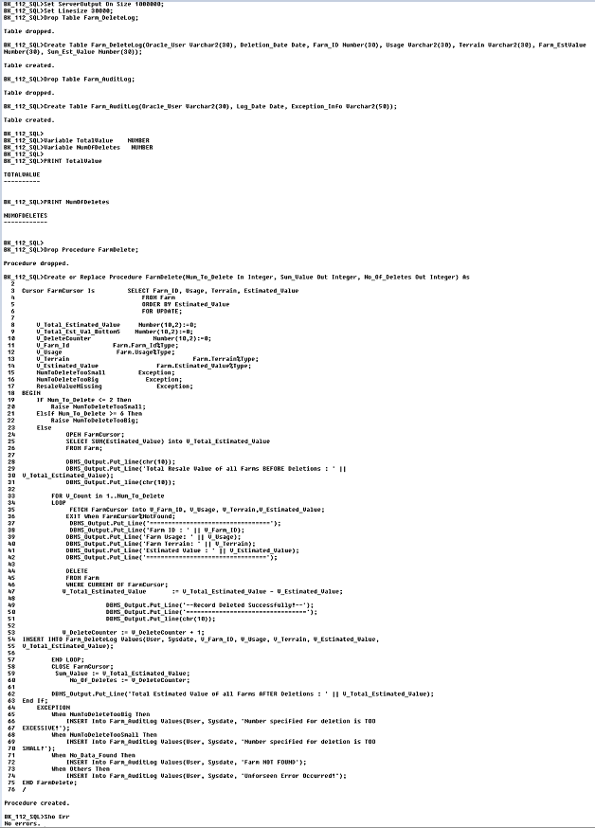

**-- Test NumToDeleteTooBig Exception**

**SELECT** **Count(*)** **FROM** **Farm;**

**Execute** **FarmDelete(7,** **:TotalValue,** **:NumOfDeletes);**

**SELECT** **Count(*)** **FROM** **Farm;**

**SELECT** **\*** **FROM** **Farm_DeleteLog;**

**SELECT** **\*** **FROM** **Farm_AuditLog;**

**PRINT TotalValue**

**PRINT** **NumOfDeletes**

**rollback;**

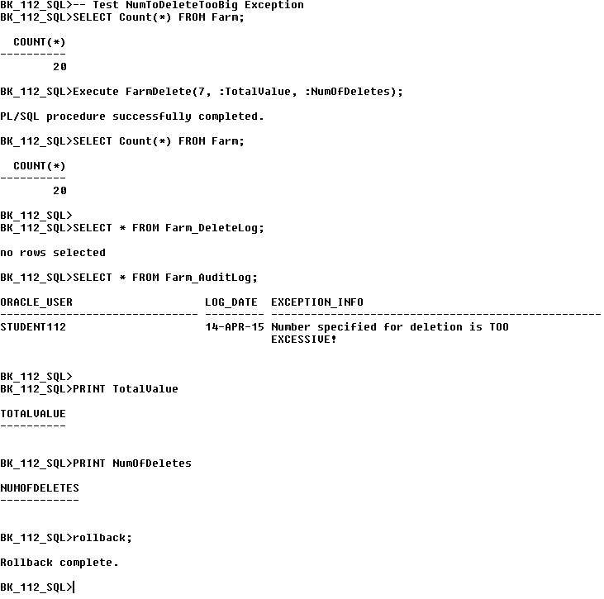

**-- Test NumToDeleteTooSmall Exception**

**SELECT** **Count(*)** **FROM** **Farm;**

**Execute** **FarmDelete(1,** **:TotalValue, :NumOfDeletes);**

**SELECT** **Count(*)** **FROM** **Farm;**

**SELECT** **\*** **FROM** **Farm_DeleteLog;**

**SELECT** **\*** **FROM** **Farm_AuditLog;**

**PRINT** **TotalValue**

**PRINT** **NumOfDeletes**

**rollback;**

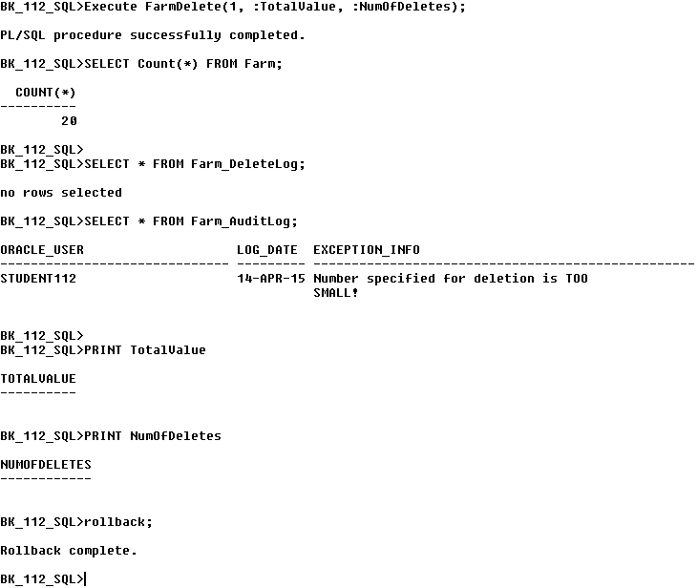

**-- Successful Execution**

**SELECT** **Count(*)** **FROM** **Farm;**

**Execute** **FarmDelete(3,** **:TotalValue, :NumOfDeletes);**

**SELECT** **Count(*)** **FROM** **Farm;**

**SELECT** **\*** **FROM** **Farm_DeleteLog;**

**SELECT** **\*** **FROM** **Farm_AuditLog;**

**PRINT** **TotalValue**

**PRINT** **NumOfDeletes**

**rollback;**

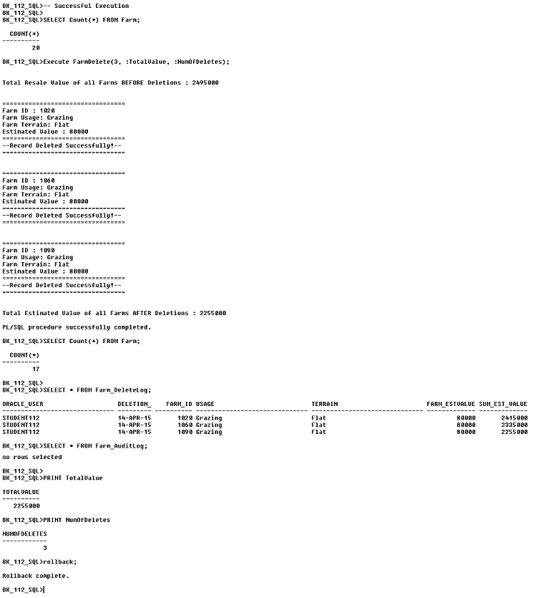

**Drop Table Farm_DeleteLog;**

**Drop Table Farm_AuditLog;**

**Drop Procedure FarmDelete;**

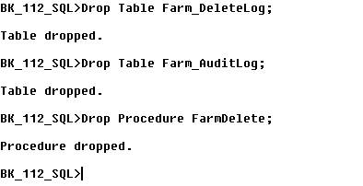

**\*\*\*\*\*\*\*\*\*\*\*\*\*\*\*\*\*\*\*\*\*\*\*\*\*\*\*\*\*\*\*\*\*\*\*\*\*\*\*\*\*\*\*\*\*\*\*\*\*\*\*\*\*\*\*\*\*\*\*\*\*\*\*\*\*\*\*\*\*\*\*\*\*\*\*\*\*\*\*\*\*\*\*\*\*\*\*\*\*\*\*\*\*\*\*\*\*\*\*\*\*\*\*\*\*\*\*\*\*\*\*\*\*\*\*\*\*\*\*\*\*\*\*\*\*\*\*\*\*\*\*\*\*\*\*\*\*\*\*\*\*\*\*\*\*\*\*\*\*\*\*\*\*\*\*\*\*\*\*\*\*\*\*\*\*\*\*\*\*\*\*\*\*\*\*\*\*\*\*\*\*\*\*\*\*\*\*\*\*\*\*\*\*\*\*\*\*\*\*\*\*\*\*\*\*\*\*\*\*\*\*\*\*\*\*\*\*\*\*\*\*\*\*\*\*\***

## ***Q.11 Package with Three Procedures***

***The following SQL Package incorporates three different Procedures, based on Questions 8, 9 and 10.***

***\*\*\*\*\*\*\*\*\*\*\*\*\*\*\*\*\*\*\*\*\*\*\*\*\*\*\*\*\*\*\*\*\*\*\*\*\*\*\*\*\*\*\*\*\*\*\*\*\*\*\*\*\*\*\*\*\*\*\*\*\*\*\*\*\*\*\*\*\*\*\*\*\*\*\*\*\*\*\*\*\*\*\*\*\*\*\*\*\*\*\*\*\*\*\*\*\*\*\*\*\*\*\*\*\*\*\*\****

**Set** Linesize 30000

**Set** Serveroutput **On** **Size** 1000000

-- Audit Table for Find_Single_Farm Procedure

**Drop** **Table** Farm_Size_Failures**;**

**Create Table Farm_Size_Failures (Farm_No number(4),New_Size number(5),Error_Msg Varchar2(25),User_Name Varchar2(10),System_Date Date);**

-- Variable for Find_Single_Farm Procedure

**Variable NumOfContracts NUMBER**

**PRINT NumOfContracts**

-- Audit Table for Increase_Lowest_Fees Procedure

**Drop Table Fee_Change_Log;**

**Create Table Fee_Change_Log(**Ora_User **Varchar2(**20**),** Change_Date **Date,**  Rows_Changed **Number(**3**),** Details **Varchar(**40**));**

-- Audit Table for FarmDelete Procedure

**Drop** **Table** **Farm_DeleteLog;**

**Create** **Table** **Farm_DeleteLog(**Oracle_User **Varchar2(30),** Deletion_Date **Date,** Farm_ID **Number(30),** Usage **Varchar2(30),** Terrain **Varchar2(30),** Farm_EstValue **Number(30),** Sum_Est_Value **Number(30));**

-- Audit Table for FarmDelete Procedure

**Drop** **Table** **Farm_AuditLog;**

**Create** **Table** **Farm_AuditLog(**Oracle_User **Varchar2(30),** Log_Date **Date,** Exception_Info **Varchar2(50));**

-- Variable for FarmDelete Procedure

**Variable TotalValue** **NUMBER**

**Variable** **NumOfDeletes** **NUMBER**

**PRINT TotalValue**

**PRINT** **NumOfDeletes**

**Create** **or** **Replace** **Package** Procedure_Package **Is**

**Procedure** Find_Single_Farm

(**Farmno IN** **integer,New_Size IN integer, No_Contracts OUT Number);**

**Procedure** Increase_Lowest_Fees

**(Increase** **IN** **Integer);**

**Procedure** FarmDelete

**(**Num_To_Delete **In** **Integer,** Sum_Value **Out** **Integer,** No_Of_Deletes **Out** **Integer);**

**End** Procedure_Package**;**

**/**

Sho Err

**Create** **Or** **Replace** **Package** **BODY** Procedure_Package **Is**

-- ==================================================

-- First procedure included is : Find_Single_Farm

-- ==================================================

**Procedure Find_Single_Farm**(**Farmno IN** **integer,New_Size IN integer, No_Contracts OUT Number) is**

**V_Farm_Id Farm.Farm_Id%Type;**

**V_Size_ Farm.Size_%Type;**

**V_Terrain Farm.Terrain%Type;**

**V_Count_Contracts Number(**30**):=**0**;**

**Min_Size_Inc Exception;**

**Max_Size_Inc Exception;**

**Begin**

**If New_Size<50 Then**

**Raise Min_Size_Inc;**

**End if;**

**If New_Size>150 Then**

**Raise Max_Size_Inc;**

**End if;**

**Select Farm_Id,Size_,Terrain Into V_Farm_Id,V_Size_,V_Terrain**

**From Farm**

**Where Farm.Farm_Id =** **Farmno;**

**DBMS_Output.Put_Line(‘Here is the farm number: ’|| V_Farm_Id);**

**DBMS_Output.Put_Line(‘Here is the farm size: ’|| V_Size_);**

**DBMS_Output.Put_Line(‘Here is the farm terrain: ’|| V_Terrain);**

**DBMS_Output.Put_Line(‘Total number of contracts: ’|| V_Count_Contracts);**

**Select Count(*) into V_Count_Contracts**

**From Rental_Contract**

**Where Farm_Id = Farmno;**

**Update Farm**

**Set Size_= Size_+ New_Size**

**Where Farm.Farm_Id=Farmno;**

**No_Contracts :=V_Count_Contracts;**

**Select Farm_Id,Size_,Terrain Into V_Farm_Id,V_Size_,V_Terrain**

**From Farm**

**Where Farm.Farm_Id =** **Farmno;**

**DBMS_Output.Put_Line(‘Here is the farm number: ’|| V_Farm_Id);**

**DBMS_Output.Put_Line(‘Here is the farm size: ’|| V_Size_);**

**DBMS_Output.Put_Line(‘Here is the farm terrain: ’|| V_Terrain);**

**DBMS_Output.Put_Line(‘Total number of contracts: ’|| V_Count_Contracts);**

**Exception**

**When Min_Size_Inc Then**

**Insert into Farm_Size_Failures values (Farmno,New_Size, ‘Min Increase is 50’,User,SysDate);**

**When Max_Size_Inc Then**

**Insert into Farm_Size_Failures values (Farmno,New_Size, ‘Max Increase is 150’,User,SysDate);**

**When No_Data_Found Then**

**Insert into Farm_Size_Failures values (Farmno,New_Size, ‘No Such Farm’,User,SysDate);**

**When Others Then**

**Insert into Farm_Size_Failures values (Farmno,New_Size, ‘Unforseen Problem’,User,SysDate);**

**End Find_Single_Farm;**

-- ==================================================

-- Second procedure included is : Increase_Lowest_Fees

-- ==================================================

**Procedure Increase_Lowest_Fees(Increase** **IN** **Integer) As**

**Cursor** **Rentalcur** Is **Select Rental_Fee, Payment_Terms, Contract_Date**

**From Rental_Contract**

**Order by Rental_Fee Asc**

**For Update;**

**V_Rental_Fee** **Rental_Contract**.**Rental_Fee%Type;**

**V_Payment_Terms** **Rental_Contract**.**Payment_Terms%Type;**

**V_Contract_Date** **Rental_Contract**.**Contract_Date%Type;**

**V_Rows_Changed** **Number(3) :=0;**

**Increase_Too_High Exception;**

**Increase_Too_Low Exception;**

**Increase_Denied Exception;**

**Begin**

**Open** **Rentalcur;**

**DBMS_Output.Put_Line(‘Here are the five contracts with the lowest fees in sequence’);**

**For V_Count in 1..5**

**Loop**

**Fetch Rentalcur Into** **V_Rental_Fee, V_Payment_Terms,V_Contract_Date;**

**Exit** **When** **Rentalcur** **%Notfound**;

**Dbms_output.Put_line(chr(**10**));**

**DBMS_Output.Put_Line('The User Specified Increase for Fee increase is : '** **||** **Increase);**

**DBMS_Output.Put_Line(‘The Contract Fee is: ’ || V_Rental_Fee**);

**DBMS_Output.Put_Line(‘The Payment Terms are: ’ || V_Payment_Terms**);

**DBMS_Output.Put_Line(‘The Contract date is: ’** || **V_Contract_Date**);

**DBMS_Output.Put_Line(‘***********************************************’);**

**If Increase>1500** **Then**

**Raise** **Increase_Too_High;**

**ElsIf Increase<1000** **Then**

**Raise** **Increase_Too_Low;**

**Else**

**If V_Payment_Terms = ‘Monthly Instalments’ Then**

**Raise** **Increase_Denied;**

**Else**

**Update Rental_Contract**

**Set Rental_Fee = Rental_Fee+Increase**

**Where Current Of Rentalcur;**

**End If;**

**End If;**

**V_Rows_Changed :=V_Rows_Changed+1;**

**End Loop;**

**Insert** **Into** **Fee_Change_Log** **Values(User,** **Sysdate,** **V_Rows_Changed, ‘Fee Increased’);**

**Close** **Rentalcur;**

**Exception**

**When** **Increase_Too_High** **Then**

**Insert** **into** **Fee_Change_Log Values** **(User,** **Sysdate,** **V_Rows_Changed,** **'Increase Too High!');**

**When** **Increase_Too_Low Then**

**Insert** **into** **Fee_Change_Log Values** **(User,** **Sysdate,** **V_Rows_Changed,** **'Increase Too Low!');**

**When** **Increase_Denied Then**

**Insert** **into** **Fee_Change_Log Values** **(User,** **Sysdate,** **V_Rows_Changed,** **‘Increase_Denied!');**

**When** **Dup_Val_On_Index** **Then**

**Insert** **into** **Fee_Change_Log Values(User,** **Sysdate,** **V_Rows_Changed,** **'Duplicate Entry Found!**'**);**

**When** **Others** **Then**

**Insert** **into** **Fee_Change_Log Values(User,** **Sysdate,** **V_Rows_Changed,** **'Unforseen Error!');**

**End Increase_Lowest_Fees;**

-- ==================================================

-- Third procedure included is : FarmDelete

-- ==================================================

**Procedure** **FarmDelete(**Num_To_Delete **In** **Integer,** Sum_Value **Out** **Integer,** No_Of_Deletes **Out** **Integer)** **As**

**Cursor** **FarmCursor** **Is** **SELECT** **Farm_ID, Usage, Terrain, Estimated_Value**

**FROM** **Farm**

**ORDER** **BY** **Estimated_Value**

**FOR** **UPDATE;**

**V_Total_Estimated_Value** **Number(10,2):=0;**

**V_Total_Est_Val_Bottom5** **Number(10,2):=0;**

**V_DeleteCounter** **Number(10,2):=0;**

**V_Farm_Id Farm.Farm_Id%Type;**

**V_Usage Farm.Usage%Type;**

**V_Terrain** **Farm.Terrain%Type;**

**V_Estimated_Value** **Farm.Estimated_Value%Type;**

**NumToDeleteTooSmall** **Exception;**

**NumToDeleteTooBig** **Exception;**

**ResaleValueMissing** **Exception;**

**BEGIN**

**IF** **Num_To_Delete** **<=** **2** **Then**

**Raise** **NumToDeleteTooSmall;**

**ElsIf** **Num_To_Delete** **>=** **6** **Then**

**Raise** **NumToDeleteTooBig;**

**Else**

**OPEN** **FarmCursor;**

**SELECT** **SUM(Estimated_Value)** **into** **V_Total_Estimated_Value**

**FROM** **Farm;**

**DBMS_Output.Put_line(chr(10));**

**DBMS_Output.Put_Line('Total Resale Value of all Farms BEFORE Deletions** : ' **||**

**V_Total_Estimated_Value);**

**DBMS_Output.Put_line(chr(10));**

**FOR** V_Count **in** **1..Num_To_Delete**

**LOOP**

**FETCH** **FarmCursor** **Into** V_Farm_ID**,** V_Usage**,** V_Terrain**,**V_Estimated_Value**;**

**EXIT** **When** **FarmCursor%**NotFound**;**

**DBMS_Output.Put_Line('=================================');**

**DBMS_Output.Put_Line('Farm ID : ' || V_Farm_ID);**

**DBMS_Output.Put_Line('Farm Usage: ' || V_Usage);**

**DBMS_Output.Put_Line('Farm Terrain: ' || V_Terrain);**

**DBMS_Output.Put_Line('Estimated Value : ' || V_Estimated_Value);**

**DBMS_Output.Put_Line('=================================');**

**DELETE**

**FROM** **Farm**

**WHERE** **CURRENT** **OF** **FarmCursor;**

V_Total_Estimated_Value **:=** V_Total_Estimated_Value **-** V_Estimated_Value**;**

**DBMS_Output.Put_Line('--Record Deleted Successfully!--');**

**DBMS_Output.Put_Line('=================================');**

**DBMS_Output.Put_line(chr(10));**

V_DeleteCounter **:=** V_DeleteCounter **+** 1**;**

**INSERT** **INTO** **Farm_DeleteLog** **Values(User,** **Sysdate,** V_Farm_ID**,** V_Usage**,** V_Terrain**,** V_Estimated_Value**,**

V_Total_Estimated_Value**);**

**END** **LOOP;**

**CLOSE** **FarmCursor;**

Sum_Value **:=** V_Total_Estimated_Value**;**

No_Of_Deletes **:=** V_DeleteCounter**;**

**DBMS_Output.Put_Line('Total Estimated Value of all Farms AFTER Deletions : ' || V_Total_Estimated_Value);**

**End** **If;**

**EXCEPTION**

**When** **NumToDeleteTooBig** **Then**

**INSERT** **Into** **Farm_AuditLog** **Values(User,** **Sysdate,** **'Number specified for deletion is TOO**

**EXCESSIVE!**'**);**

**When** **NumToDeleteTooSmall** **Then**

**INSERT** **Into** **Farm_AuditLog** **Values(User,** **Sysdate,** **'Number specified for deletion is TOO**

**SMALL!');**

**When** **No_Data_Found** **Then**

**INSERT** **Into** **Farm_AuditLog** **Values(User,** **Sysdate,** **'Farm NOT FOUND');**

**When** **Others** **Then**

**INSERT** **Into** **Farm_AuditLog** **Values(User,** **Sysdate,** **'Unforseen Error Occurred!');**

**END** **FarmDelete;**

**END** Procedure_Package**;**

**/**

**Sho Err**



**-- Test Find_Single_Farm Procedure**

**-- Farm does not exist**

**Execute Procedure_Package.Find_Single_Farm(1096,140, :NumOfContracts);**

**Select * From Farm_Size_Failures;**

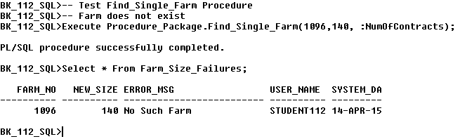

**-- Test Find_Single_Farm Procedure**

**-- Successful Update**

**Execute Procedure_Package.Find_Single_Farm(1015,140, :NumOfContracts);**

**Select * From Farm_Size_Failures;**

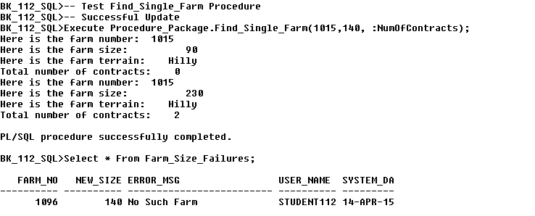

**-- Test Increase_Lowest_Fees Procedure**

**-- Increase too High**

**Execute** **Procedure_Package.Increase_Lowest_Fees(1700);**

**Select * From Fee_Change_Log;**

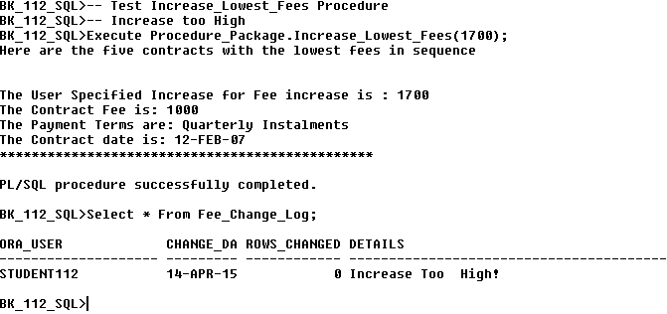

**-- Test Increase_Lowest_Fees Procedure**

**-- Increase too Low**

**Execute** **Procedure_Package.Increase_Lowest_Fees(900);**

**Select * From Fee_Change_Log;**

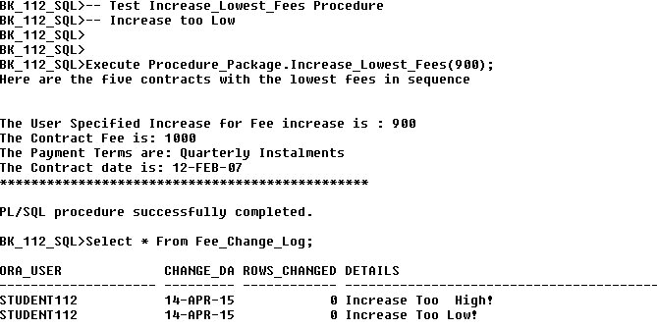

**-- Test Increase_Lowest_Fees Procedure**

**-- Successful Increase**

**Execute** **Procedure_Package.Increase_Lowest_Fees(1000);**

**Select * From Fee_Change_Log;**

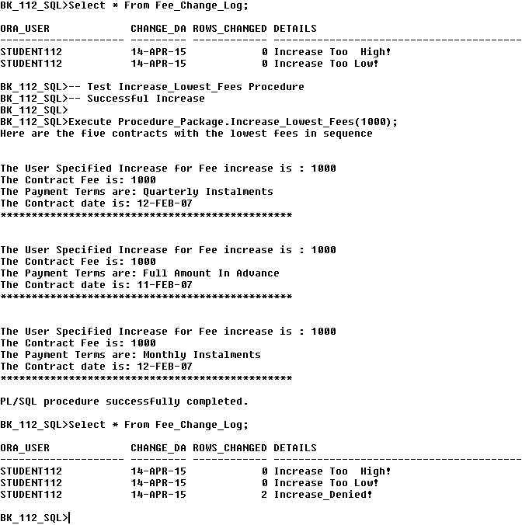

**-- Test NumToDeleteTooBig Exception**

**-- Test FarmDelete Procedure**

**-- Deletes Too High Exception**

**SELECT** **Count(*)** **FROM** **Farm;**

**Execute** **Procedure_Package.FarmDelete(7,** **:TotalValue,** **:NumOfDeletes);**

**SELECT** **Count(*)** **FROM** **Farm;**

**SELECT** **\*** **FROM** **Farm_DeleteLog;**

**SELECT** **\*** **FROM** **Farm_AuditLog;**

**PRINT TotalValue**

**PRINT** **NumOfDeletes**

**rollback;**

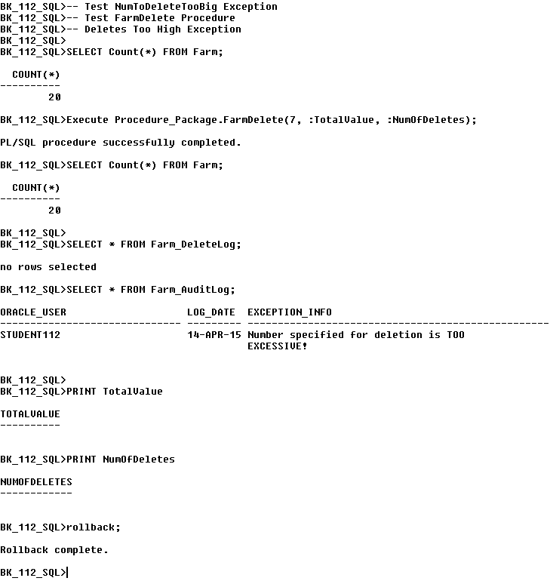

**-- Test FarmDelete Procedure**

**-- NumToDeleteTooSmall Exception**

**SELECT** **Count(*)** **FROM** **Farm;**

**Execute** **Procedure_Package.FarmDelete(1,** **:TotalValue, :NumOfDeletes);**

**SELECT** **Count(*)** **FROM** **Farm;**

**SELECT** **\*** **FROM** **Farm_DeleteLog;**

**SELECT** **\*** **FROM** **Farm_AuditLog;**

**PRINT** **TotalValue**

**PRINT** **NumOfDeletes**

**rollback;**

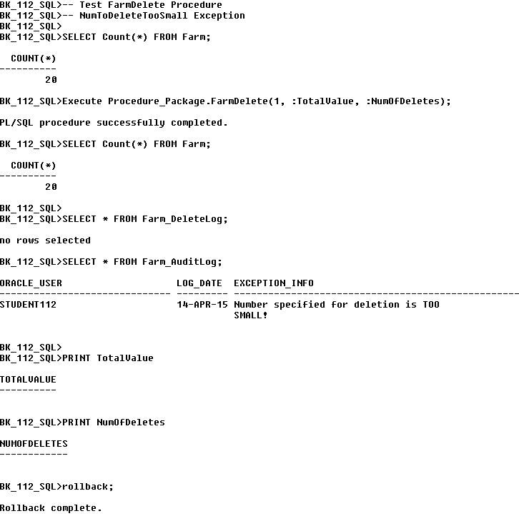

**-- Test FarmDelete Procedure**

**-- Successful Execution**

**SELECT** **Count(*)** **FROM** **Farm;**

**Execute** **Procedure_Package.FarmDelete(5,** **:TotalValue, :NumOfDeletes);**

**SELECT** **Count(*)** **FROM** **Farm;**

**SELECT** **\*** **FROM** **Farm_DeleteLog;**

**SELECT** **\*** **FROM** **Farm_AuditLog;**

**PRINT** **TotalValue**

**PRINT** **NumOfDeletes**

**rollback;**

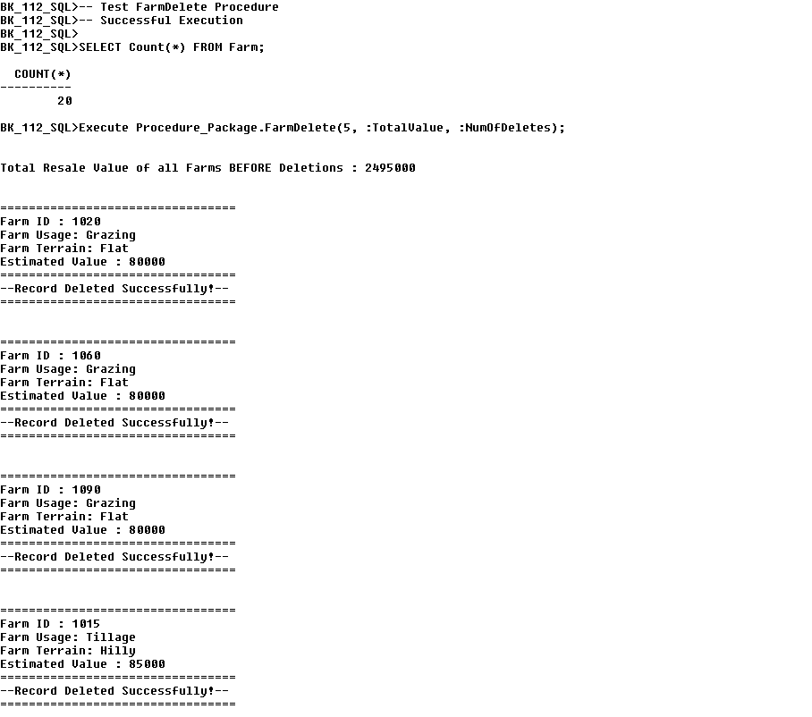

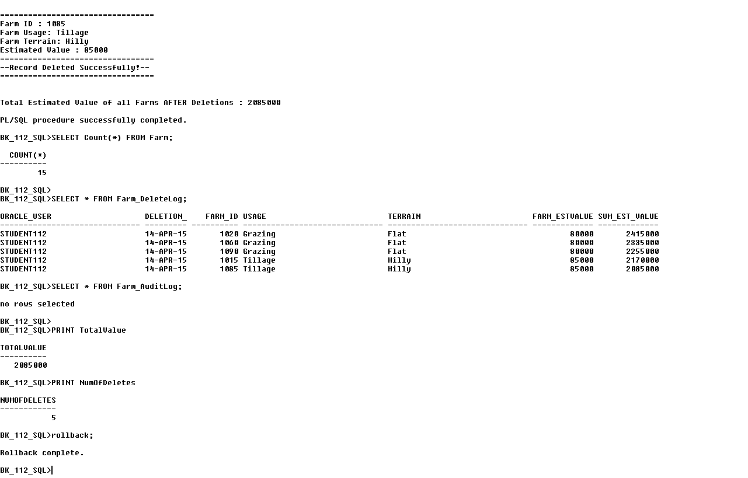

**Drop** **Table** Farm_Size_Failures**;**

**Drop Table Fee_Change_Log;**

**Drop** **Table** **Farm_DeleteLog;**

**Drop** **Table** **Farm_AuditLog;**

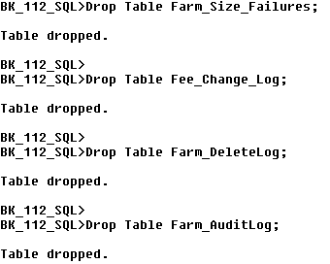

**Drop Package** Procedure_Package**;**



**\*\*\*\*\*\*\*\*\*\*\*\*\*\*\*\*\*\*\*\*\*\*\*\*\*\*\*\*\*\*\*\*\*\*\*\*\*\*\*\*\*\*\*\*\*\*\*\*\*\*\*\*\*\*\*\*\*\*\*\*\*\*\*\*\*\*\*\*\*\*\*\*\*\*\*\*\*\*\*\*\*\*\*\*\*\*\*\*\*\*\*\*\*\*\*\*\*\*\*\*\*\*\*\*\*\*\*\*\*\*\*\*\*\*\*\*\*\*\*\*\*\*\*\*\*\*\*\*\*\*\*\*\*\*\*\*\*\*\*\*\*\*\*\*\*\*\*\*\*\*\*\*\*\*\*\*\*\*\*\*\*\*\*\*\*\*\*\*\*\*\*\*\*\*\*\*\*\*\*\*\*\*\*\*\*\*\*\*\*\*\*\*\*\*\*\*\*\*\*\*\*\*\*\*\*\*\*\*\*\*\*\*\*\*\*\*\*\*\*\*\*\*\*\*\*\*\*\*\*\*\*\*\*\*\*\*\*\*\*\*\*\*\*\*\*\*\*\*\*\*\*\*\*\*\*\*\*\***

## ***Appendix***

## ***Q.17 Package with Insert, Update And Delete Procedures***

***The below PL/SQL Package incorporates three individual Procedures, all of which are based on the same table. The Procedures included in this package allow the User to Add a new record to the Farmer Table, Update the Specialism for a specified Farmer and Delete a specified record from the Farmer Table.***

***\*\*\*\*\*\*\*\*\*\*\*\*\*\*\*\*\*\*\*\*\*\*\*\*\*\*\*\*\*\*\*\*\*\*\*\*\*\*\*\*\*\*\*\*\*\*\*\*\*\*\*\*\*\*\*\*\*\*\*\*\*\*\*\*\*\*\*\*\*\*\*\*\*\*\*\*\*\*\*\*\*\*\*\*\*\*\*\*\*\*\*\*\*\*\*\*\*\*\*\*\*\*\*\*\*\*\*\*\*\*\*\*\*\*\*\*\*\*\*\**Set** ServerOutput **On** **Size** **1000000;**

**Set** Linesize **30000;**

**Create** **or** **Replace** **Package** Farmer_Pack **Is**

**Procedure** **Add_Farmer**

**(**A_Id **In** Farmer**.**Farmer_Id**%Type,** A_Fname **In** Farmer**.F**name**%Type,** A_Sname **In** Farmer**.S**name**%Type,** A_Address **In**

Farmer**.**Address**%Type,** A_County **In** Farmer**.**County**%Type,** A_Gender **In** Farmer**.**Gender**%Type,** A_Date_Of_Birth **In** Farmer**.**Date_Of_Birth**%Type,** A_Phone **In** Farmer**.**Mobile_No**%Type,** A_Email **In** Farmer**.**Email_Address**%Type,** A_Qualifications **in** Farmer**.**Qualifications**%Type,** A_Specialism **in** Farmer**.**Specialism**%Type,** A_Sales **in** Farmer**.**Annual_Sales**%Type);**

**Procedure** **Upd_Farmer_Specialism**

**(**A_Id **In** Farmer**.Farmer**_Id**%Type,** A_Specialism **In** Farmer**.**Specialism**%Type);**

**Procedure** **Del_Farmer**

**(**A_Id **In** Farmer**.**Farmer_Id**%Type);**

**End** Farmer_Pack**;**

**/**

Sho Err

**Create** **Or** **Replace** **Package** **BODY** Farmer_Pack **Is**

**-- ===============================================**

**-- First procedure included is : Add_Farmer**

**-- ===============================================**

**Procedure** Add_Farmer

**(**A_Id **In** Farmer**.**Farmer_Id**%Type,** A_Fname **In** Farmer**.F**name**%Type,** A_Sname **In** Farmer**.S**name**%Type,** A_Address **In** Farmer**.**Address**%Type,** A_County **In** Farmer**.**County**%Type,** A_Gender **In** Farmer**.**Gender**%Type,** A_Date_Of_Birth **In** Farmer**.**Date_Of_Birth**%Type,** A_Phone **In** Farmer**.**Mobile_No**%Type,** A_Email **In** Farmer**.**Email_Address**%Type,** A_Qualifications **in** Farmer**.**Qualifications**%Type,** A_Specialism **in** Farmer**.**Specialism**%Type,** A_Sales **in** Farmer**.**Annual_Sales**%Type)** **Is**

**BEGIN**

**INSERT** **into** Farmer**(**Farmer_ID**,** Fname**,** Sname, Address**,** County**,** Gender,Date_Of_Birth**,** Mobile_No**,** Email_Address**,**

Qualifications**,** Specialism, Annual_Sales**)** **Values** **(**A_Id**,** A_Fname**,**A_Sname**,** A_Address**,** A_County**,** A_Gender**,** A_Date_Of_Birth**,** A_Phone**,** A_Email**,** A_Qualifications, A_Specialism, A_Sales**);**

**END** Add_Farmer**;**

**-- ===============================================**

**-- Second procedure included is : Upd_Farmer_Specialism**

**-- ===============================================**

**Procedure** **Upd_Farmer_Specialism**

**(**A_Id **In** Farmer**.**Farmer_Id**%Type,** A_Specialism **In** Farmer**.**Specialism**%Type)** **Is**

**BEGIN**

**UPDATE** Farmer

**SET** Specialism **=** A_Specialism

**WHERE** Farmer_ID **=** A_Id**;**

**IF** **SQL%**NotFound **Then**

Raise_Application_Error**(-**20203**,** 'Farmer ID does NOT Exist, UPDATE Failed!'**);**

**End** **If;**

**END** Upd_Farmer_Specialism**;**

**-- ===============================================**

**-- Third procedure included is : Del_Farmer**

**-- ===============================================**

**Procedure** **Del_Farmer**

**(**A_Id **In** Farmer**.**Farmer_Id**%Type)** **Is**

**BEGIN**

**DELETE**

**FROM** Farmer

**WHERE** Farmer_Id **=** A_Id**;**

**IF** **SQL%**NotFound **Then**

Raise_Application_Error**(-**20203**,** 'Farmer ID does NOT Exist, DELETE Failed!'**);**

**End** **If;**

**END** Del_Farmer**;**

**END** Farmer_Pack**;**

**/**

Sho Err

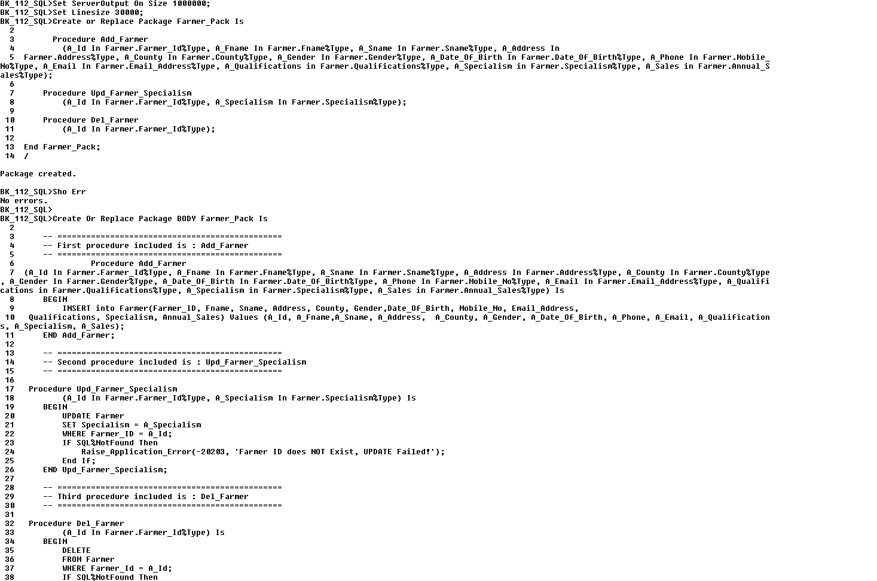

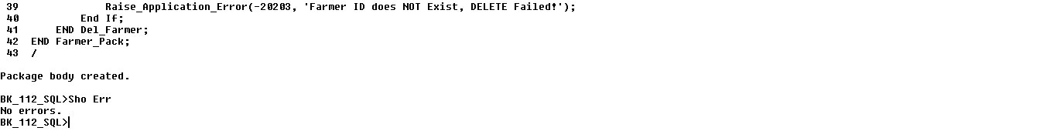

**Execute** Farmer_Pack**.**Add_Farmer**(**3191**,**'Steve', 'Jobs'**,**'10 Apple Drive'**,**'Longford'**,'**Male'**,**'27-Mar-89'**,** '872326558'**,**'SteveJobs@apple.com'**,** 'Farming Cert','Tillage',20000**);**

**SELECT** **\***

**FROM** Farmer

**WHERE** Farmer_ID **=** 3191**;**

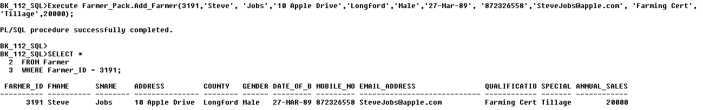

-- Test Upd_Farmer_Specialism Procedure

**SELECT** Specialism

**FROM** Farmer

**WHERE** Farmer_Id **=** 3191**;**

**Execute** Farmer_Pack**.** Upd_Farmer_Specialism**(**3191**,** 'Beef'**);**

**SELECT** Specialism

**FROM** Farmer

**WHERE** Farmer_Id **=** 3191**;**

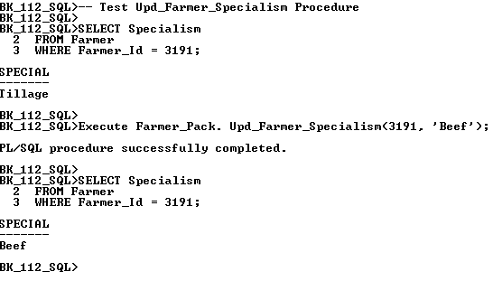

-- Test Del_Farmer Procedure

**SELECT** **Count(*)**

**FROM** Farmer

**WHERE** Farmer_Id **=** 3191**;**

**Execute** Farmer_Pack**.**Del_Farmer**(**3191**);**

**SELECT** **Count(*)**

**FROM** Farmer

**WHERE** Farmer_Id **=** 3191**;**

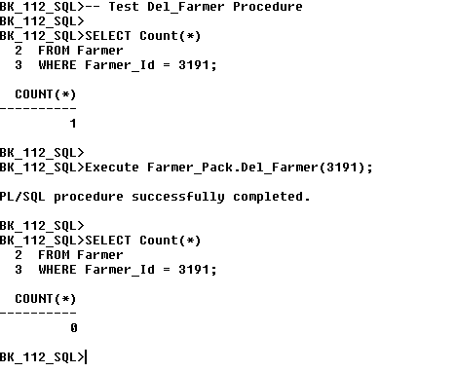

Drop **Package** Farmer_Pack;

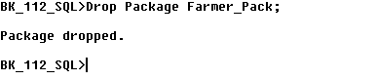**\*\*\*\*\*\*\*\*\*\*\*\*\*\*\*\*\*\*\*\*\*\*\*\*\*\*\*\*\*\*\*\*\*\*\*\*\*\*\*\*\*\*\*\*\*\*\*\*\*\*\*\*\*\*\*\*\*\*\*\*\*\*\*\*\*\*\*\*\*\*\*\*\*\*\*\*\*\*\*\*\*\*\*\*\*\*\*\*\*\*\*\*\*\*\*\*\*\*\*\*\*\*\*\*\*\*\*\*\*\*\*\*\*\*\*\*\*\*\*\*\*\*\*\*\*\*\*\*\*\*\*\*\*\*\*\*\*\*\*\*\*\*\*\*\*\*\*\*\*\*\*\*\*\*\*\*\*\*\*\*\*\*\*\*\*\*\*\*\*\*\*\*\*\*\*\*\*\*\*\*\*\*\*\*\*\*\*\*\*\*\*\*\*\*\*\*\*\*\*\*\*\*\*\*\*\*\*\*\*\*\*\*\*\*\*\*\*\*\*\*\*\*\*\*\*\***

## ***Q.19 Trigger That Uses a Cursor***

***Below is a demonstration of an After Update Trigger, based upon the Auctioneer Table, which incorporates the use of a Cursor to make specified changes to the Rental Contract Table as follows: When an Auctioneer's Annual Turnover figure is updated, two Rental Contracts with the lowest Fee, associated with the Auctioneer in question will have €1000 added to their Rental Fee.***

***\*\*\*\*\*\*\*\*\*\*\*\*\*\*\*\*\*\*\*\*\*\*\*\*\*\*\*\*\*\*\*\*\*\*\*\*\*\*\*\*\*\*\*\*\*\*\*\*\*\*\*\*\*\*\*\*\*\*\*\*\*\*\*\*\*\*\*\*\*\*\*\*\*\*\*\*\*\*\*\*\*\*\*\*\*\*\*\*\*\*\*\*\*\*\*\*\*\*\*\*\*\*\*\*\*\*\*\*\*\*\*\*\*\*\*\*\*\*\*\*\*\*\*\*\*\*\*\*\*\*\*\*\*\*\*\*\*\*\****

**Set serveroutput on size 1000000;**

**Drop** **Table** **Auct_Audit_Log;**

**Create** **Table** Auct_Audit_Log**(**Name **Varchar2(**30**),** Pre_Tot_Rental_Fee **Number(**6**),** Post_Tot_Rental_Fee **Number(**6**),** Tot_Rental_Fee_Increase **Number(**6**),** Oracle_User **Varchar2(**30**),** Date_Changed **Date);**

**Drop** **Table** **Auct_Exceptions_Log;**

**Create** **Table** Auct_Exceptions_Log**(**Oracle_User **VarChar2(**20**),** Date_Changed **Date,** Auct_ID **Number(**4**),** Details **Varchar(**40**));**

**Create** **Or** **Replace** **Trigger** **Auct_Adjust_Inc_Rental_Fee**

**After** **Update** **Of** Annual_Turnover **On** Auctioneer

**For** **Each** **row**

**Declare**

**Cursor** Rental_Fee_Cur **Is** **SELECT** Contract_Date**,** Duration**,** Rental_Fee

**FROM** Rental_Contract

**WHERE** Auctioneer_ID **=** **:new.**Auctioneer_ID

**Order** **By** Rental_Fee

**For** **Update** **Of** Rental_Fee**;**

V_Contract_Date Rental_Contract**.**Contract_Date**%Type;**

V_Duration Rental_Contract**.**Duration**%Type;**

V_Rental_Fee Rental_Contract**.**Rental_Fee**%Type;**

V_Sum_Fee_Before **Number(**30**):=**0**;**

V_Sum_Fee_After **Number(**30**):=**0**;**

**BEGIN**

**Open** Rental_Fee_Cur**;**

**SELECT** **Sum(**Rental_Fee**)** **into** V_Sum_Fee_Before

**FROM** Rental_Contract

**WHERE** Auctioneer_ID **=** **:new.**Auctioneer_ID**;**

DBMS_Output**.**Put_Line**(**'Sum Total of Rental Fees Before Changes are made is : ' **||**

V_Sum_Fee_Before**);**

**For** V_Count **in** 1..2

**Loop**

**Fetch** Rental_Fee_Cur **into** V_Contract_Date**,** V_Duration**,** V_Rental_Fee**;**

**Exit** **When** Rental_Fee_Cur**%**NotFound**;**

DBMS_Output**.**Put_Line**(**'=================================='**);**

DBMS_Output**.**Put_Line**(**'Contract Date: ' **||** V_Contract_Date**);**

DBMS_Output**.**Put_Line**(**'Duration: ' **||** V_Duration**);**

DBMS_Output**.**Put_Line**(**'Rental Fee : ' **||** V_Rental_Fee**);**

DBMS_Output**.**Put_Line**(**'=================================='**);**

**UPDATE** Rental_Contract

**SET** Rental_Fee **=** Rental_Fee **+** 1000

**WHERE** **Current** **Of** Rental_Fee_Cur**;**

**End** **Loop;**

**Close** Rental_Fee_Cur**;**

**SELECT** **Sum(**Rental_Fee**)** **into** V_Sum_Fee_After

**FROM** Rental_Contract

**WHERE** Auctioneer_ID **=** **:new.**Auctioneer_ID**;**

DBMS_Output**.**Put_Line**(**'Sum Total of Rental Fees After Changes are made is : ' **||**

V_Sum_Fee_After**);**

**INSERT** **into** **Auct_Audit_Log Values(:new.**Auctioneer_ID**,** V_Sum_Fee_Before**,** V_Sum_Fee_After**,** V_Sum_Fee_After **–**

V_Sum_Fee_Before**,** **User,** **Sysdate);**

-- Exceptions Handling

**Exception**

**When** No_Data_Found **Then**

**Insert** **into** **Auct_Exceptions_Log** **Values(User,** **Sysdate,** **:new.**Auctioneer_ID**,** 'Data Not Found!'**);**

**When** DUP_VAL_ON_INDEX **Then**

**Insert** **into** **Auct_Exceptions_Log** **Values(User,** **Sysdate,** **:new.**Auctioneer_ID**,** 'Duplicate Entry Found!'**);**

**When** **Others** **Then**

**Insert** **into** **Auct_Exceptions_Log** **Values(User,** **Sysdate,** **:new.**Auctioneer_ID**,** 'Unforseen Error!'**);**

**END** **Auct_Adjust_Inc_Rental_Fee;**

**/**

Sho Err

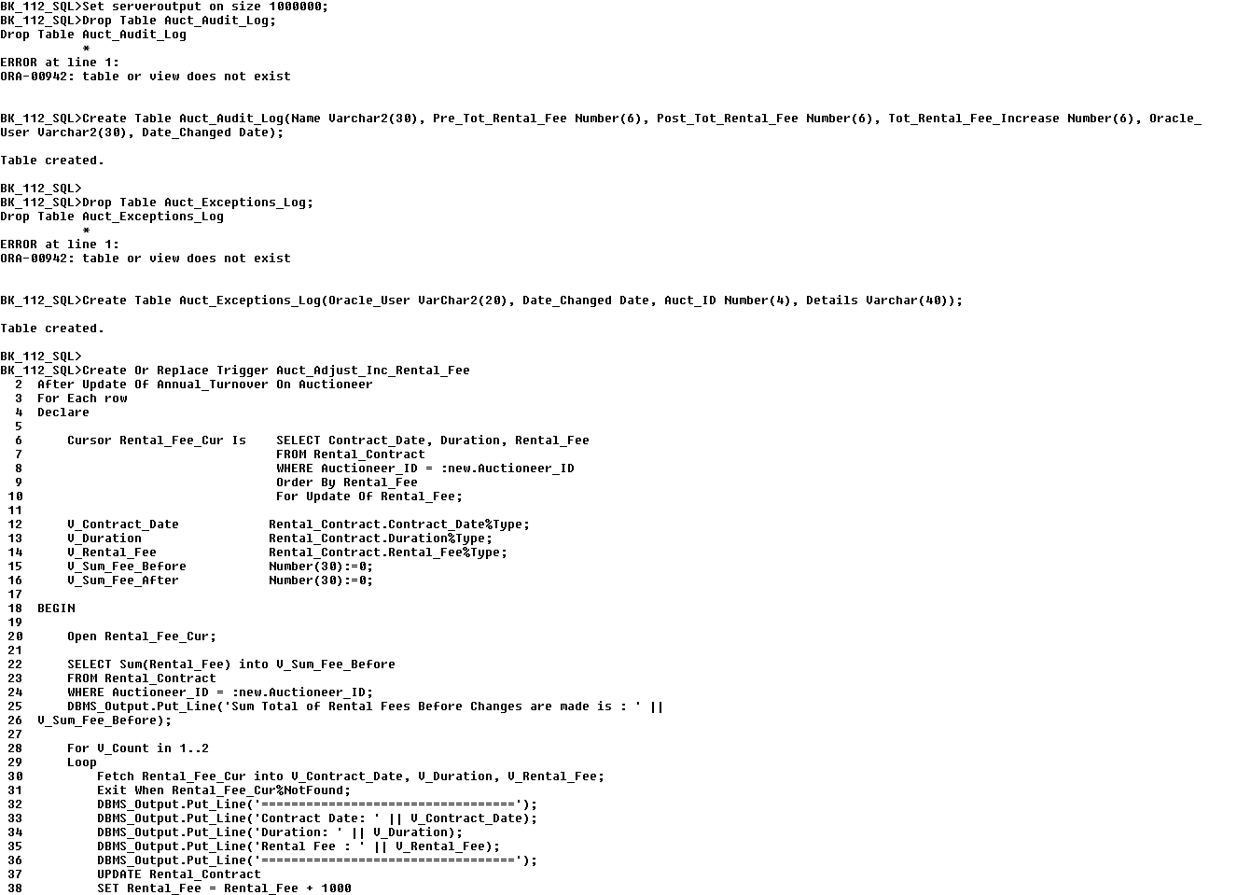

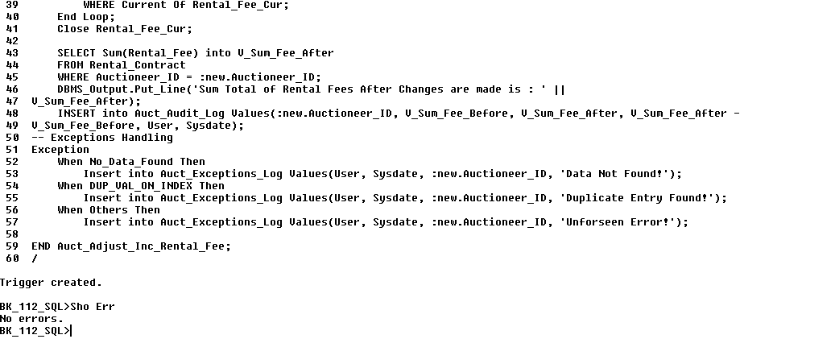

-- Test Trigger

**Update** Auctioneer

**SET** Annual_Turnover **=** 160000

**WHERE** Auctioneer_ID **=** 7110**;**

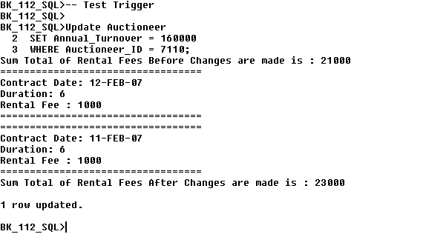

**Drop Trigger Auct_Adjust_Inc_Rental_Fee;**



## ***Q.18 Trigger that Calls a Procedure***

**The following Trigger calls a Procedure to update the Auctioneer's Annual Turnover depending on what action the User has performed on the Rental Contract table.**

**(a) If a New Contract is added to the Rental Contract Table :**

**The Auctioneer associated with this new contract will have their Annual Turnover increased by the Rental Fee amount of the recently added Contract.**

**(b) If an Existing Contract has had its Fee Updated :**

**The Auctioneer of the Contract in question will have their Annual Turnover increased by the difference between the previous Rental Fee of the recently updated Rental Fee.**

**(c) If a New Rental Contract is Removed to the Rental Contract :**

**The Auctioneer of the Contract in question will have their Annual Turnover decreased by the Rental Fee of the recently deleted Contract.**

**\*\*\*\*\*\*\*\*\*\*\*\*\*\*\*\*\*\*\*\*\*\*\*\*\*\*\*\*\*\*\*\*\*\*\*\*\*\*\*\*\*\*\*\*\*\*\*\*\*\*\*\*\*\*\*\*\*\*\*\*\*\*\*\*\*\*\*\*\*\*\*\*\*\*\*\*\*\*\*\*\*\*\*\*\*\*\*\*\*\*\*\*\*\***

-- Create the Inc_Auct_Turnover Procedure

**Drop** **Procedure** Inc_Auct_Turnover**;**

**Create** **or** **Replace** **Procedure** Inc_Auct_Turnover**(**V_Auct_ID **In** Auctioneer**.**Auctioneer_ID**%Type,** V_Amount **In** Auctioneer**.**Annual_Turnover**%Type)** **Is**

**BEGIN**

**UPDATE** Auctioneer

**SET** Annual_Turnover **=** **Nvl(**Annual_Turnover**,** 0**)** **+** V_Amount

**WHERE** Auctioneer_ID **=** V_Auct_ID**;**

**END** Inc_Auct_Turnover**;**

**/**

Sho Err

-- Create the Compute_Turnover Trigger

**Drop** **Trigger** Compute_Turnover**;**

**Create** **Or** **Replace** **Trigger** Compute_Turnover

**After** **INSERT** **OR** **UPDATE** **Of** Rental_Fee **OR** **DELETE** **ON** Rental_Contract

**For** **Each** **Row**

**BEGIN**

**If** Deleting **Then**

Inc_Auct_Turnover**(:Old.**Auctioneer_ID**,** **-**1 **\*** **:Old.**Rental_Fee**);**

**ElsIf** Updating **Then**

Inc_Auct_Turnover**(:New.**Auctioneer_ID**,** **:New.**Rental_Fee **-** **:Old.**Rental_Fee**);**

**Else**

Inc_Auct_Turnover**(:New.**Auctioneer_ID**,** **:New.**Rental_Fee**);**

**End** **If;**

**END** Compute_Turnover**;**

**/**

Sho Err

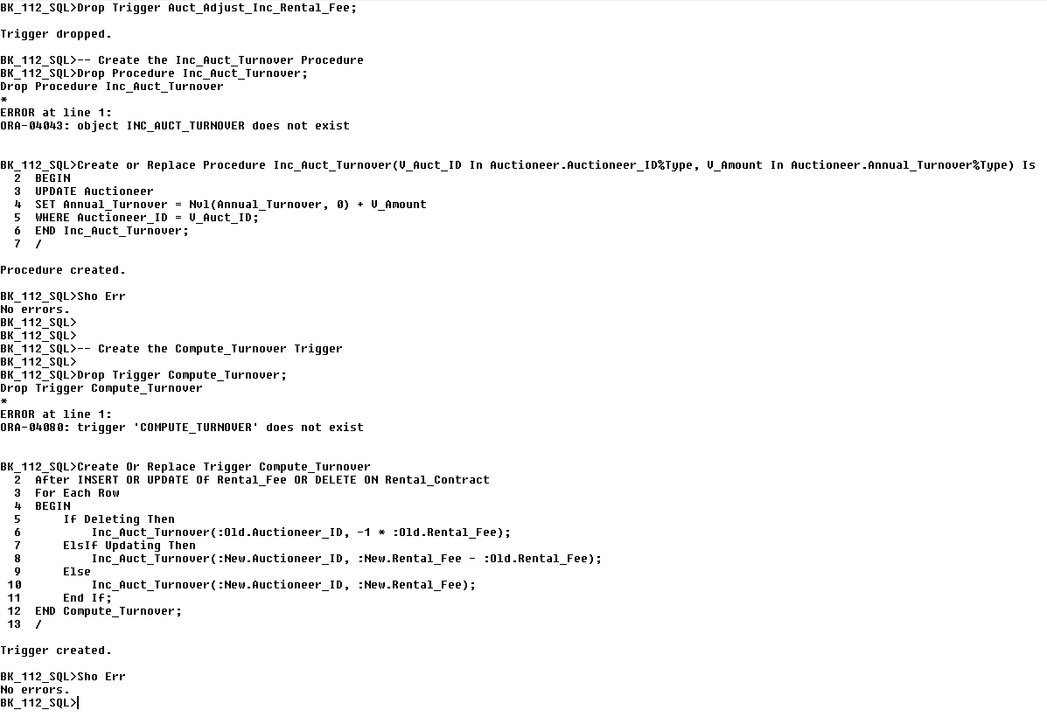

-- Test the Trigger with an by Inserting a new Rental Contract

**SELECT** Annual_Turnover **FROM** Auctioneer **WHERE** Auctioneer_ID **=** 7110**;**

**Insert into** Rental_Contract **values** (1010,3010,'11-Dec-07',12,5000,'Full Amount In Advance',5000,7110);

**SELECT** Annual_Turnover **FROM** Auctioneer **WHERE** Auctioneer_ID **=** 7110**;**

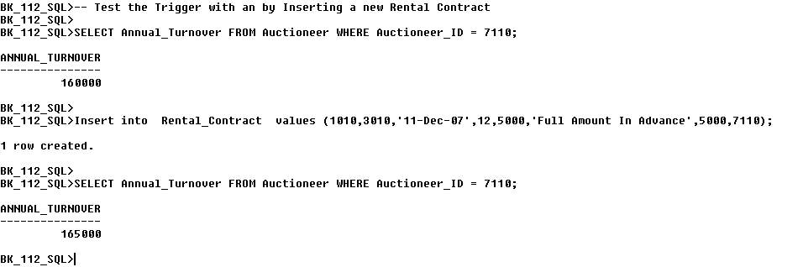

-- Test the Trigger by Updating a Rental Contract

**SELECT** Annual_Turnover **FROM** Auctioneer **WHERE** Auctioneer_ID **=** 7110**;**

**Update** Rental_Contract

**SET** Rental_Fee **=** 10000

**WHERE** Auctioneer_Id **=** 7110**;**

**SELECT** Annual_Turnover **FROM** Auctioneer **WHERE** Auctioneer_ID **=** 7110**;**

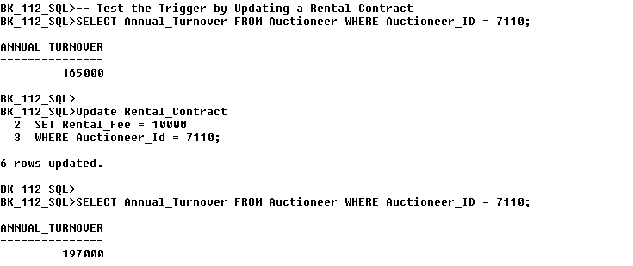

-- Test the Trigger by Deleting a Rental Contract

**SELECT** Annual_Turnover **FROM** Auctioneer **WHERE** Auctioneer_ID **=** 7110**;**

**DELETE**

**FROM** Rental_Contract

**WHERE** Auctioneer_Id **=** 7110**;**

**SELECT** Annual_Turnover **FROM** Auctioneer **WHERE** Auctioneer_ID **=** 7110**;**

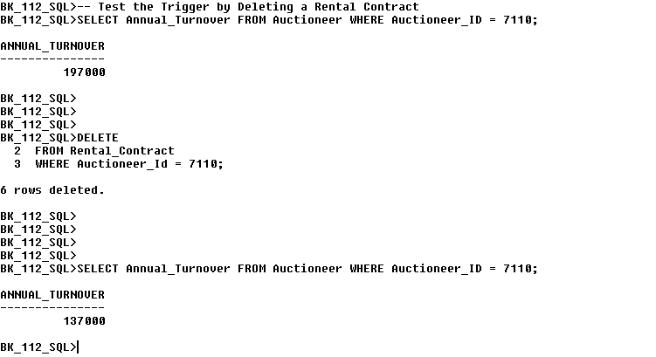

**Rollback;**

**Drop** **Procedure** Inc_Auct_Turnover**;**

**Drop** **Trigger** Compute_Turnover**;**

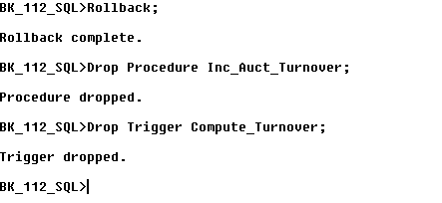

## ***Q.14 Table Level Trigger Before Delete***

***This Table Level Trigger dictates the following conditions before a Deletion can occur on the Rental Contract Table:***

***a) A User may not delete an entry from the Rental Contract table if there are less than 15 Records present on the Table.***

***b) In the case that a Deletion will be allowed, the Rental Contract Audit table will be updated to reflect the User details, date of deletion and the Number of entries residing on the Rental Contract Table before the Deletion takes place.***

***\*\*\*\*\*\*\*\*\*\*\*\*\*\*\*\*\*\*\*\*\*\*\*\*\*\*\*\*\*\*\*\*\*\*\*\*\*\*\*\*\*\*\*\*\*\*\*\*\*\*\*\*\*\*\*\*\*\*\*\*\*\*\*\*\*\*\*\*\*\*\*\*\*\*\*\*\*\*\*\*\*\*\*\*\*\*\*\*\*\*\*\*\*\*\*\*\*\*\*\*\*\*\*\*\*\*\*\*\*\*\*\*\****

**Set Serveroutput on Size 1000000;**

**DROP** **TABLE** Audit_Contracts**;**

**CREATE** **TABLE** Audit_Contracts**(**Oracle_User **VarChar2(**20**),** Delete_Date **Date,** No_Contracts **Number(**30**,**2**),** Sum_Fees **Number(**30**,**2**));**

**Create** **Or** **Replace** **Trigger** Q14_Contract_Audit

**Before** **Delete** **On** Rental_Contract

**Declare**

V_No_Contracts **Number(**30**):=**0**;**

V_Sum_Rental_Fee **Number(**30**):=**0**;**

**Begin**

**SELECT** **COUNT(*)** **into** V_No_Contracts

**FROM** Rental_Contract**;**

**SELECT** **SUM(**Rental_Fee**)** **into** V_Sum_Rental_Fee

**FROM** Rental_Contract**;**

**If** V_No_Contracts **<** 15 **Then**

Raise_Application_Error**(-**20101**,** 'You may NOT DELETE from this Table if the number of entries is less than 15'**);**

**Elsif** V_No_Contracts **>=** 15 **Then**

**INSERT** **INTO** Audit_Contracts **Values** **(User,** **Sysdate,** V_No_Contracts**,** V_Sum_Rental_Fee**);**

**End** **If;**

**End;**

**/**

Sho Err

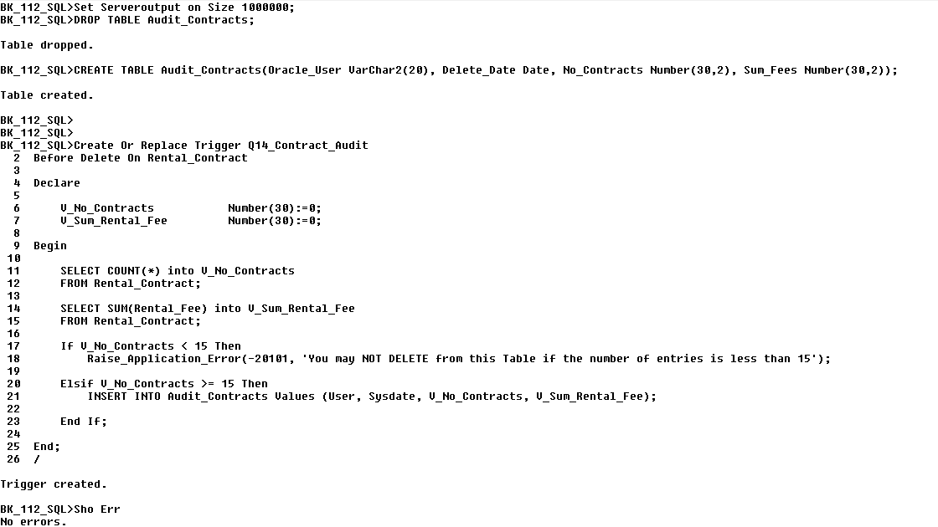

**-- Test Case a**

**DELETE**

**FROM** Rental_Contract

**WHERE** Auctioneer_ID **=** 7110**;**

**SELECT** **\*** **FROM** Audit_Contracts **Order** **By** No_Contracts**;**

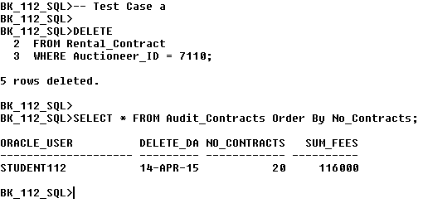

**--Test Case b**

**DELETE**

**FROM** Rental_Contract

**WHERE** Auctioneer_ID **=** 7080**;**

**SELECT** **\*** **FROM** Audit_Contracts **Order** **By** No_Contracts**;**

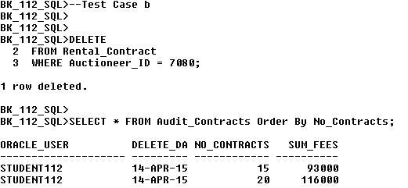

**DELETE**

**FROM** Rental_Contract

**WHERE** Auctioneer_ID **=** 7140**;**

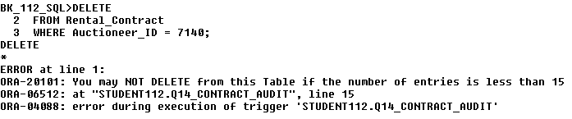

**DROP** **TABLE** Audit_Contracts**;**

**Drop Trigger** Q14_Contract_Audit;

