***KENNY FLYING LESSONS***



**Athlone Institute of Technology**



**COURSE:** MASTER OF SCIENCE IN SOFTWARE ENGINEERING

**COURSE ID:** AL_KSWFT_R_5G

**SUBJECT:** Database APPLICATIONS

**YEAR:** 5

**LECTURER**: Mr. Michael Thornton

**SUBJECT:** Database Systems

**PROJECT TITLE:** KennyAir Database

|  |  |  |
| --- | --- | --- |
| Student Number | Student Name | Signature (for hardcopy) |
| A00037189 | Brendan Kenny |  |

***Table of Contents***

***Introduction*** 3

***Database Overview*** 4

***Database Schema*** 5

***Errors and Anomalies*** 10

***Queries*** 11

***Normalisation Of Data*** 18

***Entity Relationship Diagram*** 21

***Testing the cardinality of the table relationships*** 22

***A Comparison Of ER Model and Normalized Model*** 24

***Final Database Design*** 24

***Final Database Design*** 25

***Business Rules applicable to the database*** 28

***Implementation of Business Rules*** 30

***1.*** ***Salary Conditions*** 30

***2. Flight Lesson Fees*** 32

***2.*** ***Tutors Commission on Flights*** 33

***3.*** ***Deletions from the database shall be limited.*** 36

***5. Trigger to increase Tutor’s Salaries*** 37

***4.*** ***Procedure to increase Fees For All Flights*** 39

***7. Procedure to Increase Salaries For All Tutors*** 41

***Errors and Anomalies*** 42

***Views and Privileges*** 43

***Views*** 44

***Testing Of User Privileges*** 46

***Privilege Restrictions*** 47

***Concurrency Management*** 48

***Query Optimization*** 49

***Procedure to Populate Table with Test Data*** 51

***Implementing Indexing*** 52

***Main Menu – Flights Table*** 53

***Tutors*** 54

***Location*** 56

***Students*** 57

***Flow Chart For Java Database Application*** 58

***Sample Java Code For Database Front End Application*** 59

***Backup And Recovery*** 62

## ***Introduction***

The following database was created to facilitate agreed flying lesson appointments between the relevant parties. All aspects of database design were considered and implemented in the design and implementation of this database including normalisation of data, entity relationship diagrams in accordance with best practices.

Brendan Kenny

24 April 2016



# ***Database Overview***

***Kenny Flying Lessons***

The following database will record flying lesson bookings for my company - Kenny Flying Lessons. The company will be based in several locations around Ireland.

The database will comprise of the following tables:

**Tutors**

**Students**

**Location**

**Flights**

**Planes**

***The Tutors table***

The Tutors table will comprise of the following fields:

Tutor_Id (Primary Key), Firstname, Surname, Address, Ranking, Location_Id (Foreign Key)

***The Students table***

The Students table will comprise of the following fields:

Student_Id (Primary Key), Firstname, Surname, Address, Phone_No, Email_Address

***The Location table***

The Location table will comprise of the following fields:

Location_Id (Primary Key), Centre_name, Address, Phone_No, Email_Address

***The Flights table***

The Flights table will comprise of the following fields:

Student_Id (Primary Key), Tutor_Id, Location_Id, Lesson_Date, Aircraft_ID, Flight_Duration

***The Aircraft table***

The Aircraft table will comprise of the following fields:

Aircraft_ID (Primary Key), Location_Id, Make, Model, Age

# ***Database Schema***

The initial database schema will now be implemented. This is subject to change as other design considerations are considered and implemented later in the development of the database. With regards to functionality, it is important that the database function in an efficient manner, this will be addressed later with indexing, also it is important that different users have different privileges that are in keeping with their rank, for example, a junior administrator should have less privileges than a senior administrator. Due to the fact that data loss can occur as a result of hardware/software problems, the database will be subject to regular backups. The customer would wish to have a fully functioning front end application that is easy to use. This will be addressed by implementing a Java gui application for the customer.

**Tutors**

**Students**

**Location**

**Flights**

**Planes**

**CREATE** DATABASE KENNYAIR_DB**;**

**USE** KENNYAIR_DB**;**



**DROP** **TABLE** **IF** **EXISTS** TUTORS**;**

**DROP** **TABLE** **IF** **EXISTS** STUDENTS**;**

**DROP** **TABLE** **IF** **EXISTS** LOCATION**;**

**DROP** **TABLE** **IF** **EXISTS** FLIGHTS**;**

**DROP** **TABLE** **IF** **EXISTS** AIRCRAFT**;**

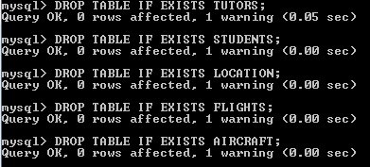

**\*\*\*\*\*\*\*\*\*\*\*\*\*\*\*\*\*\*\*\*\*\*\*\*\*\*\*\*\*\*\*\*\*\*\*\*\*\*\*\*\*\*\*\*\*\*\*\*\*\*\*\*\*\*\*\*\*\*\*\*\*\*\*\*\*\*\*\*\*\*\*\*\*\*\*\*\*\*\*\*\*\*\*\*\*\*\*\*\*\*\*\*\*\*\*\*\*\*\*\*\*\*\*\*\*\*\*\*\*\*\*\*\*\*\*\*\*\*\*\*\*\*\*\*\*\*\*\*\*\*\*\*\*\*\*\*\*\*\*\*\*\*\*\*\*\*\*\*\*\***

**CREATE** **TABLE** TUTORS **(**

TUTOR_ID **CHAR(**14**)** **NOT** **NULL,**

FIRSTNAME **CHAR(**14**),**

SURNAME **CHAR(**14**),**

ADDRESS **CHAR(**14**),**

**CONSTRAINT** TUTORS_PRIMARY_KEY **PRIMARY** **KEY** **(**TUTOR_ID**));**

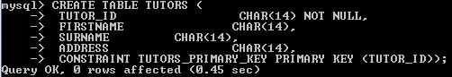

**INSERT** **INTO** TUTORS **VALUES** **(**'0001'**,**'BRENDAN'**,** 'KENNY'**,**'LONGFORD'**);**

**INSERT** **INTO** TUTORS **VALUES** **(**'0002'**,**'OLIVER'**,** 'KENNY'**,**'LONGFORD'**);**

**INSERT** **INTO** TUTORS **VALUES** **(**'0003'**,**'PATRICK'**,** 'KENNY'**,**'LONGFORD'**);**

**INSERT** **INTO** TUTORS **VALUES** **(**'0004'**,**'BERNARD'**,** 'KENNEDY'**,**'LONGFORD'**);**

**INSERT** **INTO** TUTORS **VALUES** **(**'0005'**,**'JOHN'**,** 'CLINTON'**,**'ATHLONE'**);**

**INSERT** **INTO** TUTORS **VALUES** **(**'0006'**,**'EAMONN'**,** 'DEVALERA'**,**'DUBLIN'**);**

**INSERT** **INTO** TUTORS **VALUES** **(**'0007'**,**'ALBERT'**,** 'EINSTEIN'**,**'MULLINGAR'**);**

**INSERT** **INTO** TUTORS **VALUES** **(**'0008'**,**'RICHARD'**,** 'FEYNMAN'**,**'MULLINGAR'**);**

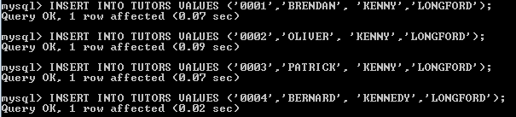

**\*\*\*\*\*\*\*\*\*\*\*\*\*\*\*\*\*\*\*\*\*\*\*\*\*\*\*\*\*\*\*\*\*\*\*\*\*\*\*\*\*\*\*\*\*\*\*\*\*\*\*\*\*\*\*\*\*\*\*\*\*\*\*\*\*\*\*\*\*\*\*\*\*\*\*\*\*\*\*\*\*\*\*\*\*\*\*\*\*\*\*\*\*\*\*\*\*\*\*\*\*\*\*\*\*\*\*\*\*\*\*\*\*\*\*\*\*\*\*\*\*\*\*\*\*\*\*\*\*\*\*\*\*\*\*\*\*\*\*\*\*\*\*\*\*\*\*\*\*\***

**\*\*\*\*\*\*\*\*\*\*\*\*\*\*\*\*\*\*\*\*\*\*\*\*\*\*\*\*\*\*\*\*\*\*\*\*\*\*\*\*\*\*\*\*\*\*\*\*\*\*\*\*\*\*\*\*\*\*\*\*\*\*\*\*\*\*\*\*\*\*\*\*\*\*\*\*\*\*\*\*\*\*\*\*\*\*\*\*\*\*\*\*\*\*\*\*\*\*\*\*\*\*\*\*\*\*\*\*\*\*\*\*\*\*\*\*\*\*\*\*\*\*\*\*\*\*\*\*\*\*\*\*\*\*\*\*\*\*\*\*\*\*\*\*\*\*\*\*\*\***

**CREATE** **TABLE** STUDENTS **(**

STUDENT_ID **CHAR(**14**)** **NOT** **NULL,**

FIRSTNAME **CHAR(**14**),**

SURNAME **CHAR(**14**),**

ADDRESS **CHAR(**14**),**

PHONE_NO **CHAR(**14**),**

**CONSTRAINT** STUDENTS_PRIMARY_KEY **PRIMARY** **KEY** **(**STUDENT_ID**));**

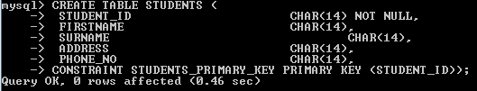

**INSERT** **INTO** STUDENTS **VALUES** **(**'0011'**,**'RICHARD'**,** 'KELLY'**,** 'LONGFORD'**,** '0876543219'**);**

**INSERT** **INTO** STUDENTS **VALUES** **(**'0022'**,**'JOHN'**,** 'NIXON'**,** 'WEXFORD'**,** '0835531155'**);**

**INSERT** **INTO** STUDENTS **VALUES** **(**'0033'**,**'PAUL'**,** 'ARMSTRONG'**,**'MULLINGAR'**,** '0876581199'**);**

**INSERT** **INTO** STUDENTS **VALUES** **(**'0044'**,**'LUCY'**,** 'CULLEN'**,**'ATHLONE'**,** '0859943217'**);**

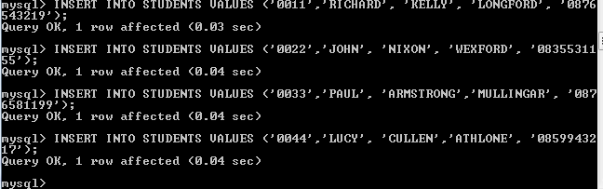

**\*\*\*\*\*\*\*\*\*\*\*\*\*\*\*\*\*\*\*\*\*\*\*\*\*\*\*\*\*\*\*\*\*\*\*\*\*\*\*\*\*\*\*\*\*\*\*\*\*\*\*\*\*\*\*\*\*\*\*\*\*\*\*\*\*\*\*\*\*\*\*\*\*\*\*\*\*\*\*\*\*\*\*\*\*\*\*\*\*\*\*\*\*\*\*\*\*\*\*\*\*\*\*\*\*\*\*\*\*\*\*\*\*\*\*\*\*\*\*\*\*\*\*\*\*\*\*\*\*\*\*\*\*\*\*\*\*\*\*\*\*\*\*\*\*\*\*\*\*\***

**CREATE** **TABLE** LOCATION **(**

LOCATION_ID **CHAR(**14**)** **NOT** **NULL,**

ADDRESS **CHAR(**14**),**

COUNTY **CHAR(**14**),**

PHONE_NO **CHAR(**14**),**

**CONSTRAINT** LOCATION_PRIMARY_KEY **PRIMARY** **KEY** **(**LOCATION_ID**));**

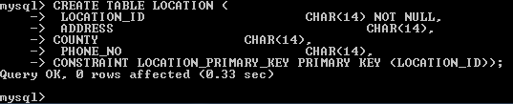

**INSERT** **INTO** LOCATION **VALUES** **(**'1011'**,**'ABBEYSHRULE'**,** 'LONGFORD'**,** '0855566894'**);**

**INSERT** **INTO** LOCATION **VALUES** **(**'2022'**,**'NEW ROSS'**,** 'WEXFORD'**,** '0865549988'**);**

**INSERT** **INTO** LOCATION **VALUES** **(**'3033'**,**'ARDILAUN'**,**'MULLINGAR'**,** '0848897722'**);**

**INSERT** **INTO** LOCATION **VALUES** **(**'4044'**,**'GLASSON'**,**'ATHLONE'**,** '0838889944'**);**

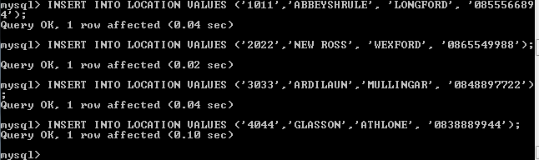

**CREATE** **TABLE** AIRCRAFT **(**

AIRCRAFT_ID **CHAR(**14**)** **NOT** **NULL,**

MAKE **CHAR(**14**),**

MODEL **CHAR(**14**),**

AGE **CHAR(**14**),**

LOCATION_ID **CHAR(**14**),**

**CONSTRAINT** AIRCRAFT_FOREIGN_KEY **FOREIGN** **KEY** **(**LOCATION_ID**)** **REFERENCES** LOCATION **(**LOCATION_ID**),**

**CONSTRAINT** AIRCRAFT_PRIMARY_KEY **PRIMARY** **KEY** **(**AIRCRAFT_ID**));**

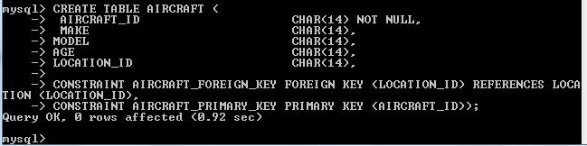

**INSERT** **INTO** AIRCRAFT **VALUES** **(**'1155884'**,**'HAWKER'**,**'HURRICANE'**,** '10'**,** '1011'**);**

**INSERT** **INTO** AIRCRAFT **VALUES** **(**'3344584'**,**'BOEING'**,**'B-17'**,** '5'**,** '2022'**);**

**INSERT** **INTO** AIRCRAFT **VALUES** **(**'6589427'**,**'AVRO'**,**'504'**,** '6'**,** '3033'**);**

**INSERT** **INTO** AIRCRAFT **VALUES** **(**'6542873'**,**'CESSNA'**,**'206'**,** '3'**,** '4044'**);**

**INSERT** **INTO** AIRCRAFT **VALUES** **(**'8843373'**,**'BOEING'**,**'B-10'**,** '4'**,** '3033'**);**

**INSERT** **INTO** AIRCRAFT **VALUES** **(**'1144884'**,**'NOWING'**,**'CRASHER'**,** '2'**,** '1011'**);**

**INSERT** **INTO** AIRCRAFT **VALUES** **(**'2255444'**,**'SQUAWKER'**,**'C-15'**,** '4'**,** '1011'**);**

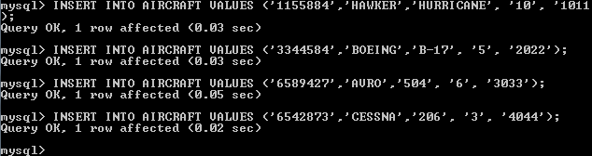

**\*\*\*\*\*\*\*\*\*\*\*\*\*\*\*\*\*\*\*\*\*\*\*\*\*\*\*\*\*\*\*\*\*\*\*\*\*\*\*\*\*\*\*\*\*\*\*\*\*\*\*\*\*\*\*\*\*\*\*\*\*\*\*\*\*\*\*\*\*\*\*\*\*\*\*\*\*\*\*\*\*\*\*\*\*\*\*\*\*\*\*\*\*\*\*\*\*\*\*\*\*\*\*\*\*\*\*\*\*\*\*\*\*\*\*\*\*\*\*\*\*\*\*\*\*\*\*\*\*\*\*\*\*\*\*\*\*\*\*\*\*\*\*\*\*\*\*\*\*\***

**CREATE** **TABLE** FLIGHTS **(**

STUDENT_ID **CHAR(**14**)** **NOT** **NULL,**

TUTOR_ID **CHAR(**14**)** **NOT** **NULL,**

AIRCRAFT_ID **CHAR(**14**)** **NOT** **NULL,**

FLIGHT_DATE **DATE,**

FLIGHT_DURATION **SMALLINT(**4**),**

LESSON_FEE **CHAR(**14**),**

PAYMENT **CHAR(**14**),**

LOCATION_ID **CHAR(**14**),**

**CONSTRAINT** FLIGHTS_FOREIGN_KEY **FOREIGN** **KEY** **(**STUDENT_ID**)** **REFERENCES** STUDENTS **(**STUDENT_ID**),**

**CONSTRAINT** FLIGHTS_FN_KEY **FOREIGN** **KEY** **(**TUTOR_ID**)** **REFERENCES** TUTORS **(**TUTOR_ID**),**

**CONSTRAINT** FLIGHTS_F_KEY **FOREIGN** **KEY** **(**AIRCRAFT_ID**)** **REFERENCES** AIRCRAFT **(**AIRCRAFT_ID**),**

**CONSTRAINT** FLIGHTS_PRIMARY_KEY **PRIMARY** **KEY** **(**STUDENT_ID**,** TUTOR_ID**,** AIRCRAFT_ID**,** FLIGHT_DATE**));**

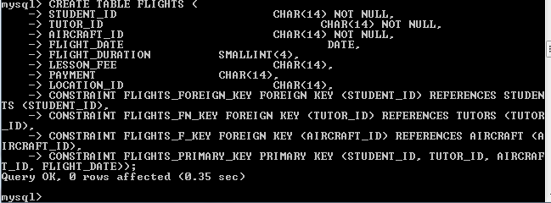

**INSERT** **INTO** FLIGHTS **VALUES** **(**'0011'**,**'0004'**,**'1155884'**,** '2016-01-10'**,** '1'**,** '250.00'**,** 'CHEQUE'**,** '4044'**);**

**INSERT** **INTO** FLIGHTS **VALUES** **(**'0033'**,**'0003'**,**'6589427'**,** '2016-02-04'**,** '1'**,** '250.00'**,** 'CASH'**,** '2022'**);**

**INSERT** **INTO** FLIGHTS **VALUES** **(**'0022'**,**'0002'**,**'6542873'**,** '2016-02-15'**,** '1'**,** '250.00'**,** 'VISA'**,** '1011'**);**

**INSERT** **INTO** FLIGHTS **VALUES** **(**'0044'**,**'0001'**,**'3344584'**,** '2016-03-03'**,** '1'**,** '250.00'**,** 'CASH'**,** '3033'**);**

**INSERT** **INTO** FLIGHTS **VALUES** **(**'0011'**,**'0003'**,**'6589427'**,** '2016-04-05'**,** '2'**,** '300.00'**,** 'CASH'**,** '1011'**);**

**INSERT** **INTO** FLIGHTS **VALUES** **(**'0044'**,**'0001'**,**'1155884'**,** '2016-05-15'**,** '3'**,** '350.00'**,** 'CASH'**,** '3033'**);**

**\*\*\*\*\*\*\*\*\*\*\*\*\*\*\*\*\*\*\*\*\*\*\*\*\*\*\*\*\*\*\*\*\*\*\*\*\*\*\*\*\*\*\*\*\*\*\*\*\*\*\*\*\*\*\*\*\*\*\*\*\*\*\*\*\*\*\*\*\*\*\*\*\*\*\*\*\*\*\*\*\*\*\*\*\*\*\*\*\*\*\*\*\*\*\*\*\*\*\*\*\*\*\*\*\*\*\*\*\*\*\*\*\*\*\*\*\*\*\*\*\*\*\*\*\*\*\*\*\*\*\*\*\*\*\*\*\*\*\*\*\*\*\*\*\*\*\*\*\*\***

## ***Errors and Anomalies***

The one problem I noticed with the initial implementation was that it does not take into account normalization or an ER diagram. This means there could in fact be some data redundancy in the above tables and it would not be wise to proceed with the above implementation without first checking to see if there are any redundancies and to identify clearly the relationships between the tables that would be identified by means of an Entity Relationship Diagram.

# ***Queries***

Briefly, I will just go through a small selection of typical user queries to demonstrate the intended usage of the database. The user typically, in any given day should be able to perform certain operations and standard queries and if there are any anomalies at this stage it will be of great concern and the database design will have to be reviewed.

1. ***Display all tables.***

**Show tables;**

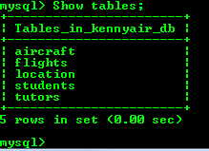

1. ***Describe the Structure of the Aircraft Table.***

**DESCRIBE aircraft;**

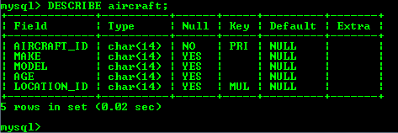

1. ***List all of the information in all of the fields in the Aircraft table.***

**Select** *

**From** Aircraft;

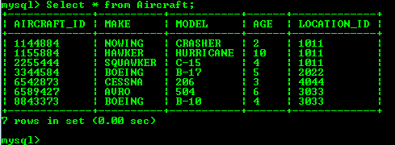

1. ***List the names and Id Numbers of all the Students in the STUDENTS table.***

**Select** Firstname, Surname, Student_Id

**From** Students

**Group By** Surname Desc;

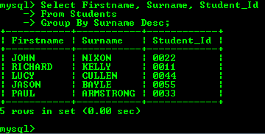

1. ***Add a record containing a new student number (0055), student first-name (JASON), surname(BAYLE), address (ENFIELD), phone number (0896557219) into the STUDENTS table.***

INSERT INTO **STUDENTS** VALUES ('0055','JASON', 'BAYLE', 'ENFIELD', '0896557219');



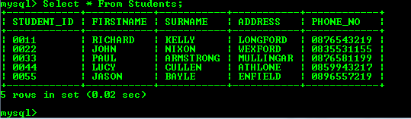

1. ***Show how many aircraft recorded in the Aircraft table are over the age of 3 years.***

**Select** Count(*)

**From** Aircraft

**Where** Age > 3;

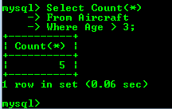

1. ***List all of the information in the EMP table for those employees who are in department number 30.***

**Select** *

**From** Flights

**Where** Payment= 'Cash'

**And** Lesson_Fee BETWEEN 200 AND 300;

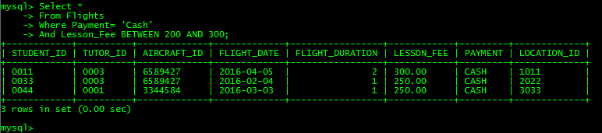

1. ***Show the Student Id, Tutor Id, Aircraft Id, Flight Date and County of all flights not held in Longford.***

**Select** Student_Id, Tutor_Id, Aircraft_Id, Flight_Date, County

**From** Flights, Location

**Where** Flights.Location_Id = Location.Location_Id

**And** County <> 'LONGFORD';

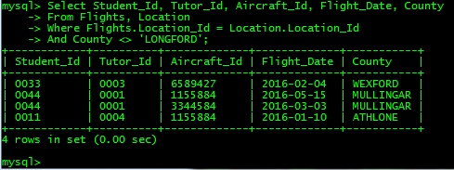

1. ***Get the maximum Lesson Fee for each flight booked.***

**Select** Avg(Lesson_Fee), Max(Lesson_Fee)

**From** Flights;

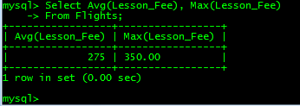

1. ***Show the Student Id, Aircraft Id, Flight Date and the Tutor names for Tutors based in Longford.***

**Select** Student_Id, Aircraft_Id, Flight_Date, Firstname, Surname

**From** Flights, Location, Tutors

**Where** Flights.Location_Id = Location.Location_Id

**And** Flights.Tutor_Id = Tutors.Tutor_Id

**And** Tutors.Address = 'LONGFORD';

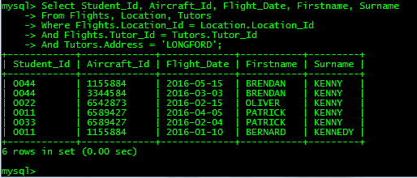

1. ***Show the Aircraft Id, Make, Model and County for Aircraft based in Longford that are greater than two years old.***

**Select** Aircraft_Id, Make, Model, Age, County

**From** Aircraft, Location

**Where** Aircraft.Location_Id = Location.Location_Id

**And** County = 'LONGFORD'

**And** Age > 2;

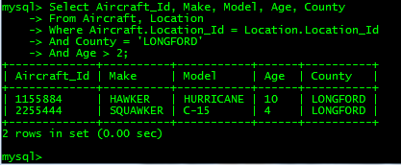

1. ***Update the Flights table to increase all fees by 10%***

**Update** Flights

**Set** Lesson_Fee = Lesson_Fee * 1.10;

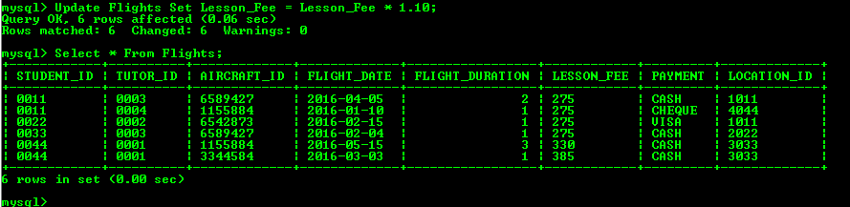

1. ***Show the total flight time and the average flight duration for flight lessons.***

**Select** Sum(Lesson_Fee) AS 'Total Earnings', Avg(Flight_Duration) AS 'Hours Flown'

**From** Flights;

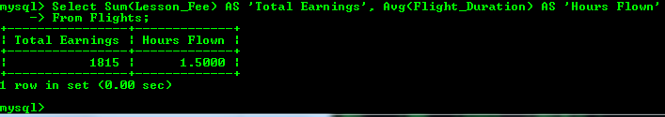

1. ***Show the Student names, Lesson fees and Counties in which lessons were held.***

**Select** Firstname,Surname, Lesson_Fee, County

**From** Students, Flights, Location

**Where** Students.Student_Id = Flights.Student_Id

**And** Flights.Location_Id = Location.Location_Id;

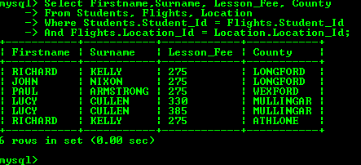

1. ***Show the relevant student names, counties and flight durations for lessons for which the fee was over €275.***

**Select** Firstname,Surname, Lesson_Fee, County, Flight_Duration

**From** Students, Flights, Location

**Where** Students.Student_Id = Flights.Student_Id

**And** Flights.Location_Id = Location.Location_Id

**And** Lesson_Fee > 275;

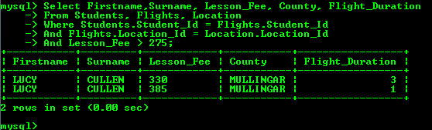

# ***Normalisation Of Data***

**The Database comprises of the following fields:**

***First Normal Form***

* + **All values should be atomic. Done**
  + **No repeating groups. Done**
  + **Primary Key. Done**

**Table1: Tutor_Id**, **Student_Id**, **Location_Id**, **Aircraft_ID**,Firstname, Surname, Address, Ranking, Firstname, Surname, Address, Phone_No, Address, County, Phone_No, Flight_Duration, Make, Model, Age

**Table2: Tutor_Id**, Lesson_Date

***Second Normal Form***

***The rules for Second Normal Form are:***

* + ***The data model must be in 1NF* Done**
  + **No partial functional dependencies can exist. Done**

**Table1: Student_Id**, **Location_Id**, **Aircraft_ID**,Lesson_Date, Flight_Duration

**Table2: Tutor_Id**, Firstname, Surname, Address, Ranking

**Table3: Student_Id,** Firstname, Surname, Address, Phone_No

**Table4: Location_Id**, Address, County, Phone_No,

**Table5: Aircraft_ID,** Make, Model, Age

***Third Normal Form***

***The rules for Third Normal Form are:***

* + **The data model must be in 2NF. *DONE***
  + **No transitive functional dependencies can exist. *DONE***

***The normalisation of 2NF relations to 3NF involves the removal of transitive dependencies***

**Tutors: Tutor_Id**, Firstname, Surname, Address, Ranking

**Students: Student_Id,** Firstname, Surname, Address, Phone_No

**Location: Location_Id**, Address, County, Phone_No

**Aircraft: Aircraft_ID,** Make, Model, Age

**Flights: Student_Id**, **Location_Id**, **Aircraft_ID**,Lesson_Date, Flight_Duration

***With the consideration of normalisation, the schema for the database is now implmented:***

**CREATE** DATABASE KENNYAIR_DB**;**

**USE** KENNYAIR_DB**;**

**DROP** **TABLE** **IF** **EXISTS** TUTORS**;**

**DROP** **TABLE** **IF** **EXISTS** STUDENTS**;**

**DROP** **TABLE** **IF** **EXISTS** LOCATION**;**

**DROP** **TABLE** **IF** **EXISTS** AIRCRAFT**;**

**DROP** **TABLE** **IF** **EXISTS** FLIGHTS**;**

**CREATE** **TABLE** TUTORS **(**

TUTOR_ID **CHAR(**14**)** **NOT** **NULL,**

FIRSTNAME **CHAR(**14**),**

SURNAME **CHAR(**14**),**

ADDRESS **CHAR(**14**),**

RANKING **CHAR(**14**),**

**CONSTRAINT** TUTORS_PRIMARY_KEY **PRIMARY** **KEY** **(**TUTOR_ID**));**

**INSERT** **INTO** TUTORS **VALUES** **(**'0001'**,**'BRENDAN'**,** 'KENNY'**,**'LONGFORD'**,** 'SENIOR'**);**

**INSERT** **INTO** TUTORS **VALUES** **(**'0002'**,**'OLIVER'**,** 'KENNY'**,**'LONGFORD'**,**'JUNIOR'**);**

**INSERT** **INTO** TUTORS **VALUES** **(**'0003'**,**'PATRICK'**,** 'KENNY'**,**'LONGFORD'**,** 'SENIOR'**);**

**INSERT** **INTO** TUTORS **VALUES** **(**'0004'**,**'BERNARD'**,** 'KENNEDY'**,**'LONGFORD'**,** 'JUNIOR'**);**

**INSERT** **INTO** TUTORS **VALUES** **(**'0005'**,**'JOHN'**,** 'CLINTON'**,**'ATHLONE'**,** 'SENIOR'**);**

**INSERT** **INTO** TUTORS **VALUES** **(**'0006'**,**'EAMONN'**,** 'DEVALERA'**,**'DUBLIN'**,** 'SENIOR'**);**

**INSERT** **INTO** TUTORS **VALUES** **(**'0007'**,**'ALBERT'**,** 'EINSTEIN'**,**'MULLINGAR'**,** 'JUNIOR'**);**

**INSERT** **INTO** TUTORS **VALUES** **(**'0008'**,**'RICHARD'**,** 'FEYNMAN'**,**'LONGFORD'**,** 'SENIOR'**);**

**CREATE** **TABLE** STUDENTS **(**

STUDENT_ID **CHAR(**14**)** **NOT** **NULL,**

FIRSTNAME **CHAR(**14**),**

SURNAME **CHAR(**14**),**

ADDRESS **CHAR(**14**),**

PHONE_NO **CHAR(**14**),**

TUTOR_ID **CHAR(**14**),**

**CONSTRAINT** STUDENTS_FN_KEY **FOREIGN** **KEY** **(**TUTOR_ID**)** **REFERENCES** TUTOR**(**TUTOR_ID**),**

**CONSTRAINT** STUDENTS_PRIMARY_KEY **PRIMARY** **KEY** **(**STUDENT_ID**));**

**INSERT** **INTO** STUDENTS **VALUES** **(**'0011'**,**'RICHARD'**,** 'KELLY'**,** 'LONGFORD'**,** '0876543219'**,** '0008'**);**

**INSERT** **INTO** STUDENTS **VALUES** **(**'0022'**,**'JOHN'**,** 'NIXON'**,** 'WEXFORD'**,** '0835531155'**,** '0007'**);**

**INSERT** **INTO** STUDENTS **VALUES** **(**'0033'**,**'PAUL'**,** 'ARMSTRONG'**,**'MULLINGAR'**,** '0876581199'**,** '0006'**);**

**INSERT** **INTO** STUDENTS **VALUES** **(**'0044'**,**'LUCY'**,** 'CULLEN'**,**'ATHLONE'**,** '0859943217'**,** '0004'**);**

**CREATE** **TABLE** LOCATION **(**

LOCATION_ID **CHAR(**14**)** **NOT** **NULL,**

ADDRESS **CHAR(**14**),**

COUNTY **CHAR(**14**),**

PHONE_NO **CHAR(**14**),**

TUTOR_ID **CHAR(**14**),**

**CONSTRAINT** LOCATION_FN_KEY **FOREIGN** **KEY** **(**TUTOR_ID**)** **REFERENCES** TUTOR**(**TUTOR_ID**),**

**CONSTRAINT** LOCATION_PRIMARY_KEY **PRIMARY** **KEY** **(**LOCATION_ID**));**

**INSERT** **INTO** LOCATION **VALUES** **(**'1011'**,**'ABBEYSHRULE'**,** 'LONGFORD'**,** '0855566894'**,** '0008'**);**

**INSERT** **INTO** LOCATION **VALUES** **(**'2022'**,**'NEW ROSS'**,** 'WEXFORD'**,** '0865549988'**,** '0007'**);**

**INSERT** **INTO** LOCATION **VALUES** **(**'3033'**,**'ARDILAUN'**,**'MULLINGAR'**,** '0848897722'**,** '0006'**);**

**INSERT** **INTO** LOCATION **VALUES** **(**'4044'**,**'GLASSON'**,**'ATHLONE'**,** '0838889944'**,** '0005'**);**

**CREATE** **TABLE** AIRCRAFT **(**

AIRCRAFT_ID **CHAR(**14**)** **NOT** **NULL,**

MAKE **CHAR(**14**),**

MODEL **CHAR(**14**),**

AGE **CHAR(**14**),**

LOCATION_ID **CHAR(**14**),**

**CONSTRAINT** AIRCRAFT_FOREIGN_KEY **FOREIGN** **KEY** **(**LOCATION_ID**)** **REFERENCES** LOCATION **(**LOCATION_ID**),**

**CONSTRAINT** AIRCRAFT_PRIMARY_KEY **PRIMARY** **KEY** **(**AIRCRAFT_ID**));**

**INSERT** **INTO** AIRCRAFT **VALUES** **(**'1155884'**,**'HAWKER'**,**'HURRICANE'**,** '10'**,** '1011'**);**

**INSERT** **INTO** AIRCRAFT **VALUES** **(**'3344584'**,**'BOEING'**,**'B-17'**,** '5'**,** '2022'**);**

**INSERT** **INTO** AIRCRAFT **VALUES** **(**'6589427'**,**'AVRO'**,**'504'**,** '6'**,** '3033'**);**

**INSERT** **INTO** AIRCRAFT **VALUES** **(**'6542873'**,**'CESSNA'**,**'206'**,** '3'**,** '4044'**);**

**INSERT** **INTO** AIRCRAFT **VALUES** **(**'8843373'**,**'BOEING'**,**'B-10'**,** '4'**,** '3033'**);**

**INSERT** **INTO** AIRCRAFT **VALUES** **(**'1144884'**,**'NOWING'**,**'CRASHER'**,** '2'**,** '1011'**);**

**INSERT** **INTO** AIRCRAFT **VALUES** **(**'2255444'**,**'SQUAWKER'**,**'C-15'**,** '4'**,** '1011'**);**

**CREATE** **TABLE** FLIGHTS **(**

STUDENT_ID **CHAR(**14**)** **NOT** **NULL,**

AIRCRAFT_ID **CHAR(**14**)** **NOT** **NULL,**

TUTOR_ID **CHAR(**14**)** **NOT** **NULL,**

LESSON_DATE **DATE,**

FLIGHT_DURATION **SMALLINT(**4**),**

LOCATION_ID **CHAR(**14**),**

**CONSTRAINT** FLIGHTS_FOREIGN_KEY **FOREIGN** **KEY** **(**STUDENT_ID**)** **REFERENCES** STUDENTS **(**STUDENT_ID**),**

**CONSTRAINT** FLIGHTS_FN_KEY **FOREIGN** **KEY** **(**TUTOR_ID**)** **REFERENCES** TUTORS **(**TUTOR_ID**),**

**CONSTRAINT** FLIGHTS_F_KEY **FOREIGN** **KEY** **(**AIRCRAFT_ID**)** **REFERENCES** AIRCRAFT **(**AIRCRAFT_ID**),**

**CONSTRAINT** FLIGHTS_PRIMARY_KEY **PRIMARY** **KEY** **(**STUDENT_ID**,** TUTOR_ID**,** AIRCRAFT_ID**,** FLIGHT_DATE**));**

**INSERT** **INTO** FLIGHTS **VALUES** **(**'0011'**,**'1155884'**,** '0001'**,** '2016-01-10'**,** '1'**,** '4044'**);**

**INSERT** **INTO** FLIGHTS **VALUES** **(**'0033'**,** '6589427'**,** '0002'**,** '2016-02-04'**,** '1'**,** '2022'**);**

# ***Entity Relationship Diagram***

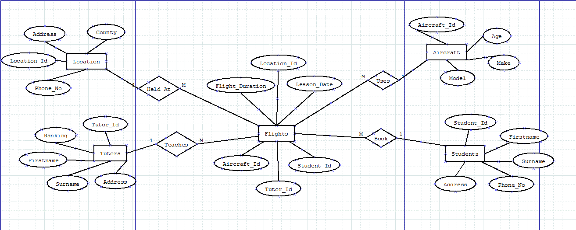

***ER Diagram for Kennys Flying Lessons Database***

The above ER Diagram is composed of the following Tables:

* ***Tutors,***
* ***Students,***
* ***Location,***
* ***Aircraft,***
* *And*
* ***Flights***

***The Relationships are:***

***Location and Flights have a One to Many relationship so for instance one location can be used for many flights.***

***Tutors and Flights have a One to Many relationship meaning one tutor can be booked for several flights.***

***Students and Flights have a One to Many relationship meaning one student can book many flights.***

***Aircraft and Flights have a One to Many relationship meaning a single aircraft can be used for multiple flight bookings.***

***There are no week entities, as no table in this database depends on another to justify it’s existence.***

## ***Testing the cardinality of the table relationships***

***Location and Flights have a One to Many relationship***

***one location can be used for many flights.***

**SELECT** Flights.Student_Id, Flights.Tutor_Id, Flights.Aircraft_Id, Flights.Flight_Date, Location.Address,Location.Location_Id

**FROM** Flights, Location

**WHERE** Flights.Location_Id = Location.Location_Id;

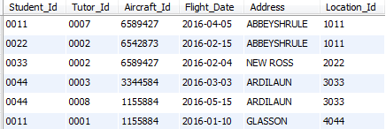

In the above example a booked flight can only be held at one location at a time, that same location can be used many times for different flight bookings.

***Tutors and Flights have a One to Many relationship meaning:***

***one tutor can be booked for several flights.***

**SELECT** Flights.Student_Id, Flights.Tutor_Id, Flights.Aircraft_Id, Flights.Flight_Date, Tutors.Tutor_Id,Tutors.Firstname, Tutors.Surname

**FROM** Flights, Tutors

**WHERE** Flights.Tutor_Id = Tutors.Tutor_Id;

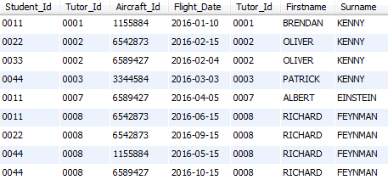

***Students and Flights have a One to Many relationship meaning:***

***one student can book many flights.***

**SELECT** Flights.Student_Id, Flights.Tutor_Id, Flights.Aircraft_Id, Flights.Flight_Date, Students.Firstname, Students.Surname

**FROM** Flights, Students

**WHERE** Flights.Student_Id = Students.Student_Id;

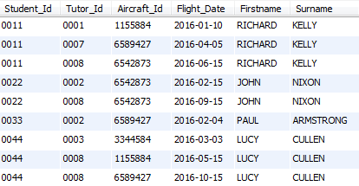

***Aircraft and Flights have a One to Many relationship meaning:***

***A single aircraft can be used for multiple flight bookings.***

**SELECT** Flights.Student_Id, Flights.Tutor_Id, Flights.Aircraft_Id, Flights.Flight_Date,

**FROM** Flights, Aircraft

**WHERE** Flights.Aircraft_Id = Aircraft.Aircraft_Id;

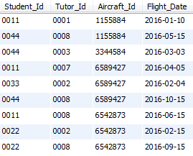

## ***A Comparison Of ER Model and Normalized Model***

The normalised model and the ER model have the same structure. I think while the normalised version turned out pretty much as I had envisioned initially, I think it was a good exercise so as to ensure that redundancies are kept to a minimum. The found the ERD diagram to be very useful so I could see the relationships between the table and the Database structure overall was defined clearly. I am happy that the relationship cardinality is properly implemented.

## ***Final Database Design***

The design of my database has not changed much since my initial design. The ultimate aim of the database was to record business transactions/agreements that took place between students and tutors and as such the flights table is the child table in this database. So the structure of the database has not changed and it is how I envisioned it from the start.

I am glad I applied the normalisation technique to the database as I am now reasonably confident that any redundancies have been kept to a minimum. In future, I would not neglect to apply these steps.

The ERD was beneficial as it made the structure of the database and the relationships between the tables clearer to me.

The only changes I have made are I put in some extra fields in the tables: the Tutors table has a salary field, commission field and years’ service, the Students table has an email field, the Location table has an email field, the Aircraft table has a Service Date field, the flights table has a fee field to record the fee for that session.

# ***Final Database Design***

***The final database design is now implemented thus:***

**CREATE** DATABASE KENNYAIR_DB**;**

**USE** KENNYAIR_DB**;**

**DROP** **TABLE** **IF** **EXISTS** TUTORS**;**

**DROP** **TABLE** **IF** **EXISTS** STUDENTS**;**

**DROP** **TABLE** **IF** **EXISTS** LOCATION**;**

**DROP** **TABLE** **IF** **EXISTS** AIRCRAFT**;**

**DROP** **TABLE** **IF** **EXISTS** FLIGHTS**;**

**CREATE** **TABLE** TUTORS **(**

TUTOR_ID **CHAR(**14**)** **NOT** **NULL,**

FIRSTNAME **CHAR(**14**),**

SURNAME **CHAR(**14**),**

ADDRESS **CHAR(**14**),**

YRS_SERVICE **SMALLINT(**4**),**

SALARY **INTEGER,**

COMMISSION **INTEGER,**

RANKING **CHAR(**14**),**

LOCATION_ID **CHAR(**14**),**

**CONSTRAINT** TUTORS_PRIMARY_KEY **PRIMARY** **KEY** **(**TUTOR_ID**));**

**INSERT** **INTO** TUTORS **VALUES** **(**'0001'**,**'BRENDAN'**,** 'KENNY'**,**'LONGFORD'**,** '5'**,** '45000.00'**,** '250'**,** 'SENIOR'**,**'1011'**);**

**INSERT** **INTO** TUTORS **VALUES** **(**'0002'**,**'OLIVER'**,** 'KENNY'**,**'LONGFORD'**,** '1'**,** '25000.00'**,** '250'**,**'JUNIOR'**,**'2022'**);**

**INSERT** **INTO** TUTORS **VALUES** **(**'0003'**,**'PATRICK'**,** 'KENNY'**,**'LONGFORD'**,** '5'**,** '45000.00'**,** '250'**,**'SENIOR'**,**'3033'**);**

**INSERT** **INTO** TUTORS **VALUES** **(**'0004'**,**'BERNARD'**,** 'KENNEDY'**,**'LONGFORD'**,** '1'**,** '25000.00'**,** '250'**,**'JUNIOR'**,**'4044'**);**

**INSERT** **INTO** TUTORS **VALUES** **(**'0005'**,**'JOHN'**,** 'CLINTON'**,**'ATHLONE'**,** '8'**,** '55000.00'**,** '250'**,**'SENIOR'**,**'1011'**);**

**INSERT** **INTO** TUTORS **VALUES** **(**'0006'**,**'EAMONN'**,** 'DEVALERA'**,**'DUBLIN'**,** '5'**,** '45000.00'**,** '250'**,**'SENIOR'**,**'1011'**);**

**INSERT** **INTO** TUTORS **VALUES** **(**'0007'**,**'ALBERT'**,** 'EINSTEIN'**,**'MULLINGAR'**,** '1'**,** '25000.00'**,** '250'**,**'JUNIOR'**,**'2022'**);**

**INSERT** **INTO** TUTORS **VALUES** **(**'0008'**,**'RICHARD'**,** 'FEYNMAN'**,**'LONGFORD'**,** '5'**,** '45000.00'**,** '250'**,**'SENIOR'**,**'3033'**);**

**CREATE** **TABLE** STUDENTS **(**

STUDENT_ID **CHAR(**14**)** **NOT** **NULL,**

FIRSTNAME **CHAR(**14**),**

SURNAME **CHAR(**14**),**

ADDRESS **CHAR(**14**),**

PHONE_NO **CHAR(**14**),**

EMAIL **CHAR(**50**),**

TUTOR_ID **CHAR(**14**),**

**CONSTRAINT** STUDENTS_FN_KEY **FOREIGN** **KEY** **(**TUTOR_ID**)** **REFERENCES** TUTORS**(**TUTOR_ID**),**

**CONSTRAINT** STUDENTS_PRIMARY_KEY **PRIMARY** **KEY** **(**STUDENT_ID**));**

**INSERT** **INTO** STUDENTS **VALUES** **(**'0011'**,**'RICHARD'**,** 'KELLY'**,** 'LONGFORD'**,** '0876543219'**,** 'rich123@gmail.com'**,** '0008'**);**

**INSERT** **INTO** STUDENTS **VALUES** **(**'0022'**,**'JOHN'**,** 'NIXON'**,** 'WEXFORD'**,** '0835531155'**,** 'john007@gmail.com'**,** '0007'**);**

**INSERT** **INTO** STUDENTS **VALUES** **(**'0033'**,**'PAUL'**,** 'ARMSTRONG'**,**'MULLINGAR'**,** '0876581199'**,** 'parmstrong12@hotmail.com'**,** '0006'**);**

**INSERT** **INTO** STUDENTS **VALUES** **(**'0044'**,**'LUCY'**,** 'CULLEN'**,**'ATHLONE'**,** '0859943217'**,** 'lucy00@gmail.com'**,** '0004'**);**

**CREATE** **TABLE** LOCATION **(**

LOCATION_ID **CHAR(**14**)** **NOT** **NULL,**

ADDRESS **CHAR(**14**),**

COUNTY **CHAR(**14**),**

PHONE_NO **CHAR(**14**),**

EMAIL **CHAR(**50**),**

TUTOR_ID **CHAR(**14**),**

**CONSTRAINT** LOCATION_FN_KEY **FOREIGN** **KEY** **(**TUTOR_ID**)** **REFERENCES** TUTORS**(**TUTOR_ID**),**

**CONSTRAINT** LOCATION_PRIMARY_KEY **PRIMARY** **KEY** **(**LOCATION_ID**));**

**INSERT** **INTO** LOCATION **VALUES** **(**'1011'**,**'ABBEYSHRULE'**,** 'LONGFORD'**,** '0855566894'**,** 'info@abbeyshrule.com'**,** '0008'**);**

**INSERT** **INTO** LOCATION **VALUES** **(**'2022'**,**'NEW ROSS'**,** 'WEXFORD'**,** '0865549988'**,** 'info@newross.com'**,** '0007'**);**

**INSERT** **INTO** LOCATION **VALUES** **(**'3033'**,**'ARDILAUN'**,**'MULLINGAR'**,** '0848897722'**,** 'info@ardilaun.ie'**,** '0006'**);**

**INSERT** **INTO** LOCATION **VALUES** **(**'4044'**,**'GLASSON'**,**'ATHLONE'**,** '0838889944'**,** 'queries@glasson.ie'**,** '0005'**);**

**drop** **TABLE** AIRCRAFT**;**

**CREATE** **TABLE** AIRCRAFT **(**

AIRCRAFT_ID **CHAR(**14**)** **NOT** **NULL,**

MAKE **CHAR(**14**),**

MODEL **CHAR(**14**),**

AGE **CHAR(**14**),**

LOCATION_ID **CHAR(**14**),**

SERVICE_DATE **DATE,**

**CONSTRAINT** AIRCRAFT_FOREIGN_KEY **FOREIGN** **KEY** **(**LOCATION_ID**)** **REFERENCES** LOCATION **(**LOCATION_ID**),**

**CONSTRAINT** AIRCRAFT_PRIMARY_KEY **PRIMARY** **KEY** **(**AIRCRAFT_ID**));**

**INSERT** **INTO** AIRCRAFT **VALUES** **(**'1155884'**,**'HAWKER'**,**'HURRICANE'**,** '10'**,** '1011'**,** '2016-06-15'**);**

**INSERT** **INTO** AIRCRAFT **VALUES** **(**'3344584'**,**'BOEING'**,**'B-17'**,** '5'**,** '2022'**,** '2016-06-15'**);**

**INSERT** **INTO** AIRCRAFT **VALUES** **(**'6589427'**,**'AVRO'**,**'504'**,** '6'**,** '3033'**,** '2016-09-10'**);**

**INSERT** **INTO** AIRCRAFT **VALUES** **(**'6542873'**,**'CESSNA'**,**'206'**,** '3'**,** '4044'**,** '2016-10-25'**);**

**INSERT** **INTO** AIRCRAFT **VALUES** **(**'8843373'**,**'BOEING'**,**'B-10'**,** '4'**,** '3033'**,** '2017-03-15'**);**

**DROP** **TABLE** FLIGHTS**;**

**CREATE** **TABLE** FLIGHTS **(**

STUDENT_ID **CHAR(**14**)** **NOT** **NULL,**

AIRCRAFT_ID **CHAR(**14**)** **NOT** **NULL,**

TUTOR_ID **CHAR(**14**)** **NOT** **NULL,**

FLIGHT_DATE **DATE,**

FLIGHT_DURATION **SMALLINT(**4**),**

FEE **INTEGER,**

LOCATION_ID **CHAR(**14**),**

**CONSTRAINT** FLIGHTS_FOREIGN_KEY **FOREIGN** **KEY** **(**STUDENT_ID**)** **REFERENCES** STUDENTS **(**STUDENT_ID**),**

**CONSTRAINT** FLIGHTS_FN_KEY **FOREIGN** **KEY** **(**TUTOR_ID**)** **REFERENCES** TUTORS **(**TUTOR_ID**),**

**CONSTRAINT** FLIGHTS_F_KEY **FOREIGN** **KEY** **(**AIRCRAFT_ID**)** **REFERENCES** AIRCRAFT **(**AIRCRAFT_ID**),**

**CONSTRAINT** FLIGHTS_PRIMARY_KEY **PRIMARY** **KEY** **(**STUDENT_ID**,** TUTOR_ID**,** AIRCRAFT_ID**,** FLIGHT_DATE**));**

**INSERT** **INTO** FLIGHTS **VALUES** **(**'0011'**,**'1155884'**,** '0001'**,**'2016-01-10'**,** '1'**,** '250.00'**,** '4044'**);**

**INSERT** **INTO** FLIGHTS **VALUES** **(**'0033'**,** '6589427'**,** '0002'**,**'2016-02-04'**,** '1'**,** '250.00'**,** '2022'**);**

**INSERT** **INTO** FLIGHTS **VALUES** **(**'0022'**,** '6542873'**,** '0002'**,**'2016-02-15'**,** '1'**,** '250.00'**,** '1011'**);**

**INSERT** **INTO** FLIGHTS **VALUES** **(**'0044'**,** '3344584'**,** '0003'**,**'2016-03-03'**,** '1'**,** '250.00'**,** '3033'**);**

**INSERT** **INTO** FLIGHTS **VALUES** **(**'0011'**,** '6589427'**,** '0007'**,**'2016-04-05'**,** '2'**,** '500.00'**,** '1011'**);**

**INSERT** **INTO** FLIGHTS **VALUES** **(**'0044'**,** '1155884'**,** '0008'**,**'2016-05-15'**,** '3'**,** '750.00'**,** '3033'**);**

**INSERT** **INTO** FLIGHTS **VALUES** **(**'0011'**,** '6542873'**,** '0008'**,**'2016-06-15'**,** '2'**,** '500.00'**,** '1011'**);**

**INSERT** **INTO** FLIGHTS **VALUES** **(**'0022'**,** '6542873'**,** '0008'**,**'2016-09-15'**,** '1'**,** '250.00'**,** '2022'**);**

**INSERT** **INTO** FLIGHTS **VALUES** **(**'0044'**,** '6589427'**,** '0008'**,**'2016-10-15'**,** '2'**,** '500.00'**,** '4044'**);**

**INSERT** **INTO** FLIGHTS **VALUES** **(**'0011'**,** '1155884'**,** '0008'**,**'2016-10-16'**,** '3'**,** '500.00'**,** '4044'**);**

**INSERT** **INTO** FLIGHTS **VALUES** **(**'0033'**,** '1155884'**,** '0002'**,**'2016-10-12'**,** '2'**,** '500.00'**,** '4044'**);**

**INSERT** **INTO** FLIGHTS **VALUES** **(**'0033'**,** '1155884'**,** '0003'**,**'2016-10-12'**,** '2'**,** '500.00'**,** '8088'**);**

# ***Business Rules applicable to the database***

***The business rules for my database are:***

***1.Salary Conditions***

*Tutors salaries shall be in accordance with years service with KennyAir. The conditions are:*

***(a) Tutors with over five years experience are deemed to be Senior Flight Instructors, their salary shall be €45000 per annum.***

***(b) Tutors with less than five years experience are deemed to be Junior Flight Instructors, their salary shall be €25000 per annum.***

***(c) Senior Flight Instructors with eight years experience or more shall be paid €55000 with an increase of €2000 every four years after that.***

***2. Flight Lesson Fees***

The fees per lession shall be determined based on the duration of the flight. The conditions are:

***(a) For flights of one hours duration, the fee shall be €250,***

***(b) €500 for two hour flight lessons,***

***(c) three hour flights shall cost €750.00.***

***3. Tutors Commission on Flights***

In addition to their yearly salary, tutors shall be paid a commision on flight lessons, based on the number of hours flown.

The criteria for commissions are:

***(a) Senior Flight Instructors who teach for over 3 hours shall be paid a commission of €250.***

***(b) Junior Flight Instructors shall be paid a commision of €150 for flights that are over 3 hours in length.***

***(c) Senior Flight Instructors shall be paid a commission of €400 for flights of a duration greater than five hours in length.***

***4. Deletions from the database shall be limited.***

*The new database administrator has proposed that all deletions from the database be limited with respect to the Flights table. This is in response to an error on behalf of the last administrator who accidently deleted all records from the database. To address this, all deletions shall now be recorded in an audit table and the deletions shall now be limited, so that if the Flights table has only five records left, no more deletions shall be permitted.*

***5. Trigger to increase Tutor’s Salaries***

New flights that are presided over by tutors who are based in Longford will have their salaries increased by 20% to address the fact that the Longford based flight school is currently short staffed. It is hoped the new bonuses will prevent further resignations.

***6. Procedure to increase Fees For All Flights***

Due to an accounting anomaly, it appears that the fees recorded in the flights table have been incorrectly recorded as lower than they actually were. This happened around the time the company was filing its tax returns for the previous year in which a lower than usual yearly profit was recorded. To correct this oversight, the database administrator has been instructed to increase the fees for the flights table to the correct flat rate of €1250.

***7. Procedure to Increase Salaries For All Tutors***

Due to a recent High Court ruling which KennyAir intends to contest, it has been ruled by the Chief Justice Thornton that the salaries for all KennyAir Flight Instructors are well below EU average salaries for that industry. Unfortunately this means that KennyAir now has to increase the salaries for all employees by €10000.

## ***Implementation of Business Rules***

### ***Salary Conditions***

*Tutors salaries shall be in accordance with years service with KennyAir. The conditions are:*

***(a)*** *Tutors with over five years experience are deemed to be Senior Flight Instructors, their salary shall be €45000 per annum.*

***(b)*** *Tutors with less than five years experience are deemed to be Junior Flight Instructors, their salary shall be €25000 per annum.*

***(c)*** *Senior Flight Instructors with eight years experience or more shall be paid €55000 with an increase of €2000 every four years after that.*

Delimiter $$

**Create** **Trigger** BeforeInsertOnTutors

**Before** **Insert** **On** Tutors

**For** **Each** **Row**

**Begin**

**If** **new.**yrs_service **>** 5 **And** **new.**salary **<** 45000 **Then**

**SET** **NEW=**'Error: Salary must be in line with years service.'**;**

**End** **If;**

**If** **new.**yrs_service **<** 5 **And** **new.**salary **!=** 25000 **Then**

**SET** **NEW=**'Error: Salary must be in line with years service.'**;**

**End** **If;**

**If** **new.**ranking **=** 'Senior' **And** **new.**yrs_service **>** 8 **And** **new.**salary **!=** 55000 **Then**

**SET** **NEW=**'Error: Salary must be in line with years service.'**;**

**End** **If;**

**End**$$**;**

Delimiter **;**

1. ***Tutors with over five years experience are deemed to be Senior Flight Instructors, their salary shall be €45000 per annum.***

**Invalid Insert**

INSERT INTO **TUTORS** VALUES ('0009','JOAN', 'FEYNMAN','LONGFORD', '8', '25000.00', 'SENIOR');



**Valid Insert**

INSERT INTO **TUTORS** VALUES ('0009','JOAN', 'FEYNMAN','LONGFORD', '8', '46000.00', 'SENIOR');



***(b)***

Tutors with less than **five years** experience are deemed to be **Junior Flight Instructors**, their **salary shall be €25000** per annum.

**Invalid Insert**

INSERT INTO **TUTORS** VALUES ('0010','PAUL', 'DIRAC','LONGFORD', '3', '20000.00', 'SENIOR');



**Valid Insert**

INSERT INTO **TUTORS** VALUES ('0010','PAUL', 'DIRAC','LONGFORD', '3', '25000.00', 'JUNIOR');



***(c)***

Senior Flight Instructors with **eight years experience** or more shall be paid **€55000** with an increase of **€2000** every four years after that.

**Invalid Insert**

INSERT INTO **TUTORS** VALUES ('0011','ENRICO', 'FERMI','LONGFORD', '9', '20000.00', 'SENIOR');



**Valid Insert**

INSERT INTO **TUTORS** VALUES ('0011','ENRICO', 'FERMI','LONGFORD', '9', '55000.00', 'SENIOR');

**\*\*\*\*\*\*\*\*\*\*\*\*\*\*\*\*\*\*\*\*\*\*\*\*\*\*\*\*\*\*\*\*\*\*\*\*\*\*\*\*\*\*\*\*\*\*\*\*\*\*\*\*\*\*\*\*\*\*\*\*\*\*\*\*\*\*\*\*\*\*\*\*\*\*\*\*\*\*\*\*\*\*\*\*\*\*\*\*\*\*\*\*\*\*\*\*\*\*\*\*\*\*\*\*\*\*\*\*\*\*\*\*\*\*\*\*\*\*\*\*\*\*\*\*\*\*\*\*\*\*\*\*\*\*\*\*\*\*\*\*\*\*\*\*\*\*\*\*\*\*\*\*\*\*\*\*\*\*\*\*\*\*\*\*\*\*\*\*\*\*\*\*\*\*\*\*\*\*\*\*\*\*\*\*\*\*\*\*\*\*\*\***

### ***2. Flight Lesson Fees***

*The fee per flight shall be determined on the number of hours flown. The conditions are:*

1. *For flights of one hours duration, the fee shall be €250,*
2. *€500 for two hour flight lessons,*
3. *Three hour flights shall cost €750.00.*

Delimiter $$

**Create** **Trigger** BeforeInsertOnFlights

**Before** **Insert** **On** Flights

**For** **Each** **Row**

**Begin**

**If** **new.**flight_duration **=** 1 **And** **new.**fee **!=** 250 **Then**

**SET** **NEW=**'Error: Fee must be €250 for this flight.'**;**

**End** **If;**

**If** **new.**flight_duration **=** 2 **And** **new.**fee **!=** 500 **Then**

**SET** **NEW=**'Error: Fee must be €250 for this flight.'**;**

**End** **If;**

**If** **new.**flight_duration **=** 3 **And** **new.**fee **!=** 750 **Then**

**SET** **NEW=**'Error: Fee must be €250 for this flight.'**;**

**End** **If;**

**End**$$**;**

Delimiter **;**

(a)

**Invalid Insert**

INSERT INTO **FLIGHTS** VALUES ('0022','1155884', '0002','2016-04-10', '1', '350.00', '4044');



**Valid Insert**

INSERT INTO **FLIGHTS** VALUES ('0022','1155884', '0003','2016-05-11', '1', '250.00', '4044');



**(b)**

**Invalid Insert**

INSERT INTO **FLIGHTS** VALUES ('0033','1155884', '0008','2016-05-05', '2', '350.00', '4044');



**Valid Insert**

INSERT INTO **FLIGHTS** VALUES ('0033','1155884', '0008','2016-05-05', '2', '500.00', '4044');



**(c)**

**Invalid Insert**

INSERT INTO **FLIGHTS** VALUES ('0011','1155884', '0007','2016-05-12', '3', '350.00', '2022');



**Valid Insert**

INSERT INTO **FLIGHTS** VALUES ('0011','1155884', '0007','2016-05-11', '3', '750.00', '2022');



### ***Tutors Commission on Flights***

In addition to their yearly salary, tutors shall be paid a commission on flight lessons, based on the number of hours flown.

The criteria for commissions are:

***(a) Senior Flight Instructors who teach for over 3 hours shall be paid a commission of €250.***

***(b) Junior Flight Instructors shall be paid a commision of €150 for flights that are over 3 hours in length.***

***(c) Senior Flight Instructors shall be paid a commission of €400 for flights of a duration greater than five hours in length.***

DELIMITER $$

**CREATE** **TRIGGER** commission

**AFTER** **INSERT** **ON** `Flights` **FOR** **EACH** **ROW**

**begin**

**DECLARE** id_rank **varchar(**50**);**

**SELECT** ranking

**INTO** @id_rank

**FROM** Tutors

**WHERE** Tutors**.**Tutor_Id**=** **NEW.**Tutor_Id**;**

**IF** @id_rank **=** 'Senior' **And** **New.**Flight_Duration **>** 3

**THEN**

**UPDATE** Tutors

**SET** commission **=** commission **+**'250'

**WHERE** Tutor_Id **=** **NEW.**Tutor_Id**;**

**END** **IF;**

**IF** @id_rank **=** 'Junior' **And** **New.**Flight_Duration **>** 3

**THEN**

**UPDATE** Tutors

**SET** commission **=** commission **+**'150'

**WHERE** Tutor_Id **=** **NEW.**Tutor_Id**;**

**END** **IF;**

**IF** @id_rank **=** 'Senior' **And** **New.**Flight_Duration **>** 5

**THEN**

**UPDATE** Tutors

**SET** commission **=** commission **+** '400'

**WHERE** Tutor_Id **=** **NEW.**Tutor_Id**;**

**END** **IF;**

**END;**

$$

DELIMITER **;**

(a)

/*This insert meets the condition, commission should now be €250*/

**INSERT** **INTO** FLIGHTS **VALUES** **(**'0011'**,**'1155884'**,** '0001'**,**'2016-01-10'**,** '5'**,** '100.00'**,** '4044'**);**/* Senior*/

**Select** **\*** **From** Tutors

**Where** Tutor_Id **=** 0001**;**



/*This insert does not meet the condition, commission should be unchanged*/

**INSERT** **INTO** FLIGHTS **VALUES** **(**'0044'**,** '3344584'**,** '0003'**,**'2016-03-03'**,** '1'**,** '100.00'**,** '3033'**);**/*Senior*/

**Select** **\*** **From** Tutors

**Where** Tutor_Id **=** 0003**;**



(b)

/*This insert meets the condition, commission should now be €150*/

**INSERT** **INTO** FLIGHTS **VALUES** **(**'0033'**,** '6589427'**,** '0002'**,**'2016-02-04'**,** '4'**,** '250.00'**,** '2022'**);**/* Junior*/

**Select** **\*** **From** Tutors

**Where** Tutor_Id **=** 0002**;**



/*This insert does not meet the condition, commission should be unchanged*/

**INSERT** **INTO** FLIGHTS **VALUES** **(**'0022'**,** '6542873'**,** '0002'**,**'2016-02-15'**,** '2'**,** '250.00'**,** '1011'**);**/*Junior*/

**Select** **\*** **From** Tutors

**Where** Tutor_Id **=** 0002**;**



(c)

/*This insert meets the condition, commission should now be €400*/

**INSERT** **INTO** FLIGHTS **VALUES** **(**'0044'**,** '1155884'**,** '0008'**,**'2016-05-15'**,** '6'**,** '750.00'**,** '3033'**);**/*Senior*/

**Select** **\*** **From** Tutors

**Where** Tutor_Id **=** 0008**;**



/*This insert does not meet the condition, commission should be unchanged*/

**INSERT** **INTO** FLIGHTS **VALUES** **(**'0011'**,** '6542873'**,** '0008'**,**'2016-06-15'**,** '1'**,** '500.00'**,** '1011'**);**/*Senior*/

**Select** **\*** **From** Tutors

**Where** Tutor_Id **=** 0008**;**



**\*\*\*\*\*\*\*\*\*\*\*\*\*\*\*\*\*\*\*\*\*\*\*\*\*\*\*\*\*\*\*\*\*\*\*\*\*\*\*\*\*\*\*\*\*\*\*\*\*\*\*\*\*\*\*\*\*\*\*\*\*\*\*\*\*\*\*\*\*\*\*\*\*\*\*\*\*\*\*\*\*\*\*\*\*\*\*\*\*\*\*\*\*\*\*\*\*\*\*\*\*\*\*\*\*\*\*\*\*\*\*\*\*\*\*\*\*\*\*\*\*\*\*\*\*\*\*\*\*\*\*\*\*\*\*\*\*\*\*\*\*\*\*\*\*\*\*\*\*\*\*\*\*\*\*\*\*\*\*\*\*\*\*\*\*\*\*\*\*\*\*\*\*\*\*\*\*\*\*\*\*\*\*\*\*\*\*\*\*\*\*\*\*\*\*\*\*\*\*\*\*\*\*\*\*\*\*\*\*\*\*\*\*\*\*\*\*\*\*\*\*\*\*\***

### ***Deletions from the database shall be limited.***

*The new database administrator has proposed that all deletions from the database be limited with respect to the Flights table. This is in response to an error on behalf of the last administrator who accidently deleted all records from the database. To address this, all deletions shall now be recorded in an audit table and the deletions shall now be limited, so that if the Flights table has only five records left, no more deletions shall be permitted.*

**DROP** **TABLE** Audit_Flights**;**

**CREATE** **TABLE** Audit_Flights **(** Location_id **CHAR(**14**),**

deleted_date **date,**

deleted_by **CHAR(**14**));**

**Drop** **Trigger** Flights_Audit**;**

DELIMITER $$

**Create** **Trigger** Flights_Audit

**Before** **Delete** **On** Flights

**For** **each** **row**

**Begin**

**DECLARE** vUser **varchar(**50**);**

**Declare** id_NumFlights **INTEGER;**

**SELECT** **COUNT(*)** **into** @id_NumFlights

**FROM** Flights**;**

**IF** @id_NumFlights **<** 5

**Then**

**SET** **NEW=**’You may not delete from the Flights table.’**;**

**else**

-- Find username of person performing the DELETE into table

**SELECT** **USER()** **INTO** vUser**;**

-- Insert record into audit table

**INSERT** **INTO** Audit_Flights

**(** Location_id**,**

deleted_date**,**

deleted_by**)**

**VALUES**

**(** **OLD.**Location_id**,**

**SYSDATE(),**

vUser **);**

**END** **IF;**

**END;**

$$

DELIMITER **;**

**SET** SQL_SAFE_UPDATES **=** 0**;**

**Valid Delete:**

**Delete** **From** Flights **Where** Location_Id **=** ‘4044’**;**



**Invalid Delete:**

**Delete** **From** Flights **Where** Location_Id **=** ‘2022’**;**



**Select** **\*** **From** Audit_Flights**;**



**\*\*\*\*\*\*\*\*\*\*\*\*\*\*\*\*\*\*\*\*\*\*\*\*\*\*\*\*\*\*\*\*\*\*\*\*\*\*\*\*\*\*\*\*\*\*\*\*\*\*\*\*\*\*\*\*\*\*\*\*\*\*\*\*\*\*\*\*\*\*\*\*\*\*\*\*\*\*\*\*\*\*\*\*\*\*\*\*\*\*\*\*\*\*\*\*\*\*\*\*\*\*\*\*\*\*\*\*\*\*\*\*\*\*\*\*\*\*\*\*\*\*\*\*\*\*\*\*\*\*\*\*\*\*\*\*\*\*\*\*\*\*\*\*\*\*\*\*\*\*\*\*\*\*\*\*\*\*\*\*\*\*\*\*\*\*\*\*\*\*\*\*\*\*\*\*\*\*\*\*\*\*\*\*\*\*\*\*\*\*\*\*\*\*\*\*\*\*\*\*\*\*\*\*\*\*\*\*\*\*\*\*\*\*\*\*\*\*\*\*\*\*\*\***

### ***5. Trigger to increase Tutor’s Salaries***

New flights that are presided over by tutors who are based in Longford will have their salaries increased by 20% to address the fact that the Longford based flight school is currently short staffed. It is hoped the new bonuses will prevent further resignations.

Delimiter $$

**Create** **Trigger** BeforeInsertOnFlights

**Before** **Insert** **On** Flights

**For** **Each** **Row**

**Begin**

**If** **new.**flight_duration **>** 2 **Then**

**Update** Tutors

**Set** Salary **=** Salary **\*** 1.20

**Where** Tutors**.**Tutor_Id **IN**

**(Select** Tutor_Id

**From** Location

**Where** Location**.**County **=** 'Longford'**);**

**End** **If;**

**End**$$**;**

Delimiter **;**

**Set** SQL_SAFE_UPDATES **=** 0**;**

**Select** Tutor_Id

**From** Location

**Where** County **=** 'Longford'**;**



**Select** Firstname**,** Surname**,** Ranking**,** Salary **From** Tutors **Where** Tutor_Id **=** '0008'**;**



**Select** Firstname**,** Surname**,** Ranking**,** Salary **From** Tutors **Where** Tutor_Id **=** '0008'**;**



**\*\*\*\*\*\*\*\*\*\*\*\*\*\*\*\*\*\*\*\*\*\*\*\*\*\*\*\*\*\*\*\*\*\*\*\*\*\*\*\*\*\*\*\*\*\*\*\*\*\*\*\*\*\*\*\*\*\*\*\*\*\*\*\*\*\*\*\*\*\*\*\*\*\*\*\*\*\*\*\*\*\*\*\*\*\*\*\*\*\*\*\*\*\*\*\*\*\*\*\*\*\*\*\*\*\*\*\*\*\*\*\*\*\*\*\*\*\*\*\*\*\*\*\*\*\*\*\*\*\*\*\*\*\*\*\*\*\*\*\*\*\*\*\*\*\*\*\*\*\*\*\*\*\*\*\*\*\*\*\*\*\*\*\*\*\*\*\*\*\*\*\*\*\*\*\*\*\*\*\*\*\*\*\*\*\*\*\*\*\*\*\*\*\*\*\*\*\*\*\*\*\*\*\*\*\*\*\*\*\*\*\*\*\*\*\*\*\*\*\*\*\*\*\***

### ***Procedure to increase Fees For All Flights***

Due to an accounting anomaly, it appears that the fees recorded in the flights table have been incorrectly recorded as lower than they actually were. This happened around the time the company was filing its tax returns for the previous year in which a lower than usual yearly profit was recorded. To correct this oversight, the database administrator has been instructed to increase the fees for the flights table to the correct flat rate of €1250.

DELIMITER $$

**CREATE** **PROCEDURE** build_fees **()**

**BEGIN**

**DECLARE** v_finished **INTEGER** **DEFAULT** 0**;**

**DECLARE** v_fees **INTEGER** **DEFAULT** 0**;**

-- declare cursor for Fees

**DEClARE** fees_cursor **CURSOR** **FOR**

**SELECT** fee **FROM** Flights**;**

-- declare NOT FOUND handler

**DECLARE** **CONTINUE** HANDLER

**FOR** **NOT** **FOUND** **SET** v_finished **=** 1**;**

**OPEN** fees_cursor**;**

get_fees**:** **LOOP**

**FETCH** fees_cursor **INTO** v_fees**;**

**IF** v_finished **=** 1 **THEN**

LEAVE get_fees**;**

**END** **IF;**

**UPDATE** Flights

**SET** Fee **=** 1250**;**

**End** **Loop;**

**CLOSE** fees_cursor**;**

**END**$$

DELIMITER **;**

**SET** SQL_SAFE_UPDATES **=** 0**;**

**CALL** build_fees**();**

**Drop** **Procedure** build_fees**;**

**Select** **\*** **From** Flights**;**

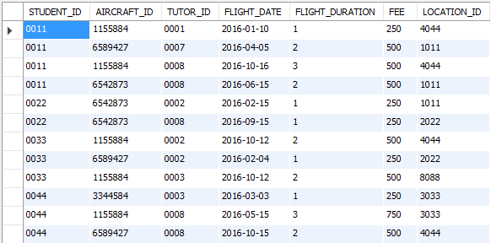

**Select** **\*** **From** Flights**;**

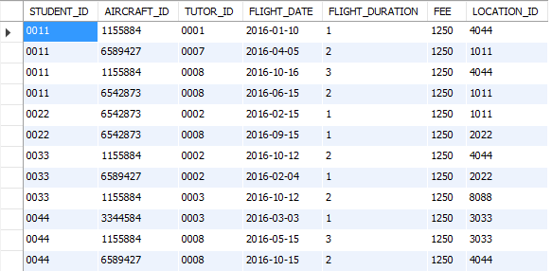

**\*\*\*\*\*\*\*\*\*\*\*\*\*\*\*\*\*\*\*\*\*\*\*\*\*\*\*\*\*\*\*\*\*\*\*\*\*\*\*\*\*\*\*\*\*\*\*\*\*\*\*\*\*\*\*\*\*\*\*\*\*\*\*\*\*\*\*\*\*\*\*\*\*\*\*\*\*\*\*\*\*\*\*\*\*\*\*\*\*\*\*\*\*\*\*\*\*\*\*\*\*\*\*\*\*\*\*\*\*\*\*\*\*\*\*\*\*\*\*\*\*\*\*\*\*\*\*\*\*\*\*\*\*\*\*\*\*\*\*\*\*\*\*\*\*\*\*\*\*\*\*\*\*\*\*\*\*\*\*\*\*\*\*\*\*\*\*\*\*\*\*\*\*\*\*\*\*\*\*\*\*\*\*\*\*\*\*\*\*\*\*\*\*\*\*\*\*\*\*\*\*\*\*\*\*\*\*\*\*\*\*\*\*\*\*\*\*\*\*\*\*\*\*\***

### ***7. Procedure to Increase Salaries For All Tutors***

Due to a recent High Court ruling which KennyAir intends to contest, it has been ruled by the Chief Justice Thornton that the salaries for all KennyAir Flight Instructors are well below EU average salaries for that industry. Unfortunately this means that KennyAir now has to increase the salaries for all employees by €10000.

DELIMITER $$

**CREATE** **PROCEDURE** increaseSal**(IN** increase **INTEGER)**

**BEGIN**

**UPDATE** Tutors

**SET** Salary **=** Salary **+** increase**;**

**END**$$

DELIMITER **;**

**SET** SQL_SAFE_UPDATES **=** 0**;**

**Select** **\*** **From** Tutors**;**

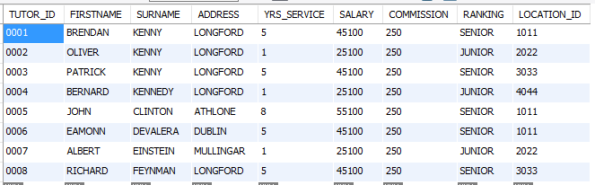

**CALL** increaseSal**(**10000**);**

**Select** **\*** **From** Tutors**;**

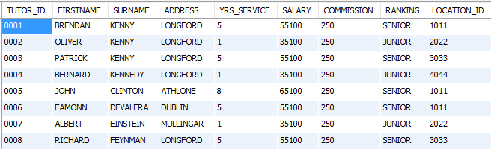

**Drop** **Procedure** increaseSal**;**

**\*\*\*\*\*\*\*\*\*\*\*\*\*\*\*\*\*\*\*\*\*\*\*\*\*\*\*\*\*\*\*\*\*\*\*\*\*\*\*\*\*\*\*\*\*\*\*\*\*\*\*\*\*\*\*\*\*\*\*\*\*\*\*\*\*\*\*\*\*\*\*\*\*\*\*\*\*\*\*\*\*\*\*\*\*\*\*\*\*\*\*\*\*\*\*\*\*\*\*\*\*\*\*\*\*\*\*\*\*\*\*\*\*\*\*\*\*\*\*\*\*\*\*\*\*\*\*\*\*\*\*\*\*\*\*\*\*\*\*\*\*\*\*\*\*\*\*\*\*\*\*\*\*\*\*\*\*\*\*\*\*\*\*\*\*\*\*\*\*\*\*\*\*\*\*\*\*\*\*\*\*\*\*\*\*\*\*\*\*\*\*\*\*\*\*\*\*\*\*\*\*\*\*\*\*\*\*\*\*\*\*\*\*\*\*\*\*\*\*\*\*\*\*\***

# ***Errors and Anomalies***

While implementing the business rules, I noticed an anomaly with the relationship between the Tutors table and the Location table that was not identified in the ER diagram. This is unfortunate but I would not have been able to create the table Tutors if there was a reference to another table Location that did not exist at that time. I was unsure how to address this but I think prior to creating the table, I can set the foreign key checks to 0, create the table, add the constraint and then set foreign key checks to 1.

**ALTER** **TABLE** Tutors

**ADD** **CONSTRAINT** F_KEY

**FOREIGN** **KEY(**LOCATION_ID**)**

**REFERENCES** LOCATION**(**LOCATION_ID**);**

**SET** foreign_key_checks **=** 1**;**

**SET** foreign_key_checks **=** 0**;**

# ***Views and Privileges***

I have identified four database administrators who will be working on the database on a regular basis. The first two – John and Mary are senior database administrators and will be given privileges befitting their roles. James and Diarmuid, however, are Junior database administrators and they will be given limited privileges.

**CREATE** **USER** ‘john’@’localhost’ **IDENTIFIED** **BY** 'password1'**;**

**CREATE** **USER** ‘mary’@’localhost’ **IDENTIFIED** **BY** 'marypass'**;**

**CREATE** **USER** ‘james’@’localhost’ **IDENTIFIED** **BY** 'jamespass'**;**

**CREATE** **USER** ‘diarmuid’@’localhost’ **IDENTIFIED** **BY** 'diarmuidpass'**;**

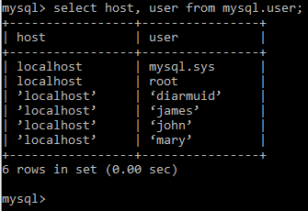

**GRANT** **SELECT,** **INSERT,** **UPDATE,** **DELETE,** **CREATE,** **DROP,**

**INDEX,** **ALTER,** **CREATE** **TEMPORARY** TABLES

**ON** **\*.\*** **TO** 'mary’@’localhost' **IDENTIFIED** **BY** 'marypass'**;**

**GRANT** **SELECT,** **INSERT,** **UPDATE,** **DELETE,** **CREATE,** **DROP,**

**INDEX,** **ALTER,** **CREATE** **TEMPORARY** TABLES

**ON** **\*.\*** **TO** 'john'@'localhost' **IDENTIFIED** **BY** 'johnpass'**;**

**GRANT** **SELECT**

**ON** **\*.\*** **TO** 'james'@'localhost' **IDENTIFIED** **BY** 'jamespass'**;**

**GRANT** **SELECT,** **CREATE**

**ON** **\*.\*** **TO** 'diarmuid'@'localhost' **IDENTIFIED** **BY** 'diarmuidpass'**;**

# ***Views***

**CREATE** **VIEW** Kenny_Flights **AS** **SELECT** Student_Id**,** Flight_Date**,** Location_Id **from** Flights**;**

**Select** **\*** **From** Kenny_Flights**;**

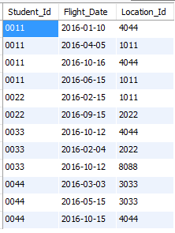

**GRANT** **SELECT**

**ON** Kenny_Flights **TO** 'james'@'localhost' **IDENTIFIED** **BY** 'jamespass'**;**

**CREATE** **VIEW** Kenny_Tutors **AS** **SELECT** Tutor_Id**,** Firstname**,** Surname**,** Salary **from** Tutors**;**

**Select** **\*** **From** Kenny_Tutors**;**

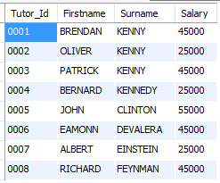

**GRANT** **SELECT**

**ON** Kenny_Tutors **TO** 'james'@'localhost' **IDENTIFIED** **BY** 'jamespass'**;**



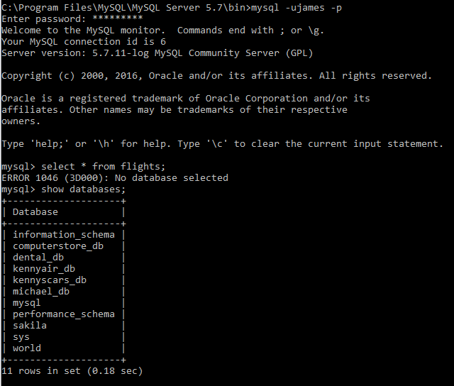

## ***Testing Of User Privileges***

To test the user privileges, I will first log into MySQL using the command line:



Now that I am in the correct folder for MySQL, I will log in as James the Junior Database Administrator.

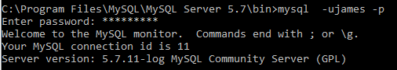

I have given James access to the Kenny_Tutors view, I will now check to see if James can access Kenny_Tutors.

**Select * From Kenny_Tutors;**

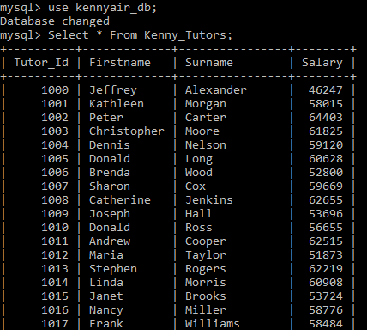

## ***Privilege Restrictions***

As James is a Junior Administrator, I have not given him the privilege to delete from the Tutors table. When James tries to delete a record from the table he will be informed that the DELETE command is denied for this table.

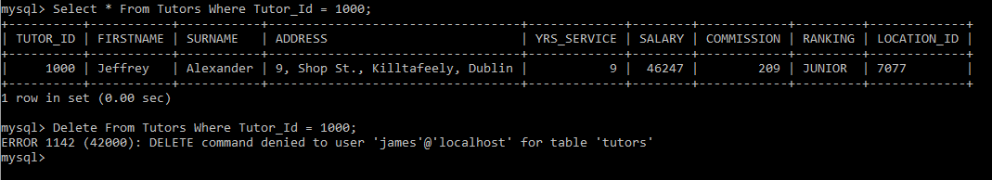

Now James will attempt to update a field in the Tutors Table to no avail:



After a few months, management at KennyAir have decided that James will now be able to select and delete on the Tutors table. Furthermore James can now give other users the same options/privileges.

**Grant** **select,** **delete** **on** Tutors **to** james@localhost **with** **grant** **option;**

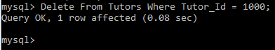

## ***Concurrency Management***

It is important in any database for the administrator to address the possible anomalies that concurrent transactions may pose. It is common for multiple users to have concurrent access to a database at any given time. If many users can potentially access the same data concurrently, known problems can arise, for example updates can be lost. There would not be a problem if two users for example were merely reading data from a certain table. What if both of them are performing transactions such as updates or deletes at the same time on the same record. Data inconsistencies can arise. To address this, I will implement the locking mechanism in MySQL.

For the purposes of demonstration, I will log into workbench as two users – ***root@localhost*** and ***james@localhost.***

***First, I will grant select, delete and insert privileges to James with the option to grant to other users the same privileges.***

**Grant** **select,** **delete, insert** **on** Students **to** james@localhost **with** **grant** **option;**



***Now, I will lock the Students table. Until I disable this lock, James will only be able to read from this table, he will not be able to insert or delete on this table.***

**Lock** **Table** Students **read;**



***Now, James will attempt to insert a new row into the Students table. As the table is locked, the transaction is suspended until such a time as I disable the lock.***



***Now, I will disable the Lock on Students.***



***As the lock is now disabled, the insert transaction for James can now go ahead.***



# ***Query Optimization***

When dealing with large amounts of data it is important to be as efficient as possible with how you access and retrieve the most important data to you the administrator. This is done by adding indexes. An index can be compared to the index in a book, you have two options – say if you wanted to look up a particular topic in the book, you could read through every page until you find it or you could just go to the index, find the page number and then go to that page. It is obvious that by using the index, you will be more efficient in your approach. Similarly, we will implement such an approach in our database. Without an index, the system would have to read through the entire table to retrieve a result(s). This is called table scanning, and is very inefficient. To address this, I will implement indexing. Firstly, I will populate the relevant tables with a large amount of test data by means of a stored procedure. It is necessary to do this as up to this point, I had a relatively small amount of data in each table. By implementing indexing under those conditions, the benefits of indexing would not be apparent.

**SELECT**

table_name **AS** 'Table'**,**

**round(((**data_length **+** index_length**)** **/** 1024 **/** 1024**),** 2**)** **as** 'Size(mb)'

**FROM** information_schema**.**TABLES

**WHERE** table_schema **=** "kennyair_db"

**ORDER** **BY** 'Size(mb)' **;**

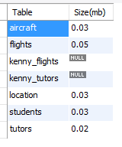

The initial size of the tables is in my opinion, too small to justify using a index as the benefits would not be apparent. To address this and to demonstrate the benefits of indexing, I will increase the table sizes by means of a stored procedure to implement test data. Each table will now contain 2000 records.

**SELECT**

table_name **AS** 'Table'**,**

**round(((**data_length **+** index_length**)** **/** 1024 **/** 1024**),** 2**)** **as** 'Size(mb)'

**FROM** information_schema**.**TABLES

**WHERE** table_schema **=** "kennyair_db"

**ORDER** **BY** 'Size(mb)' **;**

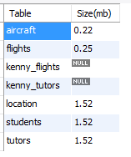

The tables have been increased in size for the purposes of demonstrating the benefits of indexing.

## ***Procedure to Populate Table with Test Data***

**drop** **procedure** **if** **exists** InsertIntoStudents**;**

delimiter $$

**create** **procedure** InsertIntoStudents**(**p1 **bigint)**

**BEGIN**

**DECLARE** STUDENT_ID **int(**4**);**

**DECLARE** FIRSTNAME **VARCHAR(**15**);**

**DECLARE** SURNAME **VARCHAR(**14**);**

**DECLARE** ADDRESS **VARCHAR(**200**);**

**DECLARE** PHONE_NO **VARCHAR(**14**);**

**DECLARE** EMAIL **VARCHAR(**50**);**

**DECLARE** TUTOR_ID **INT(**4**);**

**DECLARE** HouseNo **tinyint;**

**DECLARE** Street **VARCHAR(**20**);**

**DECLARE** Town **VARCHAR(**20**);**

**DECLARE** County **VARCHAR(**20**);**

**DECLARE** PhoneNumber **varchar(**20**);**

**DECLARE** TelNo **int;**

**DECLARE** **Prefix** **char(**3**);**

**DECLARE** eAddress **char(**15**);**

**DECLARE** sID **char(**4**);**

**DECLARE** sName **char(**15**);**

label1**:** **loop**

**IF** p1 **>=** 0 **THEN**

**set** FIRSTNAME **=** ELT**(FLOOR(**1 **+** **(RAND()** **\*** **(**100**-**1**))),** "Django"**,**"Hulio"**,**"Ulysses"**,**"James"**,**"Mary"**,**"John"**,**"Patricia"**,**"Robert"**,**"Linda"**,**"Michael"**,**"Barbara"**,**"William"**,**"Elizabeth"**,**"David"**,**"Jennifer"**,**"Richard"**,**"Maria"**,**"Charles"**,**"Susan"**,**"Joseph"**,**"Margaret"**,**"Thomas"**,**"Dorothy"**,**"Christopher"**,**"Lisa"**,**"Daniel"**,**"Nancy"**,**"Paul"**,**"Karen"**,**"Mark"**,**"Betty"**,**"Donald"**,**"Helen"**,**"George"**,**"Sandra"**,**"Kenneth"**,**"Donna"**,**"Steven"**,**"Carol"**,**"Edward"**,**"Ruth"**,**"Brian"**,**"Sharon"**,**"Ronald"**,**"Michelle"**,**"Anthony"**,**"Laura"**,**"Kevin"**,**"Sarah"**,**"Jason"**,**"Kimberly"**,**"Matthew"**,**"Deborah"**,**"Gary"**,**"Jessica"**,**"Timothy"**,**"Shirley"**,**"Jose"**,**"Cynthia"**,**"Larry"**,**"Angela"**,**"Jeffrey"**,**"Melissa"**,**"Frank"**,**"Brenda"**,**"Scott"**,**"Amy"**,**"Eric"**,**"Anna"**,**"Stephen"**,**"Rebecca"**,**"Andrew"**,**"Virginia"**,**"Raymond"**,**"Kathleen"**,**"Gregory"**,**"Pamela"**,**"Joshua"**,**"Martha"**,**"Jerry"**,**"Debra"**,**"Dennis"**,**"Amanda"**,**"Walter"**,**"Stephanie"**,**"Patrick"**,**"Carolyn"**,**"Peter"**,**"Christine"**,**"Harold"**,**"Marie"**,**"Douglas"**,**"Janet"**,**"Henry"**,**"Catherine"**,**"Carl"**,**"Frances"**,**"Arthur"**,**"Ann"**,**"Ryan"**,**"Joyce"**,**"Roger"**,**"Diane"**);**

**set** SURNAME **=** ELT**(FLOOR(**1 **+** **(RAND()** **\*** **(**100**-**1**))),** "Dedalus"**,**"O'Seachnasaigh"**,**"Hynes"**,**"Smith"**,**"Johnson"**,**"Williams"**,**"Jones"**,**"Brown"**,**"Davis"**,**"Miller"**,**"Wilson"**,**"Moore"**,**"Taylor"**,**"Anderson"**,**"Thomas"**,**"Jackson"**,**"White"**,**"Harris"**,**"Martin"**,**"Thompson"**,**"Garcia"**,**"Martinez"**,**"Robinson"**,**"Clark"**,**"Rodriguez"**,**"Lewis"**,**"Lee"**,**"Walker"**,**"Hall"**,**"Allen"**,**"Young"**,**"Hernandez"**,**"King"**,**"Wright"**,**"Lopez"**,**"Hill"**,**"Scott"**,**"Green"**,**"Adams"**,**"Baker"**,**"Gonzalez"**,**"Nelson"**,**"Carter"**,**"Mitchell"**,**"Perez"**,**"Roberts"**,**"Turner"**,**"Phillips"**,**"Campbell"**,**"Parker"**,**"Evans"**,**"Edwards"**,**"Collins"**,**"Stewart"**,**"Sanchez"**,**"Morris"**,**"Rogers"**,**"Reed"**,**"Cook"**,**"Morgan"**,**"Bell"**,**"Murphy"**,**"Bailey"**,**"Rivera"**,**"Cooper"**,**"Richardson"**,**"Cox"**,**"Howard"**,**"Ward"**,**"Torres"**,**"Peterson"**,**"Gray"**,**"Ramirez"**,**"James"**,**"Watson"**,**"Brooks"**,**"Kelly"**,**"Sanders"**,**"Price"**,**"Bennett"**,**"Wood"**,**"Barnes"**,**"Ross"**,**"Henderson"**,**"Coleman"**,**"Jenkins"**,**"Perry"**,**"Powell"**,**"Long"**,**"Patterson"**,**"Hughes"**,**"Flores"**,**"Washington"**,**"Butler"**,**"Simmons"**,**"Foster"**,**"Gonzales"**,**"Bryant"**,**"Alexander"**,**"Russell"**,**"Griffin"**,**"Diaz"**,**"Hayes"**);**

**set** HouseNo **=** 1 **+** **RAND()** **\*** 100**-**1**;**

**set** Street **=** ELT**(FLOOR(**1 **+** **(RAND()** **\*** **(**10**))),** "Hight St."**,**"Store St."**,**"Bog Road"**,**"Dublin Road"**,**"Shop St."**,**"Naas Road"**,**"Harbour St."**,**"Arden Hill"**,**"Elm St."**,**"New Road"**);**

**set** Town **=** ELT**(FLOOR(**1 **+** **(RAND()** **\*** **(**10**))),** "Ballytubbert"**,**"Killtafeely"**,**"Killaville"**,**"Abbeytown"**,**"Charlestown"**,**"Ballybridgewater"**,**"Woodville"**,**"Thomastown"**,**"Woodstown"**,**"Billsborough"**);**

**set** County **=** ELT**(FLOOR(**1 **+** **(RAND()** **\*** **(**16**))),** "Offaly"**,**"Cork"**,**"Galway"**,**"Westmeath"**,**"Dublin"**,**"Waterford"**,**"Wicklow"**,**"Limerick"**,**"Donegal"**,**"Kerry"**,**"Tipperary"**,**"Kilkenny"**,**"Cavan"**,**"Carlow"**,**"Kildare"**,**"Longford"**);**

**set** ADDRESS **=** **concat(**HouseNo**,**', '**,**Street**,** ', '**,**Town**,** ', '**,** County**);**

**set** TelNo **=** **RAND()** **\*** 10000000**;**

**set** **Prefix** **=** ELT**(FLOOR(**1 **+** **(RAND()** **\*** **(**4**))),** "083"**,**"085"**,**"086"**,**"087"**);**

**set** Phone_No **=** **concat(Prefix,**Telno**);**

**set** sName **=** ELT**(FLOOR(**1 **+** **(RAND()** **\*** **(**4**))),** "flyer"**,**"123"**,**"student"**,**"info"**,**"mail"**);**

**set** sID **=** ELT**(FLOOR(**1 **+** **(RAND()** **\*** **(**4**))),** "1234"**,**"5487"**,**"9587"**,**"12"**);**

**set** eAddress **=** ELT**(FLOOR(**1 **+** **(RAND()** **\*** **(**4**))),** "@gmail.com"**,**"@yahoo.com"**,**"@ireland.com"**,**"hotmail.com"**);**

**set** EMAIL **=** **concat(**sName**,**sID**,**eAddress**);**

**SET** TUTOR_ID **=** **FLOOR(**1000 **+** **(rand()** **\*** **(**1999**-**1000**)));**

**Insert** **into** Students**(**`FIRSTNAME`**,**`SURNAME`**,**`ADDRESS`**,**`PHONE_NO`**,**`EMAIL`**,**`TUTOR_ID`**)**

**VALUES(**FIRSTNAME**,** SURNAME**,**ADDRESS**,** PHONE_NO**,** EMAIL**,**TUTOR_ID**);**

**SET** p1 **=** p1**-** 1**;**

**ITERATE** label1**;**

**END** **IF;**

Leave label1**;**

**END** **Loop** label1**;**

**END**

$$

delimiter **;**

## ***Implementing Indexing***

**Explain select** **\*** **from** **tutors;**

**Show Status like** **'last_query_cost';**







**Alter table Tutors Add Index NAMEINDEX(SURNAME);**

**Explain SELECT SURNAME FROM TUTORS;**





The benefits can be observed as after the index has been implemented, the response time has been reduced for retrieving the relevant results. So rather than implement a ‘table scan’ which would be inefficient. The database goes straight to the requested records.

**Create** **Unique** **Index** flight_index

**ON** Flights **(**Student_ID**,** Flight_Date**,** Location_ID**);**

Show **Index** **From** Flights**;**

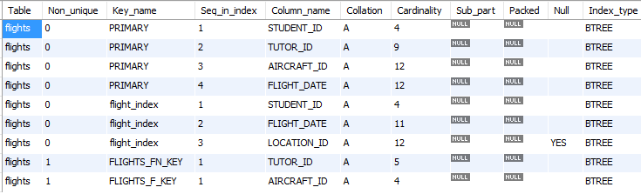

***Front End Technology***

I decided to implement a front end application using java to implement the front end aspect of the database. It is conceivable that such an application would be of benefit to administrative staff in the KennyAir flying school. To this end, I built a java application using NetBeans and a Microsoft Access database. I will discuss, in the following pages, how a user would operate such a system and what features are on offer.

## ***Main Menu – Flights Table***

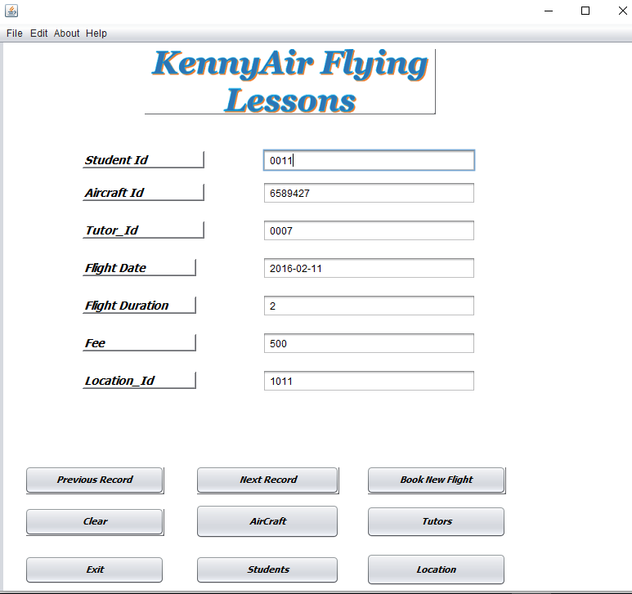

The first screen the user will see on activating the application is the Main Menu. The flights table is displayed as it is the most important table in the database. Here, the user can scroll through the various records in the table and can book new flights, navigate to the other screens – Tutors, Aircraft, Students and Location. The clear button clears all fields and the user can exit the system if they so wish by using the Exit button.

## ***Tutors***

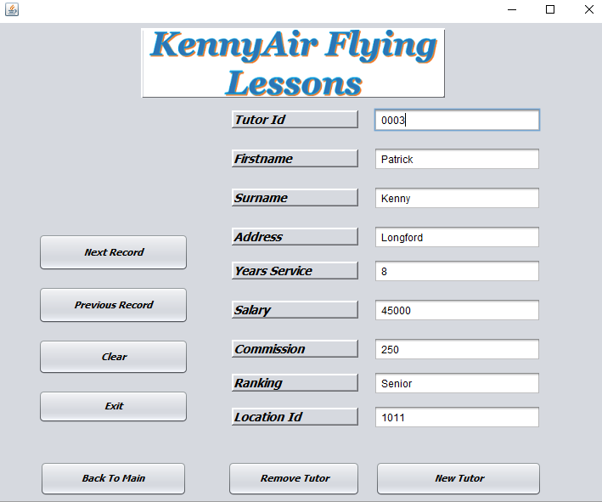

The user can navigate to any of the other forms in any order they wish, here we discuss the Tutors form. The user can navigate, as before with the Main Menu through the various records on file for the Tutors table. They can navigate to other forms and/or perform updates such as adding or removing a tutor.

***Aircraft***

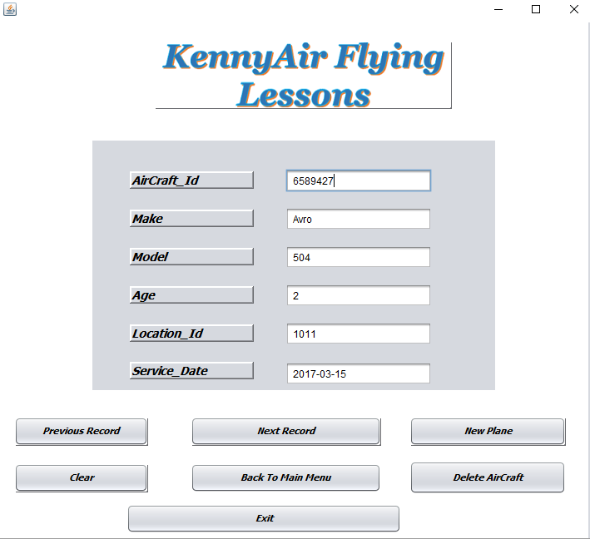

The next form is the Flights form, this displays information relevant to the Flights table. The user can navigate through the various records and back to the main menu if they wish. The user also has the option to remove a record from the Aircraft table by using the Delete AirCraft option.

## ***Location***

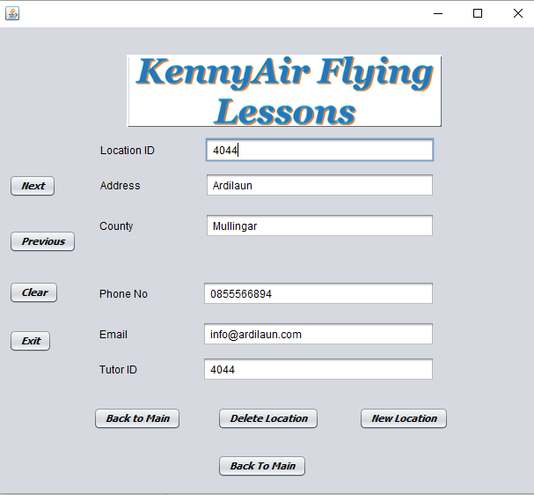

The Location form displays information about the various KennyAir flying centres where the various flights are held. The user can scroll through the various records, navigate back to the main menu, delete a location or add a new record to the database.

## ***Students***

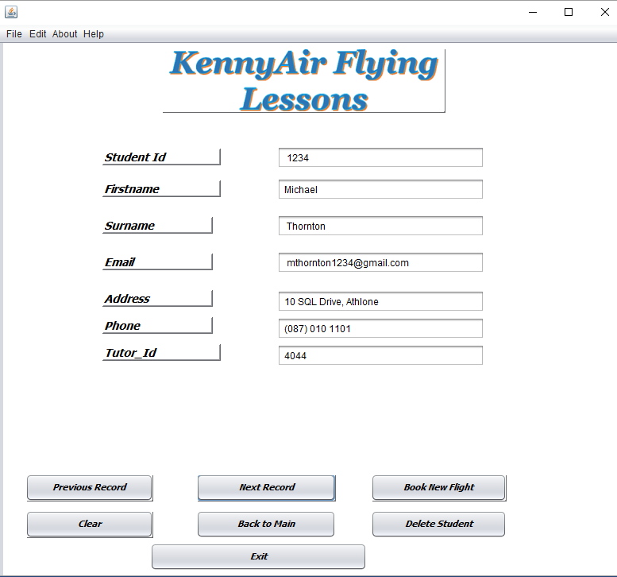

The user can navigate through the various records pertaining to the students in the database in the Students form. The user can also delete a record and navigate back to the main menu if they so wish.

## ***Flow Chart For Java Database Application***

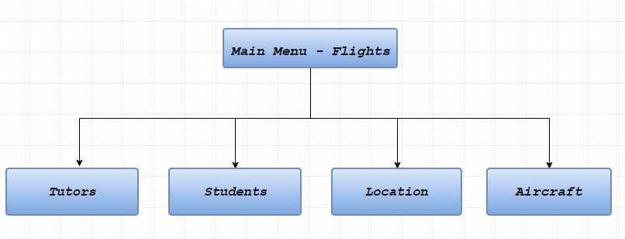

The above flowchart depicts the layout of the Java application. The user can navigate from the first point of entry – the main menu to any form and then navigate back.

## ***Sample Java Code For Database Front End Application***

package my**.**aircompany**;**

/**

*

* @author A00037189

*/

**import** java**.**awt**.*;**

**import** java**.**awt**.**event**.*;**

**import** java**.**io**.**File**;**

**import** java**.**io**.**IOException**;**

**import** java**.**sql**.*;**

**import** javax**.**swing**.*;**

**import** java**.**net**.**MalformedURLException**;**

**import** java**.**net**.**URL**;**

**import** javax**.**net**.**ssl**.**HttpsURLConnection**;**

**import** java**.**awt**.**Toolkit**;**

**import** java**.**awt**.**event**.**ActionEvent**;**

public class KennyAir **extends** javax**.**swing**.**JFrame **{**

private String CustName**;**

private String CustAcc**;**

private String PhoneNbr**;**

private String FlightDur**;**

private String LocationId**;**

private String Fee**;**

private String FlightDate**;**

private String TutorId**;**

private String AirCraftId**;**

Connection con**;**

Statement stmt**;**

ResultSet rs**;**

int count**;**

int current**;**

/**

* Creates new form

*/

public KennyAir**()** **{**

initComponents**();**

con**=null;**

stmt**=null;**

rs**=null;**

count**=**0**;**

int current**;**

CustName**=**""**;**

CustAcc**=**""**;**

PhoneNbr**=**""**;**

FlightDur**=**""**;**

LocationId**=**""**;**

Fee**=**""**;**

FlightDate**=**""**;**

TutorId**=**""**;**

AirCraftId**=**""**;**

dbConn**();** // method to connect to database using odbc-jdbc

initDB**();** // method to initialise gui with database info

**}**

public void dbConn**()**

**{**

**try**

**{** // load the jdbc-odbc bridge driver manager

//Class.forName("sun.jdbc.odbc.JdbcOdbcDriver");

// driver to use with named database

String url **=** "jdbc:ucanaccess://c:/KennyAir/KennyAir.mdb"**;**

// connection represents a session with a specific database

con **=** DriverManager**.**getConnection**(**url**);**

// stmt used for executing sql statements and obtaining results

stmt **=** con**.**createStatement**();**

rs **=** stmt**.**executeQuery**(**"SELECT * FROM Flights"**);**

**while(**rs**.**next**())** // count number of rows in table

count**++;**

rs**.**close**();**

**}**

**catch(**Exception e**)** **{** System**.**out**.**println**(**"Error in start up......"**);}**

**}**

private void initDB**()**

**{**

**try** // display database info in gui

**{**

rs **=** stmt**.**executeQuery**(**"SELECT * FROM Flights"**);**

rs**.**next**();**

CustAcc **=** rs**.**getString**(**"CustAcc"**);**

AirCraftId **=** rs**.**getString**(**"AirCraft_Id"**);**

TutorId **=** rs**.**getString**(**"Tutor_Id"**);**

FlightDate **=** rs**.**getString**(**"Flight_Date"**);**

FlightDur **=** rs**.**getString**(**"Flight_Duration"**);**

Fee **=** rs**.**getString**(**"Fee"**);**

LocationId **=** rs**.**getString**(**"Location_Id"**);**

cName**.**setText**(**" " **+**CustAcc**);**

aNum**.**setText**(**" " **+**AirCraftId**);**

F_Date**.**setText**(**" " **+**FlightDate**);**

cFee**.**setText**(**" "**+** Fee**);**

cLocation**.**setText**(**" "**+**LocationId**);**

cFlightDur**.**setText**(**" "**+**FlightDur**);**

cTutor**.**setText**(**" "**+**TutorId**);**

current **=** 1**;**

rs**.**close**();**

**}**

**catch(**Exception e**)** **{**System**.**out**.**println**(**"Error in initialising DB info to GUI"**);}**

**}**

public void moveToRow**(**int index**)**

**{**

**try**

**{**

rs **=** stmt**.**executeQuery**(**"SELECT * FROM Flights"**);**

**for(**int i **=** 0**;** i **<** index**;** i**++)**

rs**.**next**();** // move to specific row in table (at index)

CustAcc **=** rs**.**getString**(**"CustAcc"**);**

AirCraftId **=** rs**.**getString**(**"AirCraft_Id"**);**

TutorId **=** rs**.**getString**(**"Tutor_Id"**);**

FlightDate **=** rs**.**getString**(**"Flight_Date"**);**

FlightDur **=** rs**.**getString**(**"Flight_Duration"**);**

Fee **=** rs**.**getString**(**"Fee"**);**

LocationId **=** rs**.**getString**(**"Location_Id"**);**

cName**.**setText**(**" " **+**CustAcc**);**

aNum**.**setText**(**" " **+**AirCraftId**);**

F_Date**.**setText**(**" " **+**FlightDate**);**

cFee**.**setText**(**" "**+** Fee**);**

cLocation**.**setText**(**" "**+**LocationId**);**

cFlightDur**.**setText**(**" "**+**FlightDur**);**

cTutor**.**setText**(**" "**+**TutorId**);**

current **=** index**;**

rs**.**close**();**

**}**

**catch(**Exception e**)** **{**System**.**out**.**println**(**"Error in moving to row at index specified"**);}**

**}**

public void findCust**(**String nameToFind**)**

**{**

int foundCust **=** 0**;**

boolean found **=** **false;**

**try** // get name to search database for, use .equals() to match names

**{**

System**.**out**.**println**(**"Finding: " **+**nameToFind**);**

rs **=** stmt**.**executeQuery**(**"SELECT * FROM Account"**);**

**while(**rs**.**next**()** **&&** found **==** **false)**

**{**

foundCust**++;**

String CustName **=** rs**.**getString**(**"CustName"**);**

CustName**.**trim**();**

**if(**CustName**.**equals**(**nameToFind**))**

found **=** **true;**

**}**

rs**.**close**();**

**}**

**catch(**Exception e**)** **{**System**.**out**.**println**(**"Error in finding Customer in database"**);}**

**if(**found **==** **true)**

moveToRow**(**foundCust**);**

**else**

cName**.**setText**(**"Not Found"**);**

**}**

***Errors and Anomalies***

As the above mentioned Java application is but a prototype, full functionality is not present at this time. For example, I had more time I would add more CRUD functionality in addition to an extra form Login, which would be the first point of entry for users. Based on their status as an administrator, certain actions would be permitted, some would not, as in the case of the privileges discussed earlier on.

# ***Backup And Recovery***

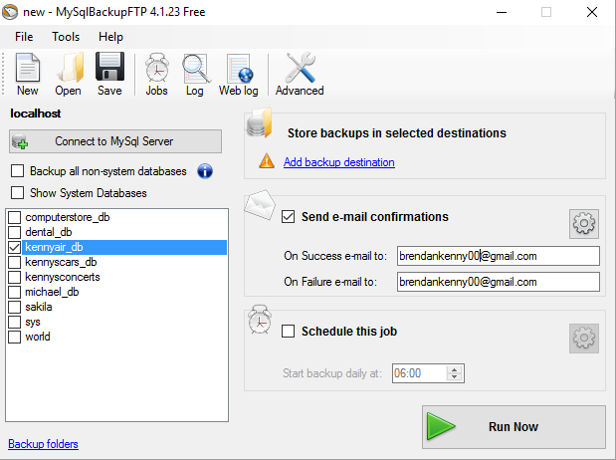

Due to hardware and/or software problems, sometimes data can be lost. To address this possibility, it is good practice to backup data regularly. For the purposes of demonstration, I backed up my database using MySqlBackupFTP. With this software, I can backup my database to GoogleDrive, DropBox, OneDrive etc.

