|  |
| --- |
|  |
|  |



**Athlone Institute of Technology**

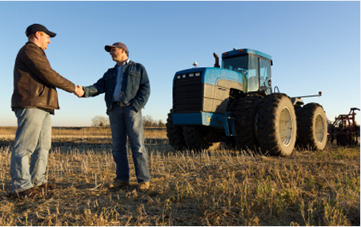

**COURSE:** Higher Diploma In Computing

**COURSE ID:** Al_Kcomp_G

**SUBJECT:** Database Applications

**YEAR:** 5

**LECTURER**: Mr. Noel Tierney

**SUBJECT:** PL/SQL

**PROJECT TITLE:** Farm Rental Agreements

|  |  |  |
| --- | --- | --- |
| Student Number | Student Name | Signature (for hardcopy) |
| A00037189 | Brendan Kenny |  |

Table of Contents

Introduction 3

Original Data 4

Entity Relationship Diagram (ERD): 6

Extended ERD with Table Column Names: 7

Create Table Statements. 8

Create Landlord table 8

Create Farm table 9

Create Farmer Table 10

Create Solicitor Table 11

Create Auctioneer Table 12

Create Rental Contract Table 13

Insert Statements 14

Insert into Landlord Table 14

Insert Into Farm Table 16

Insert into Farmer Table 17

Insert into Solicitor Table 19

Insert into Auctioneer Table 21

Insert into Farmer table 23

Single Table Queries 25

Join Queries 32

Summary Queries 38

Sub-Queries 42

Views 50

Deletes 56

# Introduction

The following database was created to facilitate farm rental agreements between the relevant parties that would be party to such agreements, namely Farmers, Landlords, Auctioneers and Solicitors. The resulting agreements are recorded in the Rental Contract table and relate to the relevant Farms as recorded in the Farm table. The relationships between the relevant tables are displayed in the ERD diagrams and were an aid to me in the creation of the database, when creating the user constraints and in the subsequent queries in later stages of my project.

Brendan Kenny

01 December 2014



# Original Data

**Farm_Rental_Agreements FRA SEPTEMBER 2014**

|  |  |  |  |
| --- | --- | --- | --- |
| **Kenny, Brendan** | **Farm_Rental_Agreements** | **FRA** | **HDC - Sept 2014** |

**Original**

DB required to capture details of farms that are rented by farmers from landlords. A Landlord may own a number of farms and a farmer may rent a number of farms. Over time, the same farm may be rented by many different farmers. Rental contracts are drawn up and solicitors and auctioneers are other parties that will be involved in the process.

**Landlord**(Landlord**_**Id, Fname, Sname, Address, County, Gender, Birth_Date, Mobile_No, Email, Specialism, Category (*Retired Farmer, Current Farmer, Non-Farmer*)

**Farm** (Farm_Id, Size (*express in hectares*), Terrain (*Flat, Hilly*), Drainage (*Dry, Wet, Boggy*), Usage (*Grazing, Tillage*), Landlord**_**Id, Estimated_Value)

**Farmer** (Farmer**_**Id**,** Fname, Sname, Address, County, Gender, Date_Of_Birth, Mobile_No, Email_Address, Qualifications (*Farming Cert, B. Agr*), Specialism (*Sheep, Beef, Tillage*), Annual_Sales)

**Rental**_**Contract** (Farm_Id, Farmer**_**Id, Contract_Date, Duration (*11 months, 3 years, 5 years*), Rental_Fee, Payment_Terms (*Full Amount in Advance, Monthly Instalments, Quarterly Instalments),* Solicitor_Id, Auctioneer_Id)

**Solicitor** (Solicitor_Id, Fname, Sname, Address, County, Gender, Date_Of_Birth, Mobile_No, Email_Address, Qualifications, Specialism(*Property, Crime, Family law*) ,

**Auctioneer** (Auctioneer_Id, Fname, Sname, Address, County, Gender, Birth_Date, Mobile_No, Email, Qualifications, Specialism(Land, Commercial Property, Housing, Retail Units), Annual_Turnover)

**Farm_Rental_Agreements FRA SEPTEMBER 2014**

|  |  |  |  |
| --- | --- | --- | --- |
| **Kenny, Brendan** | **Farm_Rental_Agreements** | **FRA** | **HDC - Sept 2014** |

**Modified**

**Landlord**(Landlord**_**Id, Fname, Sname, Address, County, Gender, Birth_Date, Mobile_No, Email, Specialism, Category (*Retired Farmer, Current Farmer, Non-Farmer*)

**Farm** (Farm_Id, Size (*express in hectares*), Terrain (*Flat, Hilly*), Drainage (*Dry, Wet, Boggy*), Usage (*Grazing, Tillage*), Landlord**_**Id, Estimated_Value)

**Farmer** (Farmer**_**Id**,** Fname, Sname, Address, County, Gender, Date_Of_Birth, Mobile_No, Email_Address, Qualifications (*Farming Cert, B. Agr*), Specialism (*Sheep, Beef, Tillage*), Annual_Sales)

**Solicitor** (Solicitor_Id, Fname, Sname, Address, County, Gender, Date_Of_Birth, Mobile_No, Email_Address, Qualifications, Specialism(*Property, Crime, Family law*) ,

**Auctioneer** (Auctioneer_Id, Fname, Sname, Address, County, Gender, Birth_Date, Mobile_No, Email, Qualifications, Specialism(Land, Commercial Property, Housing, Retail Units), Annual_Turnover)

**Rental**_**Contract** (**Farm_Id, Farmer_Id, Contract_Date**, Duration (*11 months, 3 years, 5 years*), Rental_Fee, Payment_Terms (*Full Amount in Advance, Monthly Instalments, Quarterly Instalments),* Solicitor_Id, Auctioneer_Id)

**Farm_Rental_Agreements FRA SEPTEMBER 2014**

|  |  |  |  |
| --- | --- | --- | --- |
| **Kenny, Brendan** | **Farm_Rental_Agreements** | **FRA** | **HDC - Sept 2014** |

**Finalise for Excel (TAB-SEQUENCE)**

**Landlord**

Landlord**_**Id, Fname, Sname, Address, County, Gender, Birth_Date, Mobile_No, Email, Specialism, Category

**Farm**

Farm_Id, Size, Terrain, Drainage, Usage, Landlord**_**Id, Estimated_Value

**Farmer**

Farmer**_**Id**,** Fname, Sname, Address, County, Gender, Date_Of_Birth, Mobile_No, Email_Address, Qualifications, Specialism, Annual_Sales

**Solicitor**

Solicitor_Id, Fname, Sname, Address, County, Gender, Date_Of_Birth, Mobile_No, Email_Address, Qualifications, Specialism

**Auctioneer**

Auctioneer_Id, Fname, Sname, Address, County, Gender, Birth_Date, Mobile_No, Email, Qualifications, Specialism, Annual_Turnover

**Rental**_**Contract**

Farm_Id, Farmer**_**Id, Contract_Date, Duration, Rental_Fee, Payment_Terms*,* Solicitor_Id, Auctioneer_Id

# Entity Relationship Diagram (ERD):

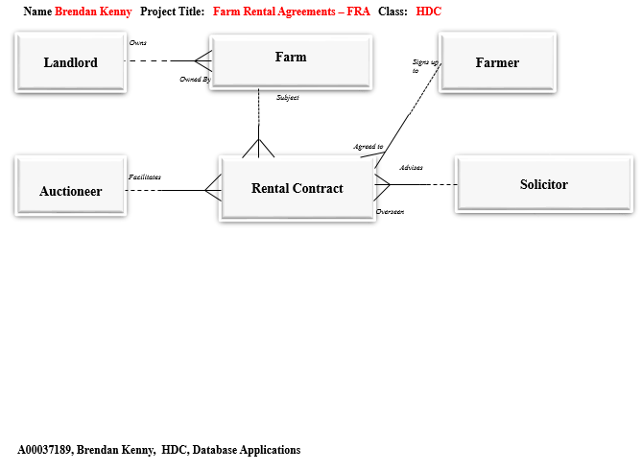

# Extended ERD with Table Column Names:

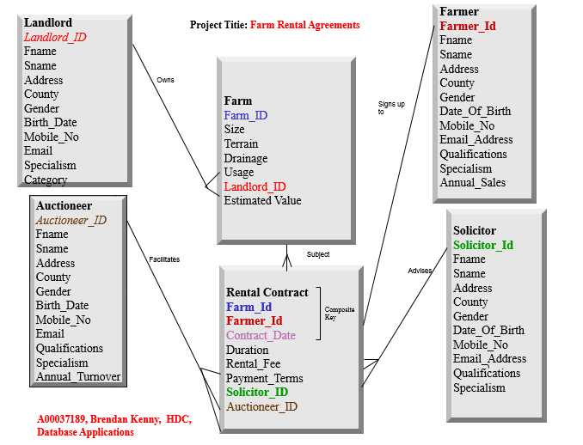

# Create Table Statements.

**drop table Rental_Contract ;**

**drop table Auctioneer ;**

**drop table Solicitor ;**

**drop table Farmer ;**

**drop table Farm ;**

**drop table Landlord ;**

## Create Landlord table

drop table Landlord ;

create table Landlord (

Landlord_Id Number ( 3 ) ,

Fname Varchar2 ( 8 ) Constraint Landlord_Fname_NN Not Null,

Sname Varchar2 ( 9 ) Constraint Landlord_Sname_NN Not Null,

Address Varchar2 ( 9 ) ,

County Varchar2 ( 10 ) ,

Gender Varchar2 ( 6 ) ,

Birth_Date Date ,

Mobile_No Varchar2 ( 9 ) ,

Email Varchar2 ( 25 ) ,

Specialism Varchar2 ( 7 ) ,

Category Varchar2 ( 14 ) ,

Constraint Landlord_Landlord_Id_Pk Primary Key(Landlord_Id),

Constraint Landlord_Specialism_Ck Check(Specialism in('Dairy','Sheep','Tillage','Beef')),

Constraint Landlord_Category_Ck Check(Category in('Retired Farmer','Current Farmer','Non Farmer')),

Constraint Landlord_Email_Uq Unique(Email),

Constraint Landlord_Mobile_No_Uq Unique(Mobile_No),

Constraint Landlord_Gender_Ck Check(Gender in('Male','Female')),

Constraint Landlord_County_Ck Check(Specialism in('Dairy','Sheep','Tillage','Beef')));

## Create Farm table

drop table Farm ;

create table Farm (

Farm_Id Number ( 4 ) ,

Size_ Number ( 3 ) ,

Terrain Varchar2 ( 5 ) ,

Drainage Varchar2 ( 5 ) ,

Usage Varchar2 ( 7 ) ,

Landlord_Id Number ( 3 ) ,

Estimated_Value Number ( 6 ) ,

Constraint Farm_Farm_Id_Pk Primary Key(Farm_Id),

Constraint Farm_Landlord_Id_Fk Foreign Key(Landlord_Id) References Landlord(Landlord_Id),

Constraint Farm_Size_Ck Check(Size_ between 80 and 300),

Constraint Farm_Terrain_Ck Check(Terrain in('Flat','Hilly')),

Constraint Farm_Drainage_Ck Check(Drainage in('Boggy','Wet','Dry')),

Constraint Farm_Usage_Ck Check(Usage in ('Grazing','Tillage')),

Constraint Farm_Estimated_Value_Ck Check(Estimated_Value between 80000 and 250000));

## Create Farmer Table

drop table Farmer;

create table Farmer (

Farmer_Id Number ( 4 ) ,

Fname Varchar2 ( 10 ) Constraint Farmer_Fname_NN Not Null,

Sname Varchar2 ( 8 ) Constraint Farmer_Sname_NN Not Null,

Address Varchar2 ( 15 ) ,

County Varchar2 ( 8 ) ,

Gender Varchar2 ( 6 ) ,

Date_Of_Birth Date ,

Mobile_No Varchar2 ( 9 ) ,

Email_Address Varchar2 ( 28 ) ,

Qualifications Varchar2 ( 12 ) ,

Specialism Varchar2 ( 7 ) ,

Annual_Sales Number ( 5 ) ,

Constraint Farmer_Farmer_Id_Pk Primary Key(Farmer_Id),

Constraint Farmer_County_Ck Check(County in('Dublin','Galway','Louth','Cork','Sligo','Monaghan','Offaly')),

Constraint Farmer_Gender_Ck Check(Gender in('Male','Female')),

Constraint Farmer_Mobile_No_Uq Unique(Mobile_No),

Constraint Farmer_Email_Address_Uq Unique(Email_Address),

Constraint Farmer_Qualifications_Ck Check(Qualifications in ('Farming Cert','B.Agr')),

Constraint Farmer_Specialism_Ck Check(Specialism in ('Beef','Tillage','Sheep')),

Constraint Farmer_Annual_Sales_Ck Check(Annual_Sales between 11000 and 25000));

## Create Solicitor Table

drop table Solicitor ;

create table Solicitor (

Solicitor_Id Number ( 4 ) ,

Fname Varchar2 ( 10 ) Constraint Solicitor_Fname_NN Not Null,

Sname Varchar2 ( 9 ) Constraint Solicitor_Sname_NN Not Null,

Address Varchar2 ( 33 ) ,

County Varchar2 ( 9 ) ,

Gender Varchar2 ( 6 ) ,

Date_Of_Birth Date ,

Mobile_No Varchar2 ( 9 ) ,

Email_Address Varchar2 ( 27 ) ,

Qualifications Varchar2 ( 15 ) ,

Specialism Varchar2 ( 10 ) ,

Constraint Solicitor_Solicitor_Id_Pk Primary Key(Solicitor_Id),

Constraint Solicitor_County_Ck Check(County in('Galway','Dublin','Donegal','Louth','Tipperary','Westmeath','Meath','Mayo')),

Constraint Solicitor_Gender_Ck Check(Gender in('Male','Female')),

Constraint Solicitor_Mobile_No_Uq Unique(Mobile_No),

Constraint Solicitor_Email_Address_Uq Unique(Email_Address),

Constraint Solicitor_Qualifications_Ck Check(Qualifications in ('B.A. (Hons) Law','M.A. Law')),

Constraint Solicitor_Specialism_Ck Check(Specialism in ('Property','Crime','Family Law')));

## Create Auctioneer Table

drop table Auctioneer ;

create table Auctioneer (

Auctioneer_Id Number ( 4 ) ,

Fname Varchar2 ( 8 ) Constraint Auctioneer_Fname_NN Not Null,

Sname Varchar2 ( 8 ) Constraint Auctioneer_Sname_NN Not Null,

Address Varchar2 ( 44 ) ,

County Varchar2 ( 9 ) ,

Gender Varchar2 ( 6 ) ,

Birth_Date Date ,

Mobile_No Varchar2 ( 9 ) ,

Email Varchar2 ( 27 ) ,

Qualifications Varchar2 ( 33 ) ,

Specialism Varchar2 ( 19 ) ,

Annual_Turnover Number ( 6 ) ,

Constraint Auctioneer_Auctioneer_Id_Pk Primary Key(Auctioneer_Id),

Constraint Auctioneer_County_Ck Check(County in('Roscommon','Meath','Dublin','Clare','Donegal','Cork')),

Constraint Auctioneer_Gender_Ck Check(Gender in('Male','Female')),

Constraint Auctioneer_Mobile_No_Uq Unique(Mobile_No),

Constraint Auctioneer_Email_Uq Unique(Email),

Constraint Auctioneer_Qualifications_Ck Check(Qualifications in ('M.I.P.A.V.','F.I.P.A.V. Commissioner for Oaths')),

Constraint Auctioneer_Specialism_Ck Check(Specialism in ('Land','Commercial Property','Retail Units','Housing')),

Constraint Auctioneer_Annual_Turnover_Ck Check(Annual_Turnover between 75000 and 150000));

## Create Rental Contract Table

drop table Rental_Contract ;

create table Rental_Contract (

Farm_Id Number ( 4 ) ,

Farmer_Id Number ( 4 ) ,

Contract_Date Date ,

Duration Number ( 2 ) ,

Rental_Fee Number ,

Payment_Terms Varchar2 ( 22 ) ,

Solicitor_Id Number ( 4 ) ,

Auctioneer_Id Number ( 4 ) ,

Constraint Rental_Contract_F_F_C_Id_Pk Primary Key(Farmer_Id,Farm_Id,Contract_Date),

Constraint Rental_Contract_Duration_Ck Check(Duration between 6 and 18),

Constraint Rental_Contract_Pay_Terms_Ck Check(Payment_Terms in('Full Amount In Advance','Monthly Instalments', 'Quarterly Instalments','Monthly Instalments')),

Constraint Rental_Contract_Solicit_Id_Fk Foreign Key(Solicitor_Id)References Solicitor(Solicitor_Id),

Constraint Rental_Contract_Auction_Id_Fk Foreign Key(Auctioneer_Id)References Auctioneer(Auctioneer_Id),

Constraint Rental_Contract_Farmer_Id_Fk Foreign Key(Farmer_Id)References Farmer(Farmer_Id),

Constraint Rental_Contract_Farm_Id_Fk Foreign Key(Farm_Id)References Farm(Farm_Id));

# Insert Statements

## Insert into Landlord Table

Insert into Landlord values (10,'John','Lennon','Legan','Longford','Male','05-Jul-89','871234567','JohnLennon@gmail.com','Dairy','Retired Farmer');

Insert into Landlord values (20,'James','Bond','Mullingar','Westmeath','Male','03-Sep-89','871234568','JamesBond@gmail.com','Sheep','Current Farmer');

Insert into Landlord values (30,'Paul','McCartney','Rooskey','Roscommon','Male','20-Nov-93','851234569','PaulMcCartney@gmail.com','Tillage','Non Farmer');

Insert into Landlord values (40,'Patrick','Whitton','Ardagh','Longford','Male','19-Jan-94','871234570','PatrickWhitton@gmail.com','Sheep','Retired Farmer');

Insert into Landlord values (50,'Lucy','Cullen','Legan','Longford','Female','05-Jul-89','871234571','LucyCullen@gmail.com','Tillage','Current Farmer');

Insert into Landlord values (60,'Emily','Cullen','Legan','Longford','Female','03-Sep-89','871234572','EmilyCullen@gmail.com','Beef','Non Farmer');

Insert into Landlord values (70,'Juliana','Kelly','Rathowen','Westmeath','Female','05-Jul-89','891234573','JulianaKelly@hotmail.com','Dairy','Retired Farmer');

Insert into Landlord values (80,'Oliver','Kenny','Legan','Longford','Male','03-Sep-89','891234574','OliverKenny@hotmail.com','Tillage','Current Farmer');

Insert into Landlord values (90,'Eric','Kelly','Legan','Longford','Male','15-Feb-85','871234575','EricKelly@gmail.com','Dairy','Non Farmer');

Insert into Landlord values (100,'Seamus','Kenny','Legan','Longford','Male','20-Jul-87','871234576','SeamusKenny@aol.com','Sheep','Retired Farmer');

Insert into Landlord values (110,'Bernard','Kennedy','Rathowen','Westmeath','Male','18-Sep-87',null,'BernardKennedy@gmail.com','Dairy','Current Farmer');

Insert into Landlord values (120,'John','Kennedy','Legan','Longford','Male','15-Feb-85','841234578','JohnKennedy@gmail.com','Tillage','Non Farmer');

Insert into Landlord values (130,'Claire','Kelly','Legan','Longford','Female','20-Jul-87','871234579','ClaireKelly@gmail.com','Tillage','Current Farmer');

Insert into Landlord values (140,'Peter','McGuirk','Mullingar','Westmeath','Male','18-Sep-87','871234580','PeterMcGuirk@gmail.com','Tillage','Current Farmer');

Insert into Landlord values (150,'Andrew','McGuirk','Rooskey','Roscommon','Male','20-Jul-87','871234581','AndrewMcGuirk@aol.com','Dairy','Retired Farmer');

Insert into Landlord values (160,'James','McGuirk','Ardagh','Longford','Male','18-Sep-87',null,'JamesMcGuirk@aol.com','Sheep','Current Farmer');

Insert into Landlord values (170,'Jimi','Hendrix','Legan','Longford','Male','20-Nov-93','871234583','JimiHendrix@info.com','Sheep','Non Farmer');

Insert into Landlord values (180,'Robert','Kennedy','Mullingar','Westmeath','Male','19-Jan-94','851234584','RobertKennedy@gmail.com','Sheep','Retired Farmer');

Insert into Landlord values (190,'Caroline','Kennedy','Rooskey','Roscommon','Female','05-Jul-89','871234585','CarolineKennedy@gmail.com','Dairy','Current Farmer');

Insert into Landlord values (200,'Patricia','Kenny','Ardagh','Longford','Female','03-Sep-89','871234586','PatriciaKenny@gmail.com','Beef','Non Farmer');

## Insert Into Farm Table

/*Farm_Id,Size_, Terrain, Drainage, Usage, Landlord_Id, Estimated_Value */

Insert into Farm values (1000,200,'Flat','Dry','Grazing',10,200000);

Insert into Farm values (1005,150,'Hilly','Dry','Tillage',20,90000);

Insert into Farm values (1010,300,'Flat','Boggy','Grazing',30,250000);

Insert into Farm values (1015,90,'Hilly','Wet','Tillage',40,85000);

Insert into Farm values (1020,80,'Flat','Dry','Grazing',50,80000);

Insert into Farm values (1025,100,'Hilly','Boggy','Tillage',60,100000);

Insert into Farm values (1030,110,'Flat','Wet','Tillage',120,110000);

Insert into Farm values (1035,115,'Hilly','Dry','Tillage',130,100000);

Insert into Farm values (1040,200,'Flat','Boggy','Grazing',140,200000);

Insert into Farm values (1045,200,'Hilly','Wet','Grazing',150,90000);

Insert into Farm values (1050,150,'Flat','Dry','Grazing',160,250000);

Insert into Farm values (1055,300,'Hilly','Boggy','Grazing',140,85000);

Insert into Farm values (1060,200,'Flat','Wet','Grazing',150,80000);

Insert into Farm values (1065,80,'Hilly','Dry','Tillage',160,100000);

Insert into Farm values (1070,100,'Flat','Boggy','Grazing',10,110000);

Insert into Farm values (1075,200,'Hilly','Boggy','Tillage',20,100000);

Insert into Farm values (1080,200,'Flat','Wet','Tillage',30,200000);

Insert into Farm values (1085,150,'Hilly','Dry','Tillage',10,85000);

Insert into Farm values (1090,90,'Flat','Wet','Grazing',20,80000);

Insert into Farm values (1095,80,'Hilly','Dry','Tillage',30,100000);

## Insert into Farmer Table

/*Farmer_Id, Fname, Sname, Address, County, Gender, Date_Of_Birth, Mobile_No, Email_Address, Qualifications, Specialism, Annual_Sales */

Insert into Farmer values (3000,'Jonathan','Brimble','Moylough','Sligo','Male','04-Nov-68','862306528','JonathanBrimble@aol.com','Farming Cert','Beef',12000);

Insert into Farmer values (3010,' James','Byrne','27 Swiftwood ','Dublin','Male','03-Jan-69','872509845',' JamesByrne@hotmail.com','B.Agr','Tillage',12200);

Insert into Farmer values (3020,' Kate','Byrne','Ballinasloe','Galway','Female','04-Mar-69','872509854',' KateByrne@gmail.com','Farming Cert','Sheep',12400);

Insert into Farmer values (3030,' Martin','Campbell','Drogheda','Louth','Male','03-May-69','872509866',' MartinCampbell@hotmail.com','Farming Cert','Beef',12600);

Insert into Farmer values (3040,' Denis','Carey','Glen Cardon','Cork','Male','02-Jul-69','872509878',' DenisCarey@gmail.com','Farming Cert','Tillage',12800);

Insert into Farmer values (3050,' Brian','Carroll',' Ballybay ','Monaghan','Male','31-Aug-69','872509898',' BrianCarroll@gmail.com','Farming Cert','Sheep',13000);

Insert into Farmer values (3060,' Agnes','Choiseul','Tullamore ','Offaly','Female','05-Dec-79','872509787',' AgnesChoiseul@hotmail.com','Farming Cert','Beef',13200);

Insert into Farmer values (3070,' Sean','Chrystal','Drumcliff','Sligo','Male','03-Feb-80','872509954',' SeanChrystal@gmail.com','B.Agr','Tillage',11000);

Insert into Farmer values (3080,' Ursula','Clarke','47 Donard','Dublin','Female','03-Apr-80','872509321',' UrsulaClarke@hotmail.com','B.Agr','Sheep',11150);

Insert into Farmer values (3090,' David','Clifford','50 Priorswood','Dublin','Male','02-Jun-80','872509222',' DavidClifford@aol.com','B.Agr','Beef',11300);

Insert into Farmer values (3100,' Sean','Clohessy',' Dundrum','Dublin','Male','01-Aug-80',null,' SeanClohessy@hotmail.com','B.Agr','Tillage',11450);

Insert into Farmer values (3110,' Leo','Coady','Hermitage','Dublin','Male','30-Sep-80','872509444',' LeoCoady@gmail.com','B.Agr','Beef',11600);

Insert into Farmer values (3120,' Frank','Acton','Tullyvoheen','Galway','Male','29-Nov-80','872509111',' FrankActon@aol.com','Farming Cert','Tillage',11750);

Insert into Farmer values (3130,' Geraldine','Adamson','Edenderry','Offaly','Female','28-Jan-81','873509865',' GeraldineAdamson@gmail.com','Farming Cert','Sheep',11900);

Insert into Farmer values (3140,' Michael ','Barrett','Kilglass','Monaghan','Male','29-May-85',null,' Michael Barrett@hotmail.com','Farming Cert','Tillage',12050);

Insert into Farmer values (3150,' Norman','Bell','Drumcar','Louth','Male','28-Jul-85','875509867',' NormanBell@hotmail.com','B.Agr','Tillage',15000);

Insert into Farmer values (3160,' David','Bingham','11 Birchwood','Dublin','Male','26-Sep-85','876509868',' DavidBingham@aol.com','B.Agr','Sheep',17000);

Insert into Farmer values (3170,' Stefania','Borza','Templeogue','Dublin','Female','25-Nov-85','877509869',' StefaniaBorza@hotmail.com','B.Agr','Beef',16500);

Insert into Farmer values (3180,' Adrian','Boyle','Mullacrew','Louth','Male','24-Jan-86','878509870',' AdrianBoyle@gmail.com','Farming Cert','Beef',20000);

Insert into Farmer values (3190,' Justin','Branagan','8 Cloonlara','Dublin','Male','25-Mar-86','879509871',' JustinBranagan@hotmail.com','Farming Cert','Sheep',25000);

## Insert into Solicitor Table

Insert into Solicitor values (5000,'Karen','Clabby','North Clarinbridge','Galway','Female','01-Dec-80','855555555','KarenClabby@gmail.com','B.A. (Hons) Law','Property');

Insert into Solicitor values (5010,'Marguerite','Buckley','Rathcoole','Dublin','Female','30-Jan-81','865555555','MargueriteBuckley@gmail.com','M.A. Law','Crime');

Insert into Solicitor values (5020,'Eugene','Collins','Raphoe','Donegal','Male','31-Mar-81','877777777','EugeneCollins@hotmail.com','B.A. (Hons) Law','Family Law');

Insert into Solicitor values (5030,'Anthony','Brady','Edentubber Dundalk','Louth','Male','30-May-81','872222222','AnthonyBrady@aol.com','M.A. Law','Property');

Insert into Solicitor values (5040,'Michael','Butler','2 Glenville Garth Blanchardstown','Dublin','Male','29-Jul-81','872222223','MichaelButler@gmail.com','B.A. (Hons) Law','Crime');

Insert into Solicitor values (5050,'Patrick','Connellan','Ballytarsna Cashel','Tipperary','Male','27-Sep-81','872222224','PatrickConnellan@gmail.com','M.A. Law','Family Law');

Insert into Solicitor values (5060,'Fergus','Feeney','Ratheany House Lusk','Dublin','Male','26-Nov-81','872222225','FergusFeeney@hotmail.com','M.A. Law','Crime');

Insert into Solicitor values (5070,'Stephen','Lyons','Raheny Farm Lusk','Dublin','Male','25-Jan-82','872222226','StephenLyons@hotmail.com','B.A. (Hons) Law','Crime');

Insert into Solicitor values (5080,'Brid','Mimnagh','9 Cabra Road Thurles','Tipperary','Female','26-Mar-82','872222227','BridMimnagh@gmail.com','M.A. Law','Crime');

Insert into Solicitor values (5090,'Alan','Mitchell','2 Ballsbridge','Dublin','Male','04-Feb-79','872222228','AlanMitchell@aol.com','B.A. (Hons) Law','Crime');

Insert into Solicitor values (5100,'Brendan','Muldowney','2 Ballsbridge','Dublin','Male','01-Jul-68','872222229','BrendanMuldowney@gmail.com','B.A. (Hons) Law','Family Law');

Insert into Solicitor values (5110,'James','Quinn','2 West Oranmore','Galway','Male','01-Dec-80','872222230','JamesQuinn@aol.com','M.A. Law','Family Law');

Insert into Solicitor values (5120,'Robert','Marren','3 Woodgrange Dublin Road Drogheda','Louth','Male','30-May-81',null,'RobertMarren@gmail.com','B.A. (Hons) Law','Family Law');

Insert into Solicitor values (5130,'Peter','Jones','Hightown Coralstown Kinnegad','Westmeath','Male','29-Jul-81','872222232','PeterJones@hotmail.com','M.A. Law','Property');

Insert into Solicitor values (5140,'Kevin','Shedwell','Kells Road Oldcastle','Meath','Male','27-Sep-81',null,'KevinShedwell@hotmail.com','M.A. Law','Property');

Insert into Solicitor values (5150,'Robert','Deans','Knock Castletown Navan','Meath','Male','26-Nov-81','872222234','RobertDeans@hotmail.com','B.A. (Hons) Law','Property');

Insert into Solicitor values (5160,'Liam','Dempsey','18 De Verdon Place','Meath','Male','04-Feb-79','872222235','LiamDempsey@hotmail.com','B.A. (Hons) Law','Crime');

Insert into Solicitor values (5170,'Noel','Devine','Kirkneedy','Donegal','Male','05-Sep-90','872222236','NoelDevine@gmail.com','M.A. Law','Property');

Insert into Solicitor values (5180,'Geraldine','Doherty','Clooncondra','Mayo','Female','04-Nov-90',null,'GeraldineDoherty@gmail.com','B.A. (Hons) Law','Property');

Insert into Solicitor values (5190,'Eamonn','Donelon','13 Castlehill Park','Mayo','Male','03-Jan-91','872222238','EamonnDonelon@gmail.com','M.A. Law','Family Law');

## Insert into Auctioneer Table

/*Auctioneer_Id, Fname, Sname, Address, County, Gender, Birth_Date, Mobile_No, Email, Qualifications, Specialism, Annual_Turnover */

Insert into Auctioneer values (7000,'Gordon','Murray','Boheroe Elphin','Roscommon','Male','01-Apr-69','855551111','GordonMurray@hotmail.com','M.I.P.A.V.','Land',90000);

Insert into Auctioneer values (7010,'Frank','Cullen','4 Knocklyon Heights Knocklyon','Meath','Male','31-May-69','863335552','FrankCullen@outlook.com','F.I.P.A.V. Commissioner for Oaths','Commercial Property',80000);

Insert into Auctioneer values (7020,'Alec','Kane','48 Templeview Green Clarehall','Dublin','Male','30-Jul-69','863335553','AlecKane@gmail.com','M.I.P.A.V.','Housing',100000);

Insert into Auctioneer values (7030,' Paul','Byrne','Kyleglass House North Circular Road','Dublin','Male','28-Sep-69','863335554','PaulByrne@gmail.com','M.I.P.A.V.','Retail Units',150000);

Insert into Auctioneer values (7040,' John ','Connor','Milford Road','Meath','Male','22-Nov-70','863335555','John Connor@hotmail.com','M.I.P.A.V.','Land',100000);

Insert into Auctioneer values (7050,' Kieran','Connor','Beechwood','Meath','Male','21-Jan-71','863335556','KieranConnor@gmail.com','M.I.P.A.V.','Commercial Property',75000);

Insert into Auctioneer values (7060,' Olan','Connor','Main Street Lahinch','Clare','Male','22-Mar-71','863335557','OlanConnor@outlook.com','M.I.P.A.V.','Housing',80000);

Insert into Auctioneer values (7070,' Trevor','Connor','9 Foxhill Green Donaghmede','Dublin','Male','21-May-71','863335558','TrevorConnor@hotmail.com','M.I.P.A.V.','Retail Units',85000);

Insert into Auctioneer values (7080,' Eugene','Jones','Meendernasloe Annagry','Donegal','Male','20-Jul-71','863335559','EugeneJones@outlook.com','M.I.P.A.V.','Land',90000);

Insert into Auctioneer values (7090,' Hugh','Kelly','Main Street Killybegs','Donegal','Male','18-Sep-71','863335560','HughKelly@aol.com','M.I.P.A.V.','Commercial Property',80000);

Insert into Auctioneer values (7100,' Colm','Leonard','136 Leslies Arch Old Quarter Ballincollig','Cork','Male','17-Nov-71','863335561','ColmLeonard@outlook.com','M.I.P.A.V.','Housing',100000);

Insert into Auctioneer values (7110,' Brendan','Flynn','106 St Anthonys Crescent','Dublin','Male','16-Jan-72','863335562','BrendanFlynn@aol.com','F.I.P.A.V. Commissioner for Oaths','Housing',150000);

Insert into Auctioneer values (7120,' Michael','Nolan','Heirhill Ballyheigue','Dublin','Male','16-Mar-72','863335563','MichaelNolan@aol.com','M.I.P.A.V.','Retail Units',100000);

Insert into Auctioneer values (7130,' Michael','Tierney','Mucklon Road','Meath','Male','15-May-72','863335564','MichaelTierney@hotmail.com','M.I.P.A.V.','Land',75000);

Insert into Auctioneer values (7140,' Thomas','Brennan','Silverville Lotamore Glanmire','Meath','Male','14-Jul-72','863335565','ThomasBrennan@aol.com','M.I.P.A.V.','Commercial Property',80000);

Insert into Auctioneer values (7150,' William','Phelan','The Business Centre Blackthorn Business Park','Clare','Male','12-Sep-72','863335566','WilliamPhelan@outlook.com','F.I.P.A.V. Commissioner for Oaths','Housing',85000);

Insert into Auctioneer values (7160,' John','Whitton','Derreen Upper','Dublin','Male','11-Nov-72','863335567','JohnWhitton@aol.com','F.I.P.A.V. Commissioner for Oaths','Housing',90000);

Insert into Auctioneer values (7170,' Sean','Harrison','9 Glendown Close Templeogue','Dublin','Male','10-Jan-73','863335568','SeanHarrison@outlook.com','F.I.P.A.V. Commissioner for Oaths','Retail Units',100000);

Insert into Auctioneer values (7180,' Brendan','Quaine','20 Henry Street','Dublin','Male','20-Jul-71','863335569','BrendanQuaine@gmail.com','M.I.P.A.V.','Land',150000);

Insert into Auctioneer values (7190,' Noelle','Owens','Main Street Lusk','Dublin','Female','01-Apr-69','863335570',' NoelleOwens@aol.com','M.I.P.A.V.','Commercial Property',100000);

## Insert into Farmer table

/* Farm_Id, Farmer_Id, Contract_Date, Duration, Rental_Fee, Payment_Terms, Solicitor_Id, Auctioneer_Id*/

Insert into Rental_Contract values (1000,3000,'12-Dec-06',12,5000,'Full Amount In Advance',5000,7080);

Insert into Rental_Contract values (1005,3010,'10-Feb-07',6,7000,'Monthly Instalments',5010,7090);

Insert into Rental_Contract values (1010,3020,'13-Dec-06',18,2500,'Quarterly Instalments',5020,7100);

Insert into Rental_Contract values (1015,3030,'11-Feb-07',6,8500,'Monthly Instalments',5030,7110);

Insert into Rental_Contract values (1020,3080,'14-Dec-06',12,8000,'Full Amount In Advance',5040,7180);

Insert into Rental_Contract values (1025,3090,'12-Feb-07',6,1000,'Quarterly Instalments',5050,7110);

Insert into Rental_Contract values (1045,3100,'15-Dec-06',18,5000,'Quarterly Instalments',5060,7120);

Insert into Rental_Contract values (1050,3110,'13-Feb-07',6,7000,'Quarterly Instalments',5110,7130);

Insert into Rental_Contract values (1055,3120,'12-Dec-06',12,2500,'Full Amount In Advance',5120,7100);

Insert into Rental_Contract values (1060,3150,'10-Feb-07',6,8500,'Full Amount In Advance',5130,7140);

Insert into Rental_Contract values (1065,3160,'13-Dec-06',18,8000,'Monthly Instalments',5140,7150);

Insert into Rental_Contract values (1015,3170,'11-Feb-07',6,1000,'Full Amount In Advance',5150,7110);

Insert into Rental_Contract values (1020,3010,'14-Dec-06',12,5000,'Monthly Instalments',5050,7120);

Insert into Rental_Contract values (1025,3020,'12-Feb-07',6,7000,'Quarterly Instalments',5060,7130);

Insert into Rental_Contract values (1070,3030,'15-Dec-06',18,2500,'Full Amount In Advance',5070,7110);

Insert into Rental_Contract values (1075,3120,'13-Feb-07',6,8500,'Monthly Instalments',5080,7180);

Insert into Rental_Contract values (1080,3130,'14-Dec-06',12,8000,'Quarterly Instalments',5190,7110);

Insert into Rental_Contract values (1060,3140,'12-Feb-07',6,1000,'Monthly Instalments',5000,7120);

Insert into Rental_Contract values (1000,3110,'15-Dec-06',18,8000,'Monthly Instalments',5010,7130);

Insert into Rental_Contract values (1005,3120,'13-Feb-07',6,10000,'Monthly Instalments',5020,7090);

# Single Table Queries

**Q.1. *Show all the names of Landlords born after 01/05/1960 with a First name containing letter “e” from Longford and Westmeath .Show only Landlord with id number between 1 and 120 without Mobile Number***

**Select**  Landlord_Id,Birth_Date,Fname,Sname,County,Mobile_No

**From**  Landlord

**Where** Landlord_Id **Between** 1 **And** 120

**And** Fname **Like** ‘%e%’

**And**  County **In**(‘Westmeath’,’Longford’)

**And**  Birth_Date > ‘01-May-1960’

**And**  Mobile_No  **Is Null;**

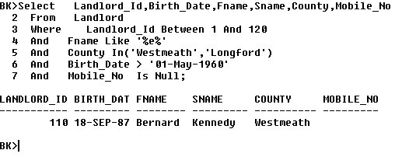

***Qualified Column Names***

**Select** Landlord.Landlord_Id, Landlord.Birth_Date, Landlord.Fname, Landlord.Sname, Landlord.County, Landlord.Mobile_No

**From Landlord**

**Where Landlord.Landlord_Id Between** 1 **And** 120

**And Landlord.Fname Like** ‘%**e**%’

**And Landlord.County In(**‘Westmeath’,’Longford’**)**

**And Landlord.Birth_Date > ‘**01-May-1960’

**And Landlord.Mobile_No Is Null;**

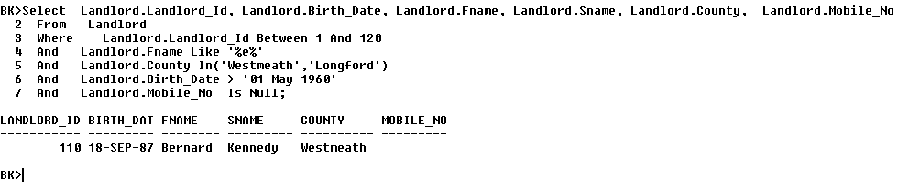

**Q2.*Show all Farms with Farm Id lower than 1100 , Using not containing letter “z” , with Estimated Value not null and Size not between 200 and 205 and with no Dry or Boggy Drainage***

**Select** Farm_Id,Usage,Estimated_Value,Size_,Drainage

**From** Farm

**Where** Farm_Id <1100

**And** Usage **Not Like** ‘%z%’

**And** Estimated_Value **Is Not Null**

**And** Size_ **Not Between** 200 **And** 205

**And** Drainage **NOT IN** (‘Boggy’, ‘Dry’);

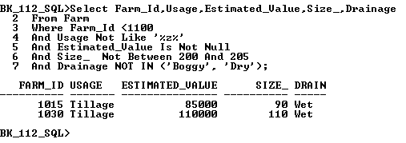

***Qualified Column Names***

**Select** Farm.Farm_Id, Farm.Usage, Farm.Estimated_Value,Size_, Farm.Drainage

**From** Farm

**Where** Farm.Farm_Id <1100

**And** Farm.Usage **Not** **Like** ‘%z%’

**And** Farm.Estimated_Value **Is Not Null**

**And** Farm.Size_ **Not Between** 200 **And** 205

**And** Farm.Drainage **NOT IN** (‘Boggy’, ‘Dry’);

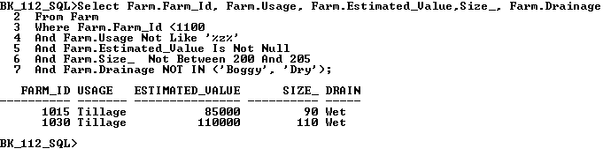

***Q.3.******Show all Farmers from County Longford and Westmeath , with Surname containing letter “e”, Order by Farmer Id Ascending . Show County as Co***

**Select Farmer_Id , Sname, Fname, County As Co**

**From Farmer**

**Where County IN (‘Dublin’,’Westmeath’)**

**And Sname like ‘%e%’**

**Order by Farmer_Id Asc;**

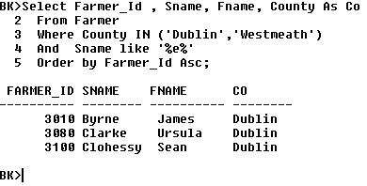

***Using Table Aliases***

**Select F.Farmer_Id , F.Sname, F.Fname, F.County As Co**

**From Farmer F**

**Where F.County IN (‘Dublin’,’Westmeath’)**

**And F.Sname like ‘%e%’**

**Order by F.Farmer_Id Asc;**

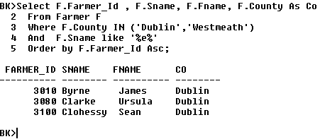

**Q.4.** **Show all Solicitors with the length of the first name and show the second name in uppercase with county in lowercase, except solicitors from meath**

**Select Length(Fname), Upper(Sname), Lower(County), Gender, Specialism**

**From Solicitor**

**Where County <> ‘Meath’**

**Order By Specialism DESC;**

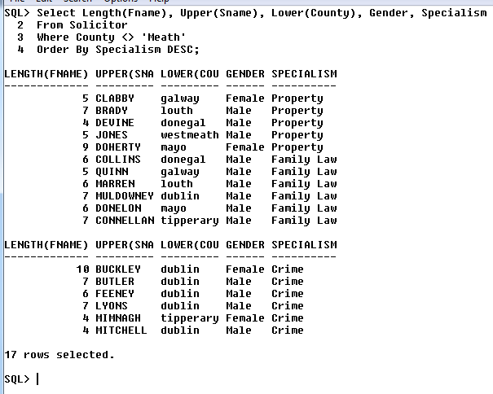

***Using Table Aliases***

**Select Length(S.Fname), Upper(S.Sname), Lower(S.County), S.Gender, S.Specialism**

**From Solicitor S**

**Where S.County <> ‘Meath’**

**Order By S.Specialism DESC;**

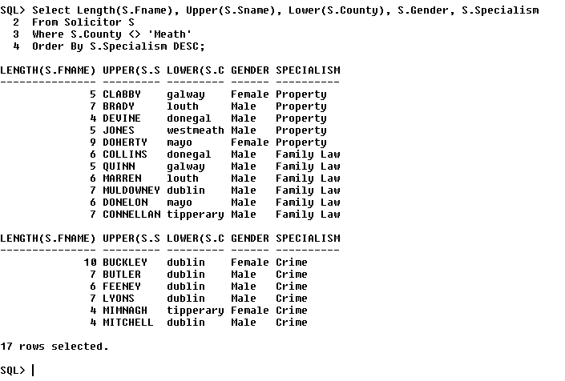

**Q.5. Show all Auctioneers with ID numbers less than or equal to 7090, with first name not containing the letter z, show the firstnames in title case, trim gender column to the left, and the specialism column to the right.**

**Select Auctioneer_Id, INITCAP(Fname), LTRIM(Gender),RTRIM(Specialism)**

**From Auctioneer**

**Where Auctioneer_ID <=7090**

**Or Fname NOT LIKE ‘%z%’**

**Or Sname LIKE ‘%c%’**

**Or Annual_Turnover NOT BETWEEN 5000 AND 6000;**

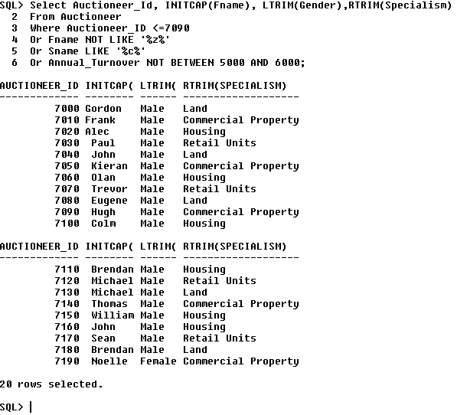

***Using Table Aliases***

**Select** A.Auctioneer_Id**, INITCAP(**A.Fname**), LTRIM(**A.Gender**),RTRIM(**A.Specialism**)**

**From** Auctioneer A

**Where** A.Auctioneer_ID **<=7090**

**Or** A.Fname **NOT LIKE ‘%z%’**

**Or** A.Sname **LIKE ‘%c%’**

**Or** A.Annual_Turnover **NOT BETWEEN 5000 AND 6000;**

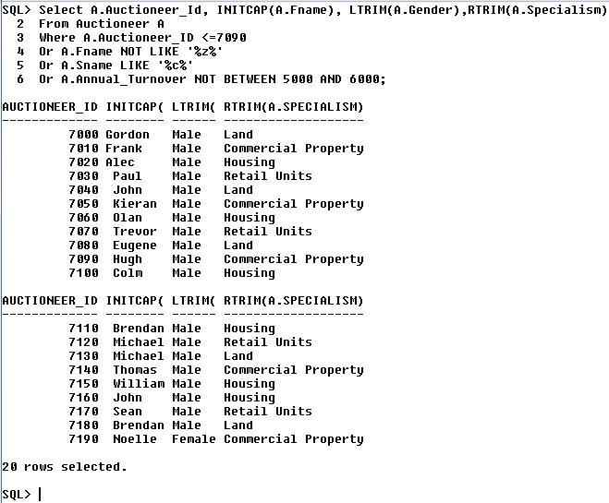

***Q.6. For Rental Contracts where the duration is greater or equal to six months and the payment terms are not monthly or quarterly instalments, show the Farm Id, ther Farmer_Id, Contract Date and Payment terms for those contracts. Also show the first three letters of the payment terms.***

**Select** Farm_Id, Farmer_Id, Contract_Date,Payment_Terms, **SUBSTR**(Payment_Terms, 1,3) S_13

**From** Rental_Contract

**Where** Duration >=6

**And** Payment_Terms **Not In** (‘Monthly Instalments’, ‘Quarterly Instalments’)

**Order By** Farmer_Id;

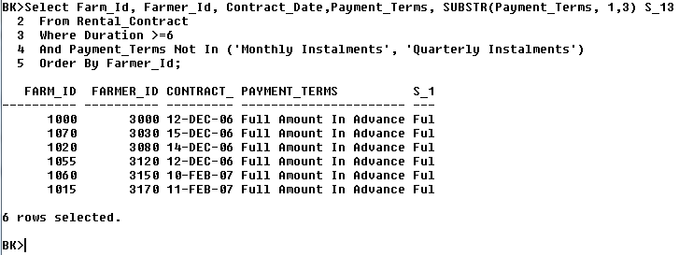

***Using Table Aliases***

**Select** RC**.**Farm_Id, RC.Farmer_Id, RC.Contract_Date,RC.Payment_Terms, **SUBSTR**(RC.Payment_Terms, 1,3) S_13

**From** Rental_Contract RC

**Where** RC.Duration >=6

**And** RC.Payment_Terms **Not In** (‘Monthly Instalments’, ‘Quarterly Instalments’)

**Order By** RC.Farmer_Id;

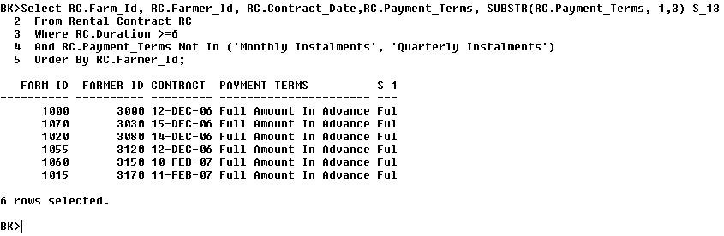

# Join Queries

**Q1. – *Show the fullnames of Landlords and the Estimated Value and Drainage of Farms in situations where the landlords firstname contains the letter J, the estimated value of the farms are between 90000 and 200000 and the farm’s drainage is either boggy or wet.***

**Select** Fname, Sname, Estimated_Value, Drainage

**From** Landlord , Farm

**Where** Landlord.Landlord_Id=Farm.Landlord_Id

**And** Fname LIKE ‘%J%’

**And** Estimated_Value BETWEEN 90000 AND 200000

**And** Drainage IN (‘Boggy’, ‘Wet’)

**Order** by Estimated_Value;

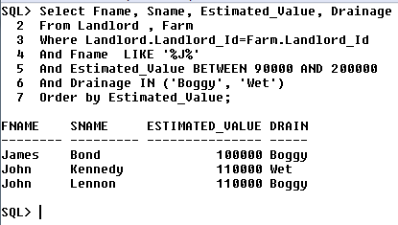

***Using Qualified Column Names:***

**Select** Landlord.Fname, Landlord.Sname,Farm.Estimated_Value,Farm.Drainage

**From** Landlord, Farm

**Where** Landlord.Landlord_Id=Farm.Landlord_Id

**And** Landlord.Fname LIKE ‘%J%’

**And** Farm.Estimated_Value BETWEEN 90000 AND 200000

**And** Farm**.**Drainage IN (‘Boggy’, ‘Wet’)

**Order** by Farm.Estimated_Value;

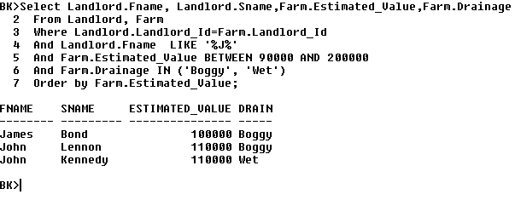

**Q2 – *Show the fullnames in titlecase of farmers,their gender and the associated contract dates where there is a rental fee.***

**Select** INITCAP(Fname),INITCAP(Sname),LTRIM(Gender),RTRIM(Contract_Date)

**From** Farmer, Rental_Contract

**Where** Farmer.Farmer_Id = Rental_Contract.Farmer_Id

**And** Rental_Contract.Rental_Fee Is Not Null;

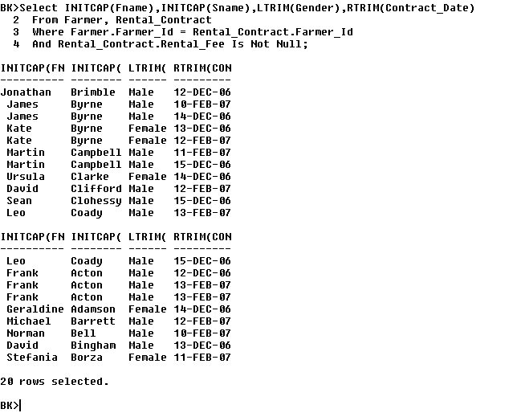

***Using Quaified Column Names:***

**Select** INITCAP(Farmer.Fname),INITCAP(Farmer.Sname),LTRIM(Farmer.Gender),RTRIM(Rental_Contract.Contract_Date)

**From** Farmer, Rental_Contract

**Where** Farmer.Farmer_Id = Rental_Contract.Farmer_Id

**And** Rental_Contract.Rental_Fee Is Not Null;

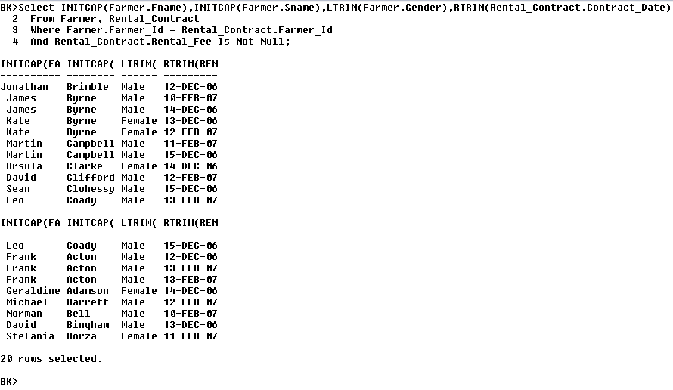

**Q3 - *Show the names of Auctioneers, the names of Solicitors and the Rental Contract duration for all contracts except those where the rental fees are between 1000 and 5000 and where the solicitors have the letter m in their first names.***

**Select**  Upper(Auctioneer.Fname),Upper(Auctioneer.Sname),Upper(Solicitor.Fname),Upper(Solicitor.Sname),Rental_Contract.Duration

**From** Auctioneer,Solicitor,Rental_Contract

**Where** Auctioneer.Auctioneer_Id = Rental_Contract.Auctioneer_Id

**And** Solicitor.Solicitor_Id=Rental_Contract.Solicitor_Id

**And** Rental_Contract.Rental_Fee NOT BETWEEN 1000 And 5000

**And** Solicitor.Fname NOT LIKE ‘%M%’

**And** Solicitor.Fname NOT LIKE ‘%m%’;

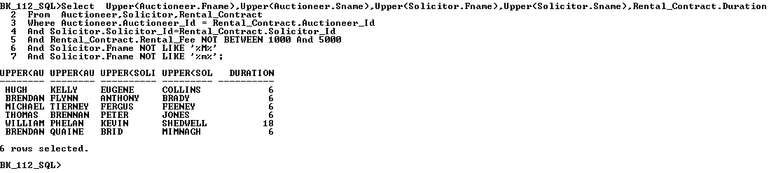

**Using Qualified Column Names**

**Select**  Upper(A.Fname),Upper(A.Sname),Upper(S.Fname),Upper(S.Sname),RC.Duration

**From** Auctioneer A, Solicitor S, Rental_Contract RC

**Where** A.Auctioneer_Id = RC.Auctioneer_Id

**And** S.Solicitor_Id=RC.Solicitor_Id

**And** RC.Rental_Fee NOT BETWEEN 1000 And 5000

**And** S.Fname NOT LIKE ‘%m%’

And S.Fname NOT LIKE '%M%';

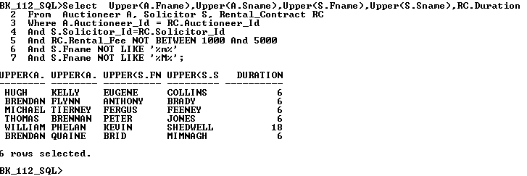

**Q4 – *Show the full names of landlords, farmers, auctioneers and solicitors, the rental contract dates, the farm estimated values in the cases where the landlords are based in county Longford only.***

**Select** Landlord**.**Fname “Lnd_Fname”, Landlord.Sname “Lnd_SName”, Farm.Estimated_Value “Farm_Est_Val”, Rental_Contract.Contract_Date “C_Date”, Auctioneer.Fname “A_Fname”, Auctioneer.Sname “A_Sname”, Solicitor.Fname “S_Fname”,Solicitor.Sname “S_Sname”, Farmer.Fname “Fmr_Fn”, Farmer.Sname “Fmr_Sn”

**From** Landlord, Farm, Rental_Contract, Auctioneer, Solicitor, Farmer

**Where** Landlord.Landlord_Id = Farm.Landlord_Id

**And** Farm.Farm_Id = Rental_Contract.Farm_Id

**And** Auctioneer.Auctioneer_Id =Rental_Contract.Auctioneer_Id

**And** Solicitor.Solicitor_Id = Rental_Contract.Solicitor_Id

**And** Farmer.Farmer_Id = Rental_Contract.Farmer_Id

**And** Landlord.County IN(‘Longford’)

**Order By** Landlord.Sname ASC;

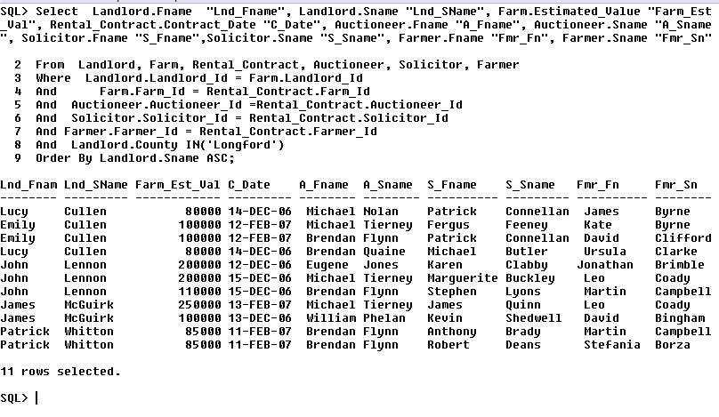

**Using Table Aliases**

**Select** L.Fname “Lnd_Fname”, L.Sname “Lnd_SName”, F.Estimated_Value “Farm_Est_Val”, RC.Contract_Date “C_Date”, A.Fname “A_Fname”, A.Sname “A_Sname”, S.Fname “S_Fname”,S.Sname “S_Sname”, FR.Fname “Fmr_Fn”, FR.Sname “Fmr_Sn”

**From** Landlord L, Farm F, Rental_Contract RC, Auctioneer A, Solicitor S, Farmer FR

**Where** L.Landlord_Id = F.Landlord_Id

**And** F.Farm_Id = RC.Farm_Id

**And** A.Auctioneer_Id =RC.Auctioneer_Id

**And** S.Solicitor_Id = RC.Solicitor_Id

**And** FR.Farmer_Id = RC.Farmer_Id

**And** L.County IN(‘Longford’)

**Order By** L.Sname ASC;

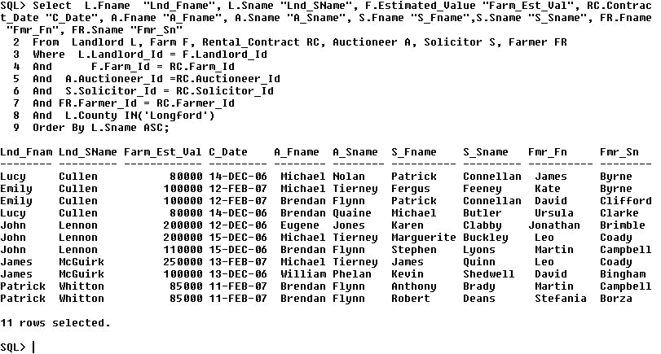

**Q5 - *Give the name and qualifications of pairs of Farmers who have identical qualifications other than Farming Cert. Show names in uppercase and qualifications in lowercase, and where the length of the farmers firstnames is greater than the length of the other farmers second names.***

**Select** Upper(F1.Fname), Upper(F1.Sname), Lower(F1.Qualifications), Upper(F2.Fname), Upper(F2.Sname), Lower(F2.Qualifications)

**From** Farmer F1, Farmer F2

**Where** F1.Qualifications = F2.Qualifications

**And** F1.Qualifications NOT IN(‘Farming Cert’)

**And** F2.Qualifications NOT IN(‘Farming Cert’)

**And** Length(F1.Fname)>Length(F2.Fname)

**And** F1.Farmer_Id >F2.Farmer_Id;

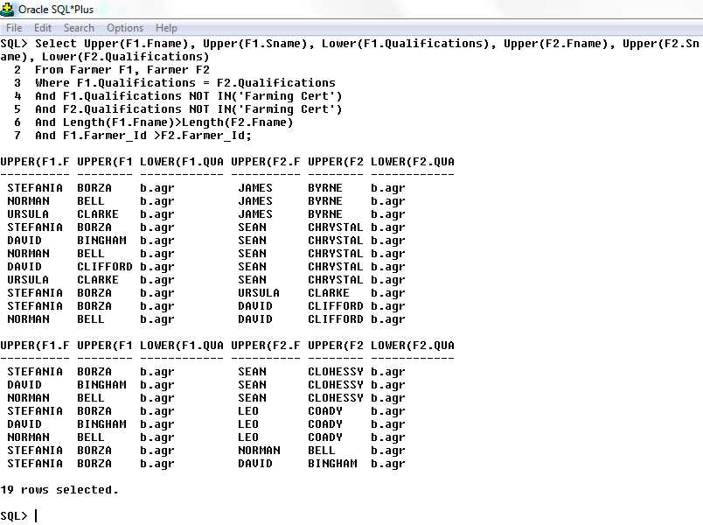

**Q6 - *Show the fullnames of solicitors in titlecase and the associated rental contract dates where the solicitors have mobile numbers and the solicitors were born after 01 Dec 1980.***

**Select** INITCAP(Solicitor.Fname),INITCAP(Solicitor.Sname), LTRIM(Rental_Contract.Contract_Date), RTRIM(Rental_Contract.Duration)

**From** Solicitor, Rental_Contract

**Where** Solicitor.Mobile_No Is Not Null

**And** Solicitor.Date_Of_Birth >= ‘01-DEC-80’

**And** Solicitor.Solicitor_Id = Rental_Contract.Solicitor_Id(+);

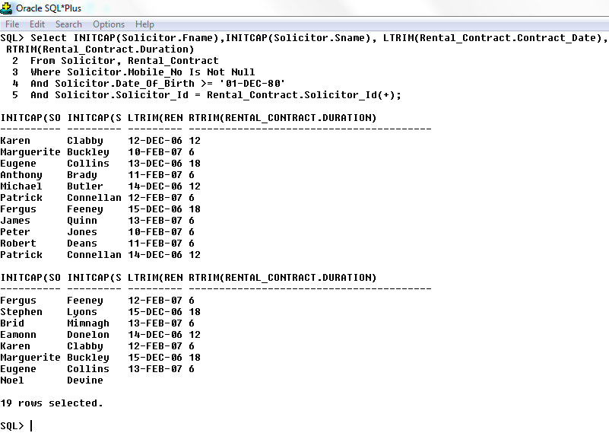

***Using Table Aliases***

**Select** INITCAP(S.Fname),INITCAP(S.Sname), LTRIM(RC.Contract_Date), RTRIM(RC.Duration)

**From** Solicitor S, Rental_Contract RC

**Where** S.Mobile_No Is Not Null

**And** S.Date_Of_Birth >= ‘01-DEC-80’

**And** S.Solicitor_Id = RC.Solicitor_Id(+);

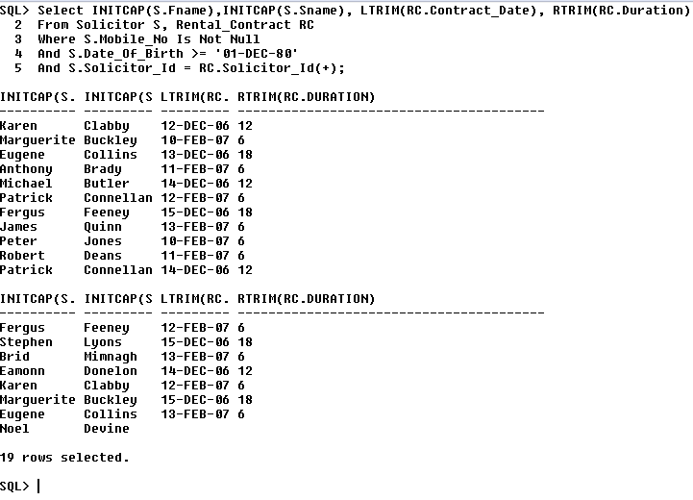

# Summary Queries

**Q1.** ***Show the Youngest and the Oldest Landlords in County Longford that have the letter e in their address.***

**Select** **Max**(L.Birth_Date), **Min**(L.Birth_Date)

**From** Landlord L

**Where**  L.County IN (‘Longford’)

**And** L.Address LIKE ‘%e%’;

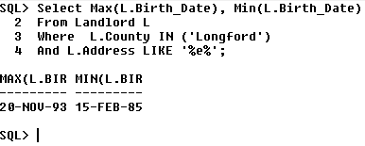

**Q.2. *Show the Total Estimated Values and the Average Size of all Farms other than those in the Dry category for Drainage and where the size of the farm is not between 80 and 115 acres. Show how the number of results for this query.***

**Select** **Sum**(F.ESTIMATED_VALUE) **AS** “Est Val”, Avg(F.SIZE_) **AS** “Farm Size”, Count(*) **AS** “Results”

**From** Farm F

**Where** F.DRAINAGE **NOT LIKE**(‘Dry’)

**And** F.SIZE_ **NOT BETWEEN** 80 AND 115;

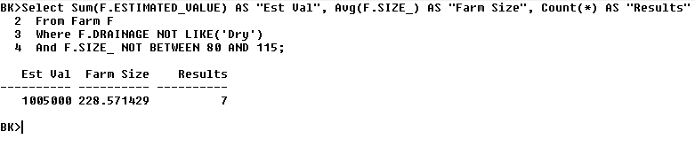

**Q.3.** ***Show the number of solicitors that do not have a mobile number on record.***

**Select Count**(S.Fname),**Count(*)**

**From** Solicitor S

**Where** S.Mobile_No **IS NULL;**

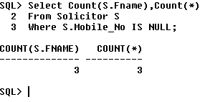

**Q.4. *Show the birth dates of youngest and oldest landlords that do not a mobile phone.***

**Select** **Min**(L.Birth_Date),**Max**(L.Birth_Date)

**From** Landlord L

**Where** L.Mobile_No **IS NULL**;

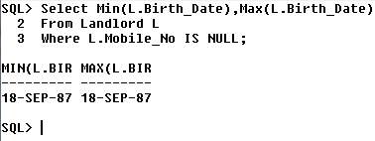

**Q.5. *Show the Rental Fee range for Rental Contracts that are associated with auctioneers between numbers 7080 to 7140.***

**Select Max**(RC.Rental_Fee)**-Min**(RC.Rental_Fee) “Fee Range”

**From** Rental_Contract RC

**Where** RC.Auctioneer_Id BETWEEN 7080 AND 7140;

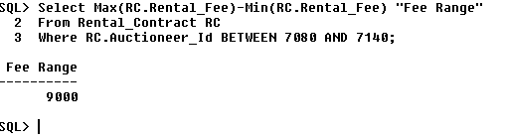

**Q.6. *Show the Counties and the average turnover of the youngest and eldest male Auctioneers, starting with the youngest.***

**Select** A.County,Min(Birth_Date) *Eldest*,Max(Birth_Date) *Youngest,* Avg(Annual_Turnover) *Avg_Tnr*

**From** Auctioneer A

**Where** A.Gender = ‘Male’

**Group** By A.County

**Order** By *Youngest*;

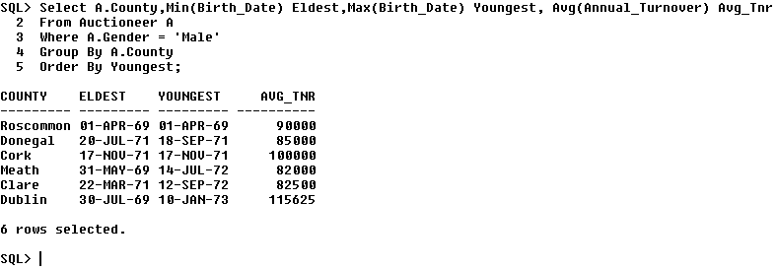

**Q.7.** ***Show the youngest and oldest Landlords that are currently farmers by county in ascending order by the length of the county names.***

**Select** L.County,**Max**(L.Birth_Date),**Min**(L.Birth_Date)

**From** Landlord L, Farm F

**Where** L.Landlord_Id=F.Landlord_Id

**And** L.Category **LIKE** ‘Current_Farmer’

**Group By** L.County

**Order By** Length(L.County) Asc;

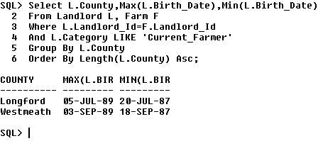

**Q.8.** ***Show the counties, average Rental Contract Fees and the highest turnover, having an average rental fee of over 5000 by County. Order by the the lengths of the county names in descending order.***

**Select** A.County,**Avg**(Rental_Fee) *AvgFee,***Max**(Annual_Turnover) *Highest_Turnover*

**From** Auctioneer A, Rental_Contract RC

**Where** A.Auctioneer_Id=RC.Auctioneer_Id

**Group By** A.County

**Having Avg**(RC.Rental_Fee)>5000

**Order By** **Length**(A.County) Desc;

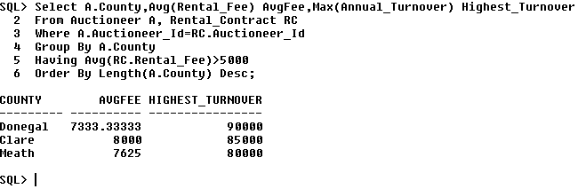

# Sub-Queries

**Q.1. Show the names of farmers and their annual sales where the annual sales are equal to the maximum annual sales for farmers from Dublin or Sligo.**

**Select** F.Fname,F.Sname,F.Annual_Sales

**From** Farmer F

**Where** F.Annual_Sales =

(**Select** Max(F.Annual_Sales)

**From** Farmer F

**Where** F.County IN (‘Dublin’, ‘Sligo’));

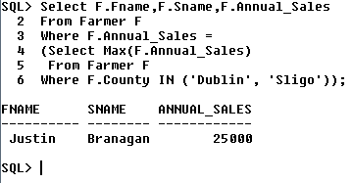

**Q.2. Show the names and birthdates for the youngest landlords who do not have the letter p in their first names.**

**Select** L.Fname,L.Sname,L.Birth_Date *Birthday*

**From** Landlord L

**Where** L.Fname NOT LIKE ‘%P%’

**And** L.Birth_Date =

(**Select** Max(Birth_Date)

From Landlord);

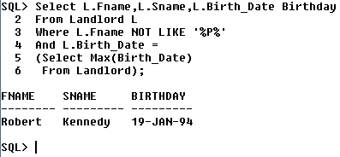

***Q.3. Name the Auctioneers who specialise in land where the annual turnover is greater than those auctioneers where the specialism is in Commercial Property.***

**Select** A.Fname,A.Sname,A.Annual_Turnover

**From** Auctioneer A

**Where** A.Specialism = ‘Land’

**And** A.Annual_Turnover >

(**Select** Avg(A.Annual_Turnover)

**From** Auctioneer A

**Where** A.Specialism = ‘Commercial Property’);

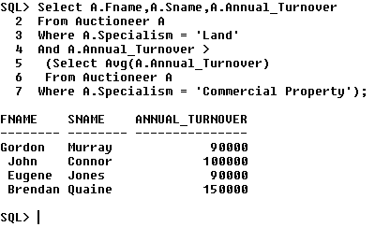

***Q.4 Display the first and last names, counties and gender of solicitors whose specialism is the same as those solicitors who reside in Dublin and are male.***

**Select** S.Fname, S.Sname, S.County, S.Gender

**From** Solicitor S

**Where** S.Specialism IN

**(Select** S.Specialism

**From** Solicitor S

**Where** S.Gender = ‘Male’

**And** S.County = ‘Dublin’);

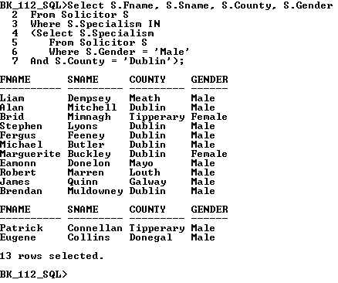

***Q.5. Show the names and IDs of landlords that own farms with flat terrain.***

**Select** L.Landlord_Id,L.Fname,L.Sname

**From** Landlord L

**Where** L.Landlord_Id **IN**

(**Select** F.Landlord_Id

**From** Farm F

**Where** F.Terrain = ‘Flat’);

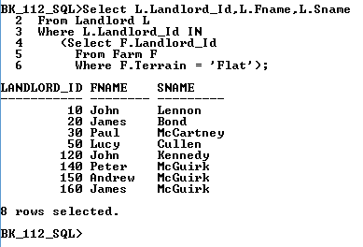

***Q.6. Show the names of Landlords and their IDs for landlords based in Longford or Westmeath whose farms have an estimated value of between 85000 and 250000 and have a rental fee range between €1000 and €8000.***

**Select** L.Landlord_Id, L.Fname,L.Sname

**From** Landlord L

**Where** L.County **IN** (‘Longford’, ‘Westmeath’)

**And** L.Landlord_Id **IN**

**(Select** F.Landlord_Id

**From** Farm F

**Where** F.Estimated_Value **Between** 85000 **And** 250000

**And** F.Farm_Id **IN**

(**Select** RC.Farm_Id

**From** Rental_Contract RC

**Where** RC.Rental_Fee **Between** 1000 And 8000**));**

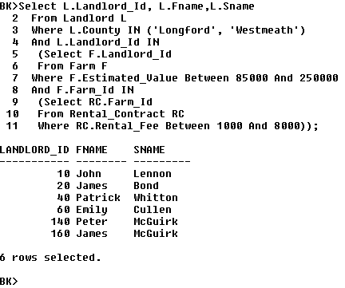

***Q.7. Show the farmer IDs, the Farm IDs and the Rental Fees where the rental fees are in quarterly instalments only and the rental fee is greater than any rental fees for contracts of 12 months duration.***

**Select** Farmer_Id, Farm_Id, Rental_Fee

**From** Rental_Contract

**Where** Payment_Terms = ‘Quarterly Instalments’

**And** Rental_Fee> **ANY**

(**Select** Rental_Fee

**From** Rental_Contract

**Where** Duration = ‘12’);

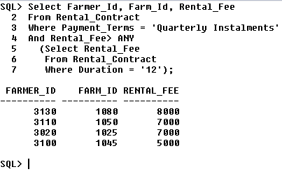

**Select** RC.Farmer_Id *FrmerId*, RC.Farm_Id *FrmId*, RC.Rental_Fee *RFee*

**From** Rental_Contract RC

**Where** RC.Payment_Terms = ‘Quarterly Instalments’

**And** RC.Rental_Fee> **ANY**

(**Select RC.**Rental_Fee

**From** Rental_Contract RC

**Where** RC.Duration = ‘12’);

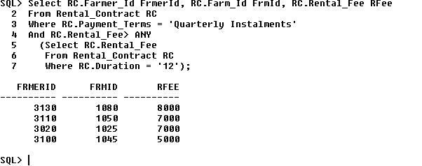

***Q.8. Give the Farm ID, the farm size and the estimated value where the terrain is flat and the estimated value is greater than the estimated value of all of the farms with hilly terrain.***

**Select** Farm_Id, Size_, Estimated_Value

**From** Farm

**Where** Terrain = **‘Flat’**

**And** Estimated_Value > All

**(Select** Estimated_Value

**From** Farm

**Where** Terrain = **‘Hilly’);**

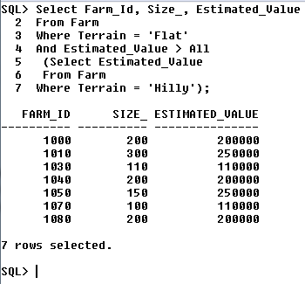

***Q.8. Give the Farm ID, the farm size and the estimated value where the terrain is flat and the estimated value is greater than the estimated value of all of the farms with hilly terrain.***

**Select** F.Farm_Id, F.Size_, F.Estimated_Value

**From** Farm F

**Where** F.Terrain = ‘Flat’

**And** F.Estimated_Value > All

**(Select** F.Estimated_Value

**From** Farm F

**Where F.**Terrain = ‘Hilly’**);**

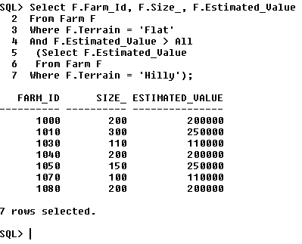

# Views

***Q.1.***

***Create a vertical view which will show the landlords firstname, surname, address,county, gender and specialism where the specialism is dairy. Call the view Landlord_Retired_Dairy_Farmer.***

**Create** View Landlord_Retired_Diary_Farmer **As**

**Select** Fname, Sname, Address, Specialism, County, Gender

**From** Landlord

**Where** Landlord.Specialism = **‘Dairy’;**

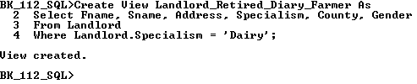

**Select** *

**From** Landlord_Retired_Diary_Farmer;

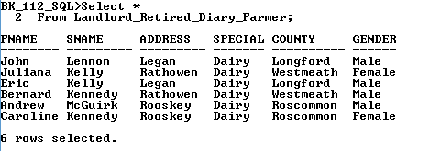

**Drop** View Landlord_Retired_Diary_Farmer;

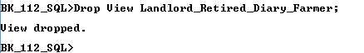

**Q.2. *Create a horizontal view which will show the following farm details: Farm Id, Terrain, Drainage, Usage, Landlord Id, and the estimated value if the value of the relevant farms were doubled in value. This view relates to those farms where the terrain is flat and are used for grazing. Call the view Farm_Details.***

**Drop View** Farm_Details;

**Create View** Farm_Details **As**

**Select** Farm_Id, Size_,Terrain,Drainage,Usage,Landlord_Id,Estimated_Value*2 as Value_Doubled

**From** Farm

**Where** Terrain=’Flat’

**And** Usage= ‘**Grazing**’;

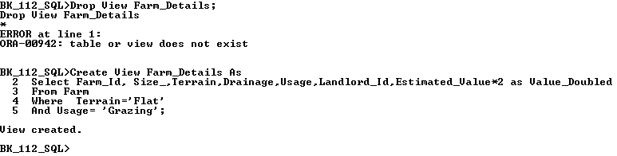

**Select \***

**From** Farm_Details**;**

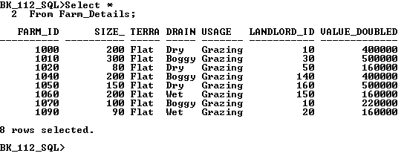

**Drop View** Farm_Details;

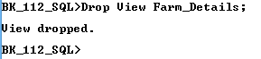

***Q.3. Create a view based on the Rental Contract Table which will show Auctioneer's first and last names as First Name and Last name respectively, the associated solicitor's first and last names, the rental contract duration, payment terms and rental fee where the rental fee is not between €1000 and €5000 and the solicitor name does not contain the letter m.***

**Create View Rental_Contract_Details As**

**Select** Auctioneer.Fname as First_Name,Auctioneer.Sname as surname,Solicitor.Fname,Solicitor.Sname,Rental_Contract.Duration, Rental_Contract.Payment_Terms, Rental_Contract.Rental_Fee

**From** Auctioneer,Solicitor,Rental_Contract

**Where** Auctioneer.Auctioneer_Id = Rental_Contract.Auctioneer_Id

**And** Solicitor.Solicitor_Id=Rental_Contract.Solicitor_Id

**And** Rental_Contract.Rental_Fee NOT BETWEEN 1000 And 5000

**And** Solicitor.Fname NOT LIKE ‘%M%’;

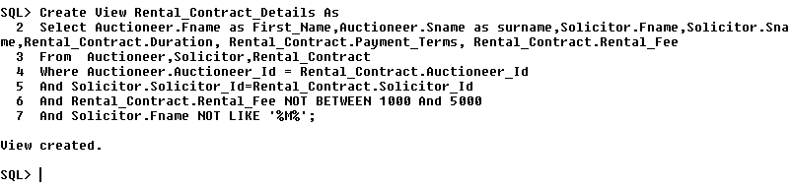

**Select** *

**From** **Rental_Contract_Details**;

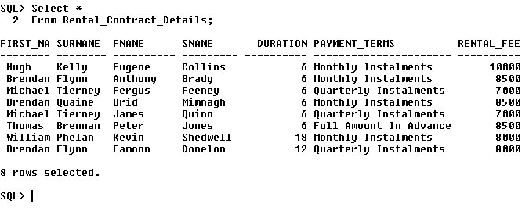

**Drop View Rental_Contract_Details;**



***Q.4. Create a permanently stored query or view that will show the youngest and the oldest landlords who reside in County Longford, who have the letter e in their address. Call the view Longford Landlords.***

**Create View Longford_Landlords As**

**Select** **Max**(L.Birth_Date) Youngest, **Min**(L.Birth_Date) ***Eldest***

**From** Landlord L

**Where**  L.County **IN** (‘Longford’)

**And** L.Address **LIKE** ‘%e%’;

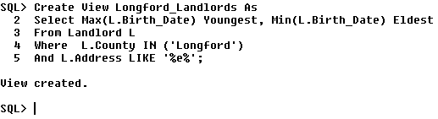

**Select \***

**From Longford_Landlords;**

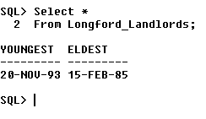

**Drop View Longford_Landlords;**

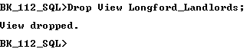

***Q.5. Create a view based on the Solicitor table showing the first and second names of solicitors, their Solicitor Ids, their county, specialism, qualifications where the specialism is not property, the solicitor id is between 5040 and 5140, who are not qualified in M.A. Law and do not have the letter L in their County name. Call the view Solicitor Details.***

**Drop View** **Solicitor_Details;**

**Create View** **Solicitor_Details** **As**

**Select** Fname, Sname, Solicitor_Id, County, Specialism, Qualifications

**From** Solicitor

**Where** Specialism **<>** ‘Property’

**And** Solicitor_Id **between** 5040 and 5140

**And** Qualifications **NOT IN**(‘M.A. Law’)

**And** County **Not Like** ‘%L%’;

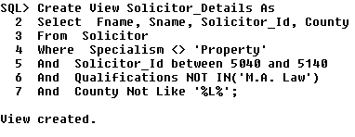

**Select** *

**From** Solicitor_Details;

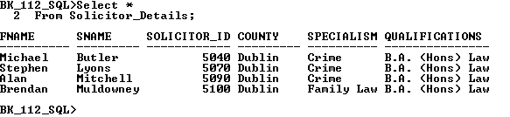

Insert into Solicitor_Details values(‘Brendan’, ‘Kenny’, 5023, ‘Mayo’,’Property’,’M.A. Law’);

Insert into Solicitor_Details values(‘Patrick’, ‘Whitton’,5024, ‘Mayo’, ‘Crime’, ‘B.A. (Hons) Law’);

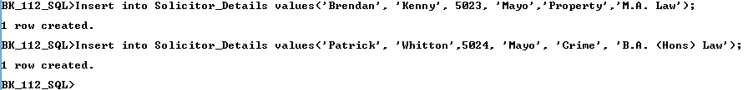

**Select** *

**From** Solicitor_Details;

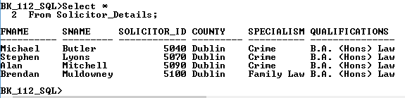

**Drop View** **Solicitor_Details;**

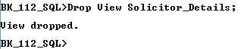

6. ***Create a view based on the Solicitor table showing the first and second names of solicitors, their Solicitor Ids, their county, specialism, qualifications where the specialism is not property, the solicitor id is between 5040 and 5140, who are not qualified in M.A. Law and do not have the letter L in their County name. Call the view Solicitor Details2. Include a Check Option with this View.***

**Create View Solicitor_Details2 As**

**Select** Fname, Sname, Solicitor_Id, County, Specialism, Qualifications

**From** Solicitor

**Where** Specialism <> ‘**Property**’

**And** Solicitor_Id between 5040 and 5140

**And** Qualifications **NOT IN**(‘M.A. Law’)

**And** County **Not Like** ‘%L%’

**With** **Check Option;**

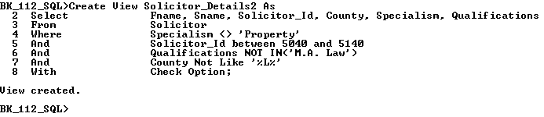

**Insert** into Solicitor_Details2 values(‘Brendan’, ‘Kenny’, 5023, ‘Longford’,’Property’,’M.A. Law’);

**Insert** into Solicitor_Details2 values(‘Patrick’, ‘Whitton’,5041, ‘Mayo’, ‘Crime’, ‘B.A. (Hons) Law’);

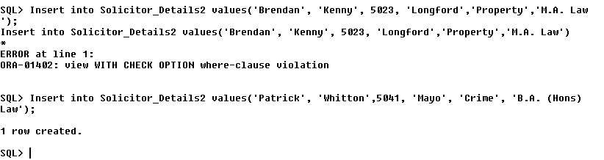

**Drop View Solicitor_Details2;**

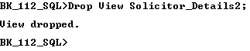

# Deletes

***Q.1. Failed DELETE due to integrity constraint***

**Attempt to Remove the records from the Farm table where the Landlord Id = 10 from the Farm table.**

**Select Landlord_Id**

**From Farm;**

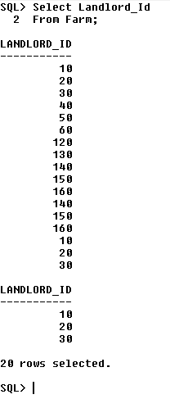

**Delete**

**From Farm**

**Where Landlord_Id=10;**

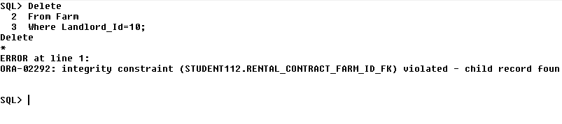

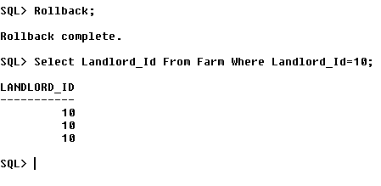

***Q. 4 Delete from the Landlord table, records for landlords who have farms with flat terrain.***

**Select** L.Landlord_Id,L.Fname,L.Sname

**From** Landlord L

**Where** L.Landlord_Id **IN**

(**Select** F.Landlord_Id

**From** Farm F

**Where** F.Terrain = ‘Flat’);

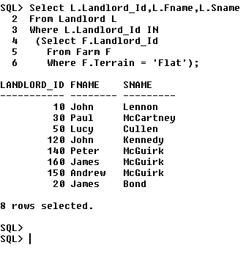

**Delete**

**From** Landlord L

**Where** L.Landlord_Id **IN**

(**Select** F.Landlord_Id

**From** Farm F

**Where** F.Terrain = ‘Flat’);

