Table of Contents

Preprocessing Sequence: Split → Fit → Transform → Resample
The order of operations that prevents test-set information from leaking into training
DSP391m – Group 1 · Report 2 (Data Tasks), Chapter 3 · Work item STT 22 (Duc) Implemented in src/features/preprocessing.py.

1. The core principle
Every component that learns from data — imputation statistics, encoders, the scaler, and any resampler — must be fit on the training fold only and then applied (transform) to the test set. Fitting on the full dataset before splitting leaks test-set statistics (means, category sets, class structure) into training and yields optimistic, non-reproducible estimates.

2. The sequence
flowchart TD
A["master_raw / dataset_t"] --> B["1. SPLIT (group-aware + stratified)\nby id_student, fixed test set"]
B --> C["2. handle_missing\nfit logic on TRAIN, apply to both"]
C --> D["3. handle_outliers\nlog1p / winsorize, thresholds from TRAIN"]
D --> E["4. ColumnTransformer.fit(TRAIN)\nscaler + ordinal + one-hot + binary"]
E --> F["4b. transform(TRAIN) and transform(TEST)"]
F --> G["5. RESAMPLE (SMOTE/ADASYN)\nTRAIN ONLY — never the test set"]
G --> H["Model training / evaluation"]
ASCII form (for environments without Mermaid):
master_raw / dataset_t
|
[1] SPLIT (StratifiedGroupKFold by id_student; fixed 20% test set)
|
[2] handle_missing -> impute logic learned on TRAIN, applied to TRAIN+TEST
|
[3] handle_outliers -> log1p / winsorize; thresholds from TRAIN
|
[4] ColumnTransformer.fit(TRAIN) -> StandardScaler + Ordinal + OneHot + Binary
|
[4b] transform(TRAIN), transform(TEST)
|
[5] RESAMPLE (SMOTE / ADASYN) -> TRAIN ONLY
|
model.fit(TRAIN_resampled) ; evaluate on TEST
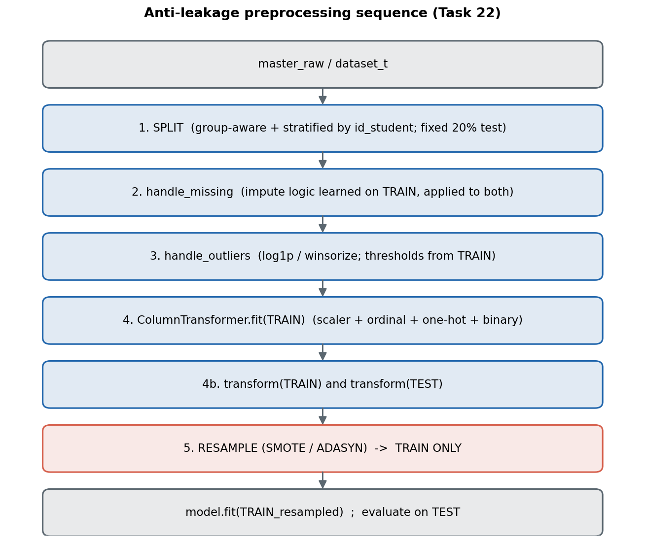
Preprocessing sequence

3. Why each step sits where it does
Step | Anti-leakage reason
1. Split first | Nothing is learned before the test set is separated, so no statistic can flow from test to train.
2. Missing | imd_band → "Unknown"; assessment gaps → 0 plus the not_submitted flag; date_registration → train median.
3. Outliers | log1p for right-skewed clickstream features; winsorize thresholds learned per fold; no rows dropped.
4. Encode + scale | StandardScaler, OrdinalEncoder, OneHotEncoder, BinaryEncoder are fit on train only; scaler.mean_ is computed from train and printed as evidence.
5. Resample | SMOTE/ADASYN run inside the training fold only; the test set must reflect the real class distribution, so it is never resampled.

4. Evidence of correctness
- scaler.mean_ is derived solely from the training fold (printed by fit_transform_train).
- The test set is transformed with .transform() only — never .fit() / .fit_transform().
- Resampling is applied after transforming, on X_train only.
This ordering is the practical embodiment of the leakage-prevention rules (STT 12) on the feature axis, complementing the time axis enforced by cut_at_checkpoint.

References
- N. V. Chawla et al., “SMOTE: Synthetic Minority Over-sampling Technique,” JAIR, 2002.

