Table of Contents

Report 2 — Data Tasks: Collection, Cleaning, and Exploratory Data Analysis
DSP391m – Data Science Capstone Project · Group 1 · FPT University Project: Time-Aware Explainable Machine Learning for Early At-Risk Student Prediction on OULAD · Supervisor: Nguyễn Thị Hoàng Yến Scope: CLO3–CLO4 · Chapter 3 (Collection & Cleaning) and Chapter 4 (EDA). This draft synthesises the team deliverables; detailed standalone documents are referenced inline.

Chapter 3 — Data Collection and Cleaning

3.1 Data source, licence, and ethics
This project uses the Open University Learning Analytics Dataset (OULAD) (Kuzilek et al., 2017 [3]): 32,593 student–module–presentation records over 22 module-presentations and 7 relational tables, covering three feature groups (demographic, engagement/VLE, assessment performance) and the outcome final_result. OULAD is anonymised at source and distributed under CC-BY 4.0, so the ethical requirement is met by correct citation; no sensitive personal data is processed. Data-collection methods and the rationale for a public secondary dataset are analysed in docs/02_collection/Data_Collection_Methods; the source/licence/ethics statement is in docs/02_collection/Data_Source_License_Ethics.

3.2 Target variable definition
The task is binary classification. The label is derived from final_result and fixed across all checkpoints:
Class | Values | Count | Share
not-at-risk (0) | Pass (12,361) + Distinction (3,024) | 15,385 | 47.2%
at-risk (1) | Fail (7,052) + Withdrawn (10,156) | 17,208 | 52.8%
The at-risk class is a slight majority (imbalance is mild); the 68/32 figure on the course slides is illustrative only. Full justification and the Withdrawn-over-time convention (Option A: fixed label, fixed population, keep Withdrawn-before-t as at-risk) are in docs/01_data_specification/Target_Variable_Definition (agreement BB-B0-N1).

3.3 Data integration — the master table
The seven tables are merged into one flat master table, one row per student–module–presentation. studentInfo is the base; studentRegistration, the aggregated engagement table, and the aggregated performance table are joined with left joins; a before/after join log proves integrity:
Step | rows_before | rows_after | n_students
studentInfo (base) | 32,593 | 32,593 | 28,785
+ registration | 32,593 | 32,593 | 28,785
+ engagement | 32,593 | 32,593 | 28,785
+ performance | 32,593 | 32,593 | 28,785
No row is duplicated or lost. Engagement features are aggregated from the 10,655,280-row studentVle clickstream (joined to vle for activity type): total_clicks, n_days_active, eight clicks_<type> counts, max_clicks_single_day, mean_clicks_per_active_day, and days_since_last_activity. Performance features are aggregated from studentAssessment with assessment weights/deadlines: mean_score_to_date, weighted_score_to_date, n_assessments_submitted, and the not_submitted risk flag (a deadline passed without submission). Result: master_raw = 32,593 × 33 columns (src/data/build_master_table.py, notebook 01).

3.4 Data cleaning
- Duplicates: 0 duplicate composite keys after drop_duplicates.
- Consistency: categorical labels standardised; cardinalities match the data dictionary (region 13, education 5, imd_band 10, age_band 3, gender/disability 2).
- Missing values: imd_band (1,111) → "Unknown"; assessment gaps → 0 plus the not_submitted indicator (a signal, not noise); date_registration (45) → train median. The only large gap, date_unregistration (22,521), is expected — most students never withdraw — and is not used as a feature.
- Outliers: right-skewed clickstream features use log1p; others use winsorize; no rows are dropped (src/features/preprocessing.py, docs/04_transformation/Preprocessing_Sequence).

3.5 Time-aware feature extraction
Course lengths differ, so each progress percentage is converted to a concrete day: cutoff_day = round(module_presentation_length × t / 100) for t ∈ {10,20,40,60,80,100} (data/checkpoint_map.csv, 22×6 rows). cut_at_checkpoint() keeps only events on or before the cutoff, and the master pipeline is re-run per checkpoint to produce six datasets (dataset_t10 … dataset_t100), each 32,593 rows sharing an identical roster (Option A). At-risk rate is constant at 52.8% across checkpoints (labels are fixed); only engagement/performance features change with t.

3.6 Leakage prevention and splitting
Two leakage axes are controlled. On the time axis, three rules (drop post-cutoff submissions; drop post-cutoff clicks; keep Withdrawn-before-t as at-risk) are documented in docs/03_cleaning/Leakage_Prevention_Rules. On the feature axis, the sequence split → impute → outliers → encode/scale → resample fits every learner on the training fold only (docs/04_transformation/Preprocessing_Sequence). The split is group-aware (by id_student) + stratified with a fixed 20% test set reused across checkpoints (docs/05_splitting/Split_Strategy_Analysis): train ≈ 26,104 rows, test ≈ 6,489 rows, 0 student overlap, class ratio 0.53/0.52. CV on the training set uses 5-fold × 5 seeds; headline metrics are PR-AUC and recall on the at-risk class. tests/test_leakage.py asserts all of this: 16/16 tests pass.

3.7 Reproducibility
RANDOM_SEED = 42 throughout; provenance in data/data_manifest.txt (MD5 + size + date); environment pinned in requirements.txt/environment.yml; notebooks run Restart & Run All; long steps are checkpointed/resumable; parquet writes are atomic. Full steps in docs/07_standards/Reproducibility.

Chapter 4 — Exploratory Data Analysis
Every comparison is supported by an appropriate statistic, not visual impression alone: Mann-Whitney U tests (Benjamini-Hochberg corrected) with Cohen’s d for numeric features, chi-square with Cramér’s V for categorical features, and Pearson/Spearman correlation with an explicit leakage check. Figures follow the chart standard (docs/07_standards/Chart_Standards); the analysis is src/eda/eda.py, narrated in notebook 02, with result tables under reports/tables/.

4.0 Data quality
Only three columns contain gaps: date_unregistration (22,521 — structurally absent for students who never withdraw, not a feature), imd_band (1,111 → Unknown) and date_registration (45 → train median). No feature column is materially incomplete.
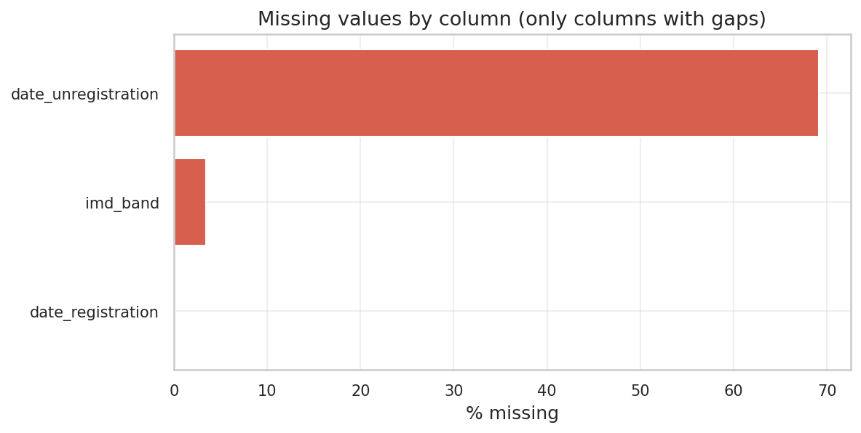
Missing values by column

4.1 Class distribution and imbalance (STT 27)
The observed at-risk rate is 52.8% (imbalance ratio 1.12) — a slight majority, not the illustrative 68/32 on the slides. Imbalance is therefore mild (reported honestly; it frames RQ3); PR-AUC and recall on the at-risk class remain the headline metrics because a missed at-risk student is the costly error.
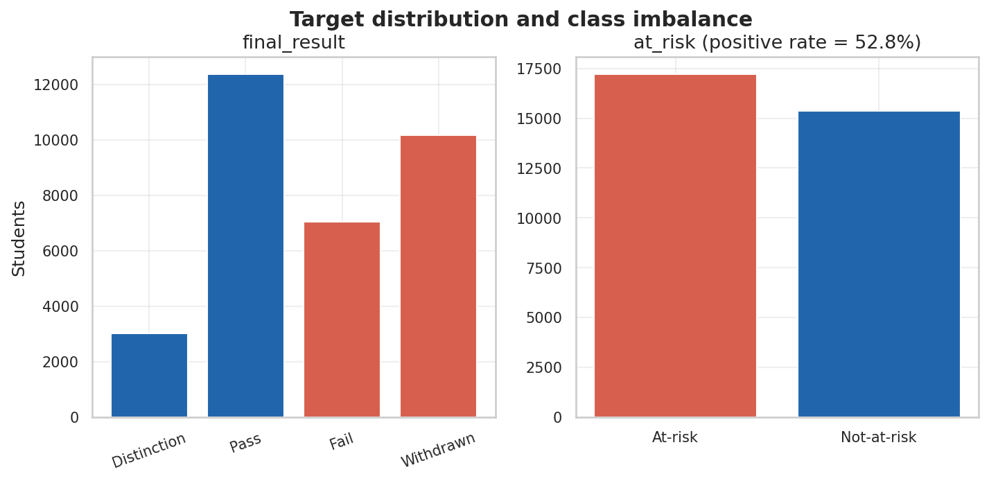
Target distribution and imbalance

4.2 Univariate description (STT 28)
Engagement features are strongly right-skewed and heavy-tailed — clicks_resource (skew ≈ 35, kurtosis ≈ 2,125), clicks_url (skew ≈ 13), max_clicks_single_day (skew ≈ 11) — empirically justifying the log1p transform applied during cleaning. The full table (mean/median/std/quartiles/skew/kurtosis) is reports/tables/univariate_numeric.csv.
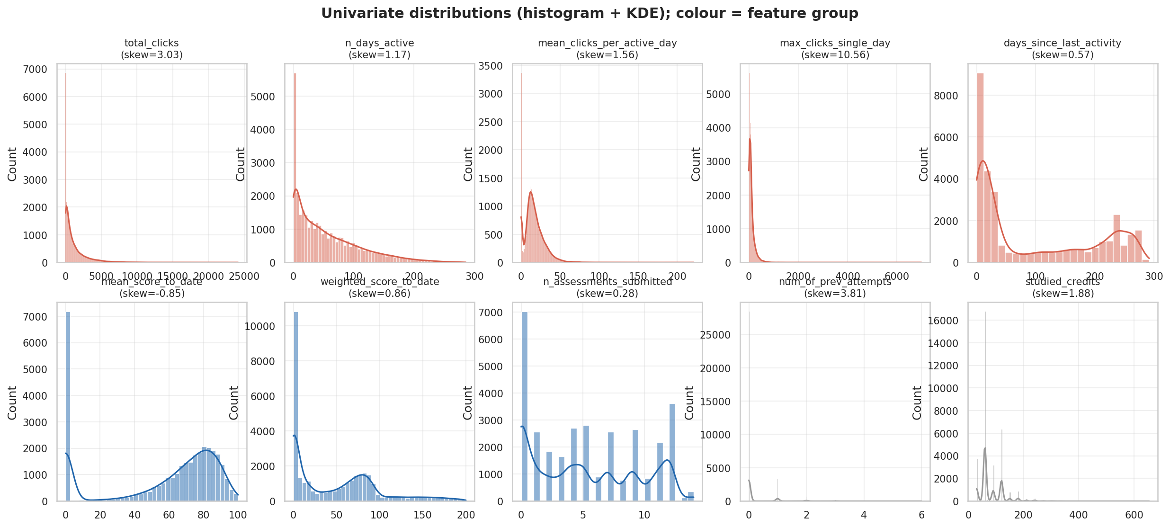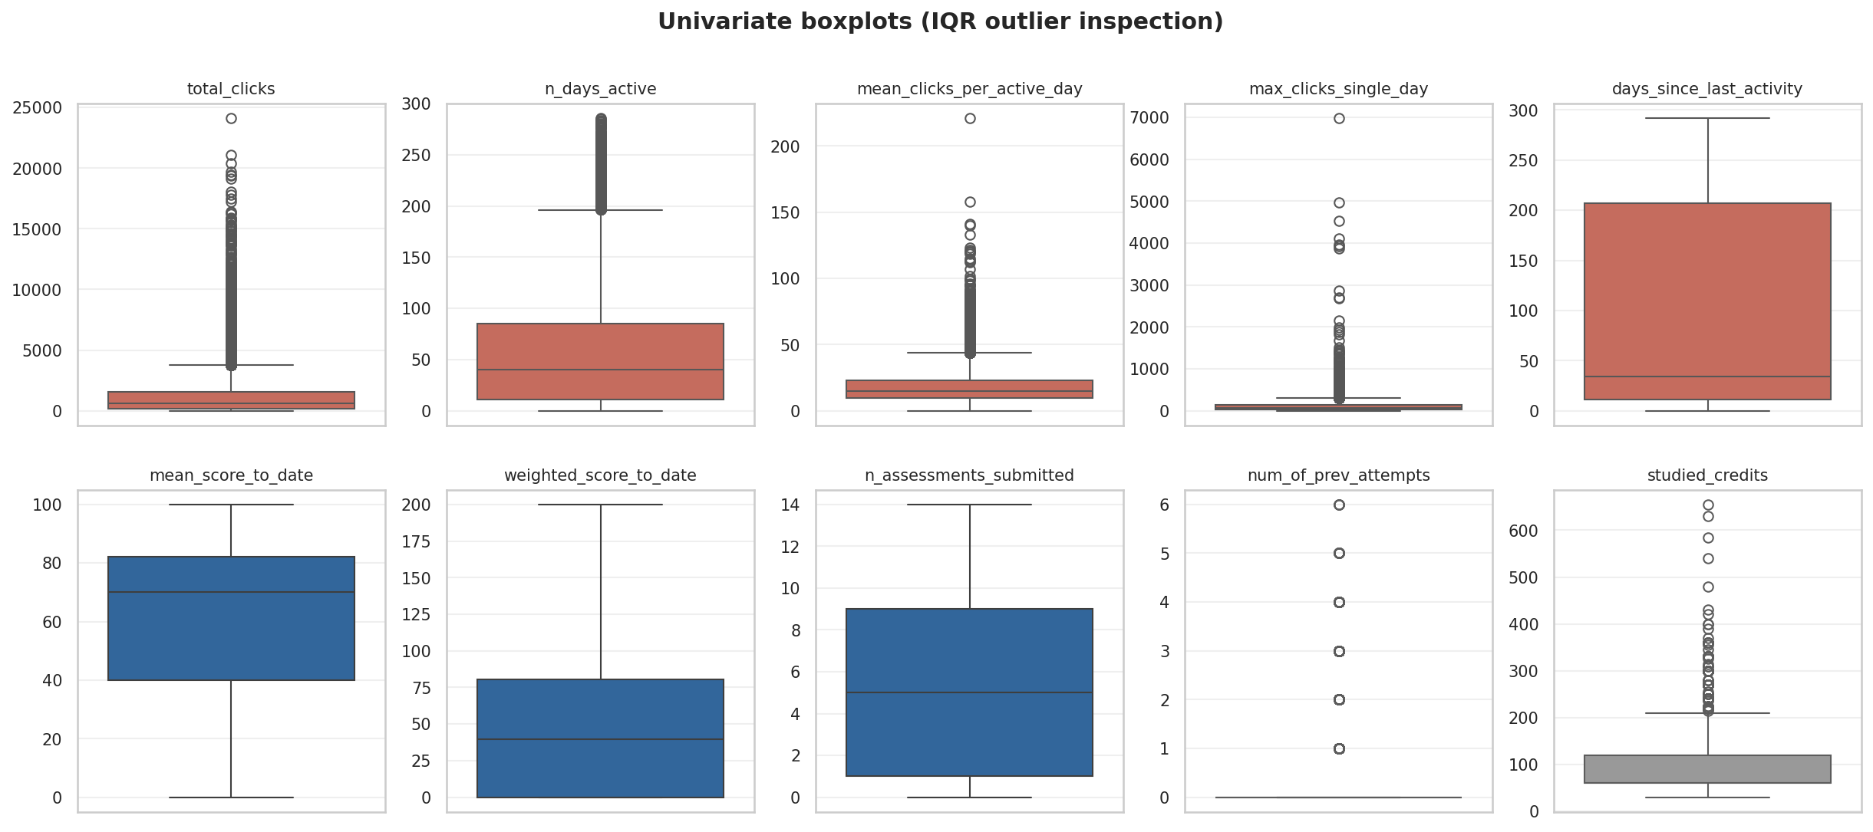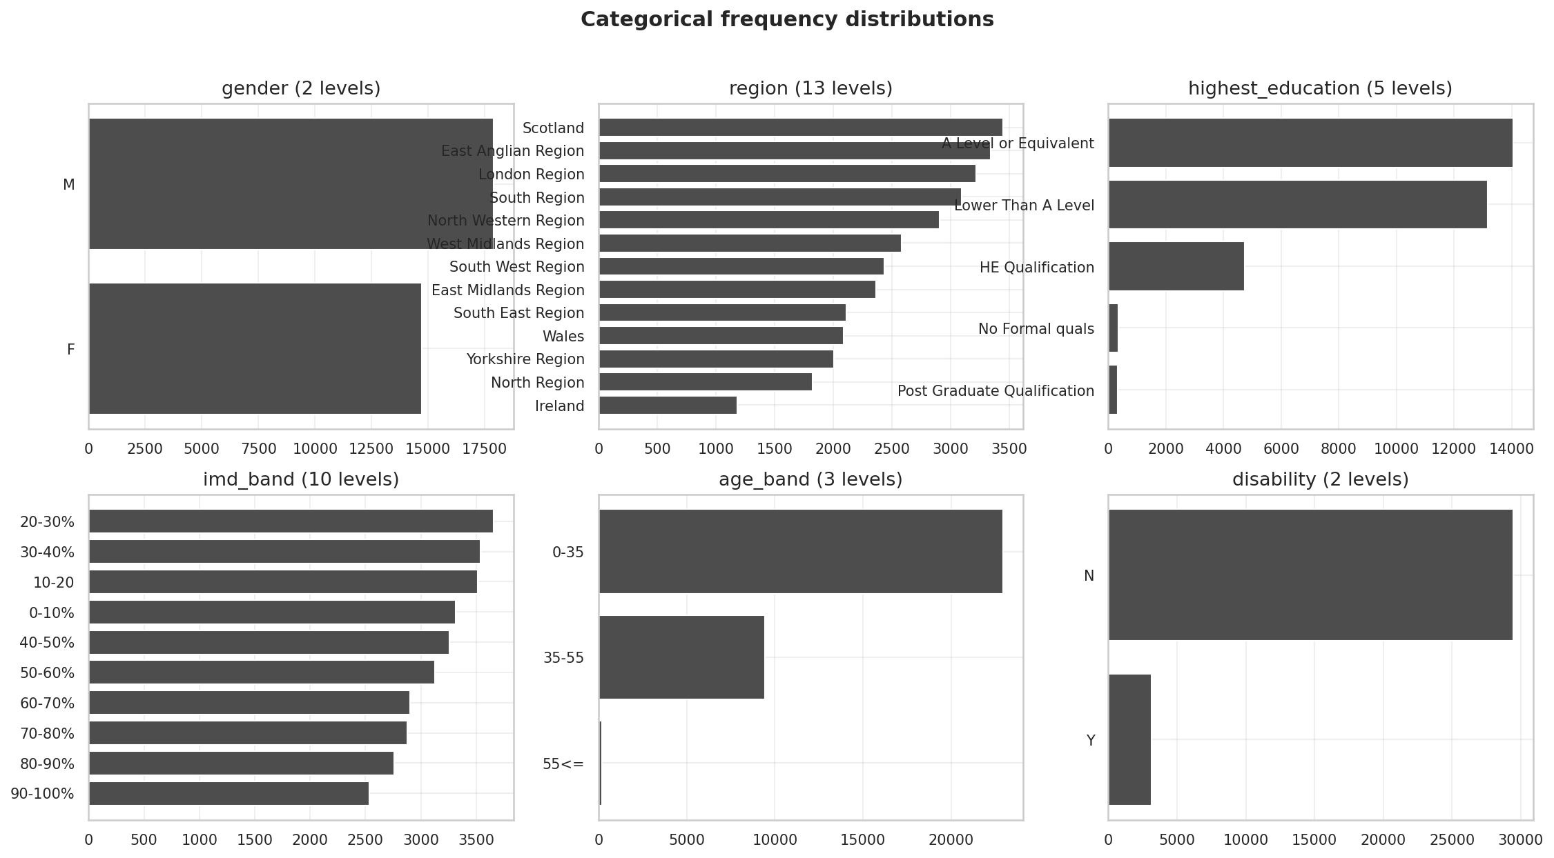

4.3 Bivariate — numeric features vs. the target (STT 36)
Mann-Whitney U tests (BH-corrected) find all 19 numeric features significant (q < 0.05) — unsurprising at n ≈ 32,593 — so effect size, not the p-value, is the discriminator. Ranked by |Cohen’s d|:
Feature | Group | |Cohen’s d|
days_since_last_activity | Engagement | 2.55
n_assessments_submitted | Performance | 2.05
weighted_score_to_date | Performance | 1.96
n_days_active | Engagement | 1.58
mean_score_to_date | Performance | 1.58
Behaviour and performance dominate; demographics are weakest (studied_credits 0.28, num_of_prev_attempts 0.21). Full test table: reports/tables/bivariate_numeric_tests.csv.
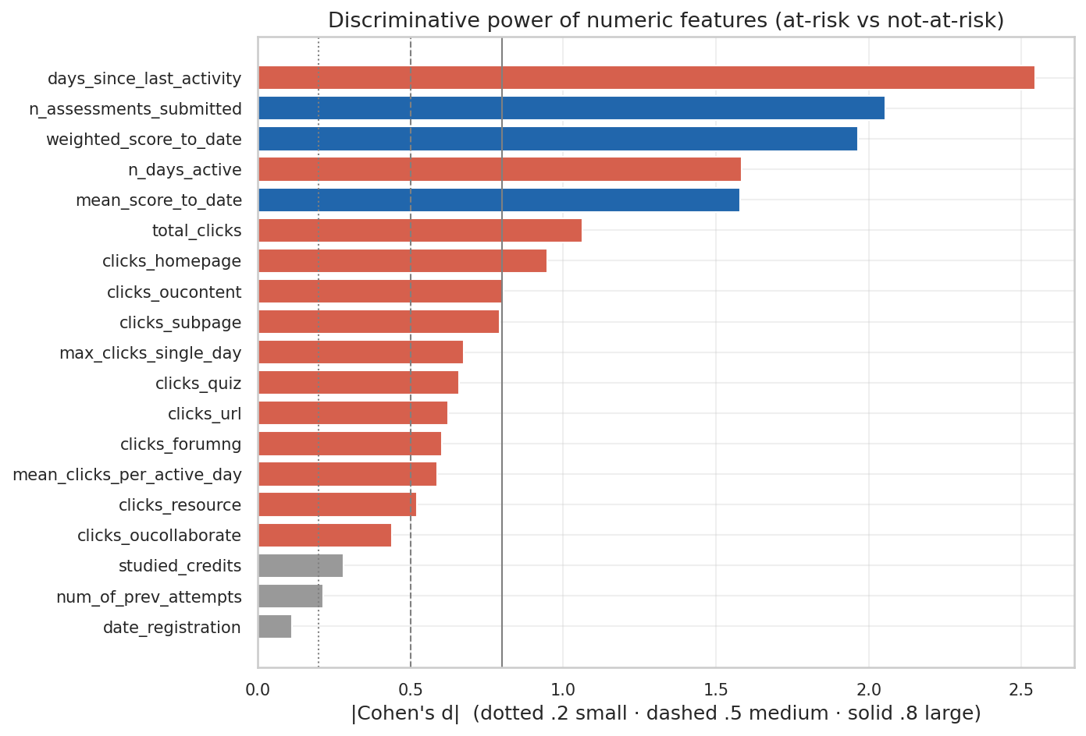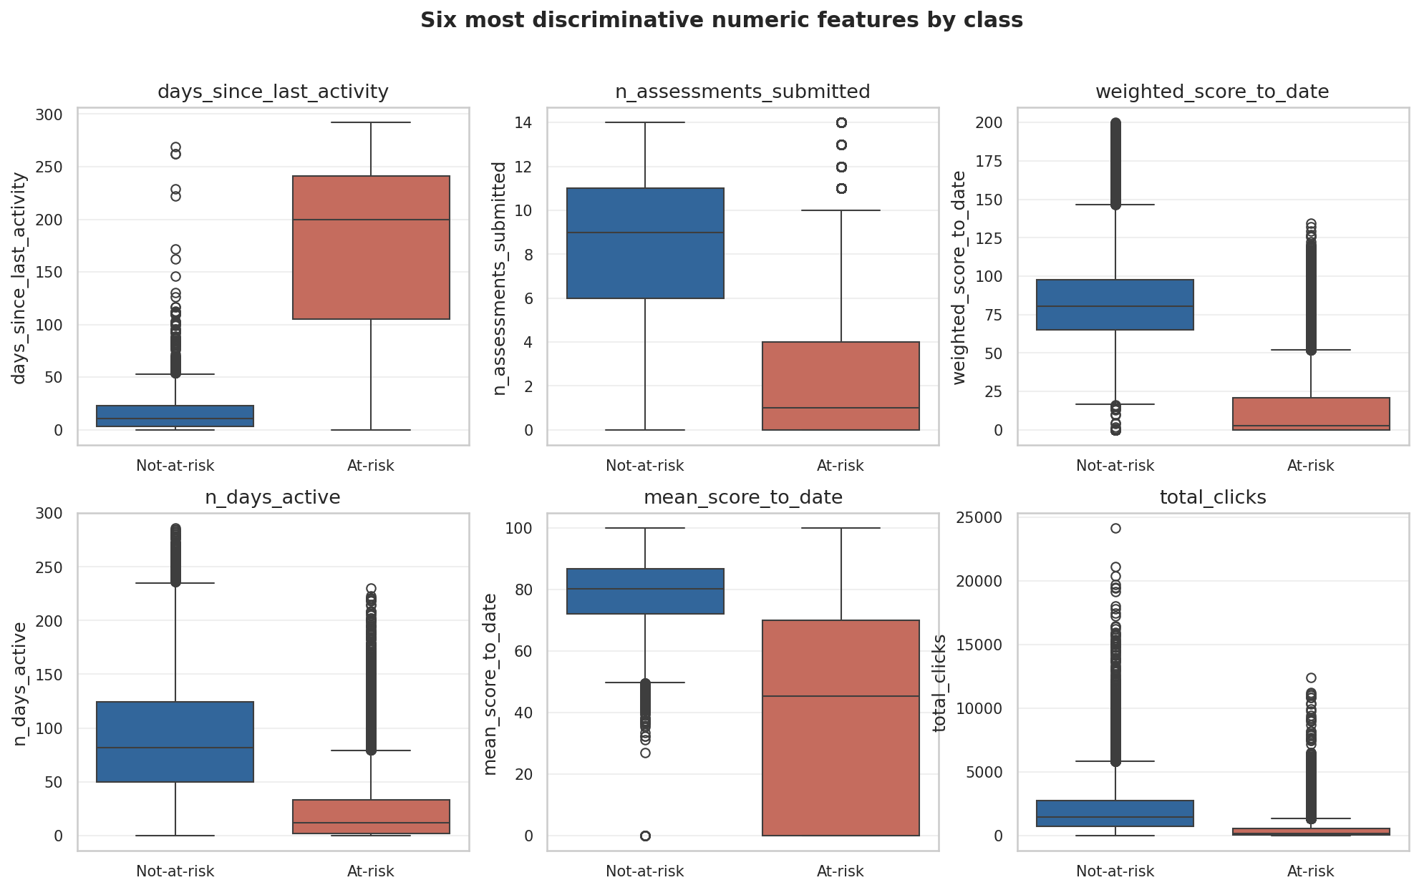

4.4 Bivariate — categorical features vs. the target
Chi-square tests are significant, but the Cramér’s V effect sizes are small: highest_education (0.15) and imd_band (0.15) lead, while gender (0.02) is negligible. Demographics carry limited standalone signal and are best retained for fairness analysis rather than predictive reliance.
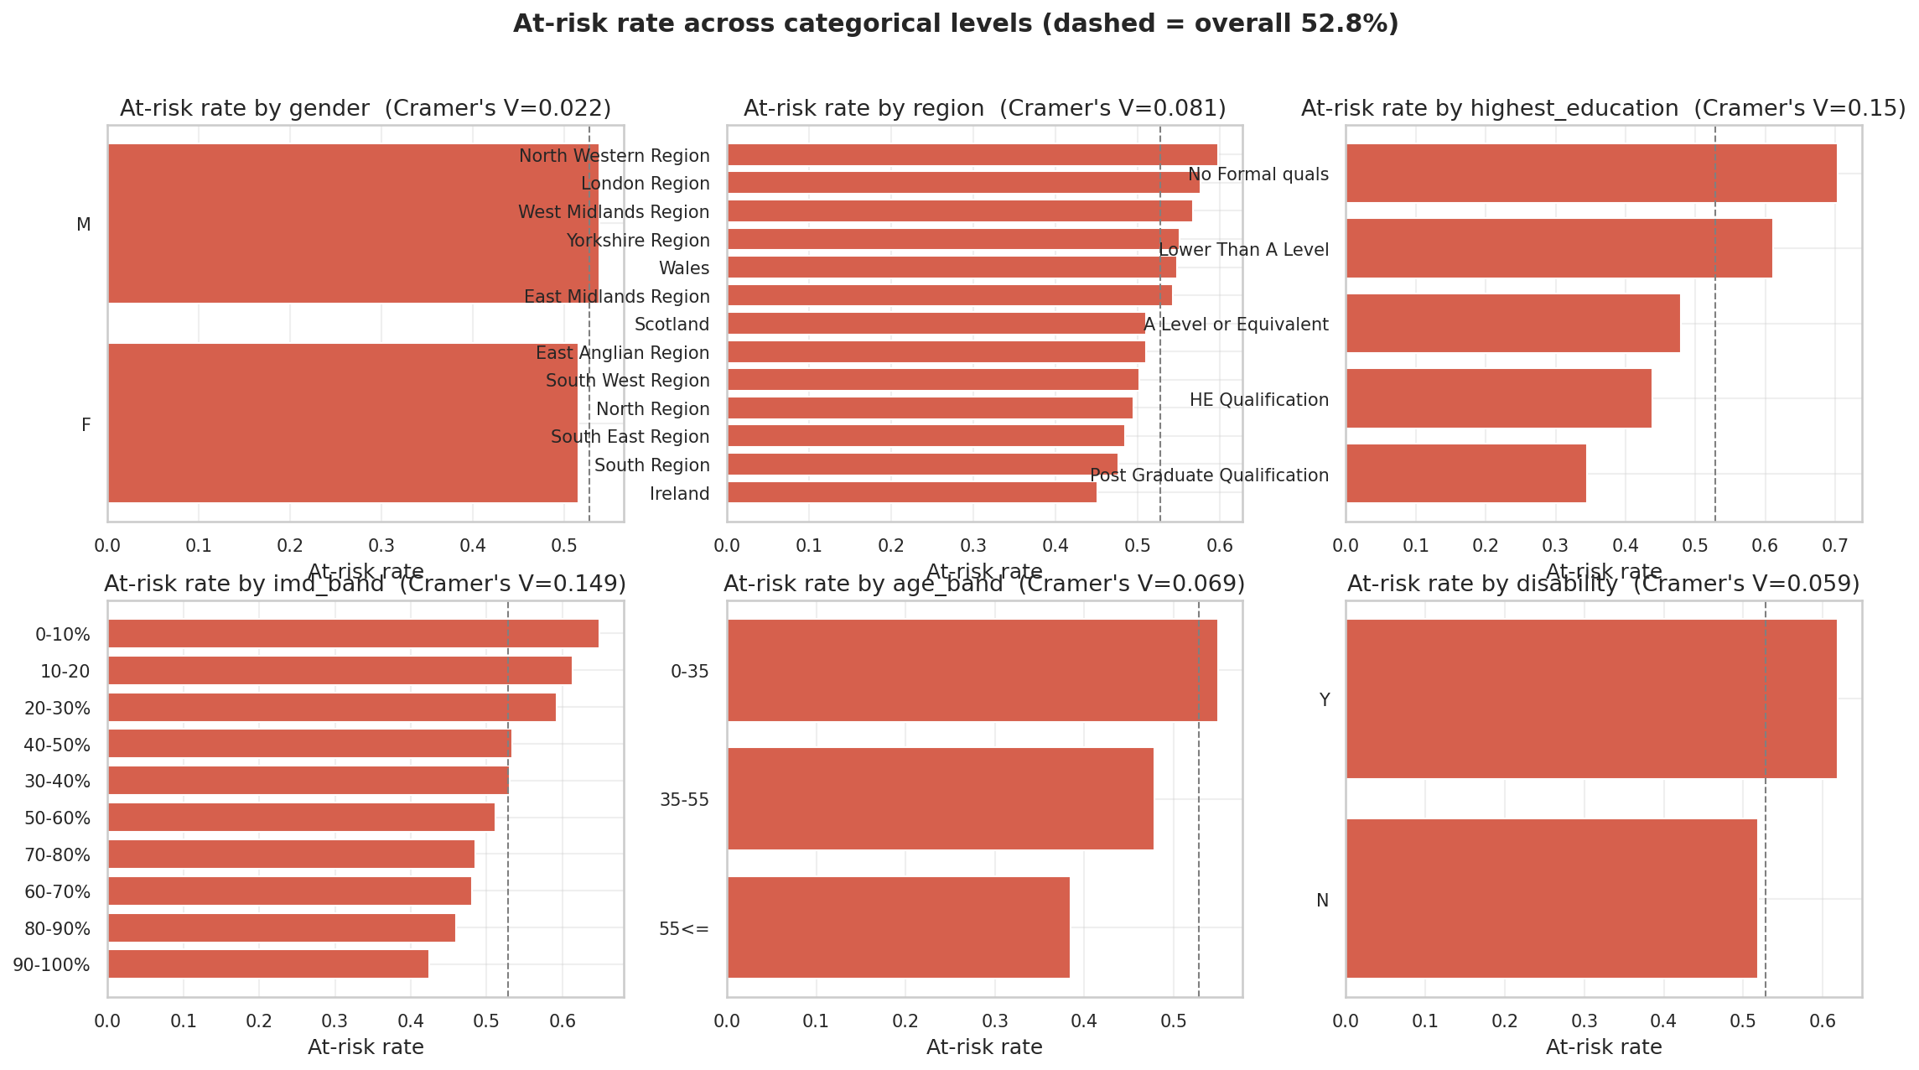
At-risk rate across categorical levels (dashed = overall 52.8%)

4.5 Multivariate — correlation, multicollinearity, leakage (STT 37)
Pearson and Spearman agree on the structure. Two pairs are multicollinear (|r| ≥ 0.8): n_days_active–total_clicks (0.84) and days_since_last_activity–n_assessments_submitted (−0.83) — relevant to explanation stability (RQ2). Strongest target correlations: days_since_last_activity (0.78), n_assessments_submitted (0.72), weighted_score_to_date (0.71). No feature correlates ≥ 0.95 with the target, so none acts as a leakage proxy.
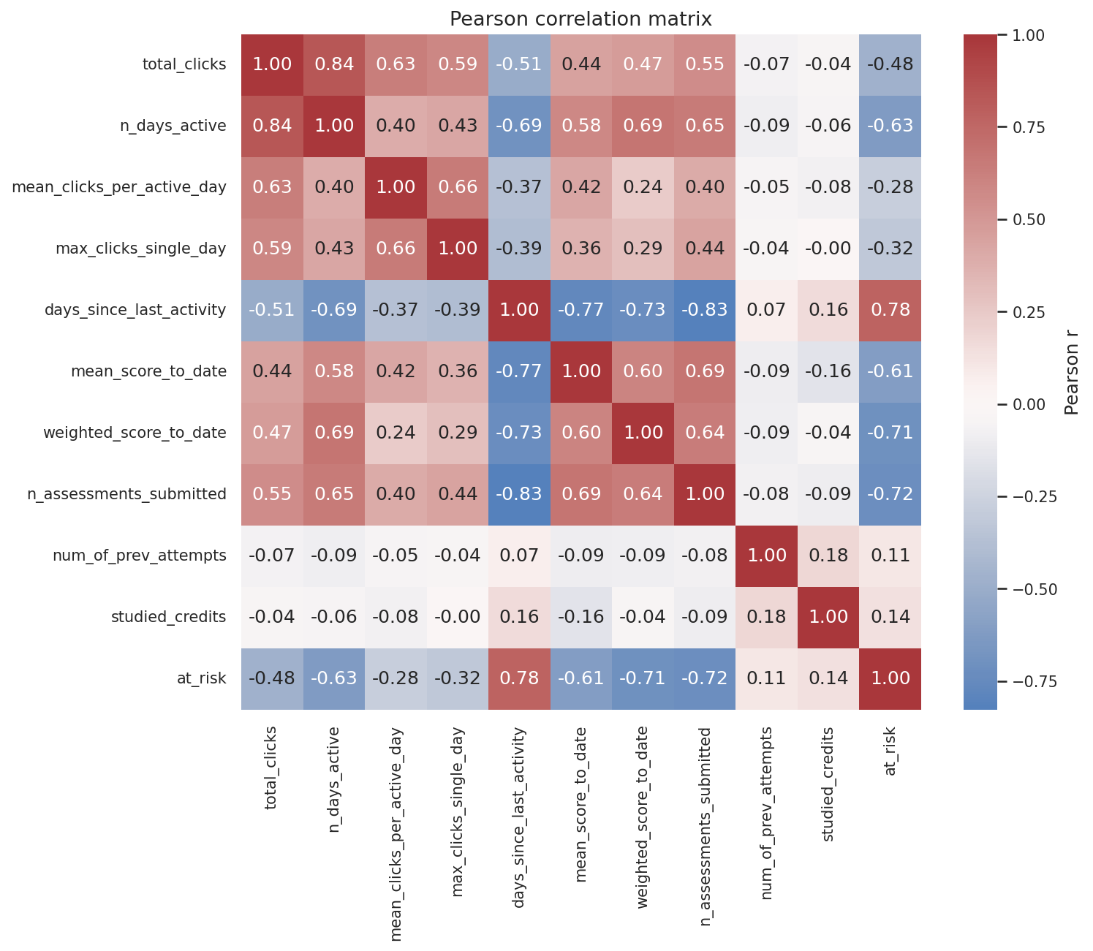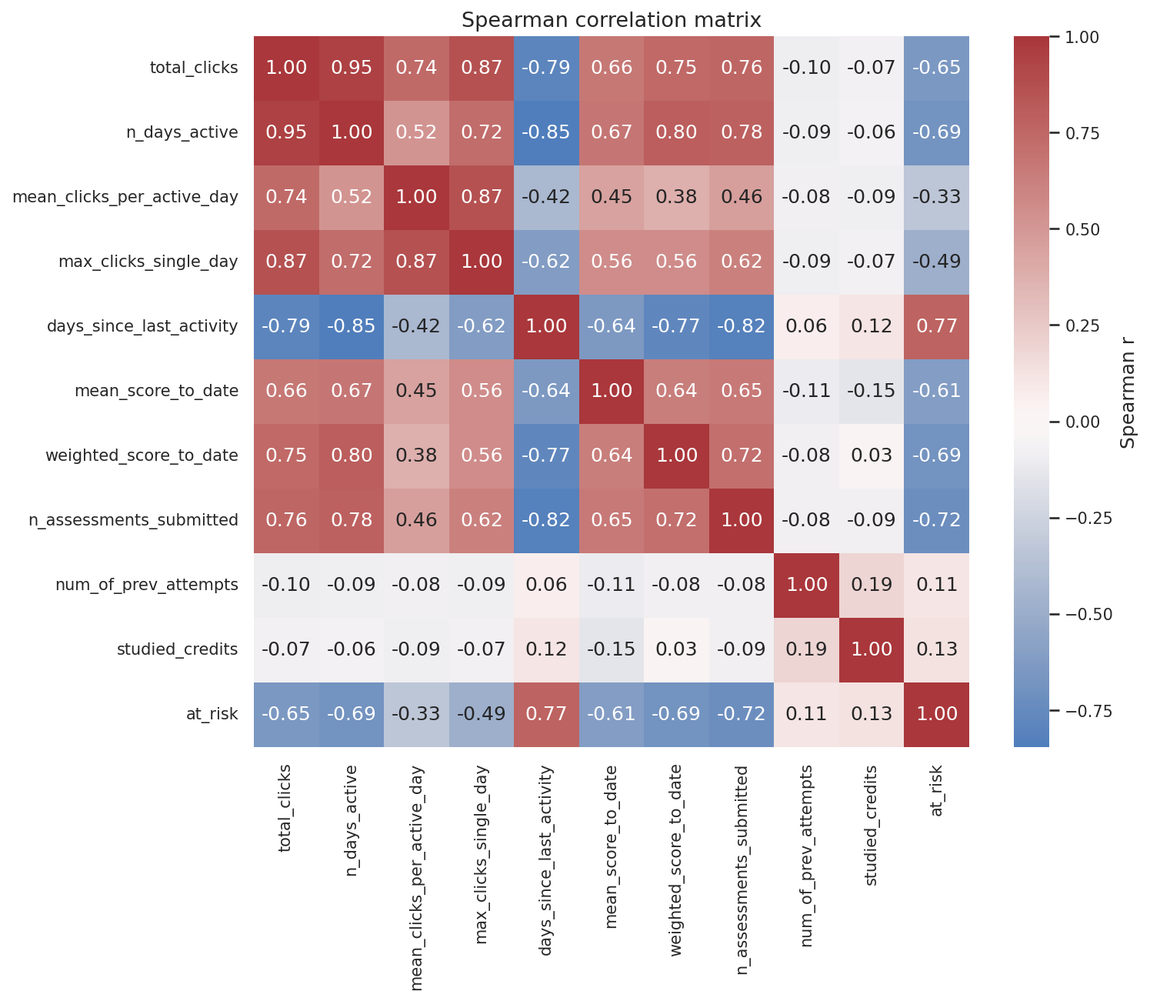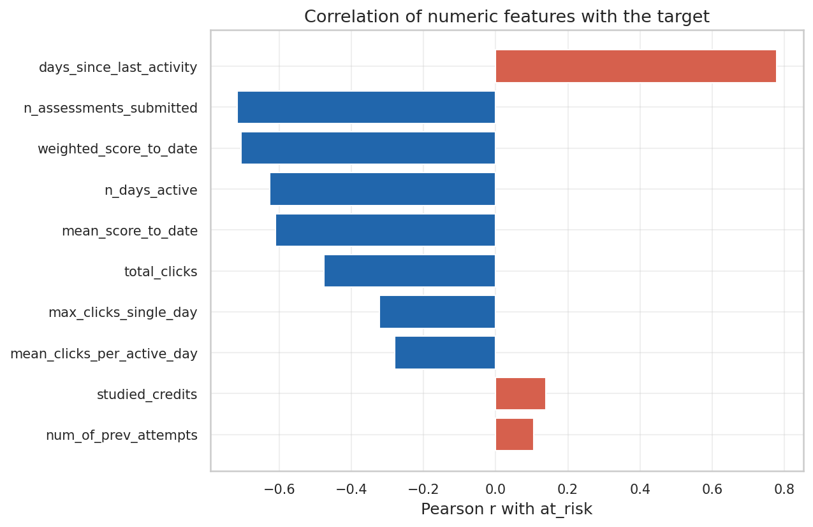

4.6 Time-aware analysis — when does the signal emerge? (STT 38, RQ1)
Tracking |Cohen’s d| per checkpoint shows how class separability grows as the course progresses. n_days_active already exceeds the large-effect threshold (d ≥ 0.8) at t = 10%; the score and submission features cross it by t = 20%; days_since_last_activity by t = 40%. The behavioural signal is therefore actionable from ~20–40% of course length, grounding the RQ1 schedule in evidence.
Feature | earliest t with |d| ≥ 0.8
n_days_active | 10%
mean_score_to_date · n_assessments_submitted · weighted_score_to_date | 20%
days_since_last_activity | 40%
total_clicks | 60%
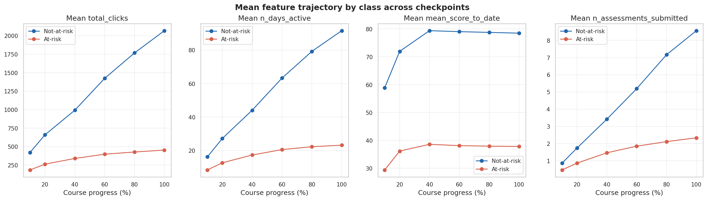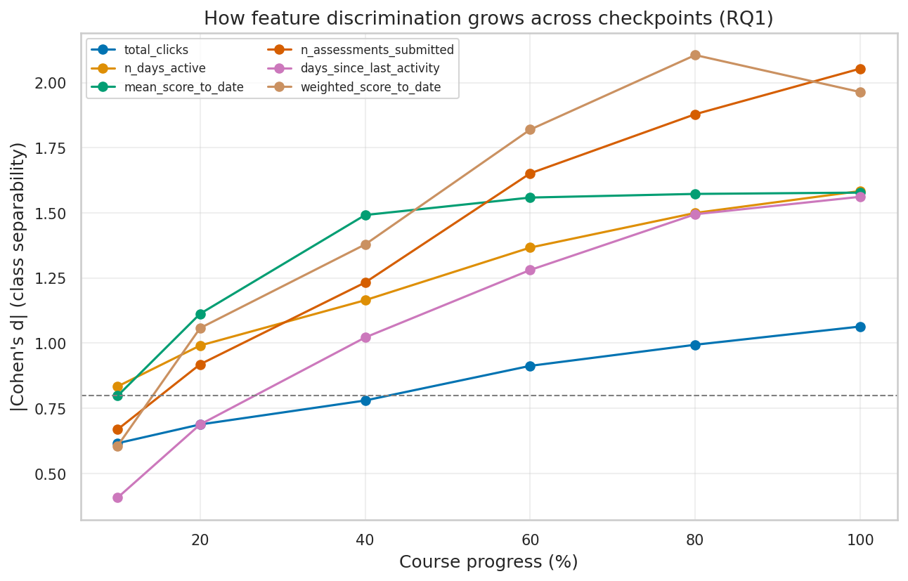

4.7 The Withdrawn early-warning signal (Step-0 Option A)
The data confirms Option A’s premise that withdrawal produces a genuine signal rather than noise: median inactivity is 11 days for not-at-risk, 116 for Fail, and 233 for Withdrawn, while median total clicks fall from 1,425 (not-at-risk) to 89 (Withdrawn). The activity collapse of withdrawing students is exactly what makes early detection feasible.
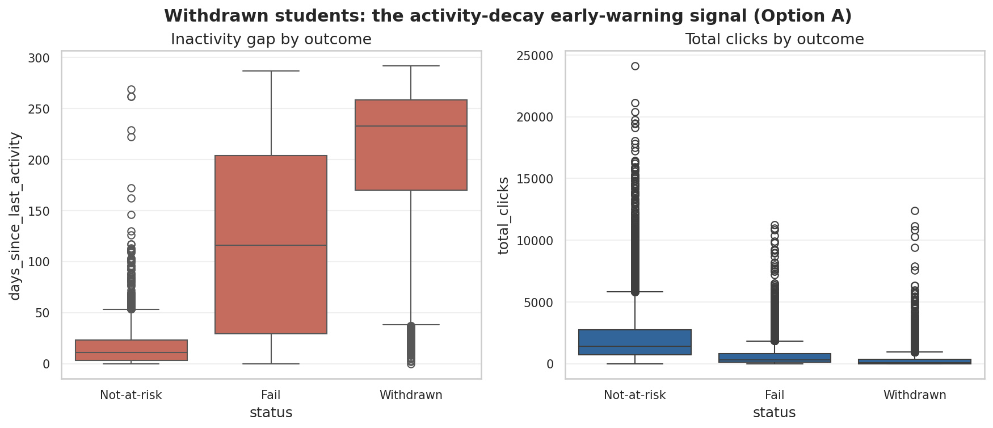
Withdrawn students: the activity-decay signal

4.8 Findings and implications for modelling
- F1 (RQ1) — early, growing signal. Behavioural/performance features separate the classes from t = 10–20% and strengthen monotonically; 40–60% is a robust, actionable window (consistent with Adnan et al. [1]).
- F2 (RQ1/RQ2) — behaviour ≫ demographics. Engagement/performance reach d > 2 while demographic association stays small (Cramér’s V ≤ 0.15), reproducing Tomasevic et al. [2]; SHAP/LIME are expected to rank behavioural features highest.
- F3 (RQ3) — mild imbalance. At 52.8% at-risk, resampling may add little; RQ3 quantifies SMOTE/ADASYN/class-weight against this baseline using PR-AUC/recall.
- F4 (RQ2) — correlated features. Multicollinear engagement features may destabilise explanation importance — a factor the stability metric must account for.
- F5 — no leakage. No feature is near-perfectly correlated with the label, and the time-aware cut removes future events; held-out estimates should be trustworthy.

References
- M. Adnan et al., “Predicting at-Risk Students at Different Percentages of Course Length for Early Intervention,” IEEE Access, vol. 9, pp. 7519–7539, 2021.
- N. Tomasevic, N. Gvozdenovic, S. Vranes, “An overview and comparison of supervised data mining techniques for student exam performance prediction,” Computers & Education, vol. 143, art. 103676, 2020.
- J. Kuzilek, M. Hlosta, Z. Zdrahal, “Open University Learning Analytics dataset,” Scientific Data, vol. 4, art. 170171, 2017.
- S. Gunasekara, M. Saarela, “Explainable AI in Education: Techniques and Qualitative Assessment,” Applied Sciences, 2025.
- N. V. Chawla et al., “SMOTE: Synthetic Minority Over-sampling Technique,” JAIR, 2002.

