<https://luimanhon.azurewebsites.net/>  
\*This app service is NOT always on in free tier app service plan, so it will take a few minutes to load in the first time.   
\*It is a demo frontend website with fake data and no backend is supported, so you can enter anything in username and password to login

Part 1: Login

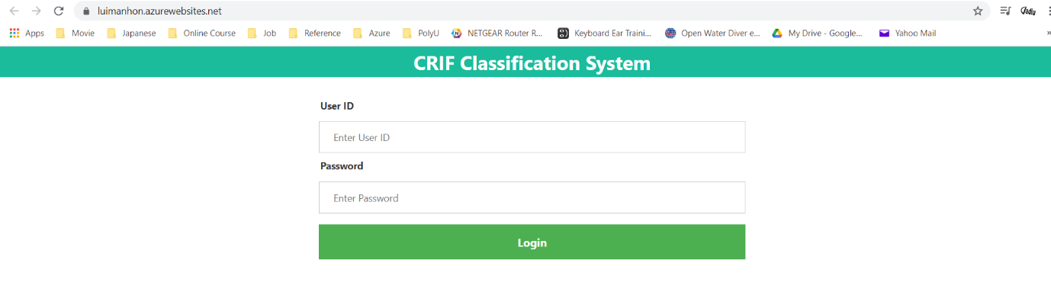

After entering invalid username and password:  
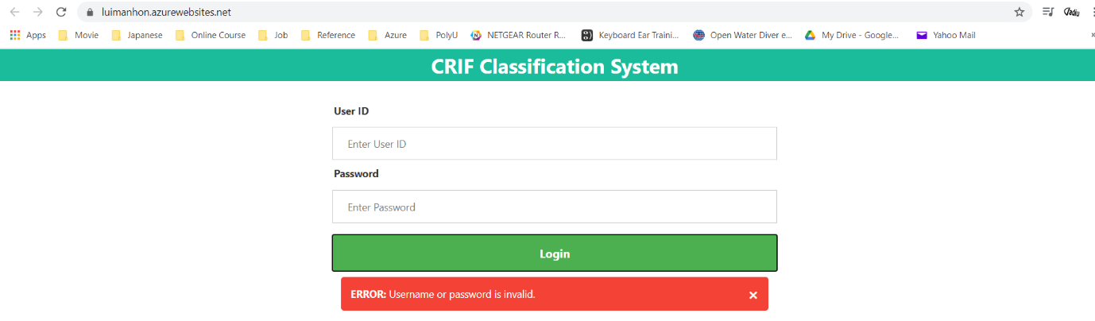

After successful login:  
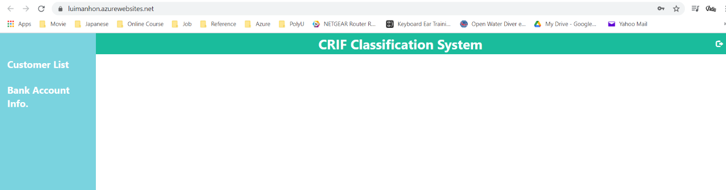

Part 2: Customer List  
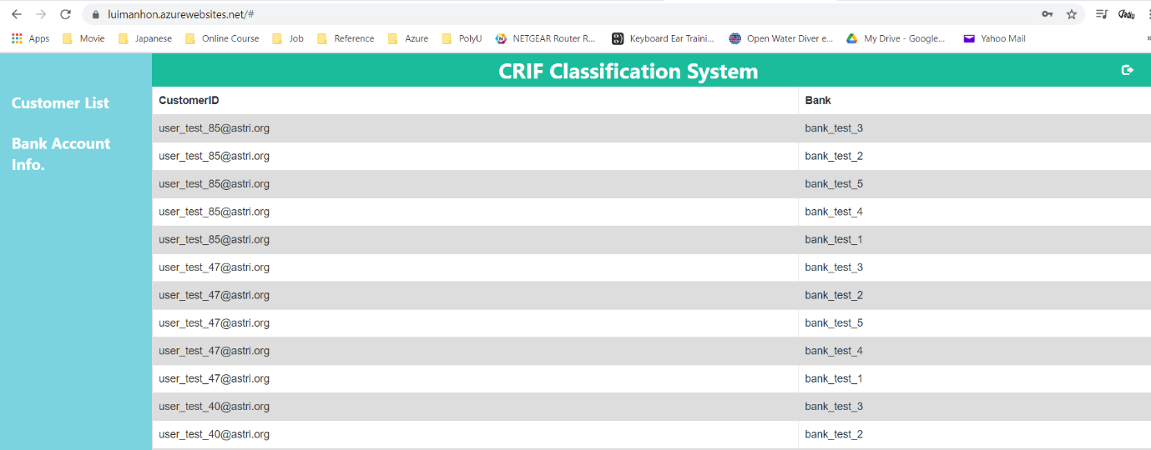

Part 3: Bank Account Info.

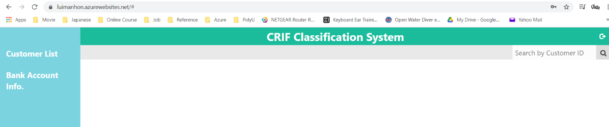

After searching an invalid customer ID in search bar:  
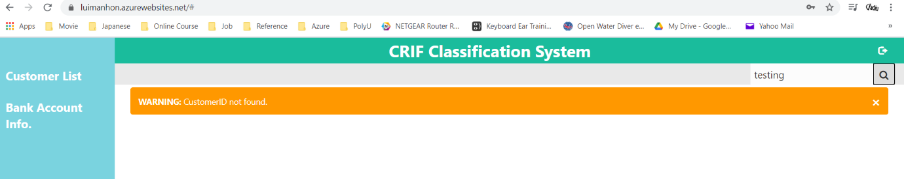

After searching an existed customer ID:  
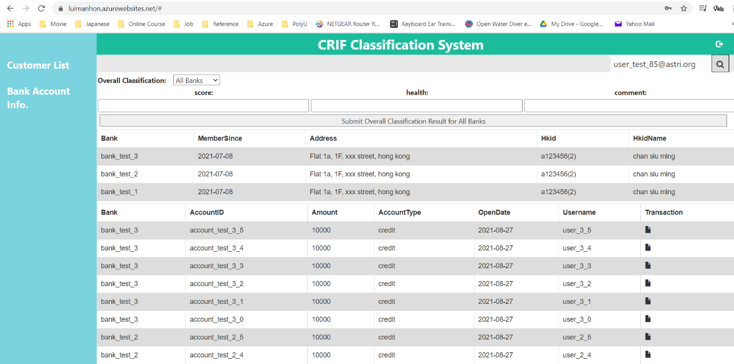

After submitting overall classification result for all banks or a particular bank:  
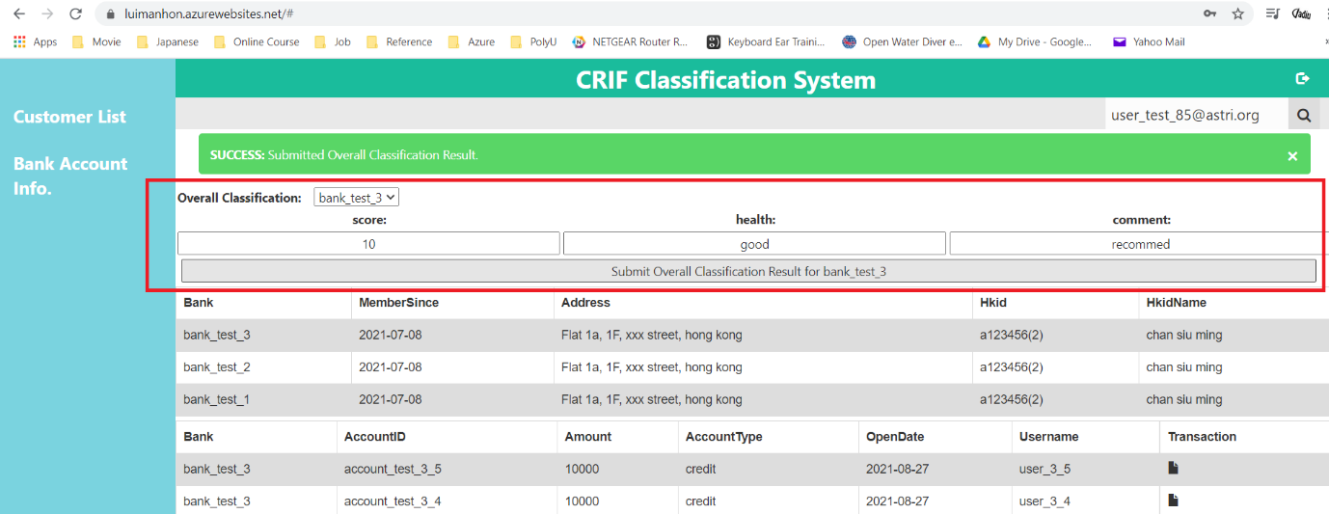

Part 4: Transaction Info.  
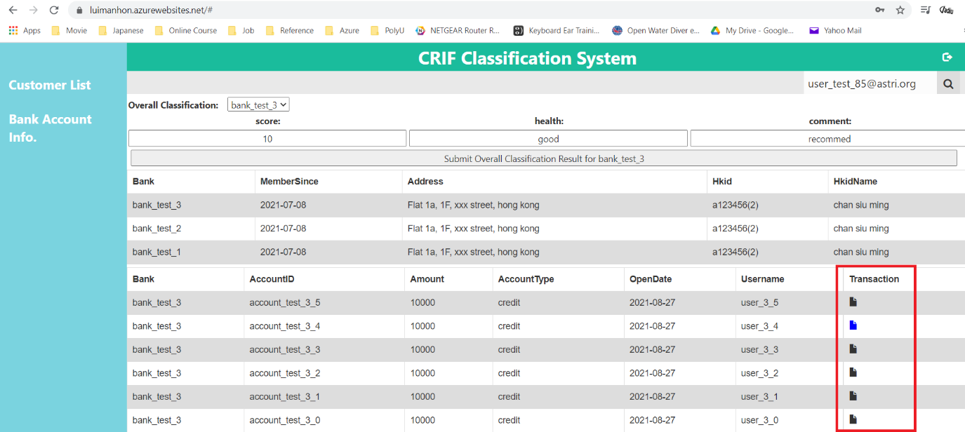

After clicking the transaction icon for a particular account but no transaction record found:

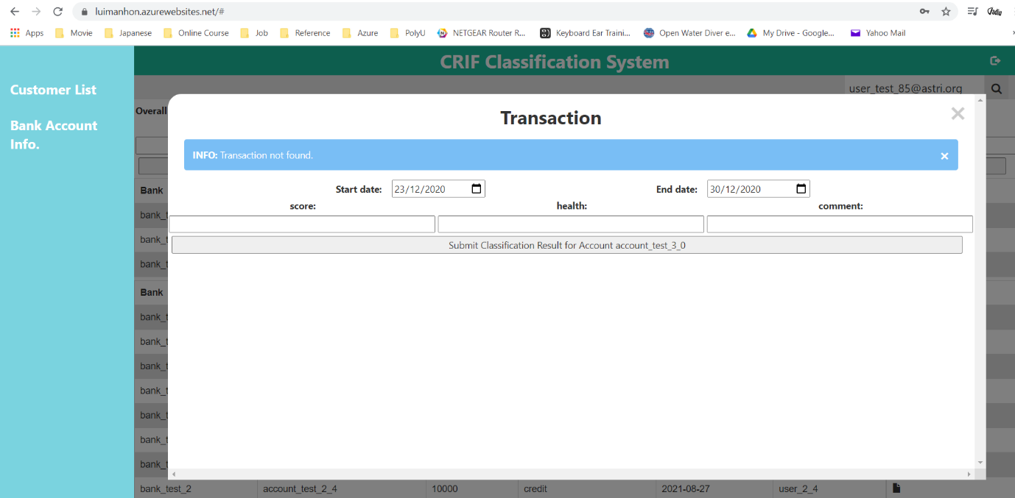

After clicking the transaction icon for a particular account and transaction record found:

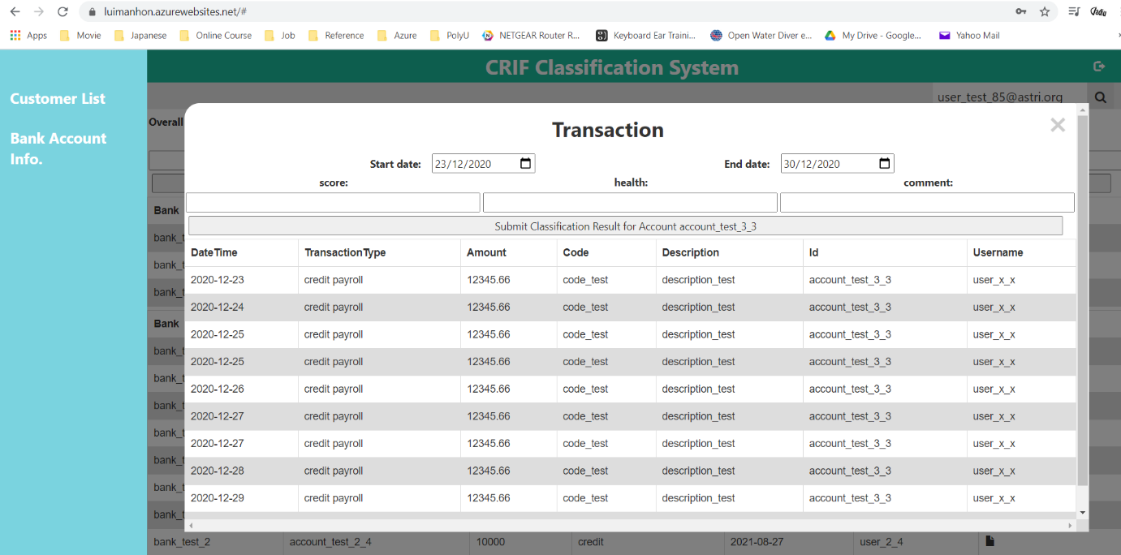

After submitting the classification result for a particular account:  
