1.  
Download the test script  
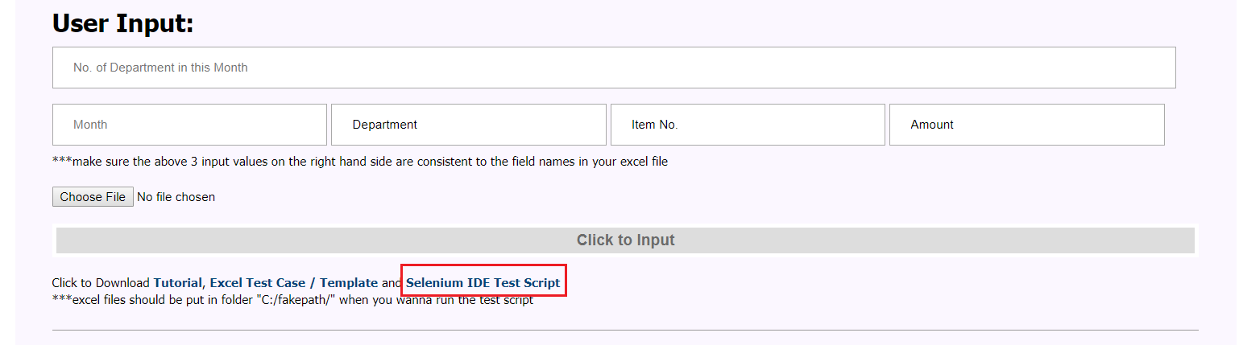

2.  
Download the test case  
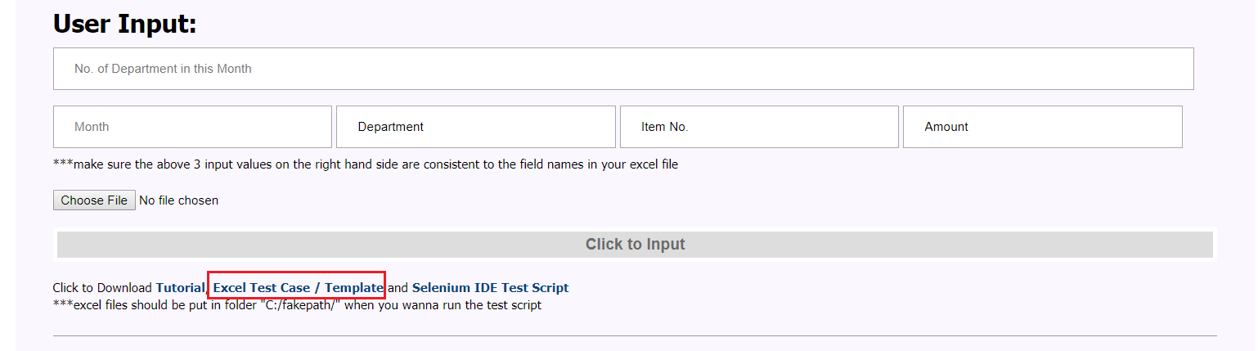

3.  
Download Selenium IDE  
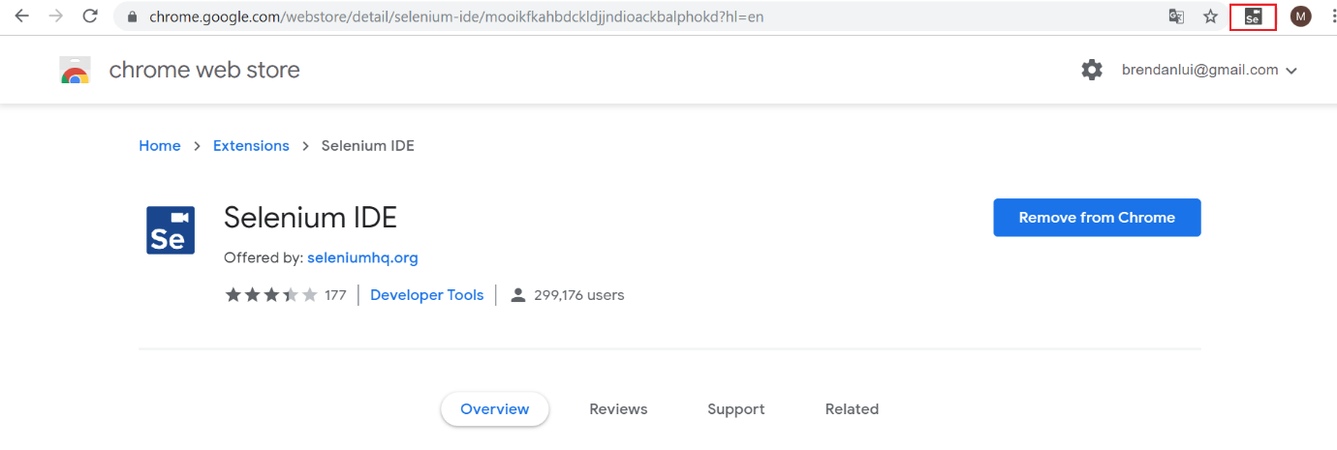

4.  
Click More Tools -> Extensions  
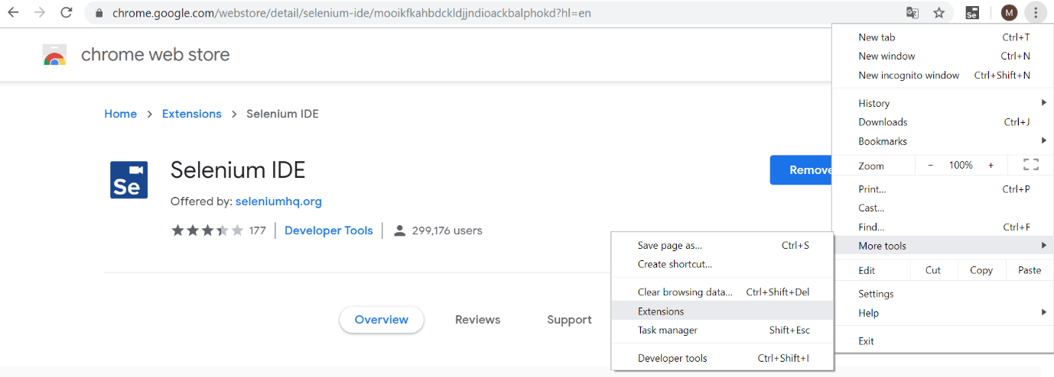

Click Selenium IDE Details

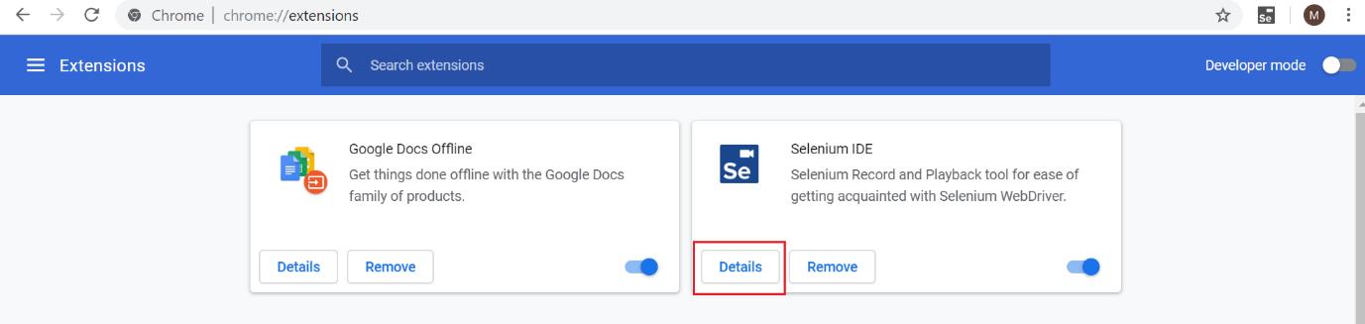

Check the following – “Allow access to file URLs”  
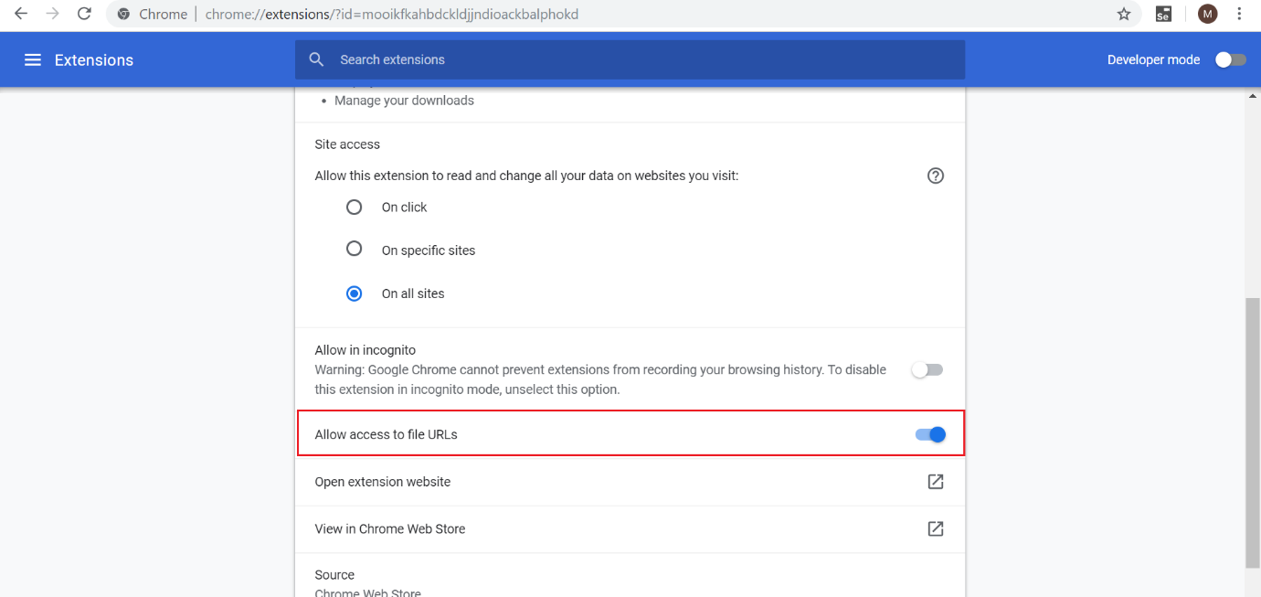

5.  
Put the Excel test case files under the path – “C:\fakepath\”  
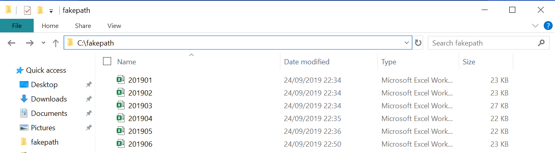

6.  
Open the Selenium IDE with the test script  
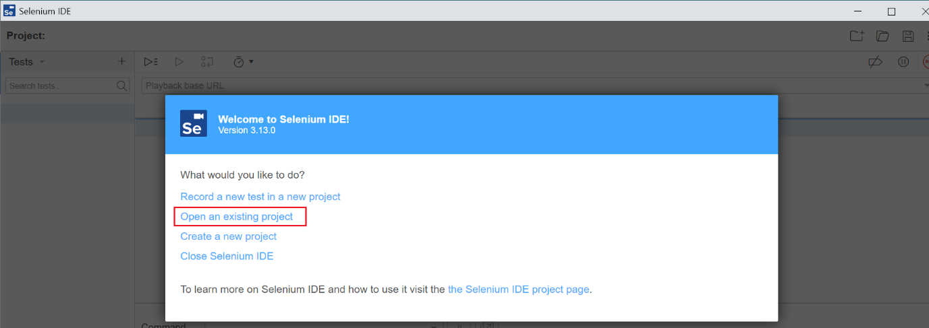

7.  
Click RUN  
