Step 1:  
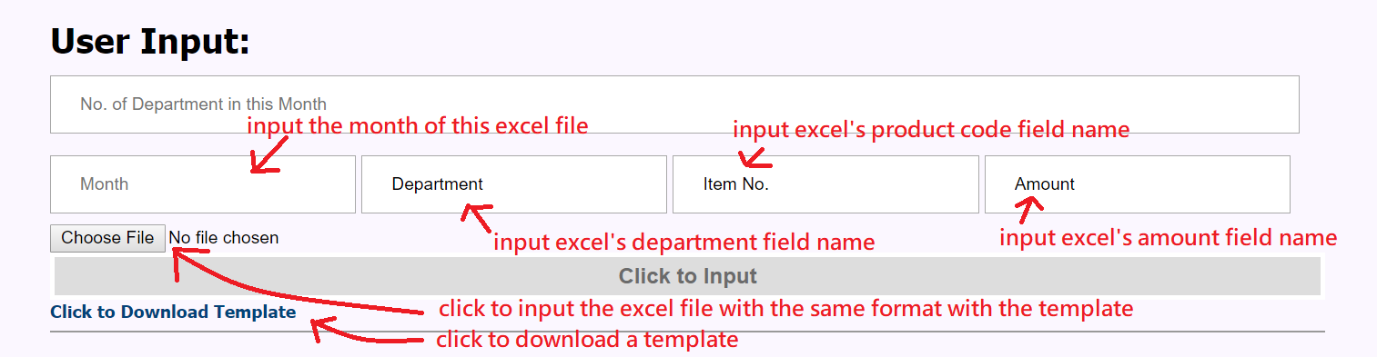

Step 2:  
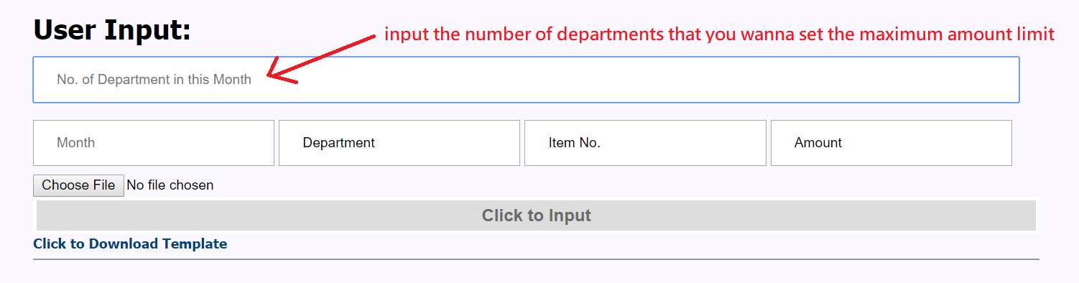

Step 3:  
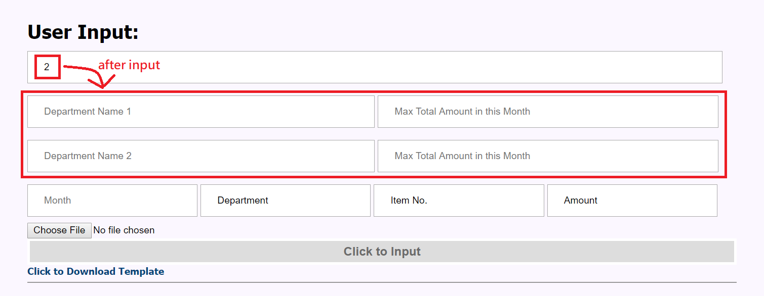

Step 4:  
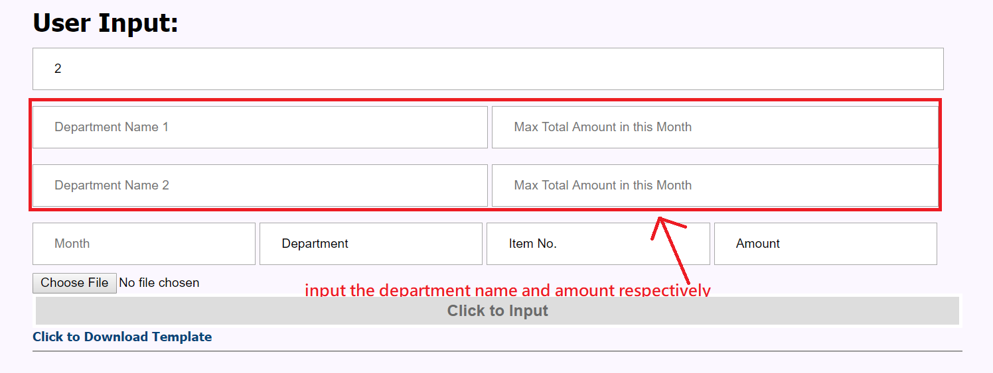

Step 5:  
For your reference,  
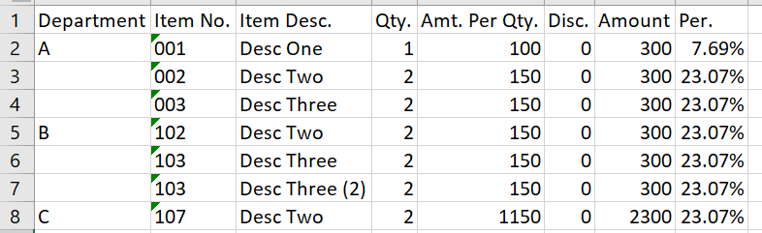

Step 6:  
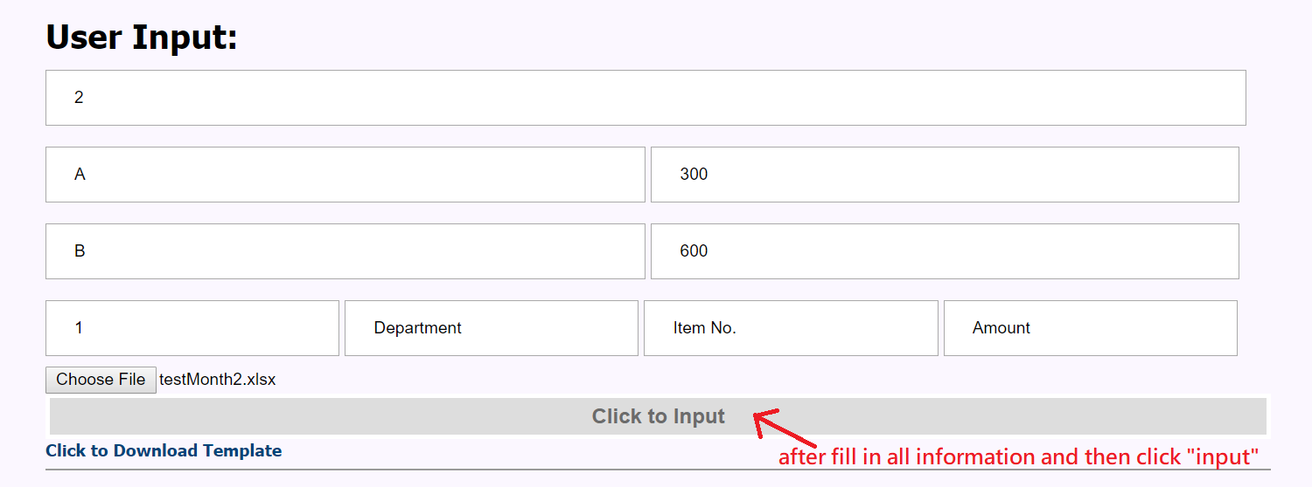

Step 7:  
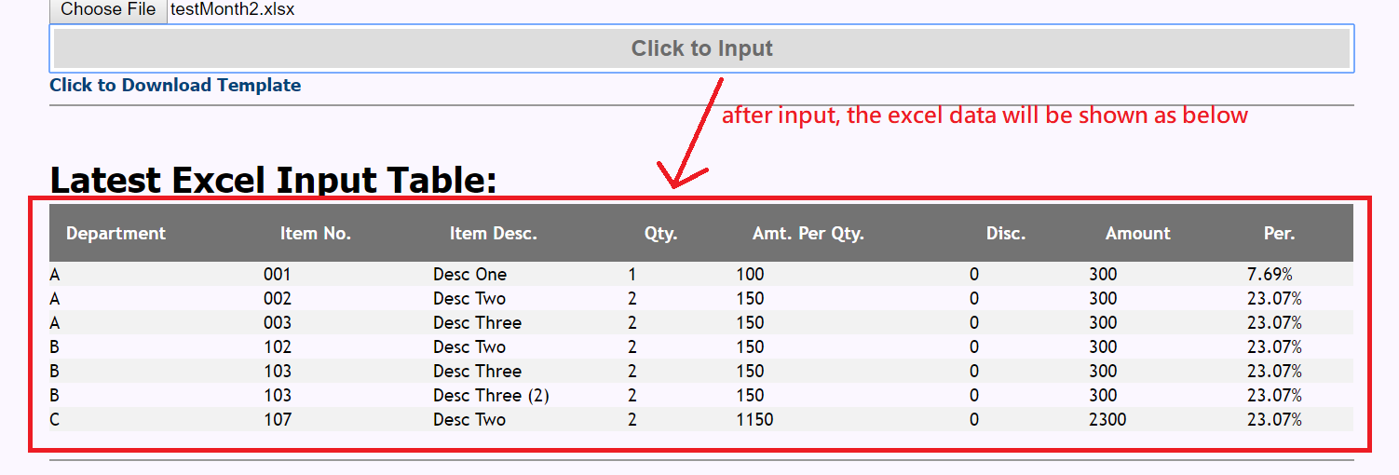

Step 8:  
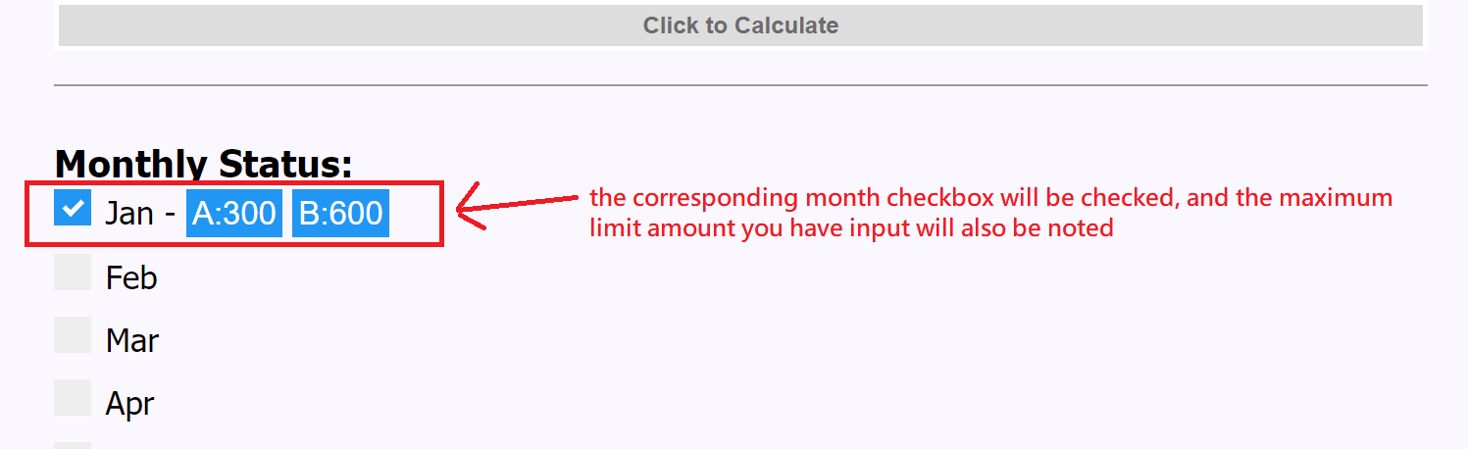

Step 9:  
With the above same step to input another excel with different months  
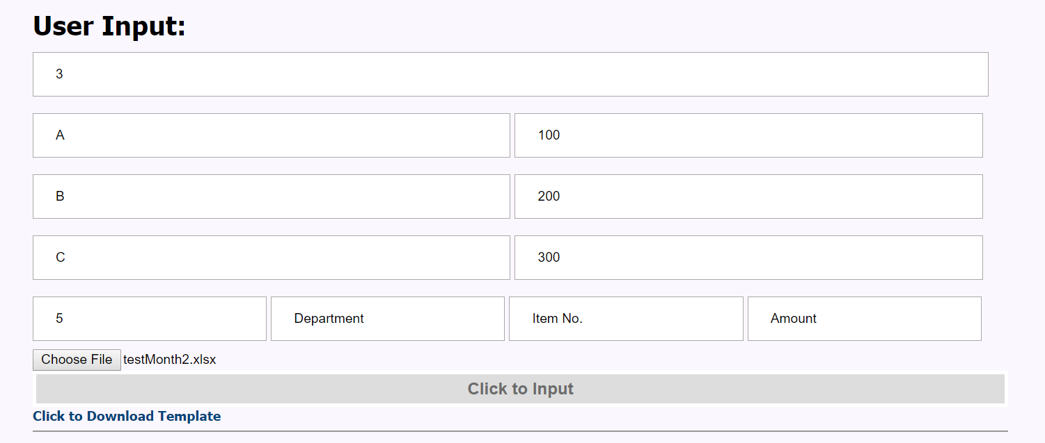

Then we can see the below note:  
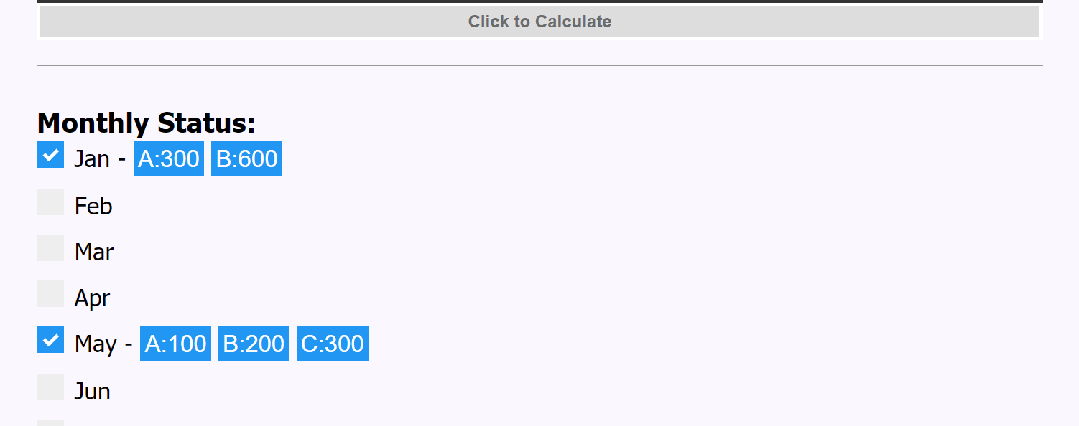

Step 10:  


Step 11:  
