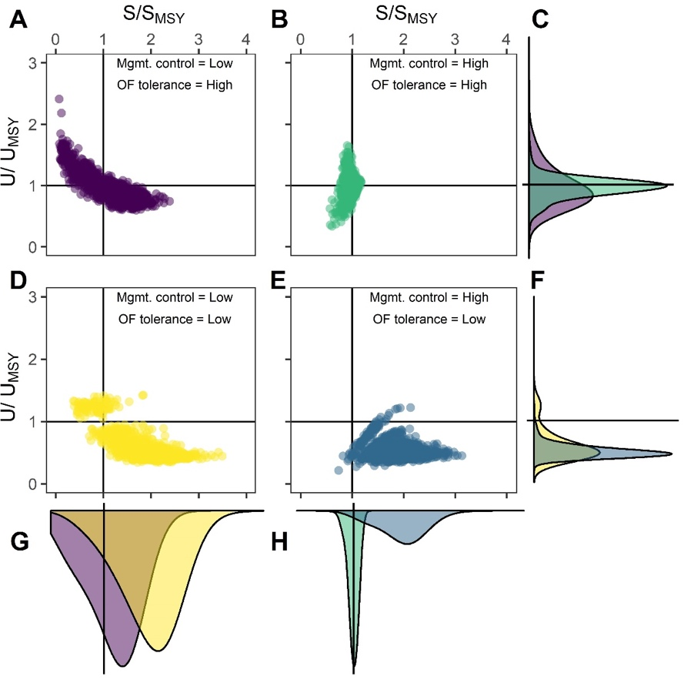
Figure 3.

Old Figure 4.
New Figure 4.

