`

**DementiaTrack**

**Final Report**

**Team Members:**

Chase Walters

Tyler McCaulley

Brendan Perry

Ryan Hurd

**Revision History**

|  |  |  |  |
| --- | --- | --- | --- |
| **Version** | **Author(s)** | **Description** | **Date** |
| 1.0 | Hurd, Ryan | Added Bibliography (working on putting into .bib file) | 09/28/20 |
| 1.1 | Walters, Chase | Added Bibliography | 09/28/20 |
| 1.2 | McCaulley, Tyler | Added Bibliography, set layout, added content | 09/28/20 |
| 1.21 | Hurd, Ryan | Proof-reading | 09/29/20 |
| 1.3 | Perry, Brendan | Added bibliography, left bar styling will need adjusting | 09/30/20 |
| 1.4 | McCaulley, Tyler | Setting everything up for final assembly | 9/30/20 |
| 1.5 | Walters, Chase | Slight Adjustments Made | 10/1/20 |
| 1.51 | Perry, Brendan | Formatting | 10/1/20 |
| 1.6 | Walters, Chase | Software Architecture Design Added | 10/26/20 |
| 1.61 | Walters, Chase | Began Adjusting Requirements to new plan | 10/27/20 |
| 1.62 | Walters, Chase | Tasks & Previous Tasks | 10/27/20 |
| 1.7 | McCaulley, Tyler | Added reading, data collection plan | 10/27/20 |
| 1.8 | Perry, Brendan | Added citation, proofreading | 10/28/20 |
| 1.81 | Hurd, Ryan | Added citations, proofreading | 10/29/20 |
| 1.82 | Perry, Brendan | Proofreading | 10/29/20 |
| 1.83 | McCaulley, Tyler | Proofreading | 10/29/20 |
| 2.0 | Perry, Brendan | Updated Project Plan and requirements to reflect post midterm goals | 12/3/20 |
| 2.01 | Perry, Brendan | Minor adjustments in wording | 12/4/20 |
| 2.02 | Walters, Chase | Adjusting Software Architecture | 12/8/20 |
| 2.03 | McCaulley, Tyler | Adding to reading list | 12/8/20 |
| 2.04 | Perry, Brendan | Minor adjustments, added to reading list | 12/10/20 |
| 3.0 | Walters, Chase | Began preparation for CS465 Midterm Report | 3/20/2021 |
| 3.1 | McCaulley, Tyler | Added to report | 3/20/2021 |
| 3.11 | Walters, Chase | Added parts to report | 3/20/2021 |
| 3.12 | Hurd, Ryan | Added parts to report | 3/20/2021 |
| 4.0 | Walters,Chase | Began Final Document | 4/28/2021 |
| 4.1 | Perry, Brendan | Testing Report | 4/29/2021 |
| 4.1 | Hurd, Ryan | Testing Report | 4/29/2021 |

**Problem Statement:**

As a team, we want to correlate the symptoms of dementia to data, by researching said symptoms and the data that pertains to each symptom, to then be analyzed by Artificial Intelligence (AI). Once all symptoms are mapped to data that can be analyzed by AI, we will implement a prototype system to cover the collection of data. This data will pertain to said symptoms to the best of our ability given the availability of sensor technology at this time. The prototype system will then be used to advance the tracking of the early onset of dementia in a patient and develop an efficient alert system to notify if the progression is worsening. Once the system is in place, we hope to pursue publication of our work.

**Requirements:**

All requirements for the Senior Capstone have been met by the DementiaTrack team.

**Project Plan:**

Finalizing this semester. I, Chase Walters, will begin the project proposal for the Senior Capstone 2021-2022 Team in the Fall, in hopes that a team will pick this project to continue the work that we had begun. With this I hope to be able to guide them as well as a sort of Mentor for this project. My teammates will begin their work in the field as many of them have obtained or are maintaining a position in the Computer Science field of work. I will keep pursuing education and further it towards a master's degree.

**Data Description:**

Data collection of this project needed to be premade. Our scope didn’t have the capability to add the time to be able to collect data in segment of time that as allotted for this course. Since that was the case, we found a series of online free data provided to the public to utilize. The primary data points we needed to secure where:

* Data for Movement Analysis (Date, Location) - Data was provided by: [Center of Advanced Studies In Adaptive System](http://casas.wsu.edu/datasets/)
* Data for Sleep analysis (x, y, z, temperature, luminance) - Self generated/came with library
* Data for UTI analysis (Date, Location) - Bathroom Trips – Self generated and data provided by: [Center of Advanced Studies In Adaptive System](http://casas.wsu.edu/datasets/); (Date, Temperature) Body Temperature – Self generated and data provided by [B Kemp, AH Zwinderman, B Tuk, HAC Kamphuisen, JJL Oberyé](https://physionet.org/content/sleep-edfx/1.0.0/sleep-cassette/)
* Data for Daily Activities Analysis (Date, Location) - Self generated and data provided by: [Center of Advanced Studies In Adaptive System](http://casas.wsu.edu/datasets/);

**Tasks:**

All the tasks and assignments are now being held on the Product Backlog. For more information look at the DementiaTrack Excel Sheet provided in the submission.  
  
**Sprint Artifacts:**

The Sprint Artifacts are limited to the cases of each sprint. Since the projects requirements and goals have maintained the same throughout the process of the Software Development, the use-cases have needed only a minor adjustment which was the database that was being used for this project. Instead of us utilizing the MLDB database, we switched over to MySQL since MLDB was purchased out and their qualities didn’t match the standards we wanted for this project. Other than that architecture change. We record all our teams' efforts and work by an Hour Log system on our Excel spreadsheet, as well as the amount of commits and work done can be shown through our GitLab or by utilizing the custom library known as GitBlame which shows the work done to the project. The burndown chart can be accessed through the Excel sheet as well as the product backlog.  
  
  
**Software Libraries:**

Movement Analysis- Libraries are limited to that of pyplot and seaborn for data handling to present the graphs to the front end for visualization. As for the algorithm that is presented with my work. The logic and pseudocode credit go to Vuong and his team for the creation of the logic, the implementation was done by Chase Walters. Information for his work can be found [here](https://journal.gerontechnology.org/archives/2233-2660-1-SM.pdf).

Sleep Analysis – Libraries used are NumPy, pandas, Pyplot for data handling to create graphs for front end visualization. In regards to algorithms for sleep scoring it is done using a library called SleepPy created by Yiorgos Christakis (linked [here](https://pypi.org/project/sleeppy/)), in which was implemented into the system by Tyler McCaulley.

UTI Analysis – The libraries used are pycaret for detecting bathroom trip anomalies and adtk for detecting body temperature anomalies along with pandas and matplotlib for data handling and graphs. Pycaret ([link](https://pycaret.org/)) and adtk ([link](https://adtk.readthedocs.io/en/stable/)) both rely on other various libraries.

Daily Activities Analysis - The libraries used are pyspcalt, a slightly modified version of pyspc, for taking the cumulative sum (a.k.a. CUSUM) calculations for the datasets. Both libraries can be found at: Pyspc ([link](https://github.com/carlosqsilva/pyspc)) and Pyspcalt ([link](https://github.com/brendanperry/pyspc)).

**Software Test Cases:**

**Movement:**

**Normal:**

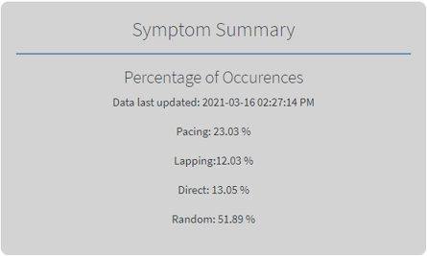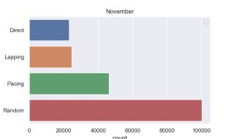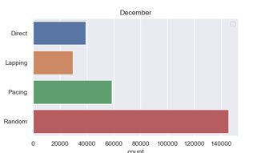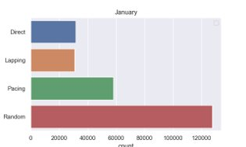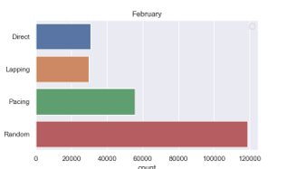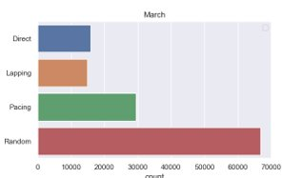

**Abnormal:**

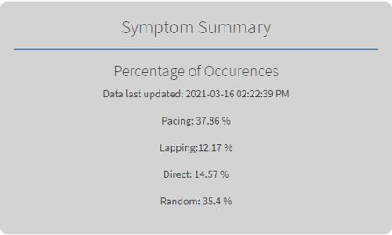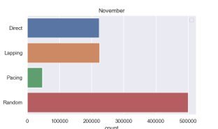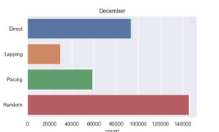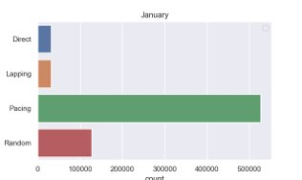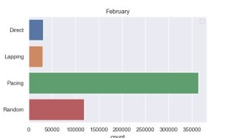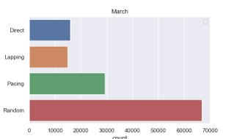

**Random:**

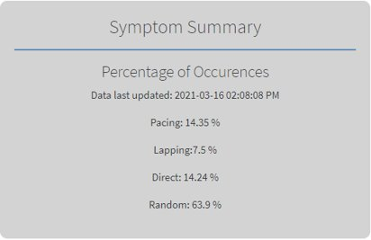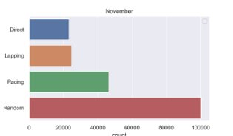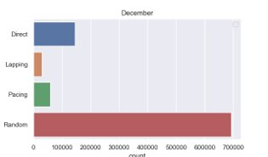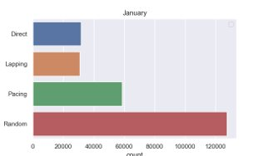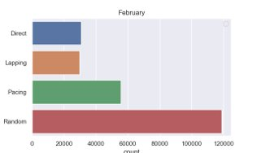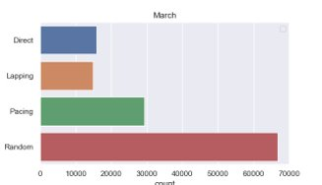

**Sleep Disorders:**

**Normal:**

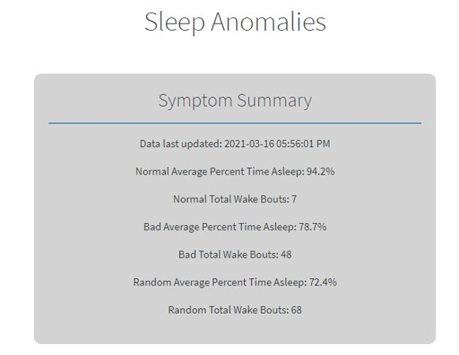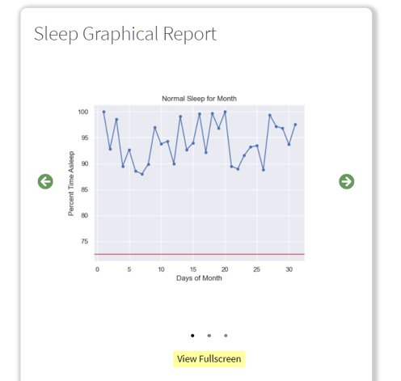

**Abnormal:**

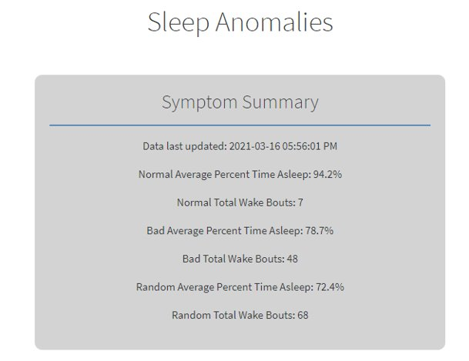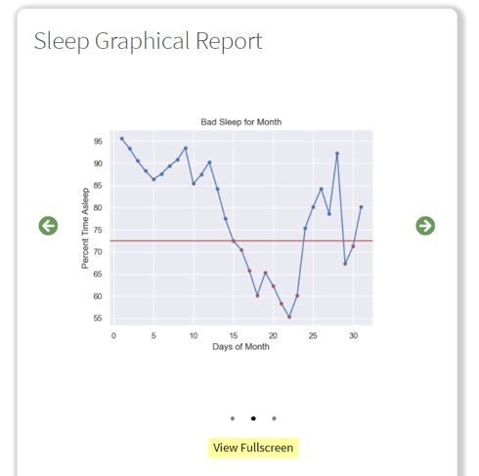

**Random:**

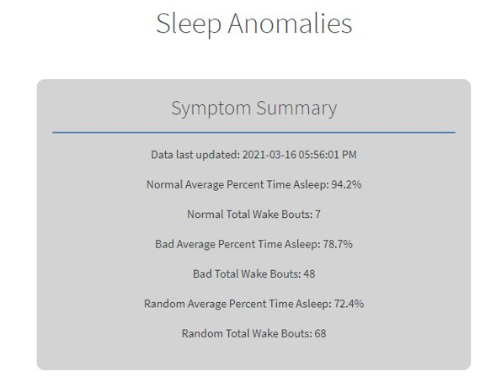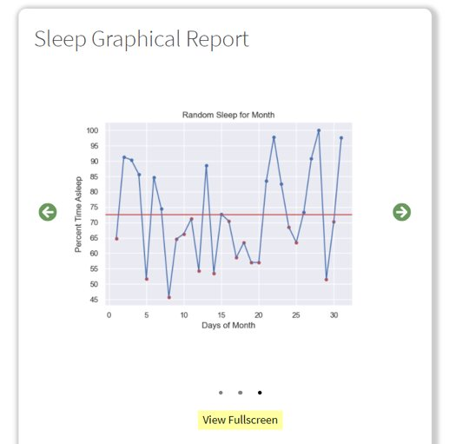

**UTI:**

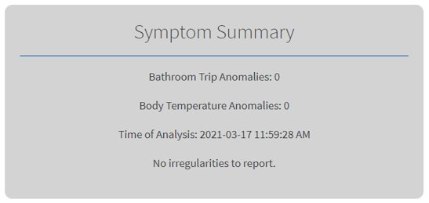

**Normal:**

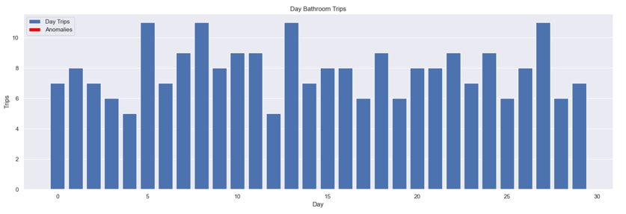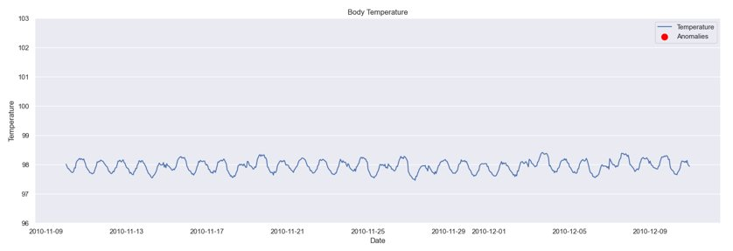

**Abnormal:**

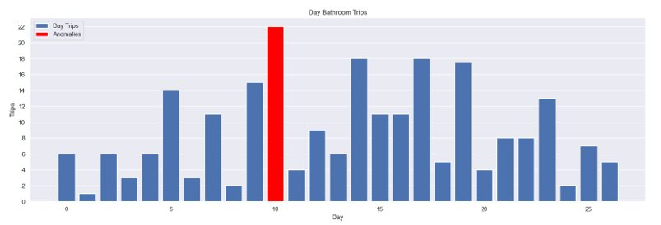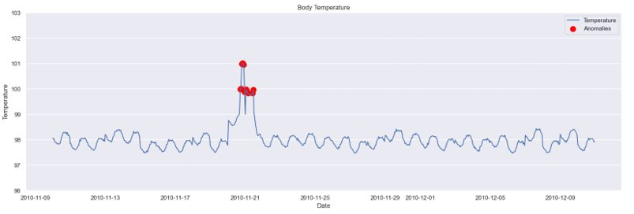

**Random:**

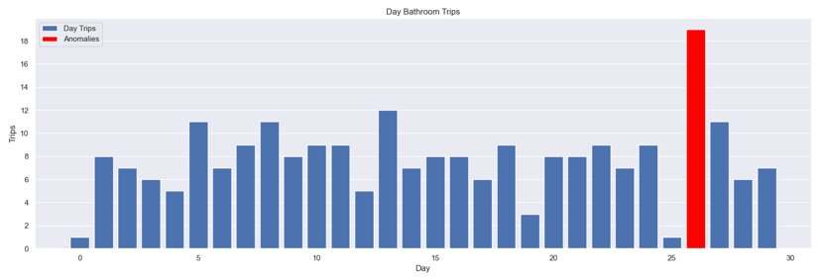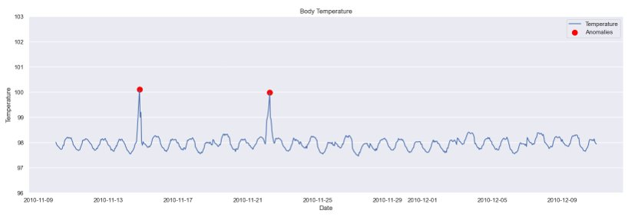

**Daily Activities:**

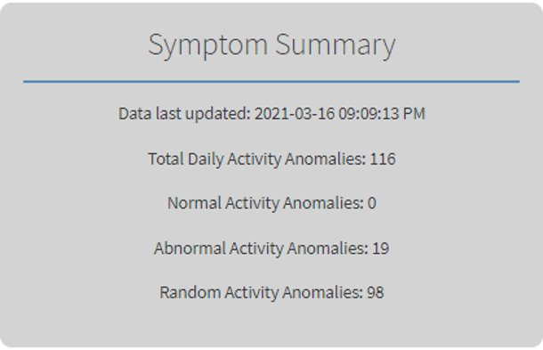

**Normal:**

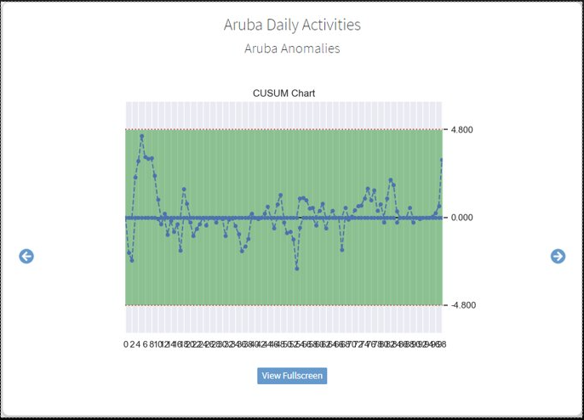

**Abnormal:**

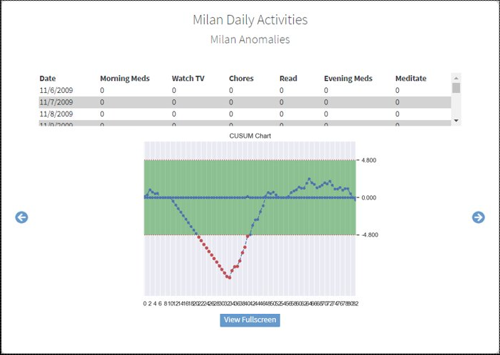

**Random:**

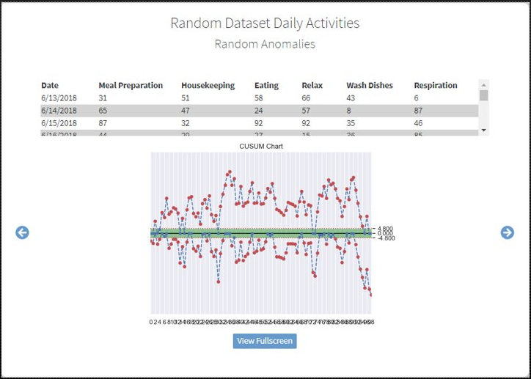

**Dashboard:**

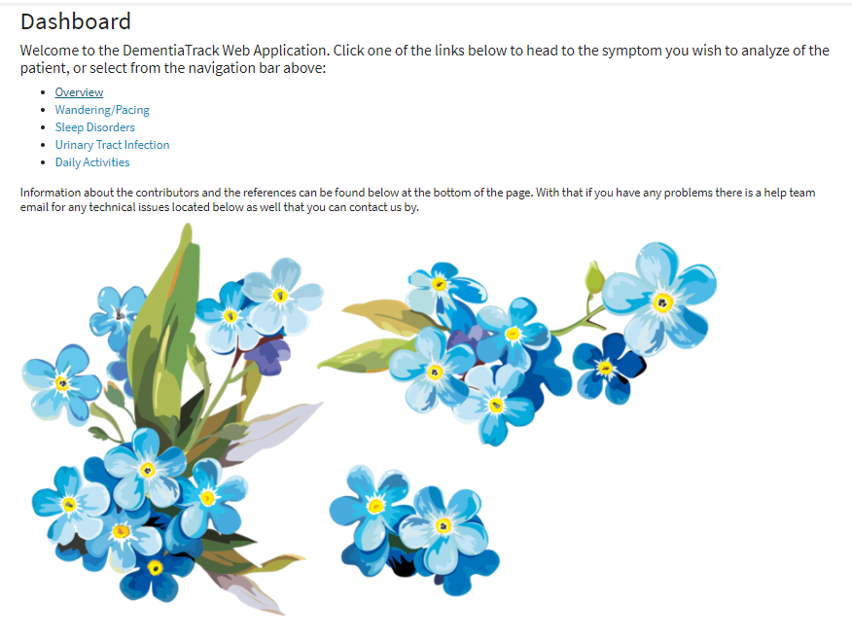

**Overview:**

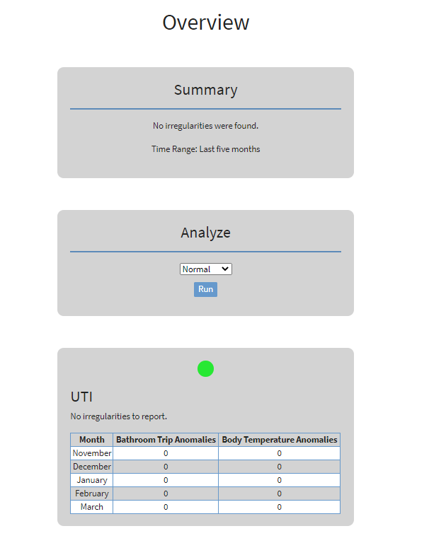

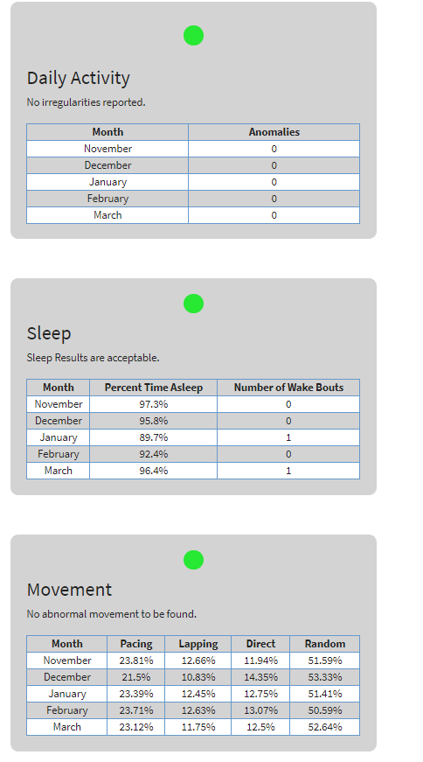

**Contributions:**

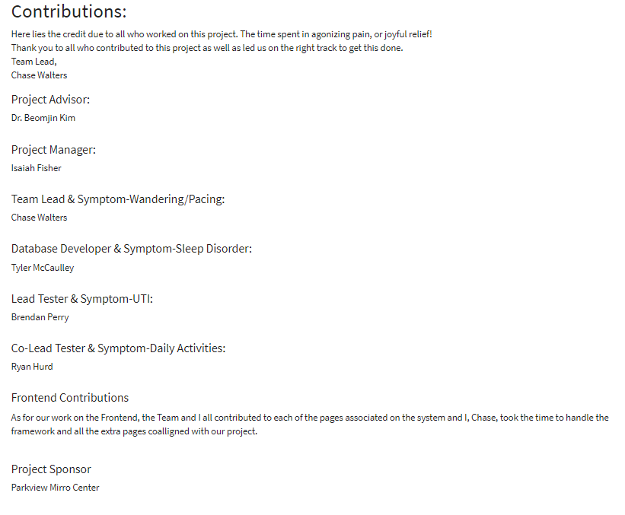

**Reference List:**

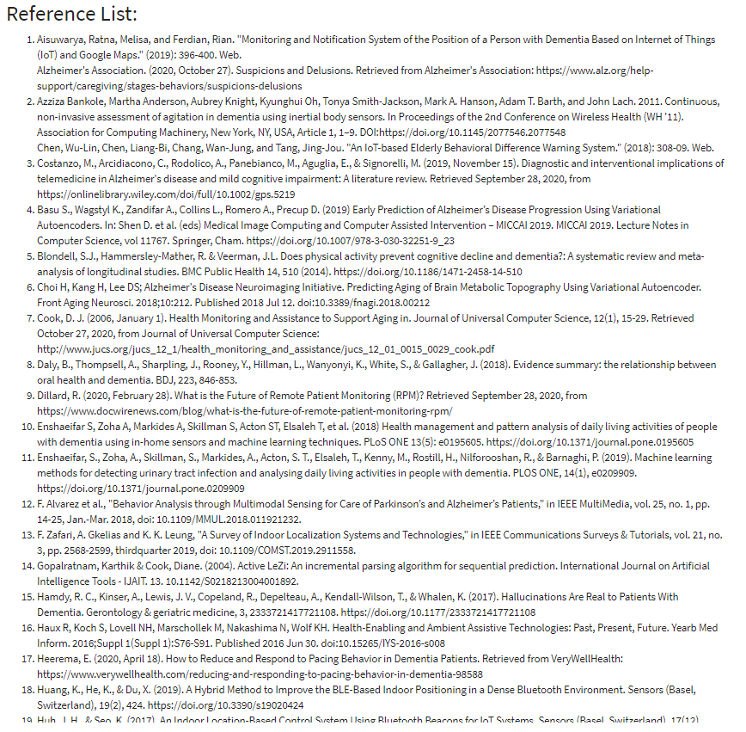

**Contact Us:**

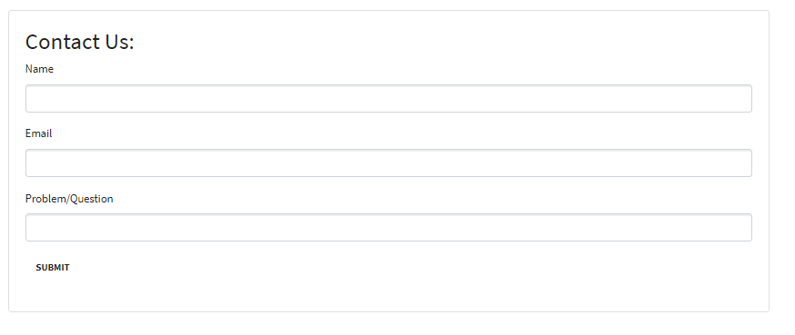

**Software Architecture Diagram (Updated):**

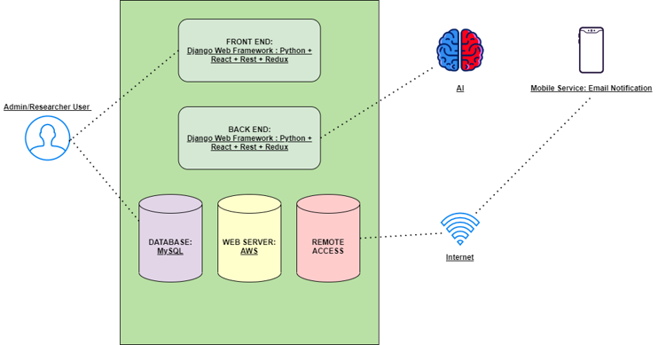

**High Level Use Case Diagram:**

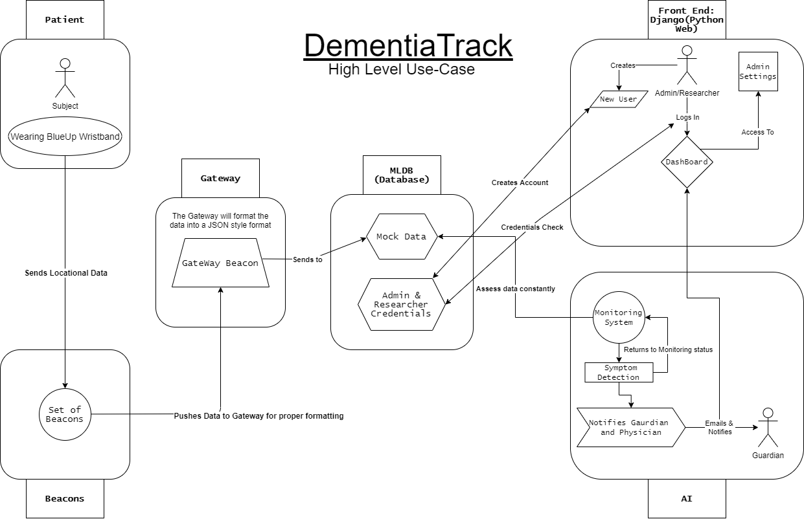

**Tech Stack:**

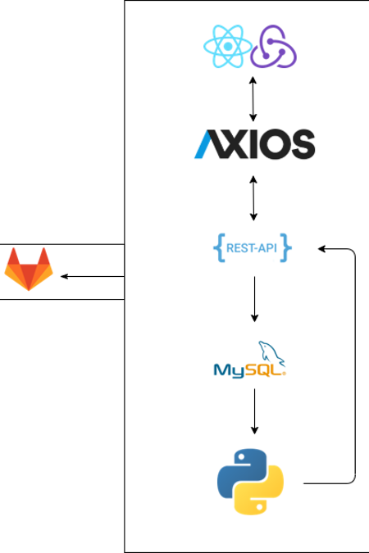

**Use Case Descriptions:**

**1.)**

|  |  |
| --- | --- |
| ID: | 001 |
| Title: | Admin/Researcher Logs In |
| Description: | Admin/Researcher puts in their credentials and system accepts |
| Primary Actor: | Admin/Researcher |
| Preconditions: | Must have made an account before hand |
| Postconditions: | Gives them access to the dashboard |
| Main  Success Scenario: | User enters their credentials correctly and gains user access to the dashboard |
| Extensions: | Errors would bring about incorrect credentials would result in an error message informing them that they need to attempt reentering their credentials correctly |
| Frequency of Use: | Every case where the user wishes to access the dashboard in order to assess the tech as well as the data being received from the tech |
| Status: | To-Be-Started |
| Owner: | To-Be-Determined |
| Priority: | Low |

**2.)**

|  |  |
| --- | --- |
| ID: | 002 |
| Title: | Admin/Researcher Logs Out |
| Description: | Admin/Researcher selected the logout button |
| Primary Actor: | Admin/Researcher |
| Preconditions: | Admin/Researcher has logged into their account already |
| Postconditions: | Logs them out of the system |
| Main  Success Scenario: | User has done what they wanted on the dashboard and selects the log out button |
| Extensions: | User does not properly log out and just closes the website via the close button on the entire web browser |
| Frequency of Use: | In every scenario the user no longer wants to be on the dashboard site. |
| Status: | To-Be-Started |
| Owner: | To-Be-Determined |
| Priority: | Low |

**3.)**

|  |  |
| --- | --- |
| ID: | 003 |
| Title: | Subject is being tracked |
| Description: | Subject is wearing the BlueUp wristband to be tracked by the mini beacons |
| Primary Actor: | Subject + Wristband |
| Preconditions: | Subject must be wearing the wristband |
| Postconditions: | Allows the researcher and physician monitor the subject from home |
| Main  Success Scenario: | User wears the wristband all the time so that the data collected is proper data over a long period of time |
| Extensions: | Errors would bring about incorrect data if the user at any moment takes the wristband off |
| Frequency of Use: | Every case where the user is wearing the wristband and performing their normal day to day activities |
| Status: | To-Be-Started |
| Owner: | To-Be-Determined |
| Priority: | Medium |

**4.)**

|  |  |
| --- | --- |
| ID: | 004 |
| Title: | Mini Beacons received data from wristband |
| Description: | Subject is wearing the BlueUp wristband to be tracked by the mini beacons and the mini beacons receive the data |
| Primary Actor: | Subject + Wristband + Mini Beacon |
| Preconditions: | Must be wearing the wristband and the mini beacons batteries must not be dead |
| Postconditions: | The data is successfully pulled to the mini beacons by locating the wristband via BLE |
| Main  Success Scenario: | Subject is always wearing the band and the beacons maintain connectivity and a charged battery |
| Extensions: | Errors would bring about incorrect data if the user at any moment takes the wristband off or the batteries in the beacons die over a long period of time |
| Frequency of Use: | Every case where the user is wearing the wristband and performing their normal day to day activities and the beacons are collecting the data |
| Status: | To-Be-Started |
| Owner: | To-Be-Determined |
| Priority: | Medium |

**5.)**

|  |  |
| --- | --- |
| ID: | 005 |
| Title: | Mini Beacons Sends Data to be formatted by the Gateway |
| Description: | This is where the subject wearing the bracelet and the beacons are active, the Gateway will format the data into a JSON |
| Primary Actor: | Subject + Wristband + Mini Beacon + Gateway |
| Preconditions: | Subject is wearing their wristband and the Mini Beacons and Gateway are all powered up and connected |
| Postconditions: | The data collected over a period will be transformed into a readable JSON file that can be pushed to the database |
| Main  Success Scenario: | All devices are working properly and the JSON file has correct data inputted into it |
| Extensions: | Errors would bring about incorrect data if the user at any moment takes the wristband off or the batteries in the beacons die over a long period of time, or the Gateway is disconnected from the internet or other devices at any point |
| Frequency of Use: | Every case where the user wishes to access the dashboard in order to assess the tech as well as the data being received from the tech and being pushed to the Gateway to be turned into the JSON file |
| Status: | To-Be-Started |
| Owner: | To-Be-Determined |
| Priority: | Medium |

**6.)**

|  |  |
| --- | --- |
| ID: | 006 |
| Title: | Gateway sends JSON file to MYSQL database |
| Description: | This part is the collection of the JSON file being sent to the MYSQL database that can be then sorted in the database |
| Primary Actor: | Gateway + Database |
| Preconditions: | Gateway and database must always be actively running to have the data in the database constantly updated as time goes on |
| Postconditions: | Database successfully receives the data over the set time that the systems are active and maintains the uptime of the devices so that all data has been collected |
| Main  Success Scenario: | All devices are working properly and the JSON file has correct data inputted into it and from that JSON it gets sent to the database to be queried into it |
| Extensions: | Errors would bring about incorrect data if the user at any moment takes the wristband off or the batteries in the beacons die over a long period of time, or the gateway is disconnected from the internet or other devices at any point  This would also make a domino effect and the database would never receive the data and at that point, the system would not be able to track the patient’s whereabouts |
| Frequency of Use: | Every case where the user wishes to access the dashboard in order to assess the tech as well as the data being received from the tech and being pushed to the Gateway to be turned into the JSON file |
| Status: | To-Be-Started |
| Owner: | To-Be-Determined |
| Priority: | Medium |

**7.)**

|  |  |
| --- | --- |
| ID: | 007 |
| Title: | MYSQL database is updated on User Credentials when new user is created |
| Description: | This is when the user decides to make a new account and the saved credentials gets added to the database |
| Primary Actor: | Database and User |
| Preconditions: | User enters in the preferred credentials for making a new account |
| Postconditions: | The credentials they entered are put into the database securely so that no one else can gain access to their account |
| Main  Success Scenario: | Database successfully collects the credentials they entered without a problem |
| Extensions: | Errors would occur if the credentials they entered aren't allowed due to the necessary characters in the credentials, or the database is down so in that case the credentials were never saved, and the user cannot get into their account nor create one |
| Frequency of Use: | Every scenario the user wishes to make an account or access it |
| Status: | To-Be-Started |
| Owner: | To-Be-Determined |
| Priority: | Medium |

**8.)**

|  |  |
| --- | --- |
| ID: | 008 |
| Title: | MYSQL database is filled with data |
| Description: | This is when the database is filled with the gathered mock data |
| Primary Actor: | MYSQL Database |
| Preconditions: | Database must be up and running along with ability to be queried |
| Postconditions: | Database will be filled with the mock data |
| Main  Success Scenario: | The database is successfully queried with the mock data and is accessible by the AI system |
| Extensions: | Errors would bring about incorrect data being put into the system by accident or the database is down |
| Frequency of Use: | One scenario when the compiled data is ready to be put into the database |
| Status: | To-Be-Started |
| Owner: | To-Be-Determined |
| Priority: | High |

**9.)**

|  |  |
| --- | --- |
| ID: | 009 |
| Title: | AI access the Data to analyze |
| Description: | This is when the AI is accessing the data from the database to analyze it. |
| Primary Actor: | Database + AI |
| Preconditions: | Database is up and running |
| Postconditions: | AI will search through the data to find any abnormalities. |
| Main  Success Scenario: | AI will look through the data and properly and successfully find an abnormality and make note of it |
| Extensions: | Errors would be if the AI does not properly detect abnormalities in the data resulting in the lack of proper early detection of the symptoms correlated to dementia |
| Frequency of Use: | The AI will constantly be at a steady non-stop rate studying the data in order to detect symptoms from the abnormalities in the data |
| Status: | To-Be-Started |
| Owner: | To-Be-Determined |
| Priority: | Extremely High |

**10.)**

|  |  |
| --- | --- |
| ID: | 010 |
| Title: | AI detects abnormalities |
| Description: | This is when the AI is analyzing the data there is a trigger or flag that alerts an abnormality |
| Primary Actor: | AI + Database |
| Preconditions: | Database is running and AI is constantly looking throughout the data and an abnormality is detected |
| Postconditions: | AI will send an email to the Guardian and the Researcher/Admin |
| Main  Success Scenario: | AI has properly detected an abnormality and it is not a flux, if so, it will continue to the next phase of this system |
| Extensions: | Errors would occur if it was a false positive scenario; Where the AI does not properly analyze the data and results in a “false alarm” |
| Frequency of Use: | The AI will constantly be at a steady non-stop rate studying the data in order to detect symptoms from the abnormalities in the data |
| Status: | To-Be-Started |
| Owner: | To-Be-Determined |
| Priority: | Extremely High |

**11.)**

|  |  |
| --- | --- |
| ID: | 011 |
| Title: | AI sends an Alert Message to the Researcher/Admin and Guardian |
| Description: | This is when the detection of an abnormality arises, and the AI moves to the alert system by sending an email to the Guardian and the Admin on the dashboard |
| Primary Actor: | Guardian, Researcher/Admin, AI |
| Preconditions: | AI has successfully detected the case of an abnormality |
| Postconditions: | AI has properly sent out a notification email to the proper sources |
| Main  Success Scenario: | AI sends an email about the detection of an abnormality and then continues back into the search for an abnormality |
| Extensions: | Errors would be a false positive occurrence or the case that the email the AI sends the information to does not exist or it sends it incorrectly |
| Frequency of Use: | Every occurrence will be when the abnormality occurs, so, it will be constantly running but until an abnormality occurs again  It will go back to searching and send yet another email upon a reoccurrence |
| Status: | To-Be-Started |
| Owner: | To-Be-Determined |
| Priority: | High |

**Background Survey:**

The research began with the intention of answering the following questions: Is this idea feasible? Can motion sensing technology help to point out the underlying symptoms of Dementia? Our research pointed to the fact that yes, this can be done, and in fact, it has been done by Wu-Lin, et al. (2018) this group proposed the use of wearable smart glasses paired with a Bluetooth Low Energy (BLE) beacon which would determine the location of the individual and recognize daily movements such as standing, walking, running, etc. Further research showed that even companies who develop smart home atmospheres like the MavHome, are capable of determining when an individual is sidetracked and notify them or ask questions in a way to send them back on their right path (Cook, 2006, p. 25). With that in mind, we were able to determine that this project is feasible. This is where we broke into two teams: The Database & Data Analytics Team, and The Artificial Intelligence Team. The Database & Data Analytics team started to look into technology and databases that would bring us results we could count on. We were not worried about having Passive Infrared (PIR) systems in which could determine the individual’s movements down to a centimeter, but rather BLE suited our needs better. The Database & Data Analytics Team found a technology and a database that suited our needs perfectly, this technology is BlueUp Beacons and the Database system is Machine Learning Database (MYSQL). The beacons found by the team are capable of tracking motion, acceleration, and a couple more useful values. And we were even able to get our hands-on a JSON file of what the beacons/wristbands will put out data wise. While the Artificial Intelligence team had plentiful amounts of research, a roadblock appeared quickly trying to determine “how is a symptom truly measurable with a system we are unfamiliar with?” The team had assumptions about how we could measure very basic ideas from research (NHS UK, 2020; Phelps, R., 2020; Alzheimer's Association, 2020). Once word came around that the Database & Data Analytics Team had found actual values for the functionality of the beacon system we were to be using, it became quite easy to pinpoint how symptoms can be mapped within our system. The first symptoms to be laid out were restlessness, wandering, and pacing. These symptoms are rather easy to determine how they can be tracked, because they simply take an individual's movements in relation to beacons. This can also be seen in Ishii, et al.’s paper titled *An Early Detection System for Dementia Using the M2 M/IoT Platform*. Further symptoms would be revealed through other researches. Mielke, et al. (2020) wrote an entire paper on how dementia can be detected early through psychomotor agitation symptoms being monitored by environments with sensor implementations. One example that resonated well was Motarjemi (2017), is that an individual may forget the process of cooking and leave out ingredients, or just forget how to cook and revert to solely using a microwave. This means that we could determine a symptom like memory loss is occurring if an individual is spending more or less time in a room.

**Testing Plan:**

**Test items:**

* Login workflow
* Register workflow
* Logout workflow
* Navigation
* Overview Page (Normal, Abnormal, Random)
* Movement Page (Normal, Abnormal, Random)
* Sleep Page (Normal, Abnormal, Random)
* Daily Activities Page (Normal, Abnormal, Random)
* Urinary Tract Infection (UTI) Page (Normal, Abnormal, Random)

**Which testing tasks to be done:**

* Integration testing for Login / Register / Logout workflows
* Unit tests for decision logic on symptom pages
* User Acceptance Testing for each test item

**Who will perform each task?**

* Brendan and Ryan will work on Unit Testing and Integration Testing
* All member of the team took part in the User Acceptance Testing

**Test environment:**

* Tests will be run locally on each developer’s machine.

**Test design techniques:**

* We will use Jest for unit testing and Cypress for integration testing.

**The rationale for choices made:**

* We chose to write unit tests for the most integral parts of the application and covered important aspects of the user interface with Integration Tests. User Acceptance Testing will be done continuously by all members.

**Risks requiring contingency plans:**

* We will likely not have time to unit test everything, so we will make sure that each section of the application is properly tested using User Acceptance Testing.

**Testing Results:**

**Login workflow:**

Valid Login

1. On Login page
2. Enter in valid username and password
3. User is logged in a redirected to dashboard

Invalid Login

1. On Login page
2. Enter invalid username or password
3. User is not logged in and remain on the login screen

**Register workflow:**

Valid Register

1. On Register page
2. Enter in non-taken username and email address
3. Enter password and confirm password
4. User is logged in and redirected to dashboard

Invalid Register

1. On Register page
2. Enter in taken username and email address
3. Enter password and confirm password
4. User account uncreated and remain on register screen

**Logout workflow:**

1. User is logged in anywhere in the application
2. Select the logout button
3. User is redirected to the login page and logged out

**Navigation:**

1. For any link or button that changes screens
2. The user is taken to the correct location

**Overview Page (Normal, Abnormal, Random):**

Normal

1. On Overview Page
2. User selects Normal from the dropdown
3. User selects the Run button
4. Each symptom displays the results of the normal dataset

Abnormal

1. On Overview Page
2. User selects Abnormal from the dropdown
3. User selects the Run button
4. Each symptom displays the results of the abnormal dataset

Random

1. On Overview Page
2. User selects Random from the dropdown
3. User selects the Run button
4. Each symptom displays the results of the random dataset

**Movement Page (Normal, Abnormal, Random):**

Normal

1. On Movement (Wandering/Pacing) Page
2. User selects Normal from the dropdown
3. User selects the Run button
4. Summary and table update accordingly

Abnormal

1. On Movement (Wandering/Pacing) Page
2. User selects Abnormal from the dropdown
3. User selects the Run button
4. Summary and table update accordingly

Random

1. On Movement (Wandering/Pacing) Page
2. User selects Random from the dropdown
3. User selects the Run button
4. Summary and table update accordingly

**Sleep Page (Normal, Abnormal, Random):**

Normal

1. On Sleep Page
2. User selects Normal from the dropdown
3. User selects the Run button
4. Summary and table update accordingly

Abnormal

1. On Sleep Page
2. User selects Abnormal from the dropdown
3. User selects the Run button
4. Summary and table update accordingly

Random

1. On Sleep Page
2. User selects Random from the dropdown
3. User selects the Run button
4. Summary and table update accordingly

**Daily Activities Page (Normal, Abnormal, Random):**

Normal

1. On Daily Activities Page
2. User selects Normal from the dropdown
3. User selects the Run button
4. Summary and table update accordingly

Abnormal

1. On Daily Activities Page
2. User selects Abnormal from the dropdown
3. User selects the Run button
4. Summary and table update accordingly

Random

1. On Daily Activities Page
2. User selects Random from the dropdown
3. User selects the Run button
4. Summary and table update accordingly

**Urinary Tract Infection (UTI) Page (Normal, Abnormal, Random):**

Normal

1. On Urinary Tract Infection (UTI) Page
2. User selects Normal from the dropdown
3. User selects the Run button
4. Summary and table update accordingly

Abnormal

1. On Urinary Tract Infection (UTI) Page
2. User selects Abnormal from the dropdown
3. User selects the Run button
4. Summary and table update accordingly

Random

1. On Urinary Tract Infection (UTI) Page
2. User selects Random from the dropdown
3. User selects the Run button
4. Summary and table update accordingly

**Testing Evaluation Summary:**

Our goal with the software testing was to cover the entire application in tests and to write more specific tests for critical areas of the application. The result of our testing left us with each team member providing valuable User Acceptance Testing throughout the entire development process and more specifically before demos during the Midterm and Final presentations. This made sure that our app would function as intended for these live demos. In order to better automate testing on a more granular level, Ryan and Brendan worked to write some Unit Tests and Integration tests to better cover the application. These tests succeeded in Unit Testing logic for the result tables for each symptom page, the image carousel on each symptom page, the decision logic for the Urinary Tract Infection page, and the decision logic for the Daily Activity page. They also successfully wrote automated Integration Tests for the login, register, and logout processes. Areas that could be improved include Unit Testing the logic for Movement and Sleep decision making. Overall, the testing plan worked out as we expected.

**Paper Reading List:**

Aisuwarya, Ratna, Melisa, and Ferdian, Rian. "Monitoring and Notification System of the Position of a Person with Dementia Based on Internet of Things (IoT) and Google Maps." (2019): 396-400. Web.

Alzheimer's Association. (2020, October 27). Suspicions and Delusions. Retrieved from Alzheimer's Association: <https://www.alz.org/help-support/caregiving/stages-behaviors/suspicions-delusions>

Azziza Bankole, Martha Anderson, Aubrey Knight, Kyunghui Oh, Tonya Smith-Jackson, Mark A. Hanson, Adam T. Barth, and John Lach. 2011. Continuous, non-invasive assessment of agitation in dementia using inertial body sensors. In Proceedings of the 2nd Conference on Wireless Health (WH '11). Association for Computing Machinery, New York, NY, USA, Article 1, 1–9. DOI:https://doi.org/10.1145/2077546.2077548

Chen, Wu-Lin, Chen, Liang-Bi, Chang, Wan-Jung, and Tang, Jing-Jou. "An IoT-based Elderly Behavioral Difference Warning System." (2018): 308-09. Web.

Costanzo, M., Arcidiacono, C., Rodolico, A., Panebianco, M., Aguglia, E., & Signorelli, M. (2019, November 15). Diagnostic and interventional implications of telemedicine in Alzheimer's disease and mild cognitive impairment: A literature review. Retrieved September 28, 2020, from <https://onlinelibrary.wiley.com/doi/full/10.1002/gps.5219>

Basu S., Wagstyl K., Zandifar A., Collins L., Romero A., Precup D. (2019) Early Prediction of Alzheimer’s Disease Progression Using Variational Autoencoders. In: Shen D. et al. (eds) Medical Image Computing and Computer Assisted Intervention – MICCAI 2019. MICCAI 2019. Lecture Notes in Computer Science, vol 11767. Springer, Cham. <https://doi.org/10.1007/978-3-030-32251-9_23>

Blondell, S.J., Hammersley-Mather, R. & Veerman, J.L. Does physical activity prevent cognitive decline and dementia?: A systematic review and meta-analysis of longitudinal studies. BMC Public Health 14, 510 (2014). <https://doi.org/10.1186/1471-2458-14-510>

Choi H, Kang H, Lee DS; Alzheimer's Disease Neuroimaging Initiative. Predicting Aging of Brain Metabolic Topography Using Variational Autoencoder. Front Aging Neurosci. 2018;10:212. Published 2018 Jul 12. doi:10.3389/fnagi.2018.00212

Cook, D. J. (2006, January 1). Health Monitoring and Assistance to Support Aging in. Journal of Universal Computer Science, 12(1), 15-29. Retrieved October 27, 2020, from Journal of Universal Computer Science: <http://www.jucs.org/jucs_12_1/health_monitoring_and_assistance/jucs_12_01_0015_0029_cook.pdf>

Daly, B., Thompsell, A., Sharpling, J., Rooney, Y., Hillman, L., Wanyonyi, K., White, S., & Gallagher, J. (2018). Evidence summary: the relationship between oral health and dementia. BDJ, 223, 846-853.

Dillard, R. (2020, February 28). What is the Future of Remote Patient Monitoring (RPM)? Retrieved September 28, 2020, from <https://www.docwirenews.com/blog/what-is-the-future-of-remote-patient-monitoring-rpm/>

Enshaeifar S, Zoha A, Markides A, Skillman S, Acton ST, Elsaleh T, et al. (2018) Health management and pattern analysis of daily living activities of people with dementia using in-home sensors and machine learning techniques. PLoS ONE 13(5): e0195605. <https://doi.org/10.1371/journal.pone.0195605>

Enshaeifar, S., Zoha, A., Skillman, S., Markides, A., Acton, S. T., Elsaleh, T., Kenny, M., Rostill, H., Nilforooshan, R., & Barnaghi, P. (2019). Machine learning methods for detecting urinary tract infection and analysing daily living activities in people with dementia. PLOS ONE, 14(1), e0209909. https://doi.org/10.1371/journal.pone.0209909

F. Alvarez et al., "Behavior Analysis through Multimodal Sensing for Care of Parkinson’s and Alzheimer’s Patients," in IEEE MultiMedia, vol. 25, no. 1, pp. 14-25, Jan.-Mar. 2018, doi: 10.1109/MMUL.2018.011921232.

F. Zafari, A. Gkelias and K. K. Leung, "A Survey of Indoor Localization Systems and Technologies," in IEEE Communications Surveys & Tutorials, vol. 21, no. 3, pp. 2568-2599, thirdquarter 2019, doi: 10.1109/COMST.2019.2911558.

Gopalratnam, Karthik & Cook, Diane. (2004). Active LeZi: An incremental parsing algorithm for sequential prediction. International Journal on Artificial Intelligence Tools - IJAIT. 13. 10.1142/S0218213004001892.

Hamdy, R. C., Kinser, A., Lewis, J. V., Copeland, R., Depelteau, A., Kendall-Wilson, T., & Whalen, K. (2017). Hallucinations Are Real to Patients With Dementia. Gerontology & geriatric medicine, 3, 2333721417721108. <https://doi.org/10.1177/2333721417721108>

Haux R, Koch S, Lovell NH, Marschollek M, Nakashima N, Wolf KH. Health-Enabling and Ambient Assistive Technologies: Past, Present, Future. Yearb Med Inform. 2016;Suppl 1(Suppl 1):S76-S91. Published 2016 Jun 30. doi:10.15265/IYS-2016-s008

Heerema, E. (2020, April 18). How to Reduce and Respond to Pacing Behavior in Dementia Patients. Retrieved from VeryWellHealth: <https://www.verywellhealth.com/reducing-and-responding-to-pacing-behavior-in-dementia-98588>

Huang, K., He, K., & Du, X. (2019). A Hybrid Method to Improve the BLE-Based Indoor Positioning in a Dense Bluetooth Environment. Sensors (Basel, Switzerland), 19(2), 424. <https://doi.org/10.3390/s19020424>

Huh, J. H., & Seo, K. (2017). An Indoor Location-Based Control System Using Bluetooth Beacons for IoT Systems. Sensors (Basel, Switzerland), 17(12), 2917. <https://doi.org/10.3390/s17122917>

Husebo, B. S., Heintz, H. L., Berge, L. I., Owoyemi, P., Rahman, A. T., & Vahia, I. V. (2020). Sensing Technology to Monitor Behavioral and Psychological Symptoms and to Assess Treatment Response in People With Dementia. A Systematic Review. Frontiers in pharmacology, 10, 1699. <https://doi.org/10.3389/fphar.2019.01699>

Ishii, H., Kimino, K., Aljehani, M., Ohe, N. , & Inoue, M. (2016). An Early Detection System for Dementia Using the M2 M/IoT Platform. Procedia Computer Science, 96, 1332-1340. doi:https://doi.org/10.1016/j.procs.2016.08.178

Kueper, J. K., Speechley, M., & Montero-Odasso, M. (2018). The Alzheimer's Disease Assessment Scale-Cognitive Subscale (ADAS-Cog): Modifications and Responsiveness in Pre-Dementia Populations. A Narrative Review. Journal of Alzheimer's disease: JAD, 63(2), 423–444. <https://doi.org/10.3233/JAD-170991>

K. Takahashi, K. Kitamura, Y. Nishida and H. Mizoguchi, "Battery-less shoe-type wearable location sensor system for monitoring people with dementia," 2019 13th International Conference on Sensing Technology (ICST), Sydney, Australia, 2019, pp. 1-4, doi: 10.1109/ICST46873.2019.9047673.

K. Kawanishi, H. Kawanaka, H. Takase and S. Tsuruoka, "A study on dementia detection method with stroke data using anomaly detection," 2017 6th International Conference on Informatics, Electronics and Vision & 2017 7th International Symposium in Computational Medical and Health Technology (ICIEV-ISCMHT), Himeji, 2017, pp. 1-4, doi: 10.1109/ICIEV.2017.8338566.

Laxman, S., Sastry, P. S., & Unnikrishnan, K. P. (2007, August). A Fast Algorithm For Finding Frequent Episodes In Event. Proceedings of the 13th ACM SIGKDD International Conference on Knowledge Discovery and Data Mining (KDD 2007), 410-419. Retrieved October 27, 2020, from Microsoft: <https://www.microsoft.com/en-us/research/publication/a-fast-algorithm-for-finding-frequent-episodes-in-event-streams/>

Mielke, C. , Antons, R., & Haux, R. (n.d.). Detection of Psychomotor Agitation Pattern from Motion Sensor Data in a Living Environment of a Patient with Dementia. Studies in Health Technology and Informatics, 270, 746-750. doi:10.3233/SHTI200260

Motarjemi, R. (2017, July 30). Symptoms of Dementia. San Diego, California, United States of America. Retrieved October 27, 2020, from <https://www.youtube.com/watch?v=WAQCXs3TNh8>

New Findings on Dementia from Sikkim University Summarized (A Systematic Review and Implementation of IoT-Based Pervasive Sensor-Enabled Tracking System for Dementia Patients). (2019). Mental Health Weekly Digest, 412.

NHS UK. (2020, January 16). Symptoms Frontotemporal Dementia. Retrieved September 28, 2020, from <https://www.nhs.uk/conditions/frontotemporal-dementia/>

NHS UK. (2020, June 12). Symptoms of dementia. (NHS) Retrieved October 27, 2020, from <https://www.nhs.uk/conditions/dementia/symptoms/>

Medina, M., & Castillo-Pino, E. (2019). An introduction to the epidemiology and burden of urinary tract infections. Therapeutic Advances in Urology, 11, 175628721983217. https://doi.org/10.1177/1756287219832172

M. Gochoo, T. Tan, V. Velusamy, S. Liu, D. Bayanduuren and S. Huang, "Device-Free Non-Privacy Invasive Classification of Elderly Travel Patterns in a Smart House Using PIR Sensors and DCNN," in IEEE Sensors Journal, vol. 18, no. 1, pp. 390-400, 1 Jan.1, 2018, doi: 10.1109/JSEN.2017.2771287.

Olivia Walch, Yitong Huang, Daniel Forger, Cathy Goldstein, Sleep stage prediction with raw acceleration and photoplethysmography heart rate data derived from a consumer wearable device, *Sleep*, Volume 42, Issue 12, December 2019, zsz180, <https://doi.org/10.1093/sleep/zsz180>

Paudel, Ramesh. (2018). Anomaly Detection of Elderly Patient Activities in Smart Homes using a Graph-Based Approach.

Phelps, R. (2020, June 8). An Inside Take on Dementia Behaviors. Retrieved from AgingCare: <https://www.agingcare.com/articles/an-inside-take-on-dementia-behaviors-197990.htm#:~:text=They%20simply%20cannot%20believe%20what,and%20often%20%E2%80%9Cannoying%E2%80%9D%20behaviors>.

Potter, P. A., Perry, A. G., Hall, A. M., & Stockert, P. A. (2017). *Fundamentals of Nursing*. St. Louis, Mo: Mosby Elsevier.

Potter, R., Ellard, D., Rees, K. and Thorogood, M. (2011), A systematic review of the effects of physical activity on physical functioning, quality of life and depression in older people with dementia. Int. J. Geriat. Psychiatry, 26: 1000-1011. doi: <https://onlinelibrary.wiley.com/action/showCitFormats?doi=10.1002%2Fgps.2641>

P. Zappi, E. Farella and L. Benini, "Tracking Motion Direction and Distance With Pyroelectric IR Sensors," in IEEE Sensors Journal, vol. 10, no. 9, pp. 1486-1494, Sept. 2010, doi: 10.1109/JSEN.2009.2039792.

Ray, Partha Pratim, Dash, Dinesh, & De, Debashis. (2019). A Systematic Review and Implementation of IoT-Based Pervasive Sensor-Enabled Tracking System for Dementia Patients. Journal of Medical Systems, 43(9), 1-21.

Ridwan Alam, Nutta Homdee, Sean Wolfe, James Hayes, and John Lach. (2019). Besi: behavior learning and tracking with wearable and in-home sensors - a dementia case-study: poster abstract. In Proceedings of the International Conference on Internet of Things Design and Implementation (IoTDI '19). Association for Computing Machinery, New York, NY, USA, 281–282. DOI: <https://doi.org/10.1145/3302505.3312595>

S. Enshaeifar et al., "The Internet of Things for Dementia Care," in IEEE Internet Computing, vol. 22, no. 1, pp. 8-17, Jan./Feb. 2018, doi: 10.1109/MIC.2018.112102418.

Simone. (2020, August 09). Wifi indoor positioning using Arduino and Machine Learning in 4 steps. Retrieved September 28, 2020, from <https://eloquentarduino.github.io/2019/12/wifi-indoor-positioning-on-arduino/>

Sposaro, F., Danielson, J., & Tyson, G. (2010). iWander: An Android application for dementia patients. Annual International Conference of the IEEE Engineering in Medicine and Biology Society. IEEE Engineering in Medicine and Biology Society. Annual International Conference, 2010, 3875–3878. <https://doi.org/10.1109/IEMBS.2010.5627669>

Stavropoulos, Thanos G, Papastergiou, Asterios, Mpaltadoros, Lampros, Nikolopoulos, Spiros, & Kompatsiaris, Ioannis. (2020). IoT Wearable Sensors and Devices in Elderly Care: A Literature Review. Sensors (Basel, Switzerland), 20(10), 2826.

Syrjälä, A.‐M.H., Ylöstalo, P., Ruoppi, P., Komulainen, K., Hartikainen, S., Sulkava, R. and Knuuttila, M. (2012), Dementia and oral health among subjects aged 75 years or older. Gerodontology, 29: 36-42. doi:[10.1111/j.1741-2358.2010.00396.x](https://doi.org/10.1111/j.1741-2358.2010.00396.x)

Toot, S., Devine, M., Akporobaro, A., & Orrell, M. (2013). Causes of Hospital Admission for People With Dementia: A Systematic Review and Meta-Analysis. Journal of the American Medical Directors Association, 14(7), 463–470. https://doi.org/10.1016/j.jamda.2013.01.011

Tosi, Jacopo, Taffoni, Fabrizio, Santacatterina, Marco, Sannino, Roberto, & Formica, Domenico. ([1]2017). Performance Evaluation of Bluetooth Low Energy: A Systematic Review. Sensors (Basel, Switzerland), 17(12), 2898.

T. Qassem, G. Tadros, P. Moore and F. Xhafa, "Emerging Technologies for Monitoring Behavioural and Psychological Symptoms of Dementia," 2014 Ninth International Conference on P2P, Parallel, Grid, Cloud and Internet Computing, Guangdong, 2014, pp. 308-315, doi: 10.1109/3PGCIC.2014.82.

Vivien Bromundt, Anna Wirz-Justice, Marc Boutellier, Seraina Winter, Markus Haberstroh, Michael Terman, Mirjam Münch, Effects of a dawn-dusk simulation on circadian rest-activity cycles, sleep, mood and well-being in dementia patients, Experimental Gerontology,Volume 124, 2019, 110641, ISSN 0531-5565, <https://doi.org/10.1016/j.exger.2019.110641>

Vuong, N.K. & Chan, Syin & Lau, C.T.. (2014). Automated detection of wandering patterns in people with dementia. Gerontechnology. 12. 127-147. 10.4017/gt.2014.12.3.001.00.

Yang, D., Xu, B., Rao, K., & Sheng, W. (2018, January 24). Passive Infrared (PIR)-Based Indoor Position Tracking for Smart Homes Using Accessibility Maps and A-Star Algorithm. Retrieved September 28, 2020, from <https://www.ncbi.nlm.nih.gov/pmc/articles/PMC5855945/>

Y. Watanabe, Y. Kobayashi, M. Tanaka, T. Asada, K. Ishii and T. Yagi, "An analysis for Alzheimer’s disease using cross-correlation and averaged frequency of EEG data," 2018 11th Biomedical Engineering International Conference (BMEiCON), Chiang Mai, 2018, pp. 1-5, doi: 10.1109/BMEiCON.2018.8609932.

1.