David Bennett and the First Pig-Heart Transplant: Xenotransplantation, Consent, and the Rule of Rescue
“It was either die or do this transplant” — a bioethics case study
Brendan Shea, PhD
2026-06-18
Table of contents

- Who: David Bennett Sr. (1964–2022), a 57-year-old Maryland handyman dying of heart failure; surgeons Bartley Griffith and Muhammad Mohiuddin of the University of Maryland.
- What: On January 7, 2022, Bennett received the heart of a genetically modified pig — the first such transplant into a living human. He lived about two months.
- Where / When: University of Maryland Medical Center, Baltimore, 2022.
- Why it matters: The case tests whether a dying patient can give real informed consent, whether the rule of rescue justified an untried procedure, and whether a risk to the wider public — xenozoonosis — can ever be consented to by one patient alone.
- Pair with: Animal Ethics

The Case
By the fall of 2021, David Bennett’s heart was failing for the last time. He was 57, a father of two, a former handyman who liked motorcycles and the beach. He had lived for years with a faulty heart rhythm. Now he lay in a Baltimore hospital bed, hooked to a machine called ECMO that pumped and oxygenated his blood because his own heart no longer could. He could not leave the bed. Without something drastic, he would die within weeks.
ECMO (extracorporeal membrane oxygenation). A machine that takes over for the heart and lungs, pumping a patient’s blood out of the body, adding oxygen, and returning it. It buys time during a crisis. It is not a long-term fix; patients cannot live on it indefinitely, and it carries its own risks of clots and bleeding.
Bennett was out of ordinary options. He was not eligible for a human heart transplant. His doctors said he had not always followed medical advice in the past — he had missed appointments and skipped medications — and transplant programs weigh such history, because a donated heart is scarce and must not be wasted. He was also turned down for an implanted mechanical pump, because his irregular heartbeat made it too risky. Every standard door had closed.
Then his doctors offered a door no one had ever walked through alive. Bartley Griffith, the surgeon who would lead the operation, put it to him plainly: they could not give him a human heart, but they might be able to give him a pig’s. Bennett, by the hospital’s account, understood the gamble. “It was either die or do this transplant,” he said before the surgery. “I know it’s a shot in the dark, but it’s my last choice.”
What made the offer possible was decades of genetic engineering. The pig heart did not come from an ordinary farm animal. It came from a pig built, gene by gene, to survive inside a human body.
Xenotransplantation and the gene-edited pig. Xenotransplantation means transplanting organs or tissue from one species into another. The human body destroys ordinary pig tissue within minutes. The donor pig was modified at ten genes: three pig genes that trigger instant rejection were switched off, six human genes were added to calm the body’s attack, and one growth gene was disabled so the heart would not outgrow its new chest. The pig was supplied by a company, Revivicor, that breeds animals for this purpose.
The surgery, on January 7, 2022, was not a normal, approved treatment. No such operation had ever been formally tested in people. Instead, the U.S. Food and Drug Administration granted a one-time emergency clearance — a path called compassionate use — that let a single dying patient try an experimental therapy outside of a clinical trial.
Compassionate use (expanded access). A route by which a patient with a serious illness and no good alternatives may receive an experimental treatment that has not finished testing. It is meant as mercy for an individual, not as a study. Because it treats one person at a time, it produces little of the careful, controlled data that a real trial is designed to gather.
The operation itself was the easy part to imagine and the hard part to reach. Muhammad Mohiuddin, who ran the Maryland program’s xenotransplant lab, had spent some thirty years trying to keep pig hearts alive in animals long enough to matter. Griffith had practiced the surgery on the bench for years. On the day, the team removed Bennett’s failing heart and sewed in the pig’s, then watched to see whether the human body would tear it apart. It did not. The heart took.
For a while, it worked. The pig heart beat on its own. Bennett came off ECMO. He watched the Super Bowl, did physical therapy, and joked with his nurses about going home to see his dog. For several weeks he was, by every visible sign, a man saved by an animal’s heart. It was a genuine medical first, reported around the world.
The decline came in March. The new heart thickened and stiffened. Fluid built up in his body, and the organ slowly lost its strength. On March 8, 2022 — about sixty days after the surgery — David Bennett died.
Months later came a detail that reframed the whole story. In analyzing the heart, the Maryland team found traces of a pig virus, porcine cytomegalovirus (PCMV), that screening was supposed to have caught and missed (Mohiuddin et al. 2023). The virus may have contributed to the heart’s failure. It also pointed at the deepest worry about the entire enterprise: a germ carried in an animal organ, into a human body, that no one had agreed to invite.
His family chose to read the sixty days as a gift. His son thanked the doctors for “every extra moment” and for the chance to help patients who would come later. Griffith, the surgeon, said the team had learned a great deal and grieved the man they had come to know. Even framed as a triumph of nerve and science, though, the case left a set of questions that the obituaries mostly skipped.
There was one more fact, and it sat uneasily with the celebration. Decades earlier, in 1988, Bennett had stabbed a young man named Edward Shumaker, leaving him paralyzed; Shumaker died years later after a life of disability. When Bennett received his historic heart, Shumaker’s sister asked aloud why a man who had ruined her brother’s life should be the one to make medical history (Associated Press 2022). Bennett’s family asked that he be judged by his final act of courage, not his worst one. The hospital said, as medicine generally does, that it does not rank patients by their pasts.
So the case leaves a hard question on the table. When a desperate patient, a designed animal, and an unconsenting public all meet in one operating room, what made this permissible — and was it?

The Argument the Bennett Case Started
The Bennett case is worth study because the people involved were not careless. The surgeons were experts acting in good faith; the patient wanted to live; the regulators signed off. The disagreement is about something deeper than any mistake. What follows is a connected exchange — each move answering the one before.

The rescue argument: he had nothing to lose
The simplest defense is also the most powerful. Bennett was going to die in days. He understood that the pig heart had never kept a human alive. He chose it anyway. To deny him that choice would be to deny a dying man his last act of self-determination — and might cost him the only chance he had.
The Rule-of-Rescue Argument
- A competent patient may choose a risky treatment when the alternative is near-certain death.
- Bennett was competent, fully informed of the risks, and faced near-certain death.
- The transplant offered a real, if small, chance of benefit and could not leave him worse off than dying.
- Therefore, performing the transplant respected Bennett’s autonomy and served his good.
This appeals to the rule of rescue — the deep pull we feel to save an identifiable person in front of us, whatever the odds. The disputed premise is the second one: that Bennett was fully informed and freely choosing, and that the benefit was real rather than imagined. That is exactly where the reply lands.

The reply: this was an experiment dressed as treatment
A treatment is meant to help the patient. An experiment is meant to produce knowledge. The Bennett operation, critics argue, was mostly the second while being sold as the first — and that confusion poisons the consent.
The Therapeutic-Misconception Reply
- Valid consent to treatment requires a realistic expectation of personal benefit.
- No pig heart had ever kept a human alive, so the realistic aim was knowledge for future patients, not benefit to Bennett.
- A patient who believes a research procedure is really treatment is under a therapeutic misconception and cannot give valid consent to it.
- Therefore, Bennett’s “choice” was not the free, informed consent the rescue argument assumes.
Therapeutic misconception. The well-documented tendency of patients in research to believe that an experimental procedure is designed to help them, when its real purpose is to gather data. The more desperate the patient, the stronger the misconception — and the harder it is to correct.
Add desperation to the mix and the worry sharpens. A man hours from death, offered his “last choice,” is in no position to weigh odds coolly. Consent given at the edge of the grave may be sincere and still not be free.

The counter-reply: desperate patients can still choose
Defenders of the surgery answer that the reply proves too much. If desperation canceled consent, no dying patient could ever volunteer for anything — and medicine would be forbidden from trying the new thing that someday becomes standard. The first human heart transplant patients, in 1967, also died within weeks; we do not now call them dupes.
But this answer concedes the key point: if the real goal was knowledge, then Bennett was, at least in part, a research subject — and research subjects are owed protections that a one-off compassionate-use case cannot provide. There is no control group. There is no plan to test the result against an alternative. There is no committee weighing risks to a whole class of future patients. The data from a single dramatic case are thin, and a death teaches less than a trial would.
Here Kant’s warning bites. To use Bennett partly as a means to medical knowledge is not automatically wrong; Kant forbids using a person merely as a means, without regard to their own ends. Bennett wanted to live, and he also wanted his ordeal to help others — he said as much. So the surgeons could honor both aims at once. The hard question is which aim was really steering the ship. If the chance of saving him was close to zero, then “treatment” was the story told at the bedside while “experiment” was the work being done. A dying man’s hope can be honored as his own end, or quietly borrowed to serve science, and from the outside the two can look identical.

The reframing move: it was never only about the patient
The whole debate so far assumes the only person at stake is Bennett. The most distinctive feature of xenotransplantation is that this assumption is false.
A pig organ can carry pig viruses. If one of them adapts to humans inside a recipient, it could spread to other people — a xenozoonosis, an animal-to-human infection with the recipient as the doorway. The discovery of PCMV in Bennett’s heart was a live rehearsal of that fear. The HIV pandemic almost certainly began as an animal virus that crossed into humans; the worry is not science fiction.
And here consent runs out.
The Public-Risk Argument
- A person can consent to a risk that falls only on themselves.
- Xenotransplantation creates a risk of a new infection that could spread to other people.
- That shared risk falls on family, clinicians, and strangers who never agreed to it.
- Therefore, the patient’s consent alone cannot make the procedure permissible; the public has a stake no individual can sign away.
Bennett could accept a risk to himself. He could not consent on behalf of the nurses who cared for him or the strangers who would bear the cost of an outbreak. There is also the pig, engineered from conception to be killed for its parts and raised in sterile isolation — a being used wholly as a means, with no say at all.

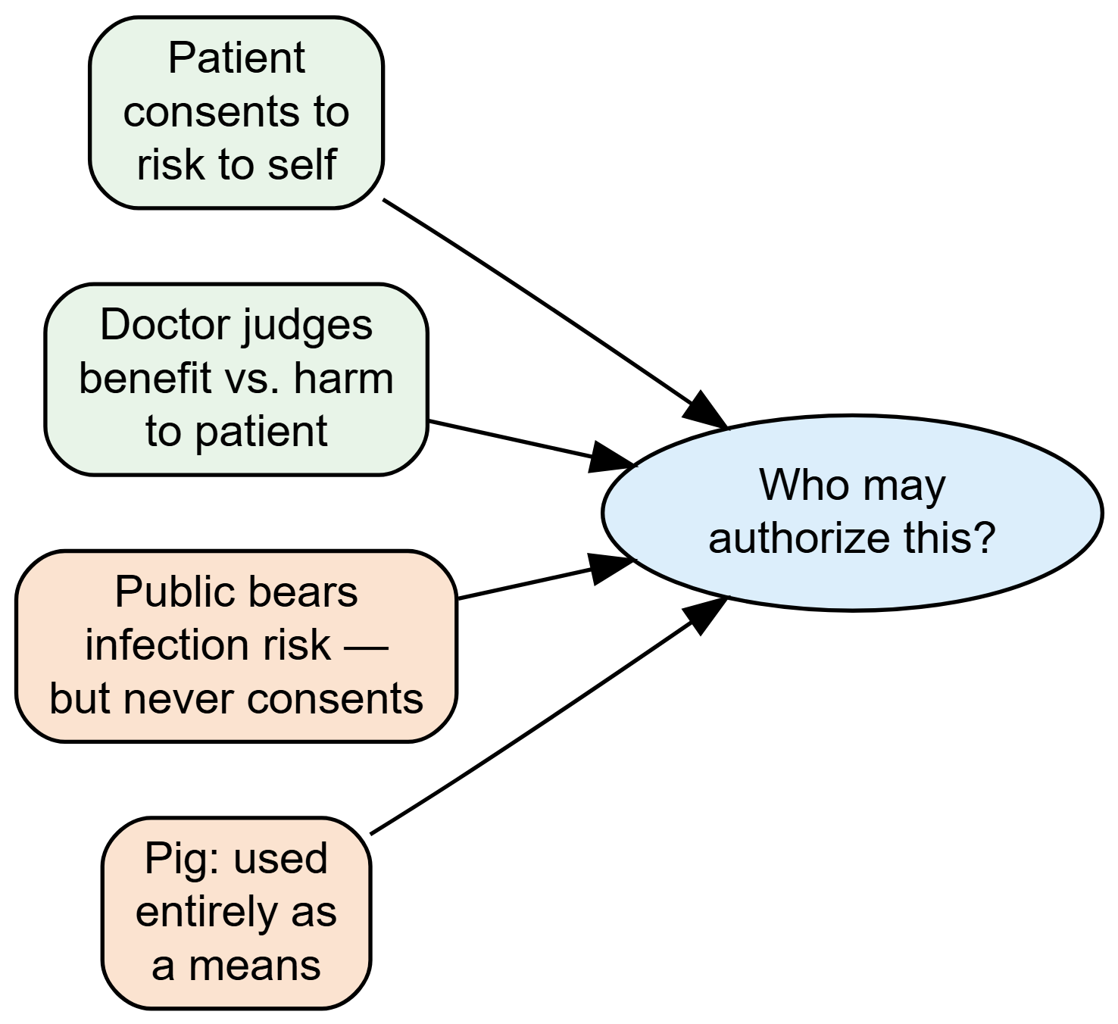

This reframes the decision from a private one — patient and doctor — into a public one. If the risk is shared by people who never agreed to it, then perhaps patient and surgeon alone should never have held the whole decision. Some body speaking for the community arguably belongs in the room.

The move that hasn’t ended: from rescue to routine
Bennett’s case was a single act of rescue. The field has since tried to become a discipline. In 2024, surgeons gave gene-edited pig kidneys to living patients — Rick Slayman and Towana Looney — who, like Bennett, were out of other options. And in 2025, the FDA cleared the first true clinical trials of pig-organ transplantation, moving the practice out of one-off exceptions and into planned, regulated studies with rules, oversight, and consent designed in advance (United Therapeutics Corporation 2025).
Slayman lived about two months after his pig kidney; Looney lived longer than any xenotransplant patient before her before the organ was removed. Each result, good or bad, now feeds a planned study rather than a single news cycle. This is meant to answer the objections. A trial replaces the therapeutic misconception with honest research consent. It builds in screening for viruses like PCMV. It submits the public-risk question to regulators rather than to a single operating team. Yet the deepest tensions do not vanish. Trial subjects will still be desperate people choosing under pressure. The infection risk still falls on a public that cannot sit in the consent conversation. The pigs are still made to die. The move from rescue to routine makes the practice more careful — but careful is not the same as settled. The question Bennett’s case opened is now being asked at scale: not may we save this one dying man, but on what terms may we build a whole supply of human organs out of animals?

Discussion Questions
- Reconstruct the Rule-of-Rescue Argument and the Therapeutic-Misconception Reply. They turn on one shared premise — whether Bennett’s consent was genuinely informed and free. Take a side and defend it, using the facts of his condition.
- Bennett had been turned down for a conventional transplant partly because of his medical history, yet was chosen for a world-first surgery. Was that consistent? Should a patient’s past — including the 1988 stabbing — ever factor into who receives scarce or experimental care? Defend your answer.
- You are the nurse responsible for walking Bennett through the consent form the night before surgery. He says, “So this is going to fix me, right?” What do you say, and what would you refuse to let him believe before you signed off?
- The “nothing to lose” defense assumes the transplant could not leave Bennett worse off than dying. Pressure-test that premise. Are there outcomes — prolonged suffering, dying as a research subject, a public infection — that count as worse? Who should weigh them?
- In 2025 the FDA approved the first regulated clinical trials of pig-organ transplantation. Does moving from one-off compassionate use to planned trials actually resolve the consent and public-risk objections raised by Bennett’s case, or only manage them? Defend your view.

Further Reading
- Roni Caryn Rabin, “In a First, Man Receives a Heart from a Genetically Altered Pig,” The New York Times, January 10, 2022 — the contemporary account of the surgery and the patient.
- Muhammad M. Mohiuddin et al., “Graft Dysfunction in Compassionate Use of Genetically Engineered Pig-to-Human Cardiac Xenotransplantation,” The Lancet, 2023 — the surgical team’s own analysis of what went wrong, including the PCMV finding.

References
Associated Press. 2022. Pig Heart Recipient Stabbed Man in 1988, Victim’s Family Says. Associated Press. https://apnews.com/article/pig-heart-transplant-stabbing.
Mohiuddin, Muhammad M., Avneesh K. Singh, Linda Scobie, Corbin E. Goerlich, et al. 2023. “Graft Dysfunction in Compassionate Use of Genetically Engineered Pig-to-Human Cardiac Xenotransplantation: A Case Report.” The Lancet 402 (10399): 397–410. https://doi.org/10.1016/S0140-6736(23)00775-4.
United Therapeutics Corporation. 2025. FDA Clears First Clinical Trial of Genetically Modified Pig Kidney Xenotransplantation. United Therapeutics press release. https://ir.unither.com/.

