Venn Diagrams and the Square of Opposition

Interpreting Particular Statements. In ALL forms of categorical logic, the word “Some” means at least one. For example, “Some cats are mammals” means “At least one cat is a mammal” (so, this is true). Similarly, “Some philosophers are not logicians” means “There exists at least one philosopher who is not a logician.”
Interpreting Universal Statements. In contrast to particular statements, logicians have constructed two different ways of interpreting universal statements that are useful for different purposes. According to the Aristotelian (traditional) interpretation, the universal statements “All S are P” and “No S are P” should be interpreted as (implicitly) claiming that there is at least one existing thing that is an S. There is an exception if we know that S refers to something fictional. For example:
- “All trees are plants” entails “Some trees are plants.”
- “No dogs are fish” entails “Some dogs are not fish.”
- “All unicorns have one horn” does NOT entail “Some unicorns have one horn.” [In this case, we know that S refers to a fictional thing. This is a special case in which the Aristotelian agrees with the Boolean interpretation]
By contrast, according to the Boolean (modern) interpretation, “All S are P” means “If there exist any things that are S, then they are P.” “No S are P” means “If there are any things that are S, then they are not P.” This does NOT assume that any there exist any S’s. For example:
- “All trees are plants” does NOT entail “Some trees are plants.”
- “No dogs are fish” does NOT entail “Some dogs are not fish.”
- “All unicorns have one horn” does NOT entail “Some unicorns have one horn.”
The following contradictory relationships hold according to both interpretations:
- “Some S are P” and “No S are P” have opposite truth values.
- “Some S are not P” and “All S are P” have opposite truth values.

The Modern Square of Opposition
The Boolean interpretation of categorical logic can be visually represented by the modern square of opposition. It does NOT assume that S exists.
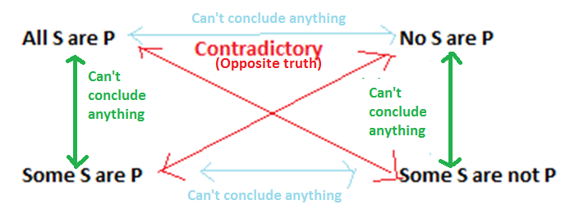

The Traditional Square of Opposition
Similarly, the Aristotelian interpretation can be represented by the traditional square of opposition. It always assumes that at least one S exists.
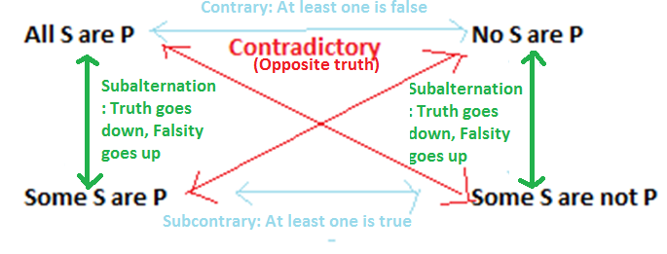

What is a Venn Diagram?
A Venn diagram is a way of visually representing the content of a categorical statement. SHADING means “nothing is here”. An “X” means “something is here.” No area that is SHADED can have an X.
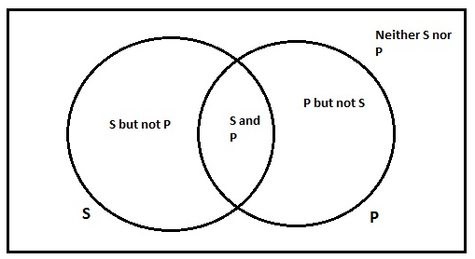

“All S are P” (Boolean)
To represent an A-statement on the Boolean interpretation, we SHADE the area where things that are S but not P would go. According o the contradictory relationship, this is equivalent to the claim that “Some S are not P” is FALSE.
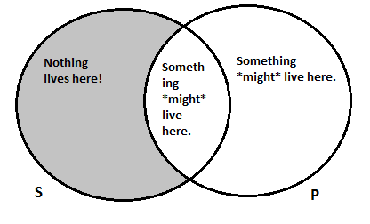

“No S are P” (Boolean)
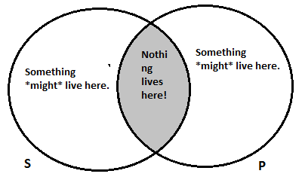

“Some S are P” (Both)
We represent O-statements (on both Boolean and Aristotelian interpretations) by putting an X in the appropriate place. This also entails that “No S are P” is FALSE.
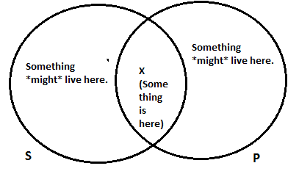

“Some S are not P” (Both)
We represent O-statements (on both interpretations) by putting an X in the area of S that is NOT part of P. This statement is equivalent to the claim that “All S are P” is FALSE.
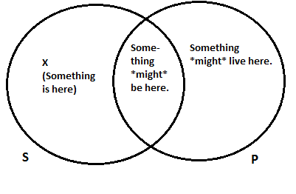

“All S are P” (Aristotelian)
On the Aristotelian tradition diagram for A-statements, we have the exact same shading as on the Boolean. However, we add a circled ‘X’ to indicate that we are assuming that at least one thing actually is S. This entails that “Some S are P” is TRUE, “Some S are not P” is FALSE, and “No S are P” is FALSE.
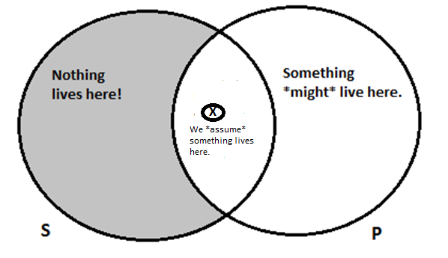

“No S are P” (Aristotelian)
On the Aristotelian diagram for E-statements, we have the exact same shading as on the Boolean. However, we add a circled ‘X’ to indicate that we are assuming that at least one thing actually is S. This entails “Some S are not P” is TRUE, “Some S are P” is FALSE, and “All S are P” is FALSE.
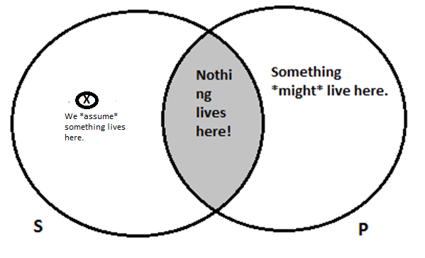

Review Questions
- Which categorical statements are true, according to the following diagram (there are at least 4)? Which statements are false (there are at least 4)?
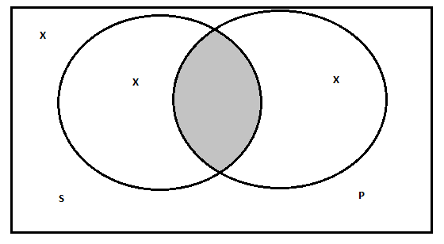
- Using the Boolean standpoint, draw Venn diagrams for the following statements:
  - No Ewoks are assassins.
  - Some varieties of cancer are treatable diseases.
  - All Charles Dickens novels are fun books to read.
  - No things that Iago says are things that you ought to believe.
  - All non-billionaires are people who worry about money. (Try to do this with one of the circles representing “billionaires”.)
  - No non-poets are people who like William Wordsworth. (Try do this with one of the circles representing “poets”).

