Immediate Inferences

- What is an immediate inference? How can you determine the validity/invalidity of an immediate inference?
- What is the modern (Boolean) square of opposition? Why is the relationship between contradictory statements so important?
- What are obversion, conversion, and contraposition? How do they relate to the logical equivalence of certain pairs of categorical statements?
- How do you use Venn diagrams to test the validity of immediate inferences?’
An immediate inference is a deductive argument that has one categorical statement as a premise and one categorical statement as a conclusion. Since immediate inferences are deductive arguments, we want to evaluate whether they are valid or invalid. They are valid if it is impossible for the premises to be true and the conclusion to be false. There are (at least) two ways to test immediate inferences for validity: The square of opposition and Venn diagrams. We’ll talk about both ways.

The Boolean INterprtation (MODern)
The Boolean interpretation is represented by the modern square of opposition. A and E statements do NOT assume that S exists, but E and I statements DO assume this.
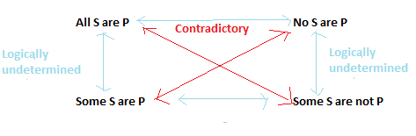

Contradictory Relationship
On the Boolean interpretation, the truth value of “All S are P” is the opposite of “Some S are not P.” (If one is true, the other is false.). Similarly, the truth value of “No S are P” is the opposite of “Some S are P.” This is called the contradictory relation. Using the modern square of opposition, we can tell that the following immediate inferences (which use the contradictory relation) are valid:
- All doctors are clowns. So, it is false that some doctors are not clowns. (VALID)
- It is false no vegetarians are overweight people. So, some vegetarians are overweight people. (VALID)

Existential Fallacy
On the Boolean interpretation, universal statements (“All” or “No”) do NOT entail the existence of the terms. However, the particular statements (“Some”) DO entail existence. Because of this, the Boolean interpretation holds that the following arguments are invalid, since they commit the existential fallacy (they try to go from a universal premise to a particular conclusion):
- All detectives are jerks. So, some detectives are jerks. (INVALID)
- No scissors are dull things. So, some scissors are not dull things. (INVALID)

Logical Equivalence Rules
Each categorical statement is logically equivalent (i.e. always has the same truth value) to a number of other statements. If a premise is logically equivalent to the conclusion, the argument is valid. For example, “No S are non-P. Therefore, All S are P” is a valid argument.
- Obversion changes the quality (Affirmative/Negative) and replaces P with non-P. It works for all statements (A, E, I, and O).
  - “All S are P” = “No S are non-P”
  - “No S are P” = “All S are non-P”
  - “Some S are P” = “Some S are not non-P”
  - “Some S are not P” = “Some S are non-P”
- Conversion switches the location of S and P. It works for E and I, but not for A and O.
  - “No S are P” = “No P are S”
  - “Some S are P” = “Some P are S”.
- Contraposition switches the location of S and P, and replaces S with non-S and P with non-P. It works for A and O, but not for E and I.
  - “All S are P” = “All non-P are non-S”
  - “Some S are not P” = “Some non-P are not non-S”
All of these relationships work for FALSE statements as well. For example, if “All S are P” is FALSE, then the obversion “No S are non-P” is FALSE as well.

The Aristotelian INterpretatioN
The Aristotelian (traditional) interpretation can be represented by the traditional square of opposition. It always assumes that at least one S exists. The contradictory relationship is the same as before. Obversion, conversion, and contraposition all work. However, there are few new rules as well.
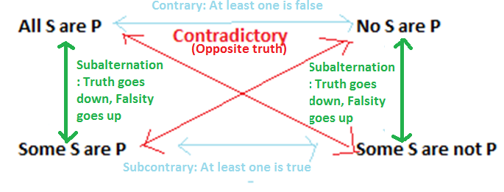
Subalternation refers to a relationship between universal and particular statements with the same quality. It is unique to the Aristotelian tradition. (“Truth flows downward, falsity flows upward.”)
- If “All S are P” is TRUE, then “Some S are P” is TRUE. If “No S are P” is TRUE, then “Some S are not P” is TRUE.
- Ex: If “all mustangs are horses” is true, then so is “some horses are mustangs.”
- If “Some S are P” is FALSE, then “All S are P” is FALSE. If “Some S are not P is FALSE”, then “No S are P” is FALSE.
- Ex: If “some dogs are cats” is false, then “all dogs are cats is false.”
The contrary relationship holds between universal statements. It says that it is impossible for BOTH “All S are P” and “No S are P” to be true. However, they might both be false.
- Ex: Since “all cats are mammals” is TRUE, we can conclude “no cats are mammals” is FALSE.
The subcontrary relationship (“At least one universal statement is FALSE. At least one particular statement is TRUE.”) holds between particular statements. It says that it is impossible for BOTH “Some S are P” and “Some S are not P” to be FALSE.
- Ex: Some “Some cats are not mammals” is FALSE, we can conclude that “Some cats are mammals is TRUE.

Immediate Inference Relationships (Summary)
Name | Rule | Statements | Boolean or Aristotelian
Contradictory | A and O have opposite truth values  E and I have opposite truth values | All | Both
Obversion | Changes the quality (Affirmative/Negative) and switches P with non-P (and vice versa: non-P becomes P). | All | Both
Conversion | Switches the location of S and P. | E, I | Both
Contraposition | Switches the location of S and P. Switches S with non-S and P with non-P (and vice versa). | A, O | Both
Subalternation | If A is true, I is true; If I is false, A is false  If E is true, O is true; If O is false, E is false  “Truth flows downward; falsity flows upward” | All | Aristotelian
Contrary | If A is true, E is false; If E is true, A is false  “A and E can’t BOTH be true (but they both might be false)” | A and E | Aristotelian
Subcontrary | If I is false, O is true; If O is false, I is true  “I and O can’t BOTH be false (but they both might be true)” | I and O | Aristotelian

Using Venn Diagrams to Test Immediate Inferences (Boolean)
Testing the validity of an argument using Venn diagrams is very easy:
- You draw a Venn diagram that representing the premises.
- You put you pencil down, and then look to see if it is possible for the conclusion to be false. If it helps, you can draw a second Venn diagram representing the conclusion.
- If it is possible for the conclusion to be false, then the argument is invalid. If it is NOT possible for the conclusion to be false (the conclusion is guaranteed to be true), then the argument is valid.
A Venn diagram has three sorts of areas:
- SHADING means “nothing exists here.”
- CHECK means “something does exist here.”
- BLANK means “I have no idea. Something might exist here, or it might not.”

Review Question: Boolean
- According to following diagram (for the statement “All S are P”), which of the following immediate inferences are valid? You should use the Boolean interpretation.
  - All S are P. So, all P are S.
  - All S are P. So, no S are non-P.
  - All S are P. So, some S are P.
  - All S are P. So, all non-P are non-S.
  - All S are P. So, it is false that some S are not P.

