Statistics: Basic Concepts
Statistics is the branch of mathematics and inductive logic that deals with the relationship between populations and samples. While it can get pretty complex, it is based on a number of fairly simple concepts, which we’ll be talking about today:
- A population is a set of things. Some populations: people in the United States, squirrels currently living on campus, things under my bed, blood cells in my body, and so on.
- A sample is a subset of the population. We get samples by selecting some, but not all, members of the population.
- A random sample is a sample in which each member of the population has an equal chance of being picked for the sample.
- Random samples are generally representative samples—i.e., the properties of the sample resemble the properties of the population at large.
- A biased sample is an unrepresentative sample.
Three Meanings of “Average.” Suppose we have the following set of numbers: 1, 2, 2, 7, 10, 11, 25. If someone asks “What is the average value?” we might give one of three answers.
- The mean is obtained by (1) adding up all the numbers and (2) dividing by how many numbers there are. So, (1+2+2+7+10+11+25)/7 = 58/7 = 8.3
- The median is the “middle” number when the numbers are arranged in order (as they are above). In the example above, this is 7.
- The mode is the most frequently appearing number. In the example above, this is 2.

Statistical Arguments and INductive Generalizations
Many arguments in statistics have the (implicit) form of an inductive generalization:
- Premise: S is a sample of population P.
- Premise: X% of the members of S have attribute A.
- Conclusion: X% (+/- margin of error CI%) of population P have attribute A. This is with confidence level L.
Your confidence level L is a claim about how accurate the sampling procedure is. 95% confidence (which is normal) claims that a sampling procedure of this sort will produce a representative sample (i.e., one within the margin of error) 95% of the time, at least under ideal conditions. In almost every case, conditions are NOT ideal—so, a 95% confidence DOES NOT mean “there is a 95% chance this poll is accurate” (even though this is the way polls are sometimes reported). Instead, it means something closer to “there is no more than a 95% chance this poll is accurate.” Your margin of error, or confidence interval (CI), gives a range in which you think the true population falls. A +-3% CI means that the population might differ by as much as 3% from a representative sample.
Determining Margin of Error (CI) Using Tables
In general, a larger sample and a lower confidence level entails a smaller margin of error. A sample table for a large, normally distributed population:
Sample size | Confidence Level
 | 99.00% | 95.00% | 90.00%
10 | 40.48% | 30.99% | 25.93%
50 | 18.10% | 13.86% | 11.60%
100 | 12.80% | 9.80% | 8.20%
250 | 8.10% | 6.20% | 5.19%
500 | 5.72% | 4.38% | 3.67%
1000 | 4.05% | 3.10% | 2.59%
2000 | 2.86% | 2.19% | 1.83%
3000 | 2.34% | 1.79% | 1.50%

Evaluating Inductive generalizations and Statistical Arguments
In general, the fact that a statistical argument has a confidence level of 95% does NOT mean that there is a 95% of its conclusion being true. When considering how much weight to give a particular inductive generalization, you need consider ALL of the following:
- What was the size of the sample? Are the margin of error and confidence level reported? Remember, small samples mean big margins of error and/or low confidence levels. Studies or polls that don’t report sample size and/or margin of error are generally garbage.
- How representative was the sample? The confidence level and margin of error (CI) only tell you how good the argument would be if the sampling procedure were perfect and the population is normal. This is never exactly true.
- Was the sample chosen randomly? Did participants “self-select” for the study? Are there any reasons to suspect that the sample is biased, in the sense that it does not represent the real population? (Almost all samples are biased; the question is simply how much)
- How do the results of this study fit with the results of other polls or studies, or with other information you have? Remember not to “suppress evidence”—making claims about populations requires you consider all relevant evidence. Don’t put too much weight on the results of a particular poll.
Sources of Bias. Here’s some things that can contribute to bias:
- Small sample size. Small samples are likely (purely as a matter of chance) to have some “strange” features that the real population doesn’t.
- Sample selection procedure. Some members of the population are more likely to be selected for the sample. For example, those who own phones are more likely to be surveyed in presidential polls; poor college students are more likely to participate in paid psychology experiments.
- Testing conditions. It’s sometimes very tough to get a good measurement. For example, people are unlikely to admit things like “I am a violent murderer/pedophile/arsonist” to a person doing a survey.
Don’t let the fact that statistics looks “mathematical” fool you—statisticians can’t prove things about populations in the same way that geometers prove things about triangles. Statistics is merely a useful tool for making educated guesses about populations, and you should never accept any particular statistical argument with considering how it fits with your “total evidence.”

Dispersion and Normal Distributions
The dispersion of a data set has to do with how “far apart” the various members of the data set are from one another.
- The range is given by (biggest data item) - (smallest data item).
- One measure of dispersion is variance, which is calculated by determining the mean squared distance from the mean of the data set. The standard deviation is the square root of the variance.
  - If the data set is 1, 2, 3, the mean is 2. The variance is $σ^{2}=\frac{{\left(1-2\right)}^{2}+{\left(2-2\right)}^{2}+{\left(3-2\right)}^{2}}{3}=\frac{2}{3}.$
  - The standard deviation for 1, 2, 3 is $σ=\sqrt{\frac{2}{3}}=.81$
  - Another data set with a mean of 2 is -200, -100, 306. The variance here is 35,906. The standard deviation is 189.5.
Histograms. A histogram plots the frequency of each data item. That is, it tells you how frequently each data item appears. This graph tells you that 10 students are taking 10 credits and 5 students are taking 8 credits.

The Normal Distribution. The normal distribution can be represented by a histogram with a “peak” in the middle and a “slope” on either side. This peak represents the mean, median, and mode. Many properties of interest to scientists are distributed normally.
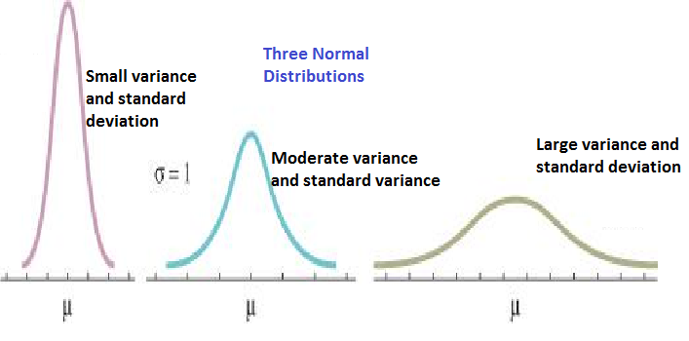

Using Dispersion Data and Making Graphs
Knowing the standard deviation and variation can tell you quite a bit. For example, consider the following data sets:
- The ages of every high school senior in the U.S..
- The hourly wages of every U.S. worker (expressed in $US).
- The number of hours of TV watched weekly by every U.S. citizen.
Let’s suppose that the mean, median, and mode for each of these data sets is 18, and that they are all distributed normally. This doesn’t mean that they are all the same.
- The ages of high schoolers have a very small variance and standard deviation. Because of this, you can be very confident that most seniors you meet will be around 18.
- The hourly wages have a fairly large variance and standard deviation. Because of this, you CANNOT be very confident that most people you meet will earn around $18 an hour.
- The hours of TV watched per week are probably somewhere in the middle.
How to Make a Bad, Deceptive Graph. It’s easy to make a chart or graph that seems to show something really important, but actually doesn’t. Here’s how:
- Only graph the small amount of data that looks good for your case. Leave all of the other data off the chart.
- Fiddle with the scale of the X-axis or Y-axis so that (a) small changes suddenly appear large or (b) large changes suddenly appear small.
- Use lots of 3D effects, colors, strange fonts, etc. Make your graph look like an art project.
- Don’t worry about the order in which your data appear. For example, since “Alabama” comes first in the alphabet, put it first on your chart, even if it would make more sense to order states by population.
- Use confusing legends and labels.
When you are looking at charts, pay attention to whether they seem to be doing any of these things. Ask yourself: “What is this chart really showing me?” For example, here’s a chart that tells you about the raises I have got at while working at grocery store for the 5 years. It’s a bit misleading, to say the least.

And here is the same data, graphed in a somewhat more responsible manner:

It’s now pretty obvious that I didn’t make nearly so much money .

