# Tricking Ourselves: Informal Logic and Behavorial Economics

Brendan Shea, PhD ([Brendan.Shea@rctc.edu](mailto:Brendan.Shea@rctc.edu))

**Informal logic** is the branch of logic that studies arguments and decision-making procedures as they occur in our everyday lives, where the tools of formal (categorical, propositional, or predicate) logic may be difficult to apply. While the study of informal logic is very old, it has often been criticized as amounting to little more than a collection of “rules of thumb,” such “people tend to be overconfident” or “arguments that involve personal attacks are generally bad ones”. In recent years, however, researchers have begun combining insights from formal logic, philosophy, statistics and probability, cognitive science, neuroscience, and economics to piece together a more systematic picture of just *where* people tend to go wrong, and *why* they do so. This research has been strongly associated with the emerging field of **behavioral economics,** which studies the various ways in which humans *differ* from the perfectly logical and rational “consumers” that economists have traditionally assumed in their model. In this lecture, we’ll be taking a brief look of the concepts of behavioral economics, especially as they are formulated by **Daniel Kahneman** (the only psychologist ever to win a Nobel Prize in Economics).

## The people inside Your Head: System 1 and System 2

In his book, *Thinking, Fast and Slow,* Kahneman argues that we humans have two different sorts of “thinking systems.” These aren’t literally different areas of the brain; instead, they are “useful fictions” that help us to understand how we make decisions and, more specifically, why/when we are prone to make *bad* decisions.

**System 1 (“Automatic” or “Associative” thinking)** responds quickly and automatically to the world around us “with little or no effort and no sense of voluntary control.” When we act in response to System 1 processes, we often don’t consciously realize this. System 1 governs much of our day-to-day life. Common examples of System 1 thinking include:

* Understanding simple sentence such as the “there is a cat on the mat.”

1. Together, a bat and a ball cost $1.10. The bat costs one dollar more than the ball. How much does the ball cost?

2. Suppose three painters can paint three fences in three hours. How long does it take one painter to paint one fence?

3. A deck of cards has numbers on one side and letters on the other. The four cards on the table are “A”, “F”, “5”, and “10.” Which card(s), if any, must you flip over to figure out whether the conditional “If a card has a vowel on one side, it has an odd number on the other side?” is true?

4. How many animals of each type did Moses take on the ark?

* Directing attention toward a new sound/sight, and judging distance
* Detecting hostility or anger in someone’s voice, or expressing disgust/anger in response to certain stimuli
* Doing something we are very good at: driving in low traffic, operating our smartphones, adding “2 + 3”, tying our shoes, etc.
* Recognizing and applying various stereotypes relating to gender, profession, religion, race, political affiliation, etc.
* Applying “deontic” ethical thinking (e.g., “Don’t kill! Don’t steal! Don’t lie!”)

**System 2 (“Algorithmic thinking”)** involves allocating attention and mental effort, and characterizes mathematical or logical inference. Applications System 2 are “often associated with the subjective experience of agency, choice, and concentration.” Using System 2 is, in general, more *difficult* than using System 1, and we tend to use it only when feel “forced” to do so. Common examples of examples of System 2 include:

Figure These problems rely on simple math/logical concepts that the System 2 of most adults is certainly *capable* of using. Yet, because System 1 has strong “intutions” about them, most people get them wrong. Can you figure out the answers? (Answers: $.05; 3 hours; A and 10; it’s Noah’s ark, not Moses’)

* Completing complex mathematical or logical proofs, or making sense out of difficult texts/arguments
* Counting the vowels in the sentence “there is a cat on the mat.”
* Focusing our attention on a particular person, image, or sound in a crowded environment
* Comparing two similar items, and deciding which one to purchase
* Completing tasks that are difficult or new for us: parallel parking, learning a new computer program, etc.
* Monitoring one’s behavior in stressful social situation (such as a job interview)
* Search one’s memory for specifics (“What was his phone number again? Where exactly did I meet her?”)
* Applying “utilitarian” ethical thinking (e.g., “Depending on the situation, It may OK to kill one to save ten.”)

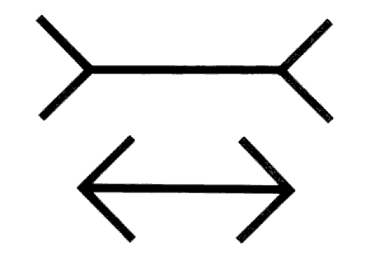**The “Law of Least Effort.”** Kahneman notes that most of us like to *think* that we make our most important decisions (whether these be professional, financial, ethical, or romantic) by carefully applying System 2, and weighing the evidence for/against various conclusions. However, as it turns out, this is often not the case. Instead, because we (instinctively) try to minimize mental effort, we rely on System 1 wherever possible, and use System 2 only when forced to. This leads to the following process:

* Our System 1 makes a snap decision regarding something: what to buy, whether to like/dislike someone, whether to do a task now or procrastinate, or whatever.
* If we are challenged to *defend* or *explain* this decision (perhaps just to ourselves, when we are thinking about it later), System 2 comes along and provides an *excuse* for the actions of System 1. However, System 2 doesn’t actually play any role in the decision-making process.

Figure The Müller-Lyer illusion. If you are like most people, your System 1 tells you "the top one." If you measure them (a System 2 process), though, you'll find they are actually the same length.

Part of Kahneman’s goal (and that of behavioral economics generally) is to identify the types of situations where System 1 is *most likely* to get things wrong, and where it is *most important* to get System 2 actually involved in the process.

## Some Glitches in System 1 THinking

One major emphasis of behavioral economics has been that we are generally *not aware* of System 1’s influence on our decision-making process, even though this influence is much larger than we think it is. System 1 produces strong impressions, intuitions, or beliefs that can be *altered* by System 2, but which nevertheless have a strong impact (even if they shouldn’t). Kahneman describes System 1 as a **“machine for jumping to conclusions”** that is always seeking to construct a coherent narrative/story quickly tying together anything and everything. System 2, by contrast, is a **“lazy controller”** that often neglects to carefully examine whether the conclusions and stories of System 1 are actually supported by good arguments.

**Priming** occurs when exposure to one sort of stimulus influences our reaction to a later sort of stimulus. This can cause problems in cases where System 1 makes faulty links between stimuli, as it is often does. For example, experimenters have shown that merely exposing people to *pictures* of money will lead them to do things like (1) work more diligently on a task, (2) be less likely to help experimenters in small ways (picking up a dropped pencil), and (3) stay further away from others. This phenomenon is not limited to money: pictures of eyes make people more likely to contribute to the workplace coffee fund, seeing words like “retirement” makes people walk slower (as if they were elderly….). Priming plays a major role in our tendency to fall prey to the **anchoring effect,** which occurs when we place too much weight on the first piece of evidence we have when trying to make a decision. So, for example, in negotiations, the *first offer* plays a much larger role than it should in affecting the end result.

* **Lessons?** When engaging in things like negotiations or purchasing decisions, the priming/anchoring effect can be minimized by making System 2 formulate an explicit *argument* that the initial offer was inappropriate. This is different than simply offering an immediate counteroffer or compromise (since System 1 will simply try to “split the difference”).

**Cognitive Ease.** System 1 likes to make things easy, and it tends to accept things that are easy for it to process, or with which it is familiar. It likes to believe sentences printed in bold (**Aristotle was a student of Pythagoras**) as opposed to others (Aristotle was a student of Empedocles); it likes simple words more than complex ones; it finds theories increasingly plausible the more times it is exposed to them (even absent new evidence). This has clear consequences for things like political beliefs: System 1 is prone to believe simple, prominent messages to which it is repeatedly exposed over more complex, novel ideas. System 1 is especially prone to make this sort of errors when we are feeling secure and happy (so, while being a good mood might be good for creativity, it isn’t always best for critical thinking). None of this has anything to do with whether we have good *arguments* for the conclusions we are prone to accept;it simply reflects the fact we find them (emotionally) easy to believe. This is closely related to the phenomenon of **confirmation bias**—once we have a belief (“I favor candidate A over candidate B”), System 1 begins systematically paying attention to evidence that *favors* that belief, while ignoring evidence that might call it into question.

* **Lessons?** It’s good to occasionally take a close, critical look at one’s “foundational” beliefs regarding things like politics, morality, religion, health/nutrition, and so on. When doing so, pay special attention to the sorts of beliefs that you find “obvious” or that have positive associations with other parts of your life (e.g., you share these beliefs with friends or family). Ask yourself, “if I was a generally decent and intelligent person who *didn’t* agree with these beliefs, what reasons might I give?” Put your System 2 to work assessing the evidence for/against your beliefs.

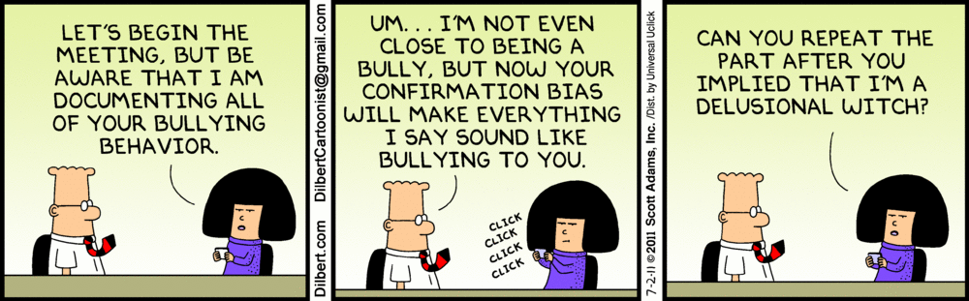**What You See Is All There Is (WYSIATI).** A key difference between System 1 and System 2 involves their treatment of evidence. System 1 tends to act as if the *evidence we have so far* is actually *all of the evidence,* and to immediately jump to conclusions on this basis. So, a good first impression of a person may produce a **halo effect,** which causes System 1 to conclude “That’s a great person.” Even if later evidence contradicts this, it can be very difficult (especially without deliberate, conscious effort by System 2) to dislodge this impression. An example: suppose that you receive information stating that Job Candidate A is “experienced, well-educated, a skilled public speaker, recommended by a trusted employee, a bad speller, and poorly dressed.” By contrast, Candidate B is “poorly dressed, a bad speller, recommended by a trusted employee, a skilled public speaker, well-educated, and experienced.” Researchers have found that people are *much* more likely to say they would hire candidates described like A than those described like B even though they only thing that has changed is the order in which the evidence was presented.

* **Lessons?** You can’t always trust System 1’s intuitive response to new evidence, since its goal is to maintain its current beliefs. Again, its important to bring System 2 in the process: How would this new evidence look to someone “just coming on the scene”? To someone who already was prone to disagree with you? Related to this, it’s important to monitor System 1’s tendency toward overconfidence: while it’s perfectly OK to act on the basis of incomplete evidence (since we’ll never know everything), we need to remember that *we could be wrong*, and take appropriate precautions.

## Problems With Causes and Probabilities: THe Base Rate Fallacy

System 1 dislikes being surprised, and it often demands an answer (from System 2) as to “Why?” something unexpected happened: why did the stock market go up (or down)? Why did I end up with the faulty oven, when my neighbor owns the same one (and it works fine)? Why did that person recover from cancer, when the other didn’t? Why did the crime rate go slightly up this year? Unfortunately for System 1, however, many of things it demands explanations for are simply the results of *chance* or *coincidence:* the stock market is a “random walk,” some percentage of ovens fail, some people (don’t) recover from cancer, and so on. Because System 1 demands a good story, it likes to believe in *conspiracies* (Somebody must have *planned* this…), even though chance is often a better explanation. One of the most important (and common) errors committed by System 1 is the **Base Rate Fallacy,** which occurs when it ignores relevant background statistics and probabilities. Some important problems related to this include the following:

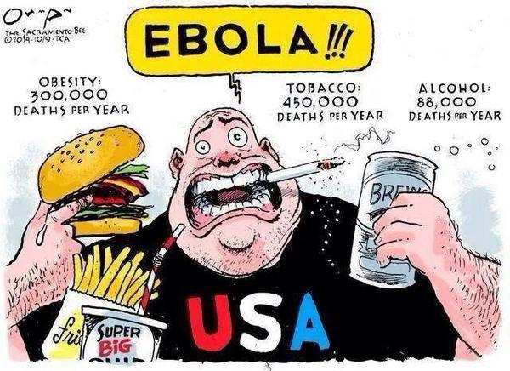The **“availability heuristic”** makes us prone to overestimate the probability of event types that “come to mind easily,” and to which we have recently been exposed. So, for example, violent deaths (by terrorism, crime, plane crashes, or whatever) generally receive plenty of media coverage, and these threats are easily “available” to System 1. Because of this, System 1 tends to vastly overweight the actual *probability* of these events compared to risks that have a much greater base rate, such as heart disease, cancer, automobile accidents. This can lead people to take counterproductive actions: avoiding exercise because of fear of being mugged, driving because of a fear of flying, and so on.

Figure The availability heuristic. From The Sacramento Bee.

The **“representativeness heuristic”** occurs when we make predictions based solely on how similar our situation is to a “representative” type of event without bothering to consider *how common events of this type actually are.* For example, consider a patient who gets a “positive” result on a breast cancer test (with no prior symptoms). Suppose she knows that (1) 90% of people who have breast can get positive results on the tests and (2) only 15% of those without breast cancer get a “false positive.” She concludes, on the basis of representativeness, that she probably has breast cancer. This is, in fact, a major error, since it ignores the *base rate* of breast cancer: only a relatively small number of women (perhaps less than 5%) who take the test actually have cancer. What should she conclude instead? That while it still unlikely that she has breast cancer, it is somewhat more likely than it used to be (and she should get more tests). The representativeness heuristic is closed linked with judgements based on “stereotypes.”

We are constantly surprised by **reversion to the mean,** which occurs when abnormal events or processes tend to “return” to the average. For example, an employee or athlete who has an extremely good year is likely to have a somewhat worse one next year, while one who had an extremelybad year is likely to improve. A stock that performs poorly improves; one that does well does less well. People who are abnormally happy will likely become less so over time; those who are extremely unhappy are likely to feel somewhat better. In every case, we tend to underestimate the role that *luck* plays in producing certain results. How do we correct this? By remembering that extremely high/low results are (statistically speaking) very improbable; while a stellar performance by an athlete one years may provide good evidence that they have skill, it does NOT mean it is reasonable to predict the same miraculous performance next year.

We all think that we are **“exceptions to the rule,”** even when we are aware of the statistical “base rate” in question. Doctors and patients may realize (intellectually) that positive test rates don’t mean that cancer is present, but (when confronted with a real-life positive test result), they act like they do. Students realize (statistically speaking) that procrastination leads to worse outcomes, but intuitively “feel” it won’t happen to them, and so on. Entrepreneurs are convinced their new business will succeed, even though most new businesses fail. We think our own lucky breaks are due to skill, while the unlucky breaks of others must be due to their personal faults, and so on.

## Prospect Theory, Framing Effects, and the Endowment effect

Logicians, economists, and others often describe what a “perfectly rational” person would do. In general, these people have certain *goals* (I want to be rich! I want to lead a long life! I want to promote the happiness of all humanity!) and they make decisions by considering which actions best advance those goals. Perfectly rational people understand the concept of marginal utility (for example, $1000 matters a lot more to a poor person than to a very rich one), and for this reason won’t take crazy risks (“Will you bet everything you own on the flip of a coin?”). However, besides this, they don’t have any special concern about “losing” or “winning”: they understand that “You win some and you lose some,” and they simply try to pursue those strategies that lead to the best outcome over the long haul. If humans were governed by System 2, this is what we would act like.

According to **prospect theory,** however, System 1 does NOT think about making choices in this way. Instead, it approaches decisions very differently. It begins by setting a **reference point** (“Everything above this counts as a gain. Everything worse than this counts as a loss”). Based on this, it values “avoiding losses” *much* more highly than it values “achieving gains.” For example:

1. Suppose you are handed $100, and are faced with the following choice: you can either have $50 extra guaranteed OR you can place a bet on a coin toss. If the coin lands heads, you get $100 extra; if not, you get nothing more.
2. Suppose you are handed $150, and are faced with the following choice: you can either immediately lose $50 OR you can place a bet on a coin toss. If it lands heads, you lose $100; if lands tails, you lose nothing.

In these sorts of choices, most people choose to go with “guaranteed” money in the first case, but are willing to “gamble” in the second case. This can’t be rational, however, *since the two “games” are just different descriptions of the same choice.* If you choose the guaranteed outcome, you walk away with $150; if you choose to gamble, there is a 50/50 chance of $100 or $200. So, what’s happened? The difference has to do with the way the choices are described: in the first case, we are dealing with things we are told to think of as “potential gains,” while in the second, these same things are described as “potential losses.” As added complication, we also have **diminished sensitivity** as regards the magnitude of losses/gains. For example, while we can “feel” the intuitive difference between losses of $50 and $100, we can’t “feel” this same difference when it comes to losses of $1000 versus $1050. This can lead to the following sorts of (irrational) behaviors:

1. Since we hate losses, we tend to be overly risk-averse in choices where we are weighing a “sure but smaller gain” (e.g., buying a savings bond) vs “a probable chance of a greater gain, but also a possible loss” (e.g., buying stocks).
2. Once we start losing, we often lose sensitivity to the importance of *minimizing* our loss. For example, in cases where we are forced to choose between a “sure loss” (going to prison for 5 years) vs. a “probable chance of a greater loss, but also a possible win” (e.g., lying to the police), we tend to go with gamble.
3. System 1 overestimates the impact of small differences (a $25 pair of pants vs. a $40 pair of pants), and underestimates the impact of big ones (a $250,000 house vs. a $400,000 one). From its point of view, these are basically the same choice, and worthy of the same amount of attention/worry.
4. We fall prey to the **endowment effect** of valuing things more *simply because we already own them.* A common example: many people would be unwilling to *purchase* a concert ticket for $100. However, once these people get a ticket (perhaps by winning one), they aren’t willing to sell it for $100. More controversially, this effect might explain why people “hold on” to bad relationships even in the face of overwhelming evidence that they ought to let them go.

So, how can we avoid these things? First, it is important to pay attention to **framing effects,** and to the way that we think of certain outcomes as “gains” and others as “losses.” In many cases, we don’t have any great reason for doing so (one common example: if you lose your job, its unwise to frame a new, lower-salary job as a “loss”). Second, remember that the goal is not to “win every battle” but to “win the war.” This involves accepting that there *will be losses along the way,* and that trying (too) hard to avoid them can lead to disaster. Finally, don’t get *too* attached to your current possessions or ways of doing things. This means using strategies that tend to produce the best results over the long run, even if this involves an occasional “loss.”

|  |  |  |  |
| --- | --- | --- | --- |
| Framing of Choice | Choice A: The Sure Thing | Choice B: Take a Chance | Result |
| As Potential Gains | “200 people will be saved” | “A 1/3 chance all 600 will be saved; a 2/3 chance that none will.” | 28% choose B |
| As Potential Losses | “400 people will die” | “A 1/3 chance 0 will die; a 2/3 chance that 600 will” | 78% choose B |

Table In a famous article, Kahneman and Tversky described a risky rescue maneuver in two different (but logically equivalent) ways. As predicted by prospect theory, people will take huge risks to avoid a loss, but will not do so when the question is rephrased.

## REview Questions

1. Explain the differences between System 1 and System 2 thinking. Give some examples (from your life) of the sorts of decisions and processes that involve each sort of System.
2. What is the “Law of Least Effort”? What does it imply about the relationship between System 1 and System 2? To what degree have you found this to be true?
3. Give some specific examples of the following sorts of errors: making decisions on the basis of “cognitive ease”, falling prey to the “halo effect,” and/or being overly influenced by priming/anchoring. How do you think the errors could have been avoided?
4. What exactly is the “base rate fallacy”? Give a few examples of how it can cause us to make bad decisions.
5. According to prospect theory, people place a much higher value on avoid things they think of as “losses” more than they do on achieving things they think of as “gains”? Why might this might be a problem? Can you think of any examples from your own experience?

## References and Bibliography

* Ariely, Dan. 2010. *Predictably Irrational, Revised and Expanded Edition: The Hidden Forces That Shape Our Decisions.* 1 Exp Rev edition. Harper Perennial.
* Daniel Kahneman. 2007. “Edge Master Class: A Short Course in Thinking About Thinking.” Edge.org. June 20. <https://www.edge.org/event/edge-master-class-2007-daniel-kahneman-a-short-course-in-thinking-about-thinking>.
* Kahneman, Daniel. 2013. *Thinking, Fast and Slow.* Reprint edition. New York: Farrar, Straus and Giroux.
* Kahneman, Daniel, and Amos Tversky. 1979. “Prospect Theory: An Analysis of Decision under Risk.” *Econometrica: Journal of the Econometric Society*, 263–91.
* Philip Tetlock. 2015. “Edge Master Class: A Short Course in Superforecasting.” Edge.org. July 30. <https://www.edge.org/event/edge-master-class-2015-philip-tetlock-a-short-course-in-superforecasting>.
* Richards J. Heuer. 2013. “Biases in Estimating Probabilities.” In *Psychology of Intelligence Analysis. Center for the Stuy of Intelligence.* <https://www.cia.gov/library/center-for-the-study-of-intelligence/csi-publications/books-and-monographs/psychology-of-intelligence-analysis/art15.html>.
* Richard Thaler, Sendhil Mullainathan, and Daniel Kahneman. 2008. “Edge Master Class: A Short Course in Behavorial Economics.” Edge.org. July 25. <https://www.edge.org/events/the-edge-master-class-2008-a-short-course-in-behavioral-economics>.
* Thaler, Richard H., and Cass R. Sunstein. 2009. *Nudge: Improving Decisions About Health, Wealth, and Happiness.* Revised & Expanded edition. New York: Penguin Books.
* Tversky, Amos, and Daniel Kahneman. 1974. “Judgment under Uncertainty: Heuristics and Biases.” *Science* 185 (4157): 1124–31.