Tanks, Terrorism, and Thomas Aquinas: The Ethics of War

Brendan Shea, Ph.D. ([Brendan.Shea@rctc.edu](mailto:Brendan.Shea@rctc.edu)) | Learning Is ForEver: Fall 2022

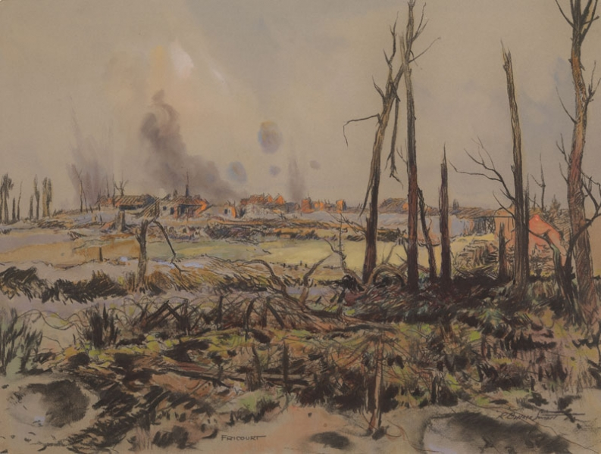

Figure 1 Fricourt by R Borlase Smart.

As traditionally understood, a **war**occurs when the members of one political community undertake large-scale, violent action against the members of another political community. So, World War 2 was a war, as was the Vietnam War. By contrast, the “war on drugs” is not a war in this sense. For this lesson (and most philosophical work about the topic), it does NOT matter whether war is “officially” declared. (So, for example, calling something a “special military operation” doesn’t change anything!).

**Just War Theory** (**JWT)** has historically been the dominant approach to the ethics of war, and it forms the basis for many religious (the Catholic Church), national (the U.S. and Canada), and multinational (E.U., NATO, U.N.) policies concerning war. In this lesson, we’ll focus on learning the basic concepts of Just War theory and its competitors and consider their application to some recent debates, such as the war in Ukraine and Western responses to terrorism.

Contents

2 Just War Theory: An Overview 2

2.1 The “Justice of War” (Jus Ad Bellum) 2

2.2 Just Conduct in War (jus In bello) 3

2.3 After War Ends (jus post bellum) 4

2.4 Alternatives to Just War Theory 5

2.5 Review Questions 5

3 Case Study 1: War in Ukraine 6

3.1 Review Questions 8

4 Case Study 2: Walzer on Terrorism 8

4.1 Some Examples of Terrorism 9

4.2 Why Is Terrorism Morally Wrong? What Should We Do About it? 9

4.3 Terrorism: Review Questions: 10

# Just War Theory: An Overview

In the Western tradition, the foundations for just war theory reach back to the Greek philosopher **Aristotle (364 to 322)** and the Roman Christian **Augustine (354 – 450 CE).** However, it is **Thomas Aquinas** who first “systematized” these insights in a way that would enable them to be formulated as principles of law (first Canon law, but later secular international law, as well). Most religious and philosophical traditions (Hinduism, Buddhism, Confucianism) have similar ideas, though the language used can be somewhat different. Each tradition also contains its version of pacifists and realist critics.

The “contemporary” debates about just war theory (in international relations and philosophy) date back to discussions during World War 2 and the post-colonial wars that followed (Algeria, Vietnam, etc.). Michael Walzer’s 1977 book *Just and Unjust Wars* is probably the most influential work, and we’ll draw on many of his ideas here.

Just War theory is generally broken into two (and sometimes three) different areas:

1. Questions about the “justice of war”, or **jus ad bellum.**
2. Questions about just “conduct of war”, or **jus In bello.**
3. Questions about post-war obligations, or **jus post bellum.**

In the following sections, we’ll explore each of these areas, before turning to some case studies.

## The “Justice of War” (Jus Ad Bellum)

JWT says that the moral acceptability of going to war depends on the following factors.

**Proper Authority.** Those declaring war must have a legitimate right to make decisions for their political community. For example, a democratically elected government that uses proper procedures is legitimate. By contrast, militant groups do not have the right to “take it upon themselves” to defend the “people” without the people’s permission.

For example, the unelected leadership of dictatorships such as Nazi Germany, Stalinist Russia, or Maoist China cannot make decisions to “go to war” on behalf of their people. However, the “people” still have a right to self-defense (e.g., the Russians resisting the German invasion). In many cases, the question of authority will not have a simple Yes” or “No” answer. For example, the U.S. decision to invade Iraq in the early 2000s was “democratic” but “flawed” (among other things, the legislators were given incomplete/inaccurate information).

**Just Cause.** The war must be fought to protect people from unjustified violence. Defending one’s citizens from an invading army is a just cause; so is sending forces into other countries to stop genocide or end slavery. The acquisition of land, prestige, power, or resources is not a just cause. Most wars are declared and fought for *many* reasons (e.g., in a large nation like the U.S., different politicians, political parties, and governmental departments that influence the decision to go to war have different “goals”). This requirement requires that the “just cause” be the *determining* factor. Like proper authority, this may be a matter of degree, and two warring combatants may each have “some” justice to their cause. In this case, only the combatant with a “juster” cause can go to war.

Examples: Modern theorists interpret this to mean that “wars of conquest” are almost always wrong. More generally, “preventative wars” or “first strikes” are especially suspect. The classic example is Germany in World War 1, which “struck first” because of worries about what Russia *might do* in the coming years and decades. The rebellion by the Southern States (in defense of slavery) is another clear example.

**Right Intention.** War must be declared with the **right intention**—decisions about waging war must be to achieve the just cause. It is immoral to consider factors like political expediency or monetary gain. A just war MUST aim at a “**sustainable peace,”** and countries waging war must be sure that do not have any unjust policies that make achieving peace more difficult. The intent is closely related to the *conduct* of the war. The requirement here is decisions about how to wage war be related to the “just cause” and not to any other (inadmissible cause). We’ll say more about this in the next section.

**Last Resort.** War must be taken only as a **last resort.** So, it would be immoral to declare war if it were still reasonable to hope that sanctions, boycotts, or negotiations could achieve the same end (without violence). An important caveat here: this requires that you be willing to make *sacrifices* to avoid war. So, for example, suppose that country A has “just cause” to go to war with country B. Moreover, it expects it will easily win this war. Still, it must pursue peace by other means, even if this peace is “more costly to it” than going to war (for example, it might require the renegotiation of trade deals, etc.)

**Probability of Success.** There must be a reasonable **probability of success** that the war will achieve its end of sustainable peace. For example, it’s usually immoral to sacrifice soldiers for a “lost cause,” no matter how good your cause or intentions are (even if the alternative is to surrender). This criterion is frequently evoked (by attackers!) as a reason for defenders to “lay down their arms.” However, the crucial point is to consider the *contract:* would the defenders (and the political community they represent) be “closer to” a sustainable peace by surrendering?

**Proportionality.** The total harm that will result from waging war must be less than the harm that would have resulted had you let your enemy do as it wished. For example, it would be immoral to go to a war that you expect would lead to 200,000 deaths to prevent the deaths of 2,000.

## Just Conduct in War (jus In bello)

JWT also offers an account of the moral requirements on soldiers and their political leaders once the (presumably just) war has been declared. There are two main principles related to this.

**Principle of Discrimination—**Those waging war should target only combatants and never non-combatants. This holds for political and military leaders (e.g., when deciding which targets to bomb, and whether to use chemical or nuclear weapons) and individual soldiers. In keeping with this idea, war combatants must also ensure that their “combatant” status is evident to the enemy (hence, no disguising soldiers as civilians or placing artillery on the roofs of elementary schools). Finally, the fact that the “other side” breaks these rules (by targeting civilians or hiding among the populace) does NOT justify “our side” doing so as well.

* Sometimes, the line between “enemy solider” and “active collaborator” can be challenging to discern. A question here: How much can a “civilian” do to aid their “side” of the war before they become a combatant?
* It is vital to remember that the principles like “It is morally OK to target enemy combatants” hold only if one is fighting a “just war” in the first place. For example, soldiers in an unjust war (for example, the U.S. Confederacy) would have no “moral right” to target *anyone.*

**Principle of Proportionality:** This is the same principle in the previous section, but this time applied to individual actions within war instead of the general decision to go to war. Again, the idea here is that military action should do more “good” than “harm,”, especially in terms of civilian lives (“enemy” civilians don’t count as any less than “our” civilians).

## After War Ends (jus post bellum)

Finally, contemporary just war theorists have extended classic JWT to consider the ethical issues that arise after a war has finished. The central principle is the same: *everything we do must aim at achieving sustainable peace.* Some of the main issues here are as follows:

**A “Just” Amount of Reparations.** Most theorists agree that the aggressor in a just war DOES owe reparations, even if this requires taxing their own “innocent” civilians. The moral obligation of these citizens to pay such taxes follows from the (limited) power they had over whether their country chose to go to war, and how they fought it. However, given the limited role of these non-combatants in starting/waging the war, it would be immoral to ask for reparations that would substantially harm them. One example of “unjust” reparations is the treatment of Germany after World War I, where excessive reparations (and their effect on ordinary Germans) helped lead to political unrest, which (in turn) helped lead to the Nazi takeover 15 years later.

**“War Criminals” vs “Ordinary Soldiers.”** Another question involves the treatment of the political/military leaders of the aggressor, as well as individual soldiers (on both sides) whose conduct was immoral. Here, proportionality plays a major role—we want to make decisions that make it *easier,* rather than *harder,* to achieve sustainable peace. History is full of plenty of examples of going wrong in both ways. For instance, the U.S. Government (led by Andrew Johnson) did very little to punish war criminals (or to seek reparations) from Southern states, which led to future problems for African Americans in the South.

**Aiming a Sustainable Peace.** Finally, there must be an effort to fix the “root problem” that led to war, but WITHOUT trying to create an unrealistic “utopia.” Historically, many “conquering” nations have attempted to impose their religion or culture upon the defeated, which violates the spirit of JWT. By contrast, the US-led Marshall Plan (aimed at rebuilding defeated Germany and Japan) is often held up as a model of the post-war “should” look like. More recent military interventions (in Vietnam, Iraq, Libya, and Afghanistan) have often been criticized for paying inadequate attention to the question: “What happens after?”.

## Alternatives to Just War Theory

Debates over the morality of war go back *thousands* of years, and natural law theory is simply ONE answer to these question. The two other main approaches are generally called **Pacifism** and **Realism.**

**Pacifism** holds it is never morally OK to go to war, even in self-defense. Pacifists often defend their position by noting that (1) killing innocent people is morally wrong and (2) waging war (even in self-defense) will almost always involve killing at least *some* innocent people. So, (3) we should never go to war.

**Realism**holds it is always morally OK for a political community to go to war (and to wage this war however it wishes), so long as this serves that community’s long-term self-interest. This is the political equivalent of **“ethical egoism”** (the ideas that you *ought* to care only about yourself). A simple argument for realism might go as follows: (1) Any political community that refused to go to war for moral reasons would quickly be destroyed by less moral enemies. (2) No community is morally required to do things that would lead to its own destruction. Therefore, (3) it is always morally OK to go to war.

**Just war theory,** as laid out above, claims it is sometimes, but not always, morally OK to go to war. Just War Theorists point out (for example) that most people agree that it was not morally OK for Nazi Germany to go to war with Poland AND that it was morally OK for the Allies to go to war with Nazi Germany. They conclude that some (but not all) acts of war are OK.

* Some just war theorists are “closer” to pacifism (for example, if they think the proportionality requirement is rarely met, and that there are many realistic alternatives to war).
* Others are “closer” to realists (for example, if they are convinced that the world is filled with “bad actors” of the Hitler-Stalin-Mao variety, and that military force is the only effective response).

## Review Questions

1. To what extent would JWT say the following were “just” wars? What sorts of evidence is there on either side?
   1. The entry into World War 1 in 1917 on the side of Britain/France/Russia, in response to the German attacks on merchant shipping.
   2. The entry into World War 2 in 1941, in response to the Japanese attack on Pearl Harbor.
   3. The decisions BEFORE World War 1 and 2 to aid Britain and France in their conflicts with authoritarian, militaristic states.
   4. More recent wars (Vietnam, the First and Second Iraq Wars, Afghanistan, etc).
2. In recent years, there has been considerable debate over what counts as an “attack” on one’s nation. For example, should Western nations consider state-sponsored “cyberattacks” by Russia, Iran, or China to be “attacks”? And if so, what is the proper response?

# Case Study 1: War in Ukraine

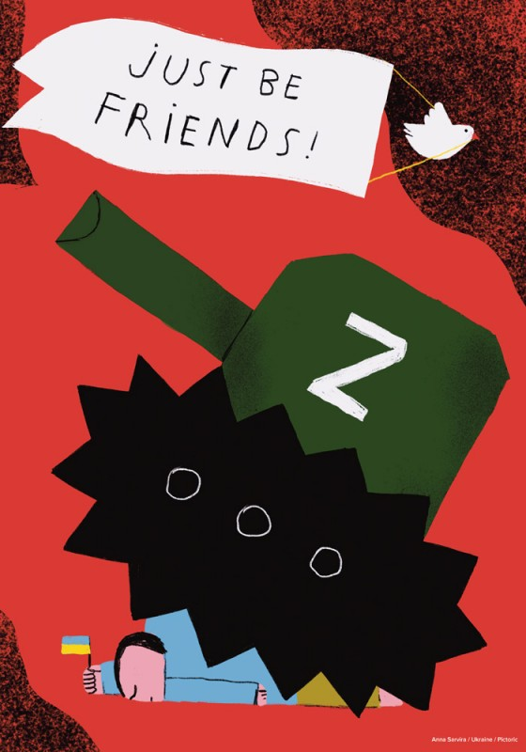

Figure 2 "Just be Friends" by Ukranian Artist Anna Sarvira.

Since the end of the Cold War (and especially after the second Iraq War) Pacifism and Realism have become increasingly popular on both the “left” and the “right.” Pacifism states that “all” war is wrong, while Realism holds that nations cannot (and should not) do anything except act in their own self-interest. Both views offer easy (though very different) reasons for the U.S./E.U./NATO to refrain from military action, especially when it comes to defending “human rights” in other rights.

The recent war in Ukraine has revealed the limitations of both Pacifism and Realism. Scholars in both traditions had generally favored “appeasing” or “working with” Russia to avoid war. For example, many had proposed that Ukraine be denied the right to join NATO, and pushed for a “negotiated” solution to the Donbas/Crimea conflicts in which Russia would (effectively) be granted partial political control over the parts of Ukraine that it had conquered. It now seems unlikely that such approaches would have worked, either morally or practically.

Just War Theory, by contrast, provides a useful framework for thinking about the conflict in Ukrain. There have been a number of articles applying Just War Theory to the war between Russia and Ukraine (which started in 2022). The overwhelming consensus is that:

* Russia violated the conditions of JWT, and was not justified in going to war.
* Ukraine has the right to defend itself, and its actions are in keeping with JWT.

We can briefly review the principles laid out above to explain this in greater depth:

|  |  |  |
| --- | --- | --- |
| Criteria | Russia | Ukraine |
| Proper Authority | Putin’s Russia is classified as an **authoritarian** state by most outside observers, and thus lacks authority to wage war on behalf of the “Russian people.” The media is tightly controlled, opposition political figures are regularly imprisoned or killed, and many war-related decisions (for example, regarding recruitment or conscription) are made on obviously discriminatory bases. | Ukraine is classified as a **transitional/hybrid** government. Compared to Russia, it has a greater ability/right to make such decisions. Moreover, many of the *ways* in which it lacks freedom relate directly to Russia’s actions (e.g., in undermining the rule of law in the Donbas). Their government had a right to mobilize the military against an invasion, and other governments had the right to aid them. |
| Just Cause | Russia made two main claims: (1) Ukraine was engaged in a “fascist” or “genocidal” campaign against Russian speakers in the Donbas and (2) a decision by Ukraine to join NATO or the E.U. would threaten Russia’s self-interest. The first claim is factually false; JWT says the second is not an acceptable reason for waging war. | Defense against an invading army is the paradigm example of a “just cause.” Other states (such as the U.S.) have a right to provide aid. However, these outside states should NOT attempt to make the war about “their” goals. |
| Right Intention | Russia’s conduct in the war (by targeting civilians, forcibly relocating them, holding staged “referendums”, stealing resources, etc.) have all suggested an imperial war of conquest, which does not keep with either of their stated “causes.” | Ukraine’s conduct in the war can and should be critiqued. However, at a large scale, there is little reason to think that they have the war aims Russia has claimed that they have (for example, genocide against Russian speakers). |
| Last Resort | The U.S. and its allies (such as the U.K.) repeatedly warned that Russia was engaged in military preparations for an invasion, which Russia denied. This denial, among other things, prevented any serious discussion of alternatives. | The initial Russian invasion appeared aimed at capturing Kyiv and overthrowing the government of Ukraine. The only realistic options were “fight” or “surrender.” |
| Proportionality | While the war may have been rational for Putin (e.g., his domestic political situation or desire to be remembered in a certain way), there’s no reason to think that Russia’s decision to wage war would be a “net benefit” for humanity. | This criterion has been the main “target” of both realists and pacifists who argued (early on) that Ukraine was “destined” to lose and that accommodation with Russia would be “cheap” (for example, it would merely involve sacrificing NATO membership). Subsequent events have suggested that both beliefs are likely to be false. |

## Review Questions

1. Do you agree that JWT better explains the Ukraine conflict than Realism or Pacifism? Why or why not?
2. The above table provides a “sketch” of how JWT might apply. What other sorts of details might be relevant?

# Case Study 2: Walzer on Terrorism

Michael Walzer (the most famous modern proponent of just war theory) has offered an analysis of the questions “What’s morally wrong with terrorism?” and “What does this mean for how we should respond to terrorism?” He begins by defining t**errorism** as “the *random* killing of *innocent* people for the purpose of inspiring pervasive fear.” On this definition, terrorism can be done by small groups, individuals, or governments. It does not require that you have a particular religious or political motivation.

A killing is **random** if you are killed merely because you are part of a community (because you are “Jewish”, “Communist”, “Atheist”, “American”, etc.) and not for any particular thing you did. Blowing up buses or planes full of civilians is “random” in this sense. A killing is NOT random if you are killed in virtue of some relevant role you hold (so, for example, it is not immediately clear that the assassination of politicians will always count as “terrorism,” even if this is wrong for other reasons.) According to JWT, you are **innocent** if and only if you are not a member of an organized military group (if you are a “civilian” and not a “combatant”). For example, a bomber pilot or military radio operator are not innocent (even if they are perfectly nice people), whereas garbage collectors and philosophy professors are innocent (even if they happen to be thieves or murders).

* 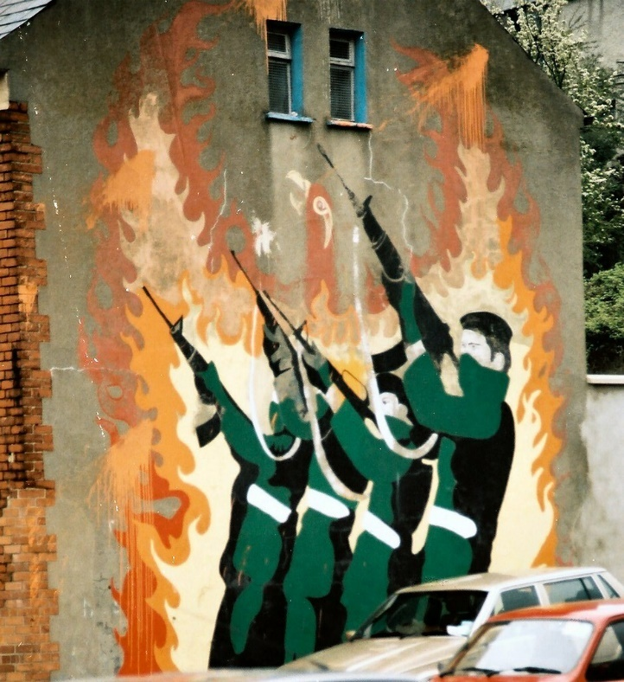How do you tell if someone is a combatant? Consider things like (1) Do they kill people, or spend lots of their time communicating (directly or indirectly) with people who do kill people, (2) Do they live in a barracks instead of houses (3) Do they have a direct “commander” and/or “subordinates”? Walzer strongly disagrees with the claim (sometimes expressed by defenders of terrorism): “Since you are an American who voted in the last election, then you are responsible for everything American military does, and are therefore a legitimate target for violence.”

Figure 3 Mural in Derry, Northern Ireland.

* For similar reasons, a member of military will NOT count as innocent even if they were conscripted and/or do not want to be part of the war effort. So, for example, many Nazi or Confederate soldiers were undoubtedly decent people who hadn’t really wanted to fight in the first place (and often had been forced to do so). Nevertheless (insofar as we were justified in fighting the Confederacy and Nazi Germany), JWT says that it was OK to kill them in certain circumstances.

On Walzer’s definition, terrorism is (unsurprisingly) aimed at inspiring terror—it does NOT work primarily by degrading an enemy’s military capabilities; it works by making the average (innocent) member of population think “That could have been me. Maybe we should just give the terrorists whatever it is they want.” And while some terrorists have inherently evil causes (e.g., genocide against groups they don’t like), others may have legitimate causes (e.g., independence from a corrupt government, repelling an enemy invasion, etc.). Walzer argues, however, that terrorist methods are almost never justified, no matter how praiseworthy the group’s goal might be.

## Some Examples of Terrorism

On Walzer’s definition, terrorism violates the intent requirement of JWT, since the actions of terrorists (whether or not the terrorists would admit it) express something like: “We don’t want your type of people here. Leave.” So what counts as terrorism on this definition?

* Religiously or political motivated attacks on civilians by non-governmental groups: the September 11th attacks; the Lockerbie plane bombing, Hamas rocket attacks on Israel, ISIS beheadings of various people, IRA bombings aimed at civilian targets.
* Government campaigns aimed at genocide (Nazi Germany, Rwanda) or inspiring terror in the populace (Stalinist “purges”). **Collective punishment** (killing or punishing the relatives or friends of an enemy combatant) also counts as terrorism, since these people are innocent, and (from their point of view) are chosen at “random.”
* Acts of war that “succeed” by killing civilians and bringing about terror (often to try and bring pressure to make the enemy government surrender). For example, the British bombing of Dresden or the American bombings of Hiroshima or Nagasaki seem to qualify (since these were aimed at random, innocent German and Japanese civilians, and not primarily at military targets).

The intent of all of these acts seemed to be something like *unconditional* surrender of the populace (and not a “just peace”), which means that terrorism is unjustified, according to JWT. By contrast, the following actions do NOT count as terrorism

* Attacks on military targets by religiously or politically motivated “rebels” or “insurgents.” While these attacks might violate JWT for *other* reasons, they do NOT clearly count as terrorism. Walzer suggests that some of the IRA activities in the 1970s and 1980s (against British military or political targets) might be classified this way. Similarly, attacks on NATO troops in Iraq/Afghanistan/etc. might not be terrorist actions, so long as the targets were military.
* Actions causing civilian casualties in cases where there was legitimate **inten**t not to harm them. “Intent” means more than “We didn’t *want* to hit civilians.” It means something more like “We were aiming at important military targets, and were willing to accept substantially increased costs and causalities to avoid harming civilians.”

## Why Is Terrorism Morally Wrong? What Should We Do About it?

**Walzer’s conclusion.** Terrorism violates two basic moral principles, according to Walzer. First it violates civilians’ rights as individual persons. In general, innocent people have the right not to be killed. In this sense, terrorism is a type of murder. Second, it violates civilians’ rights as members of their communities. According to JWT, it would never be moral to go to war for the express cause of “we want to kill all the members of group [X].” But terrorists act *as if* this is what they want to accomplish. In general, Walzer suggests that it *is* legitimate for governments to use the military to respond to terrorist threats. However, he thinks there is a tendency (because terrorists often hide within the civilian population) for governments to resort to something like terrorist methods themselves (i.e., to use irregular and non-uniformed “allies”, intimidate locals, accept high rates of civilian causalities, etc.). In Walzer’s view, this is both morally wrong and strategically stupid, since it often backfires, and ends up increasing community support for the terrorists.

**Other thoughts.** JWT also implies that responses to terrorism must be *proportional—*i.e., it is not OK to launch an anti-terrorist campaign to save 3,000 U.S. innocent civilians if the likely *cost* of this campaign will be the death of 10,000 *non-*U.S. innocent civilians. The requirement of *intent* means that any military response to terrorism must be accompanied by a careful review of the country’s own policies. It’s important to be clear here: the mere fact that a country has unjust policies does NOT make terrorist attacks on it OK; however, it does mean that this country should change those policies before considering launching its own military response to terrorism.

## Terrorism: Review Questions:

Which of the following would be classified as “terrorist” (and hence, immoral) actions, according to Walzer? Explain your answer. Do you agree? (Some answers may require more thought than others).

1. The Nazi program of ethnic killing
2. The Japanese attack on Pearl Harbor
3. The U.S. dropping nuclear bombs on Hiroshima and Nagasaki
4. The September 11 attacks
5. The U.S. use of drones to kill suspected terrorists in other countries
6. The KGB’s practice of killing the *relatives* of people who had taken Russian citizens hostage in the 1980s
7. **T**he Israeli practice of bulldozing the houses of anti-Israeli militants

# References and Bibliography

Fiala, Andrew. 2021. “Pacifism.” In *The Stanford Encyclopedia of Philosophy*, edited by Edward N. Zalta, Fall 2021. Metaphysics Research Lab, Stanford University. <https://plato.stanford.edu/archives/fall2021/entries/pacifism/>.

Grygiel, Jakub. 2022. “Russia’s Unjust Attack and Ukraine’s Just War.” *Public Discourse* (blog). March 13, 2022. <https://www.thepublicdiscourse.com/2022/03/81091/>.

Gutbrod, Hans. 2022. “Russia’s Recent Invasion of Ukraine: The Just War Perspective.” Global Policy Journal. March 21, 2022. <https://www.globalpolicyjournal.com/blog/21/03/2022/russias-recent-invasion-ukraine-just-war-perspective>.

John Davenport. 2022. “Just War Theory and Ukraine: Why Military Action against Russia Is Justifiable.” America Magazine. January 25, 2022. <https://www.americamagazine.org/politics-society/2022/01/25/just-war-nato-ukraine-putin-242271>.

Lazar, Seth. 2020. “War.” In *The Stanford Encyclopedia of Philosophy*, edited by Edward N. Zalta, Spring 2020. Metaphysics Research Lab, Stanford University. <https://plato.stanford.edu/archives/spr2020/entries/war/>.

McMahan, Jeff. 2004. “The Ethics of Killing in War.” *Ethics* 114 (4): 693–733.

———. 2009. *Killing in War*. Oxford University Press.

Moseley, Alexander. 2022. “Just War Theory.” In *Internet Encyclopedia of Philosophy*. <https://iep.utm.edu/justwar/>.

Motyl, Alexander J. 2014. “The Surrealism of Realism: Misreading the War in Ukraine.” *World Affs.* 177: 75.

Smith, Patrick Taylor. 2018. “Cyberattacks as Casus Belli: A Sovereignty-Based Account.” *Journal of Applied Philosophy* 35 (2): 222–41.

Walzer, Michael. 1977. *Just And Unjust Wars*. Basic Books.

———. 2002. “Five Questions about Terrorism.” *Dissent* 49 (1): 5–11.

———. 2006. “Terrorism and Just War.” *Philosophia* 34 (1): 3–12.