**Create a new configuration file for the box_upload.py script.**

**Brenden Sweetman**

1. Get the client ID and secret from the Box developer website (https://wustl.app.box.com/developers).

NOTE: only the admins that have been invited to the application will have access to the client ID and secret.

The client information is under the “teaching-center-upload” app in the “configuration” panel:

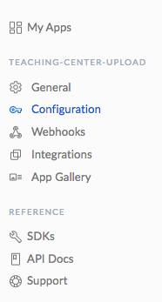

1. Open terminal or any unix command line and “cd” to the location of the auth.py script. Make sure that the system requirements for box_upload.py and auth.py are met (see technical documentation).

Run the auth.py script with the client ID and the file name for the configuration file.

NOTE: do not include the file extension in the file name

An example command line call is given below:

./auth.py –i <client ID> -f <filename>

1. The script will then ask for the client secret. Copy and paste the client secret into the command prompt.
2. This will result in the generation of a URL. Copy and paste this URL into a web browser. By logging in to your account you grant access for the script to control your account and upload files on your behalf.

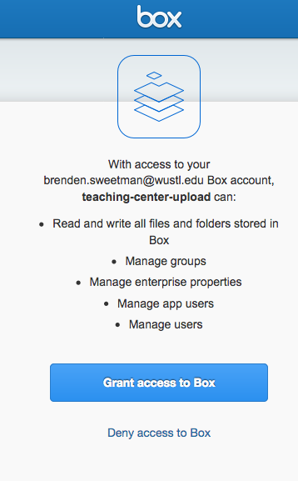

1. Upon granting access to your account, the Box API will generate a request code. You must copy and paste this code into the command prompt within **30 seconds** of its generation. If it takes you longer than 30 seconds the script will fail and you just have to start again.

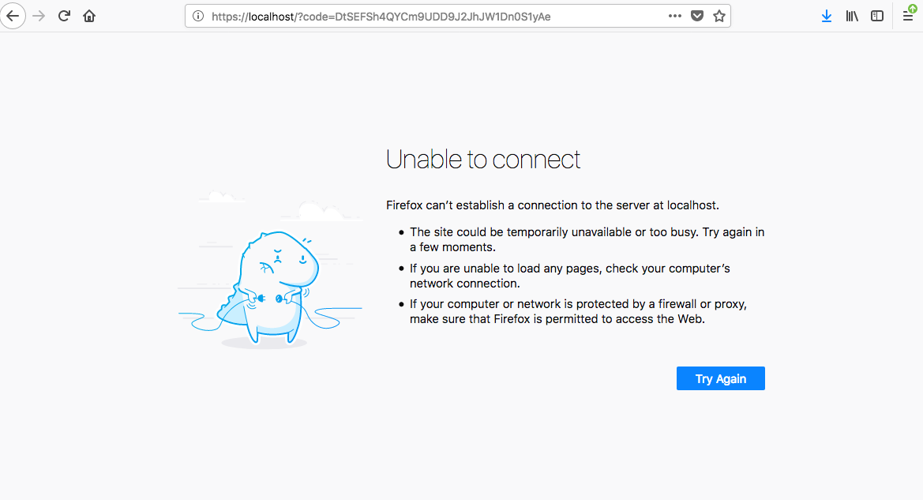The code can be found in the URL window (see below)

NOTE: I have not created a full featured web application. Therefore, when you grant access the Box API will direct you to a broken web page. This is okay. We only need the code generated in the URL window.

Copy and paste the code in the URL window to the command prompt and hit enter.

That’s it there should be a new configuration file in the same directory as auth.py

Last Modified: April 10, 2018