Link to Tableau Public: <https://public.tableau.com/profile/camille.mumm#!/vizhome/Group2HW3/Dashboard1?publish=yes>

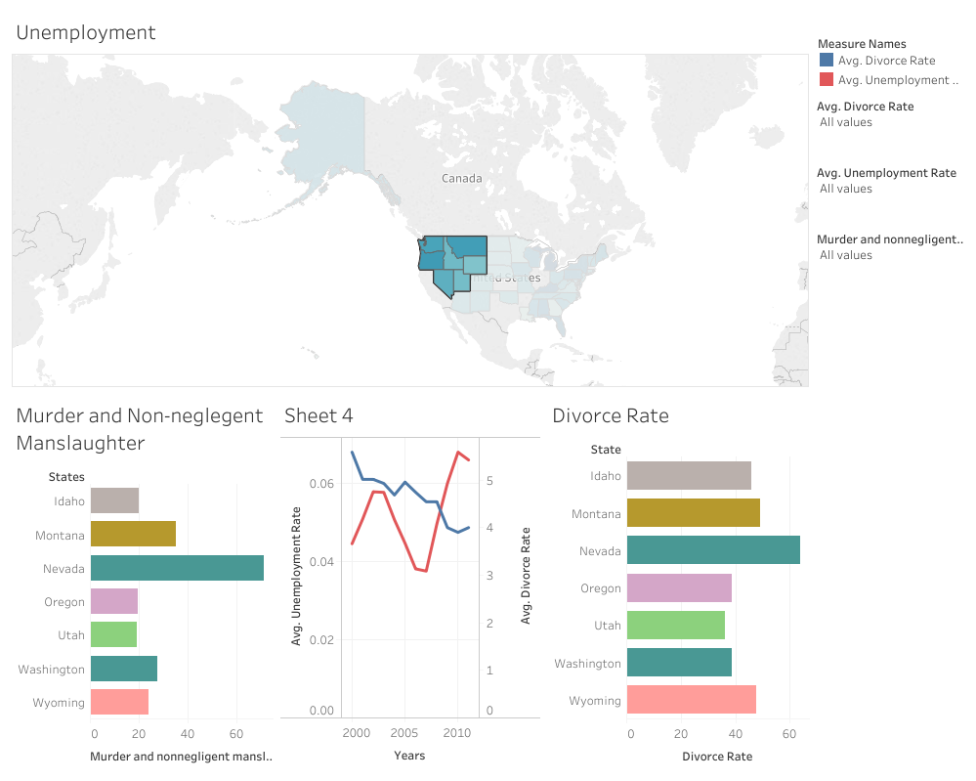

We created four visualizations based on the datasets for unemployment, property and violent crime, and divorce rates based on state from 2000 until 2011. We joined these dataset based on ‘State’ and ‘Year’ attributes. We started with a map visualization of the unemployment rate. Next, we used two bar charts, one for divorce rate and one for the murder and non-negligent manslaughter rate. These graphs interact with the map so user can highlight or select different states at a time on the map visualization and only these states will appear on three charts with the respective data. The screenshot above of our dashboard shows the selected states on the map and the respective data on the charts. Lastly, we then implemented a line graph of both rates for better comparison of the crime rates and divorce rates. This also will change with what is selected on the map. The line graph is a great way to add a time dimension to this data as well, the other graphs feature summed data but the line graph gives the user the ability to see how the data changes over time, not just between states.