ENSF409 – Post Lab 5 Screenshots – Brenden Bickner

Random Number Generator Output:

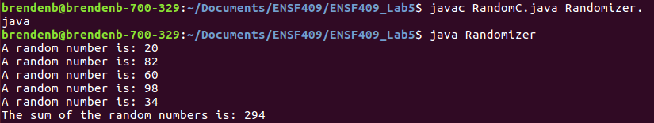
Generics Demo Output:

