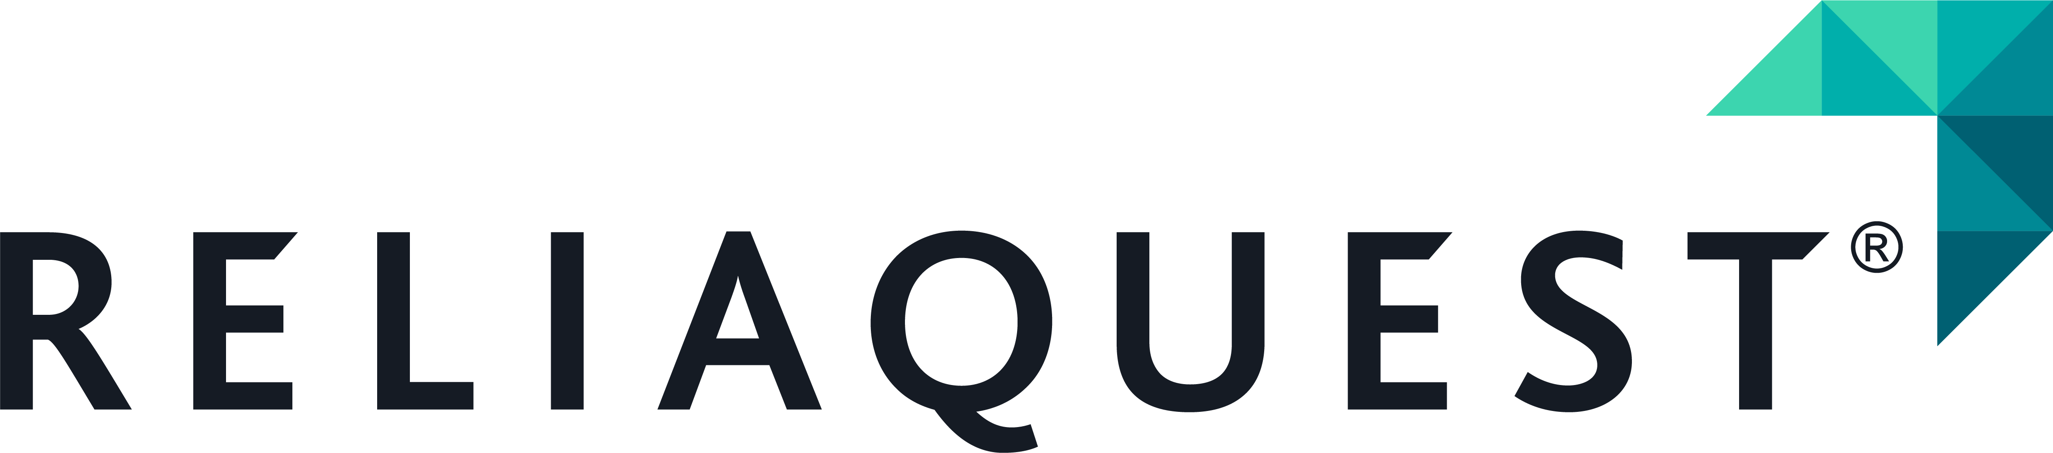 | Ariadne One question. Answers from many sources.  Technical brief · Department of Scientific Computing, Florida State University · ReliaQuest Innovation Challenge, Challenge Three: Knowledge Graph Integration · September 2026

What it is
Ariadne is a federated, agentic access layer over live cybersecurity knowledge graphs that sit on different database engines and speak different query languages. An analyst asks one question in plain English; Ariadne plans it across the sources, runs a native read-only query against each engine, and returns one answer in which every claim carries the record it came from and the query that retrieved it. The demonstration sources are MITRE ATT&CK, held in Neo4j and queried in Cypher, and MITRE CAPEC, held in a Gremlin Server and queried in Gremlin. Nothing is merged or copied into a warehouse and no vector index is built: the sources stay where their publishers put them, and the question travels to them.
What it does
Input: a question such as "Which ATT&CK techniques does CAPEC-555 map to, and what mitigations apply?" Output: a set of verified claims with citations, an optional plain-prose narrative written over those claims, and, when a source holds nothing, an abstention that shows the query that ran and returned no records. The analyst workbench shows the plan and its gate, one lane per database with the validated query in that database's own language, the normalised evidence, and the join index that links records across sources. Three per-question controls are off by default: Verify asks a model for a second opinion on whether the evidence suffices, Prose asks a model to write readable text over the verified claims, and Thinking sets that model's reasoning budget. The default path is deterministic and byte-reproducible; a model may draft, but deterministic code grades every seam, and no model ever writes a query.
How it does it
Stage | What happens | Model
Source cards | One JSON sheet per database, generated from the live schema: node labels, relationship types, properties, declared join keys, safety limits (read-only, max depth, max rows, timeout) and provenance pinned to a snapshot hash. The planner routes only on what a card declares. | none
Discovery | Each request probes every source: reachable, loaded, expected labels present. A source that is down is reported with a reason and its part of the plan is marked unsupported rather than invented. | none
Planner | Classifies the intent, drafts per-source sub-questions and declared joins, and passes the draft through a deterministic gate that rejects any label, edge, join or limit the cards do not declare. A rewrite stage may canonicalise questions that cite no identifier; the model only picks from a closed candidate list and never chooses the entity. | optional, gated
Specialists | One per database. Resolves the entities against the card, composes the query from five schema-derived primitives (describe, neighbors, walk, chain, bridge), validates it before execution (read-only, card-declared labels and edges, bounded depth and rows), executes once under a timeout, and normalises every record with provenance: source, executed query, record id, timestamp. | none
Retrieval loop | Judges whether the evidence closes the question; grafts only the missing sub-questions onto the plan; re-runs them seeded from what was already found; capped at five rounds and a total deadline. | none
Synthesis | Composes claims from retrieved records; a verifier checks each through four gates: cited, resolvable, grounded, correlated. What fails is cut from the prose and kept flagged. An empty result becomes an abstention carrying the executed query as proof; conflicts between sources are flagged, never silently resolved. | narrator optional; it cannot add a claim
Structural facts
3 databases · 2 query languages · 1 process | ATT&CK (Neo4j), CAPEC (Gremlin Server) and an identity graph (Neo4j) answered live in one process; adding the third changed nothing about the questions.
0 vs 1,083 records rewritten | Federating left both catalogues as published. Merging ATT&CK and CAPEC into one store required editing 1,083 of 9,138 nodes, an edit that must be redone every release.
240 / 240 adversarial queries blocked | Generated by crossing rejection categories with syntactic mutations; 15 real bypasses were found and closed before the audit reached 240 of 240.
39 KB card · 19.9 MB graph | The ATT&CK source card is two tenths of one percent of the graph it describes. That is the whole per-database input.
Where it stops today
- Questions that cite an identifier work; rewording the question keeps about half; paraphrasing an entity's name keeps about a third with the identifier-gated rewrite stage; describing an entity without naming it is not yet supported.
- Every published headline replays a human-authored retrieval plan. Answer quality through the workbench's own planner has not been judged yet; the planner is the next target.
- The ReliaQuest identity schema (72 node types, 21 relationship types, five identity systems) ran with synthetic records that conform to it; the schema is real, the records are not. A declared bridge maps 13 of its 21 relationship types to ATT&CK techniques, for example DC_SYNC to T1003.006.
Repository and research record: github.com/brendondgr/Ariadne, docs/research/ (every figure above is traceable there). Olmo S. Zavala Romero, PI · Brendon DGR, technical lead. Apache 2.0; ATT&CK® and CAPEC™ are trademarks of The MITRE Corporation.

