Project Screen Shots by Requirement (taken from log files which are available at: )

1.

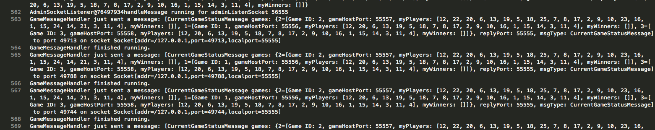

2.

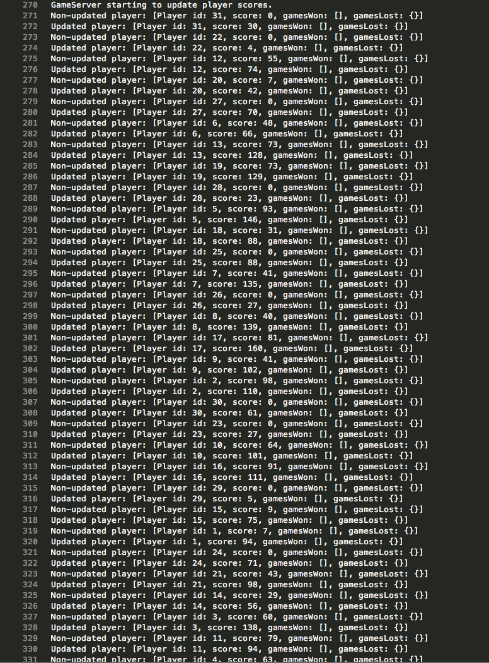

3.

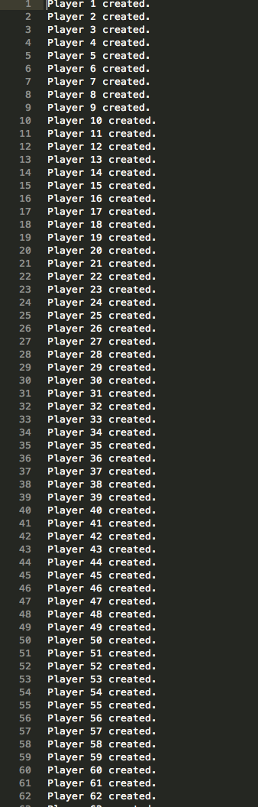

4.

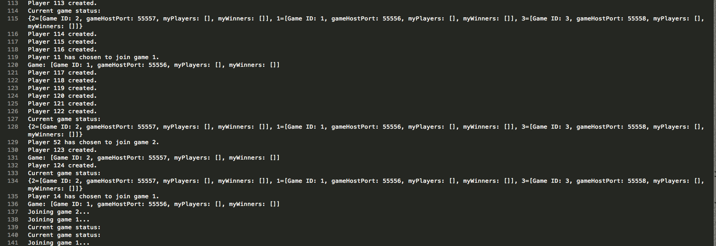

5.
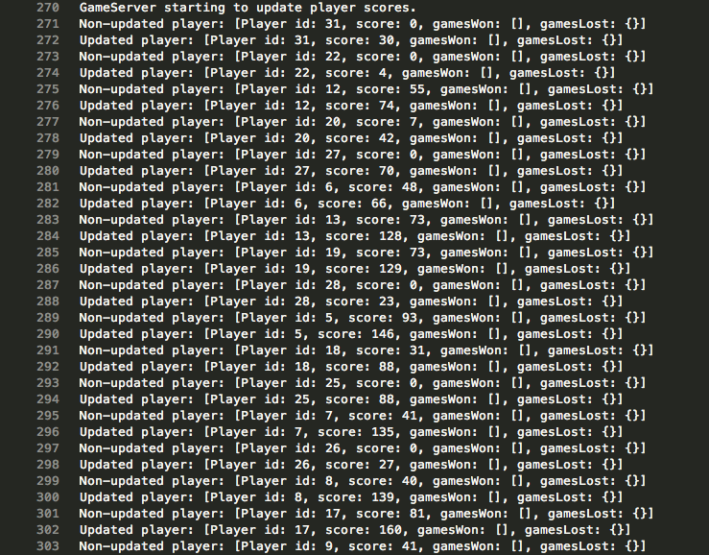

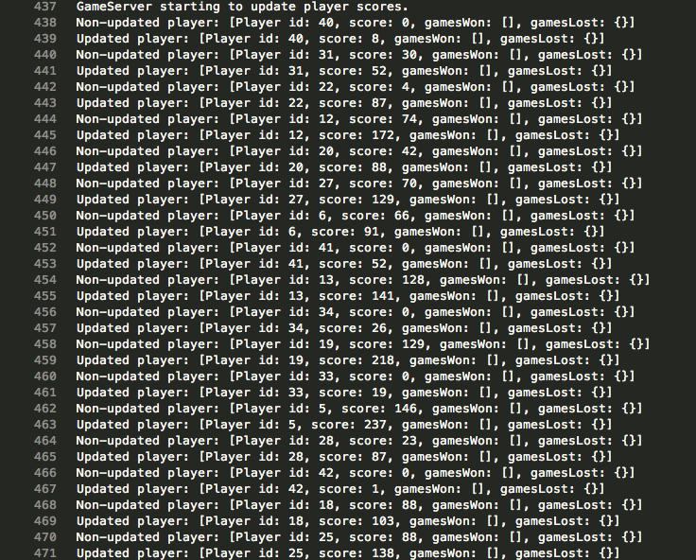

6.

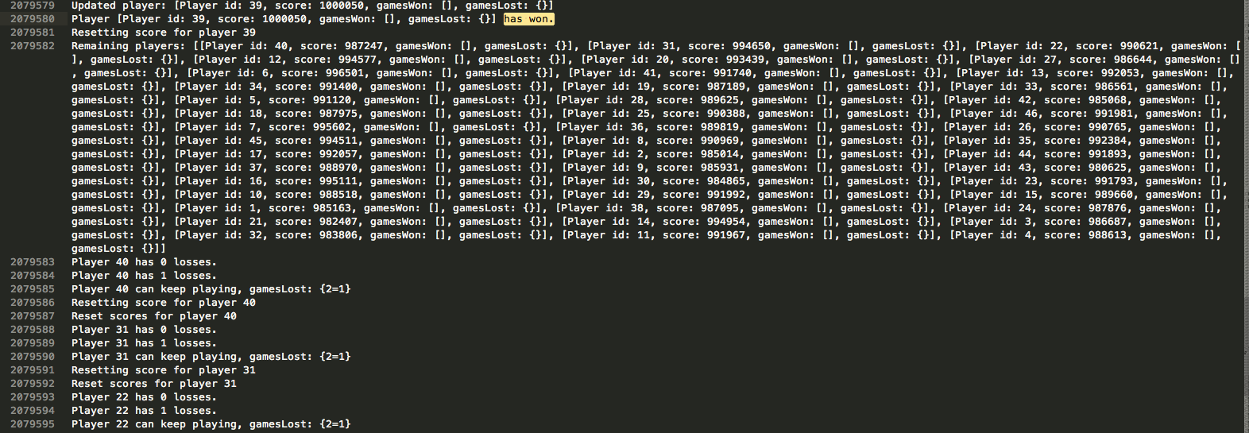

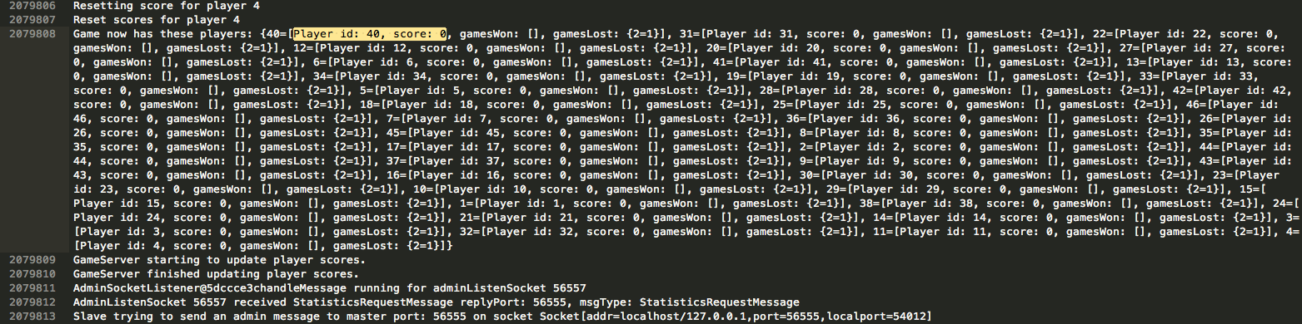
7. (Taken from a run in which winning score is 500, as running the simulator with winning score 1,000,000 would take days to yield this output)
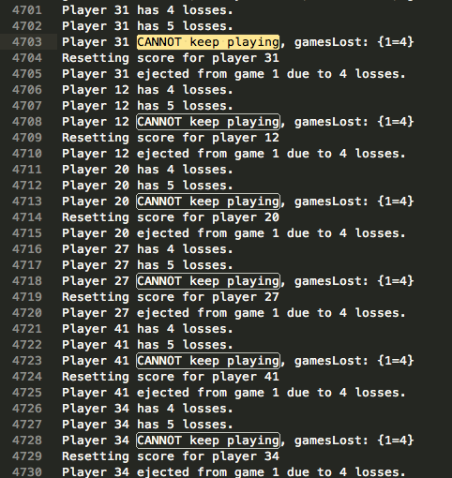
8. Not working correctly because duplicate Player IDs are being created on each Slave Server. I need to fix it so that all Players are maintained by the Master Server, and each Slave obtains a User object from the Master rather than creating one locally.
9. Not working correctly because duplicate Player IDs are being created on each Slave Server. I need to fix it so that all Players are maintained by the Master Server, and each Slave obtains a User object from the Master rather than creating one locally.
10. Not working correctly because duplicate Player IDs are being created on each Slave Server. I need to fix it so that all Players are maintained by the Master Server, and each Slave obtains a User object from the Master rather than creating one locally.
11. (Taken from a run in which winning score is 500, as running the simulator with winning score 1,000,000 would take days to yield this output)

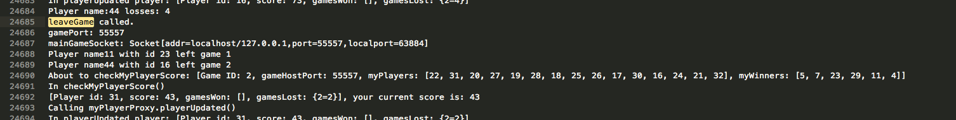
12. (Taken from a run in which winning score is 500, as running the simulator with winning score 1,000,000 would take days to yield this output)

