Climate Risk and Local Demographic Outcomes in Minnesota Counties
Brendyn Beasley
Research paper draft
March 2026

This paper builds a Minnesota county-year panel from NOAA climate data, FEMA risk measures, Census population estimates, and IRS migration files to study whether climate conditions are associated with local demographic outcomes.

Abstract
This paper studies whether local climate conditions and baseline hazard exposure are associated with demographic outcomes across Minnesota counties. I construct a county-year panel for all 87 Minnesota counties by harmonizing NOAA county climate data, FEMA National Risk Index measures, Census county population estimates, and IRS county migration data. The resulting long panel covers population outcomes from 2011–2023 and IRS migration outcomes from 2012–2023. Using county fixed-effects models with year fixed effects and county-clustered standard errors, I estimate the relationship between annual temperature, annual precipitation, and demographic outcomes. In the long panel, annual temperature is not a robust predictor of either population growth or IRS-based net migration. By contrast, annual precipitation is negative and statistically significant in both the population-growth and IRS migration specifications. Interactions between temperature and baseline FEMA risk measures are generally imprecisely estimated. Taken together, the evidence suggests that precipitation is more consistently associated with demographic outcomes in Minnesota counties than temperature in the longer sample.

1. Introduction
How climate conditions shape local adjustment is an increasingly important question in regional and applied economics. Much of the public discussion focuses on coastal flooding, wildfire exposure, or extreme heat in large metropolitan areas, but climate-related local stress can also matter in inland states through precipitation, flooding, infrastructure strain, agricultural disruption, and household relocation. This paper examines whether county-level climate conditions are associated with demographic outcomes across Minnesota counties.
Minnesota provides a useful setting for this question. Its counties vary meaningfully in precipitation, inland flood exposure, and population change, while still forming a manageable universe for a fully harmonized county-year panel. Minnesota is also substantively interesting because it is not an obvious “headline” climate-risk state. If climate-related local conditions matter even in this setting, that strengthens the case that environmental variation may be relevant for local demographic outcomes more broadly.
The paper asks two related questions. First, are annual climate conditions associated with county population growth and migration outcomes? Second, do those relationships differ in counties with higher baseline hazard exposure? To answer these questions, I combine four data sources into a Minnesota county-year panel and estimate fixed-effects models that isolate within-county changes over time.
The contribution of the project is twofold. Empirically, it provides evidence on the relationship between climate conditions and demographic outcomes in Minnesota counties. Methodologically, it demonstrates the construction of a multi-source county-year panel that harmonizes climate, hazard, population, and migration data using a consistent geographic crosswalk. This kind of data engineering is central to modern applied economics, especially in work that connects environmental conditions to local outcomes.

2. Data
The dataset is built by combining four sources. First, NOAA Climate at a Glance provides county-level climate data. From NOAA, I use annual average temperature and annual precipitation as the primary time-varying climate variables. Second, FEMA’s National Risk Index provides county-level baseline hazard measures, especially an overall county risk score and an inland flood risk score. Third, Census county population estimates provide annual county population totals, which are used to construct population growth rates and to extend the panel backward through the 2010s. Fourth, IRS county-to-county migration files provide inflow and outflow measures derived from address changes reported on individual income tax returns. These files are transformed into a county-year IRS net migration series and then scaled by population to produce an IRS net migration rate.
All sources are harmonized using the 5-digit county FIPS code as the merge key. This design choice matters because county names vary in formatting across files, whereas FIPS codes provide a stable and defensible geographic crosswalk. The final long climate-population panel contains 1,131 county-year observations for all 87 Minnesota counties over 2011–2023, with no duplicate county-year rows. The IRS migration outcome is available over 2012–2023, yielding 1,044 usable observations in the migration regressions.
Table 1. Summary Statistics
Variable | Obs. | Mean | Std. Dev. | Min | Max
Annual average temperature | 1,131 | 43.238 | 3.166 | 32.700 | 49.617
Annual precipitation | 1,131 | 353.248 | 75.787 | 187.490 | 607.190
Population | 1,131 | 63,934.050 | 153,343.533 | 3,176 | 1,281,663
Population growth rate | 1,044 | 0.183 | 0.985 | -3.331 | 6.831
IRS net migration rate | 1,044 | 0.009 | 32.341 | -97.574 | 138.581
FEMA overall risk score | 1,131 | 42.383 | 25.749 | 2.163 | 98.314
FEMA inland flood risk score | 1,131 | 49.105 | 24.390 | 8.238 | 98.028
Notes: Population growth is unavailable in the first year of each county series because it is constructed from year-over-year changes. IRS net migration rate is available for 2012–2023.

3. Empirical Strategy
The empirical strategy uses county fixed-effects models with year fixed effects. County fixed effects absorb all stable county characteristics, including persistent geographic, demographic, and institutional differences. Year fixed effects absorb statewide shocks common to all counties in a given year. Standard errors are clustered at the county level to allow for serial correlation within counties over time.
I estimate two main sets of models. The first uses population growth rate as the dependent variable in the 2011–2023 long panel. The second uses IRS net migration rate as the dependent variable in the 2012–2023 migration panel. In both sets of models, the key regressors are annual average temperature and annual precipitation.
To test whether climate effects differ in counties with different structural exposure, I interact temperature with standardized FEMA risk measures. Because the FEMA measures are effectively time-invariant within counties over the sample, their main effects are absorbed by county fixed effects and are omitted from the regressions. This is not a data problem; it is a direct implication of the fixed-effects design. Only the interactions between time-varying temperature and time-invariant risk measures are identified.

4. Results
The strongest result in the long panel is that precipitation is more consistently associated with demographic outcomes than temperature. In the population-growth specifications, annual average temperature is small and statistically insignificant, while precipitation is negative and statistically significant in both models. The estimated precipitation coefficient is approximately -0.002, implying that wetter years are associated with modestly lower population growth within counties.
The migration results tell a similar story. In the 2012–2023 IRS migration models, temperature is again not statistically significant and the temperature-by-risk interactions are imprecisely estimated. Precipitation, however, remains negative and statistically significant in both migration specifications, with coefficients around -0.055. Thus, wetter years are associated with lower IRS net migration rates within Minnesota counties.
The descriptive figures reinforce two useful points. First, the climate and demographic series vary substantially over time, which supports the panel design and the inclusion of year fixed effects. Second, the cross-county scatterplot of mean IRS net migration against mean precipitation is weak and noisy. The fitted line adds readability, but it does not replace the panel estimates; the main evidence comes from the fixed-effects regressions.

Figures
Figure 1. Average Temperature by Year
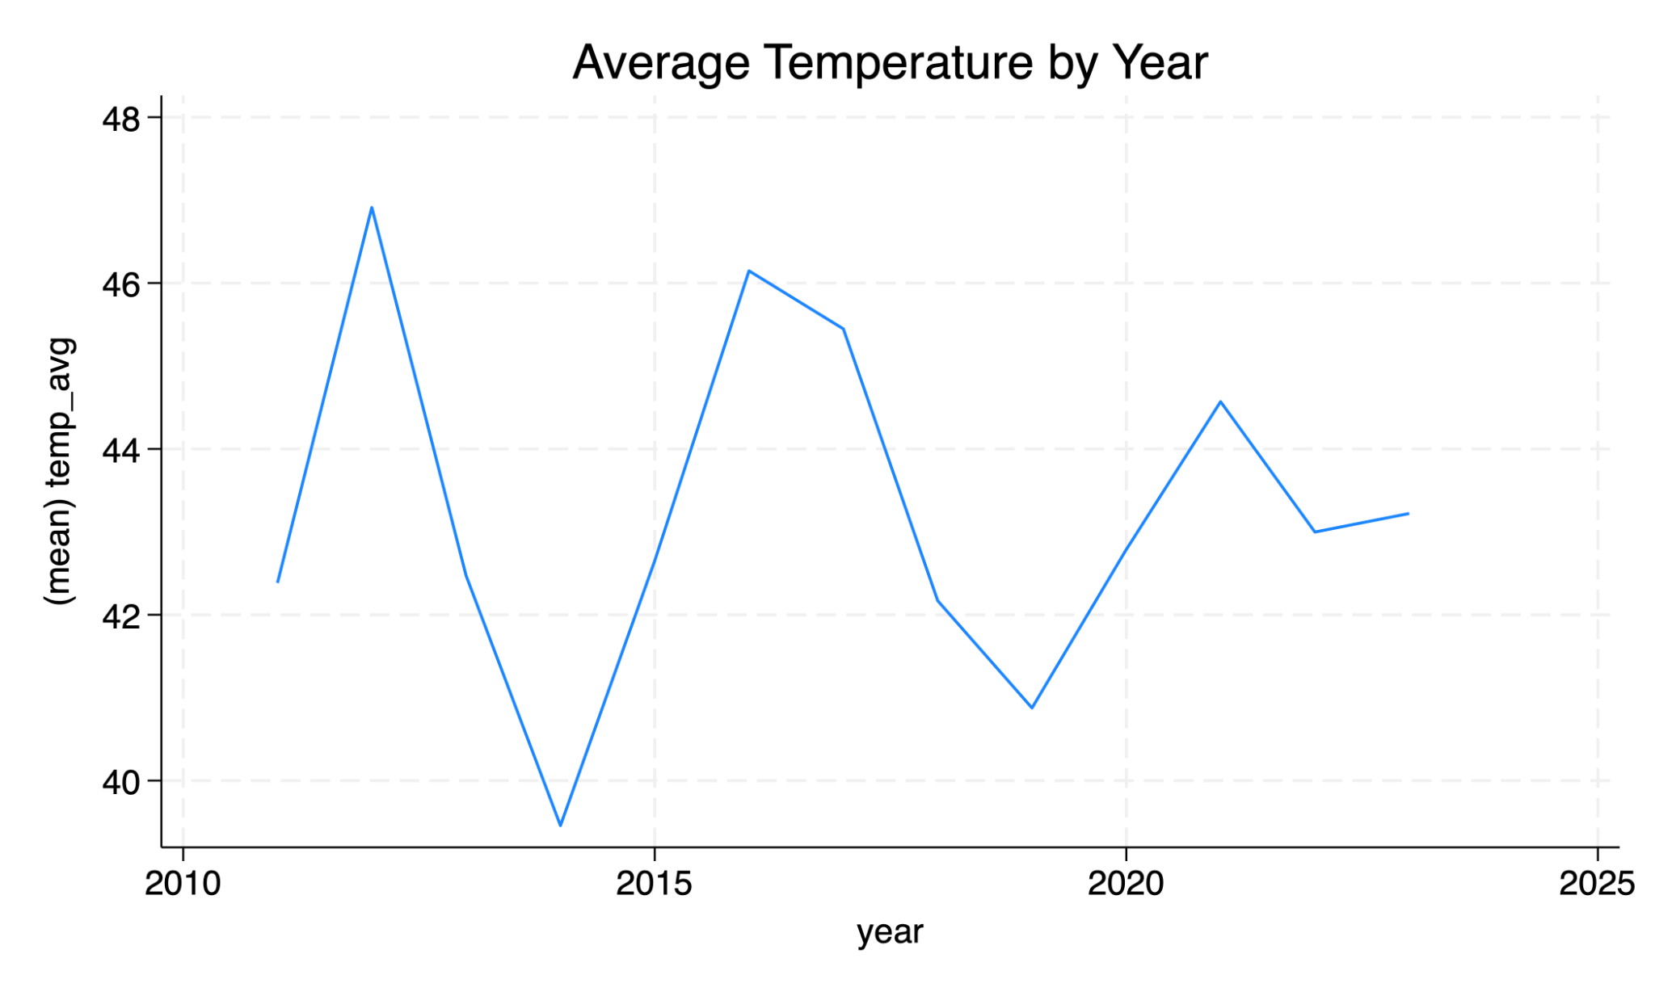
Figure 2. Average Population Growth by Year
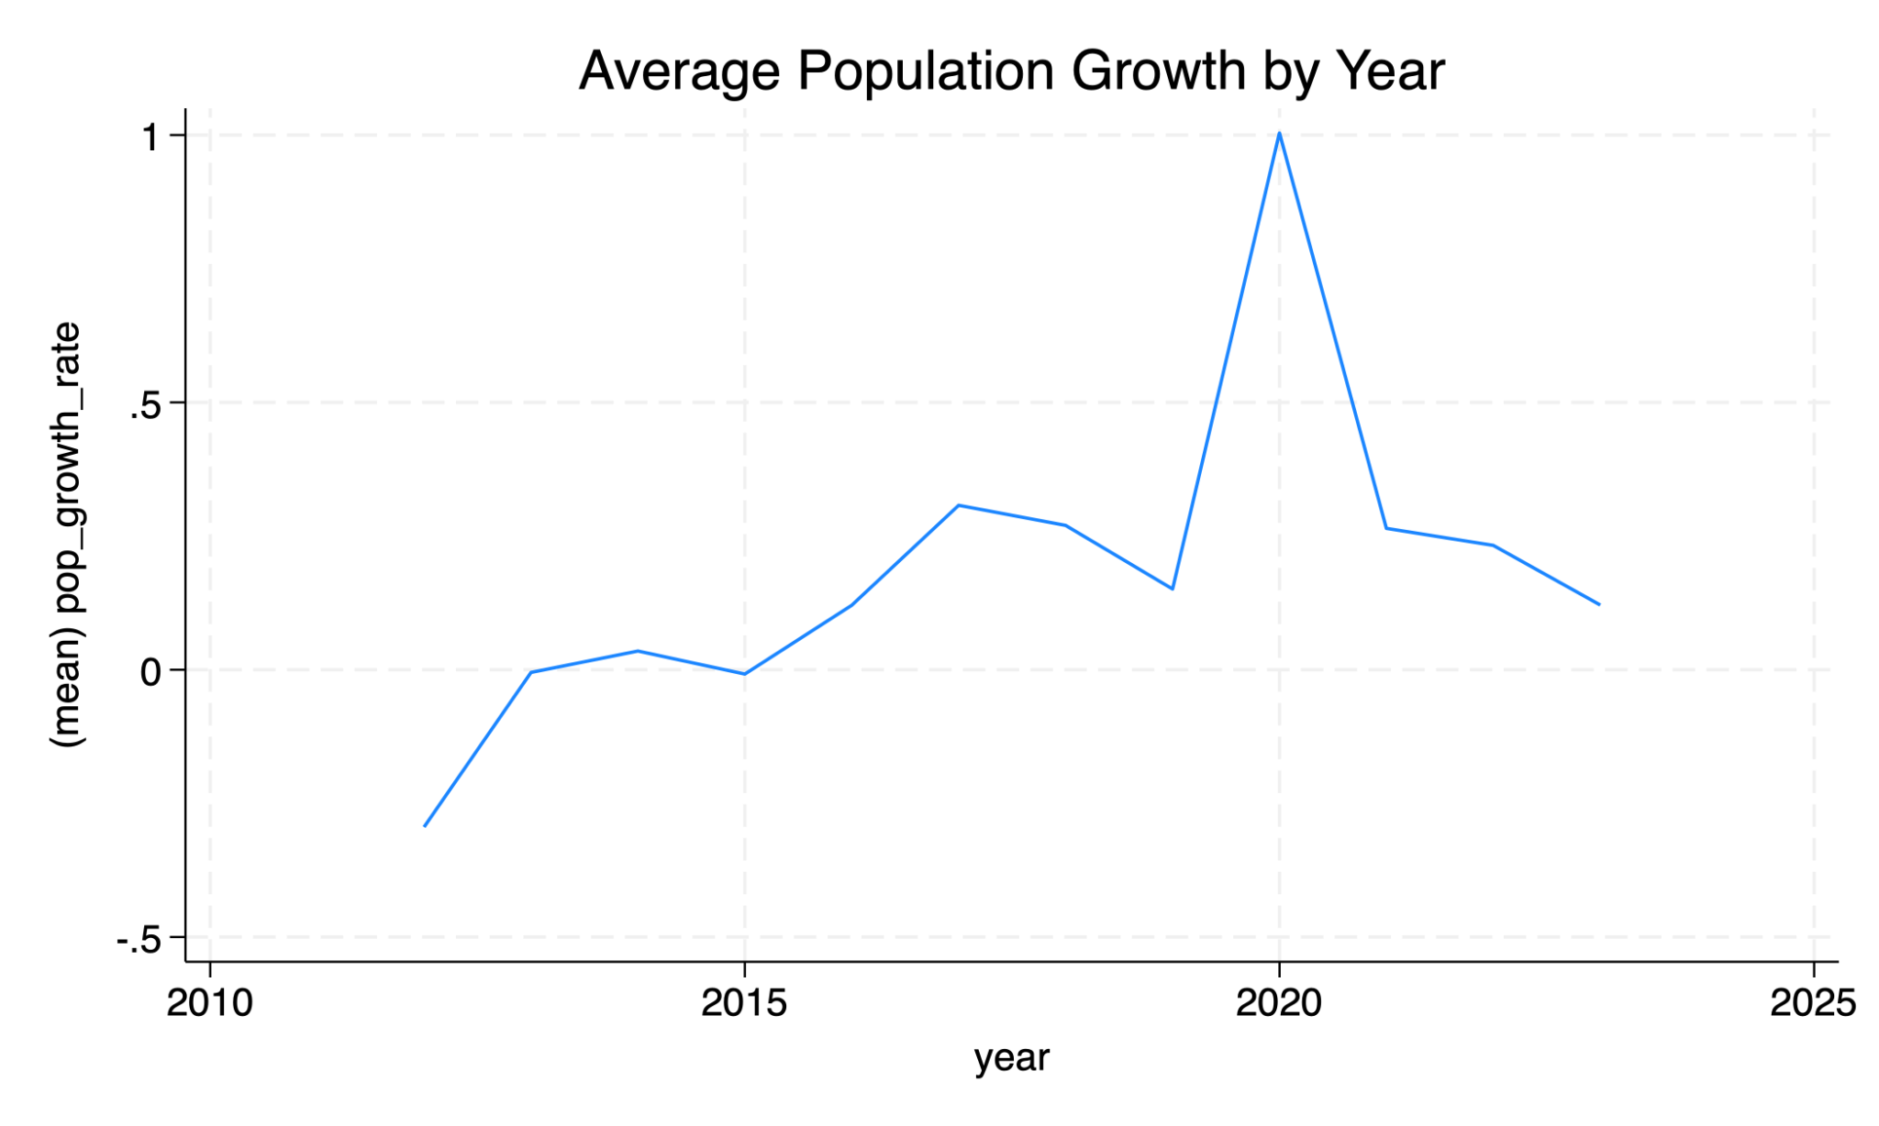
Figure 3. Average IRS Net Migration Rate by Year
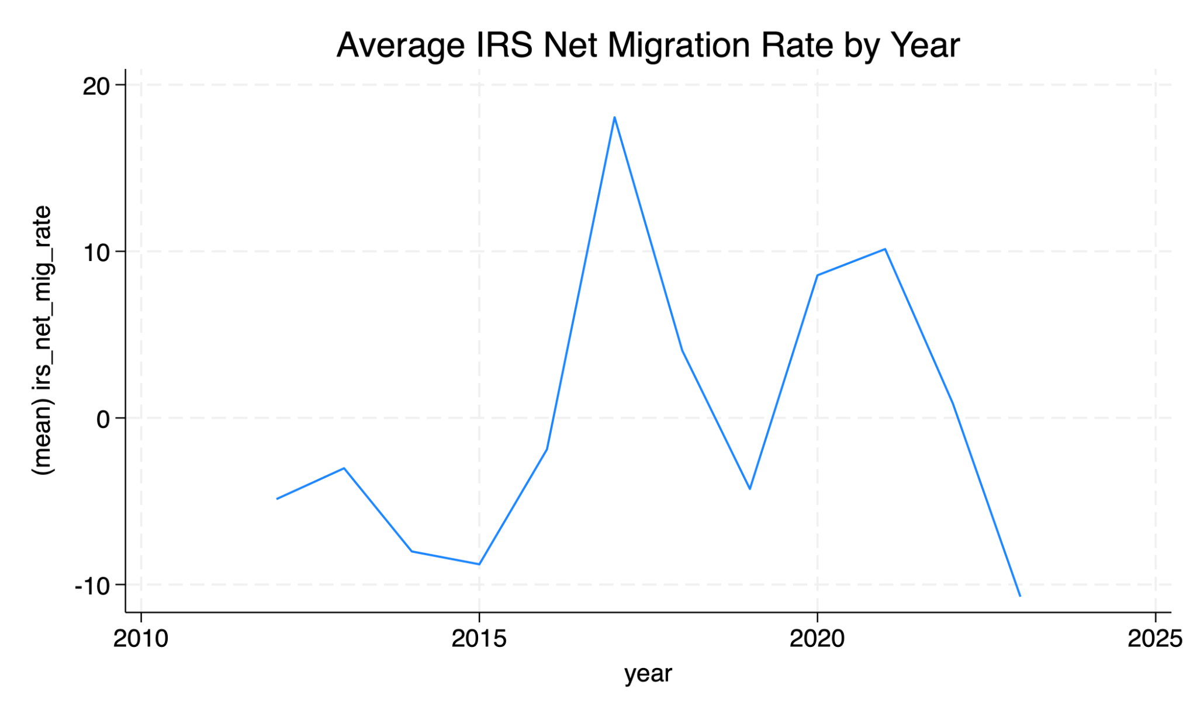
Figure 4. County Mean IRS Net Migration Rate vs. County Mean Precipitation
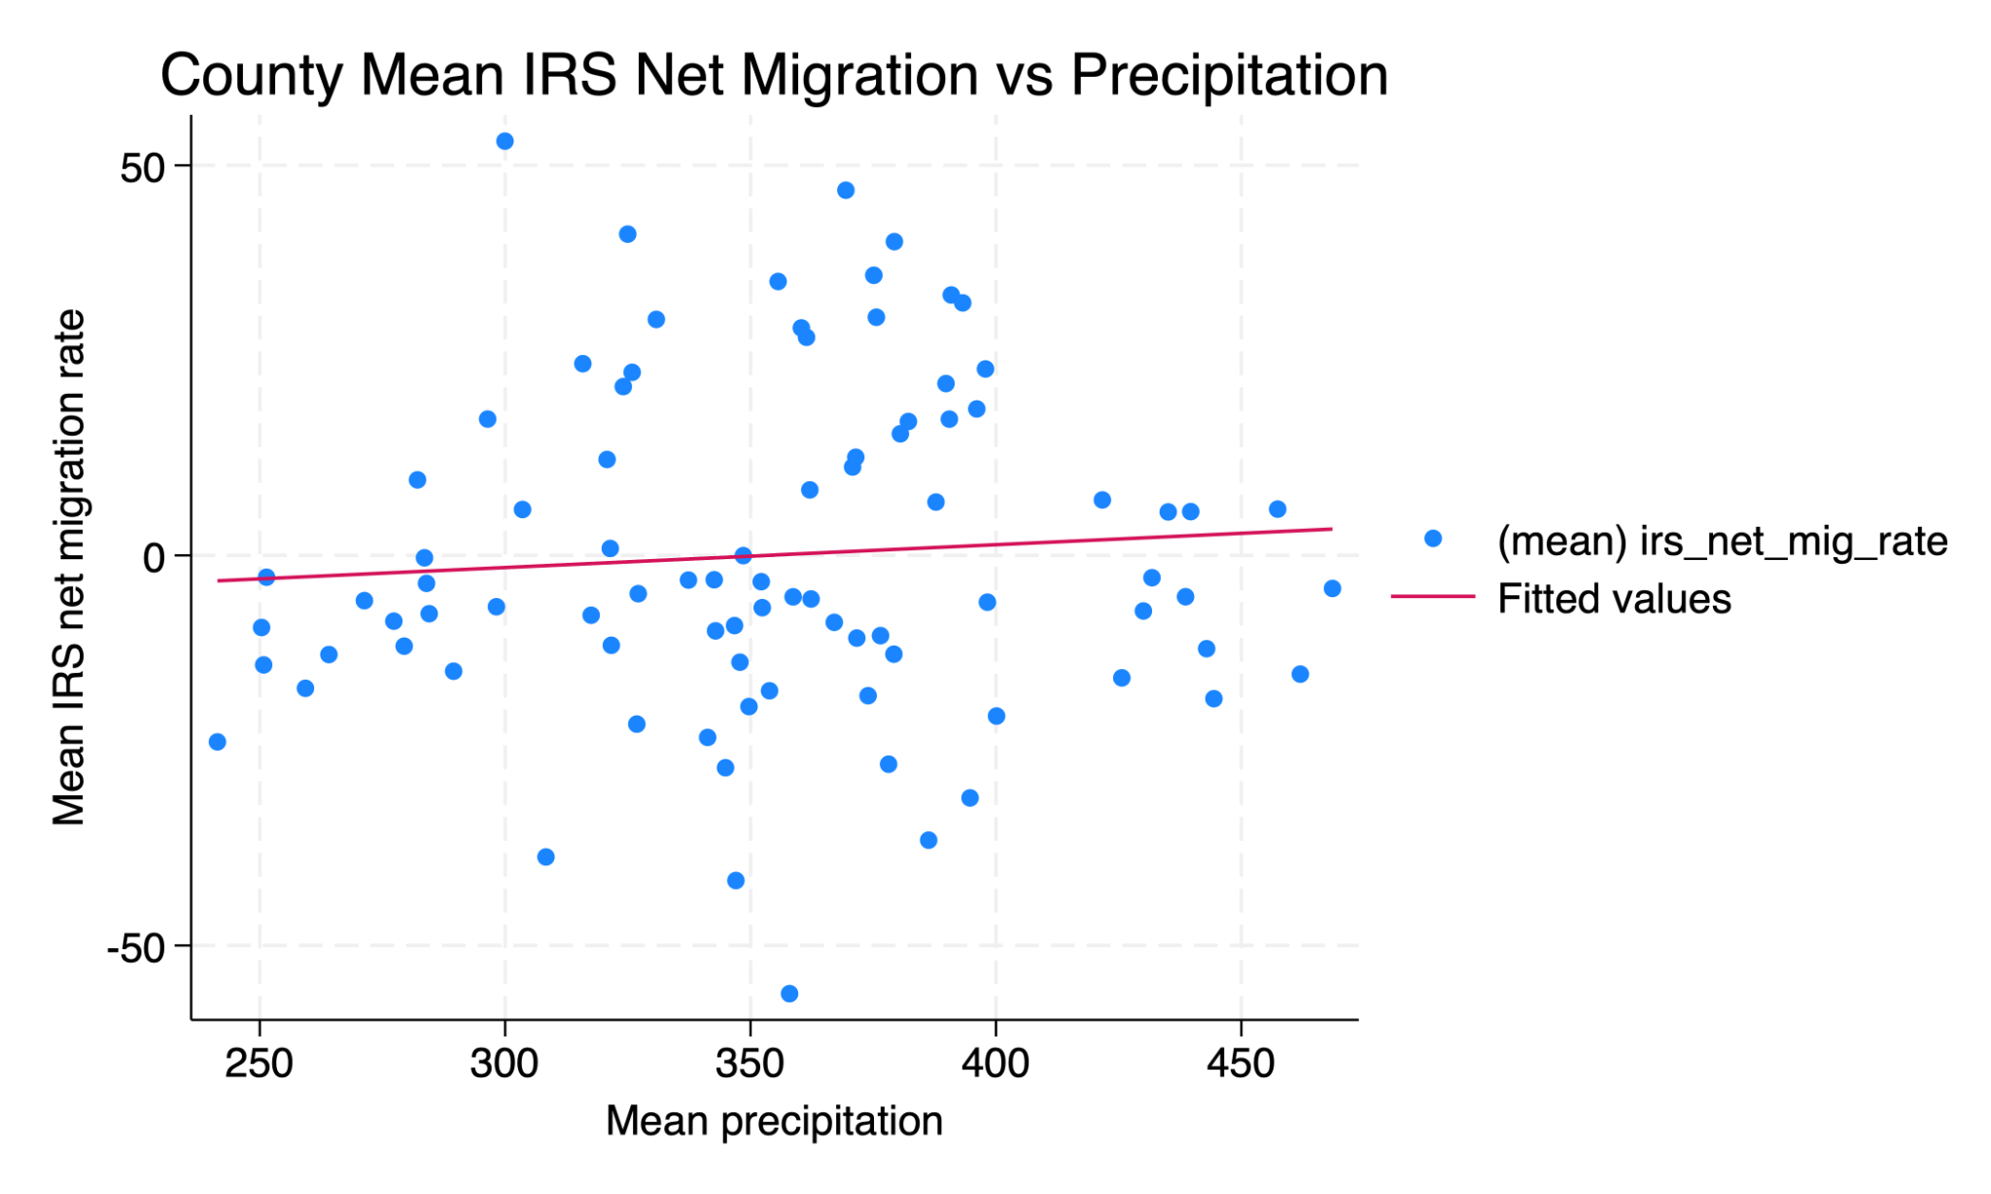
Table 2. County Fixed-Effects Regressions for Population Growth and IRS Net Migration
 | (1) Pop. growth  Overall risk | (2) Pop. growth  Flood risk | (3) IRS net migration  Overall risk | (4) IRS net migration  Flood risk
Annual average temperature | 0.0607 | 0.0592 | 1.7799 | 1.8132
 | (0.0703) | (0.0706) | (2.2221) | (2.2250)
Temperature × overall risk | 0.0149 |  | -0.2562
 | (0.0090) |  | (0.3722)
Temperature × flood risk |  | 0.0152 |  | -0.2102
 |  | (0.0094) |  | (0.3945)
Annual precipitation | -0.0020** | -0.0020** | -0.0551** | -0.0554**
 | (0.0008) | (0.0008) | (0.0269) | (0.0268)
County fixed effects | Yes | Yes | Yes | Yes
Year fixed effects | Yes | Yes | Yes | Yes
County-clustered SE | Yes | Yes | Yes | Yes
Observations | 1,044 | 1,044 | 1,044 | 1,044
Counties | 87 | 87 | 87 | 87
Within R² | 0.1337 | 0.1338 | 0.1210 | 0.1209
Notes: Standard errors clustered at the county level are in parentheses. The main effects of the standardized FEMA risk measures are omitted because they are absorbed by county fixed effects. ** denotes statistical significance at the 5 percent level.

5. Discussion
One of the most important lessons from this project is that extending the sample materially changes the interpretation of the results. In earlier short-panel work, temperature appeared more important. Once the panel is extended to 2011–2023 for population and 2012–2023 for migration, that result does not persist. Instead, the more durable relationship is between precipitation and demographic outcomes.
This shift is substantively meaningful. It suggests that short-run, short-panel findings may reflect unusual period-specific patterns rather than stable relationships. By building a longer panel and rerunning the same specifications, the analysis moves from a provisional finding to a more credible one.
The interaction terms with FEMA risk measures are generally not precisely estimated. That does not mean county risk is irrelevant, but it does imply that the data do not provide strong evidence that temperature affects higher-risk counties differently in this specification. Detecting heterogeneous effects may require richer outcome measures, alternative climate definitions, or more flexible nonlinear models.

6. Conclusion
This paper builds a Minnesota county-year panel to study whether climate conditions and baseline hazard exposure are associated with local demographic outcomes. The final panel combines NOAA climate data, FEMA risk measures, Census population estimates, and IRS migration data into a consistent county-year structure.
The main finding is that precipitation is more consistently associated with demographic outcomes than temperature in the longer sample. In county fixed-effects models, higher precipitation is associated with lower population growth and lower IRS net migration rates, while temperature does not appear robustly significant once the panel is extended. Interactions between temperature and baseline FEMA risk measures are generally imprecisely estimated.
More broadly, the project demonstrates the importance of careful panel construction and sample extension. Results that appear strong in a short panel may not survive in a longer one, while more stable relationships become clearer as the sample grows. That makes the longer panel both more informative and more credible. A natural next step would be to refine the precipitation construction further, incorporate additional county-level outcomes such as income or housing measures, and explore nonlinear or threshold-based climate effects.

Appendix A. Data Construction and Research Workflow
The project began by defining the unit of analysis as the Minnesota county-year. NOAA climate data supplied the main time-varying explanatory variables, FEMA National Risk Index data supplied time-invariant baseline hazard measures, Census county population files supplied annual population totals and population growth, and IRS county-to-county migration files supplied long-panel migration outcomes. Each source was cleaned separately and harmonized using 5-digit county FIPS codes before the final panel was assembled.
This workflow required repeated data-shape checks, duplicate checks on county-year identifiers, and panel verification in Stata. A key empirical lesson from the build process is that the overlap across datasets determines the effective sample. The long panel used in the final paper was therefore produced only after extending both the Census population series and the IRS migration series backward through earlier years.

