Project: Assignment 4.2
Course: CSD 380 DevOps
Description: Sample test cases for Todo site (Daniel Preller)
Date: 2026/01/14
To complete the test case plan, fill out the information for Project, Course, Description and Date in the header below.

TABLE OF CONTENTS
Create a new todo task item 2
Delete a todo task item 2
For invalid URLs, provide users with a custom 404 error page 3
Prevent users from submitting a task form with without entering a todo item 3
Prevent users from submitting the edit form without entering a todo item 4

For each test, the developer should: provide a test description, a test objective, the developer name and date tested. For each step, fill out the actions to be taken and describe the expected results, and indicate yes or no for each step depending upon the result. The peer tester should provide their name, date tested, indicate yes or no for each step depending upon the result, and a screenshot (thumbnail) of the result.

Test 1 | Create a new todo task item
 | Test Objective: Verifies ability to add tasks | Developer: Daniel Preller  Date tested: 2026/01/14 | Peer tester: Brennan Cheatwood  Date tested: 2026/01/18
Step | Action | Expected results: | Developer pass/fail | Tester pass/fail  + Screenshot
1 | Visit https://buwebdev.github.io/todo/ | Page will load without errors | Yes | yes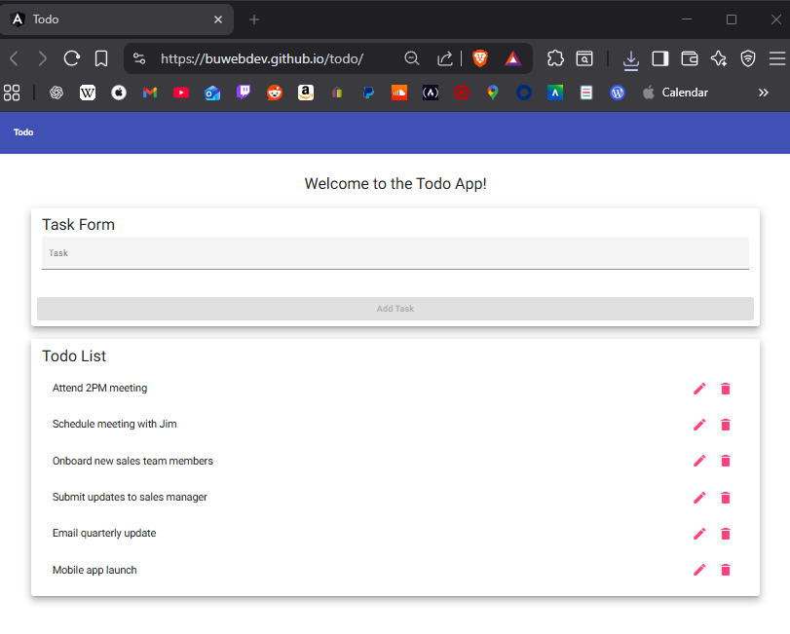
2 | Enter an item in the task form | Text will appear in the form | Yes | <yes>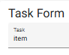
3 | Click the “Add Task” button | Task form will be cleared | Yes | <yes>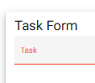
4 | Confirm new task appears in the list | Task will appear in the task list | Yes | <yes>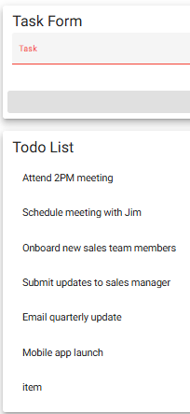
Comments | The page loaded correctly, even after refreshing the browser. I was able to populate the task form with text and add a task to the list without any errors. After a task is added to the list though, then refreshing, it restarts from the beginning and does not remember the task I had added.

Test 2 | Delete a todo task item
 | Test Objective: Verifies ability to delete tasks | Developer: Daniel Preller  Date tested: 2026/01/14 | Peer tester: Brennan Cheatwood  Date tested: 2026/01/18
Step | Action | Expected results: | Developer pass/fail | Tester pass/fail
1 | Visit https://buwebdev.github.io/todo/ | Page will load without errors | Yes | <yes>
2 | Click a delete button (trashcan icon) | Task will be deleted | Yes | <yes>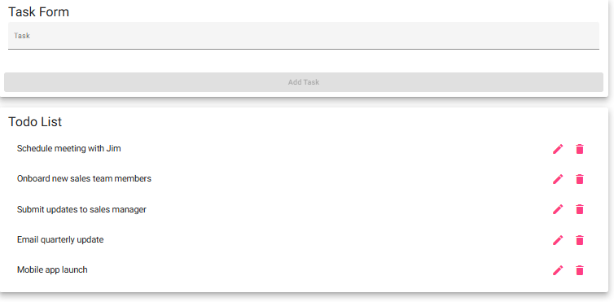
3 | Confirm matching task is deleted | Task will be removed from list | Yes | <yes>
Comments | Once again, the page loaded correctly without errors. I was able to delete the task “Attend 2PM meeting,” which was the first task on the list. I confirmed that the task I selected to remove was correctly deleted from the list.

Test 3 | For invalid URLs, provide users with a custom 404 error page
 | Test Objective: Verifies invalid URLs are properly handled | Developer: Daniel Preller  Date tested: 2026/01/14 | Peer tester: Brennan Cheatwood  Date tested: 2026/01/18
Step | Action | Expected results: | Developer pass/fail | Tester pass/fail
1 | Enter buwebdev.github.io/todo/ with text appended in browser and press enter | Error page displays | Yes | yes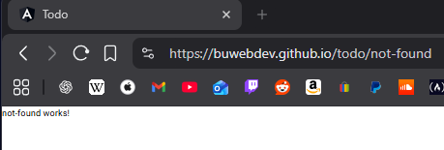
2 | Confirm 404 page displays | Custom, readable 404 page displays | No | Yes
3 | Confirm URL changes to https://buwebdev.github.io/todo/not-found | URL changes to not found URL | Yes | yes
Comments | I added random letters at the end of “github.io/todo/(random letters)” and was redirected to todo/not-found. I was able to see the custom, readable 404 page displaying “not-found works!” The end of the URL was changed from the random letters to a proper “not-found.”

Test 4 | Prevent users from submitting a task form with without entering a todo item
 | Test Objective: Verifies that a task name is required | Developer: Daniel Preller  Date tested: 2026/01/14 | Peer tester: Brennan Cheatwood  Date tested: 2026/01/18
Step | Action | Expected results: | Developer pass/fail | Tester pass/fail
1 | Visit https://buwebdev.github.io/todo/ | Page will load without errors | Yes | <yes>
2 | Click “Add Task” | Nothing will happen | Yes | <yes>
3 | Verify the list does not change | The list will not change | Yes | <yes>
4 | Enter an item in the task form | Text will appear in form | Yes | <yes>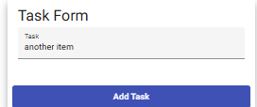
5 | Delete text from the task form | Text will be removed from form; Form will become red | Yes | <yes>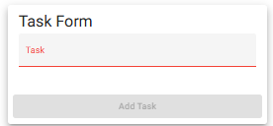
6 | Click “Add Task” | Nothing will happen | Yes | <yes>
7 | Verify the list does not change | The list will not change | Yes | <yes>
Comments | I accessed the website without errors. Clicking the “Add Task” button did nothing, as it was greyed out. Once text was entered, the button turns blue, then when the text is removed, the form becomes red and the button turns grey again. Nothing was added to the list.

Test 5 | Prevent users from submitting the edit form without entering a todo item
 | Test Objective: Verifies that a task name is required | Developer: Daniel Preller  Date tested: 2026/01/14 | Peer tester: Brennan Cheatwood  Date tested: 2026/01/18
Step | Action | Expected results: | Developer pass/fail | Tester pass/fail
1 | Visit https://buwebdev.github.io/todo/ | Page will load without errors | Yes | <yes>
2 | Click an edit button (pencil) | Edit form will open | Yes | <yes>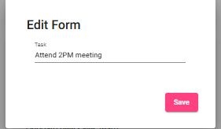
3 | Delete text in edit field | Text will be removed from edit field | Yes | <yes>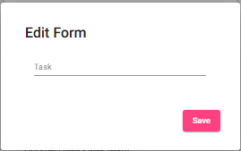
4 | Click “Save” | Edit field will close | Yes | <yes>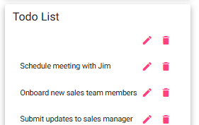
5 | Verify the task still has a name | Task will still have original name | No | No
Comments | I accessed the website without errors. Once clicking an edit button, the edit panel was shown and I was able to delete the text. After deleting the text, I clicked save, and the text was removed from the list while still showing an edit icon and a delete icon. The task did not keep the original name once text was removed and “save” was clicked.

