Project: Module 4.2 Assignment – Test Plan
Course: CSD380 DevOps
Description: For this assignment, you will be drafting a test plan based on the business requirements presented in the “Todo Business Requirements” document (linked below). The test plan must include at least 5 functional tests and those tests must encompass the requirements in the document.
Date: 2026/01/11
To complete the test case plan, fill out the information for Project, Course, Description and Date in the header below.
.
TABLE OF CONTENTS
Test Plan 1 2
Test Plan 2 3
Test Plan 3 3
Test Plan 4 4
Test Plan 5 4

For each test, the developer should: provide a test description, a test objective, the developer name and date tested. For each step, fill out the actions to be taken and describe the expected results, and indicate yes or no for each step depending upon the result. The peer tester should provide their name, date tested, indicate yes or no for each step depending upon the result, and a screenshot (thumbnail) of the result.

Test 1 | Access Website Using Standard URL
 | Test Objective: Allow users to visit the website through https://buwebdev.github.io/todo/ | Developer:  Date tested: Jackson<2026/01/11> | Peer tester: Brennan Cheatwood  Date tested: 2026/01/18
Step | Action | Expected results: | Developer pass/fail | Tester pass/fail  + Screenshot
1 | Open a web browser | Browser open | yes | <yes>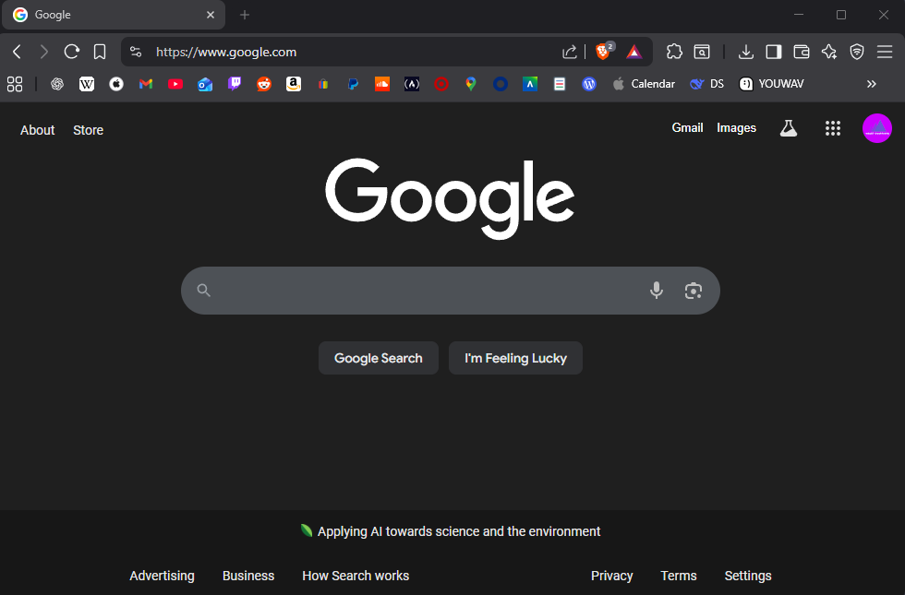
2 | Go to https://buwebdev.github.io/todo/ | Link works | yes | <yes>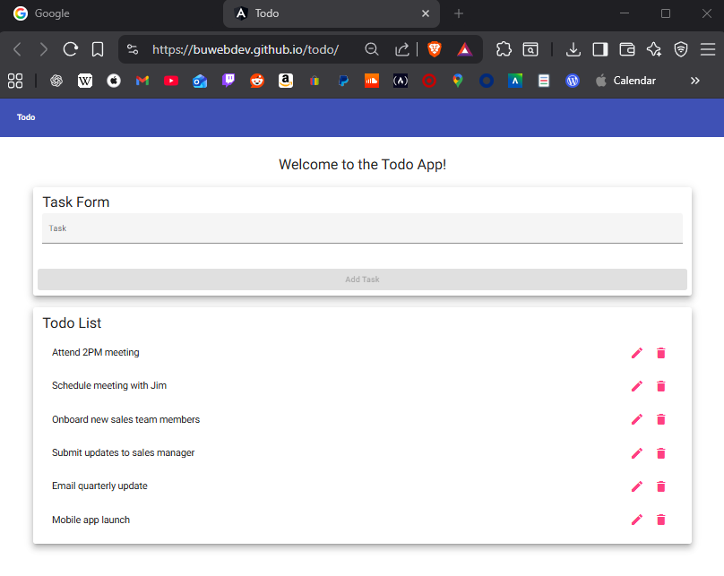
3 | Confirm pages load | Page loads correctly | yes | <yes>
4 | Refresh the window | Page continues to work | yes | <yes>
Comments | I was able to open a web browser (Brave) and open the provided link. The page loaded without any errors and displayed correctly. After refreshing the page, the website continued to work.

Test 2 | View List of ToDo Items
 | Test Objective: View a list of todo tasks | Developer:  Date tested: Jackson <2026/01/11> | Peer tester: Brennan Cheatwood  Date tested: 2026/01/18
Step | Action | Expected results: | Developer pass/fail | Tester pass/fail
1 | Load the Todo homepage | Homepage loads and displays | yes | <yes>
2 | Observe the todo list | List is visible and easy to access | yes | <yes>
Comments | I loaded the Todo homepage at the provided link. The page loaded successfully and displayed correctly. I observed the todo list, and confirmed it was easy to access.

Test 3 | Create a New Todo Item
 | Test Objective: | Developer:  Date tested: Jackson <2026/01/11> | Peer tester: Brennan Cheatwood  Date tested: 2026/01/18
Step | Action | Expected results: | Developer pass/fail | Tester pass/fail
1 | Click inside the Todo input field | Allows for typing | yes | <yes>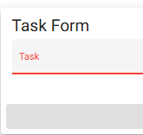
2 | Enter a task | Text is taken | yes | <yes>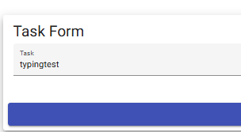
3 | Press Add Task | New item is created | yes | <yes>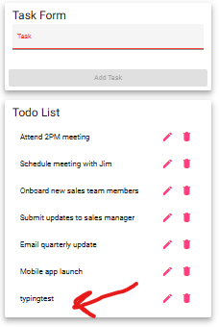
Comments | I clicked inside the input field, and was able to input text. I entered a task and confirmed that the text registered into the field. I then pressed “Add Task” and confirmed that the new item was created and displayed correctly on the list.

Test 4 | Prevent Empty Todo Submission
 | Test Objective: Prevent users from submitting a task form without entering a todo item | Developer:  Date tested: Jackson <2026/01/11> | Peer tester: Brennan Cheatwood  Date tested: 2026/01/18
Step | Action | Expected results: | Developer pass/fail | Tester pass/fail
1 | Click inside the Todo input field | Allows for typing | yes | <yes>
2 | Leave the input field empty | Input field empty | yes | <yes>
3 | Try to Add Task | Doesn’t let you press the button | yes | <yes>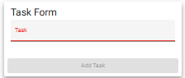
Comments | I am unable to add a task when the Task Form is empty. I can confirm that when the input field is blank, the Add Task button has no functionality.

Test 5 | Delete a Todo Item
 | Test Objective: Delete todo task item | Developer:  Date tested: Jackson <2026/01/11> | Peer tester: Brennan Cheatwood  Date tested: 2026/01/18
Step | Action | Expected results: | Developer pass/fail | Tester pass/fail
1 | Locate an existing Todo item | Find items on list | yes | <yes>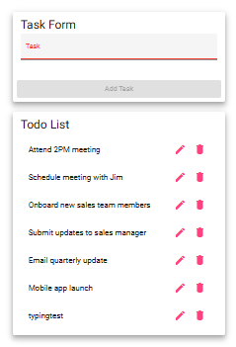
2 | Click the delete (X) button | Todo item is deleted | yes | <yes>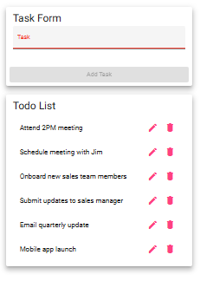
Comments | There is no (X) icon, but there is a trash icon indicating “delete.” I decided to click the trash icon on the task “typingtest” since that was one I created. When I clicked the trash icon, the task was removed and no longer displayed on the list.

