Brennan Cheatwood
CSD420 – Assignment 1.3
3/21/26
https://github.com/brengeware/csd-420
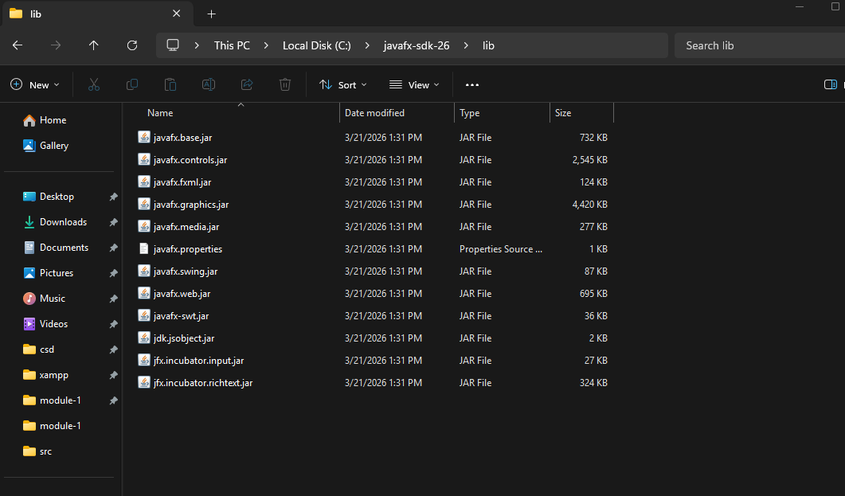
I couldn’t get it to run properly on VSCode, so I switched to IntelliJ, and it took a while to figure out, but the issues were fixed. I had to change the run properties, and add VM arguments in order for it to run. It seems overcomplicated, but I don’t know of an easier way yet. 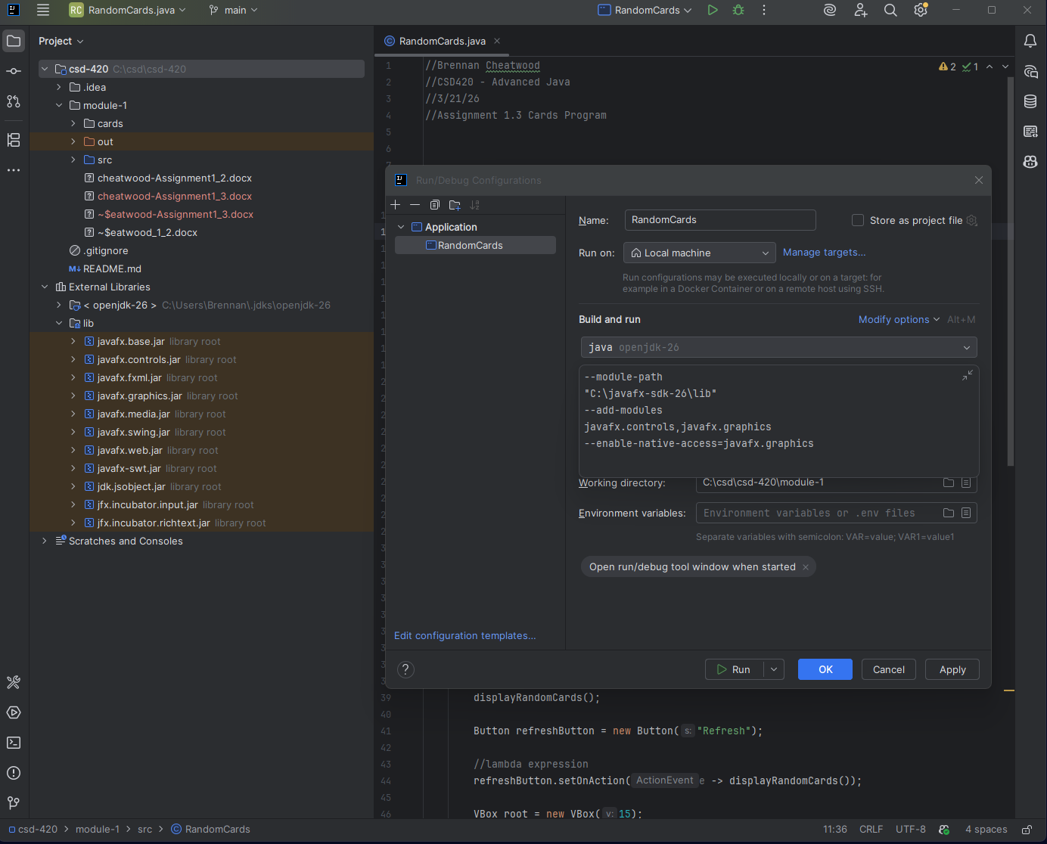
Successful compile & run (finally): 