Brennan Cheatwood
CSD420 – Review Code Example
5/31/2026
Github.com/brengeware/csd-420

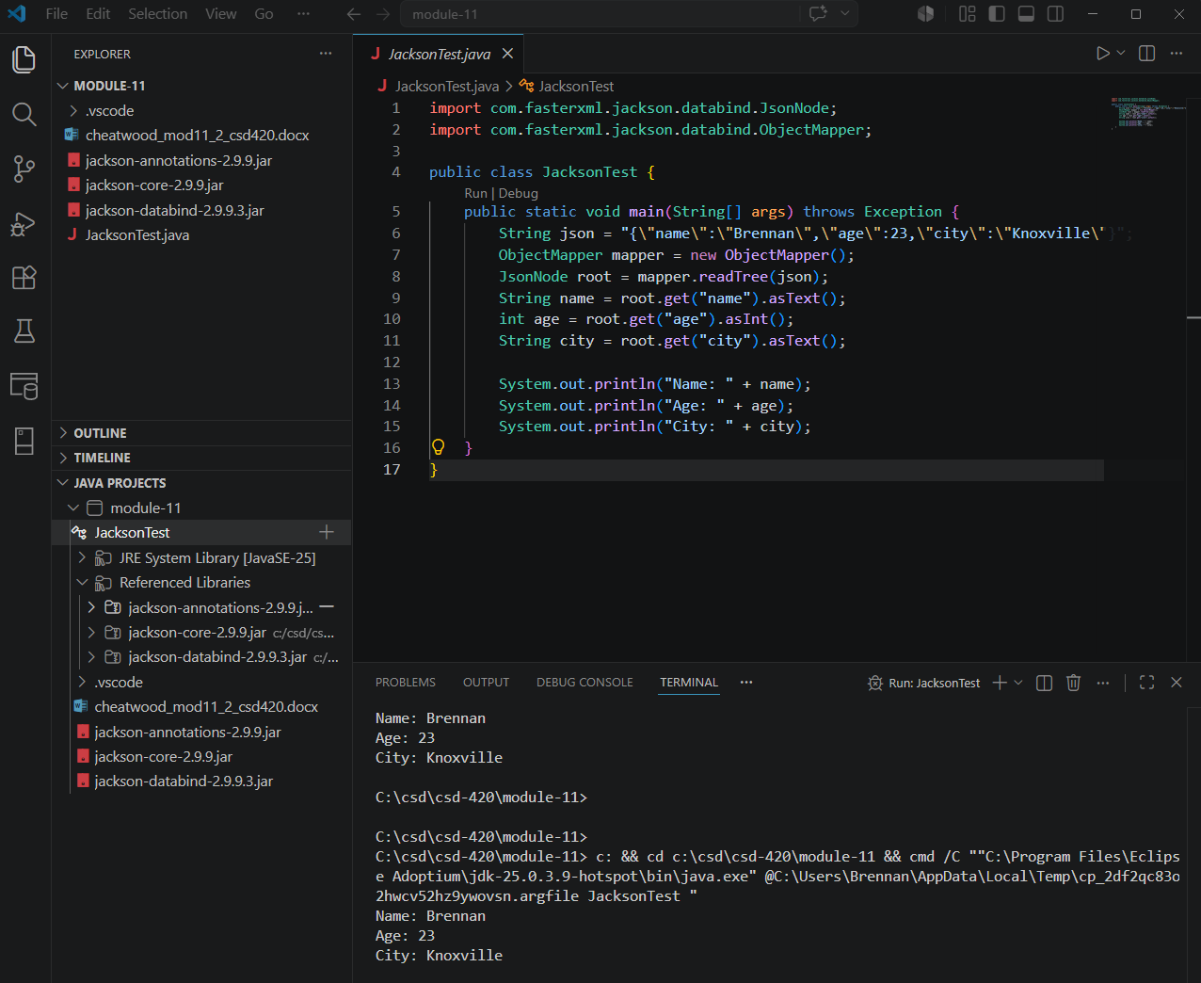
In my example, the ObjectMapper reads a JSON string and returns a JsonNode tree. Each field is accessed by key name using the get() method, and then converted to the appropriate Java type using asText() or asInt(). No custom class is needed, which is what makes the Tree so flexible.

