Brennan Cheatwood
CSD430 – Assignment 9.2
Project Part 4
8/9/2026
Github.com/brengeware/csd-430
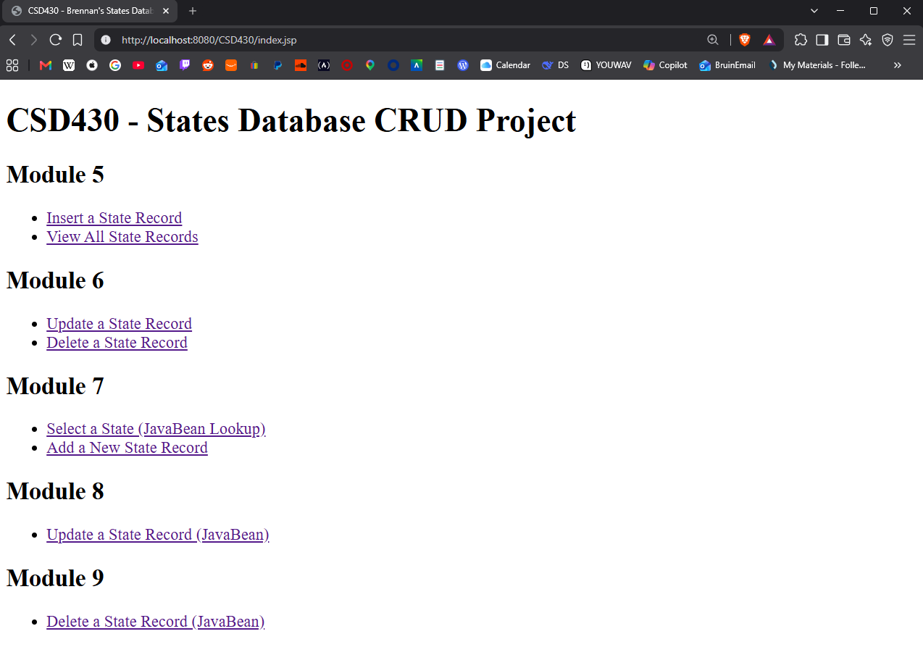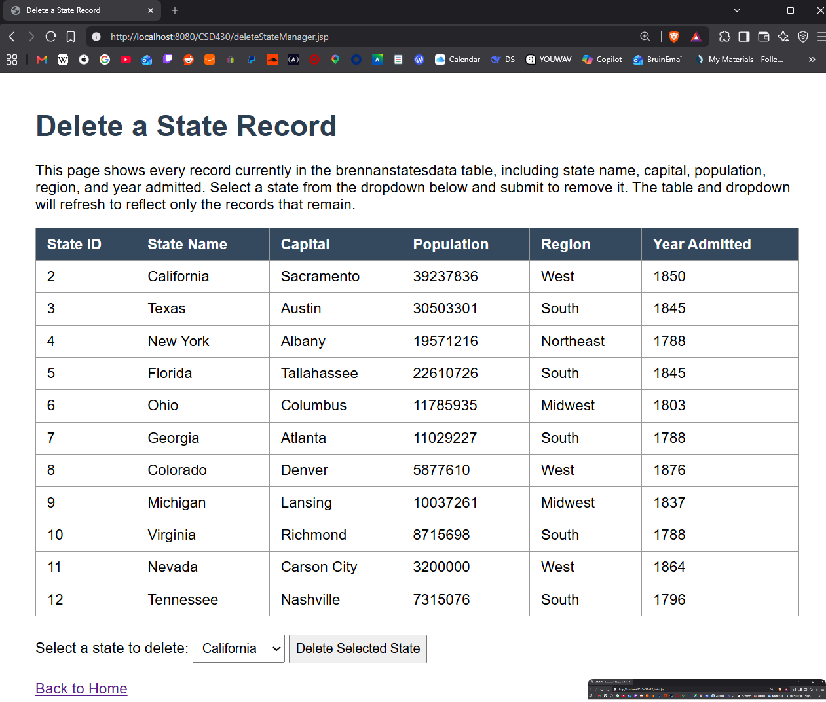
Successfully deleted California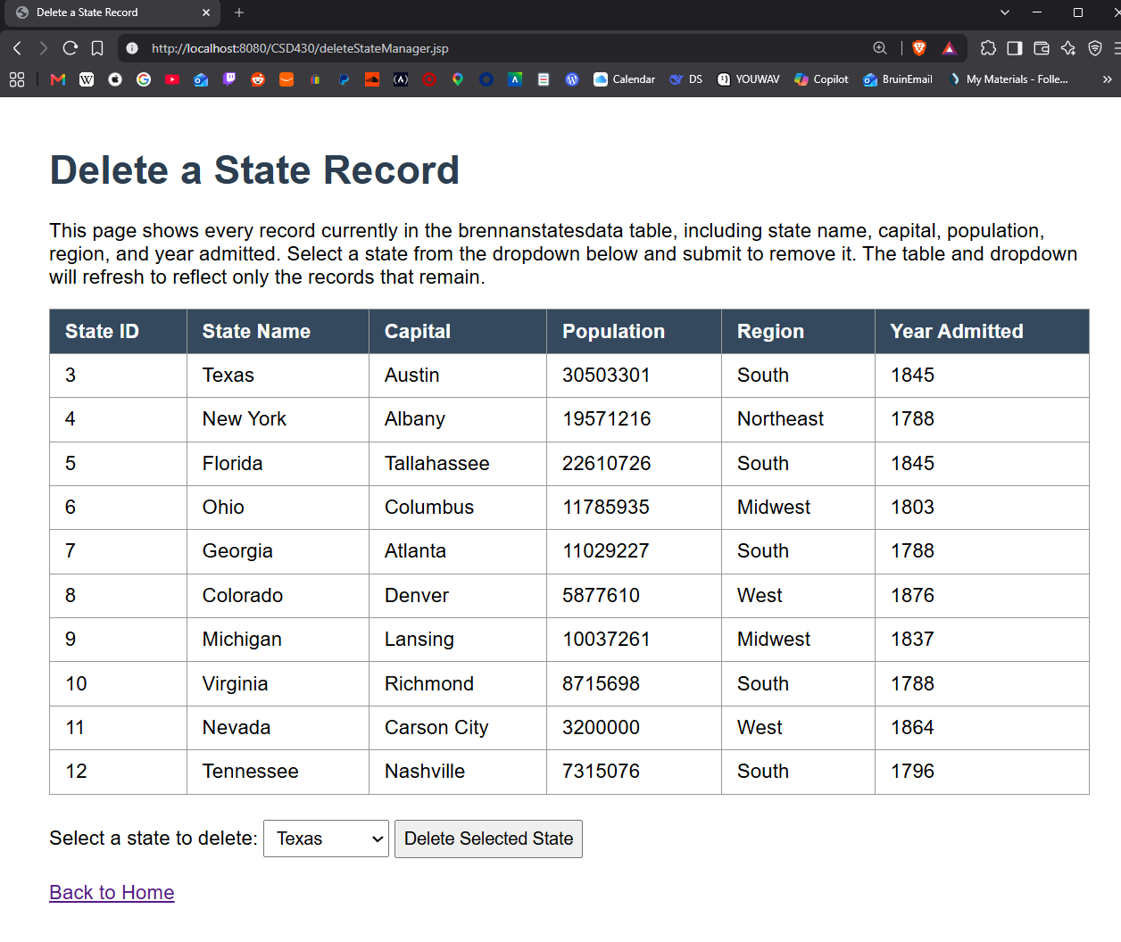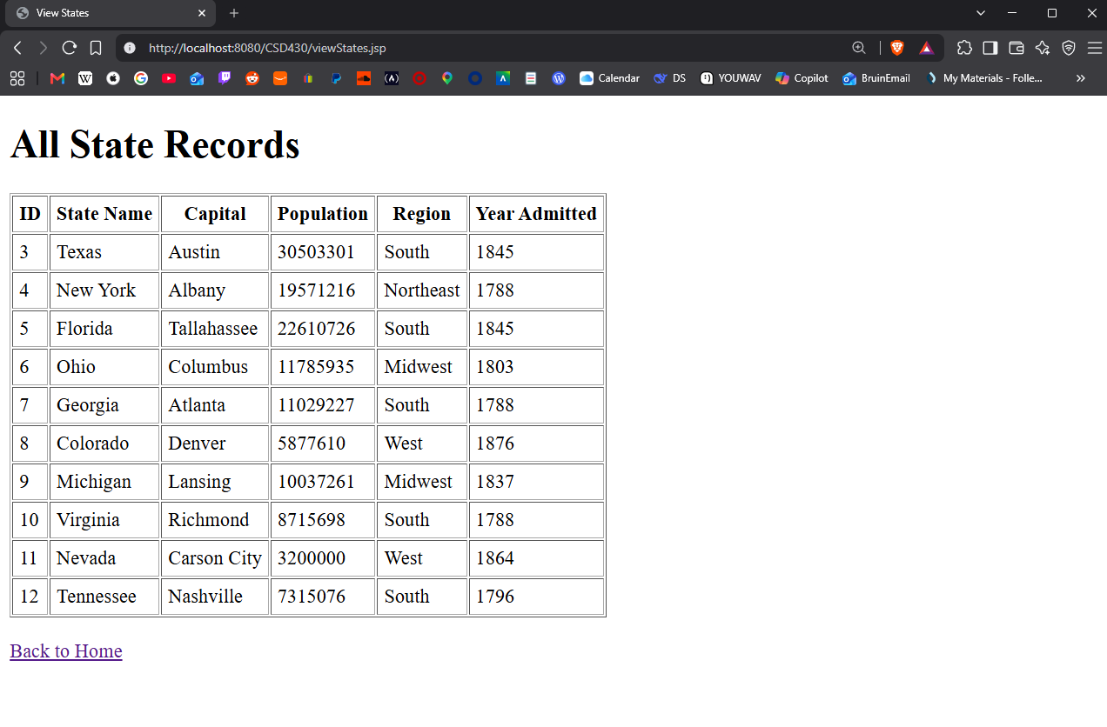
When all states are deleted, dropdown is removed
