Brennan Cheatwood
CSD430 – Assignment 1.3
6/14/26

Successful installation of Java:
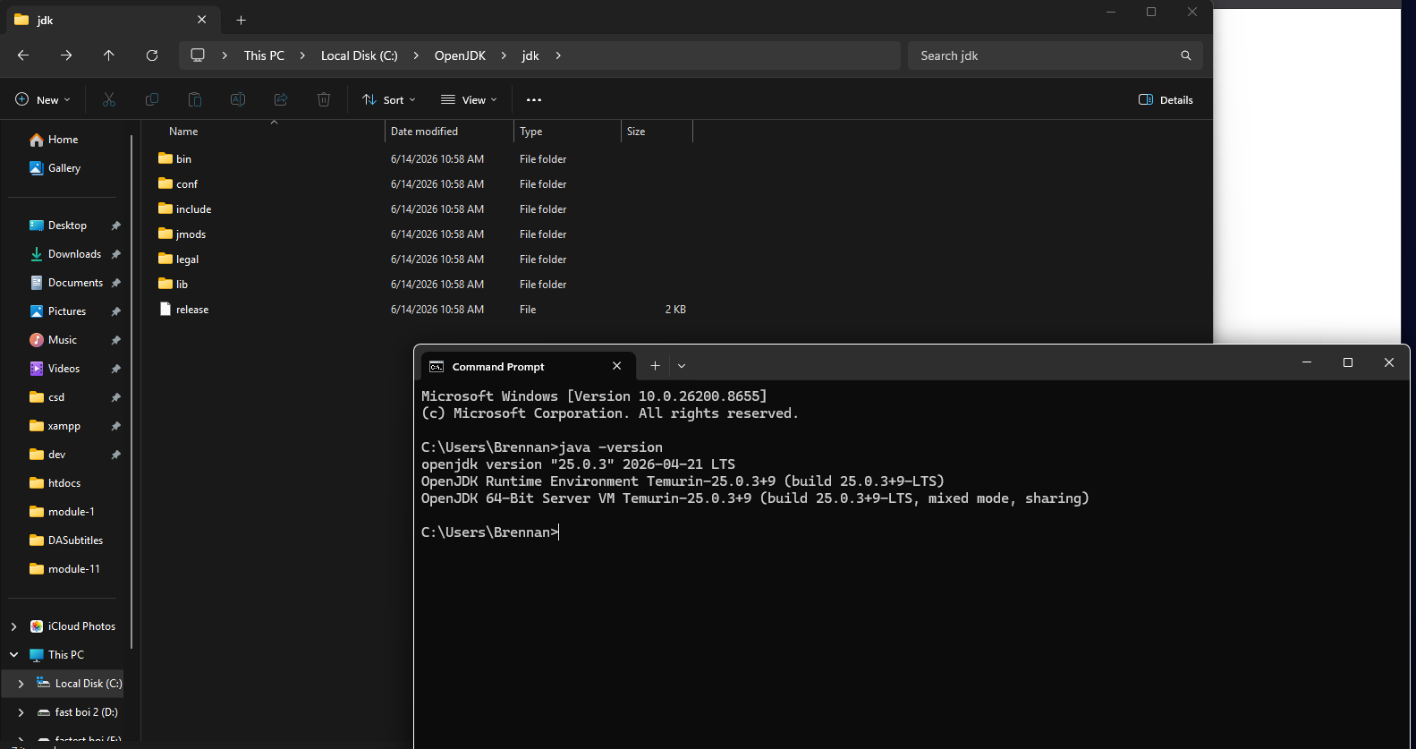
Successful Installation of Tomcat:
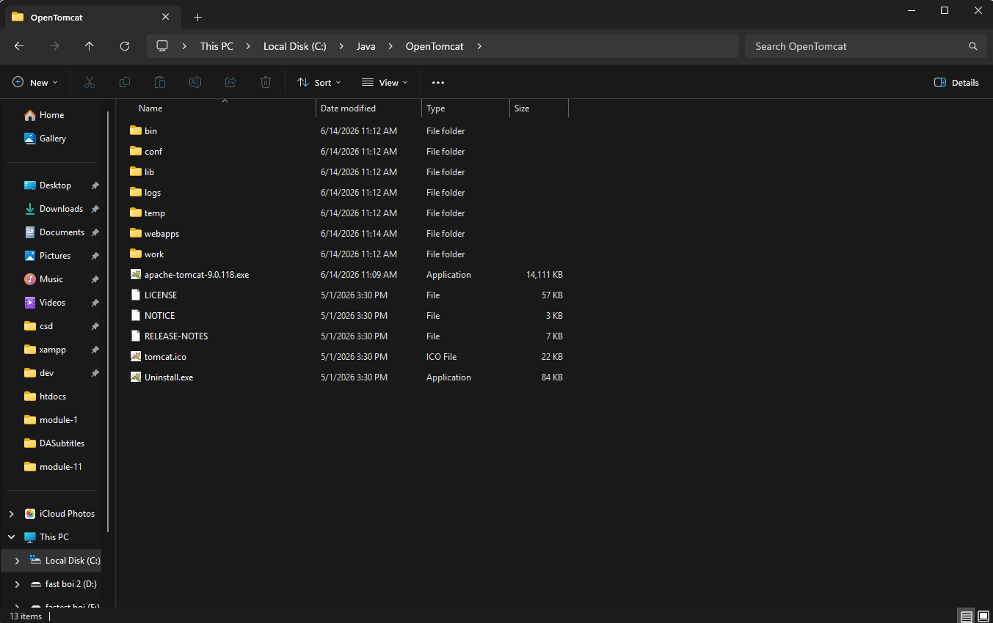
Successful installation of Eclipse IDE:
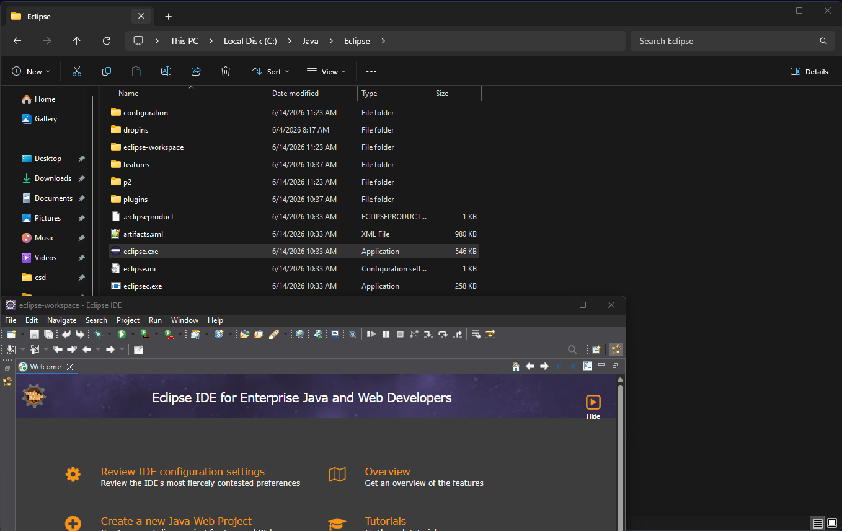

Running a .JSP file with Tomcat:
