Brennan Cheatwood
CSD430 – Assignment 6.2
7/18/26
Github.com/brengeware/csd-430
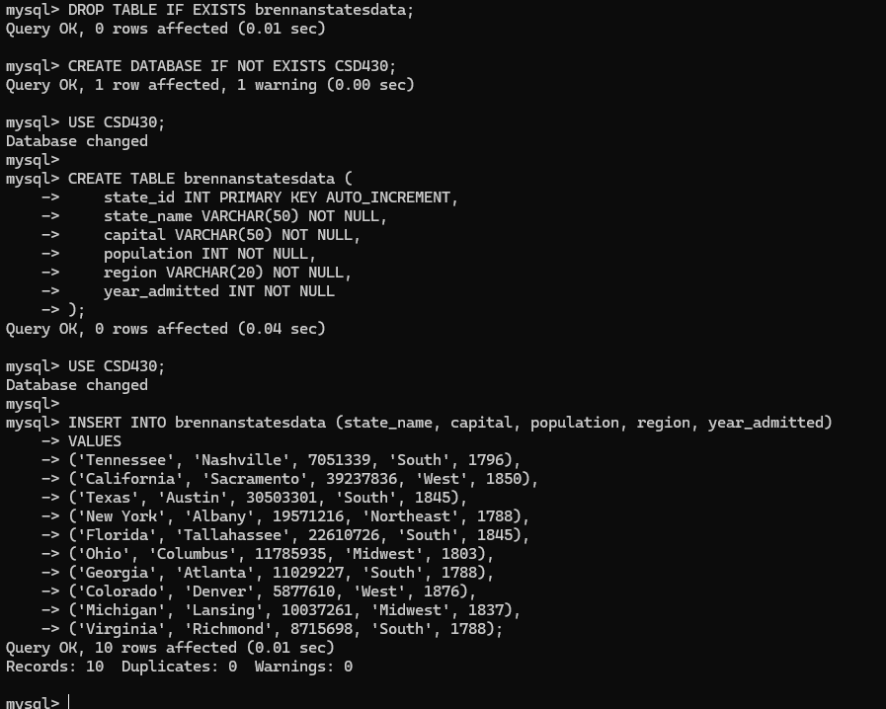
Grants for student1