Brennan Cheatwood
CSD-430 – Assignment 7.2
7/26/26
Github.com/brengeware/csd-430
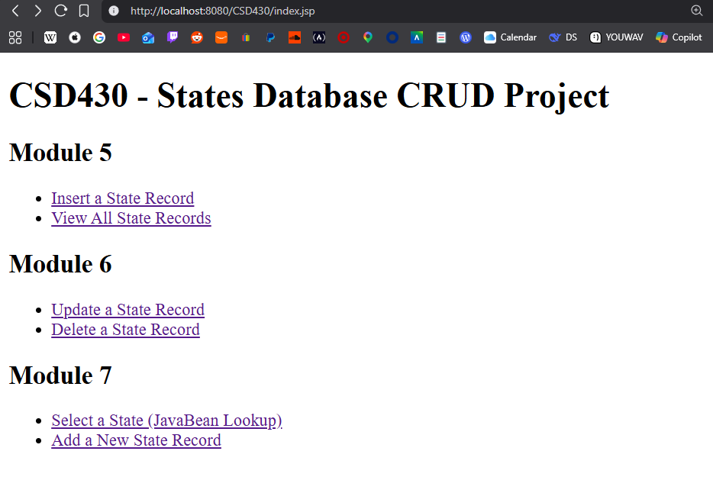

State record detail:
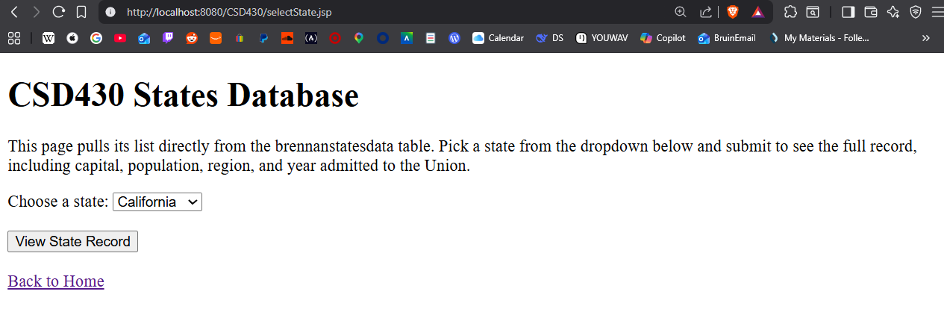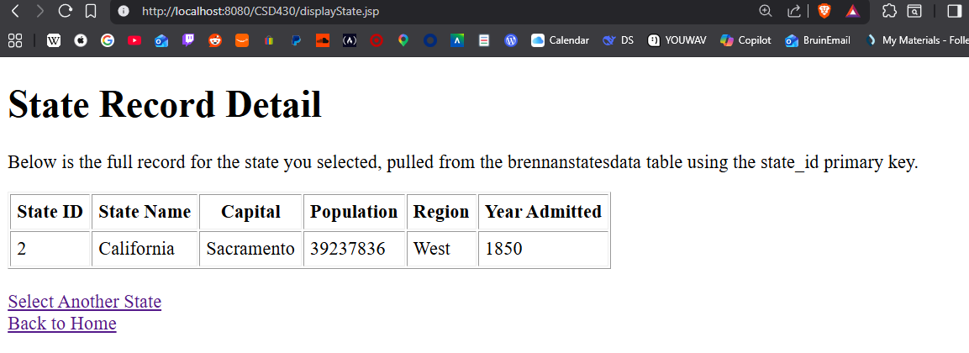
New state record:
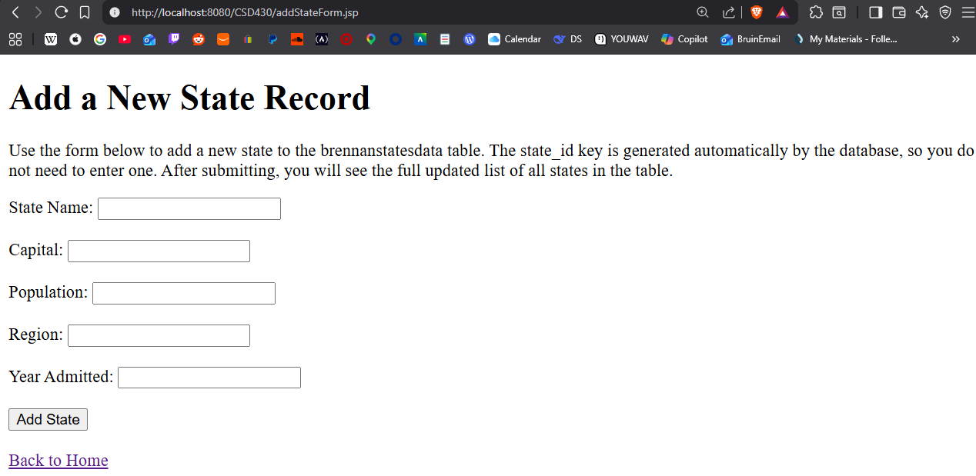
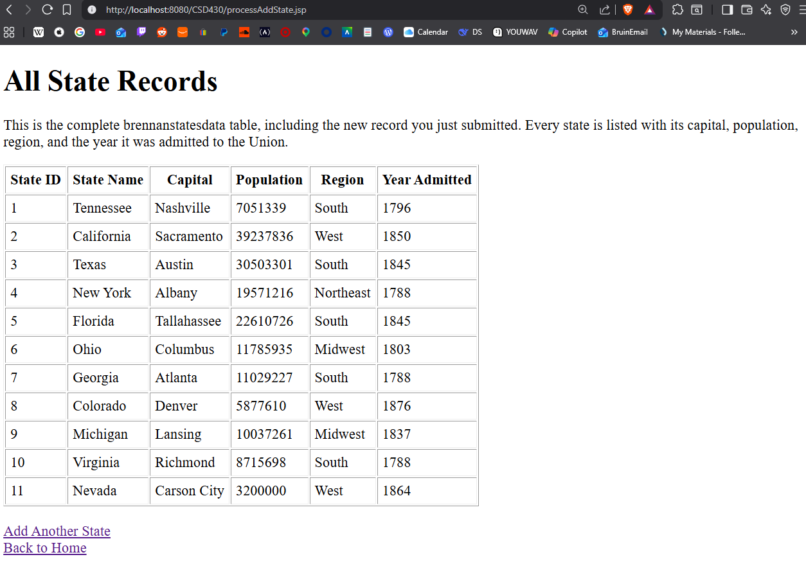
Addition successful

