Brennan Cheatwood
CSD440 – Assignment 1.3
3/21/26
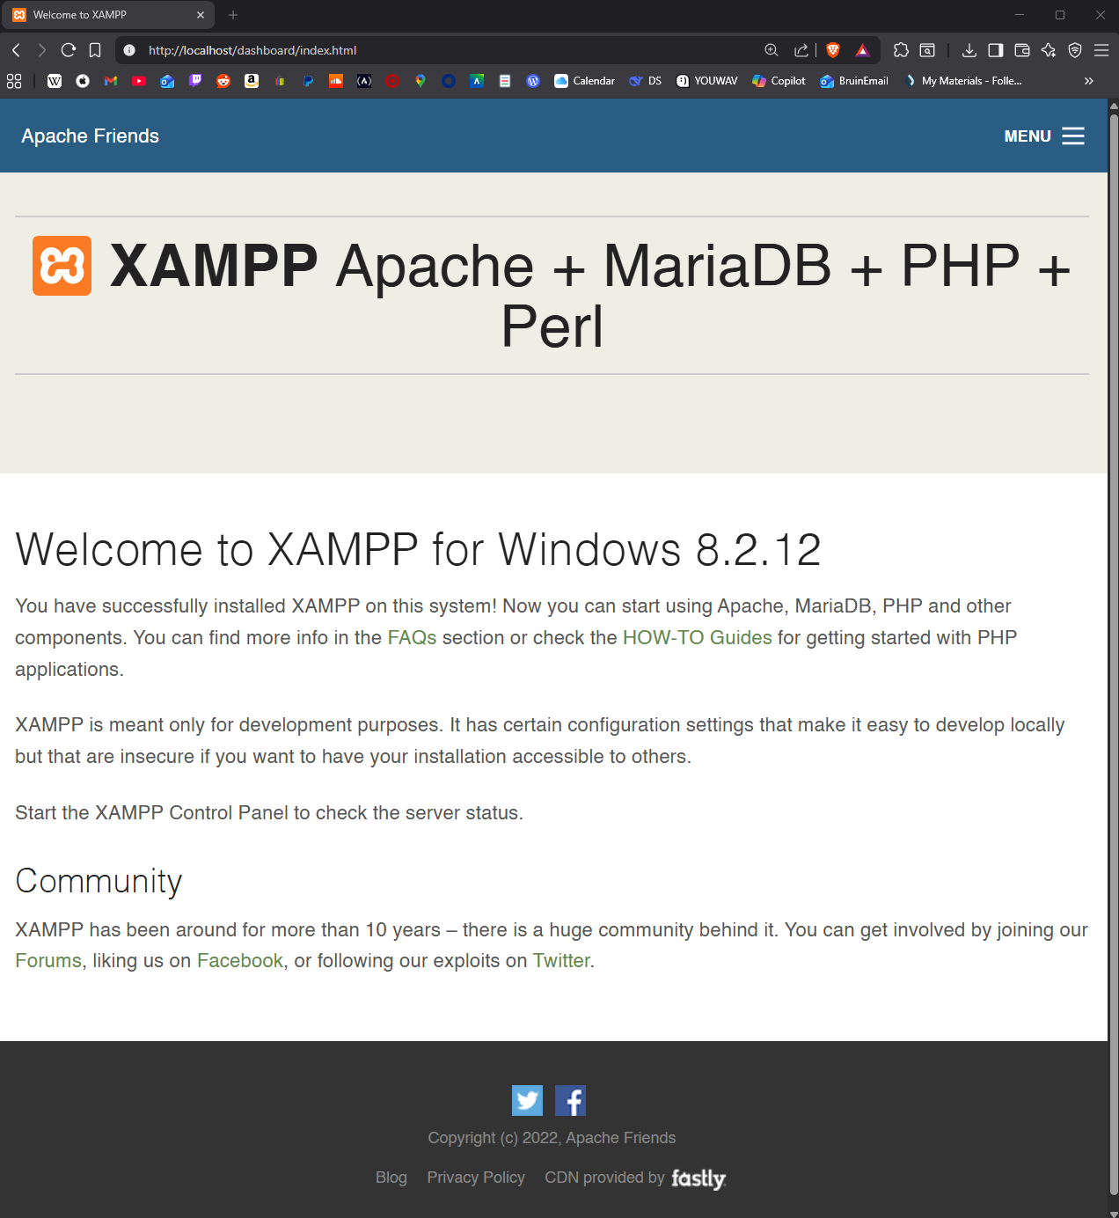
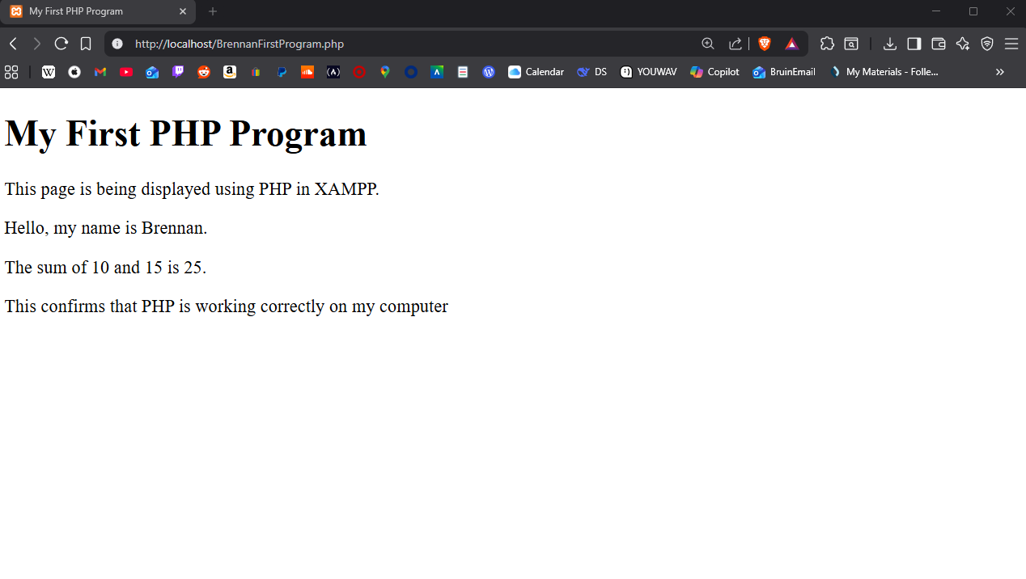
I successfully installed and configured XAMPP on my computer without errors. After starting Apache, I created a PHP file named BrennanFirstProgram.php and saved it in the htdocs folder. I tested the file in my browser using localhost, and it displayed correctly. My program includes standard HTML tags, two PHP code snippets, and comments for documentation. The output showed my name and a simple math calculation, which confirmed that PHP was working correctly in XAMPP.

