Brennan Cheatwood
CSD440 – Assignment 7.2
5/3/26
Github.com/brengeware/csd-440
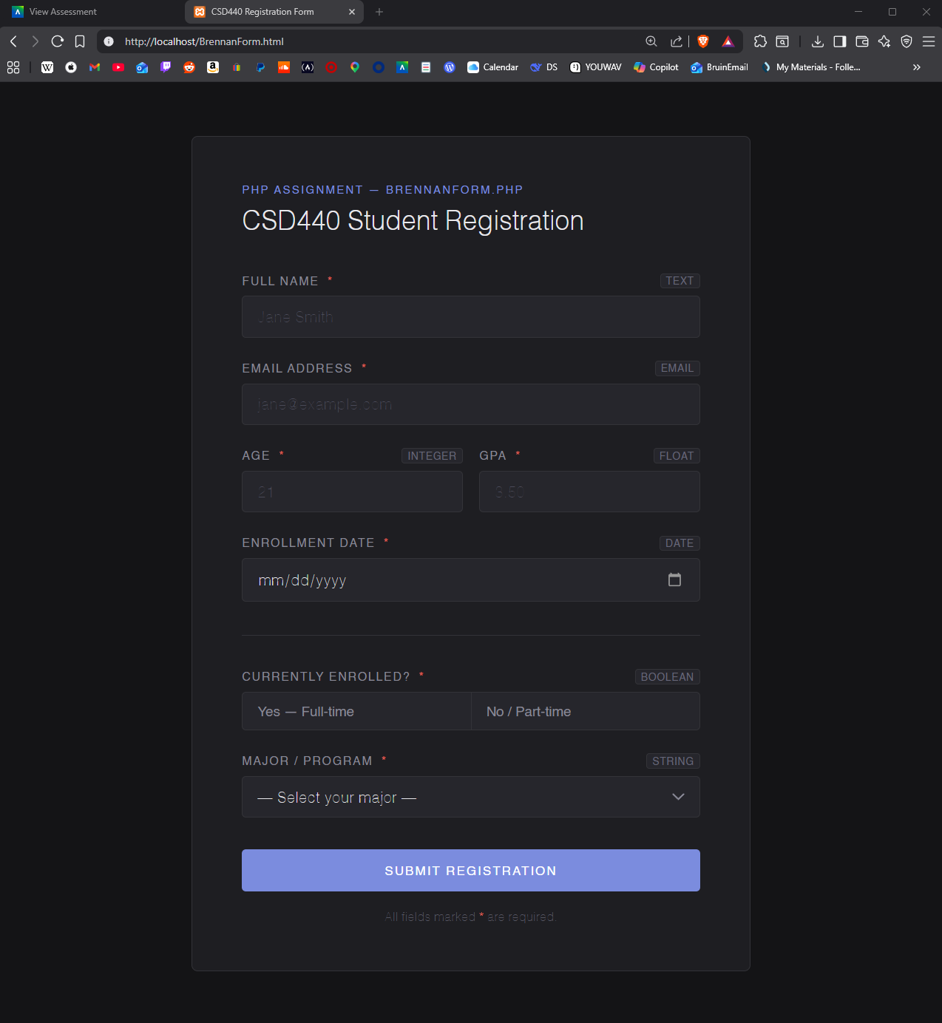
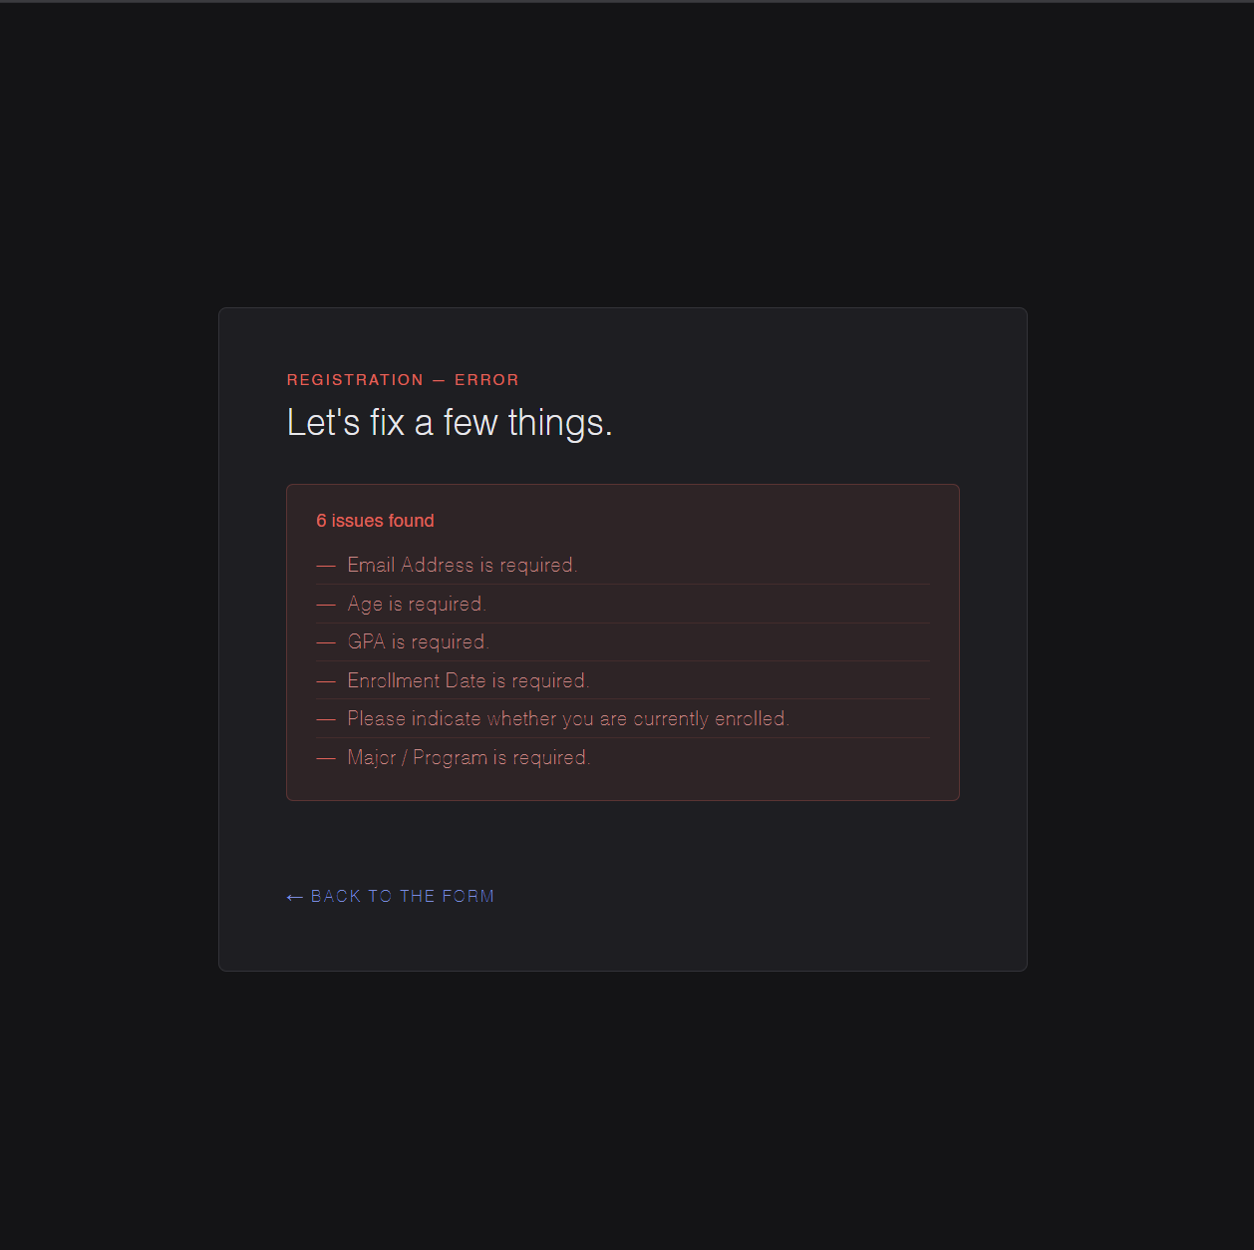if all conditions are not met

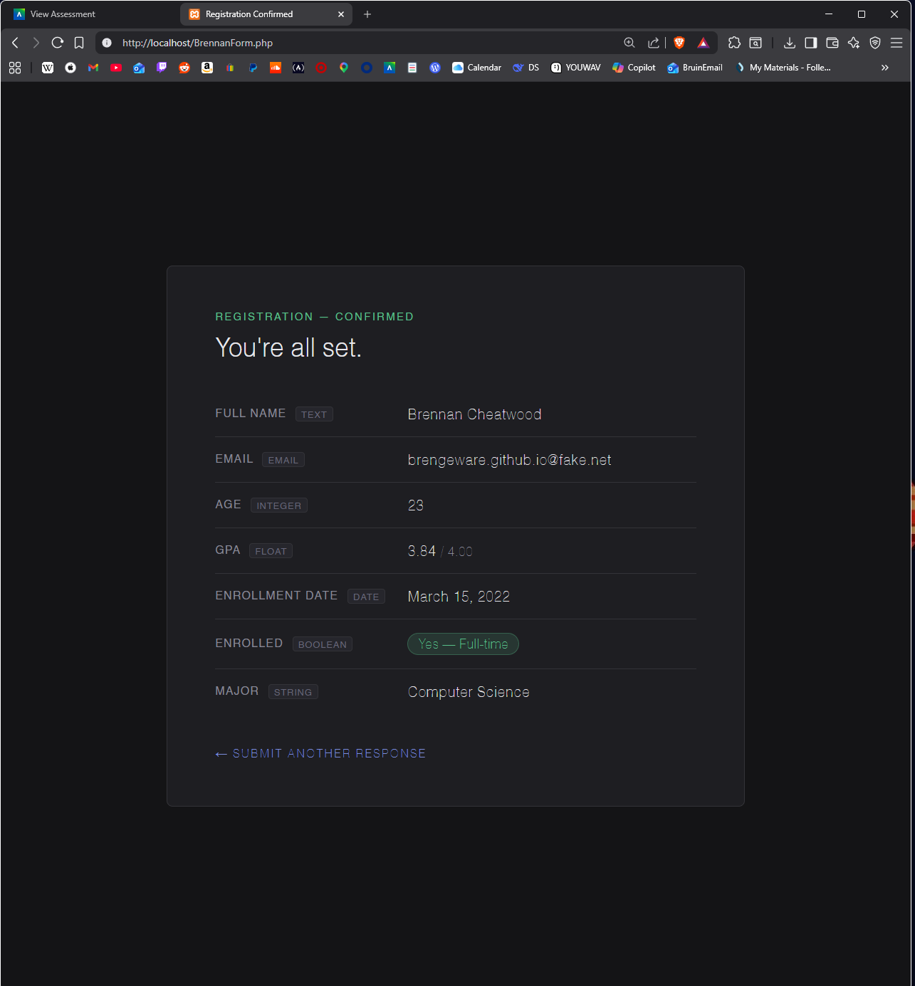when the form is submitted

